Society Outreach Program

A Report

On

**“WOMEN EMPOWERMENT (EDUCATION)”**

Submitted in partial fulfillment of the requirements

of

**BACHELOR OF ENGINEERING**

**IN**

**COMPUTER SCIENCE AND ENGINEERING**

**Submitted By**

**Ms. T Aakanksha (2451-17-733-133)**

**Ms. M Navya Sahithi (2451-17-733-134)**

**Ms. M Sumasree (2451-17-733-146)**

Under the supervision of

**Ms. K Jaya Sheela** Assistant Professer **Applied Science & Humanities** M.V.S.R.E.C., Hyderabad.

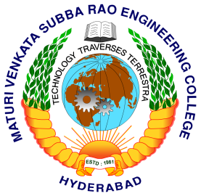

Department of Computer Science and Engineering M.V.S.R. ENGINEERING COLLEGE (Affiliated to Osmania University & Recognized by AICTE) Nadergul, Saroor Nagar Mandal, Hyderabad – 501 510 2018-19.

**M.V.S.R. ENGINEERING COLLEGE**

(Affiliated to Osmania University, Hyderabad)

Nadergul (P.O.), Hyderabad-501510

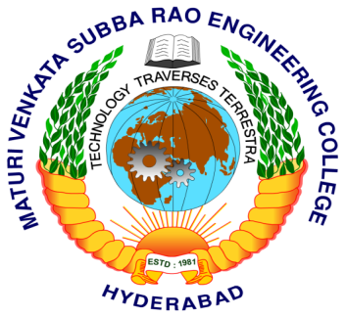

**Certificate**

This is to certify that the “S.O.P.” report entitled **“WOMEN EMPOWERMENT (EDUCATION)”** is being submitted by **T Aakanksha (**2451-17-733-133**), M Navya Sahithi (**2451-17-733-134**), M Sumasree (**2451-17-733-146**)** in partial fulfillment of the requirements of **BACHELOR OF ENGINEERING IN COMPUTER SCIENCE AND ENGINEERING as a part of S.O.P.** from M.V.S.R. Engineering College, affiliated to OSMANIA UNIVERSITY, Hyderabad, under our guidance and supervision.

The results embodied in this report have not been submitted to any other university or institute of any degree or diploma.

Project Guide HOD **Ms. K. Jaya Sheela** **Dr. AkhilKhare**  Assistant Professor Prof. & HOD  **Applied Sciences & Humanities**  **CSE Dept.** M.V.S.R.E.C., Hyd. . M.V.S.R.E.C.,Hyd.

**ACKNOWLEDGEMENTS**

We express our sincere thanks to **Dr.  G. Kanakadurga**, Principal, M.V.S.R. Engineering College, Nadergul, Hyderabad, for her encouragement and constant help.

We express our sincere gratitude to **Dr. Akhil Khare**, Professor & Head, Department of Computer Science and Engineering, M.V.S.R. Engineering College, for his precious suggestions, motivation and co-operation.

We express our sincere gratitude to **Dr.A.R.Subrahmanyam,** Professor & Head, Department of Science And Humanities, M.V.S.R. Engineering College, for his precious suggestions, motivation and co-operation.

It is our privilege and pleasure to express our profound sense of respect, gratitude and indebtedness to our guide **Ms**. **K. Jaya Sheela**, Associate professor, Department of Science and humanities, M.V.S.R. Engineering College, for her indefatigable inspiration, guidance, cogent discussion, constructive criticisms and encouragement throughout this dissertation work.

We extend our sincere thanks to all the teaching and non-teaching staff of CSE Department for their support and encouragement.

Last but not least, we wish to acknowledge our friends and family members for giving moral strength and helping us to complete this dissertation.

**ABSTRACT**

**Women's empowerment** is the process in which women elaborate and recreate what it is that they can be, do, and accomplish in a circumstance that they previously were denied. Empowerment can be defined in many ways, however, when talking about women’s empowerment, empowerment means accepting and allowing people (women) who are on the outside of the decision-making process into it. Empowerment acts as a powerful tool against exploitation and harassment of women .Without women’s empowerment, we cannot remove injustice and gender bias and inequalities .Women are deprived of decision making power, freedom of movement, access to education, access to employment, exposure to media, domestic violence, hence there is a need for women empowerment. We can empower women by teaching them job skills and seed businesses, built self-esteem and confidence, boost decision-making power. Without developing skills for effective communication, women cannot make their voices heard. It is essential for them to communicate effectively to become successful. As leaders, they need to put across their points to people so that a family, team or company can be effectively managed.

**TABLE OF CONTENTS**

**Page No**

Certificate………………………………………………......................... ii Acknowledgement……………………………………………..………..iii Abstract…………………………………………………………..……...iv

CONTENTS INSIDE THE DOCUMENT

1. Introduction 6

2. Aim and Objectives of the study 10

3. Need for the Study 11

4. Design of the Study 12-17

4.1 Questionnaire 12

4.2 Description of Study 16

4.3 Data Collection 17

5. Data Analysis 22

6. Results, Conclusion and Suggestions 33-35

6.1 Result 33

6.2 Conclusion 34

6.3 Suggestions 35

Reference

Appendix

**CHAPTER-I**

**Introduction**

Women empowerment is a process of enabling women to have access and make productive contributions to their economic independence, political participation and social development. Empowerment enables the individuals to realize their identity and powers in all spheres of life. It consists of greater access to knowledge and resources, greater autonomy in making decisions or free from the shackles imposed on them by custom, belief and practices in the society.

Empowerment enables women to acquire knowledge, skills and techniques which will help them in their personal and social growth as well as foster in them sensitivity towards problems in the society. Special efforts are required to be taken for education, health and employment of women. Economic empowerment is essential for improvement of female sex ratio but economic empowerment is possible only when women are educated.

Pandit Jawaharlal Nehru once said: *“If you educate a man you educate an individual, however, if you educate a woman you educate a whole family. Women empowered means mother India empowered*”. When women who contribute almost half of the population are empowered it will strengthen the national economy. Education is considered as a milestone for women empowerment because it enables them to respond to the challenges, to confront their traditional role and change their lives. Increasing access to education notwithstanding, gender discrimination still persists in India and lot more needs to be done in the field of women's education in India. Women have so much unexplored potential which has never been tapped. As education is both an input and input of human development, educational equity will ensure enabling and entrepreneurial development.

Education is considered as a basic requirement and a fundamental right for the citizens of any nation. It is a powerful tool for reducing inequality as it can give people the ability to become independent. Women, who come across discrimination in many spheres, have a particular need for this. Education is regarded as an important milestone of women empowerment because it enables them to face the challenges, to confront their traditional role and change their life. Education of women is the most powerful tool of change their position in the society. Still large womenfolk of our country are illiterate, backward, weak, and exploited. Education also reduces inequalities and functions as a means of improving their status within the family. Empowerment and capacity building provides women an avenue to acquire practical information and learning for their improved livelihoods. India can become a developed nation only if women contribute to the best of her capacity and ability which is possible when she is educated and empowered.

**Role of education**

It is said that education increases "people's self-confidence and also enables them to find better jobs and they can work shoulder to shoulder with men". They engage in public debate and make demands on government for health care, social security and other entitlements". In particular, education empowers women to make choices that improve their children's health, their well-being, and chances of survival. Education informs others of preventing and containing the disease, and it is an essential element of efforts to reduce malnutrition. Furthermore, it empowers women to make choices that can improve their welfare, including marrying beyond childhood and having fewer children. Crucially, education can increase women's awareness of their rights, boost their self-esteem, and provide them the opportunity to assert their rights.

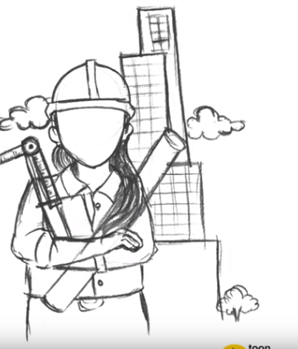Despite significant improvements in recent decades, education is not universally available and gender inequalities persist. A major concern in many countries is not only the limited numbers of girls going to school but also the limited educational pathways for those that step into the classroom. More specifically, there should be more efforts to address the lower participation and learning achievement of girls in science, technology, engineering and mathematics.

Lack of education is the root cause for women’s exploitation and negligence. Only literacy and education can help women to understand the Indian’s constitutional and legislative provisions that are made to strengthen them. Education is “*potential affirming and performance confirming”*. Empowerment of a girl starts even enterprise makes empowerment operational. That is full filling journey for a mother too: from a painful situation to a gainful situation. When women are educated, they will be able to contribute in nation building. A few women are currently holding powerful positions in India and in the world, but there is still room for improvement if more women are educated. Perhaps with increase in women holding the mantle in a male-dominated political arena, the socio-political state of affairs of the whole world will definitely improve.

**Need of Women Education in Women Empowerment**

Education means modification of behavior in every aspect, such as mentality, outlook, attitude etc. Educated women not only tend to promote education of their girl children, but also can provide better guidance to all their children. Moreover educated women can also help in the reduction of infant mortality rate and growth of the population. Education of a women leads to a better family and ultimately an ideal society to a progressive nation.

• Education empowers women: Educated girls and young women are more likely to know their rights and to have the confidence to claim them

.• Education promotes tolerance: Education helps people to understand democracy, promotes the tolerance and trust that underpin it, and motivates people to participate in the political life of their societies.

• Education equality improves job opportunities and increases economic growth: If all children had equal access to education, productivity gains would boost economic growth. Over 40 years, per capita income would be 23 per cent higher in a country with equality in education.

• Educating women avoids early marriages: If education is provided to more number of women it will be helpful in avoiding child marriage.

**CHAPTER-II**

**Aim and Objectives of the Study**

The main aim and objective of the study is

“To study the role of education in women empowerment “

It also aims

* To Determine the barriers for women education and explore the challenges that girls face to get proper education
* To create awareness on importance of women education and the benefits that educating girls brings.
* To suggest possible ways to overcome the barriers to girl education and to empower women.

Women in urban areas are allowed to get proper education with the support of their family. Also their family helps them in getting empowered. We would like to know if this is the case with women in rural areas.

The study aims to know whether they are getting education to the extent they wish, whether the family is supporting them and whether they have enough freedom to discuss education interests with their family. Some barriers could be social security, financial status, equal education opportunity between siblings in the society, act as a barrier to their education; we even want to know if early marriages and child bearing are a reason for women for not getting proper education.

**CHAPTER-III**

**Need for the Study**

Women are considered the most important factor of the society. The importance to women is declining in today's society. There is significant growth observed in underestimating women such as to make them occupied a secondary position in society and to deny them of their basic rights, thus there is need to empower women of the present day. Today we enjoy the benefits of being citizens of a free nation, but we really need to think whether each citizen of our country is really free or enjoying freedom, in the true sense. Our society has destitute women of certain basic rights due to such current situation; it is needed to make women free from all the fetters and to empower them as well.

Taking an account of this background, we came to know that women empowerment has now become a topic of global discussion. Seeing all the aspects of this discussion, we have realized that education is a milestone for empowerment of women. Literacy should spread amongst women which would help them to get empowered.

So we felt that a study on role of education in empowering women is very much needed in the present society.

Moreover this study is even more needed in rural areas, where the extent of women education is less. It is essential to create awareness on the importance of education in such areas.

**CHAPTER-IV**

**Design of the Study**

The present study is based on the collection of data from a population of size twenty**.**

Then we selected a slum area a place near Midhani for data collection.

We visited the area at 10 am and interacted with twenty women and collected data.

Following are the questions prepared by us.

**4.1 Questionnaire :**

Firstly we prepared a questionnaire based on following factors

* Need for education
* Family support for education
* Gender inequality in education
* Social security as a barrier
* Marriage as a barrier

**4.2 Description of the Study**

We have collected data from a sample of size twenty. We visited a slum area near Midhani and interacted with twenty household women from various age groups regarding their education status and the problems faced by them to pursue education.

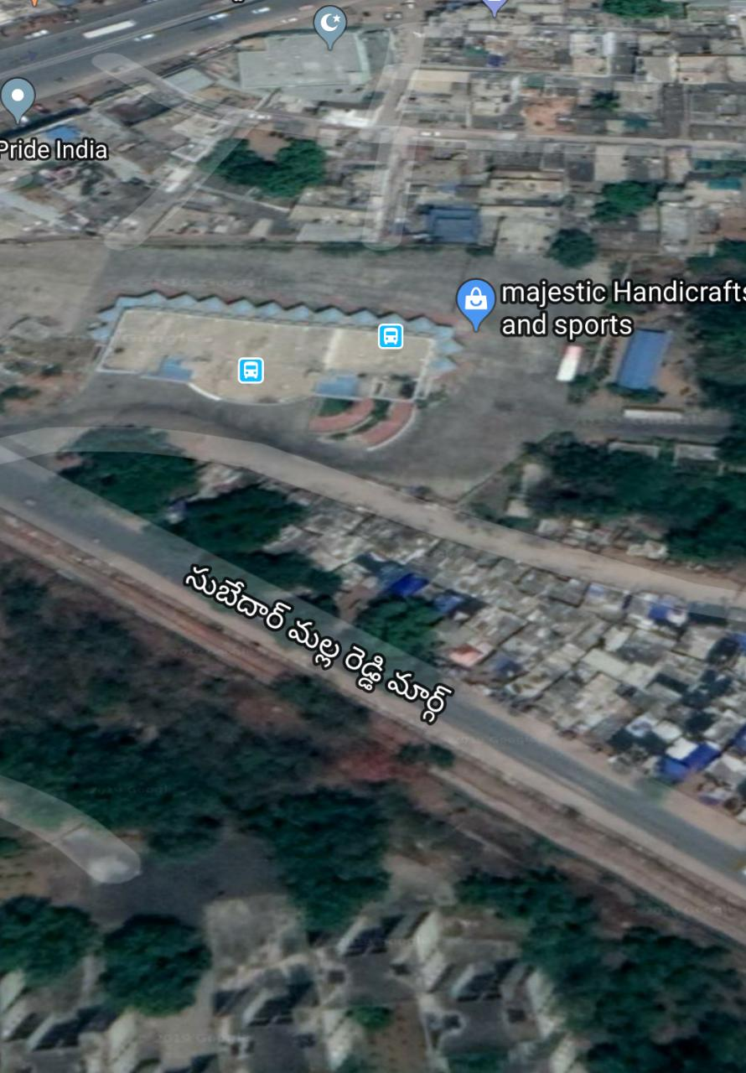

The slum area near the Midhani Bus Depot, in the Subedhar Malla Reddy Marg has just some basic facilities which are not so good. Most of the people there are illiterate and have no knowledge on importance of education. They have very less income and most of them work as daily wage laborers.

We have selected this area as it is of rural background and we felt that there is a need to create awareness here as no such surveys on women education have been done previously.

**4.3 Data Collection**

We visited a slum area near Midhani at 10am and spoke to women of age group 15-45 regarding their education. The women there have enthusiastically answered all our questions and also shared their problems and concerns about their education with us.

Below are some of the cases of women in that area. All of them have different perspectives regarding education.

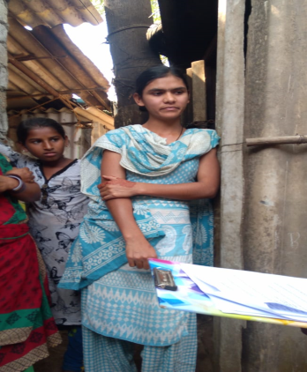

Mounika

We spoke to an eighteen year old girl, named Mounika. She has completed her Diploma and is very much interested to attend a training course, which would help her in finding a job. She wishes to have a successful career in IT field. But all dreams are being collapsed, as her mother wants to get her married and has fixed a marriage proposal.

We have questioned Mounika if her in-laws would allow continuing to her studies,

Mounika said “ *If my parents itself don’t support my education, how could I expect my in-laws who don’t even know me till now, would do so….”*

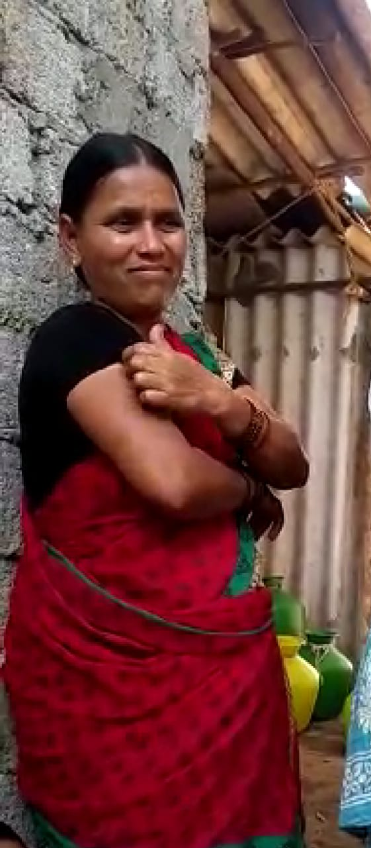

Mounika’s Mother

Though her mother wants to educate her so that she could become independent, she fears that if Mounika continues her studies without being married, then she wouldn’t get a nice bridegroom in future.

We were very much moved by the pathetic situation of Mounika. We spoke to her mother and tried to convince her regarding the importance of education and the effects of early marriages. But there was no use in talking to her mother because she was not ready to listen to us.

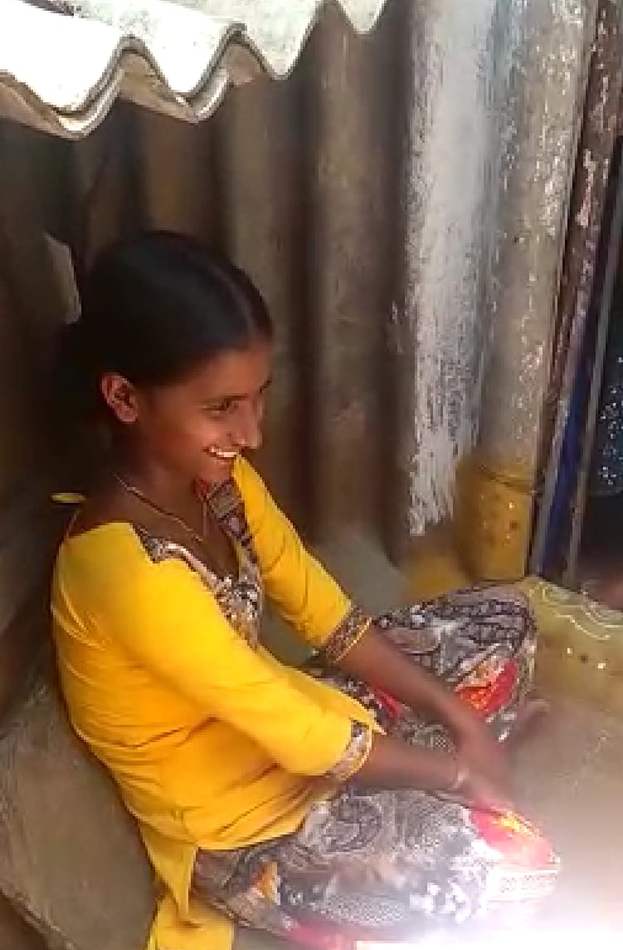

We then met a girl who discontinued her studies due to her health issues. She said that she was not interested to continue her studies. Her parents were ready to educate her to the extent she wishes and are trying to tell her the necessity of education. But here the girl was not ready and is not interested in education.

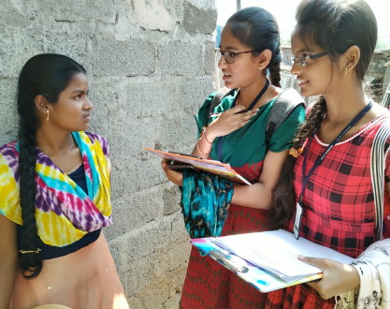

Then there is a girl named Lalitha, who said that girls of their caste in their locality were not allowed to get educated above 10th standard, though she is interested to study.

One of the girls in same area is being educated as per her choice. There are no restrictions and challenges for her education. She is currently pursuing her degree and then she would like to work in a software company. Her parents are even ready to send her to a far place if she gets a good job.

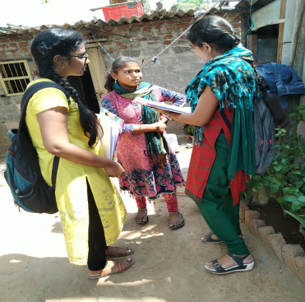

Another girl wants to get educated but at the same time she would like to support her mother who is the only source of income in her family. So she lost her interest in studies and is working in the houses so as to economically support her family.

She said that

*“I don’t like to see my mother working alone and striving hard for us. So I discontinued my studies and am supporting my mother.”*

**CHAPTER V**

**Data Analysis**

In this chapter the analysis is made on the basis of a questionnaire. There are twenty questions prepared and each question is shown with the graphical representation

**1. Current Education Status ?**

A. Under Education B. Discontinued Education C. Not Educated

**Result :**

From this we can say that many of the women are discontinuing their studies without their dreams being fulfilled. Out of twenty women six women are continuing their education without any problem. Two women are not yet studied they are of age group 25-45.These women said that there is no facility of education at their age twelve women discontinued their studies for many reasons like social security, economical problems, early marriage, gender issues. And the conclusion is there are places where women are still not allowed to get education.

**2. Do you think women should get educated?**

1. Yes B. No

**Result :** The conclusion we got from this graph is everyone has a positive opinion on women education. Among twenty women nineteen women said that women should get educated.

**3. Do you think women now have equal rights as men?**

1. Yes B. No

**Result** : The result we got from the survey is Yes, maximum women are having equal rights as men. In twenty women sixteen women are having equal rights with their brothers and four are still facing gender bias.

**4. In your opinion what is the main reason for a women to have education?**

A. Increase Earnings B. Improve Marriage Prospects

C. Can Become Independent In The Society D. Not Needed

**Result** : The main reason for women to have education is they want to become independent and want to prove that they can live without any support of men. The second main reason is to increase earnings. Out of twenty women fifteen gave their answer that they want to become independent.

**5. A women’s place is only at home. Do you agree?**

A. Strongly Agree B. Agree C. Neither Agree Nor Disagree

D. Disagree E. Strongly Disagree

**Result :** The result we got is no women’s place is not only at home. They have rights to work in society equally with men. According to survey no women agreed that the women’s place is only at home.

**6. Did your family educate you to the extent you wished?**

1. Yes B. No

**Result:** In twenty women ten are educated or will get education to the extent they wish But, ten women said that there are not allowed to get educate to the extent they wish by their parents

**7. Do you have enough freedom to discuss your education and career goals with your parents?**

1. Yes B. No

**Result :** In most of the houses they have enough freedom to discuss about their education and career goals with their parents. According to the survey out of twenty women twenty women have freedom to discuss their goals

**8. In your view, how do your parents feel if you wish to go to a city far away to pursue higher education?**

A. Very Happy B. Happy C. Neither Happy Nor Sad D. Sad E. Very Sad

**Result**: Different people have different opinion according to survey among twenty women three families were very happy to send their daughter to out of the city for higher education eight families are happy to send their daughter ,five were not happy to send their daughter and four were not at are allowed to go out of the city for higher education.

**9. Did you get equal education as that of your brother?**

1. Yes B. No

**Result:** According to the survey we can say that we are getting over gender inequality issues overall. Among twenty women fourteen are getting equal education as their brother But, still 6 are facing gender inequality.

**10. Did you discontinue your studies?**

1. Yes B. No

**Result:** From the survey we came to know that many women discontinued their studies .Among 20 women 12 women discontinued their studies .

Each and every family has a different problem to educate their girl. There are many barriers for women to get educate some of them are

Economical factors

Gender inequality

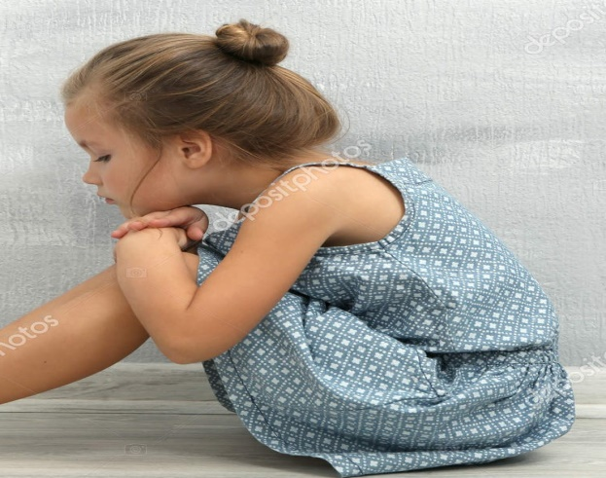

SSocial Security

Early marriage

**11. Are you married? If yes ,did you continue your education after marriage?**

A. Yes B. No

**Result :**One of the main reason for women not getting empower is early marriage. Among twenty women eight are married in that only three are continuing their education. Remaining five women are not allowed to educate by their husbands

**12. Is safety and security, in the society, a barrier for women to get educated?**

1. Yes B. No

**Result:** According to survey we came to known that safety and security in the society are not causing a barrier for women to get educated. Among twenty women twelve women are not have any security

**13. Uneducated women cannot empower herself?**

A. Strongly Agree B.Agree C. Neither Agree Nor Disagree

D. Disagree E. Strongly Disagree

**Result :** Women without education can also empower herself by her physical work, talent skills. According to the survey max women has an opinion that an uneducated women can also empower by herself

**14. Are you allowed to work after completing your education?**

1. Yes B. No

**Result :** Even though women are getting proper education But , they are not allowed to do job by their families. According to surveytwelve women were not allowed to work ,not allowed to take the fruits of their education.

**15. Do child bearing and household chores act as a barrier for women to work**?

1. Yes B. No

**Result :** Child rearing and household chores are not acting as a barrier for the women in that area . According to the survey among twenty women eleven women has an opinion that household work doesn’t stop women to get empower.

**16. A man alone should economically support his family, women cannot be a part of it .Do you agree ?**

A. Strongly Agree B.Agree C. Neither Agree Nor Disagree

D. Disagree E. Strongly Disagree

**Result :** No only man alone need not to support his family, women should also need to be part of it . According to survey all women disagree to the above statement

**17. Are you aware of government schemes to support girls education**?

1. Yes B. No

**Result :** Many of the women are not aware of the government schemes to support girls education

**18. Does knowledge of such schemes improve your chances of getting better education?**

1. Yes B. No

**Result :** Main reason for women not getting education is due to the financial inabilities . So if government provides such schemes which provide economic support then it improves their chances of getting better education.

**19. In your opinion what are the responsible factors that affect women empowerment**?

A. Marriage B. Education C. Economic Factors D. Social Security

**Result:** The main responsible factor that affecting women empowerment is economical factors .Due to the financial problems many women are discontinuing their studies .According to the survey the second main factor that affecting women empowerment is early marriage. Due to early marriage many women are not fulfilling their dreams

**20. Do you feel that more women are being empowered as compared to earlier?**

1. Yes B. No

**Result :** Yes more women are being empowered and becoming independent as compared to the past.

**CHAPTER-VI**

**6.1 Result**

During our survey we got across various women with different ideologies and got to know their barriers of education. There were different perspectives, some of the women were interested to continue education but they have various barriers such as early marriages, economic issues and lack of support from parents. On the other hand, some were not at all interested in education due to health issues or so as to support their family financially.

It was told to the young girls who discontinued their studies about the importance of education and how it can impact their lives. We created awareness on the need for women empowerment and how it can be achieved through education.

We created awareness about empowering women among twenty houses of Midhani slum area. During the data collection most of the respondents didn’t have any awareness about empowerment, even though some of them are educated. Since education is the primary avenue for empowerment and there are other dimensions that have impact on empowerment

We also told them about some of the government schemes to support women education, such as “Beti padao Beti Bachao” and “Balika Samridhi Yojana”. They would provide greater economic support for the women to get empowered.

**6.2 Conclusion**

Women empowerment is the pivotal part in any society, state or country. Education is milestone of women empowerment because it enables them to responds to the challenges, to confront their traditional role and change their life. Education is the most powerful weapon. We can use to it change the world. It is having a positive rapport with the women empowerment as per as our survey.

Education is important for the personal, social and economic development of the nation. Education is important to live with happiness and prosperity. Education empowers minds that will be able to conceive good thoughts and ideas. Education enables students to do the analysis while making life decisions.

The present study suggests that General awareness programme should be conducted among the women of rural area to sensitizes them about the modern development of science and technology so that they could give up superstitious believes and attitudes. This study concludes that generally gender barriers still continue particularly in rural area. To encourage the education of women at all levels and for dilution of gender bias in providing knowledge and education, establishing schools, colleges and universities even exclusively for women in the state. Due to current socio economic constrains in rural area, the potential of women have not been fully utilized and further pushed back into the social hierarchy.

Hence, if women’s empowerment is to be effected, it can be carried out only through the medium of education. Therefore, it is importance to raise the level of education amongst women.

**6.3 Suggestions**

There are few suggestions made for the Society out research program. They are

1. Demonstrate a positive attitude about education to the children.
2. The essential factors for empowerment are self-confidence, exposure and
3. Independence. we should develop the self-confidence in them by giving exposure to the positive vibe of education.
4. Government should provide economic support and increase the awareness on the existing schemes.
5. We should create awareness that education is the basic right for the children.
6. The Right of Children to Free and Compulsory Education Act or Right of Education Act(RTA), is an Act of the Parliament of India enacted on 4th August .

**Reference**

1. <https://en.wikipedia.org/wiki/Women%27s_empowerment>
2. <https://en.wikipedia.org/wiki/Female_education>
3. <https://files.eric.ed.gov/fulltext/EJ1081705.pdf>
4. <https://motherhooduniversity.edu.in/images/papers/Khushboo%20Singh.pdf>
5. <https://www.iied.org/why-womens-empowerment-essential-for-sustainable-development>

**Appendix**

**Questionare**

1. What is your education qualification?

2. Do you think a woman should get educated?

1. YES
2. NO

3. Do you think women now have equal rights as men?

1. YES
2. NO

4. In your opinion what is the main reason for a woman to have education?

1. Increase earnings
2. Improve marriage prospects
3. Can become independent in the society
4. Not needed

5. A woman’s place is only at home. Do you agree?

1. Strongly Agree
2. Agree
3. Neither Agree Nor Disagree
4. Strongly Disagree
5. Disagree

6. Did your family educate you to the extent you wished?

1. YES
2. NO

7. Do you have enough freedom to discuss your education and career goals with your parents?

1. YES B. NO

8. In your view, how do your parents feel if you wish to go to a city far away to pursue higher education?

1. Very Happy
2. Happy
3. Neither Happy Nor Sad
4. Very Sad
5. Sad

9. Did you get equal education as that of your brother?

1. YES
2. NO

10. Did you discontinue your studies?

1. YES
2. NO

If yes, what are the reasons? ________________

11. Are you married? If yes, did you continue your education after marriage?

1. YES
2. NO

12. Is safety and security, in the society, a barrier for women to get educated?

1. YES
2. NO

13. An uneducated woman cannot empower herself. Do you agree?

1. Strongly Agree
2. Agree
3. Neither Agree Nor Disagree
4. Strongly Disagree
5. Disagree

14. Are you allowed to work after completing your education?

1. YES
2. NO

15. Does child rearing and household chores act as a barrier for women to work?

1. YES
2. NO

16. A man alone should economically support his family, woman cannot be a part of it. Do you agree?

1. Strongly Agree
2. Agree
3. Neither Agree Nor Disagree
4. Strongly Disagree
5. Disagree

17. Are you aware of any government schemes to support girl education?

1. YES
2. NO

18. Does knowledge of such schemes improve your chances of getting better education?

1. YES
2. NO

19. In your opinion what are the responsible factors that affect women empowerment?

1. Marriage
2. Education
3. Economic Factors
4. Social Security

20. Do you feel that more women are being empowered as compared to earlier?

1. YES
2. NO



