Effects of mood and traits on human foraging behaviour under predatory threat: Analysis plan for confirmation sample

Table of Contents

- Hypothesis Tests
- Table 1: Hypothesis Tests Linking Mood States with Task-Related Behaviour
- Table 2: Hypothesis Tests Linking Clinical Traits with Task-Related Behaviour
- Table 3: Hypothesis Tests Linking Demographics with Task-Related Behaviour

- Methods
  - Task
    - Forage
    - Check
    - Hide
    - Blocks
    - Timings
    - Training
  - Questionnaires
  - Pre-processing of Data and Data Quality Checks
    - Inattentiveness and poor performance
    - Technical errors
  - Data Analysis
    - Types of behavioural measures collected and analysed:
      - Impact of task features on behaviour
      - Impact of task features on mood
      - Impact of mood on behaviour
      - Impact of behaviour on mood
      - Post-task self-reports

- Pre-registration and Hold-Out Strategy

- Model Confirmation Strategy
  - Hypothesis Tests Linking Mood States with Task-Related Behaviour
  - Hypothesis Tests Linking Clinical Traits with Task-Related Behaviour
  - Hypothesis Tests Linking Demographics with Task-Related Behaviour
  - Correction for Multiple Comparisons
  - Participants
    - Sample size
    - Data collection

- References

Hypothesis Tests

Table 1
Hypothesis Tests Linking Mood States with Task-Related Behaviour
Hypothesis (Level 1) | Sub-Hypothesis (Level 2) | Sub-Hypothesis (Level 3) | Model formula | Regressors of interest [direction of sig. effect] | Conf. sample statistic
1. Environment is linked with mood | 1A. Environment affects excitement | N/A | Eq. 2 | Effect of maximum reward on excitement^{1,2} [+] | Wilcoxon
 |  |  | Eq. 2 | Effect of predator speed on excitement^{1,2} [+]
 |  |  | Eq. 2 | Effect of number of directions to check on excitement^{1,2} [+]
 | 1B. Environment affects stress | N/A | Eq. 2 | Effect of maximum reward on stress^{1,2} [+] | Wilcoxon
 |  |  | Eq. 2 | Effect of minimum reward on stress^{1,2} [-]
 |  |  | Eq. 2 | Effect of predator speed on stress^{1,2} [+]
 |  |  | Eq. 2 | Effect of number of directions to check on stress^{1,2} [+]
 | 1C. Having been caught affects stress and excitement in opposite ways | N/A | Eq. 2 | Effect of fish caught on excitement^{1,2} [-] | Wilcoxon
 |  |  | Eq. 2 | Effect of fish caught on stress^{1,2} [+]
2. Stress and behaviour have homeostatic interactions | 2A. Stress has a homeostatic relationship with foraging behaviour before discovery of the predator | 2Ai. Stress is linked with increased foraging and more efficient checking before the predator is seen | Eq. 3 | Effect of stress on checking as % of all actions² [-] | Wilcoxon
 |  |  | Eq. 3 | Effect of stress on earlier first foraging² [-] | Wilcoxon
 |  |  | Eq. 3 | Effect of stress on pre-discovery forage rate² [+] | Wilcoxon
 |  |  | Eq. 3 | Effect of stress on earlier discovery^{1,2} [+] | Wilcoxon
 |  | 2Aii. Foraging and efficient checking are linked with reduced stress (both pre- and post-discovery) | -- | Effect of foraging rate on stress^{1,2} [-] | Wilcoxon
 |  |  | -- | Effect of % of foraging on stress^{1,2} [-] | Wilcoxon
 |  |  | -- | Effect of maximum foraging sequence length on stress^{1,2} [-] | Wilcoxon
 |  |  | -- | Effect of checking frequency on stress² [+] | Wilcoxon
 |  |  | -- | Effect of earlier discovery on stress^{1,2} [-] | Wilcoxon
 |  |  | -- | Effect of any foraging after discovery on stress^{1,2} [-] | Wilcoxon
 |  |  | -- | Effect of foraging as last action before hiding on stress^{1,2} [-] | Wilcoxon
 | 2B. Stress is linked with a behavioural shift toward hiding rather than activity | N/A | Eq. 3 | Effect of stress on the probability of checking after discovery² [-] | Wilcoxon
 |  |  | Eq. 3 | Effect of stress on earlier hiding^{1,2} [+] | Wilcoxon
 |  |  | Eq. 3 | Effect of stress on maximum foraging sequence length² [-] | Wilcoxon
3. Excitement and action vigour are in a positive feedback loop | 3A. Excitement is linked with increased response vigour | N/A | Eq. 3 | Effect of excitement on inactive check button presses^{1,2} [+] | T-test
 | 3B. Response vigour is linked with increased excitement | N/A | -- | Effect of excitement on inactive hide button presses¹ [+] | T-test
 |  |  | -- | Effect of excitement on inactive forage button presses¹ [+] | T-test
Note. This table lists hypotheses linking mood states with task environment factors and task-related behaviour. The preregistration is accompanied by Hypotheses.csv, a file containing these same hypotheses alongside specific variable names that will be used to run the confirmation tests. In these analyses we included as predictors mood ratings before the block from which the behaviour was taken coded in different ways: 1) including only stress or excitement; and 2) including both stress and excitement (i.e. measuring the independent contributions to behaviour).
¹Regressor was significant at p<0.05 in a parametric t-test in the discovery sample.
²Regressor was significant at p<0.05 in a non-parametric Wilcoxon signed-rank test in the discovery sample.

Table 2
Hypothesis Tests Linking Clinical Traits with Task-Related Behaviour
Hypothesis (Level 1) | Sub-Hypothesis (Level 2) | Sub-Hypothesis (Level 3) | Model formula | Regressors of interest [direction of sig. effect] | Subscale for conf. test [other sig. subscales]
4. OCI-RC score is associated with measures of task-related behaviour | 4A. OCI-RC score is associated with increased vigilance and decreased foraging, but in a disorganized pattern | 4Ai. OCI-RC score is associated with increased vigilance | Eq. 1 | Percentage checking (intercept) [+] | OCI-RC
 |  |  | Eq. 1 | Post-discovery checks [+] | OCI-RC
 |  |  | Eq. 1 | Last action before hiding was forage (intercept) [-] | OCI-RC
 |  |  | Eq. 1 | Last action before hiding was forage [-] | OCI-RC
 |  | 4Aii. OCI-RC score is associated with increased disorganized checking | Eq. 1 | Any partial checks [+] | OCI-RC
 |  |  | Self-report | Q20 (Checked again after just finishing checking) [+] | OCI-RC
 |  |  | Self-report | Q2 (I avoided checking for the predator because I didn't want to make a decision about when to hide) [+] | OCI-RC
 |  | 4Aiii. OCI-RC score is associated with decreased foraging, particularly when reward is low | Eq. 1 | Percentage foraging (intercept) [-] | OCI-RC
 |  |  | Eq. 1 | Rate of foraging [-] | OCI-RC
 |  |  | Eq. 1 | Effect of reward on percentage of actions that are forages [+] | OCI-RC
 |  |  | Self-report | Q10 (If I thought a round was too stressful, I did not try as hard as I could to gain lives) [+] | OCI-RC
 | 4B. OCI-RC score is associated with greater threat avoidance | N/A | Eq. 1 | Time to return from hiding [+] | OCI-RC
 |  |  | Eq. 1 | Effect of predator speed on time to return from hiding [-]* | OCI-RC
 |  |  | Self-report | Q1 (Hid longer because afraid to leave) [+] | OCI-RC
 |  |  | Self-report | Q7 (Hid earlier because I was stressed) [+] | OCI-RC
 |  |  | Self-report | Q9 (After a faster predator, took longer break) [+] | OCI-RC
 |  |  | Self-report | Q17 (Hid earlier because tired) [+] | OCI-RC
 | 4C. OCI-RC score is related to higher reported arousal (stress and excitement), in general and in anticipation of predator arrival. | N/A | Eq. 2 | Excitement (intercept) [+] | OCI-RC
 |  |  | Eq. 2 | Stress (intercept) [+] | OCI-RC
 |  |  | Self-report | Q15 (After predator detected, felt more excited) [+] | OCI-RC
 |  |  | Self-report | Q16 (After predator detected, felt more stressed) [+] | OCI-RC
5. Anxiety and intolerance to uncertainty are related to measures of task-related behaviour | 5A. Intolerance to uncertainty (IU) is associated with a change in the balance of check/forage/hide actions in response to both environment and mood | 5Ai. P-IU is associated with a reduction in the tendency for reward to shift behaviour toward foraging instead of vigilance | Eq. 1 | Effect of reward on foraging as a percentage of all actions [-]* | P-IU
 |  |  | Eq. 1 | Effect of reward on number of inactive forage button presses [-]* | P-IU
 |  |  | Eq. 1 | Effect of reward on post-discovery foraging rate [-]* | P-IU
 |  |  | Eq. 1 | Effect of reward on time to first forage [+]* | P-IU
 |  |  | Eq. 1 | Effect of reward on foraging rate [-]* | P-IU
 |  |  | Eq. 1 | Effect of reward on length of foraging sequence before predator discovery [-]* | P-IU
 |  |  | Eq. 1 | Effect of reward on checking frequency before predator discovery [+]* | P-IU
 |  |  | Eq. 1 | Effect of reward on time to first check before predator discovery [-]* | P-IU
 |  | 5Aii. I-IU is linked with changes in the effect of predator speed and stress on hiding behaviour | Eq. 1 | Effect of predator speed on hiding later [+]* | I-IU
 |  |  | Eq. 1 | Effect of predator speed on returning from hiding earlier [-]* | I-IU
 |  |  | Eq. 1 | Effect of stress on hiding earlier [-]* | I-IU
 |  | 5Aiii. P-IU and cognitive/somatic anxiety are associated with increased emotional responses to reward and threat | Eq. 2 | Effect of predator speed on excitement [+] | P-IU [STICSA Cognitive Somatic]
 |  |  | Eq. 2 | Effect of maximum reward on stress [+] | P-IU [STICSA Cognitive Somatic]
 | 5B. Trait-somatic anxiety is linked with decreased vigilance due to threat-related worry and avoidance, resulting in being caught more often | N/A | Eq. 1 | Fish being caught [+] | STICSA Trait Somatic
 |  |  | Eq. 1 | Percentage of checking  [-] | STICSA Trait Somatic
 |  |  | Self-report | Q2 (Avoided checking because indecisive) [+] | STICSA Trait Somatic
 |  |  | Self-report | Q13 (After seeing a predator I felt more nervous) [+] | STICSA Trait Somatic
6. Apathy and anhedonia are linked with measures of task-related behaviour | 6A. Behavioural apathy is associated with a reduction in vigilant and threat-avoidant behaviour in favour of foraging, despite increased emotional sensitivity to threat | 6Ai. Behavioural apathy is associated with a reduction in vigilant and threat-avoidant behaviour in favour of foraging | Eq. 1 | Early predator discovery [-] | AMI Behavioural
 |  |  | Eq. 1 | Foraging as percentage of all actions [+] | AMI Behavioural
 |  |  | Eq. 1 | Rate of foraging before predator discovery [+] | AMI Behavioural
 |  |  | Eq. 1 | Time to first forage [-] | AMI Behavioural
 |  |  | Eq. 1 | Time to return from hiding [-] | AMI Behavioural
 |  |  | Eq. 1 | Frequency of checking before predator discovery [-] | AMI Behavioural
 |  |  | Self-report | Q3 (I avoided checking in order to forage) [+] | AMI Behavioural
 |  |  | Self-report | Q18 (I avoided checking in order to save time) [+] | AMI Behavioural
 |  | 6Aii. Behavioural apathy is linked with increased self-reported emotional sensitivity to threat | Eq. 2 | Effect of predator speed on excitement [+] | AMI Behavioural [SHAPS]
 |  |  | Self-report | Q16 (Felt more stressed after seeing a predator) [+] | AMI Behavioural [SHAPS]
 |  |  | Self-report | Q4 (Difficulty foraging because of a fast predator) [+] | AMI Behavioural [SHAPS]
 | 6B. Anhedonia and emotional apathy are linked with the foraging/vigilance trade-off being more sensitive to reward, while reducing the subjective feeling of task engagement | 6Bi. Anhedonia and emotional apathy are linked with the foraging/vigilance trade-off being more sensitive to reward | Eq. 1 | Effect of reward on early discovery [-] | SHAPS [AMI Emotional]
 |  |  | Eq. 1 | Effect of reward on early hiding [-] | SHAPS [AMI Emotional]
 |  |  | Eq. 1 | Effect of reward on frequency of checking sequences before predator discovery [-] | SHAPS [AMI Emotional]
 |  |  | Eq. 1 | Effect of reward on time to return from hiding [-] | SHAPS [AMI Emotional]
 |  |  | Eq. 1 | Effect of reward on foraging rate before predator discovery [+] | SHAPS [AMI Emotional]
 |  |  | Eq. 1 | Effect of reward on length of foraging sequence before predator discovery [+] | SHAPS [AMI Emotional]
 |  |  | Eq. 1 | Effect of reward on foraging as a percentage of all actions [+] | SHAPS [AMI Emotional]
 |  | 6Bii. Anhedonia and emotional apathy are associated with a reduction in the self-reported feeling of task engagement | Self-report | Q21 (I tried to find the predator as early as possible) [-] | SHAPS [AMI Emotional]
 |  |  | Self-report | Q22 (I tried to find the predator as late as possible) [+] | SHAPS [AMI Emotional]
 |  |  | Self-report | Q23 (I tried to gather food as long as possible before hiding) [-] | SHAPS [AMI Emotional]
 |  |  | Eq. 2 | Excitement (intercept) [-] | SHAPS [AMI Emotional]
Note. This table lists hypotheses linking clinical traits with task environment factors and task-related behaviour. The preregistration is accompanied by Hypotheses.csv, a file containing these same hypotheses alongside specific variable names that will be used to run the confirmation tests.
*This effect is a weakening of the group level effect (e.g., a negative effect that represents a reduction in a generally positive group-level effect, or a positive effect that represents a diminishing of a generally negative group-level effect).

Table 3
Hypothesis Tests Linking Demographics with Task-Related Behaviour
Hypothesis (Level 1) | Sub-Hypothesis (Level 2) | Sub-Hypothesis (Level 3) | Model formula | Regressors of interest [direction of sig. effect] | Demographic
7. Gender is linked with task performance | 7A. Women overall perform worse. They tend to favour vigilance over foraging | 7Ai. Women forage less | Eq. 1 | Foraging as a percentage of all actions (intercept) [-] | Gender
 |  |  | Eq. 1 | Rate of foraging before predator discovery [-] | Gender
 |  |  | Eq. 1 | Rate of foraging before predator discovery (intercept) [-] | Gender
 |  |  | Eq. 1 | Foraging after predator discovery [-] | Gender
 |  |  | Eq. 1 | Rate of foraging after predator discovery | Gender
 |  | 7Aii. Women check more and sooner, but also get caught more often | Eq. 1 | Checking as a percentage of checking and foraging actions (intercept) [+] | Gender
 |  |  | Eq. 1 | Earlier discovery (intercept) [+] | Gender
 |  |  | Eq. 1 | Frequency of checking sequences before predator discovery (intercept) [+] | Gender
 |  |  | Eq. 1 | Time to first check in epoch (intercept) [-] | Gender
 |  |  | Eq. 1 | Last action before hide is forage (intercept) [-] | Gender
 |  |  | Self-report | Q28 (Time spent checking) [+] | Gender
 |  |  | Self-report | Q18 (I avoided checking to save time) [-] | Gender
 |  |  | Eq. 1 | Fish being caught [+] | Gender
 | 7B. Women are more stressed in general and particularly by threat | N/A | Eq. 2 | Stress (intercept) [+] | Gender
 |  |  | Self-report | Q16 (Felt more stressed after seeing a predator) [+] | Gender
 | 7C. Women show lower response vigour, particularly in situations where it is usually increased. | N/A | Eq. 1 | Rate of inactive forage button pressing (intercept) [-] | Gender
 |  |  | Eq. 1 | Effect of predator speed on rate of inactive check button pressing [-]* | Gender
 |  |  | Eq. 1 | Effect of reward on rate of inactive forage button pressing [-]* | Gender
Note. This table lists hypotheses linking gender with task environment factors and task-related behaviour. The preregistration is accompanied by Hypotheses.csv, a file containing these same hypotheses alongside specific variable names that will be used to run the confirmation tests.
*This effect is a weakening of the group level effect (e.g., a negative effect that represents a reduction in a generally positive group-level effect, or a positive effect that represents a diminishing of a generally negative group-level effect).

Table 4
Miscellaneous Hypothesis Tests
Relevant clinical or demographic measure | Regressors of interest [direction of sig. effect] | Model formula | Similar hypothesis
OCI-RC | Effect of stress on excitement [-]* | Eq. 2 | 4, 4A
OCI-RC | Effect of reward on time to first check [+] | Eq. 1 | 4, 4A, 4Ai (Not included because all other sub-hypotheses in 4Ai are main effects)
OCI-RC | Effect of reward on length of check sequence before predator discovery [+]* | Eq. 1 | 4, 4A, 4Aii
OCI-RC | Effect of fish being caught on stress† [-]* | Eq. 2 | 4, 4C
STICSA Trait Cognitive, STICSA Trait Somatic | Self-report Q11: “I didn’t dive for food until I knew where the predator was located.” [+] | Self-report | 5, 5A, 5Ai
STICSA Trait Somatic | Self-report Q4: “It was hard to focus on gathering food in a block with a fast predator.” [+] | Self-report | 5, 5A, 5Ai
STICSA Trait Somatic | Any forages after predator discovery [-] | Eq. 1 | 5, 5A, 5Ai
STICSA Trait Somatic | Effect of reward on length of foraging sequence after predator discovery [-] | Eq. 1 | 5, 5A, 5Ai
STICSA Trait Cognitive | Self-report Q7: “I hid earlier than necessary because I was stressed.” [+] | Self-report | 5, 5A, 5Aii
P-IU | Q24 (I tried not to check on the predator when it was very close because it felt threatening.) [+] | Self-report | 5, 5B
AMI Behavioural | Total payment [+] | Eq. 1 | 6, 6A, 6Ai
AMI Behavioural | Effect of fish being caught on stress† [+] | Eq. 2 | 6, 6A, 6Aii
AMI Emotional | Q17 (I hid earlier than necessary because I was tired of diving for food) [+] | Self-report | 6, 6B, 6Bii
Gender | Total points [-] |  | 7, 7A, 7Ai
Gender | Effect of fish being caught on stress† [+] | Eq. 2 | 7, 7B
STICSA Trait Cognitive | Effect of predator speed on rate of transitioning from foraging to checking [+] | Eq. 1 | --
STICSA Trait Cognitive | Effect of predator speed on rate of foraging [-] | Eq. 1 | --
STICSA Trait Cognitive | Effect of stress on checking as a percentage of actions across the epoch [-] | Eq. 3 | --
P-IU | Effect of stress on checking as a percentage of all actions in the epoch [+] | Eq. 3 | --
P-IU | Self-report Q10: “If I thought a round was too stressful, so I tried not to take it too seriously and didn't try hard to gain more lives.” [+] | Self-report
P-IU and I-IU | Self-report Q23: “I tried to gather as much food as possible right before hiding.” [+] | Self-report | --
P-IU | Effect of predator speed on checking as a percentage of all actions in the epoch [-] | Eq. 1 | --
I-IU | Effect of predator speed on foraging as a percentage of all actions in the epoch [+] | Eq. 1 | --
STICSA Trait Cognitive | Excitement [-] | Eq. 2 | --
P-IU and I-IU | Effect of stress on checking as a percentage of all actions in the epoch [+] | Eq. 3 | --
AMI Behavioural | Effect of predator speed on excitement [+] | Eq. 2 | --
AMI Behavioural | Effect of post-block excitement on stress [+] | Eq. 2 | --
AMI Emotional | Effect of stress on rate of foraging before predator discovery [+] | Eq. 3 | --
AMI Emotional | Effect of stress on whether participant checks after predator discovery [+]* | Eq. 3 | --
OCI-RC | Effect of stress on rate of inactive checks [-]* | Eq. 3 | --
OCI-RC | Effect of reward on first action being forage† [+] | Eq. 1 | --
I-IU | Effect of predator speed on foraging as a percentage of all actions [+]* | Eq. 1 | --
P-IU | Effect of reward on first action being forage† [-]* | Eq. 1 | --
AMI Behavioural | Any forages post-discovery† [+] | Eq. 1 | --
AMI Behavioural | Foraging rate post-discovery† [+] | Eq. 1 | --
Gender | Effect of number of directions to check on early predator discovery [-] | Eq. 1 | --
Gender | Effect of reward on percentage of checking relative to foraging across the epoch [+]* | Eq. 1 | --
Gender | Effect of predator speed on rate of transitioning from foraging to checking (s) [-]* | Eq. 1 | --
Gender | Effect of number of directions for checking on number of inactive hides [-] | Eq. 1 | --
Gender | Effect of number of directions for checking on rate of inactive forages [+]* | Eq. 1 | --
Gender | Time to stop hiding (intercept) [+] | Eq. 1 | --
Gender | Effect of maximum reward on excitement [-]* | Eq. 2 | --
Gender | Effect of minimum reward on stress [-] | Eq. 2 | --
Gender | Effect of stress on checking after predator discovery [+]* | Eq. 3 | --
Gender | Effect of stress on time between blocks [+] | Eq. 3 | --
*This effect is a weakening of the group level effect (e.g., a negative effect that represents a reduction in a generally positive group-level effect, or a positive effect that represents a diminishing of a generally negative group-level effect).
†Finding was moved to miscellaneous because it removed too many participants from the clinical or demographic regressions.

Methods

Task
We designed a gamified online foraging task in which participants freely make a series of choices with the goal of earning as much money as possible. During the task participants use arrow keys to control an animated fish in an ocean environment where there is rewarding food (later translated to money), threatening predators (leading to large point loss if they ‘caught’ the fish), and a hiding space (where participants could hide from the predators) (Fig. 1). Participants can choose freely between three actions: ‘forage’ for food, ‘check’ for predators, and ‘hide’ in a safe space.

Forage. The average amount of food available varies randomly (range: 0-90 units) by predator epoch (i.e. the time starting from either block start or previous predator exit, and ending with either the fish being caught or the predator exiting the environment). Participants can always see how much food is available. If participants ‘forage’ by pressing the right arrow key the fish dives down to obtain food, thereby increasing its supply of energy (Fig. 1b); when an energy bar at the left of the screen was full, the fish gains a ‘life’ which corresponds to extra payment.

Check. Predators are hidden from participants’ view unless they ‘check’ a specific portion of the surrounding area (Fig. 1c). Predators appear at the edge of the screen and move toward the fish’s location at the screen centre. When the predator reaches the centre of the screen it either catches the fish (causing the participant to lose one ‘life’) or, if the fish is in hiding (see below), it quickly exits the environment. By checking, participants can see whether a predator is in a specific area of the environment and how close it is (Fig. 1c). To check, participants press the up arrow key. If the current predator is undiscovered, the section being checked advances clockwise to the next section of the environment at each key press; after the participant discovers the predator’s location, successive up arrow key presses reveal the predator’s location. There are three types of predators that differ in speed: (1) the jellyfish is slowest (20s to reach the screen centre), (2) the squid is medium speed (15s), and (3) the shark is fastest (10s) (Fig. 1f). Each block (see below) has only one type of predator, appearing one at a time, and participants are informed which before the block start. There is a random delay (2-10.5s) between the block start or previous predator disappearance and the appearance of the subsequent predator.

Hide. Pressing the left arrow key causes the fish to escape to a safe space in a corner of the screen where it cannot be caught by the predator. While hiding the participant can press the left arrow key again to return the fish to the centre (Fig. 1d).
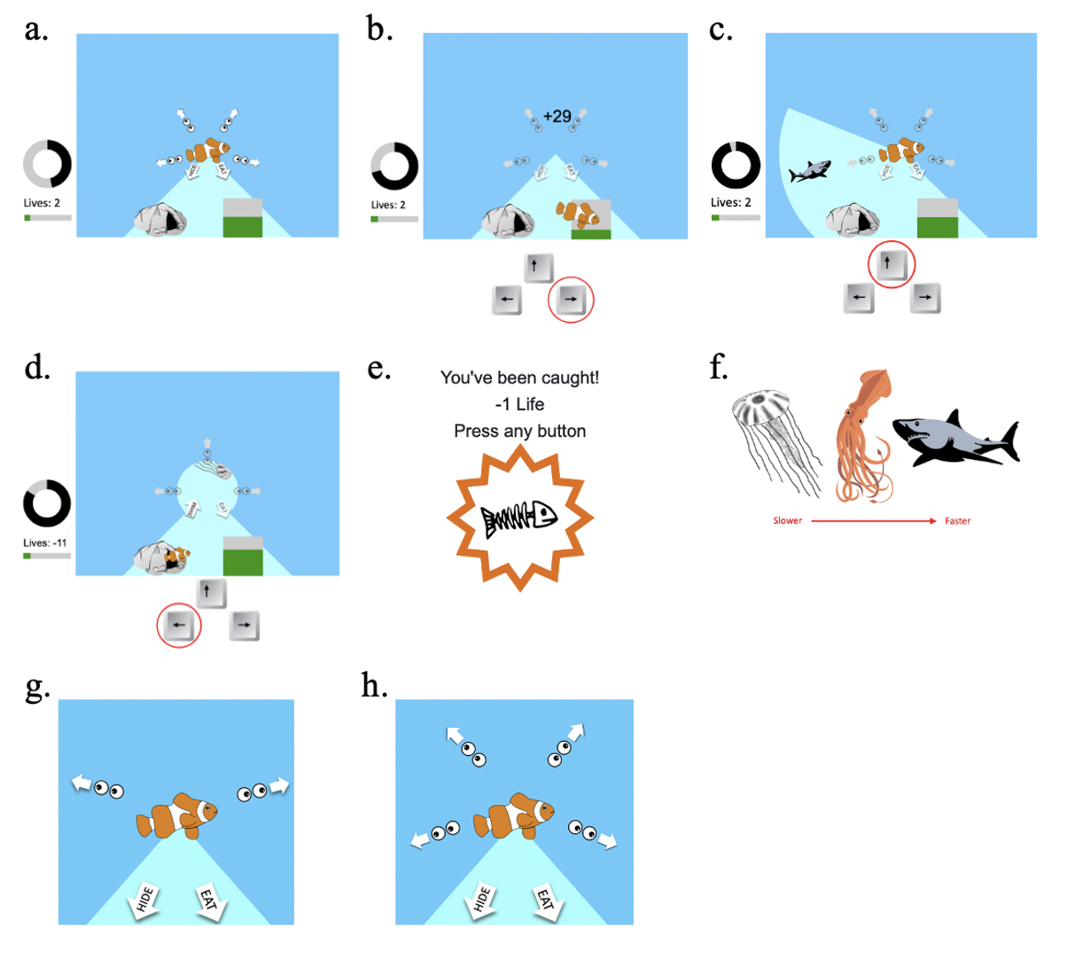
Figure 1. Illustration of the environment layout and the three possible actions during an example block. A) At the start of a block the fish begins in the centre position. In this block the surrounding area is divided into four sections that must be searched to determine whether there is a predator in the area. At left is shown amount of energy gained (green bar), number of lives gained (each ‘life’=1 bar of energy), and time remaining in the current block (grey/black wheel). B) By pressing the right arrow key the fish dives down to the patch of food and the green energy bar at left increases by the amount of reward gained. C) By pressing the up arrow key, the fish checks in a particular direction. In this example the fish discovers that there is a predator in the area being checked. D) By pressing the left arrow key, the fish dives into a cave and is safe from the predator. It can see the predator reach the screen centre and then retreat, and by clicking the right arrow key again the fish can return to the original centre position. E) If the fish fails to hide in time, it is ‘caught’ by the predator and loses one ‘life’ (equivalent to a full bar of collected energy). D) The three types of predators, in order of speed. G-H) Each block differs in the number of segments in which participants can check for predators. G) shows an example block divided into two directions for checking, while H) shows an example block divided into four directions for checking.

Blocks. Each of 20 blocks lasts 90s and has a different combination of (1) predator type (i.e. predator speed, three levels, see above) and (2) number of segments in which participants can check for predators (range 1-4; see Fig. 1g,h). With fewer segments, more of the environment is visible during each check action and therefore fewer checks are required to survey the entire surrounding area. Each participant receives one of three schedules, each having block and reward conditions randomly generated with the absolute value of all correlations between block variables kept below r = 0.3.
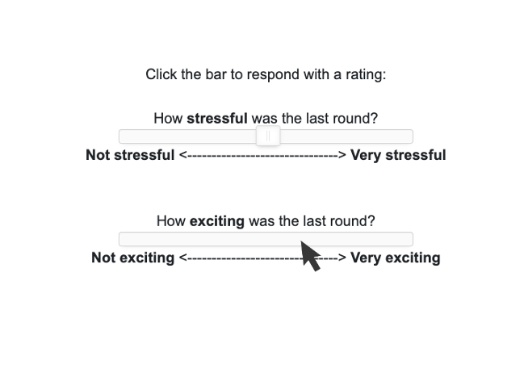
After each block, participants answer two questions about how they perceived the block: (1) “How stressful was the last round?” and (2) “How exciting was the last round?”. Participants respond to each question by moving a slider to indicate a score between 0 and 100 (see Fig. 2).

Figure 2. Post-block ratings. After each block participants are presented with two questions to rate their subjective experience of the block.

Timings. Each action involves a time cost: foraging takes 1.5s, checking takes 0.5s, hiding takes 0.5s, and returning from hiding takes 2s. Block duration is 90s, and time in between blocks is variable. The delay before appearance of a new predator is random and varies between 2-10.5s. Reward magnitude fluctuates randomly at each second.

Training. Before entering the experimental blocks participants click through a series of instructions for the task. They then complete two practice blocks and complete a multiple-choice quiz testing their understanding of the task, which they have to answer correctly in order to advance.

Questionnaires
Before the task, participants will be asked for demographic information. Demographics will be coded as follows: gender is coded as 1 for male, 2 for female and 1.5 for ‘other’; and education is coded linearly ascending (options: GCSE or middle school graduation (education up to age 15/16); A-Levels or high school diploma; Bachelor’s degree; Master’s degree; Doctorate or similarly advanced qualification).
After the task, participants will complete previously validated questionnaires to measure psychiatric symptoms and traits: the Apathy Motivation Index, including its two subscales, Behavioral and Emotional (AMI; Ang et al., 2017), State-Trait Inventory for Cognitive and Somatic Anxiety (STICSA; Grös et al., 2007), Snaith-Hamilton Pleasure Scale (SHAPS; Snaith et al., 1995), the Obsessive Compulsive Inventory (Revised) ‘Checking’ subscale (OCI-RC; Foa et al., 2002), the decentering subscale of the Experiences Questionnaire (EQ; Fresco et al., 2007), and the Intolerance of Uncertainty Scale, Short Form (IUS-12; Carleton et al., 2007), including its two subscales, prospective (P-IU) and inhibitory (I-IU; see Hong & Lee, 2015). One question from each of the three AMI, SHAPS, and OCI-R questionnaires will be repeated at the end of the questionnaire session to screen for quality data (‘consistency questions’; see below for exclusion criteria). During analysis, all questionnaire subscales will be analysed separately.
Participants will also complete a 29-item debrief questionnaire in which they report their metacognitive awareness of their task behaviour. For this they will respond to a series of statements about the task by marking how often each statement was true for them. Response options will be presented as a seven-point scale from 0 (‘Never’) to 6 (‘Very often’).

Screening, Pre-processing, and Data Quality Checks
Participants will be screened for age, language comprehension, and psychiatric measures before participation. To ensure data quality, data will be screened for indicators of inattentiveness, poor performance, and errors in recording due to technical problems.

Pre-screening. Participants will be at least 18 years old and will be native English speakers. Participants recruited under ethics approval R77387/RE003 will be pre-screened using measures of anxiety from the STICSA questionnaire (Grös et al., 2007), measures of apathy from the AMI questionnaire (Ang et al., 2017), and measures of anhedonia from the Temporal Experience of Pleasure Scale (TEPS; Gard et al., 2006). Participants will be selected such that scores in the final sample are evenly distributed across the lowest, middle, and highest thirds of the possible score range for both anxiety and apathy/anhedonia averaged.

Inattentiveness and poor performance. Participants will be excluded if they have too many (> 6) epochs in the experiment without any actions, if they check too rarely (< 40 times), if they get caught too often (> 9 times), and if they earn less than 5 extra lives. To check attentiveness to questionnaires, three questions will be repeated and participants will be excluded if the average absolute difference in repeated question scores is larger than one.
In addition, epochs will be screened for measures of inattentiveness. Problematic epochs will be either excluded from certain behavioural measures (see ‘Data Analysis’ below for details on behavioural measures) or excluded altogether. Epochs will be excluded entirely if participants stay in hiding at the beginning of the epoch for more than 2.2s, or if participants hide more than once. Behavioral measures will be computed from epochs depending on the epoch outcome: if participants discover the predator and successfully hide, epoch data will be used to compute all behavioral measures; if participants discover the predator but the block ends before they can hide, epoch data will be used to compute all pre-discovery behavioral measures; if participants do not discover the predator in an incomplete epoch with at least 10s of data, epoch data will be used to compute the ‘rate of inactive button presses’ and ‘time to first action’ measures; if participants do not discover the predator in an incomplete epoch with less than 10s of data, epoch data will be used to compute only ‘time to first action’; if participants are caught by the predator, all within-epoch behavioral measures will be computed but the data will not be used to compute measures across epochs (e.g. time to first action after the predator leaves).
Participants recruited under ethics approval R77387/RE003 will be pre-screened based on attentiveness and data quality in two unrelated online tasks.

Technical errors. Participants will be excluded if they report technical problems with the task, including the predator or the reward animations showing incorrectly. In addition, data will be screened for unreported technical errors. If errors are detected in a predator epoch, that epoch and all subsequent ones in that block will be removed from data analysis. If too many epochs are removed, the participant will be excluded. The cut-off for what is considered too many removed epochs will be determined based on the confirmation sample, such that at most 2.5% of participants will be removed by a single behavioural measure.
Two indicators of technical errors will be used to exclude data: 1) Any actions that happened in an epoch after a predator caught the participant will be removed (as these do not lead to outcomes for participants). 2) After each action, there is an enforced delay before the buttons became active again (1.5 sec for forage, 0.5 sec for check). Technical problems could sometimes mean that this is not respected. We will use a difference by more than 100 msec as a cut-off for exclusion.

Data Analysis
Data analysis will be performed in R (R Core Team, 2022) using RStan (Carpenter et al., 2017), Tidyverse (Wickham et al., 2019), ggpubr (Kassambara, n.d.), compareGroups (Subirana et al., 2021), fuzzyjoin (Robinson, 2020), data.table (Dowle & Srinivasan, 2022), ggcorrplot (Kassambara, 2019), sjPlot (Lüdecke, 2022), psych (Revelle, 2022), and brms (Bürkner, 2017, 2018). We will compute a set of 33 behavioural measures for each epoch (e.g. rate of checking before the predator was discovered). The behavioural measures that will be computed are based on results from the discovery sample (see Discovery Results document). Then we will perform regressions relating behaviours, task features, and self-reported mood separately for each participant. The following types of task-related measurements will be obtained to examine the interplay between emotions, environment, behaviour, and psychiatric traits: 1) impact of task features (e.g. speed) on behaviour; 2) impact of task features on mood; 3) impact of mood on behaviour; 4) impact of behaviour on mood; 5) post-task self-reports; 6) behavioural measures pertaining to the overall experiment (non-blockwise). Details of analyses involving each of these measures are stated below.

1. Impact of task features on behaviour. We will do regression analyses as non-hierarchical Bayesian analyses, linking behavioural measures to task features. A regression model for any behavioural measure $v$ that is obtained in each epoch before predator detection will be formulated as in Equation 1:

$$v= β_{0}*1+β_{1}*reward+β_{2}*mo\left(speed\right)+β_{3}*mo\left(checkDirections\right)+β_{4}*delay+β_{5}*block+β_{6}*firstEpoch$$ | (1)

where measures of interest include reward, indicating average epoch reward magnitude; mo(speed), indicating predator speed modelled as a monotonic variable (see Bürkner, 2018); mo(checkDirections), indicating the number of directions for checking modelled as a monotonic variable; and the intercept. Measures of no interest include delay, indicating the random delay before the predator entered the environment in each epoch; block, corresponding to block number; and firstEpoch, indicating whether the epoch was the first in the block. A regression model for any behavioural measure obtained in each epoch after predator detection will be formulated similarly but with the addition of another regressor of no interest corresponding to how much time in seconds remained until predator arrival at the time of predator discovery in that epoch (where a higher value indicates earlier predator detection). In later analyses relating these measures to questionnaire scores, we will additionally include the mean of each behavioural measure.
We will use different types of link functions available in brms, depending on the distribution of the behavioural measures, including normal, bernoulli, shifted log normal and poisson (see Table S4). All regressors will be z-score normalized and weak priors will be set (normal distribution with mean 0 and standard deviation 3). Predicted variables will not be z-scored to allow the intercept to capture individual differences (e.g. main effect in rate of checking). Four chains will be run with 4000 iterations and adapt_delta set to 0.8. Model fit will be checked using Rhat < 1.1 and the absence of divergent samples. If this is not the case, the number of samples and adapt_delta will be increased. Regressions will only be run if at least one epoch is available for all conditions of predator speed and directions for checking, if more than 15 epochs are available, and if the behaviour is not always the same (as could be the case for e.g. having been caught, which might have never happened).

2. Impact of task features on mood. Participants will rate mood (stress and excitement) after each 90s block. We will fit regressions separately for each participant predicting mood ratings. For example, stress ratings given after each block s will be modelled as Equation 2:

$$s= β_{0}*1+β_{1}*rewardMax+β_{2}*rewardMin+β_{3}*mo\left(speed\right)+β_{4}*mo\left(checkDirections\right)+β_{5}*livesGained+β_{6}*block+β_{7}*caught+ β_{8}*preblockStress+β_{9}*preblockExcitement+β_{10}*postblockExcitement$$ | (2)

where rewardMax and rewardMin indicate range of reward in the block, mo(speed) indicates predator speed modelled as a monotonic variable, mo(checkDirections) indicates the number of directions for checking modelled as a monotonic variable, livesGained indicates whether participants earned extra ‘lives’ by foraging during the block, block corresponds to block number, caught indicates whether the fish was caught by the predator at any point during the block, preblockStress corresponds to the stress rating given immediately before the block, and preblockExcitement and postblockExcitement correspond to excitement ratings given before and after the block. Other mood ratings (e.g. post-block excitement) will be modelled similarly to Equation 2, always controlling for mood rating before the block, as well as for the rating of the other mood. All regressors will be z-scored across participants. Settings for brms models were as above (see ‘1. Impact of task features on behaviour’).

3. Impact of mood on behaviour. We will analyse the influence of pre-block mood on task behaviour. For this, we will predict the residuals of regressions predicting behaviour based on task features. These will be averaged within each block to match the number of behavioural measures and mood ratings. We will include as predictors mood ratings before the block from which the behaviour was taken coded in different ways: 1) including only stress or excitement; and 2) including both stress and excitement (i.e. measuring the independent contributions to behaviour), as this approach was found to yield significant results in the discovery sample. By using the residuals of the regression of task features to behaviour, we will ensure that the mood effects are not confounded with task features. For example, the residual y of a regression predicting a behavioural measure based on task features will be modelled as a dependent variable explained by pre-block stress and excitement as in Equation 3:

$$y= β_{0}*1+ β_{1}*preblockStress+β_{2}*preblockExcitement$$ | (3)

All predictors will be z-score normalized across all participants. Settings for the brms fitting procedure are as defined above.

4. Impact of behaviour on mood. We will next examine the impact of behaviour on post-block mood ratings using two analyses. First, we will relate behaviour during each block to the mood rating given right after each block. Specifically, we will predict the residuals of regressions predicting mood based on block variables described above (see ‘2. Impact of task features on mood’). As predictor, we will include in a separate analysis each behavioural measure (e.g. rate of foraging). The analyses will be run as separate regressions for each person (settings for brms as above).

5. Post-task self reports. After the end of the experiment, participants will complete 29 questions about their behaviour in the task. These will be extracted without further pre-processing and related to participants’ questionnaire answers. See ‘Questionnaires’ section of Methods.

6. Behavioural measures pertaining to the overall experiment. Some behavioural measures, such as total payment at the end of the experiment, cannot be computed in a block-wise manner. These will be extracted without further pre-processing and related to participants’ questionnaire answers.

After the analyses and measures described in parts 1-6 are obtained, we will perform a final series of analyses relating the results to clinical and demographic measures. To identify links between subscales and task-based measures, we will perform linear, non-Bayesian regressions predicting each task-based measure based on clinical variables of interest, while controlling for demographics and clinical variables of no interest. For example, for analyses where the main variable of interest is any of the anxiety subscales, we will control for all apathy, anhedonia, and compulsivity subscales and demographical measurements (age, gender, education). For analyses where the main interest is any apathy or anhedonia subscales, we will control for all anxiety and compulsivity subscales (for IUS-12, only the P-IU subscale will be used as a control because it highly correlated with the I-IU anxiety subscale in the discovery sample) and demographics. For analyses focused on OCI-RC score we will control for all apathy, anhedonia, and anxiety subscales as well as demographics. For analyses focused on demographics, we will control for all anxiety, apathy, anhedonia, and compulsivity subscales, as well as all other demographics. When conducting regressions involving debrief questions 1-25, we will additionally control for the sum of the participant’s response to debrief questions 27-29 (“How much time did you spend performing each of these actions?” Q27: “Eating food”, Q28: “Checking for a predator”, Q29: “Hiding from a predator”); this is to account for an individual’s tendency to use the right- or left-hand side of the scale more often.

Pre-registration and Hold-Out Strategy
To generate hypotheses, we first collected a discovery sample (N=400 participants) and tested all possible links among collected measures. All models run on the discovery sample are stored in RData files together with the pre-registration documents. Findings from discovery sample tests were then grouped into hypotheses through discussion between the two authors (HT, JS). Tests run on the confirmation sample (see below) will aim to replicate these hypotheses.

Model Confirmation Strategy
We defined four groups of hypothesis tests for the confirmation sample linking task-related behaviour with 1) mood states (Table 1), 2) clinical scores (Table 2), and 3) demographics (Table 3), as well as one table with miscellaneous findings that didn’t fit neatly with other hypotheses (Table 4). All hypotheses are derived from significant results of the discovery sample. Hypotheses are organized in a hierarchical manner, and correction for multiple comparisons will be conducted hierarchically within each hypothesis group (see ‘Correction for Multiple Comparisons’ below). Plans for analysis of confirmation data are described for each group of hypothesis tests below.

Hypothesis Tests Linking Mood States with Task-Related Behaviour
We will test whether there are interactions between the task, evoked mood states, and task-related behaviour. See Table 1 for a hierarchical presentation of hypotheses. Regressions will be run (see ‘Data Analysis’ below) separately for each participant (resulting in separate regression weights for each person per regressor per behavioural measure analysed). Each hypothesis and sub-hypothesis will then be tested using one-sided t-tests or Wilcoxon tests (noted in Table 1 for each hypothesis) with significance determined at p < 0.05. In some cases, a hypothesis test might involve several regression weights (e.g., see Hypothesis 1A from Table 1, which is comprised of three regression weights). In this case, the weights will be added together before testing, taking into account whether their signs need to be flipped due to how the variables are coded. The only exception from this approach is H1C, which specifies that stress and excitement are affected in opposite ways by having been caught. Therefore, the statistic will be computed as the least significant p-value of the two individual components (one-tailed).

Hypothesis Tests Linking Clinical Traits with Task-Related Behaviour
We will test whether there is a relationship between scores representing clinical traits and task-related behaviour by conducting permutation testing on predictions for the confirmation sample. See Table 2 for a hierarchical list of hypotheses. For each hypothesis, we built regression models predicting the clinical score based on all relevant task-based measurements and fitted these regressions to the discovery sample. The regression models were formulated with the clinical measure as the dependent variable, and the task measures of interest, other clinical measures, and demographics variables entered as predictors (for example, see Equation 4):

$$Compulsivity= β_{0}*1+{β_{1}*{Behaviour}_{1}+β_{2}*{Behaviour}_{2}+β_{3}*{Behaviour}_{3}+β_{4}*{Behaviour}_{4}+β}_{5}*AMI_{Behavioural}+β_{6}*AMI_{Emotional}+ β_{7}*SHAPS+β_{8}*PIU+β_{9}*STICSA_Trait_Cognitive+β_{10}*STICSA_Trait_Somatic+β_{11}*Age+β_{12}*Education+β_{13}*Gender$$ | (4)

In control regression models, the task measures of interest were omitted and only the other clinical and demographic measurements were retained, as in Equation 5:

$$Compulsivity= β_{0}*1+β_{1}*AMI_Behavioural+β_{2}*AMI_Emotional + β_{3}*SHAPS+β_{4}*PIU+β_{5}*STICSA_Trait_Cognitive+β_{6}*STICSA_Trait_Somatic+β_{7}*Age+β_{8}*Education+β_{9}*Gender$$ | (5)

All models can be found as RData files in the Models folder (N.B. The RData files are numbered differently than the hypothesis tables; refer to the clinical/demographic label on the RData file to check to which hypotheses it pertains). Significance in the confirmation sample will be tested by using the regression models to obtain clinical and demographic predictions for each person. These will then be compared to the actual clinical scores to compute an out-of-sample R² (Campbell & Thompson, 2008) as in Equation 6:

$$R_{OOS}^{2}=1-\frac{MSE_hypothesis_regression_model}{MSE_control_regresssion_model}$$ | (6)

with MSE being the mean squared error $({\left(actual clinical score-predicted clinical score\right)}^{2})$. To determine the significance of these R² values, we will use permutation tests (10,000 shuffles of the clinical scores; see Berry et al., 2019). When a hypothesis encompasses several regressions (e.g. hypothesis 6B encompasses different regressions predicting different clinical subscales), the R² terms were combined as their mean. Significance will be defined as one-tailed 95% (i.e. non-shuffled R² value larger than 95% of R² from shuffled values).

Hypothesis Tests Linking Demographics with Task-Related Behaviour
Hypothesis tests linking demographics with task-related behaviour in the confirmation sample will be conducted in the same way as hypothesis tests linking clinical traits with task-related behaviour (see above).

Correction for Multiple Comparisons
Hypotheses are organized hierarchically (see Bach et al., 2020), and some hypotheses are composed of several more specific sub-hypotheses. To address the problem of multiple comparisons, we will conduct confirmatory tests according to this hierarchy. For each set of nested hypotheses (e.g., hypothesis 2, containing sub-hypotheses 2A, 2Ai, 2Aii, and 2B) we will first test the most general hypotheses (e.g. hypothesis 2) and only proceed with more specific sub-hypotheses if the previous tests are significant. We will not apply further correction for multiple comparisons.

Participants
Sample size. Sample size was computed for each clinical hypothesis using the WebPower (Zhang & Yuan, 2018) package in R. For this, we computed Cohen’s f² for each hypothesis (see Fig. 3). We computed the number of participants required for power between 0.8 and 0.95. This suggested that 580 participants should provide 95% power for all analyses. We planned to collect 830 participants (after a 15% drop out, this should provide 706 useable data sets; but even if drop out occurs at double the rate, at 30%, then we would still have enough participants for 95% power for all analyses). Of these, 402 will be recruited under ethics approval R77387/RE003 and the rest will be recruited under approval R54722/RE001 (see ‘Data Collection’ below). Our planned confirmation sample size exceeds the number dictated by power analysis in order to use the remainder of money set aside for data collection.

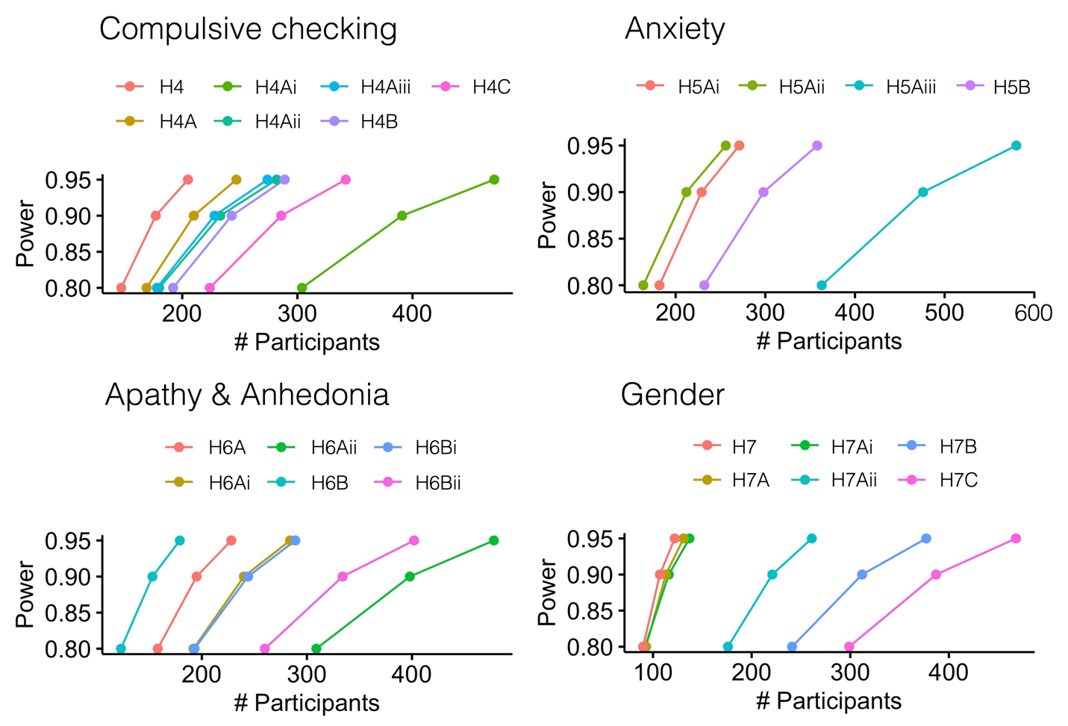
Figure 3. Power as a function of the number of participants for each hypothesis based on discovery sample.

Data collection. We recruited participants using the online platform Prolific.co (Prolific, 2022) that fulfilled inclusion criteria listed above (see ‘Screening, Pre-processing, and Data Quality Checks’). Web applications JATOS (Lange et al., 2015) and Pavlovia (Peirce et al., 2019) were used for experiment hosting and data collection. Ethics approval for the study was given by Oxford University Central University Research Ethics Committee (CUREC) (Ref-numbers: R54722/RE001 and R77387/RE003). All participants provided informed consent before taking part.
At the time of this pre-registration, data collection for the confirmation sample had completed in November 2022 with datasets collected from about 782 participants. From this initial sample, data from 50 participants was pre-processed to check that data was recorded correctly. No further analyses were performed, and in particular, no analyses of the mood or clinical effects pre-registered here were conducted.

References

Ang, Y.-S., Lockwood, P., Apps, M. A. J., Muhammed, K., & Husain, M. (2017). Distinct Subtypes of Apathy Revealed by the Apathy Motivation Index. PLOS ONE, 12(1), e0169938. https://doi.org/10.1371/journal.pone.0169938
Bach, D. R., Moutoussis, M., Bowler, A., & Dolan, R. J. (2020). Predictors of risky foraging behaviour in healthy young people. Nature Human Behaviour, 4(8), Article 8. https://doi.org/10.1038/s41562-020-0867-0
Berry, K. J., Johnston, J. E., & Mielke, P. W. (2019). A Primer of Permutation Statistical Methods. https://link.springer.com/book/10.1007/978-3-030-20933-9
Bürkner, P.-C. (2017). brms: An R Package for Bayesian Multilevel Models Using Stan. Journal of Statistical Software, 80(1), Article 1. https://doi.org/10.18637/jss.v080.i01
Bürkner, P.-C. (2018). Advanced Bayesian Multilevel Modeling with the R Package brms. The R Journal, 10(1), 395–411.
Campbell, J. Y., & Thompson, S. B. (2008). Predicting Excess Stock Returns Out of Sample: Can Anything Beat the Historical Average? The Review of Financial Studies, 21(4), 1509–1531. https://doi.org/10.1093/rfs/hhm055
Carleton, R. N., Norton, P., & Asmundson, G. (2007). Fearing the unknown: A short version of the Intolerance of Uncertainty Scale. Journal of Anxiety Disorders, 21, 105–117. https://doi.org/10.1016/j.janxdis.2006.03.014
Carpenter, B., Gelman, A., Hoffman, M. D., Lee, D., Goodrich, B., Betancourt, M., Brubaker, M., Guo, J., Li, P., & Riddell, A. (2017). Stan: A Probabilistic Programming Language. Journal of Statistical Software, 76(1). https://doi.org/10.18637/jss.v076.i01
Dowle, M., & Srinivasan, A. (2022). data.table: Extension of ‘data.frame’. https://r-datatable.com, https://Rdatatable.gitlab.io/data.table, https://github.com/Rdatatable/data.table
Foa, E. B., Huppert, J. D., Leiberg, S., Langner, R., Kichic, R., Hajcak, G., & Salkovskis, P. M. (2002). The Obsessive-Compulsive Inventory: Development and validation of a short version. Psychological Assessment, 14(4), 485–496. https://doi.org/10.1037/1040-3590.14.4.485
Fresco, D. M., Moore, M. T., van Dulmen, M. H. M., Segal, Z. V., Ma, S. H., Teasdale, J. D., & Williams, J. M. G. (2007). Initial Psychometric Properties of the Experiences Questionnaire: Validation of a Self-Report Measure of Decentering. Behavior Therapy, 38(3), 234–246. https://doi.org/10.1016/j.beth.2006.08.003
Gard, D. E., Gard, M. G., Kring, A. M., & John, O. P. (2006). Anticipatory and consummatory components of the experience of pleasure: A scale development study. Journal of Research in Personality, 40(6), 1086–1102. https://doi.org/10.1016/j.jrp.2005.11.001
Grös, D. F., Antony, M. M., Simms, L. J., & McCabe, R. E. (2007). Psychometric properties of the State-Trait Inventory for Cognitive and Somatic Anxiety (STICSA): Comparison to the State-Trait Anxiety Inventory (STAI). Psychological Assessment, 19(4), 369–381. https://doi.org/10.1037/1040-3590.19.4.369
Hong, R. Y., & Lee, S. S. M. (2015). Further clarifying prospective and inhibitory intolerance of uncertainty: Factorial and construct validity of test scores from the Intolerance of Uncertainty Scale. Psychological Assessment, 27, 605–620. https://doi.org/10.1037/pas0000074
Kassambara, A. (n.d.). ggpubr R Package: Ggplot2-Based Publication Ready Plots. STHDA: Statistical Tools for High-Throughput Data Analysis. Retrieved 15 August 2022, from http://www.sthda.com/english/articles/24-ggpubr-publication-ready-plots/
Kassambara, A. (2019). ggcorrplot: Visualization of a Correlation Matrix using ‘ggplot2’ [R]. http://www.sthda.com/english/wiki/ggcorrplot
Lange, K., Kühn, S., & Filevich, E. (2015). "Just Another Tool for Online Studies” (JATOS): An Easy Solution for Setup and Management of Web Servers Supporting Online Studies. PLOS ONE, 10(6), e0130834. https://doi.org/10.1371/journal.pone.0130834
Lüdecke, D. (2022). sjPlot: Data Visualization for Statistics in Social Science (R package version 2.8.11,) [R]. https://CRAN.R-project.org/package=sjPlot
Peirce, J., Gray, J. R., Simpson, S., MacAskill, M., Höchenberger, R., Sogo, H., Kastman, E., & Lindeløv, J. K. (2019). PsychoPy2: Experiments in behavior made easy. Behavior Research Methods, 51(1), 195–203. https://doi.org/10.3758/s13428-018-01193-y
Prolific (Version 2022). (2022). https://www.prolific.co
R Core Team. (2022). R: A language and environment for statistical computing. R Foundation for Statistical Computing. https://www.R-project.org/
Revelle, W. (2022). psych: Procedures for Psychological, Psychometric, and Personality Research (R package version 2.2.5) [R]. Northwestern University. https://CRAN.R-project.org/package=psych
Robinson, D. (2020). fuzzyjoin: Join Tables Together on Inexact Matching [R]. https://CRAN.R-project.org/package=fuzzyjoin
Snaith, R. P., Hamilton, M., Morley, S., Humayan, A., Hargreaves, D., & Trigwell, P. (1995). A Scale for the Assessment of Hedonic Tone the Snaith–Hamilton Pleasure Scale. The British Journal of Psychiatry, 167(1), 99–103. https://doi.org/10.1192/bjp.167.1.99
Subirana, I., Vila, J., & Sanz, H. (2021). compareGroups 4.0: Descriptives by groups [R]. https://cran.r-project.org/web/packages/compareGroups/vignettes/compareGroups_vignette.html
Wickham, H., Averick, M., Bryan, J., Chang, W., McGowan, L. D., François, R., Grolemund, G., Hayes, A., Henry, L., Hester, J., Kuhn, M., Pedersen, T. L., Miller, E., Bache, S. M., Müller, K., Ooms, J., Robinson, D., Seidel, D. P., Spinu, V., … Yutani, H. (2019). Welcome to the Tidyverse. Journal of Open Source Software, 4(43), 1686. https://doi.org/10.21105/joss.01686
Zhang, Z., & Yuan, K. H. (2018). Practical Statistical Power Analysis Using Webpower and R. ISDSA Press.

