awt progress # awt01 # Web Technology Lab – Experiments Summary
This repository contains all experiments and classwork done as part of the Advanced Web Technology (AWT) lab.
Each experiment focuses on different web technologies including HTML, CSS, JavaScript, jQuery, AngularJS, and Node.js.

Table of Contents
- Experiment 1
- Experiment 2
- Experiment 3
- Experiment 4
- Experiment_5,6
- Experiment 7

Experiment 1 – HTML & CSS Basics

What I Learned
- Creating web pages using HTML elements and semantic tags
- Styling pages with CSS selectors, classes, and IDs
- Building responsive layouts using flexbox and media queries
code #### index.html
<!DOCTYPE html>
<html lang="en">
<head>
<meta charset="UTF-8">
<meta name="viewport" content="width=device-width, initial-scale=1.0">
<title>LAB EXP 1</title>
<script src="https://ajax.googleapis.com/ajax/libs/jquery/3.7.1/jquery.min.js"></script>
<link rel="stylesheet" href="style.css">
</head>
<body>
<div class="container">
<h1>1. Right-Click Disabled</h1>
<p>Try right-clicking anywhere on this page. The context menu will not appear.</p>
</div>
<hr>
<div class="container">
<h1>2. Show/Hide Message</h1>
<button id="showBtn">Show Message</button>
<button id="hideBtn">Hide Message</button>
<div id="messageDiv">
<p>Hello! This message can be hidden and shown using the buttons above.</p>
</div>
</div>
<hr>
<div class="container">
<h1>3. Paragraph Color Change on Hover</h1>
<p class="hover-para">This paragraph changes color.</p>
</div>
<hr>
<div class="container" style="height: 1200px;">
<h1>4. Scroll to Top</h1>
<p>Scroll down this page to see the image in the bottom-right corner. Clicking it will bring you back to the top of the page.</p>
</div>
<img src="C:\Users\hp\Pictures\Screenshots\Screenshot 2025-08-25 231221.png" alt="Scroll to Top" id="scrollToTopBtn">
<script src="exp1.js"></script>
</body>
</html>

style.css
/* General Page Styling */
body {
font-family: 'Segoe UI', Arial, sans-serif;
background-color: #fafafa;
color: #333;
margin: 30px auto;
max-width: 800px;
line-height: 1.6;
}
/* Headings */
h2 {
text-align: center;
color: #007acc;
margin-bottom: 20px;
}
h3 {
color: #333;
border-left: 5px solid #007acc;
padding-left: 10px;
margin-top: 30px;
}
/* Scroll-to-top Image */
#topImage {
width: 60px;
cursor: pointer;
margin: 10px 0;
transition: transform 0.3s ease;
}
#topImage:hover {
transform: scale(1.2);
}
/* Paragraph Styling */
p {
margin: 10px 0;
}
.hoverText {
transition: color 0.3s ease;
cursor: pointer;
}
/* Buttons */
button {
background-color: #007acc;
color: white;
border: none;
border-radius: 6px;
padding: 10px 16px;
margin: 6px;
font-size: 15px;
cursor: pointer;
transition: background-color 0.3s ease, transform 0.2s ease;
}
button:hover {
background-color: #005f99;
transform: scale(1.05);
}
/* Message Box */
#messageBox {
display: none;
padding: 15px;
margin-top: 10px;
border
}

exp1.js
$(document).on("selectstart", function(e){
e.preventDefault();
});
$(document).on("keydown", function(e) {
if (e.ctrlKey && e.keyCode === 67) e.preventDefault();
});
$(document).ready(function() {
// 1. Disable the right-click menu
$(document).on("contextmenu", function(e) {
e.preventDefault();
});
// 2. Display and hide a message
$("#showBtn").click(function() {
$("#messageDiv").show('slow');
});
$("#hideBtn").click(function() {
$("#messageDiv").hide('slow');
});
// 3. Change paragraph color on mouseover
$(".hover-para").mouseover(function() {
$(this).css("color", "red");
});
$(".hover-para").mouseout(function() {
$(this).css("color", "#333");
});
// 4. Click an image to scroll to the top
$("#scrollToTopBtn").click(function() {
$("html, body").animate({ scrollTop: 0 }, 'slow');
})
});

output
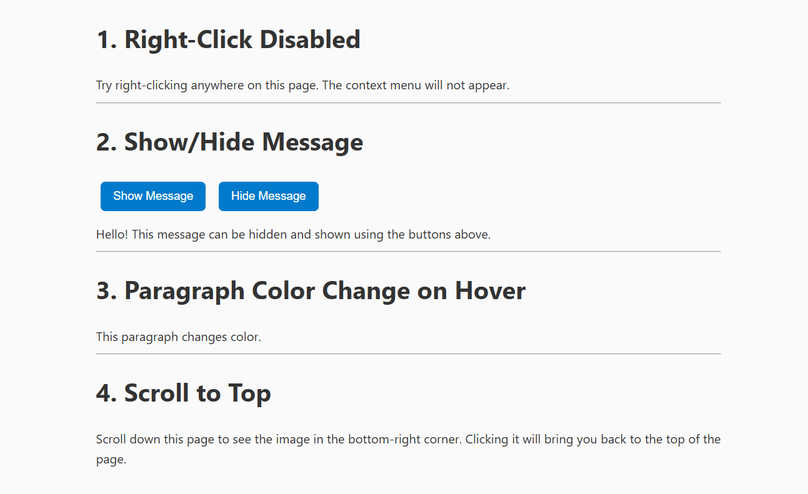
Output Screenshot

Challenges Faced
- Aligning elements correctly across different screen sizes
- Understanding the difference between inline, inline-block, and block elements

Experiment 2 – JavaScript Fundamentals

What I Learned
- Writing JavaScript functions and handling events
- Working with loops, conditions, and arrays
- Using the DOM API to change webpage content dynamically
code ####index.html
<!DOCTYPE html>
<html lang="en">
<head>
<meta charset="UTF-8">
<title>Experiment 2 - jQuery CSS and Events</title>
<script src="https://code.jquery.com/jquery-3.6.0.min.js"></script>
<link rel="stylesheet" href="exp2.css">
</head>
<body>
<h1>Experiment 2: jQuery CSS and Events</h1>
<h3>1. Add a class to an element</h3>
<p id="text">Click the button to highlight this text!</p>
<button id="addClassBtn">Add Class</button>
<h3>2. Access the position of an element</h3>
<p id="positionText">Click to see this element's position!</p>
<button id="positionBtn">Show Position</button>
<h3>3. Animate multiple CSS properties</h3>
<div id="animateBox"></div>
<button id="animateBtn">Animate Box</button>
<script src="exp2.js"></script>
</body>
</html>

exp2.css
body {
font-family: Arial, sans-serif;
padding: 20px;
}
.highlight {
background: red;
font-weight: bold;
padding: 10px;
}
#animateBox {
width: 100px;
height: 100px;
background: lightblue;
position: relative;
margin-top: 20px;
}
button {
margin: 5px;
padding: 8px 15px;
border: none;
background: #333;
color: white;
border-radius: 4px;
cursor: pointer;
}
button:hover {
background: #555;
}

exp2.js
$(document).ready(function () {
// 1. Add a class
$("#addClassBtn").click(function () {
$("#text").addClass("highlight");
});
// 2. Show position of element
$("#positionBtn").click(function () {
let pos = $("#positionText").position();
alert("Top: " + pos.top + ", Left: " + pos.left);
});
// 3. Animate multiple CSS properties
$("#animateBtn").click(function () {
$("#animateBox").animate({
left: "+=100px",
top: "+=50px",
width: "150px",
height: "150px",
opacity: 0.7
}, 1000);
});
});

output
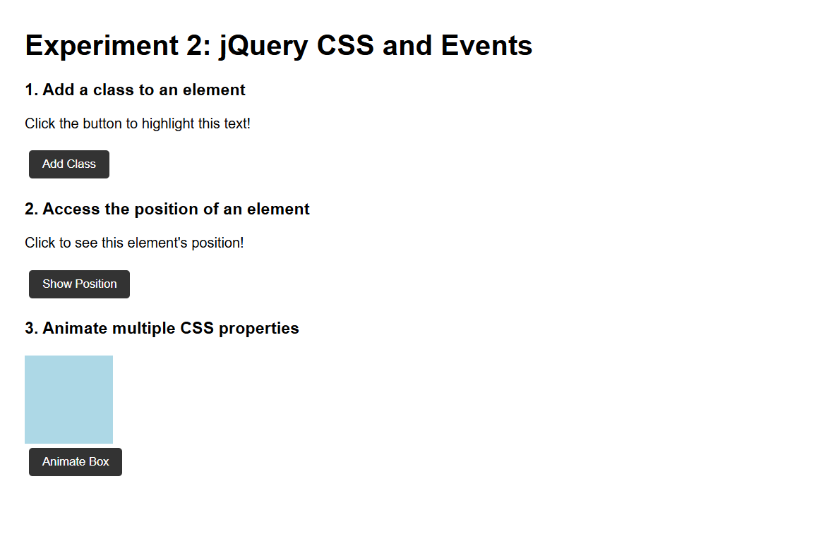
Output Screenshot

Challenges Faced
- Debugging DOM errors in the browser console
- Managing variable scopes and timing issues with event listeners

Experiment 3 – jQuery and DOM Manipulation

What I Learned
- Simplifying DOM manipulation with jQuery selectors
- Handling click and hover events easily
- Implementing form validation and effects like fade/slide
code #### index.html
<!doctype html>
<html ng-app="tableApp">
<head>
<meta charset="utf-8">
<title>Experiment 3 - AngularJS Tables</title>
<script src="https://ajax.googleapis.com/ajax/libs/angularjs/1.8.3/angular.min.js"></script>
<script src="exp3.js"></script>
<style>
table { border-collapse: collapse; width: 100%; }
th, td { border: 1px solid #ccc; padding: 8px; }
tr.even { background: #f8f8f8; }
tr.odd { background: #ffffff; }
th { background: #eee; }
</style>
</head>
<body ng-controller="TableController as ctrl">
<div class="container">
<h1>AngularJS Table Examples</h1>
<section>
<h2>1. Display a Table</h2>
<table>
<thead>
<tr>
<th>#</th>
<th>Name</th>
<th>Age</th>
<th>Department</th>
</tr>
</thead>
<tbody>
<tr ng-repeat="student in ctrl.students track by $index" ng-class-odd="'odd'" ng-class-even="'even'">
<td>{{$index + 1}}</td>
<td>{{student.name}}</td>
<td>{{student.age}}</td>
<td>{{student.dept}}</td>
</tr>
</tbody>
</table>
</section>
<section>
<h2>2. Display contents with orderBy filter</h2>
<label>Sort by:
<select ng-model="ctrl.sortKey">
<option value="name">Name</option>
<option value="age">Age</option>
<option value="dept">Department</option>
</select>
<label><input type="checkbox" ng-model="ctrl.reverse"> Reverse</label>
</label>
<table>
<thead>
<tr>
<th>#</th>
<th>Name</th>
<th>Age</th>
<th>Department</th>
</tr>
</thead>
<tbody>
<tr ng-repeat="student in ctrl.students | orderBy:ctrl.sortKey:ctrl.reverse track by $index" ng-class-even="'even'" ng-class-odd="'odd'">
<td>{{$index + 1}}</td>
<td>{{student.name}}</td>
<td>{{student.age}}</td>
<td>{{student.dept}}</td>
</tr>
</tbody>
</table>
</section>
<section>
<h2>3. Display Table with even and odd rows (styling already shown)</h2>
<p>Notice rows have alternating backgrounds using <code>ng-class-even</code> and <code>ng-class-odd</code>.</p>
</section>
</div>
</body>
</html>

exp3.js
angular.module('tableApp', [])
.controller('TableController', function() {
const vm = this;
vm.students = [
{ name: 'Asha', age: 22, dept: 'CSE' },
{ name: 'Bikram', age: 24, dept: 'ECE' },
{ name: 'Charu', age: 21, dept: 'ME' },
{ name: 'Deep', age: 23, dept: 'CSE' },
{ name: 'Esha', age: 20, dept: 'EE' }
];
vm.sortKey = 'name';
vm.reverse = false;
});

output
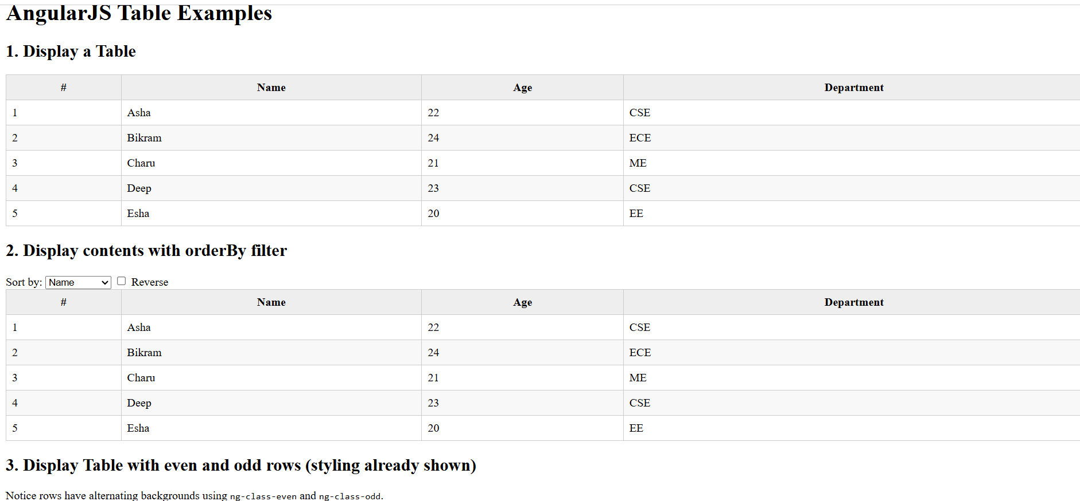
Output Screenshot

Challenges Faced
- Remembering the correct jQuery syntax
- Understanding the difference between $(document).ready() and normal JS load timing

Experiment 4 – AngularJS MVC Architecture

What I Learned
- Understanding Model-View-Controller (MVC) in AngularJS
- Using controllers, directives, and filters
- Implementing two-way data binding
code #### bill.html
<!DOCTYPE html>
<html lang="en" ng-app="billApp">
<head>
<meta charset="UTF-8">
<title>Bill Payment Record</title>
<script src="https://ajax.googleapis.com/ajax/libs/angularjs/1.8.3/angular.min.js"></script>
<style>
body { font-family: Arial, sans-serif; margin: 20px; }
table { border-collapse: collapse; width: 100%; margin-top: 20px; }
th, td { border: 1px solid #ccc; padding: 8px; text-align: left; }
th { background: #eee; }
input, button { margin: 5px; padding: 6px; }
</style>
</head>
<body ng-controller="BillController">
<h2>Bill Payment Record</h2>
<!-- Form to add new records -->
<form name="billForm" ng-submit="addRecord(billForm)" novalidate>
<label>
Name:
<input type="text" name="name" ng-model="newRecord.name" required>
</label>
<label>
Amount:
<input type="number" name="amount" ng-model="newRecord.amount" required min="0">
</label>
<label>
Date:
<input type="date" name="date" ng-model="newRecord.date" required>
</label>
<button type="submit" ng-disabled="billForm.$invalid">Add</button>
</form>
<!-- Records table -->
<table ng-if="records.length > 0">
<thead>
<tr>
<th>#</th>
<th>Name</th>
<th>Amount</th>
<th>Date</th>
</tr>
</thead>
<tbody>
<tr ng-repeat="record in records track by record.id">
<td>{{$index + 1}}</td>
<td>{{record.name}}</td>
<td>{{record.amount | currency}}</td>
<td>{{record.date | date:'mediumDate'}}</td>
</tr>
</tbody>
</table>
<script>
angular.module('billApp', [])
.controller('BillController', function($scope) {
// Initial records
$scope.records = [
{ id: 1, name: 'Electricity', amount: 1200, date: '2025-07-01' },
{ id: 2, name: 'Internet', amount: 799, date: '2025-07-05' }
];
$scope.newRecord = {};
// Add new record
$scope.addRecord = function(form) {
if (form.$valid) {
let newId = $scope.records.length + 1;
$scope.records.push({
id: newId,
name: $scope.newRecord.name,
amount: $scope.newRecord.amount,
date: $scope.newRecord.date
});
$scope.newRecord = {};
form.$setPristine();
form.$setUntouched();
}
};
});
</script>
</body>
</html>

form.html
<!DOCTYPE html>
<html lang="en" ng-app="formApp">
<head>
<meta charset="UTF-8">
<title>AngularJS Registration Form</title>
<script src="https://ajax.googleapis.com/ajax/libs/angularjs/1.8.3/angular.min.js"></script>
<style>
.error { color: red; font-size: 14px; }
input.ng-invalid.ng-touched { border: 2px solid red; }
input.ng-valid.ng-touched { border: 2px solid green; }
.success { color: green; margin-top: 10px; }
</style>
</head>
<body ng-controller="FormController">
<h2>User Registration</h2>
<form name="regForm" novalidate ng-submit="register(regForm)">
<label>Name:
<input type="text" name="name" ng-model="user.name" required ng-minlength="3">
</label>
<div class="error"
ng-show="(regForm.name.$touched || submitted) && regForm.name.$invalid">
Name must be at least 3 characters.
</div>
<br><br>
<label>Email:
<input type="email" name="email" ng-model="user.email" required>
</label>
<div class="error"
ng-show="(regForm.email.$touched || submitted) && regForm.email.$invalid">
Enter a valid email.
</div>
<br><br>
<label>Password:
<input type="password" name="password" ng-model="user.password" required ng-minlength="6">
</label>
<div class="error"
ng-show="(regForm.password.$touched || submitted) && regForm.password.$invalid">
Password must be at least 6 characters.
</div>
<br><br>
<button type="submit">Register</button>
</form>
<p class="success" ng-if="success">{{success}}</p>
<script>
angular.module('formApp', [])
.controller('FormController', function($scope) {
$scope.user = {};
$scope.submitted = false;
$scope.success = '';
$scope.register = function(form) {
if (form.$valid) {
// In real app, send data to server
$scope.success = 'Registration successful for ' + $scope.user.name;
$scope.user = {};
form.$setPristine(); // Reset form state
form.$setUntouched(); // Reset touched state
$scope.submitted = false;
} else {
$scope.success = '';
$scope.submitted = true; // Show validation messages
}
};
});
</script>
</body>
</html>

output
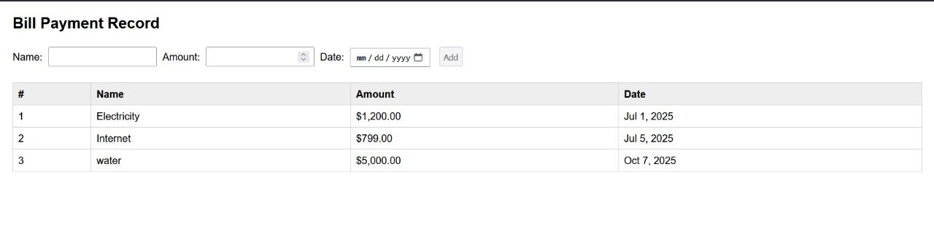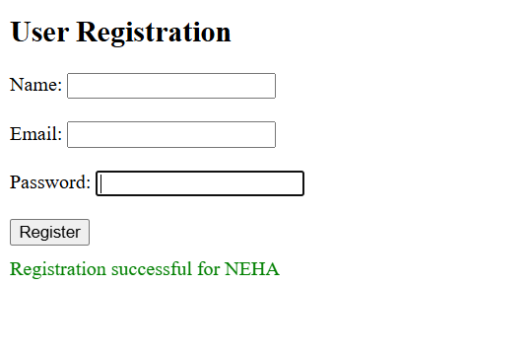

Challenges Faced
- Linking the AngularJS library properly
- Handling scope and data flow between controller and view

Experiment 5 & 6 – Node.js and Express Basics

What I Learned
- Creating a simple Node.js server
- Using Express.js to handle routes and responses
- Serving static files and building basic APIs
code #### server.js
const express = require('express');
const app = express();
const PORT = process.env.PORT || 3000;
// Hello World endpoint
app.get('/', (req, res) => {
res.send('Hello, World!');
});
// String replacement endpoint
app.get('/replace', (req, res) => {
const { text } = req.query;
if (!text) {
return res.status(400).json({ error: 'Text parameter is required' });
}
const regex = /a{2,}/g;
const result = text.replace(regex, 'b');
res.json({ original: text, replaced: result });
});
// Calculator endpoint
app.get('/calculate', (req, res) => {
const { operation, num1, num2 } = req.query;
const n1 = parseFloat(num1);
const n2 = parseFloat(num2);
if (isNaN(n1) || isNaN(n2)) {
return res.status(400).json({ error: 'Invalid numbers provided' });
}
let result;
switch (operation) {
case 'add':
result = n1 + n2;
break;
case 'subtract':
result = n1 - n2;
break;
case 'multiply':
result = n1 * n2;
break;
case 'divide':
result = n2 !== 0 ? n1 / n2 : 'Error: Division by zero';
break;
default:
return res
.status(400)
.json({ error: 'Invalid operation. Use add, subtract, multiply, or divide' });
}
res.json({ operation, num1: n1, num2: n2, result });
});
// Array iteration endpoint
app.get('/iterate', (req, res) => {
const array = [10, 20, 30, 40, 50];
const iterations = [];
// Using for loop
iterations.push("Using for loop:");
for (let i = 0; i < array.length; i++) {
iterations.push(`Index ${i}: ${array[i]}`);
}
// Using forEach
iterations.push("Using forEach:");
array.forEach((item, index) => {
iterations.push(`Index ${index}: ${item}`);
});
// Using for...of
iterations.push("Using for...of:");
for (const item of array) {
iterations.push(`Item: ${item}`);
}
res.json({ array, iterations });
});
app.listen(PORT, () => {
console.log(`Server running at http://localhost:${PORT}`);
console.log('Available endpoints:');
console.log(' GET / - Hello World');
console.log(" GET /replace?text=your_text - Replace multiple a's with b");
console.log(' GET /calculate?operation=add&num1=5&num2=3 - Calculator');
console.log(' GET /iterate - Array iteration examples');
});

package.json
{
"name": "express",
"version": "1.0.0",
"description": "testing nodejs",
"main": "server.js",
"scripts": {
"test": "node server.js",
"start": "node server.js"
},
"repository": {
"type": "git",
"url": "awt01"
},
"keywords": [
"[\"nodejs\"",
"\"express\"",
"\"lab\"]"
],
"author": "neha",
"license": "ISC"
}

output
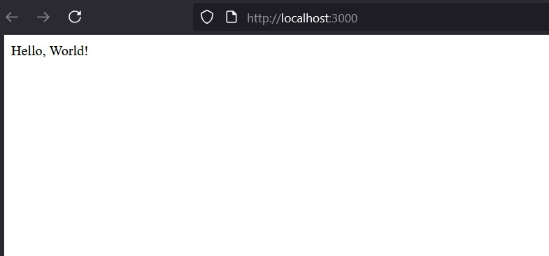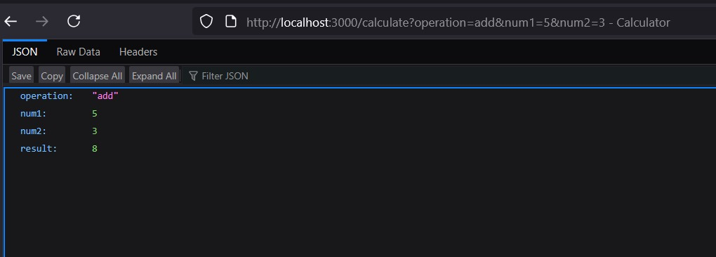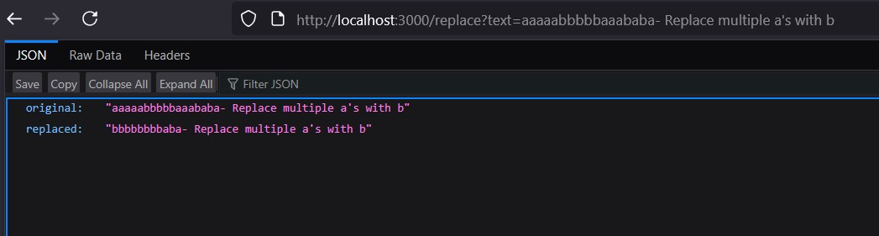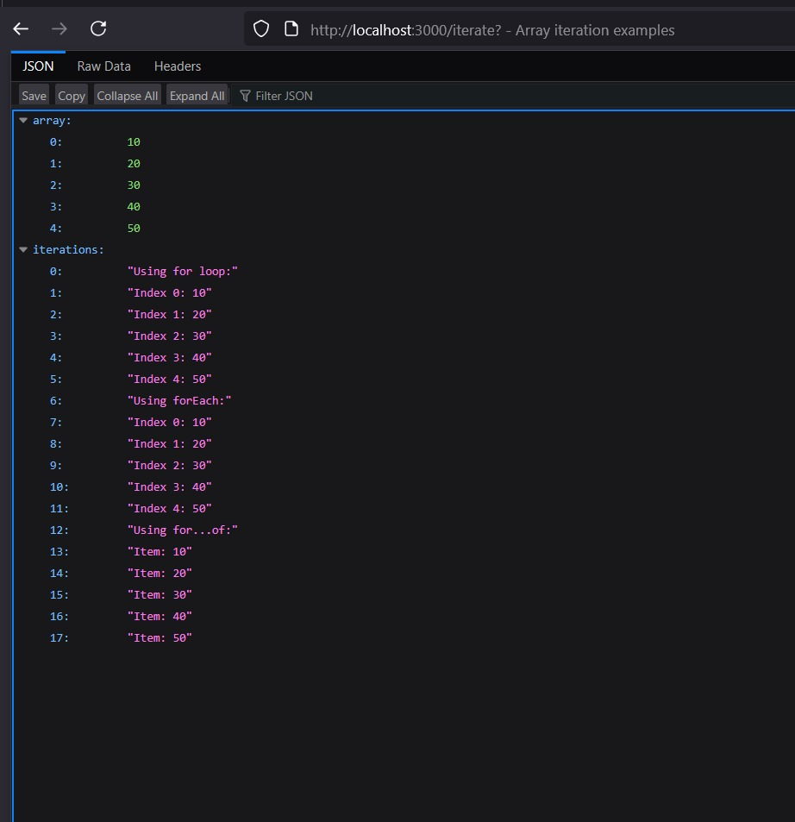

Challenges Faced
- Installing and configuring required packages using npm
- Managing file paths correctly (especially on Windows)
- Understanding the request-response cycle

Experiment 7 – Cookies and Sessions

What I Learned
- Setting and reading cookies in Node.js
- Managing sessions to store user information
- Understanding how client-server data persistence works
code #### cookie-example.js
const express = require('express');
const cookieParser = require('cookie-parser');
const app = express();
app.use(cookieParser());
// Set a cookie
app.get('/set-cookie', (req, res) => {
res.cookie('username', 'JohnDoe', { maxAge: 900000 });
res.send('Cookie has been set');
});
// Get the cookie
app.get('/get-cookie', (req, res) => {
const user = req.cookies['username'];
if (user) {
res.send(`Cookie Retrieved: ${user}`);
} else {
res.send('No cookie found');
}
});
// Delete the cookie
app.get('/delete-cookie', (req, res) => {
res.clearCookie('username');
res.send('Cookie deleted');
});
// Start the server
const PORT = process.env.PORT || 3000;
app.listen(PORT, () => {
console.log(`Server started on http://localhost:${PORT}`);
});

session-example.js
const express = require('express');
const session = require('express-session');
const app = express();
app.use(session({
secret: 'mysecretkey',
resave: false,
saveUninitialized: true
}));
app.get('/', (req, res) => {
if (req.session.views) {
req.session.views++;
res.send(`Welcome back! You visited ${req.session.views} times.`);
} else {
req.session.views = 1;
res.send('Welcome to the session demo. Refresh to count visits.');
}
});
app.get('/destroy', (req, res) => {
req.session.destroy(err => {
if (err) {
return res.send('Error destroying session');
}
res.send('Session destroyed');
});
});
const PORT = process.env.PORT || 3000;
app.listen(PORT, () => {
console.log(`Server started on http://localhost:${PORT}`);
});
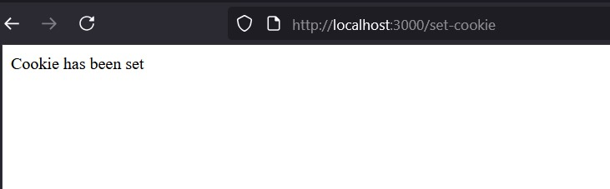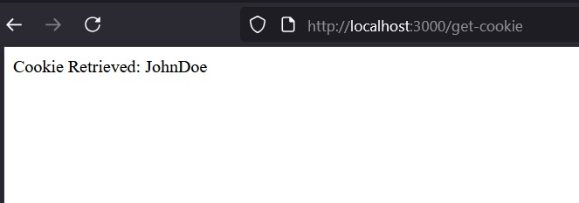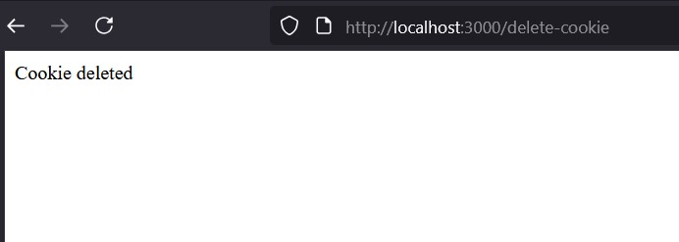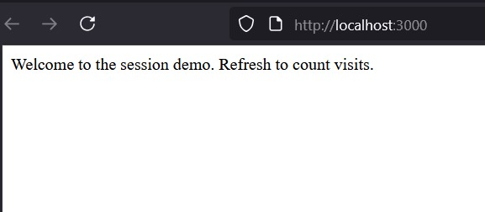

Challenges Faced
- Fixing the “Cannot find module” error while running scripts
- Understanding how cookies expire and how session IDs are managed
- Debugging Node.js modules and directory issues

Experiment 8
*Topic: NodeJS + MongoDB Integration, CRUD Operations. Files: item.js, server.js, item.html,s.css ,student.html,student.js.
What I learned: - Creating a NodeJS application to connect to a MongoDB database - Creating an application to store student details in a database - Creating a search application to find students based on criteria - Creating a shopping center application with full CRUD features
Code
shopping-app

item.html
html <!DOCTYPE html>
Shopping Center

Shopping Center Management
Add Item
Add Item
Stock Report
Name
Price
Qty
Actions

s.css
CSS /* ———- GLOBAL ———- */ body { font-family: Arial, Helvetica, sans-serif; background: #f4f6f9; margin: 0; padding: 40px; }
h1, h2 { color: #222; margin-bottom: 15px; }
h1 { font-size: 32px; font-weight: 700; }
h2 { font-size: 22px; font-weight: 600; }
/* ———- FORM AREA ———- */ form input { width: 280px; padding: 12px; margin: 8px 0; border: 1px solid #ccc; border-radius: 6px; font-size: 16px; }
button { padding: 10px 18px; background: #0051a8; border: none; color: white; border-radius: 6px; font-size: 15px; cursor: pointer; margin-right: 8px; transition: 0.2s ease; }
button:hover { background: #003d82; }
/* ———- TABLE ———- */ table { width: 100%; background: #fff; margin-top: 20px; border-collapse: collapse; border-radius: 10px; overflow: hidden; box-shadow: 0 2px 10px rgba(0,0,0,0.1); }
th { background: #0051a8; color: #fff; padding: 14px; font-size: 16px; text-align: left; }
td { padding: 14px; font-size: 16px; border-bottom: 1px solid #eee; }
/* row hover */ tr:hover { background: #f2f7ff; }
/* buttons inside table */ .action-btn { padding: 6px 14px; margin-right: 6px; border-radius: 5px; cursor: pointer; border: none; font-weight: 500; }
.delete-btn { background: #d9534f; color: white; }
.update-btn { background: #0275d8; color: white; }
.sale-btn { background: #5cb85c; color: white; }
.delete-btn:hover { background: #c9302c; } .update-btn:hover { background: #025aa5; } .sale-btn:hover { background: #449d44; }
/* ———- TABLE EMPTY STATE ———- */ .empty { text-align: center; padding: 20px; color: gray; font-style: italic; font-size: 18px; }

item.js
JS // Load stock async function loadItems() { let res = await fetch(“/items”); let items = await res.json();
let table = document.getElementById("itemTable");
table.innerHTML = "";
items.forEach(i => {
table.innerHTML += `
<tr>
<td>${i.name}</td>
<td>${i.price}</td>
<td>${i.quantity}</td>
<td>
<button onclick="deleteItem('${i._id}')">Delete</button>
<button onclick="updateItem('${i._id}')">Update</button>
<button onclick="saleItem('${i._id}')">Sale</button>
</td>
</tr>`;
});
} loadItems();
// Add item document.getElementById(“addForm”).addEventListener(“submit”, async e => { e.preventDefault();
let data = Object.fromEntries(new FormData(e.target).entries());
await fetch("/items/add", {
method: "POST",
headers: { "Content-Type": "application/json" },
body: JSON.stringify(data)
});
e.target.reset();
loadItems();
});
// Delete async function deleteItem(id) { await fetch(/items/delete/${id}, { method: “DELETE” }); loadItems(); }
// Update async function updateItem(id) { let price = prompt(“Enter new price:”); let qty = prompt(“Enter new quantity:”);
await fetch(`/items/update/${id}`, {
method: "PUT",
headers: { "Content-Type": "application/json" },
body: JSON.stringify({ price, quantity: qty })
});
loadItems();
}
// Sale async function saleItem(id) { let qty = prompt(“Enter quantity sold:”);
await fetch(`/items/sale/${id}`, {
method: "PUT",
headers: { "Content-Type": "application/json" },
body: JSON.stringify({ quantity: qty })
});
loadItems();
}

server.js
JS
const express = require(“express”); const path = require(“path”); const mongoose = require(“mongoose”);
const app = express(); app.use(express.json()); app.use(express.urlencoded({ extended: true })); app.use(express.static(__dirname));
// MongoDB Connection mongoose.connect(“mongodb://127.0.0.1:27017/shopDB”) .then(() => console.log(“MongoDB Connected”)) .catch(err => console.log(err));
// Schema const itemSchema = new mongoose.Schema({ name: String, price: Number, quantity: Number });
const Item = mongoose.model(“Item”, itemSchema);
// Serve UI app.get(“/”, (req, res) => { res.sendFile(path.join(__dirname, “item.html”)); });
// Add Item app.post(“/items/add”, async (req, res) => { let item = new Item(req.body); await item.save(); res.json({ success: true }); });
// Get All Items (Stock Report) app.get(“/items”, async (req, res) => { let items = await Item.find(); res.json(items); });
// Delete Item app.delete(“/items/delete/:id”, async (req, res) => { await Item.findByIdAndDelete(req.params.id); res.json({ success: true }); });
// Update Item app.put(“/items/update/:id”, async (req, res) => { await Item.findByIdAndUpdate(req.params.id, req.body); res.json({ success: true }); });
// Sale (reduce quantity) app.put(“/items/sale/:id”, async (req, res) => { let item = await Item.findById(req.params.id); if (!item) return res.json({ success: false });
let qty = Number(req.body.quantity); if (item.quantity < qty) return res.json({ success: false, msg: “Not enough stock” });
item.quantity -= qty; await item.save();
res.json({ success: true }); });
app.listen(3000, () => console.log(“Server running on http://localhost:3000”));
code
student-app

item.html
html <!DOCTYPE html>
Student Management
Add Student
Add Student

Search Student
Search

All Students
Name
Roll
Branch
Year

student.js
JS // ADD student document.getElementById(“addForm”).addEventListener(“submit”, async function (e) { e.preventDefault();
let data = Object.fromEntries(new FormData(e.target).entries());
let res = await fetch(“/students/add”, { method: “POST”, headers: { “Content-Type”: “application/json” }, body: JSON.stringify(data) });
let result = await res.json(); if (result.success) { alert(“Student Added!”); e.target.reset(); loadStudents(); } });
// LOAD all students async function loadStudents() { let res = await fetch(“/students”); let students = await res.json();
let table = document.getElementById(“studentTable”); table.innerHTML = ““;
students.forEach(s => { table.innerHTML += <tr> <td>${s.name}</td> <td>${s.roll}</td> <td>${s.branch}</td> <td>${s.year}</td> </tr>; }); } loadStudents();
// HIGHLIGHT SEARCH async function highlightSearch() { let keyword = document.getElementById(“searchBox”).value.toLowerCase();
let rows = document.querySelectorAll(“#studentTable tr”);
rows.forEach(row => row.classList.remove(“highlight”));
if (keyword === ““) return;
rows.forEach(row => { let name = row.children[0].textContent.toLowerCase(); let roll = row.children[1].textContent.toLowerCase();
if (name.includes(keyword) || roll.includes(keyword)) {
row.classList.add("highlight");
}
}); }

server.js
JS
const express = require(“express”); const path = require(“path”); const mongoose = require(“mongoose”);
const app = express();
app.use(express.urlencoded({ extended: true })); app.use(express.json()); app.use(express.static(__dirname));
// MongoDB Connection mongoose.connect(“mongodb://127.0.0.1:27017/studentDB”) .then(() => console.log(“MongoDB Connected”)) .catch(err => console.log(err));
// Schema const studentSchema = new mongoose.Schema({ name: String, roll: Number, branch: String, year: Number });
const Student = mongoose.model(“Student”, studentSchema);
// Serve the HTML page app.get(“/”, (req, res) => { res.sendFile(path.join(__dirname, “student.html”)); });
// Add student app.post(“/students/add”, async (req, res) => { try { await Student.create(req.body); res.json({ success: true }); } catch (err) { res.json({ success: false, error: err }); } });
// Get all students app.get(“/students”, async (req, res) => { const students = await Student.find(); res.json(students); });
// Search student (optional) app.get(“/students/search”, async (req, res) => { const q = req.query.q;
const result = await Student.find({ $or: [ { name: { $regex: q, $options: “i” } }, { roll: Number(q) } ] });
res.json(result); });
app.listen(3000, () => { console.log(“Server running on http://localhost:3000”); });

output
Output Screenshot
Output Screenshot
Challenges faced: - Understanding how async/await works with database operations. - Forgetting to use express.urlencoded() which caused form data to not reach the backend. - Schema mistakes like missing fields or wrong data types. - Difficulty connecting to MongoDB Cloud due to IP access settings.

Experiment 9&10
Topic: SVG Basics, D3.js Visualizations, Interactive Graphics, CSV Data Handling Files: csv.html,data.csv,exp.htm,index.html
What I learned: - Creating a bar chart using SVG and D3.js - Selecting and modifying particular elements using D3 - Creating circles and rectangles as interactive controls - Fetching data from CSV and creating a graph
Code

barchart.html
<!DOCTYPE html>
Bar Chart using D3
Simple Bar Chart

data.csv
name,value A,10 B,30 C,20 D,40

csvchart.html
<!DOCTYPE html>
CSV Data Graph using D3.js
Graph from CSV using SVG & D3.js

index.html
<!DOCTYPE html>
Experiment 9 & 10 - Data Visualization
<h1>Experiment 9 & 10: Data Visualization (SVG + D3.js)</h1>
<h2>Select an experiment:</h2>
<ul>
<li><a href="./barChart.html" target="_blank">1. Bar Chart using SVG & D3.js</a></li>
<li><a href="./shapes.html" target="_blank">2. Interactive Circles & Rectangles</a></li>
<li><a href="./modifyElement.html" target="_blank">3. Select & Modify an SVG Element</a></li>
<li><a href="./csvChart.html" target="_blank">4. CSV Data → Graph using SVG & D3.js</a></li>
</ul>

modifyelement.html
<!DOCTYPE html>
Modify an SVG Element Using D3
Select and Modify Element

shapes.html
<!DOCTYPE html>
Interactive Shapes
Interactive Circles & Rectangles

output
Output Screenshot
Output Screenshot
Output Screenshot Output Screenshot
Challenges faced: - Understanding the enter-update-exit pattern of D3.js - Forgetting to include the D3 script link (leading to “d3 is not defined” errors). - Getting confused between pixel values and scale values. -Difficulty in making interactions (click/hover) work correctly.

Final Reflection
This lab gave me practical, hands-on experience in full-stack web development.
Each experiment built upon the previous one, helping me connect the dots between frontend frameworks, server-side scripting, and data management.

Technologies Used
- HTML, CSS, JavaScript
- jQuery, AngularJS
- Node.js, Express.js
- Visual Studio Code
- Git & GitHub for version control
Submitted by: Neha Singh Course: Advanced Web Technology Lab
Tools Used: VS Code, Node.js, GitHub

