Template for Preparation of Papers for NSSSE2023

First A. Author*ª, Second B. Authorª., and Third C. Author^{b}
Author’s Affiliationª
Author’s Affiliation^{b} (if any)

Abstract —This document is intended to serve as a template and guidelines for preparing the full papers for the 2023 National Symposium on System Science and Engineering Use this document as a template if you are using Word 6.0 or later. Otherwise, use this document as an instruction set. The abstract body copy should be in Times New Roman, 10 pt. Bold. The maximal length of the abstract is 200 words.
Keyword: Please do not exceed six words.

Introduction
This template is created for preparing your full papers for the 2023 National Symposium on System Science and Engineering. The margins and required spacing between different sections are demonstrated for author’s convenience. If you are using Word 6.0 or later, just highlight each section and replace with your own text. Otherwise, use this as a guideline to compare your final document in terms of margins, font sizes and spacing.
The full paper is strictly limited to 6 pages, including all text, figures, tables, and references, and must contain sufficient information to allow reviewers to carry out a fair evaluation of the merits of the submissions. Do not change the page margin, font sizes or line spacing to squeeze more text. All papers should be submitted as Portable Document Format files (PDF). Only electronic submissions in PDF format will be accepted.
At least one author for each accepted paper MUST register for the conference before the deadline given for author registration. There is no limit to the number of papers that can be submitted by the same author, but additional paper charges will apply starting from the second accepted paper presented by the same author. Failure to register before the deadline will result in automatic withdrawal of your paper from the conference proceedings and program.

Basic Guidelines
When you open this document, select “Page Layout” from the “View” menu in the menu bar, which allows you to see the footnotes. The pull-down style menu is at the left of the Formatting Toolbar at the top of your Word window (for example, the style at this point in the document is “Text”). Highlight a section that you want to designate with a certain style, and then select the appropriate name on the style menu. The style will adjust your fonts and line spacing. Indent the first line of each paragraph. Use “justify” for text alignment.
The text should be formatted single-spaced and sized for A4 (210 mm x 297 mm) paper. Left and right margins should be 15 mm. A 20 mm margin should be at the top and a 40 mm margin at the bottom of all pages. Use Times New Roman as the default font. The font size of the title and author section is 16 pt and 11 pt, respectively. The author’s (or authors’) name and complete organizational affiliation should be one line below the title. If there are multiple authors, the presenter is to be identified with an asterisk. The text should start two lines below the last affiliation. The main body of text should be in the two-column format, 10 pt font. Use italics for emphasis; do not underline throughout the entire text. The section headings in this template choose a fond size of 11 pt and can be replaced by the authors with other appropriate headings. Sub headings must be in 10 pt italic, left aligned with numbering in the form of alphabets. The appendix section still uses 10 pt font whereas the reference section should use 9 pt font. Please don’t leave any page number on the submitted paper. A page numbering scheme will be adopted for the conference proceedings.

Helpful hints

Figures and Tables
All figures and tables should have adequate bold-faced titles or captions. For the benefit of the readers, the figures, tables, graphs and photos should be placed near the corresponding text. It is preferable to keep figures and tables (illustrations) to one column width, inline with text. Tables are numbered with Roman numerals. Place figure captions below the figures; place table titles above the tables. Both titles and captions use a fond size of 9 pt. If your figure has two parts, include the labels “(a)” and “(b)” as part of the artwork. Refer to the styles in Fig. 1 and Table I for your preparation.

TABLE I
The Percentage of Ill-Conditioned LMVs
Sequence | Lack of Features | Low SNR | Repeated Patterns | Valid LMV
Book | 28.74% | 0.5% | 1.10% | 70.04%
Park | 13.33% | 12.55% | 0.48% | 73.86%
Sport | 13.48% | 2.84% | 0.43% | 83.37%
Spiderman | 20.21% | 3.53% | 1.19% | 75.36%

Abbreviations and Acronyms
Define abbreviations and acronyms the first time they are used in the text, even after they have already been defined in the abstract. Abbreviations such as IEEE, SI, ac, and dc do not have to be defined. Abbreviations that incorporate periods should not have spaces: write “C.N.R.S.,” not “C. N. R. S.” Do not use abbreviations in the title unless they are unavoidable.

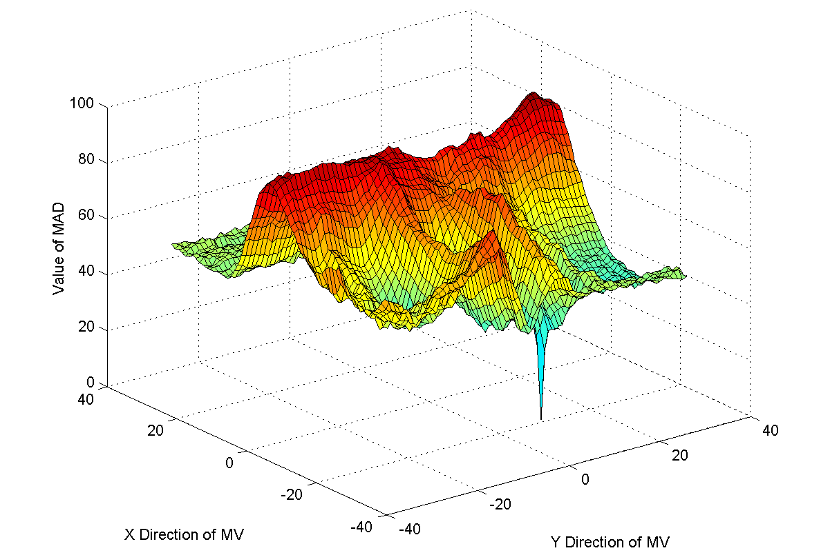
Fig. 1 MAD characteristics of a reliable LMV.

Equations
Use the Microsoft Equation Editor for equations in your paper. “Float over text” should not be selected. Number equations consecutively with equation numbers in parentheses flush with the right margin, as in (1).

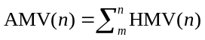. (1)

Be sure that the symbols in your equation have been defined before the equation appears or immediately following. Refer to “(1),” not “Eq. (1)” or “equation (1),” except at the beginning of a sentence: “Equation (1) is ... .”.

References
Number citations consecutively in square brackets [1]. The sentence punctuation follows the brackets [2]. Multiple references [2], [3] are each numbered with separate brackets [1]–[3]. When citing a section in a book, please give the relevant page numbers [2]. In sentences, refer simply to the reference number, as in [3]. Do not use “Ref. [3]” or “reference [3]” except at the beginning of a sentence: “Reference [3] shows ... .”
Give all authors’ names; do not use “et al.” unless there are six authors or more. Use a space after authors' initials. Papers that have not been published should be cited as “unpublished” [4]. Papers that have been submitted for publication should be cited as “submitted for publication” [5]. Papers that have been accepted for publication, but not yet specified for an issue should be cited as “to be published” [6]. Please give affiliations and addresses for private communications [7].
Remember to check spelling. Good English writing is essential to the acceptance of your paper. An excellent style manual and source of information for science writers are provided in [8].

Conclusion
A conclusion section is not required. Although it may review the main points of the paper, do not replicate the abstract as the conclusion. A conclusion might elaborate on the importance of the work or suggest applications and extensions.
Appendix
Appendixes, if needed, appear before the acknowledgment, if any.
References
- G. O. Young, “Synthetic structure of industrial plastics (Book style with paper title and editor),” in Plastics, 2nd ed. vol. 3, J. Peters, Ed. New York: McGraw-Hill, 1964, pp. 15–64.
- W.-K. Chen, Linear Networks and Systems (Book style). Belmont, CA: Wadsworth, 1993, pp. 123–135.
- H. Poor, An Introduction to Signal Detection and Estimation. New York: Springer-Verlag, 1985, ch. 4.
- B. Smith, “An approach to graphs of linear forms (Unpublished work style),” unpublished.
- J. Wang, “Fundamentals of erbium-doped fiber amplifiers arrays (Periodical style—Submitted for publication),” IEEE J. Quantum Electron., submitted for publication.
- E. H. Miller, “A note on reflector arrays (Periodical style—Accepted for publication),” IEEE Trans. Antennas Propagat., to be published.
- C. J. Kaufman, Rocky Mountain Research Lab., Boulder, CO, private communication, May 1995.
- M. Young, The Techincal Writers Handbook. Mill Valley, CA: University Science, 1989.

This work was supported in part by the MOST under Grant No. XX-0123-456-789 (sponsor acknowledgment goes here). Paper titles should be written in uppercase and lowercase letters, not all uppercase. Full names of authors are preferred in the author field.

