RC Instrument Flight Display
User Guide
Version 2.1.2 · Windows · macOS · Linux · Raspberry Pi · MAVLink · CRSF · MSP
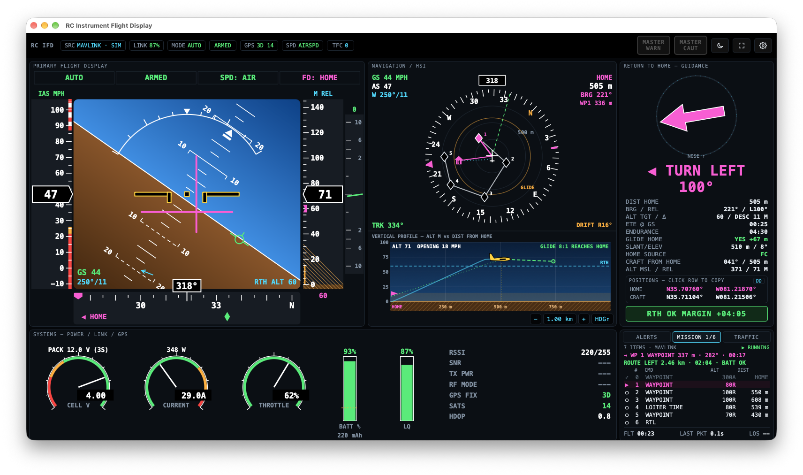
An instrument cluster for RC aircraft that lets you fly the aircraft on instruments via telemetry feed. It reads live telemetry, draws instruments, logs every flight and can replay it afterwards.

Contents
1. About the application Key capabilities, colour conventions
2. What you need Computers, telemetry sources, baud rates
3. Installing macOS, Windows, Linux, Raspberry Pi, start-up options
4. Connecting to the aircraft Connection settings, first connection, bench check
5. The screen at a glance Flight display, navigation and profile, return-to-home, systems, alerts
6. Flying home on instruments Step-by-step procedure
7. Recovery cues and failure indications Unusual attitude, lost data
8. Waypoint missions Mission list, map route, progress, protocol support
9. ADS-B traffic Receivers, setup, symbols, alerts, testing
10. Flight logs and replay Auto-logging, log locations, replay controls
11. Settings reference Every setting and its default
12. Troubleshooting Common problems and fixes
13. Sharing the application What to send to each type of computer
Quick reference card One page for the field

1. About the application
The display turns the aircraft's telemetry into a full instrument panel modelled on real cockpit displays (Boeing 787 primary flight and navigation displays, Garmin G1000, Airbus warning system).

Key capabilities
- Artificial horizon with speed and altitude tapes, vertical speed, heading tape and magenta steering bars that point you home.
- Moving map with home pointer, glide-range ring and breadcrumb trail, plus a side-view profile of the aircraft above the ground.
- Return-to-home panel with a large direction arrow, turn instruction, distance, time to home and a battery check that says whether you can make it.
- Battery, current, throttle, link quality and GPS gauges, and a colour-coded alert list with Master Warning / Master Caution.
- Works with MAVLink (ArduPilot, PX4), CRSF (ExpressLRS, Crossfire) and MSP (INAV, Betaflight) over USB/serial, UDP or TCP.
- Automatic flight logging to the computer, with replay, seek and a standard .tlog for Mission Planner.
- Home and aircraft coordinates (decimal degrees, deg-min or deg-min-sec) with one-tap copy, and a last known position that is kept if the link drops — even after an app restart.
- Waypoint missions: the route on the map and a mission list showing completed, active and pending waypoints (MAVLink and INAV).
- ADS-B traffic: nearby real aircraft from the flight controller, a ground receiver or an internet source, with collision-style symbols and alerts.

Colour conventions
The same colours mean the same thing everywhere on the screen, as in a real cockpit:
Colour | Meaning
White | Scales and current values
Green | Normal / active / within limits
Magenta | Guidance and home — steer towards magenta
Cyan | Values you have set (return altitude, wind, trail)
Amber | Caution — needs attention soon
Red | Warning or failed data. A red boxed label (ATT, SPD, ALT…) means that instrument has no valid data — do not use it

Important: This is a pilot aid, not a certified avionics system. Always follow your local regulations (including visual line-of-sight rules), configure your flight controller's own failsafe and return-to-home, and the display should not be treated as a back-up.

2. What you need
Item | Requirement
Computer | Windows 10/11, macOS 12 or later (Apple Silicon or Intel build to match), Linux desktop, or Raspberry Pi 4/5 with Raspberry Pi OS (64-bit recommended)
Telemetry source | A flight controller or radio sending MAVLink, CRSF or MSP telemetry, connected by USB cable, USB-to-serial adapter, the Pi's GPIO UART, or a Wi-Fi bridge (UDP/TCP)
Screen (field use) | A bright, sunlight-readable display. 7–10 inch works well on a Raspberry Pi
Power (field use) | A stable 5 V / 3 A or better supply for a Pi — brown-outs during radio transmit cause resets
Software | Packaged app: nothing else. Running from the source folder: Python 3.9+ (the launch scripts install pyserial and pywebview)

Recommended telemetry settings
Protocol | Typical source | Baud | Notes
MAVLink | ArduPilot / PX4 telemetry port or USB | 57600 / 115200 | Match the flight controller's SERIALx_BAUD. USB ignores baud
CRSF | ExpressLRS / Crossfire receiver telemetry | 420000 | Try 416666 if the adapter rejects 420000
MSP | INAV / Betaflight USB or UART with MSP enabled | 115200 | The app polls the flight controller; the port must be set to MSP

3. Installing

macOS (packaged app)
- Open RC-IFD.dmg and drag RC-IFD into Applications (or copy RC-IFD.app there directly).
- First launch only: right-click RC-IFD in Applications, choose Open, then Open again. macOS asks this because the app is not signed with a paid Apple developer certificate.
- If macOS says the app is damaged, run this once in Terminal, then open it again:
xattr -dr com.apple.quarantine /Applications/RC-IFD.app
Note: A build made on an Apple Silicon Mac only runs on Apple Silicon Macs, and an Intel build only on Intel Macs. Ask for the build that matches your Mac (Apple menu → About This Mac).

Windows
- Install Python 3.9 or later from python.org and tick Add python.exe to PATH.
- Unzip the RC-IFD folder somewhere permanent (for example Documents\RC-IFD).
- Double-click run_windows.bat. The first run sets itself up (about a minute); later runs open straight away.
- Windows normally installs USB serial drivers automatically. For CH340 adapters you may need the driver from the WCH website.

Linux desktop
cd RC-IFD
./run_mac_linux.sh
sudo usermod -aG dialout $USER # once, then log out and back in
sudo cp deploy/linux/99-rc-ifd.rules /etc/udev/rules.d/ # once: serial access + stops ModemManager interfering

Raspberry Pi (field unit)
bash deploy/raspberrypi/install_pi.sh
This installs everything, starts the telemetry and logging service at boot (it logs even with no screen attached), and opens the display full-screen at login. Reboot once afterwards. Press Alt+F4 to leave full-screen mode. To use the Pi's own UART pins (GPIO 14/15), turn off the serial console in raspi-config → Interface Options → Serial Port and choose /dev/serial0 as the port.

Start-up options
Option | Effect
--fullscreen | Start full-screen
--kiosk | Full-screen with no window controls (field use / Raspberry Pi)
--lan | Let phones and tablets on the same Wi-Fi view the display at http://<computer-ip>:8765 (view only)
--headless | Run telemetry and logging only, with no window
--data-dir <path> | Store settings and logs somewhere else, e.g. a USB drive

4. Connecting to the aircraft
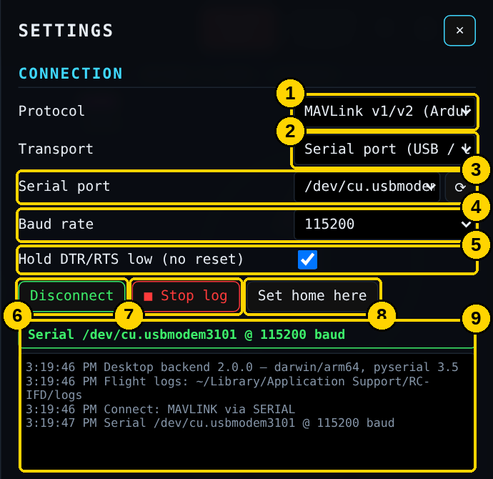
Figure 1 – Settings → Connection
# | Item | What it tells you / how to use it
1 | Protocol | MAVLink, CRSF or MSP — must match what the aircraft sends
2 | Transport | Serial port (USB/UART), UDP, TCP, Simulator or Replay
3 | Serial port + ⟳ | Ports are listed with their device name and USB ID. Press ⟳ after plugging something in
4 | Baud rate | See the table in section 2. Changing it reconnects automatically
5 | Hold DTR/RTS low | Leave ticked. Stops ESP32/Arduino-based receivers and bridges from resetting when the port opens
6 | Connect / Disconnect | Opens or closes the link. The app reconnects by itself if the cable is unplugged and plugged back in. If a connection attempt fails the button reads Retry, and changing the port, baud rate or address retries automatically
7 | Log now / Stop log | Manual logging control. Normally not needed — logging starts automatically
8 | Set home here | Makes the aircraft’s current position the home point (useful if home was set in the wrong place). Asks you to confirm if the aircraft is armed
9 | Status and log | Green = connected and receiving. The lines below show what the app detected (vehicle type, flight logs folder, errors)

First connection
- Power the aircraft and connect the telemetry source to the computer.
- Click ⚙ (top right) to open Settings.
- Choose the Protocol and Transport, then the Serial port and Baud rate (or the UDP port / TCP address).
- Click Connect. The status line turns green and the instruments come alive within a few seconds.
- Do the bench check below before the first flight with each aircraft.

Bench check (do this once per aircraft)
- Lift the aircraft's nose: the horizon line on the display must move down.
- Roll the aircraft to the right: the horizon must tilt left (anticlockwise).
- If either is wrong, tick Invert pitch or Invert roll under Protocol options. This is saved separately for each protocol.
- Check that the HOME SOURCE in the return-home panel shows FC (home from the flight controller) or ARM POINT before take-off.
Tip: With UDP, the app listens on the port you enter (14550 by default) — point MAVProxy, mavlink-router or your Wi-Fi telemetry bridge at the computer's IP address and that port. With TCP, enter host:port, for example 192.168.4.1:5760 for most ESP32 bridges.

5. The screen at a glance
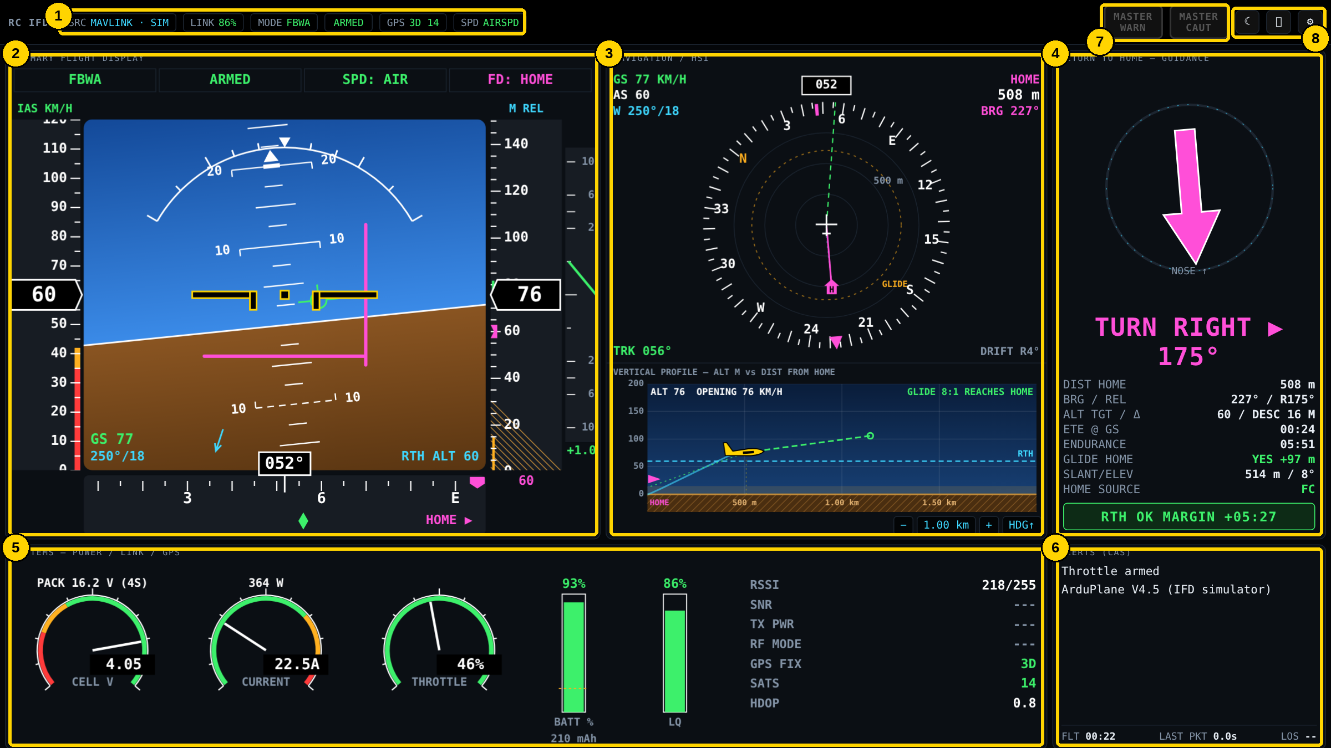
Figure 2 – Main display
# | Item | What it tells you / how to use it
1 | Status bar | Telemetry source, link quality, flight mode, armed state, GPS fix and satellites, speed source, ● REC when logging, and TFC (number of nearby aircraft; amber or red when one is a threat)
2 | Primary flight display | Attitude, speed, altitude, climb/sink and heading — your main instrument
3 | Navigation display | Map-style compass with home, trail and glide range, plus the side-view profile
4 | Return-to-home panel | Which way and how far to home, whether the battery will get you there, and the home and aircraft coordinates
5 | Systems | Battery, current, throttle, link and GPS health
6 | Alerts | Tabbed panel: ALERTS (warnings, cautions and messages), MISSION (waypoint list) and TRAFFIC (ADS-B aircraft), with flight time and link-loss timers
7 | Master Warning / Caution | Flash when a new warning or caution appears. Tap to acknowledge
8 | Night mode, full screen, settings | Moon icon switches to a red night palette. Full-screen icon (or F11) fills the screen; Esc or the button again leaves it. Gear icon opens Settings (Esc closes it)

Note: The screenshots in this guide were taken before v2.1. Since then the bottom-right panel has ALERTS / MISSION / TRAFFIC tabs, the return-to-home panel has a Positions box, and the top-bar buttons use drawn icons. Each change is described in the sections below.

Tip: The top-bar labels turn amber or red when something is degraded. A red LINK LOST or GPS LOST label is the first thing to look for if the display seems frozen.

5.1 Primary flight display
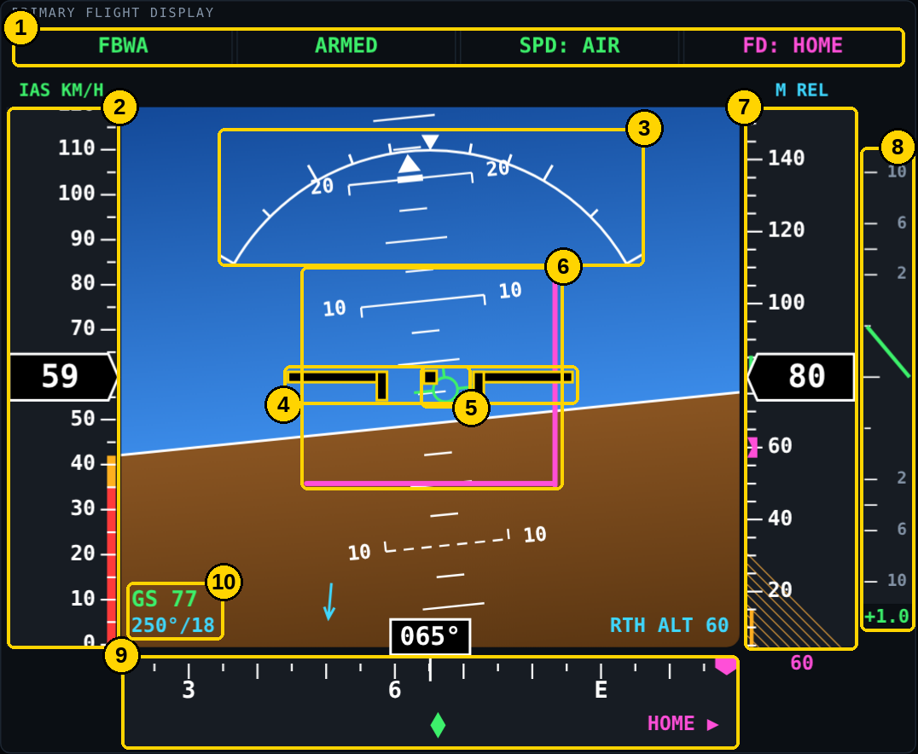
Figure 3 – Primary flight display
# | Item | What it tells you / how to use it
1 | Mode strip | Flight mode, armed state, speed source (AIR = airspeed sensor, GPS GS = ground speed) and FD: HOME when steering guidance is active
2 | Speed tape | Current speed in the box. Red band = below stall speed, amber = close to stall, red/white = above never-exceed speed. Green line = speeding up or slowing down
3 | Bank scale | Bank angle in degrees. The pointer turns amber beyond the bank limit (55° by default)
4 | Aircraft symbol | The aircraft's wings. Where it sits against the horizon is the aircraft's attitude
5 | Flight-path marker | Green circle with wings: where the aircraft is actually going, including wind drift and climb or sink. If it sits below the horizon you are descending, whatever the nose is doing
6 | Magenta steering bars | Fly the yellow aircraft symbol onto the cross of the bars — the vertical bar steers you towards home, the horizontal bar towards the return altitude
7 | Altitude tape | Height above home. Magenta marker = return altitude; amber strip = low-altitude zone; hatched = below home level
8 | Vertical speed | Climb (up) or sink (down) rate. Turns amber then red for steep descents
9 | Heading tape | Compass heading in the box. Green diamond = actual track over the ground; magenta marker = direction of home (◀ HOME / HOME ▶ when off-scale)
10 | Ground speed and wind | GS and wind direction/speed with an arrow showing which way it blows. EST means the wind is estimated by the app

5.2 Navigation display and vertical profile
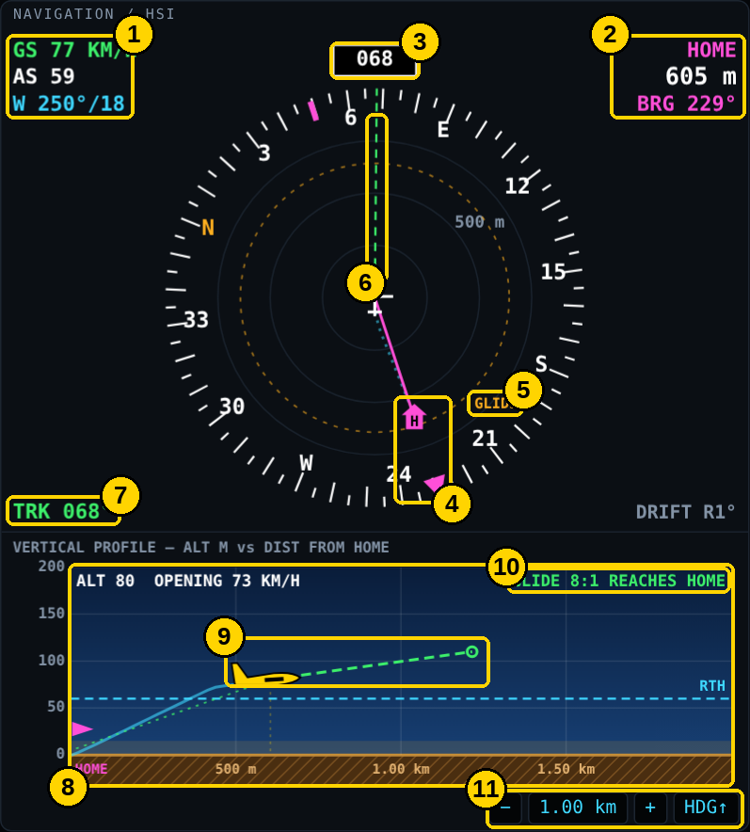
Figure 4 – Navigation display with vertical profile
# | Item | What it tells you / how to use it
1 | Speeds and wind | Ground speed, airspeed and wind
2 | Home data | Distance and compass bearing to home
3 | Heading | Current heading (or N-UP in north-up mode)
4 | Home | Magenta H and line to home, with a magenta pointer on the compass ring showing home's direction even when it is off the map
5 | Glide ring | Amber dashed circle: how far the aircraft could glide with the motor stopped, from its present height
6 | Track line | Green dashed line: the direction the aircraft is actually moving over the ground
7 | Track and drift | Ground track, and drift left/right caused by wind (amber when more than 15°)
8 | Vertical profile | Side view: distance from home left to right, height up the side. Blue line = recent path; cyan dashed = return altitude; ground = home's height (no terrain data)
9 | Aircraft and 30-second projection | The aircraft symbol faces home when you are heading towards it. The dashed line shows where you will be in 30 seconds — it turns red with an X if that is the ground
10 | Glide result | REACHES HOME or SHORT by a distance, using the glide ratio set in Settings
11 | Range and orientation | − / + change the map scale; HDG↑ / N↑ switches heading-up and north-up

5.3 Return-to-home panel
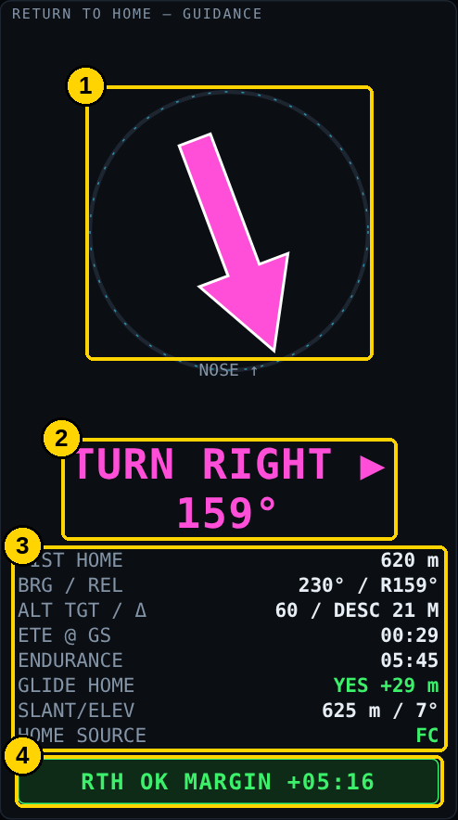
Figure 5 – Return-to-home guidance
# | Item | What it tells you / how to use it
1 | Home arrow | Points to home relative to the aircraft's nose (straight up = home is ahead)
2 | Turn instruction | Which way and how far to turn. Turns green with HOME AHEAD — HOLD once lined up, and OVERHEAD HOME when you arrive
3 | Home data | Distance, bearing, climb/descend needed to reach the return altitude, time to home at the current ground speed, battery endurance to the reserve, whether a glide would reach home, straight-line distance and angle (for pointing a ground antenna), and where home came from
4 | RTH feasibility | RTH OK (green), RTH MARGINAL (amber, less than about a minute spare) or CANNOT REACH HOME — LAND NOW (red, flashing)

Note: HOME SOURCE shows FC when home comes from the flight controller. ARM POINT, FIRST FIX or MANUAL mean the app set home itself — check it is where you launched.

Positions and last known position (v2.1)
Below the home data, the return-to-home panel now shows where home and the aircraft are, so you can find the aircraft if it comes down out of sight.
Item | What it tells you / how to use it
CRAFT FROM HOME | Bearing and distance from home to the aircraft — the direction to walk from where you are standing
ALT MSL / REL | Aircraft altitude above sea level and above home
HOME row (magenta) | Home latitude and longitude
CRAFT row | Aircraft latitude and longitude while GPS data is live
LKP mm:ss (amber) | If the link or GPS drops, the CRAFT row keeps the last known position and shows how long ago it was received. It is saved every 2 seconds and survives an app restart
Format button (DD) | Cycles decimal degrees (DD), degrees + decimal minutes (DDM) and degrees-minutes-seconds (DMS)
Click a row | Copies the coordinates as lat, lon (7 decimal places) for pasting into a maps app; a message confirms the copy

Tip: If the aircraft goes down, copy the CRAFT / LKP row straight away and paste it into Google Maps or Apple Maps on your phone. Clear an old saved position with Settings → Clear saved last-known position.

5.4 Systems
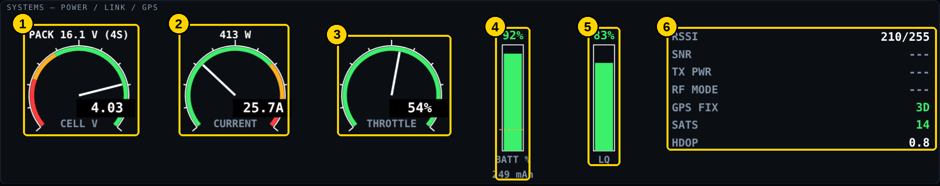
Figure 6 – Systems gauges
# | Item | What it tells you / how to use it
1 | Cell voltage | Average volts per cell, with pack voltage above. Amber and red zones follow the caution/warning voltages in Settings
2 | Current | Amps drawn, with watts above
3 | Throttle | Throttle percentage (when the protocol provides it)
4 | Battery % | Remaining capacity. The dashed amber line is your landing reserve
5 | LQ | Radio link quality. Amber below 75 %, red below 50 %
6 | Link and GPS | Signal strength, signal-to-noise, transmit power, RF mode, GPS fix, satellites and position accuracy (HDOP — lower is better, under 2 is good)

5.5 Alerts
Warnings appear in red with ▲, cautions in amber with ●, and information in cyan. New warnings and cautions flash the matching MASTER button and, if enabled, sound a tone or speak the alert. Acknowledging MASTER WARN / CAUT stays in effect while the same alert continues, even if its numbers (distance, height) keep changing.
Alert | Meaning / action
TELEMETRY LOST | No data received for 2 seconds. Instruments show red flags. Fly the last known heading and wait for the link
BANK ANGLE | Bank beyond the limit — roll towards level
STALL — LOWER NOSE / ADD POWER | Airspeed below stall speed
OVERSPEED | Airspeed above never-exceed speed
SINK RATE — PULL UP | Descending faster than 8 m/s
TERRAIN — PULL UP | At the current sink rate the aircraft reaches home level within 15 seconds
TOO LOW — TERRAIN | Below the low-altitude setting while away from home
BATTERY LOW / CRITICAL | Cell voltage below the caution / warning voltage
INSUFFICIENT ENERGY TO RTH | Battery endurance is less than the time to fly home
LINK QUALITY LOW | Link quality under 50 %
GPS DEGRADED / DATA STALE | No 3D fix, fewer than 6 satellites, or GPS data has stopped
MAX RANGE EXCEEDED | Further from home than the maximum distance setting
FC: … | A message from the flight controller (MAVLink only)
TRAFFIC 10 O’CLOCK 1.6 km +30 M N123AB | Real aircraft nearby (ADS-B): clock position, distance and height relative to you. Amber = traffic advisory, red = collision risk. See section 9
MISSION: … | Mission download problem (shown while the MISSION tab is open)

Alerts, Mission and Traffic tabs
The bottom-right panel has three tabs. Click or tap a tab to switch; it changes as soon as it is pressed. With the keyboard, Tab to a tab and use the left/right arrow keys.
Tab | Shows
ALERTS n | Warnings, cautions and messages. Red label = active warning, amber = caution
MISSION a/b | Active waypoint a of b, and the waypoint list (section 8)
TRAFFIC n | Number of nearby aircraft and the traffic list (section 9). Amber or red when one is a threat

Note: A new warning always brings the ALERTS tab forward, wherever you are. A warning that was already showing in the last 20 seconds does not keep pulling the panel back.

6. Flying home on instruments
Practise this in the simulator (Transport → Simulator) and on clear days with a spotter before you need it.
- Level the wings first. Put the yellow aircraft symbol level against the horizon and stop any climb or dive. Check speed is in the white/green part of the tape.
- Read the return-to-home panel. Note the turn instruction and RTH feasibility. If it says CANNOT REACH HOME, pick the safest place to land now.
- Turn towards home. Make a gentle, steady turn (15–30° of bank) in the direction shown until the arrow points up and the panel shows HOME AHEAD — HOLD. The magenta marker on the heading tape will centre.
- Follow the magenta steering bars. Keep the aircraft symbol on the cross of the bars. They guide you towards home and to the return altitude.
- Allow for wind. Watch the green flight-path marker and track diamond. If the track drifts away from home, turn a little more into the wind until the track diamond sits on the home marker.
- Watch the vertical profile. Keep the aircraft above the cyan return-altitude line and the 30-second projection away from the ground. Make sure the glide line still reaches home.
- Arrive overhead. When the panel shows OVERHEAD HOME, circle gently at a safe height and look for the aircraft visually, or set up your landing.
Tip: If the display itself loses telemetry (LINK LOST), keep the wings level and the last heading. The instruments come back as soon as data resumes and the LOS timer shows how long you have been without data.

Tip: If the aircraft is lost or comes down, the CRAFT row in the return-to-home panel keeps its last known position (amber LKP). Click it to copy the coordinates, and use CRAFT FROM HOME for the bearing and distance to walk.

7. Recovery cues and failure indications

Unusual attitude
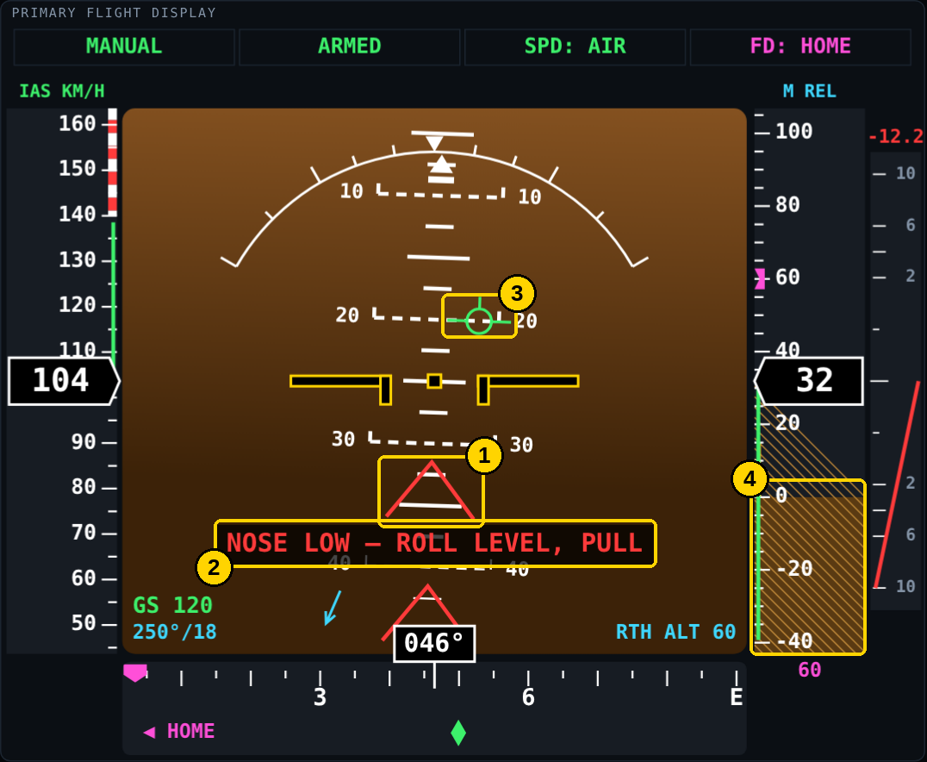
Figure 7 – Nose-low unusual attitude
# | Item | What it tells you / how to use it
1 | Red chevrons | Appear at steep pitch angles and point back towards the horizon
2 | Recovery instruction | ROLL LEVEL, NOSE HIGH — LOWER NOSE, or NOSE LOW — ROLL LEVEL, PULL. The magenta steering bars are hidden until you recover
3 | Flight-path marker | Shows the real descent path
4 | Altitude tape | Watch the hatched area — it is home level

Recovery: roll the wings level first, then ease the nose up to the horizon. Pulling while banked steeply only tightens a spiral.

Lost or invalid data
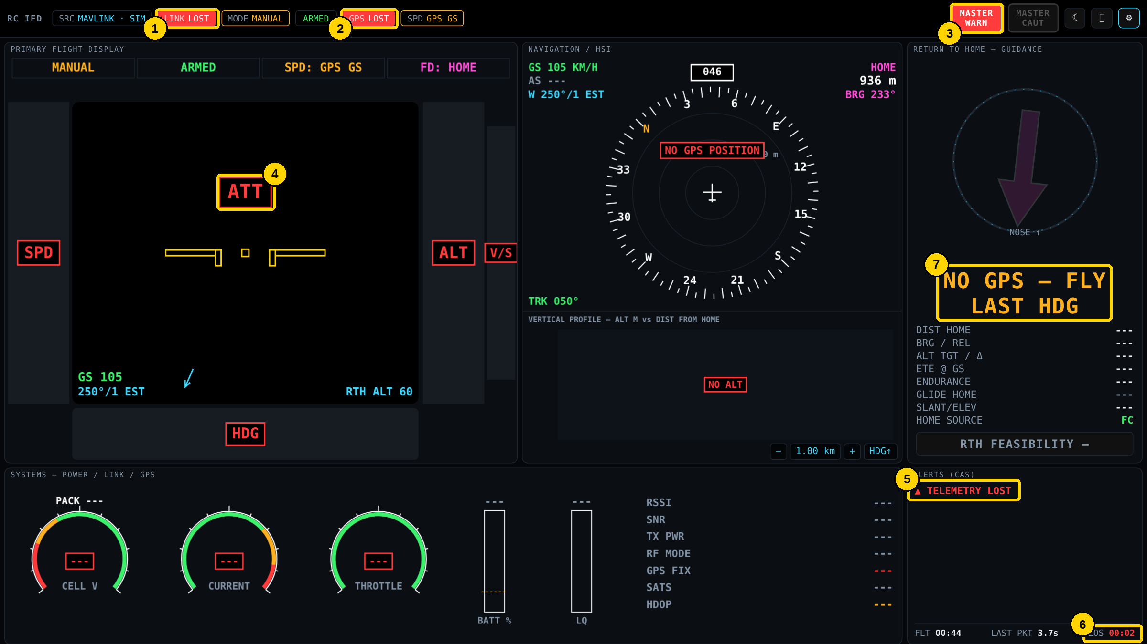
Figure 8 – Telemetry lost
# | Item | What it tells you / how to use it
1 | LINK LOST | No data from the aircraft
2 | GPS LOST | No current GPS data
3 | MASTER WARN | Flashes until acknowledged
4 | Failure flags | Red boxed labels (ATT, SPD, ALT, V/S, HDG) replace instruments that have no valid data. The app never shows old values as if they were current
5 | Alert | TELEMETRY LOST in the alerts list
6 | LOS timer | Time since data was lost
7 | Guidance | NO GPS — FLY LAST HDG: hold the last heading until data returns. The CRAFT row switches to the amber last known position (LKP)

8. Waypoint missions
When the flight controller holds a waypoint mission, the display downloads it and shows the route on the map and as a list. This lets you follow an automatic mission on instruments, and see what is left before committing to it.

Mission list (MISSION tab)
Item | Meaning
Header | Number of items, source (MAVLINK or INAV), and ▶ RUNNING when the aircraft is flying the mission (AUTO / MISSION / WP mode) or NOT IN AUTO
→ WP n … | Active waypoint: command, distance, bearing, time at the current ground speed, and cross-track error (XTK) when the flight controller reports it
ROUTE LEFT | Distance and time from the aircraft through every remaining waypoint, with BATT OK / BATT MARGINAL / BATT SHORT against your battery endurance
✓ (dim) | Completed waypoint
▶ (magenta) | Active waypoint
○ (white) | Pending waypoint
ALT column | Waypoint altitude; R = relative to home, A = above sea level, T = above terrain
DIST column | Length of the leg to that waypoint. Item 0 on ArduPilot is HOME

Mission on the map
- Completed legs: dim, dashed.
- Active leg: magenta line from the aircraft to the active waypoint.
- Pending legs: white. Waypoints are numbered diamonds.
- Under HOME at the top right: WPn and the distance to the active waypoint.

How the mission is obtained
Protocol | Source
MAVLink | Downloaded automatically after connecting (standard mission protocol). Progress comes from MISSION_CURRENT, MISSION_ITEM_REACHED and NAV_CONTROLLER_OUTPUT. Re-downloaded if the mission changes and at the start of each new log, so replays include it
MSP (INAV) | Read with MSP_WP_GETINFO and MSP_WP; progress from MSP_NAV_STATUS. Betaflight has no missions
CRSF | Carries no mission data — the MISSION tab says so

Note: Downloading needs a two-way link with MAVLink: send heartbeat + requests turned on. Use Settings → Download mission now to fetch it manually. The magenta steering bars on the flight display always guide you home, not along the mission.

Practising with the simulator
The simulator flies a six-waypoint mission ending in RTL. Press M to switch between flying the mission and free wandering.

9. ADS-B traffic
Full-size aircraft broadcast their position by ADS-B. The display can show those nearby on the map and in the TRAFFIC tab, and alert you when one is close.
Important: This is a receive-only awareness aid. Manned aircraft cannot see your model on their displays — you must always see and avoid them and give way. Many aircraft (gliders, older light aircraft) do not transmit ADS-B at all.

Traffic sources
Source | How
Receiver on the aircraft | An ADS-B receiver connected to the flight controller (for example uAvionix ping) sends ADSB_VEHICLE over MAVLink. Always accepted — no setup
Local ground receiver (recommended) | RTL-SDR USB stick + 1090 MHz antenna running dump1090, readsb or PiAware on the Pi or laptop. Works without internet, under 1 s delay, and sees low local traffic
Internet source (testing / backup) | An online aggregator such as adsb.lol. Needs internet in the field, data is several seconds old, and low aircraft are often missing
Simulated traffic | Settings → Simulate traffic. Three moving aircraft for bench-testing symbols and alerts

Receiver addresses
Choose Settings → ADS-B TRAFFIC → Ground receiver and enter the address. Open the address in a browser first: you should see text beginning with {"now":… and a list of aircraft.
Receiver | Ground receiver type / address
readsb / dump1090-mutability | aircraft.json URL: http://localhost:8080/data/aircraft.json
FlightAware PiAware (dump1090-fa) | aircraft.json URL: http://localhost/dump1090-fa/data/aircraft.json
tar1090 | aircraft.json URL: http://localhost/tar1090/data/aircraft.json
Receiver on another device | Same paths with that device’s IP address instead of localhost
SBS-1 / BaseStation stream | SBS-1 type, address host:30003
adsb.lol (internet) | aircraft.json URL: https://api.adsb.lol/v2/point/LAT/LON/RADIUS — radius in nautical miles, e.g. https://api.adsb.lol/v2/point/35.707/-81.219/10

Note: Internet sources are polled every 5 seconds (a local receiver every second). If the server returns Too Many Requests, the app pauses — 30 s, then up to 2 minutes — and the TRAFFIC tab shows rate-limited by server — pausing. Avoid testing the same URL with curl or a browser while the app is polling, as it counts against the same limit.

Reading the traffic display
Symbol | Level | Meaning
◇ white outline | Other traffic | In range, not close
◆ cyan | Proximate | Within 3× the alert radius horizontally and 2× vertically
● amber | Traffic advisory | Inside the alert radius, or predicted to pass within it in the next 60 s. Amber TRAFFIC caution
■ red | Collision risk | Inside half the alert radius, or predicted to within 30 s. Red TRAFFIC warning and MASTER WARN

- The label above or below each symbol is the height difference to your aircraft (+ above, − below), with ↑ / ↓ when it is climbing or descending.
- The short line from the symbol shows its direction of travel.
- A boxed TRAFFIC message appears at the bottom of the map when any aircraft is amber or red.
- The TRAFFIC list shows callsign (or ICAO code), distance, clock position (12 o’clock = ahead), relative height and ground speed.
- Aircraft on the ground are ignored, and an aircraft with no altitude never raises a red warning.

Testing the traffic feed
- Start the desktop app (the receiver is read by the backend, not in plain browser mode) and set Transport = Simulator.
- In ADS-B TRAFFIC, set the receiver type and address.
- Temporarily set Display range to 100 km and Hide traffic beyond ± to 12000 m (and the adsb.lol radius to 50) so airliners show.
- Within a few seconds the TRAFFIC tab header should read receiver OK — N aircraft heard. N counts everything the receiver sees; the list only shows aircraft inside your range and height band, so an empty list with N above 0 means the feed works but nothing is close.
- Set the values back (10 km, ±1500 m, radius 10) before flying.
Note: Pressure-altitude-only targets (shown as BARO internally) can differ from your GPS height by tens of metres depending on the day’s air pressure. Traffic is not yet stored in flight logs, so replays do not show it.

10. Flight logs and replay
Every telemetry session is logged automatically, straight from the link, so recording continues even if the display window is closed or reloaded. A session ends after 60 seconds without data; very short bench connections are discarded.
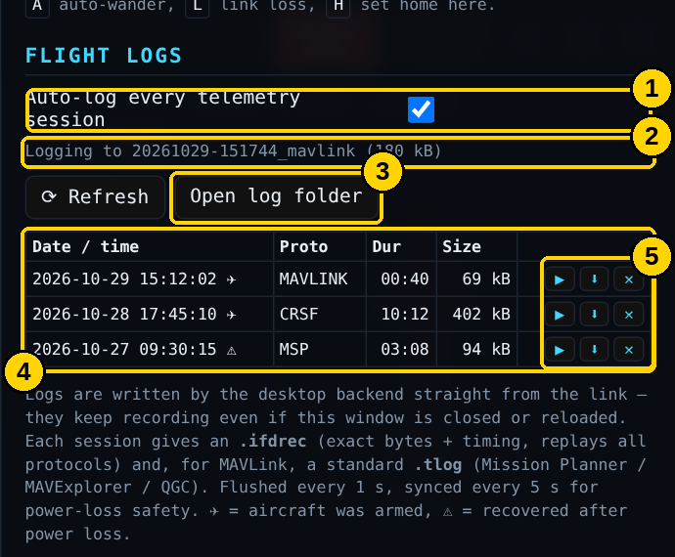
Figure 9 – Settings → Flight logs
# | Item | What it tells you / how to use it
1 | Auto-log | On by default. Untick to log only when you press ● Log now
2 | Recording status | The file currently being written and its size
3 | Open log folder | Opens the logs folder in Finder / Explorer / file manager
4 | Log list | Date, protocol, duration and size. ✈ = aircraft was armed; ⚠ = log was recovered after a power loss (still replayable)
5 | Log buttons | ▶ replay, ⬇ download (.tlog for MAVLink, otherwise .ifdrec), ✕ delete

Where logs are stored
System | Folder
Windows | %LOCALAPPDATA%\RC-IFD\logs
macOS | ~/Library/Application Support/RC-IFD/logs
Linux / Raspberry Pi | ~/.local/share/rc-ifd/logs

Each flight produces an .ifdrec file (exact recording, replays any protocol), a .json summary (arm/disarm, mode changes, warnings) and, for MAVLink, a .tlog that opens in Mission Planner, MAVExplorer and QGroundControl. Data is saved every second, so a sudden power cut loses at most about five seconds. The oldest logs are removed automatically when they exceed 2 GB in total or free disk space drops below 300 MB.

Replaying a flight
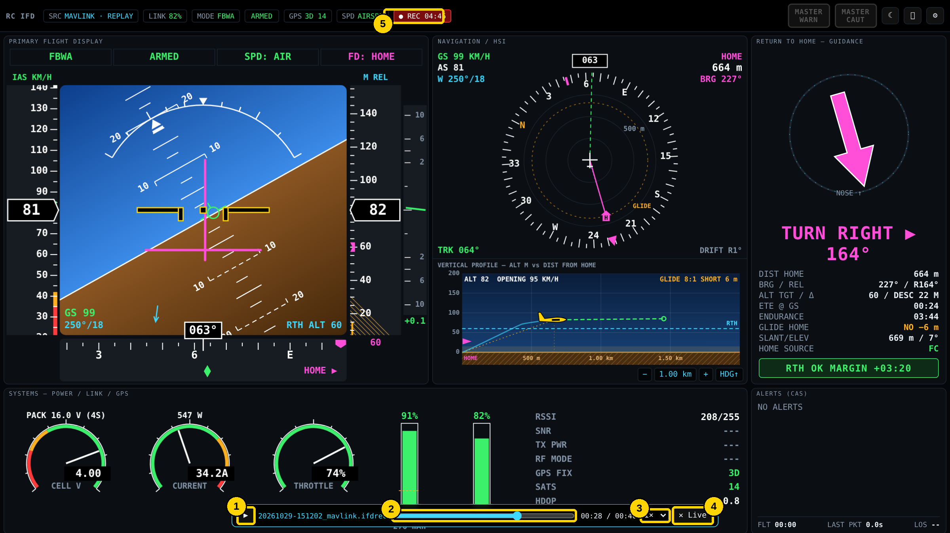
Figure 10 – Replay controls
# | Item | What it tells you / how to use it
1 | Play / pause | Also the Space bar. While paused, the instruments hold their values
2 | Seek bar | Drag to any point — the display rebuilds the exact aircraft state at that moment, including the trail and home
3 | Speed | ½× to 10×
4 | ✕ Live | Leave replay and return to live telemetry
5 | ● REC | Shows that the background logger is still recording (with elapsed time)

Note: Starting a replay disconnects the live link and closes its log, so the app asks you to confirm.

11. Settings reference
Open Settings with ⚙. Settings are saved automatically and remembered between sessions.
Setting | Default | Purpose
MAVLink: send heartbeat + requests | On | Lets the app ask the flight controller for data and home. Turn off for listen-only links
MAVLink attitude / HUD rate | 10 Hz | How often attitude and speed are requested
MSP poll rate | 10 Hz | How often an MSP flight controller is asked for data
Invert pitch / roll | Off (MSP pitch on) | Corrects reversed instruments — see the bench check
Units | km/h, metres, m/s | Speed, altitude/distance and vertical speed units
Stall speed / never-exceed speed | 35 / 140 km/h | Colour bands on the speed tape and stall/overspeed warnings
Max bank warning | 55° | Bank limit for the BANK ANGLE warning
Low altitude warning | 15 m | Amber band on the altitude tape and TOO LOW warning
RTH target altitude | 60 m | Return altitude for the steering bars and profile
Max home distance warn | 2000 m | MAX RANGE EXCEEDED caution
Glide ratio | 8 : 1 | Glide ring, glide line and GLIDE HOME. Foam wing 6–8, trainer 8–10, motor-glider 12+
Cells / capacity / reserve | 4S / 3000 mAh / 20 % | Battery gauges, endurance and RTH feasibility — set these for each pack
Cell caution / warn | 3.5 / 3.3 V | BATTERY LOW and BATTERY CRITICAL thresholds
Audio alerts / speech | Off | Tones and spoken alerts
Telemetry stale after | 2 s | How long before an instrument is flagged as failed
Frame-rate cap | Display rate (30 fps on Pi) | Lower values save power and heat
Coordinate format | Decimal degrees | DD / DDM / DMS for the Positions box (also the button on the panel)
Download mission automatically | On | Fetch the waypoint mission after connecting (MAVLink, INAV)
Show mission on map | On | Draw the mission route on the navigation display
Ground receiver / Receiver address | None | ADS-B source — see section 9
Simulate traffic | Off | Three simulated aircraft for testing
Show traffic on map | On | Draw ADS-B symbols on the navigation display
Alert radius horizontal / vertical | 1000 m / 150 m | Distance and height that make traffic amber or red
Display range | 10 km | Traffic further away is not listed
Hide traffic beyond ± | 1500 m | Traffic further above or below is not listed

Settings also include the buttons Download mission now and Clear saved last-known position, Link statistics (data rate, corrupted frames and message rates — useful when troubleshooting) and a table showing what each protocol provides. CRSF, for example, has no wind or mission data, and MSP’s airspeed is only available on INAV with an airspeed sensor.

12. Troubleshooting
Problem | What to do
Port not listed | Press ⟳. Try another cable (some are charge-only) and port. Install the CH340 or CP210x driver if your adapter needs one
Port is busy / in use | Close Mission Planner, QGroundControl, Betaflight/INAV Configurator or Arduino — only one program can use a port
Permission denied (Linux / Pi) | sudo usermod -aG dialout $USER, then log out and back in
Connected but nothing moves | Wrong protocol or baud rate, or the flight controller port is not set to MAVLink / MSP / CRSF telemetry. Check Link statistics: Bytes/s above 0 but Frames/s at 0 means a protocol or baud mismatch
CRSF at 420000 will not open | Try 416666, or use an FTDI or CP2102N adapter (some CH340 adapters cannot run this speed)
Horizon moves the wrong way | Tick Invert pitch or Invert roll (section 4)
Airspeed shows GPS GS | The aircraft has no airspeed sensor or the protocol does not send it — the tape shows ground speed in amber
Home is in the wrong place | Use Set home here before take-off, or check the flight controller's home
macOS: app won't open | Right-click → Open, or run the xattr command in section 3
macOS: old or Python icon | Copy the new app to Applications, then run killall Dock
Display is slow on Raspberry Pi | Set the frame-rate cap to 20 or 15 fps, and make sure the Pi is not overheating or under-powered
Full-screen button does nothing | Fixed in v2.1.2 — update. Otherwise press F11 (Windows / Linux) or Ctrl+Cmd+F (Mac)
Connect button reads Retry | The last attempt failed. Check the status line, fix the port / address, and it retries automatically
MISSION tab empty | CRSF has no missions; Betaflight has none. For MAVLink, turn on heartbeat + requests and press Download mission now
TRAFFIC: receiver unreachable | Check the address in a browser. On a Mac, CERTIFICATE_VERIFY_FAILED means running Applications → Python 3.x → Install Certificates.command once
TRAFFIC: rate-limited by server | The internet source is limiting requests. Wait for the pause to end and stop any other tools using the same URL
N aircraft heard but list empty | The feed works; nothing is inside Display range / Hide traffic beyond. Widen them to test (section 9)

13. Sharing the application
When passing the display on to another pilot, send the package that matches their computer together with this guide.
Recipient uses | Send
Mac (Apple Silicon) | RC-IFD.dmg (or zipped RC-IFD.app) built on an Apple Silicon Mac + this guide
Mac (Intel) | A build made on an Intel Mac + this guide
Windows | The RC-IFD folder (zipped) with run_windows.bat, or a Windows build made with build_standalone.py on Windows + this guide
Linux / Raspberry Pi | The RC-IFD folder (zipped) — they run run_mac_linux.sh or deploy/raspberrypi/install_pi.sh + this guide

Before sending
- Remove the .venv, build and dist folders from source zips (they are recreated on first run).
- Do not include your logs or settings folder unless you mean to share flight data.
- Remind recipients to do the bench check and set their own battery, speed and glide-ratio settings.
- Point them to the Quick reference card at the end of this guide for field use.
- When updating an existing install, replace web/index.html and the whole ifd_backend folder (v2.1 adds adsb.py), then rebuild. Logs and settings are kept.

Quick reference card
Before flight | If video is lost
Connected — status bar SRC and LINK green  GPS 3D with 6+ satellites  HOME SOURCE shows FC or ARM POINT  Battery cells, capacity and reserve set  Bench check done for this aircraft  ● REC showing (auto-log)  TRAFFIC tab: receiver OK (if used) | 1. Wings level, stop climb/dive  2. Read RTH panel: OK / MARGINAL / CANNOT REACH  3. Turn the way shown until HOME AHEAD — HOLD  4. Keep aircraft symbol on the magenta bars  5. Correct for wind with the green track diamond  6. Keep above the cyan RTH line in the profile  7. OVERHEAD HOME: circle and look for it  Down? Tap CRAFT/LKP row to copy position

Colours | Red flags | Recovery
Magenta = home / guidance  Green = normal  Cyan = your settings  Amber = caution  Red = warning | ATT SPD ALT V/S HDG = no valid data  LINK LOST = fly last heading  LOS timer = time without data | Bank > 60°: ROLL LEVEL  Nose low: roll level, then pull  Nose high: lower the nose  TERRAIN / SINK RATE: pull up

Keys | Baud rates | Logs folder
Space – replay pause  Moon – night mode  F11 – full screen (Esc exits)  Gear – settings (Esc closes) | MAVLink 57600 / 115200  CRSF 420000 (416666)  MSP 115200 | Win: %LOCALAPPDATA%\RC-IFD\logs  Mac: ~/Library/Application Support/RC-IFD/logs  Linux/Pi: ~/.local/share/rc-ifd/logs

