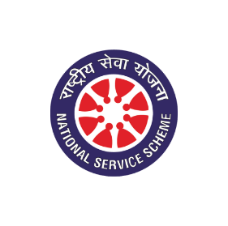

National Service Scheme Committee
Activities 2024-25

ACTIVITY REPORT

Report on {activityTitle}
EVENT DETAILS
Activity Title | {activityTitle}
Date | {date}
Venue | {venue}
Time | {time}
No. of Volunteers | {volunteers}
Activity Coordinator | {activityCoordinator}
Name of Scheme | {scheme}
Organizing Unit | {organizingUnit}
OBJECTIVES
- {in_points}
DESCRIPTION
{description}

IMPACT
{impact}

CONCLUSION
{conclusion}

PHOTOS
{insert_photos}

Prof. Rakshak Sood,
Program Officer,
NSS-VIT

