Can AI Read the Markets? LLMs for Predictive Financial Intelligence
Reading and deciding are separable, and only reading survives
[INSERT: candidate full name]
This Project is submitted as part of the requirements for the award of the MSc in Business Analytics
[INSERT: month and year of submission]
[INSERT: supervisor name and title, and industry contact if named]
[INSERT: confidentiality statement if applicable, and CONF_ prefix on the PDF filename]

Abstract
This study asks whether a large language model reading earnings documents produces directional judgements reliable enough to trade on. A model arm scoring 233 events is graded against the realised overnight price move and compared with six human raters reading the same corpus blind. Across 146 trades the mean net return is 1.86%, absorbing round-trip costs to 108 basis points against the 10 assumed. The score correlates with the overnight return at rho 0.236, yet the threshold layer turning that score into a call degenerates under honest refitting. Reading and deciding prove separable, and only reading survives.

Executive summary
An institution asking whether a language model can read an earnings release and tell a desk what to do gets two answers here, and they point in opposite directions.
The money is real and the room is wide. Across 146 traded events the model returns a mean of 1.86% per trade net of a 10 basis point round-trip cost, with a median of 1.14% and a summed total of 271.81%. The signal absorbs 196 basis points of round-trip cost before its mean reaches zero, and 108 before the lower bound of its confidence interval does, roughly ten times the assumed cost on the conservative measure. No externally cited desk cost exists in this project, so those figures describe how much room the edge has rather than proving it clears a real one.
The rule that produced the money cannot be trusted. Converting a continuous score into a call needs two cut-off values, and the pair used here was found by searching the whole dataset for the combination that maximised total return, then measuring performance on that same data. Setting them honestly, using only events that had already happened to fix cut-offs for events that came next, fails. One honest scheme fails structurally and more data would not repair it. The other improves as the sample grows and would plausibly need 400 to 500 events, making sample size the binding constraint rather than the method.
The reading itself survives independently of any rule. Rank correlation between score and realised overnight return is 0.236 at p equals 0.0003 across all 233 events, computed with no threshold, no band and no selection. It decays as the holding period lengthens and is gone within roughly five trading days, which locates the value in the overnight window and means a desk holding longer gives the advantage back.
On cost, the model reaches the same verdict from the prepared remarks alone as from the full bundle on 85.7% of events, at 42% lower cost per correct call. The extra documents do not make its calls better when it acts, they make it more willing to act.
Two cautions outrank every number. Only 95 of 361 documents read produced a gradeable outcome, so most comparisons are underpowered and a difference failing to reach significance is invisible to this sample rather than absent. And a substantial part of this work was auditing the project’s own pipeline, which found four safeguards that existed, appeared to be in force and never once executed, withdrawing six previously reported findings including the result the project had been leading with.
The practical conclusion is narrow. Extract the model’s reading as a continuous signal and pass it into a decision process carrying its own calibration. Do not let the model make the call.

Acknowledgements
[INSERT: acknowledgements. Must credit the group for designing and running the human arm, name the six raters, and thank the supervisor and the industry contact.]
Declaration on the use of AI tools. Generative AI assistance was used in this project for code authorship and debugging within the shared analysis pipeline, and for editorial support on drafts of this document. All research questions, analytical decisions, interpretation of results and final written content are my own. Where AI assistance contributed to committed code, this is recorded in the repository history. [CHECK the programme rule before submitting. If disclosure is not required, delete this paragraph. If a prescribed form of words exists, use that instead.]

Contents

List of tables
Table 1. Effective sample funnel, frozen set
Table 2. The two accuracy conventions on identical predictions
Table 3. Profit and loss on traded events, frozen set
Table 4. Section ablation, accuracy and cost per correct call
Table 5. Baseline comparison under the coverage convention
Table 6. Model against the human arm, paired events
Table 7. The four inoperative safeguards
Table 8. Delivery against the brief’s five specific aims

List of figures
Figure 1. Running sum of net return per trade, frozen set
Figure 2. Net return per trade ranked worst to best
Figure 3. Mean net return against round-trip trading cost
Figure 4. Model against an always-BUY rule
Figure 5. Mean net return by size of the realised move
Figure 6. Rank correlation and mean net return against holding horizon
Figure 7. Mean overnight return by model score decile
Figure 8. The funnel from scored events to correct calls
Figure 9. Neutral band sweep, accuracy and mean net return

1. Introduction

1.1 The problem, and the questions taken from it
On an ordinary day an equity moves by a fraction of a percent. In the trading session after a major earnings release, moves of several percent are routine, and this study’s own data contains events that moved more than ten. That earnings announcements carry priced information is among the oldest established results in empirical accounting (Ball and Brown, 1968), and the finding that prices continue drifting in the direction of the surprise for weeks afterwards is nearly as old (Bernard and Thomas, 1989). What has changed is not the information but the speed at which it can be read. A language model reads forty pages in seconds, closing the gap arithmetically and settling nothing, because speed is worthless if the judgement cannot be relied on.
The industry brief asks whether LLM-based systems can analyse financial documents accurately and efficiently enough to provide actionable insight for financial decision-making. Three questions come out of it. First, does the model’s reading carry information about the market’s reaction, stated so it can be answered without any threshold or decision rule, since a question depending on a tuned cut-off cannot be separated from the tuning. Second, can that reading be converted into a decision rule surviving honest validation. Third, what does the reading cost, and what does comparing it against human readers show.
Three audiences have a direct interest in the answer. Sell-side and buy-side trading desks evaluating whether to place an automated reader in an event-driven workflow, for whom the cost-absorption figure matters more than the accuracy figure. Research and risk functions inside banks deciding what evidence would justify deploying a hosted model against issuer disclosure. And practitioners building evaluation frameworks, for whom the finding about grading conventions applies whatever model sits underneath.
Two decisions were taken before the relevant outcomes were graded, the 2% neutral band and the measurement window convention in section 2.2. Neither is recorded in a dated artefact, so neither is presented as a pre-registration, a distinction that matters because the value of specifying an analysis in advance lies entirely in the record being fixed before outcomes are seen (Nosek et al., 2018), and every result here is treated as exploratory.

1.2 Related work and the gap this study addresses
Extracting directional signal from financial text has a two-decade lineage. Tetlock (2007) established that media pessimism predicts downward pressure on prices, and Loughran and McDonald (2011) showed that general-purpose sentiment dictionaries misclassify financial language badly, since words like liability and cost carry no negative sense in a filing. That finance-specific dictionary remains the cheapest credible comparator available and one runs as a baseline arm here. The transformer generation that followed, pre-trained or fine-tuned on financial corpora, improved classification accuracy on labelled sentiment tasks (Araci, 2019, and Yang, Uy and Huang, 2020), and the second baseline arm is drawn from it. Gentzkow, Kelly and Taddy (2019) survey the methodological terrain. That lineage classifies sentiment rather than predicting a market outcome, and the distinction matters, because a method can label a document correctly and tell you nothing about how the price will move.
Large language models have moved the field from classification towards judgement. Lopez-Lira and Tang (2023) report that ChatGPT headline scores predict next-day returns and construct long-short portfolios with substantial reported Sharpe ratios, and Kim, Muhn and Nikolaev (2024) find that a model given anonymised financial statements outperforms analyst consensus at predicting earnings direction. Those are the results this study sits against, and it reports a smaller number than either for a grading reason rather than a modelling one. Both designs grade every event on which the model expresses a view. This one grades only events where the model committed and the market then moved more than 2%. Section 3.3 shows that single choice moving the same 62 correct calls between a headline of 65.3% and one of 42.2%.
That is the gap. The literature reports accuracy under conventions that are not compatible with one another and rarely names which is in use, so published figures are not comparable even when the underlying predictions would be. The problem is familiar where analytical flexibility is high and samples are small, since defensible specifications outnumber independent observations (Ioannidis, 2005, and Harvey, Liu and Zhu, 2016). This study’s contribution is to hold predictions fixed and vary the convention, so the size of that flexibility is measured rather than argued about. The second contribution follows from it. Separating the model’s continuous reading from the rule converting that reading into a decision shows the two behave differently under validation, and evaluation work on backtest overfitting predicts exactly that asymmetry, since a rule selected on the same data it is measured on inherits a performance estimate that does not survive replication (Bailey et al., 2014).

1.3 Operational definitions
The band and FLAT. A move smaller than plus or minus 2% is FLAT. Flat events are excluded from the accuracy denominator for both arms, because a directional call cannot be graded against a move too small to have a direction worth calling.
Selectivity and coverage. Two accuracy denominators, both used throughout. Selectivity counts only graded events and asks whether the model was right when it committed. Coverage counts every event that moved more than 2% whether the model called it or not, treating a HOLD on a moving event as a miss, and asks whether the model captured the directional information available.
Matched always-DOWN floor. Accuracy achieved by a deliberately naive predictor that always says DOWN, computed on exactly the same events as the figure it is compared against. It is the level any real signal must beat to be worth anything. It is not the human arm, a separate comparator, and the two are named distinctly throughout.
Remaining terms, including event, traded and graded, and minimum detectable effect, are defined in Appendix A.

1.4 Contribution and scope
This is an individual document reporting work done inside a group project of seven members, and the boundary is stated once here. What is mine is the model arm as evaluated, meaning the audit that established what its figures measure, the corrections that followed, the extension scoring run and its analysis, and the comparative work setting the two arms against each other. The pipeline, the prompt and the human arm were built and run by the group. I contributed readings as one of the six raters without owning that arm, so my own readings sit inside every aggregate human figure here, and those figures are attributed to the group throughout.

2. Data and method

2.1 The corpus and the three event sets
Three event sets run through the study and conflating them is the easiest available error, so each is named throughout and none is called simply the data. They differ in how they were assembled rather than how they were scored.
Frozen is the primary universe of 233 events across 71 issuers, weighted towards technology and financials. Extension is 93 events across twenty companies the human arm had read and the model arm had never been given, scored in a second run once that coverage gap was noticed, with no thresholds refitted on it. Combined is both together and serves as a robustness check. Coverage runs slightly in the extension’s favour, 92 of 93 events carrying a transcript or prepared remarks against 232 of 268 frozen, so document coverage cannot explain its weaker performance.
Table 1. Effective sample funnel, frozen set.
Step | Events | Note
Scored | 268 | Documents read by the model arm
Excluded | 35 | 25 worksheet contamination, 1 misattributed transcript, 9 without a documented release timestamp
Clean universe | 233 | The reported universe. Rank correlation is computed here
Traded | 146 | Model committed to BUY or SELL rather than holding
Graded | 95 | Traded and the realised move exceeded 2%
Correct | 62 | Direction called matched direction realised
Source: author’s analysis of the project model entry record and pipeline outputs. The mechanisms behind the first two exclusion categories are set out in Section 4.
The workbook accompanying this project holds the model record at an earlier exclusion stage and recomputes to a different headline, because the nine timing exclusions are physically removed from it while the others are flagged rather than deleted. Authoritative for every figure here are the committed pipeline outputs named in the data availability statement.

2.2 Ground truth
Ground truth is the overnight price move, from the last close before the document becomes public to the open of the next trading session, which isolates the reaction to the document before the following day’s unrelated flow arrives. Choosing the shortest window that contains the announcement is the conventional response to the trade-off between capturing the reaction and admitting contamination, and the post-announcement drift literature is the reason a longer window would not simply be a cleaner version of the same measurement (Bernard and Thomas, 1989).
Which close counts depends on when the issuer reported. An issuer reporting after the close is measured from that day’s close to the next session’s open. An issuer reporting before the open is measured from the previous trading day’s close to the release-day open, so a release at 7am is priced from yesterday’s 4pm close to today’s 9.30am open, the last price untouched by the news and the first that reflects it.
Release timing is not inferred from price behaviour. For United States issuers it comes from the SEC 8-K Item 2.02 acceptance timestamp, and for others from a documented home-exchange announcement. Nine events were excluded because no public timestamp could be sourced. This convention was settled in planning and never implemented in the pipeline as inherited, which took the close of a stored report date and the following open uniformly. Correcting it moved the entry anchor on 82 events.

2.3 The band and the cost assumption
A three-way call needs a neutral band, because prices always move somewhere. The band is plus or minus 2% of the overnight move and was fixed before grading. Trading cost is 10 basis points round trip with zero slippage, applied to every trade. No externally cited desk cost exists anywhere in this project, so this is a stated assumption and no result below claims any break-even clears a realistic cost.

2.4 The model arm
The deployed configuration is a weighted combination over four layers with weights of 0.55, 0.45, 0 and 0. The micro layer scores the event’s documents. The macro layer reads FOMC minutes, is entity-agnostic and is scored once per meeting and cached, so every company reporting inside a given inter-meeting window shares the same macro score. Where no eligible minutes exist the blend redistributes weight across the layers present, degrading cleanly to the micro score alone. Twenty of the 268 scored events carry no macro score at all, because their report dates precede the earliest cached minutes release, so the earliest events in the frozen set were scored under a single-layer architecture while the remaining 248 used both. That changes no reported figure, since the renormalisation is one rule applied throughout, but a reader asking what the blend blends deserves to know that for 20 events the answer is only the document layer. A news layer and a quantitative layer were built and both carry zero weight, a development decision by the group from which no output survives, so no claim is made about what including them would have done.
The decision layer applies two HOLD thresholds, plus 0.25 on the upper side and minus 0.05 on the lower. They were selected by maximising compounded total return across the full dataset with every event visible, at 161 events, with a Probabilistic Sharpe Ratio of 0.0, meaning no confidence that the true Sharpe is above zero once sample size and the shape of the return distribution are accounted for (Bailey and López de Prado, 2012), and a permutation p of 0.150. They were fixed after outcomes were available, and the objective they were fitted on has since been retired. This is the single largest methodological weakness in the study, it is restated wherever a threshold-dependent figure appears, and it is tested directly in section 3.4.
Output robustness was designed for and never measured. An ensemble path exists in the code, documented in the prompt file as critical for consistency measurement, taking repeated runs at temperature zero and averaging the scores. Its default is a single run and the flag was never set for production, so every event was scored once and no claim about output stability is available. Of the pipeline’s four outputs this study evaluates the directional signal and the sentiment score. Evidence quotes were screened for attribution, 267 of 272 passing with one confirmed fabrication. Risk and opportunity flags and the structured summary were not evaluated.

2.5 The human arm and the baselines
The human arm was designed and run by the group. Each of the six raters was allocated a distinct set of issuers by self-selection, covering between 13 and 17 companies, so most events carry exactly one human reading and the arm is a pooled panel of single readers rather than a repeated-measures design. One or two companies were read by more than one rater and the overlap was not recorded, so no inter-rater agreement figure is available and none is claimed. Every reading recorded a sentiment score and a directional call before the rater saw the outcome or the price, and that is what makes the comparison blind. The arm produced 420 readings against the model arm’s 361, of which 408 have a model counterpart.
Human figures appear in aggregate only. Per-rater results rest on 36 to 65 traded events each and per-rater profit spans plus 2.17% to minus 3.23%, which at those sizes is noise. No ranking between raters is reported. A finance-specific sentiment dictionary supplies the cheap baseline and a finance-tuned transformer classifier the modern one, both graded on the same returns matrix at the same band.

2.6 Ethics, governance and deployment constraints
The corpus is entirely public disclosure, so no confidentiality or personal-data question arises from the documents themselves. Three governance constraints do arise from the architecture, and they bear on the brief’s fifth aim rather than on the research design.
The model is accessed through a third-party hosted API operated from a jurisdiction outside the United Kingdom and the European Union. Nothing here required sending anything an issuer had not already published, but the same pipeline pointed at pre-release drafts, internal research or client holdings would raise data-residency and cross-border transfer questions that this study does not answer and a bank would have to answer first. Second, a hosted model is not a fixed instrument. It can be updated or withdrawn by its provider without notice, so any figure produced against it measures a moving object, compounding the untested output stability described in section 2.4. Third, vendor concentration is built in, since one provider supplies the entire model arm and no result separates what the architecture achieves from what that model achieves. A deployment decision would need a second provider first.

3. Findings

3.1 Profit and loss
What the signal earns and how much cost it absorbs is the commercially decisive result, so it comes first.
Table 3. Profit and loss on traded events, frozen set. Returns are net of a 10 basis point round-trip cost.
Measure | Value | Note
Traded events | 146 | Model committed to a direction
Mean net return per trade | +1.862% | Population standard deviation 6.554
Median net return per trade | +1.144% | Mean exceeds median, so the distribution is right-skewed
Summed total return | +271.81% | Sum of independent per-trade returns. Not an account balance
Information ratio | 0.2840 | Mean divided by standard deviation, unscaled
t-statistic | 3.42 | Not a Sharpe ratio
Losing trades | 56 of 146 (38.4%)
Break-even round-trip cost, mean | 196.17 bps | Cost at which the mean net return reaches zero
Break-even round-trip cost, lower bound | 108 bps | Cost at which the 90% interval lower bound reaches zero
Cost assumption applied | 10 bps | Stated assumption, not an observed desk cost
Source: author’s analysis of committed pipeline outputs. Intervals are 90% bootstrap, 10,000 resamples.
Distribution matters more than the mean. A right tail pulls the average up without dominating it, since removing the best trade moves the mean only to 1.653%, and 38.4% of trades lose money. Any account of this as a profitable signal has to carry that number.
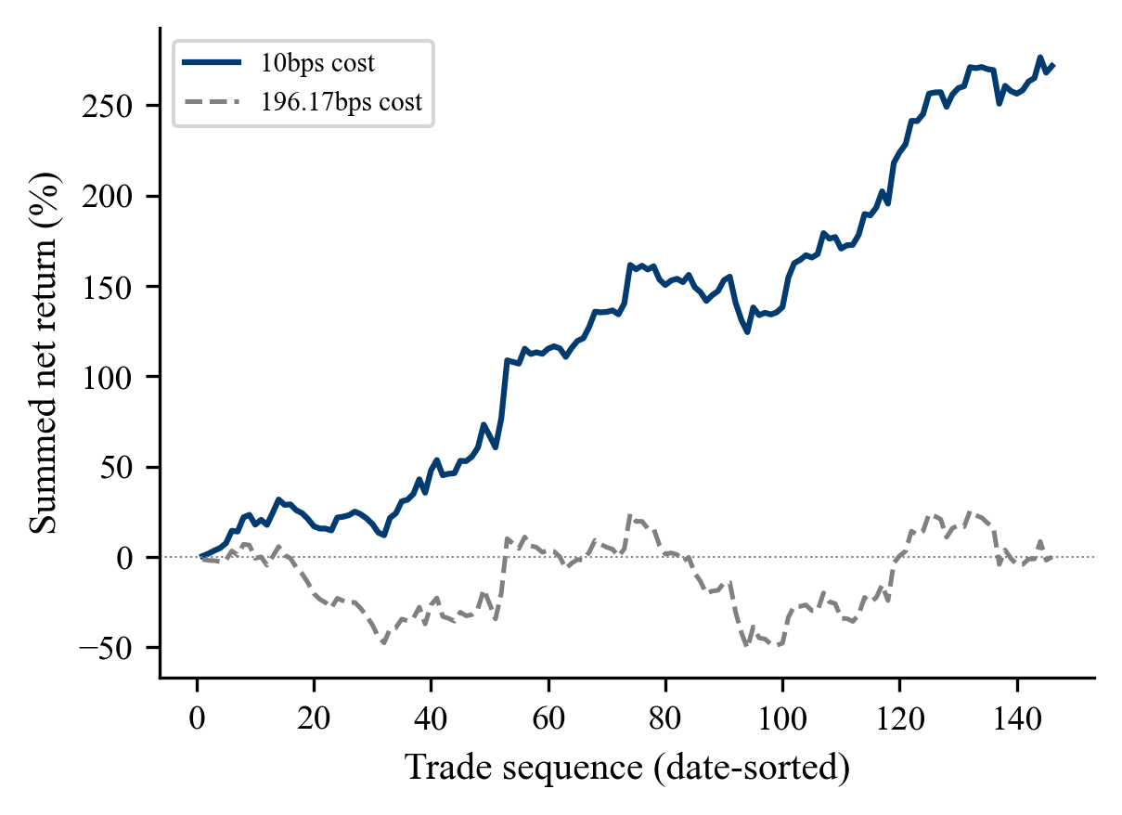
Figure 1. Running sum of net return per trade across the 146 traded frozen events in date order, at the 10 basis point cost assumption and at the 196.17 basis point break-even. This is an arithmetic running sum and not an account balance, because positions overlap when issuers report in the same week. At the break-even cost the series spends most of its length below zero and ends flat.
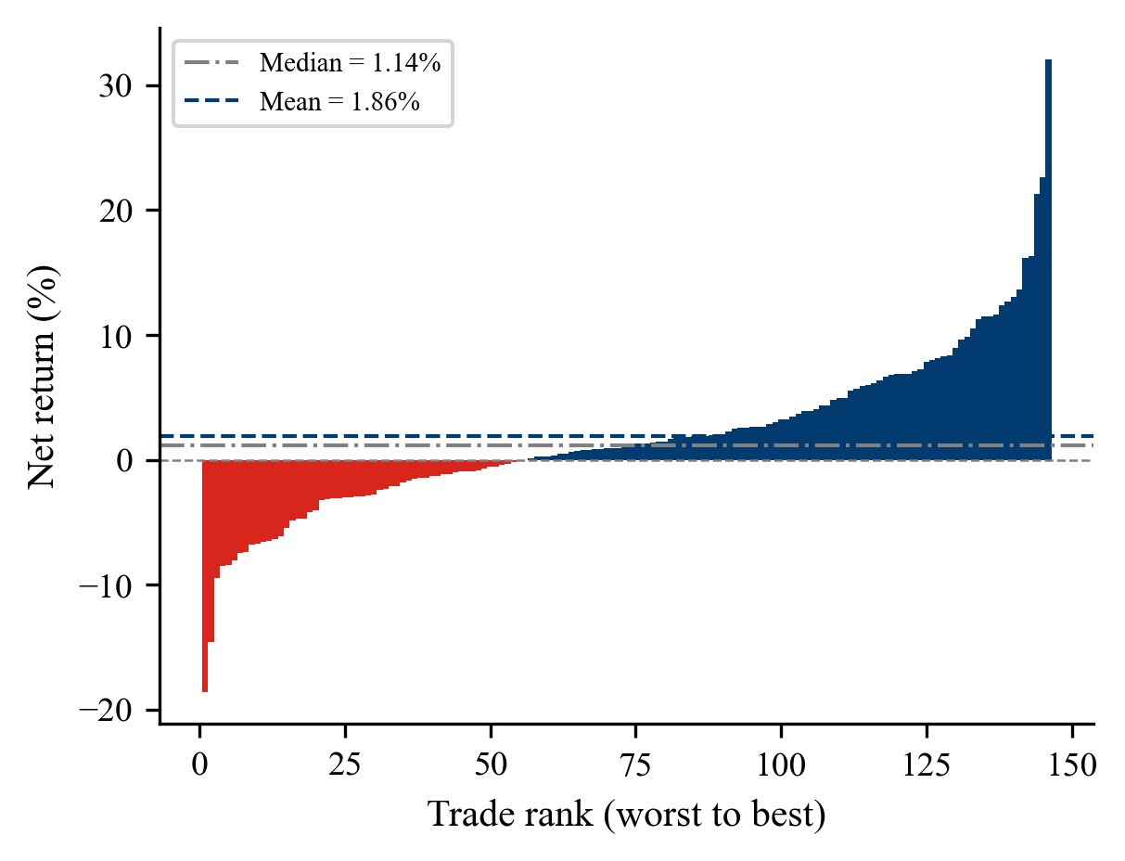
Figure 2. Net return for each of the 146 traded frozen events, ranked worst to best. Colour encodes the sign of the return, red for a loss and navy for a gain, and not the arm. Fifteen losses exceed 5% and two exceed 10%.
Desks ask about cost first. One basis point is 0.01%, so the 196.17 break-even is 1.96% of position value across both legs, about 196 dollars on a 10,000 dollar position against 10 at the stated assumption. The more conservative reading takes the lower bound of the interval rather than the mean and reaches zero at 108 basis points. Both are arithmetic about how much room the edge has, for the reason given in section 2.3.
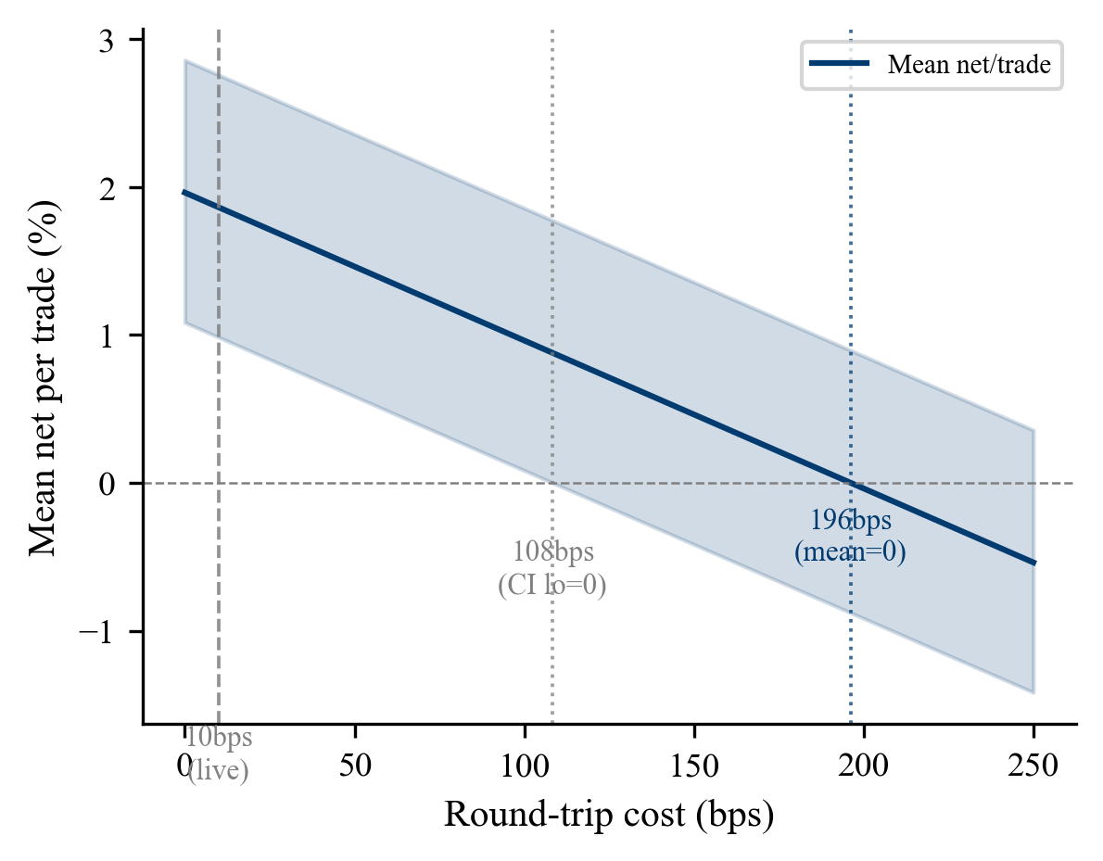
Figure 3. Mean net return per trade against round-trip trading cost, frozen set, with the 90% bootstrap interval shaded. The mean reaches zero at 196 basis points and the lower bound at 108. The 10 basis point assumption is marked at the left.
Beating a naive way of making money matters as much as beating a naive way of being right. An always-BUY rule on the same 146 events returns minus 0.231% per trade with an interval spanning zero. That is a profit-and-loss floor, a different comparator from the always-DOWN accuracy floor in section 3.3, answering a different question on a different denominator.
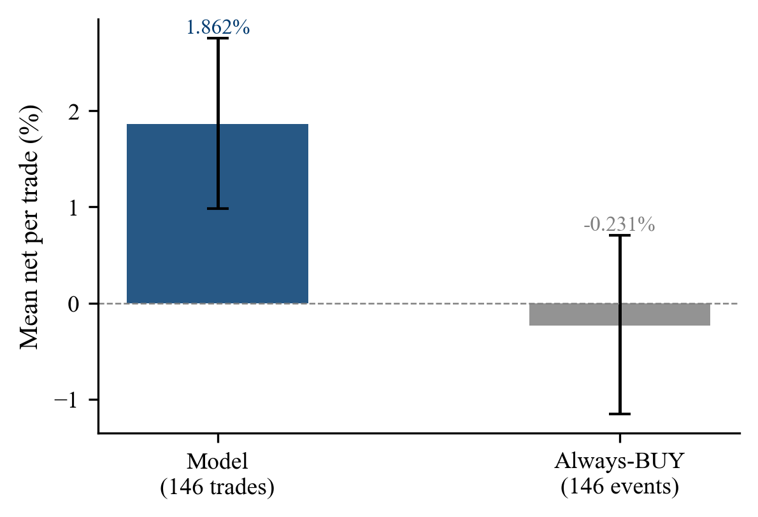
Figure 4. Mean net return per trade for the model against an always-BUY rule on the same 146 events, with 90% bootstrap intervals.
Where the money sits is the most commercially interesting pattern in the study and the one most in need of restraint. Accuracy and profit both rise sharply with the size of the realised move, from 58.1% and 0.34% per trade on the 43 events moving 2 to 5%, through 63.9% and 1.92% on the 36 moving 5 to 10%, to 87.5% and 11.45% on the 16 moving more than 10%. Sixteen events cannot carry a strong claim, and the size of a move is not knowable when the decision is made, so this is a reason to weight a call and not a rule for placing one.
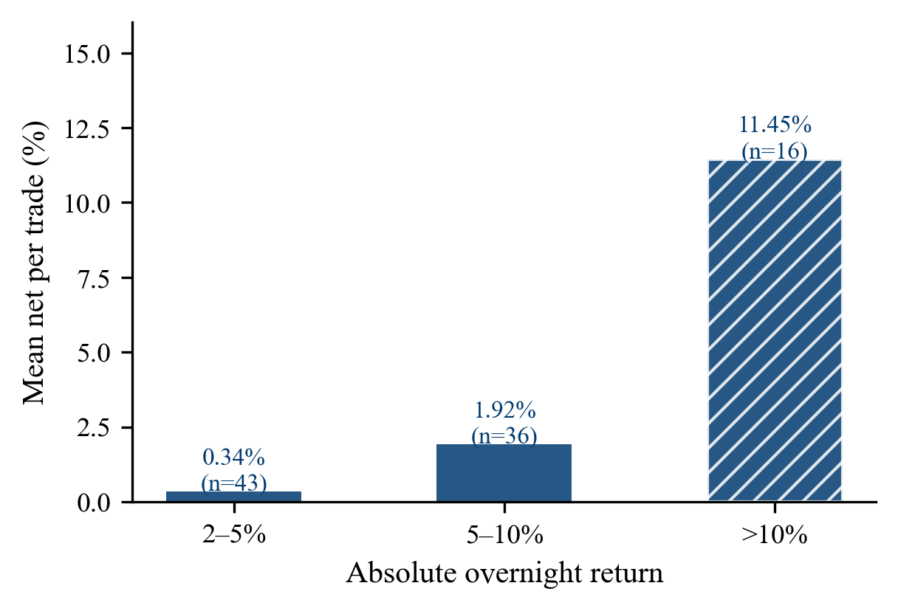
Figure 5. Mean net return per trade by absolute size of the realised overnight move, frozen set. The hatched bar marks the bucket whose sample is too small to carry a strong claim.

3.2 The reading carries information
The primary threshold-free result is a Spearman rank correlation of 0.236 between the model’s blended score and the realised overnight return at p equals 0.0003, across all 233 clean frozen events. It needs no threshold, no band and no selection, which makes it the only headline clean of the qualification attaching to everything else.
Correlation falls monotonically as the holding period lengthens, from 0.236 overnight to 0.159 at one day, 0.112 at three, 0.072 at five and 0.058 at ten, by which point p is 0.380. Significance stops early. The relationship is measurable overnight and at one day, at p equals 0.0003 and 0.015, and is indistinguishable from noise from three days onward. Two intervals reach the zero boundary over the same span, though they are different quantities and neither belongs to the other. The Fisher-z 90% interval on rho has a lower bound of 0.004 at three days and 0.036 at five. The bootstrap interval on mean net per trade has a lower bound of 0.03% at three days and crosses zero by five.
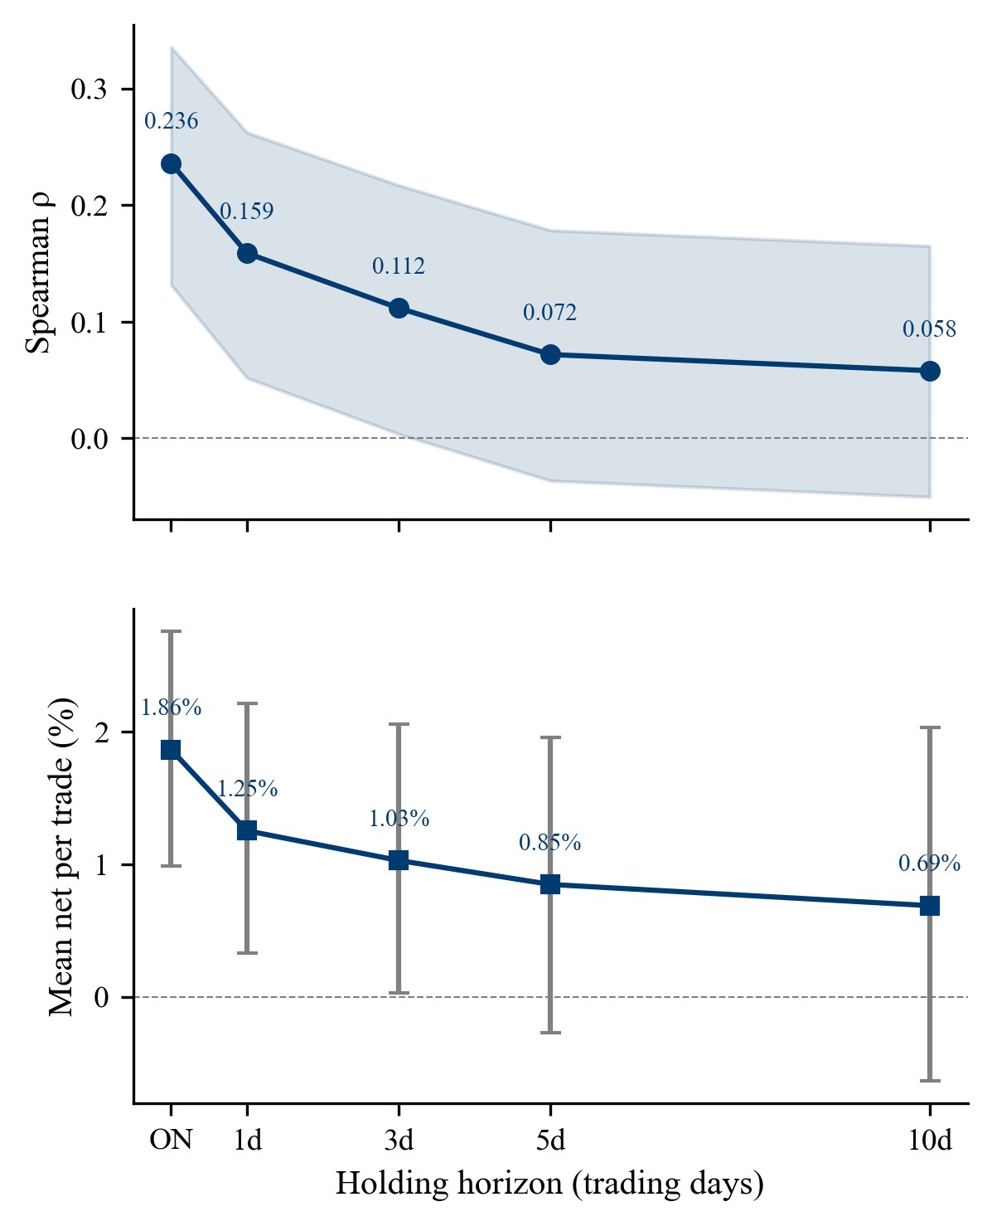
Figure 6. Rank correlation and mean net return per trade against holding horizon, frozen set, with 90% intervals. Upper panel Fisher-z on rho, lower panel bootstrap on mean net per trade. The two are separate quantities and an interval on one is not an interval on the other.
That shape matters more than the level. A reading which tells you something about the market’s reaction to a document ought to lose force as unrelated news accumulates, and it does. A signal persisting or strengthening over ten days would be describing something other than the document. Decay validates the overnight window empirically rather than by assumption, and it means a desk holding longer gives the advantage back. One caveat belongs with it. The grading band widens with horizon to preserve the overnight threshold in proportional terms, so the graded set is not identical across horizons, and the ten-day figure rests on a set that drops mean-reverting events and admits late drifters.
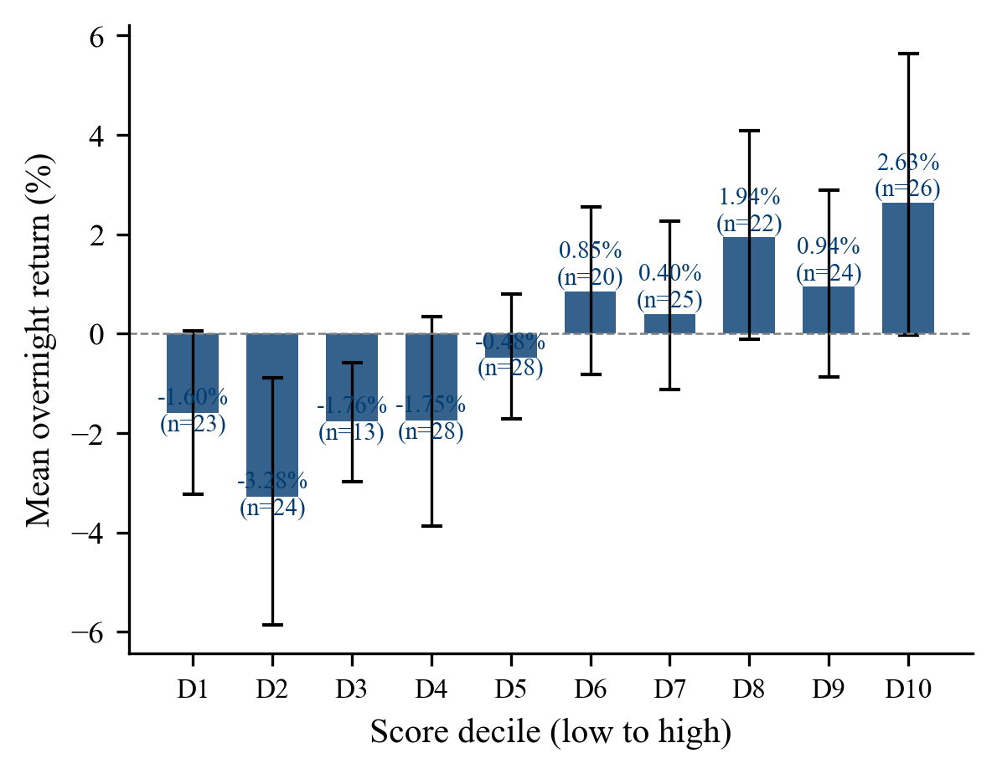
Figure 7. Mean overnight return by model score decile, frozen set, with 90% bootstrap intervals. The pattern is broadly increasing rather than strictly monotonic, with the seventh decile below the sixth and the ninth below the eighth, and most intervals crossing zero. That is what a rank correlation of 0.236 looks like cut into ten bins, and the overlap is the point rather than a defect. Bin counts range from 13 to 28.

3.3 Accuracy, the two denominators, and what the headline is measuring
Only 95 of the 361 documents read produced a gradeable outcome, because grading requires both a committed direction and a move greater than 2%. Every accuracy claim rests on those 95 in the frozen set and 14 in the extension.
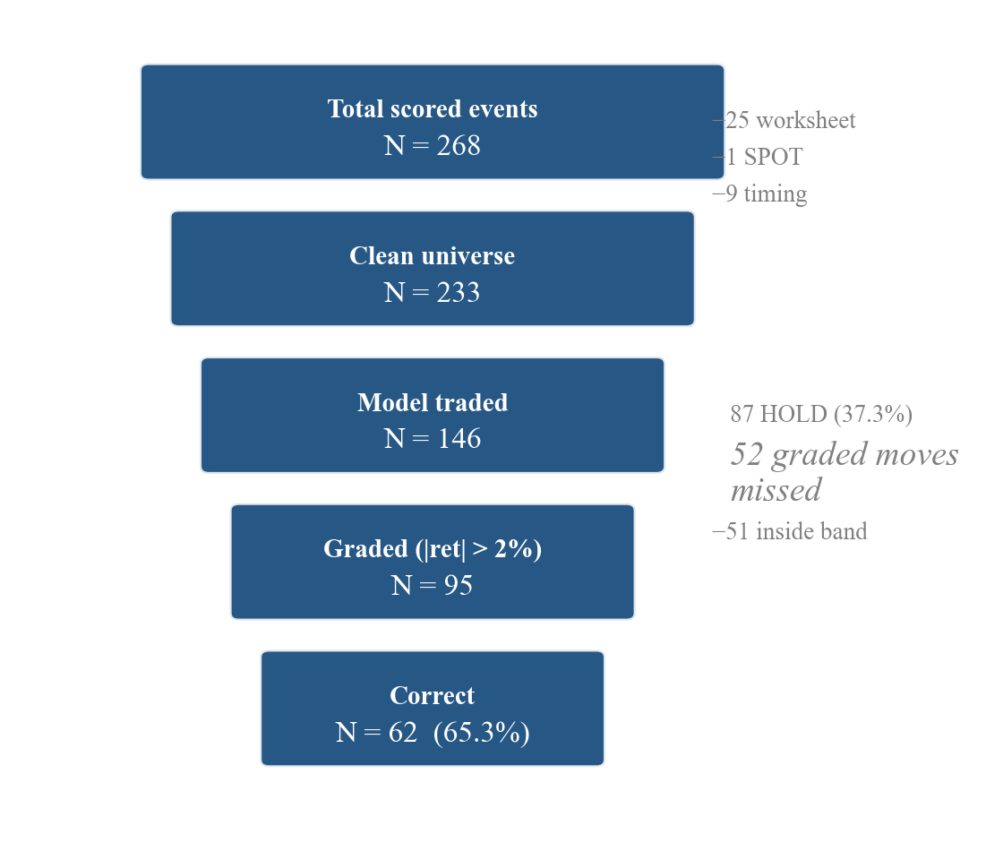
Figure 8. The funnel from 268 scored events to 62 correct calls on the frozen set. The HOLD limb carries 87 events, of which 52 moved more than 2%.
Table 2. The two accuracy conventions on identical predictions, frozen set.
 | Selectivity | Coverage
Question asked | Was the model right when it committed? | How much of the available direction did it capture?
Numerator | 62 correct | 62 correct
Denominator | 95 graded events | 147 events that moved more than 2%
Accuracy | 65.3% | 42.2%
Matched always-DOWN floor | 54.7% | 54.4%
Margin over floor | +10.5 points | −12.2 points
Significance | p = 0.024, MDE 10.8 points | Below floor
Treatment of HOLD | Excluded | Counted as a miss
Source: author’s analysis. Both columns describe the same 62 correct calls and differ only in the denominator.
Reported alone the first makes the system look selective and accurate and the second makes it look like it missed most of what was there. Both are true and the system is both, and the incompatibility of these conventions across the literature is why published results are so hard to compare.
A rival reading of the headline deserves stating, because it is the first objection a careful reader will raise. On that reading, 65.3% is not evidence that the model reads well but an artefact of which events reach the denominator. The thresholds decide when the model commits, so they decide which events are graded, and if they happen to select large unambiguous moves the accuracy would be high whatever the reading behind it. Three pieces of evidence bear on it and they do not all point the same way. Accuracy rises steeply with the size of the realised move, from 58.1% on the smallest graded bucket to 87.5% on the largest, so selection towards large movers would inflate the figure. Against that, the rank correlation is computed on all 233 events with no threshold. And the cross-issuer subset in section 3.4, on events the threshold sweep never saw, returns 63.5% against a 51.9% floor. The defensible conclusion is partial. Selection inflates the headline while the threshold-free correlation shows something surviving underneath, so 65.3% is the performance of a system that chooses when to speak rather than the accuracy of its reading.
A narrower version of the same objection is answered by the band sweep. The 2% band was fixed before grading but the HOLD thresholds were not, so the concern is that the reported accuracy reflects a favourable cut. Regrading at every band from 0 to 5% tests it. Accuracy rises monotonically from 62.8% to 71.2% as the band widens and the graded count falls from 145 to 52, with mean net per trade rising from 1.88% to 4.85%. The band actually used sits low on that curve, so the choice made cost accuracy rather than manufacturing it, and the shape holds at every threshold tested.
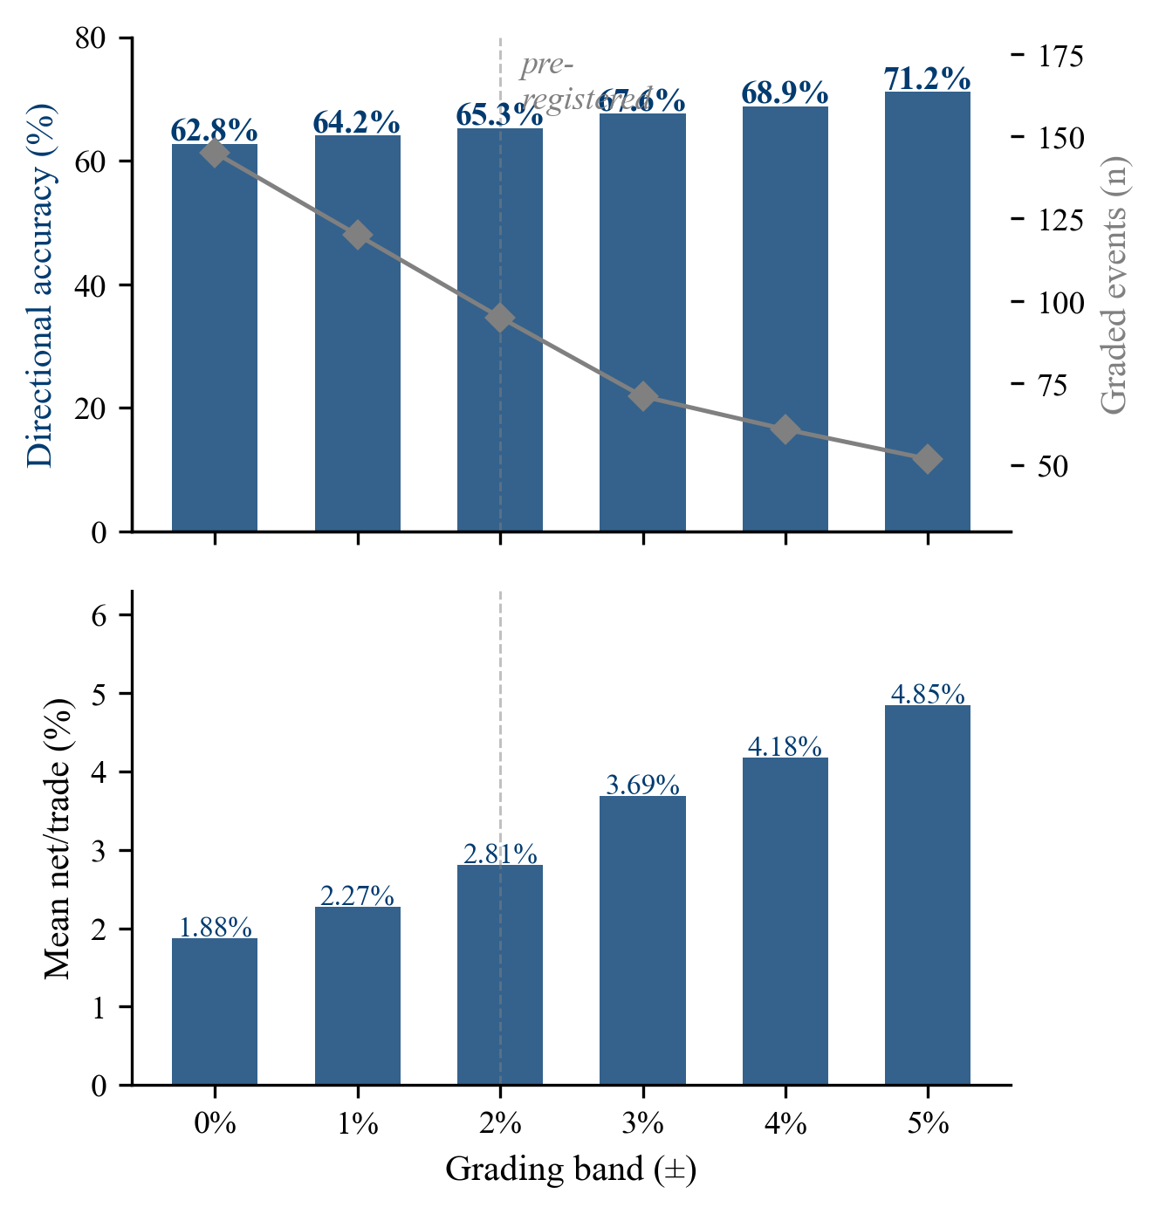
Figure 9. Neutral band sweep, frozen set, strict inequality convention. Upper panel, bars show directional accuracy on the left axis and the grey line shows how many events remain gradeable on the right axis. Lower panel, mean net return per trade at each band. The dashed vertical marks the 2% band used for grading throughout.

3.4 The decision layer does not survive honest replication
Thresholds were fitted on the full dataset with every event visible. Refitting them honestly, on windows using only events preceding the ones being predicted, is the test that matters, and it fails under both objectives tried, in two different ways.
Maximising mean net per trade fails structurally. It selects the same near-zero-trade thresholds whether trained on 203 events or 321, because an objective rewarding return per trade is drawn towards trading almost nothing, and that will not become estimable by adding data.
Maximising directional accuracy is sample-limited rather than broken. It improves from two degenerate windows to one as the sample grows from 233 to 326, and its pooled record clears its floor by 14.6 points. Full non-degeneracy would plausibly need 400 to 500 events, an extrapolation from two points. Two things must not be overstated. All 326 events had been seen before this analysis ran, so it is retrospective validation rather than out-of-sample, and the pooled minimum detectable effect is roughly 30 points against an observed gap of 14.6.
A reconstructed cross-issuer subset, assembled after the fact to stand in for a holdout the project never set aside, offers the only genuinely unseen figure available. 101 events across 29 issuers with no issuer overlap give 33 of 52 correct at 63.5% against a 51.9% floor, a margin of 11.5 points at p equals 0.063. Sweep membership is inferred rather than recorded, the two subsets are interleaved in time so issuer and time effects cannot be separated, and p does not clear 0.05. It is suggestive and not evidence of generalisation.
This pattern is what the backtest-overfitting literature would predict. Where a rule is selected on the same sample it is then evaluated on, the reported performance is a maximum over many specifications rather than an estimate of any one of them, and the gap between in-sample and replicated performance widens with the number of configurations tried (Bailey et al., 2014, and Harvey, Liu and Zhu, 2016). The conclusion this supports is narrow and useful. The score carries information independently of any threshold. The procedure converting that score into a call cannot be executed honestly at this sample size.

3.5 The model against the human arm
Table 6. Model against the human arm on events where both committed to a direction, frozen set.
Comparison | Human | Model | Difference | p | MDE | n
Direction-only, both committed | 57.9% | 60.5% | +2.6 points | 0.750 | ±22 points | 76
Against always-DOWN floor 55.3% | +2.6 | +5.2 | — | — | — | 76
SELL calls | 73.9% (23) | 65.0% (40) | — | — | — | 63
BUY calls | 50.9% (53) | 55.6% (36) | — | — | — | 89
Hold rate on the paired set | 23.4% | 40.4% | — | — | — | 171
Cohen’s kappa between arms | 0.109 |  | CI 0.030 to 0.190 | — | — | 171
Source: author’s analysis. Human figures are aggregates across six raters and no per-rater ranking is reported.
Neither arm clears the floor by a testable margin and the gap between them is untestable rather than absent. Two things complicate reading it as a gap at all. Excluding flat outcomes rewards whichever arm holds more often, because a hold on an event that barely moved is never counted against it. The model holds on 40.4% of events against the human arm’s 23.4%, so the exclusion lifts the model by 29.7 points and the human arm by 22.6, handing the model 7.1 points before either arm is read. The observed gap is 6.3 points, so the apparent advantage is smaller than the bias the metric introduces.
Cohen’s kappa, which measures agreement between two raters after subtracting the agreement expected by chance (Cohen, 1960), is 0.109 on 171 paired events, with observed agreement of 38.0% against 30.4% expected. On the conventional interpretive bands that is slight agreement at best (Landis and Koch, 1977). The two arms are close to independent, which matters twice over. It gives no reason to expect their agreement to carry information, the assumption behind the retracted agreement filter. And near-independent readers are precisely the case where combining them might add what neither adds alone.
Why the human arm performs as it does admits two readings, and the evidence favours one. The first attributes it to the raters, six part-time non-specialist readers working under time pressure with self-selected issuers, which would make the result a statement about this panel rather than about human reading. Per-rater profit spans plus 2.17% to minus 3.23%, consistent with uneven skill. The second attributes it to the corpus. Both arms read documents the issuer wrote and released, and if managed disclosure bounds what any reader can recover, then a model and a panel reading the same material should fail in similar ways. Three observations favour the second. Both arms clear chance on SELL and neither clears chance on BUY, the same asymmetry in both. Both are insensitive across information sets, the model across four document arms and the human arm across seven. And the model, reading identical documents with none of the raters’ constraints, lands within 2.6 points of them. Two near-independent readers at kappa 0.109 failing the same way is better explained by a shared ceiling than by both being weak in the same direction. The rater explanation is not eliminated, since the per-rater spread is real, but it cannot account for the model matching the panel it was meant to outperform.

3.6 Baselines, cost and speed
Table 5. Baseline comparison under the coverage convention, frozen set.
Method | Frozen | Extension | Combined | Note
Majority direction (floor) | 54.6% | 48.4% | 53.3% | Always predicting the majority realised direction
Deployed model | 42.9% | 32.3% | 40.7% | HOLD counted as a miss
FinBERT | 34.5% | 38.7% | 35.3% | Finance-tuned transformer classifier
Loughran-McDonald | 15.1% | 9.7% | 14.0% | Word-count sentiment dictionary
Graded n | 119 | 31 | 150 | Denominator for the column above
Source: author’s analysis. The coverage convention applies throughout, so these figures are comparable with the model’s 42.9% and not with its 65.3% selectivity headline.
No method clears the majority-direction floor, a real and unflattering result about the whole approach. The reversal is the interesting part, because the transformer sits below the model on the frozen set and above it on the extension. That is not better reading of unfamiliar sectors, since it called SELL on 2 of 93 extension events while trading 71% of them against the model’s 34.4%. Both fall below the floor by opposite mechanisms, one overtrading and one holding, which locates the failure in the decision layer of each and not in the reading.
Table 4. Section ablation, frozen set. Four arms read the same events.
Arm | Graded n | Accuracy | Cost per correct call | Mean tokens
Full bundle | 47 | 68.1% | $0.0358 | 30,096
Press release only | 37 | 64.9% | $0.0225 | 13,030
Prepared remarks only | 41 | 63.4% | $0.0208 | 10,287
Question and answer only | 38 | 68.4% | $0.0229 | 13,163
Source: author’s analysis of the section ablation outputs. Accuracy differences sit inside a paired minimum detectable effect of roughly 12 points.
A fifth guidance arm proved mechanically infeasible, because forward guidance is not a structurally separate section in any observed document. Prepared remarks alone agree with the full bundle on 85.7% of events at 42% lower cost per correct call. Full bundle wins by 6.8 points over the press release at p equals 0.055, and almost entirely by trading 17 events the press release passes on, so extra context buys willingness to act rather than better calls. One result bears on the information set, since the less scripted question and answer session reads highest of the four arms, well inside sample noise but pointing where the managed-disclosure argument predicts.
On speed, across 624 calls the median latency is 15.00 seconds against a human arm averaging 29.8 minutes per document, a per-document multiple of 103 to 138 times. Per correct directional call the multiple falls to about 65 times, the fairer comparison because the model holds more often and so produces fewer correct calls per unit of time.

4. What the checks found
This section reports two figures and refuses a third. Four inoperative-check instances, enumerated by the project’s corrections log. Six retracted findings. No total fault count, because the wider audit found faults not sharing the signature and one number spanning both schemes would mean neither.
The pipeline arrived complete, with headline results already recorded. The first planned extension required verifying the measurement window against an independent price source, and that check failed. Everything here followed from it.
Faults group by mechanism. The entry anchor family shares one root cause, the timing convention settled in planning and never implemented, which shifted the anchor on 82 events once corrected and which verification compounded, since 50 of 235 United States events, 21.3%, carried a stored report date disagreeing with the verified release. The contamination family centres on a prompt assembler with no document-type filter, which for 25 events, 9.3% of the dataset, fed the model a rater’s completed worksheet carrying their directional call and the realised move. Re-scoring those 25 with the filter active changed 12 predictions, 48%. The metric family holds a compounded profit figure that changed when the sort order changed, a reported Sharpe ratio that was a t-statistic by construction, and a naive baseline on the wrong denominator, which alone moved the headline margin from roughly 26 points to 10.5 with no accuracy changing.
Stated once, the signature is simple. In four instances a safeguard was visibly present and silently inoperative. The list is exhaustive.
Table 7. The four inoperative safeguards.
Artefact | Mechanism | Why nothing failed loudly
A constant naming the pre-market issuers | Read by no code path | The uniform anchor produced plausible returns
A block of manually re-priced values in the workbook | Referenced by no formula | The published cells drew from the original block
A standalone verification script | Crashed on its first input on every invocation | The failure was never surfaced to a caller
An ensemble consistency path | Command-line default was a single run, never overridden | A default is not a mistake and reads as deliberate
Source: the project’s corrections log, which enumerates each instance with its mechanism and the date it was found.
All four were non-executing from inception. Not one was a control that worked and later broke. They never ran at all, nothing ever failed loudly, and every one produced output that looked correct. Other faults found across the audit are not members, and the ticker-identity faults are excluded on the log’s own criterion, because the check there executed and caught them before scoring, the opposite of the signature.
Six findings were retracted. Four share the entry anchor as their cause, one is a comparator error and one was never a result at all. The agreement filter deserves the note, because it was the project’s headline, holding that the model was accurate on 56.1% of events where the arms agreed against 42.9% where they disagreed. It appears only as prose in the implementation specification, described there as already computed, and no script or output producing it exists on any branch. Measured on the stale anchor it showed 17.3 points at p equals 0.029. On the corrected anchor it is absent, at 0.3 points with p equals 0.959, because the stale anchor had compressed returns for 82 pre-market events and pushed most inside the band. A kappa of 0.109 predicted exactly that.
Two observations generalise. Checking that a mechanism exists is not the same as checking that it runs, so closing that gap requires evidence of execution, an output file with a timestamp and a row count, rather than evidence of intent. And the four sat in four different kinds of artefact, so a review organised around where controls are expected to live would have found all four present and stopped.

5. Discussion

5.1 Reading and deciding
This study asked whether a language model reading financial documents produces judgements accurate enough to be relied on, and under what conditions. The answer separates into two parts, and keeping them apart is what makes it usable.
Reading carries information. A model reading an earnings document arrives at an ordering of events having something to do with how the market subsequently ordered them. That relationship is modest, it is fragile, and it is there.
Converting a score into a call does not survive. That step rests on thresholds fitted in sample against an objective since retired, and refitting them honestly degenerates under both objectives tried.
Reading and deciding are separable, and only one of them works here. It is worth being precise about what that does not say. It does not say the model cannot trade. It says this study cannot demonstrate that it can, because the demonstration requires a calibration step the sample size does not support. Nor does it say the answer is simply more data, since more data addresses one failure mode and the mechanism behind the other suggests it will not.
One question the brief asked cannot be answered here. Its fourth aim concerns whether analyst overrides improve outcomes, and the analysis that would have tested it was the agreement filter, retracted at 0.3 points with p equals 0.959. The question stays live for a specific reason, because a kappa of 0.109 makes the two arms near-independent readers and near-independent readers are precisely the case where combining them might add what neither adds alone. This study establishes the precondition for a combination test without being able to run one.

5.2 What an institution should actually run
Four things follow for anyone deciding what to deploy, ordered by how much money rides on them.
Start with the cost the signal can absorb. Mean net return is 1.86% per trade across 146 trades and reaches zero at a round-trip cost of 196 basis points, or 108 on the lower bound, against the 10 assumed. That is roughly ten times the assumed cost on the conservative measure. This is arithmetic about how much room the edge has and not evidence it clears a real one, for the reason given in section 2.3.
Cheaper reading reproduces expensive reading. Prepared remarks alone agree with the full bundle on 85.7% of events at 42% lower cost per correct call. The accuracy difference sits inside a paired minimum detectable effect of roughly 12 points, so the full bundle cannot be shown to be better, while the cost difference is not in doubt because it is a property of the documents. What the full bundle buys is commitment rather than quality.
The cheapest read produced the worst calls, and this qualifies every efficiency argument above. Raters working from the guidance section alone took 18.7 minutes per document against 29.8 for a full document and scored 15.0% coverage and 17.6% selectivity against floors above 50%. That is the fastest condition in the human arm and by a wide margin the least reliable. A reader working that way gets no signal that it is going badly, because an outlook section reads as sufficient on its own and produces a confident directional view without the evidence needed to size it. Cheaper is not uniformly safe, and where the saving comes from dropping evidence rather than dropping redundancy it reverses.
Speed supports the case without carrying it, at about 65 times per correct directional call. A replay-mode interface was built as a proof of concept, running against stored results with no live API calls. What matters is not that it works but what the evaluation forced it to withhold. It surfaces the continuous score and the screened evidence quotes, and it shows no confidence percentage attached to a directional call, because nothing here would let such a number be calibrated honestly and a figure that looks calibrated and is not is worse than none.
[INSERT FIGURE: prototype interface screenshot, showing the continuous score and evidence quotes surfaced and the confidence figure withheld.]
Table 8. Delivery against the brief’s five specific aims.
Aim | Status | Where, and what is missing
1. Design and implement an LLM-powered data product | Delivered by the group | Section 2.4, with the replay interface in 5.2
2. Evaluate accuracy, robustness and cost-efficiency | Two of three | Accuracy in 3.3, cost in 3.6. Robustness not evaluated, since the ensemble path never ran and every event was scored once
3. Evaluation frameworks for sentiment, risk signals and forward guidance | One of three | Sentiment as the rank correlation in 3.2. Risk signals not evaluated. Forward guidance mechanically infeasible
4. Human-in-the-loop design to augment analyst workflows | Not tested | The analysis that would have tested it was retracted. Precondition reported in 3.5
5. Practical deployment considerations | Partial | Sections 2.6, 5.2 and the cost figures. No cited desk cost, so it stops short of a deployment case
Source: aims as stated in the industry partner brief. Three of the gaps share a cause, since the audit work in Section 4 consumed the time allocated to robustness testing, risk-signal evaluation and the qualitative comparison of the structured summary.

5.3 Limitations
Thresholds. The HOLD thresholds were fitted in sample against an objective since retired. Every threshold-dependent figure inherits this, and so does the graded denominator, since the thresholds decide which events are graded. Only the rank correlation is clean of it.
Sample size. 361 documents were scored and every accuracy claim rests on 95 graded events in the frozen set and 14 in the extension. Minimum detectable effects run from 10.8 points to 31.6, so most comparisons here are underpowered, and an underpowered study that does report a significant effect is more likely to have overstated its size than a well-powered one (Button et al., 2013). That distinction is drawn each time it matters.
No pre-registration. Two decisions were taken before grading and neither is recorded in a dated artefact, so the report avoids the language of pre-registration and treats every result as exploratory.
The information set. Both arms read documents written and released by the issuer, so both were reading managed disclosure rather than neutral evidence. Earnings releases and prepared remarks are selected for emphasis by the company, which bounds what any reader working from them can recover.
The grading band. The 2% band is strict, in the sense that a reader whose directional view was right on an event moving less than 2% receives no credit, and a HOLD on an event that moved counts as wrong under the coverage convention. The band sweep in section 3.3 shows what a wider choice would have done. Arguing after the fact that the band was too strict would be arguing against a rule set in advance, so the sweep is reported instead of the argument.
Human arm conventions and protocol compliance. Raters were allocated issuers by self-selection, which confounds rater familiarity with issuer difficulty, and most events carry a single reading so no inter-rater agreement figure is available. The protocol specified the same band and substantially the same bundle for both arms and compliance was not audited, with 2.00% and 1.00% both appearing in individual worksheets. Nothing reported here is affected, because both arms are regraded from one returns matrix at one band, but worksheet-internal correctness flags cannot be pooled and none are used. My own readings followed the protocol throughout.
Robustness and provider dependence. Output stability across repeated reads was never measured, so nothing is known about how consistent this system is when asked the same question twice, and section 2.6 sets out why a single hosted provider makes that harder to establish rather than easier.
Cost. No externally cited desk cost exists, so no claim about clearing realistic trading costs is available.

6. Conclusions and further research
This study asked whether a language model reading earnings documents produces judgements accurate enough to act on, and the answer comes in two parts that do not point the same way.
The reading carries information. Across all 233 frozen events the rank correlation between score and realised overnight return is 0.236 at p equals 0.0003. That figure needs no threshold, no band and no selection of which events to count, which makes it the only headline clean of the qualification attaching to everything else. It decays monotonically, reaching the zero boundary at three days and falling to 0.058 by ten, and its significance stops after one day. An information-driven signal should behave that way, and the decay validates the overnight window empirically.
The money is real and the room is wide, and the rule that captured it is not trustworthy. Mean net return is 1.86% per trade across 146 trades, the edge absorbs 108 basis points of round-trip cost on the conservative measure against 10 assumed, and 38.4% of trades still lose money. But the thresholds were fitted on the same data the results were measured on, and refitting them honestly degenerates under both objectives tested. Every accuracy and profit figure inherits that, and only the correlation does not.
The effective sample is much smaller than the corpus. 361 documents were scored and every accuracy claim rests on 95 graded events in the frozen set and 14 in the extension, at which sizes most comparisons here are underpowered rather than settled.
What it took to establish any of this is the part most likely to transfer. Four safeguards existed, appeared to be in force and never executed, each in a different kind of artefact, and six previously reported findings were retracted, four sharing a single measurement error as their cause. That record is not incidental to the results. It is why the surviving results can be relied on to the limited extent claimed.

6.1 Further research
Sample size for the decision layer specifically. The walk-forward analysis suggests directional-accuracy threshold selection becomes estimable somewhere around 400 to 500 events. That is a testable proposition, testing it needs only more events, and it is the single most useful next step.
Output robustness, which this study designed for and never measured, and which section 2.6 argues is harder to establish against a hosted model that can change without notice. A second provider would separate architecture from model and is the obvious first control.
Risk-signal extraction and the structured summary. Neither was evaluated, both are auditability outputs, and the fragmentary evidence available points away from the model, so both are worth testing against a human reader on a designed comparison.
Whether combining the arms helps. Section 5.1 sets out why this study cannot test it and why the near-independence of the arms keeps it open. A designed combination test on a larger sample is the obvious extension of the human-in-the-loop aim, and the one direction the brief asked for that this work leaves unaddressed.
A direction-only convention. Comparing only the sign of each arm’s continuous score against the sign of the realised return, ignoring the band, would separate errors of reading from errors of discretisation. That was not computed here and it is cheap to add.
One closing observation. A study reporting a 21.3% anchoring error, a 48% contamination effect and four mechanisms that never ran produces a smaller and more heavily qualified set of claims than the version preceding it. For an institution deciding what to deploy, that is the more useful document.

Data availability and supporting documentation
All data underpinning this project is submitted alongside this document and is available to the supervisor and examiners. The model entry record, human arm worksheets, derived metrics and figure data are held in the project workbook. The analysis pipeline, the prompt specification, the returns matrix, the calibration files and every output cited here are held in the group repository at the tagged commit corresponding to the analysis reported. Price data is drawn from public market sources as described in section 2.2, and release timestamps from SEC EDGAR filings and home-exchange announcements. Documents scored by both arms are public issuer disclosure and no non-public information was used. Figures were generated from the committed outputs and the scripts producing them are included. [CHECK before submission: confirm exactly which files are being submitted, name the repository tag, and confirm with the supervisor whether the workbook, the code, or both are required.]

References
[TO BE COMPLETED. Cite Them Right Harvard, alphabetical by author. Verify every entry against the source before including it. See the note below on what each citation is doing in the text.]

Appendix A. Definitions and conventions
Event. One issuer reporting one quarter, together with the documents released for it.
Traded and graded. An event is traded when the model committed to BUY or SELL rather than holding. It is graded when it was traded and the realised move breached the band, so both conditions must hold before a call can be marked right or wrong.
Minimum detectable effect. The smallest true difference this design could distinguish from zero at 80% power. It is the reason a non-significant comparison here is underpowered rather than null.
Price convention. Prices are unadjusted, taken from the home listing for locally listed issuers and from the New York listing for depositary receipts. Returns are computed both raw and in excess of SPY and grading uses the raw series throughout. The two disagree on 15 of 254 events, 5.9%, clustered in stressed months.

Appendix B. Findings held outside the main text
Directional asymmetry and rater rationales. Management tone is cited in 38% of SELL rationales against 17% of BUY ones. The human arm called BUY on 56.1% of events against the model’s 24.6%. Rater optimism is the obvious reading and the notes cannot settle it, because earnings documents carry positive framing even for mixed results.
Evidence integrity. A check of 174 quotes across 26 human worksheets found 172 exact matches, against the model’s 267 of 272 with one confirmed fabrication. On the auditability criterion the brief names, the human arm comes out ahead.
The extension as a second test. Extension accuracy is 71.4% on 10 of 14 graded events, but the Wilson interval runs from 45.4 to 88.3%, the test against the frozen figure gives p equals 0.649 and the minimum detectable effect at 14 events is 31.6 points against an observed difference of 6.1. What it does show is a coverage failure, since 93 events produced only 14 gradeable outcomes against an expectation of about 40.
The anchor correction did not flatter the result. The overall hit rate moved from 62.0 to 61.4%. What changed was composition, since under the old convention 25 of 27 pre-market trades bucketed as flat while corrected they produce 17 correct, none flat and 10 wrong. A fault producing flat outcomes gives a reviewer nothing to notice, and that is why it lasted.

