[TITLE NOT SETTLED — working title: Can AI Read the Markets? Reading and Deciding in an LLM System for Earnings Documents]
Nigel [SURNAME]
This project is submitted as part of the requirements for the award of the MSc in Business Analytics
Supervisor: Dr Ahmad Abu-Khazneh
September 2026

Table of Contents
Abstract 1
Executive summary 1
Acknowledgements 1
1. Introduction 1
1.1 The problem 1
1.2 Research questions and stated expectations 1
1.3 Related literature 1
1.4 Operational definitions 1
1.5 Contribution and scope 1
2. Data and methodology 1
2.1 The corpus and the three event sets 1
2.2 The measurement window and the release-timing rule 1
2.3 The band, the cost assumption and the price convention 1
2.4 The model arm 1
2.5 The human arm 1
2.6 The baseline arm 1
2.7 The funnel and the effective sample 1
2.8 The statistical approach, and what non-significance means here 1
3. Findings 1
3.1 The model’s reading carries rank information, and it decays 1
3.2 Accuracy, which cannot be reported one way 1
3.3 Where the accuracy sits, and what happens when the band moves 1
3.4 Profit and loss, and its distribution 1
3.5 The decision layer does not survive honest replication 1
3.6 The model against the human arm 1
3.7 The baseline frontier, and two ways of failing 1
3.8 Section ablation, cost and speed 1
3.9 The extension, and a coverage failure specific to unfamiliar sectors 1
4. What the checks found 1
4.1 What failed, and the four that never ran 1
4.2 Six retracted findings 1
4.3 What this implies for evaluation practice 1
5. Discussion 1
5.1 Reading and deciding 1
5.2 What an institution should actually run 1
5.3 The prototype, and what its constraints reveal 1
5.4 Limitations 1
5.5 Three of the brief’s four outputs went unevaluated 1
6. Conclusions and further research 1
6.1 Further research 1
References 1
Appendix A. Citations to verify 1
Appendix B. Supplementary figures 1

Full draft for hand annotation. Ten highlighted markers are unverified and must be resolved before submission. Confidentiality status is unconfirmed, so this document is not yet marked CONF_.

Abstract
[97 words, spec 80 to 100]
This study evaluates whether a large language model reading earnings documents produces directional judgements reliable enough to trade on. A model arm scoring 233 events is graded against the realised overnight price move and compared with six human raters reading the same corpus blind. Across 146 trades the mean net return is +1.86% per trade, and the edge survives round-trip costs up to 108 basis points on the conservative measure against the 10 assumed. The underlying score correlates with the overnight return at rho 0.236, yet the threshold layer converting that score into a trading call degenerates under honest walk-forward refitting. Reading and deciding prove separable, and only reading survives.

Executive summary
[464 words, spec 400 to 500]
A language model can read a forty-page earnings release in about fifteen seconds. A human analyst reading the same document takes roughly thirty minutes. The question this project set out to answer is not whether that speed is real, because it plainly is, but whether the judgement produced in those fifteen seconds is good enough to trade on.
The answer is that the model’s reading of a document does carry real information about how the market will react overnight, and that the system built on top of that reading to turn it into a buy or sell decision cannot be shown to work at the scale of data available here.
Those two findings need separating because they have opposite implications. The model’s continuous score, before any decision rule is applied, ranks events in an order that matches the market’s overnight reaction better than chance, at a strength that is modest but statistically clear. That relationship weakens as the holding period lengthens and is gone within about five trading days. A signal that is strongest overnight and gone within a week looks like a reaction to newly released information rather than a standing view about the company, which is what reading the document should produce. It also confirms that the overnight window is where the value sits, so a desk holding positions longer would give the advantage back.
The decision layer is the problem. Turning a score into a buy, hold or sell call requires two cut-off values, and the ones used here were found by searching the whole dataset for the pair that maximised total return, then measuring performance on that same data. Setting them honestly instead, using only events that had already happened to fix the cut-offs for events that came next, fails. One of the two honest schemes fails for a structural reason that more data would not fix. The other looks likely to work with roughly twice the events available, which makes sample size the binding constraint.
On cost, the model reaches the same directional verdict from the prepared remarks alone as from the full document bundle on 86% of events, at 42% lower cost per correct call. The extra documents do not make its calls better when it acts, they make it more willing to act.
One caution matters more than the numbers. Only 95 of the 361 documents read produced a gradeable outcome, because grading requires both that the model committed to a direction and that the market then moved more than 2%. Every accuracy figure rests on those 95. That is too few to distinguish most of the differences reported, so a comparison that does not reach significance in this study is underpowered, not settled.
The practical conclusion for an institution is narrow. The model’s reading is worth extracting as a continuous signal and passing into a decision process that carries its own calibration, but the model should not be the thing that makes the call.

Acknowledgements
To be written. The human arm was designed and run by the group, with six raters including me, and that should be acknowledged here as well as attributed in section 2.5.

1. Introduction

1.1 The problem
[241 words, plan 250, -9]
Earnings releases and central bank communications carry more market-moving information than almost any other document a financial institution reads, and they arrive in the worst possible conditions for reading them. A quarterly release lands in a narrow window outside trading hours, it can run to forty pages across a press release, a set of prepared remarks and an analyst question and answer session, and the price at which it can be acted on moves at the next open. Between the document becoming public and the market pricing it, the interval is measured in hours, and the reading has to happen inside that.
On an ordinary day an equity moves by a fraction of a percent. In the trading session after a major earnings release, moves of several percent are routine, and this study’s own data contains events that moved more than ten. That gap, between how fast information arrives and how slowly a person can process it, is the reason the question is worth asking at all.
A large language model reads forty pages in seconds, which closes the gap arithmetically and settles nothing. Speed is worth nothing if the judgement cannot be relied on. What matters is not whether a model can read quickly, it is whether it reads well enough to be acted on, and under precisely what conditions.

1.2 Research questions and stated expectations
[298 words, plan 250, +48]
The industry brief asks whether LLM-based systems can analyse financial documents accurately and efficiently enough to provide actionable insight for financial decision-making. This study takes three questions out of that.
First, does the model’s reading of an earnings document carry information about the market’s reaction to it? Stated so that it can be answered without any threshold, band or decision rule, since a question that depends on a tuned cutoff cannot be separated from the tuning.
Second, can that reading be converted into a directional decision rule that survives honest validation? This is a different question from the first and the study’s central claim is that the two come apart.
Third, what does the reading cost, how fast is it, and what does comparing it against human readers show? Covering the brief’s cost-efficiency aim, with the human arm supplying an independent check on questions the model arm cannot settle about itself.
Two decisions were taken before the relevant outcomes were graded. Neither was recorded in a dated document, so neither is presented as a pre-registration, and both are reported here as advance decisions whose timing rests on the project record rather than on a formal protocol.
The neutral band was set at plus or minus 2% of the overnight move and was fixed before any result was graded. The measurement window convention set out in Section 2.2 was also settled in advance of grading. Within the section ablation, forward guidance was expected to carry more predictive weight than its share of tokens. That expectation proved mechanically untestable, and it is reported as untestable rather than removed.
Neither decision can be evidenced by a dated artefact, and the report therefore avoids the language of pre-registration throughout and treats every result as exploratory. Where an expectation is reported it is reported as an expectation held at the time and not as a protocol commitment.

1.3 Related literature
[606 words, plan 350, +256]
Four strands bear directly on what this study does. Each is here because the study either builds on it or contests it.
Textual signals and market reaction. Finance research has extracted directional signal from text for two decades, and the reference point for doing it cheaply is the finance-specific sentiment dictionary, which established that general-purpose word lists misclassify financial language badly because words like liability and cost carry no negative sense in a filing ([[VERIFY 1 — UNVERIFIED]]). Dictionary methods remain the cheapest credible comparator available and one of them runs as a baseline arm here. The transformer generation that followed, trained or fine-tuned on financial corpora, improved classification accuracy on labelled sentiment tasks ([[VERIFY 2 — UNVERIFIED]], [[VERIFY 3 — UNVERIFIED]]), and the second baseline arm in this study is drawn from it. What both share is that they classify sentiment rather than predict a market outcome, and that distinction matters, because a method can label a document correctly and still tell you nothing about how the price will move.
LLMs as financial readers. Recent work has asked whether general-purpose language models can forecast returns from news and filings ([[VERIFY 4 — UNVERIFIED]], [[VERIFY 5 — UNVERIFIED]]). This is the strand this study sits inside, and it is also the least settled, which is why the evaluation design matters more than the model choice. Results in this area are reported across very different samples, horizons and grading conventions.
Event studies and post-earnings drift. This study’s measurement window is drawn from event-study practice, which formalises how an abnormal return around a discrete corporate event is isolated ([[VERIFY 6 — UNVERIFIED]]). Against that sits the drift literature, which documents returns continuing to move in the direction of an earnings surprise for weeks after the announcement ([[VERIFY 7 — UNVERIFIED]], [[VERIFY 8 — UNVERIFIED]]). The two together give this study a testable prediction. If the model’s signal is a reading of the document, it should be concentrated at the announcement and decay. If it is capturing drift, it should build over subsequent days. Section 3.1 reports which of those happened.
Backtest overfitting and the limits of validation. Most directly relevant is the strand concerned with what happens when a selection procedure is run over the same data on which performance is then reported. Work on the deflated Sharpe ratio and on the number of trials implicit in a strategy search sets out why a promising in-sample result carries almost no information once the search that produced it is accounted for ([[VERIFY 9 — UNVERIFIED]], [[VERIFY 10 — UNVERIFIED]]). That literature is why this study reports a Probabilistic Sharpe Ratio of 0.0 for its own threshold selection, why Section 3.5 refits the thresholds honestly and reports that the procedure degenerates, and why the largest single qualification in the report concerns a selection step and not a result.
The brief’s fourth aim concerns augmenting analyst workflows. This study does not test it, because the analysis that would have done so was retracted, and Section 3.6 reports the precondition instead.
Where this study sits against that work. The gap it addresses is comparability rather than method. Results in this area are reported across grading conventions that are not compatible with one another, and this study shows that the choice of denominator alone moves its own headline from 65.3% to 42.2% on identical predictions.

1.4 Operational definitions
[approx. 290 words, plan 250]
These are used consistently throughout and several are easy to conflate.
Event. One issuer reporting one quarter, together with the documents released for it. The window, the release-timing rule and its source are set out in section 2.2 rather than repeated here.

The band and FLAT. A move smaller than plus or minus 2% is FLAT. Flat events are excluded from the accuracy denominator for both arms, because a directional call cannot be graded against a move too small to have a direction worth calling.
Traded and graded. An event is traded when the model committed to BUY or SELL rather than holding. It is graded when it was traded and the realised move breached the band, so both conditions must hold before a call can be marked right or wrong.
Selectivity and coverage. Two accuracy denominators, both used throughout. Selectivity counts only graded events and asks whether the model was right when it committed. Coverage counts every event that moved more than 2% whether the model called it or not, treating a HOLD on a moving event as a miss, and asks whether the model captured the information available. The same predictions read 65.3% under the first and 42.2 under the second, so neither figure is meaningful without its name attached.
Matched floor. The accuracy achieved by a deliberately naive predictor that always says DOWN, computed on exactly the same events as the figure it is being compared against. It is the level any real signal must beat to be worth anything. It is not the human arm, which is a separate comparator, and the two are named distinctly throughout. Comparing an accuracy against a floor computed on a different set of events is an error this project made and corrected, and Section 4 sets out what it cost.
Minimum detectable effect. The smallest difference the design could distinguish from zero at 80% power. Reported alongside every non-significant comparison in this report, because at these sample sizes a non-significant result is underpowered rather than null.
The three event sets. Frozen is the 233-event primary universe. Extension is 93 events the human arm had already read and the model arm had never been given, scored in a second run once that coverage gap was noticed. Combined is both together, used as a robustness check. Section 2.1 gives the composition.

1.5 Contribution and scope
[193 words, plan 150, +43]
This is an individual document reporting work done inside a group project of seven members. The boundary matters and is stated once here.
What is mine. The model arm as evaluated, meaning the audit that established what its figures actually measure, the corrections that followed, the extension scoring run and its analysis, and the comparative work in Sections 3 to 5 that sets the two arms against each other. The analysis of the rater notes in Section 3.6 is mine. What I claim there is the analysis and not the material, which is the group’s and includes my own readings.
What is the group’s. The human arm’s design, its blind protocol and its aggregate results across 420 readings. I contributed readings as one of the six raters without owning the arm. Human-arm figures appear here in aggregate and are attributed to the group wherever they are used. Per-rater results are not reported, since each rests on between 36 and 65 traded events and the spread between raters is noise.
What the study contributes. A threshold-free primary result, a demonstration that the decision layer above it cannot be calibrated at this sample size, and an account of what it took to establish either, which is the part most likely to transfer to another evaluation.

2. Data and methodology

2.1 The corpus and the three event sets
[287 words, plan 300, -13]
The study reads company earnings documents and grades what the reader concluded against what the market subsequently did. Each event is one issuer reporting one quarter, and the document bundle for that event is some combination of the earnings press release, the prepared remarks delivered on the call, and the analyst question and answer session. Every document was saved by hand as a PDF from a public web page by a member of the group, a choice recorded in the planning document to avoid any scraping or terms of service question. It left no per-document source or retrieval date, which section 4.1 returns to.
Three event sets run through the study and conflating them is the easiest available error, so each is named throughout and none is called simply the data. They differ in how they were assembled rather than in how they were scored, since a single pipeline and a single set of conventions were applied to all three.
The three event sets
Set | Events | What it is
Frozen (Set A) | 233 | The primary universe. 268 events scored, 35 excluded. Tagged in the repository at model-arm-final-2026-08-13. The primary set.
Extension (Set B) | 93 | Twenty companies the human arm had read and the model arm had never been given, scored on 14 August once the coverage gap was noticed. Pure evaluation, with no thresholds refitted on it.
Combined (Set C) | 326 | Both sets together, used as a robustness check, not a replacement.
The frozen set covers 71 issuers and is weighted towards technology and financials. The extension exists because the human arm had read a wider corpus than the model arm was ever given, so the paired comparison rested on an intersection and the sector spread was narrower than the group’s own reading.
Document coverage runs slightly in the extension’s favour. 92 of the 93 extension events carry a transcript or prepared remarks, against 232 of the 268 originally scored frozen events. Coverage therefore cannot explain the weaker extension performance reported in Section 3.9, since the extension is the better covered of the two sets.
One labelling point carries through the whole report. Two definitions of combined are in circulation. Most figures use all 326 events. The baseline frontier in section 2.6 uses a development and evaluation split, so its combined set is 279 events with 150 graded. Wherever a combined figure appears, the definition appears with it.

2.2 The measurement window and the release-timing rule
[347 words, plan 350, -3]
Ground truth is the overnight price move, measured from the last close before the document becomes public to the open of the next trading session. That window isolates the reaction to the document itself before the following day’s unrelated flow arrives.
Which close counts depends on when the issuer reported.
- An issuer reporting after the close is measured from that day’s close to the next session’s open.
- An issuer reporting before the open is measured from the previous trading day’s close to the release-day open. An issuer releasing at 7am is priced from yesterday’s 4pm close to today’s 9.30am open, those being the last price untouched by the news and the first that reflects it.
Release timing is not inferred from price behaviour. For United States issuers it comes from the SEC 8-K Item 2.02 acceptance timestamp, and for other issuers from a documented home-exchange announcement. Nine events were excluded outright because no documented public timestamp could be sourced for them, a smaller number of events lost than the alternative of guessing.
This convention was settled in the group’s planning discussions and it was not implemented in the pipeline as inherited, which took the close of a stored report_date and the following open uniformly for every event. Correcting it moved the entry anchor on 82 events. Verifying report_date against EDGAR for all 235 United States events found 50 of them, 21.3%, disagreeing with the verified release date, 47 by one day, two by three days and one by minus one day. Those facts are stated here because every figure in this report sits on the corrected anchor, and the analysis of how a rule settled in advance came to be unimplemented belongs in Section 4.
Returns are computed both raw and in excess of SPY, the exchange-traded fund tracking the S&P 500 that stands in for the market as a whole, and grading uses the raw series throughout. The two disagree on 15 of 254 events, 5.9%, and that disagreement clusters in stressed months, so the raw band conflates a market-wide move with a company-specific one in turbulent periods. Fourteen home-listed events have possibly misaligned excess returns, because the excess series steps on the New York calendar while those tickers step on their own. Raw returns are unaffected.
Section 3.1 tests this window empirically.

2.3 The band, the cost assumption and the price convention
[182 words, plan 200, -18]
A three-way BUY, HOLD or SELL call needs a neutral band, because prices always move somewhere. The band was set at plus or minus 2% of the overnight move and fixed before grading. Events inside it are FLAT and are excluded from the accuracy denominator for both arms, because an event whose price barely moved has no correct direction and so cannot grade a call either right or wrong. That exclusion is not neutral between the arms and Section 3.6 quantifies how far it favours whichever arm holds more often.
Trading cost is 10 basis points round trip with zero slippage, applied to every trade. No externally cited desk cost exists anywhere in this project, so this figure is a stated assumption, and section 3.4 does not claim that any break-even clears a realistic cost.
Prices are unadjusted, pulled with auto_adjust=False, taken from the home listing for locally listed issuers and from the New York listing for depositary receipts.
Human raters did not all use the same band in their own worksheets, with 2.00% and 1.00% both in use. That does not affect anything reported here, because both arms are regraded from a single returns matrix at the single 2% band used throughout. It does mean the correctness flags written inside individual worksheets cannot be pooled, and none are used.

2.4 The model arm
[856 words, plan 650, +206]
The model arm reads each event’s document bundle and produces a continuous score, which a decision layer then maps to a directional call.
Scoring uses deepseek-v4-flash throughout, including the section ablation, so no result rests on a mixture of model versions. Temperature is set to zero.
The prompt. Each event is one API call. All documents belonging to that event are concatenated into a single labelled bundle, so the model sees the press release, the prepared remarks and the question and answer session together with their boundaries marked. The system prompt casts the model as a professional financial analyst reading one document and returning four structured outputs, under four absolute rules. It may ground claims only in the supplied document, it may not fabricate, it must flag uncertainty explicitly, and it must return strict JSON parseable without preamble. The response schema asks for a sentiment score with its rationale, a directional signal carrying both thresholds and a boundary flag where the score sits near one, a seven-field structured summary, evidence items each holding a claim with its supporting quote, a confidence value and a flag, and a set of review flags directing a human auditor to the claims the model was least sure of. All four layers share one template, with only the report type varying.
The blend. The deployed configuration is a weighted combination over four layers with weights of 0.55, 0.45, 0, 0, taken from DEFAULT_WEIGHTS in blend.py. The micro layer at 0.55 is the document score described above. The macro layer at 0.45 reads FOMC minutes and is entity-agnostic, scored once per meeting and cached, so every company whose report date falls inside a given inter-meeting window shares the same macro score. That is why the latency log counts 624 micro-layer calls and no macro ones. Where no eligible minutes exist for an event’s date the blend redistributes the weight across the layers that are present, so it degrades cleanly to the micro score alone. Twenty of the 268 scored events carry no macro score, because their report dates precede the earliest cached minutes release. For those events the blend omits the macro term and renormalises, so the score is the document layer alone at full weight. The earliest events in the frozen set were therefore scored under a single-layer architecture while the remaining 248 used both. This changes no reported figure, since the renormalisation is the same rule applied throughout and the affected events are graded identically, but a reader asking what the blend blends deserves to know that for 20 events the answer is only the document layer.
Two further elements sit in the weight vector, a news layer and a quantitative layer. Both were built and both carry zero weight in the deployed configuration, so a reader encountering a four-element vector should read it as two layers active and two designed but unused. Zeroing them was a development decision taken by the group during construction of the blend. No output survives from that stage, so no claim is made here about what including them would have done to performance. It is recorded because the vector is visible in every row of the model entry sheet.
The decision layer applies two HOLD thresholds, plus 0.25 on the upper side and minus 0.05 on the lower. A blended score above the upper threshold is a BUY, below the lower is a SELL, and anything between is a HOLD. Those thresholds were selected by maximising compounded total return across the full dataset with every event visible, at N equals 161 at the time of promotion, with a Probabilistic Sharpe Ratio of 0.0, meaning no confidence at all that the true Sharpe of the fitted configuration is above zero once sample size and the shape of the return distribution are accounted for, and a permutation p of 0.150. They were fixed on 5 August 2026, after outcomes were available, and were not settled in advance of them. The objective they were fitted on has since been retired, for reasons given in Section 4. This is the single largest methodological weakness in the study and it is stated here, restated wherever a threshold-dependent figure appears, and tested directly in section 3.5.
Output consistency was designed for and never measured. The brief names robustness as an evaluation criterion and the pipeline provides for it. An ensemble path exists in the code, is documented in the prompt file as critical for consistency measurement, and takes N runs of the same event at temperature zero and averages the sentiment scores. Its default is --ensemble 1, a single run, and the flag was never set for production scoring. Every event in both sets was scored once. No claim about the stability of the model’s output across repeated runs can be made from this study, for the frozen set or the extension. Section 4.1 returns to this, because the mechanism was built, documented and left switched off. That makes it the study’s clearest single instance of the pattern that section describes.
The system outputs, and what was evaluated. The pipeline as inherited produces four outputs. A sentiment score on a continuous bullish to bearish scale, a directional signal of BUY, HOLD or SELL, risk and opportunity flags pointing at key passages, and a structured summary capturing revenue, earnings, guidance and management tone. A fifth output, direct evidence quotes tied to each claim, was added by the group so that any claim could be traced back to the source document without rereading it.
This study evaluates two of those five. The directional signal is evaluated throughout, and the sentiment score is what the rank correlation in section 3.1 measures. The evidence quotes were screened for attribution, with 267 of 272 passing and one confirmed fabrication. The risk and opportunity flags and the structured summary were not evaluated at all. Section 5.5 sets out what this study did and did not deliver against each of the brief’s five stated aims, because a reader coming to the report from the brief will look for exactly that accounting.

2.5 The human arm
[269 words, plan 250, +19]
The human arm was designed and run by the group, and I was one of its six raters, so my own readings sit inside every aggregate human figure reported here. Each rater was allocated a distinct set of issuers by self-selection, covering between 13 and 17 companies, so most events carry exactly one human reading. One or two companies were read by more than one rater and the overlap was not recorded, so no inter-rater agreement figure is available and none is claimed. Every reading recorded a sentiment score and a directional call before the rater saw the outcome or the price, which is what makes the comparison a blind one. The arm produced 420 readings against the model arm’s 361.
Raters worked under seven different information sets, ranging from the full document down to guidance only or press release only, and recorded the time taken per document. That variation was designed for the human arm’s own purposes, and section 3.6 uses it for a different one, as an independent test of whether the model’s insensitivity across document sections is a property of the model or of the documents.
Two hazards are handled in the parser that reads the rater files. A --- SEALED --- marker separates pre-outcome reasoning from post-outcome verification, and all analysis reads only above it. One rater’s two-pass log is excluded from evidence and reasoning work, because its reason field is templated and two identical quotes appear under two different companies.
Human figures appear in this report in aggregate only. Per-rater results rest on between 36 and 65 traded events each, and per-rater profit ranges from plus 2.17% to minus 3.23%, which at those sample sizes is noise. No ranking between raters is reported and none should be read into the aggregate.
Where a human-arm figure appears it is attributed to the group. What is mine is the model arm, the corrections, the extension, and the analysis that compares the two.

2.6 The baseline arm
[119 words, plan 200, -81]
The brief asks whether the model’s cost buys anything over a cheap method, so two established methods run on the same text. FinBERT, a transformer sentiment classifier trained on financial language, and the Loughran-McDonald finance-specific sentiment dictionary, a word-counting method and the cheapest credible comparator available.
The baseline comparison holds back part of the corpus, using one portion to set each baseline up and reporting accuracy only on the other, which is why its combined set is 279 events with 150 graded rather than the 326 and 109 used elsewhere. Every figure in that comparison uses the coverage convention defined in section 2.7, counting a HOLD on an event that moved as wrong. Under that convention the deployed model reads 42.9%, 51 of 119 graded frozen events. The predictions are identical and the denominator is not.

2.7 The funnel and the effective sample
[229 words, plan 350, -121]
Two accuracy denominators run through this study and both are used, because each answers a different question and quoting either alone misleads.
Selectivity counts only events where the model committed to a direction and the realised move breached the band. It asks whether the model was right when it chose to act. Coverage counts every event that moved more than 2%, whether the model called it or not, so a HOLD on an event that moved counts as a miss. It asks whether the model captured the directional information that was available.
The funnel from scored events to graded ones is the most important table in the report and it belongs here.

The funnel from scored events to graded events
Step | Frozen | Extension | Combined
Scored | 268 | 93 | 361
After exclusions | 233 | 93 | 326
Traded, model called BUY or SELL | 146 | 32 | 178
Graded directionally, traded and move above 2% | 95 | 14 | 109
Correct | 62 | 10 | 72
The 35 frozen exclusions are 25 events whose prompts contained a rater’s completed scoring worksheet, one event with a misattributed transcript, and nine events where release timing could not be sourced from a documented public timestamp. The mechanisms behind the first two are in Section 4.
The line worth reading twice is the fourth. Every accuracy claim in this study rests on 95 graded events in the frozen set and 14 in the extension. A study that scored 361 documents reports its headline accuracy on 95 of them, because a directional call can only be graded when the model committed and the market then moved enough to say who was right.
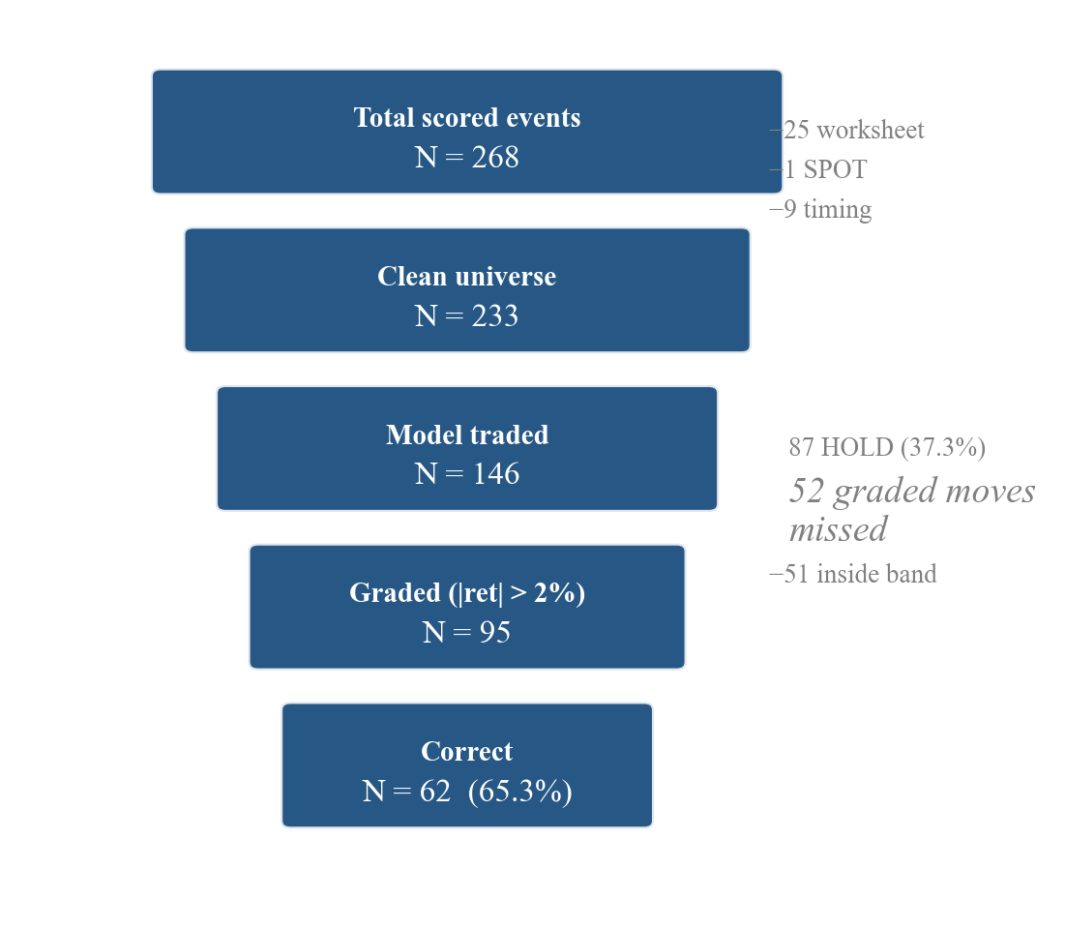
The funnel from 268 scored events to 62 correct calls on the frozen set. Exclusions are 25 worksheet contaminations, one misattributed transcript and nine events without a documented release timestamp. The HOLD limb carries 87 events, of which 52 moved more than 2% under the grading band.

2.8 The statistical approach, and what non-significance means here
[195 words, plan 250, -55]
Proportions carry Wilson intervals. Comparisons against a floor use an exact binomial test, and the floor is always the majority-direction predictor computed on the same denominator as the figure it is compared against, since a comparator on a different denominator is what produced one of the retractions in Section 4. Correlations are tested with Fisher-z intervals, the inter-rater agreement statistic carries a bootstrap interval, and the threshold sweep was tested by permutation.
More consequential is how to report the many comparisons this design cannot resolve. The minimum detectable effect is the smallest true difference this design could have distinguished from zero at 80% power, so where an observed gap falls below it the comparison is invisible to the sample rather than settled. Values at 80% power are as follows.
Minimum detectable effects by comparison
Comparison | Effective n | Approximate MDE
Selectivity accuracy against floor | 95 graded | $±$10.8 points
Extension accuracy | 14 graded | $±$32 points
Section ablation, paired | 43 to 53 | approximately $±$12 points across that range
Model against human, direction only | 76 paired | $±$23 points
Walk-forward, pooled out of sample | 25 graded | $±$30 points
Cross-issuer subset | 52 graded | $±$21 points
At these sizes most comparisons in this study cannot separate a real effect from none. A non-significant result here is underpowered rather than null, and the two are not the same claim. Where a comparison fails to reach significance this report says untestable and gives the minimum detectable effect alongside the observed difference, so a reader can see how far the design was from being able to answer. Where a finding does not depend on a threshold at all, which is true of only the rank correlation, that is stated as the reason it leads.

3. Findings

3.1 The model’s reading carries rank information, and it decays
[445 words, plan 450, -5]
The primary result is a rank correlation between the model’s blended score and the realised overnight return, computed across all 233 clean events.
Spearman rho equals 0.236 at p equals 0.0003.
This leads the report for a reason that has nothing to do with its size, and the size is modest. It leads because it is the only headline in the study that survives without a threshold. It uses the continuous score and the continuous return, so there is no band, no three-way split, no grading cut and no selection of which events to count. Every one of the 233 events contributes, the ones the model held on and the ones that barely moved alongside the rest. Every other figure in this section depends on the HOLD thresholds described in section 2.4, and those thresholds were fitted in sample on an objective the study has since retired. This one does not.
It also improved under correction, moving from 0.221 on the old anchor to 0.236 on the corrected one, a useful sign that it is not an artefact of the measurement error described in Section 4.
More informative is what happens as the holding period lengthens.
Rank correlation and mean net return by holding horizon
Horizon | Mean net per trade | 95% CI | rho | p
Overnight | +1.8617% | +0.98% to +2.76% | 0.236 | 0.0003
1 day | +1.2505% | +0.33% to +2.21% | 0.159 | 0.015
3 days | +1.0264% | +0.03% to +2.05% | 0.112 | 0.089
5 days | +0.8458% | $-$0.27% to +1.95% | 0.072 | 0.276
10 days | +0.6860% | $-$0.63% to +2.03% | 0.058 | 0.380
Correlation between the model score and the realised return falls monotonically as the holding period lengthens, and both intervals reach the zero boundary over the same span, though they are different quantities and neither figure belongs to the other. The Fisher-z 90% interval on rho has a lower bound of 0.004 at three days and $-$0.036 at five. The bootstrap 90% interval on mean net per trade has a lower bound of +0.03% at three days and crosses zero by five. By ten days the correlation is 0.058 at p equals 0.380 and nothing survives.
That shape matters more than the level, for three reasons.
An information-driven signal should behave exactly like this. A reading of a document that tells you something about the market’s reaction to that document ought to lose its force as unrelated news accumulates, and it does. A signal that persisted or strengthened over ten days would be describing something other than the document.
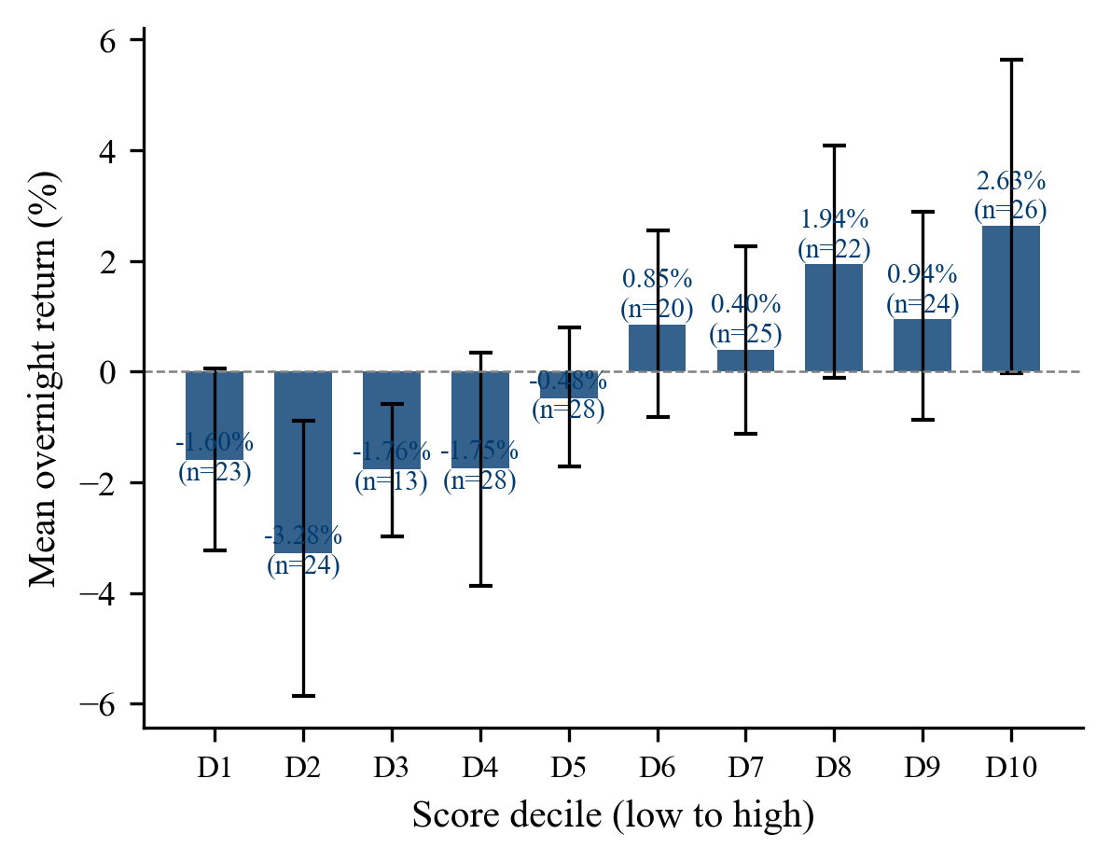
Mean overnight return by model score decile, frozen set, with 90% bootstrap intervals. The pattern is broadly increasing rather than strictly monotonic, with D7 below D6 and D9 below D8, and most intervals crossing zero. That is what a rank correlation of 0.236 looks like when it is cut into ten bins, and the overlap is the point rather than a defect. Bin counts range from 13 to 28.
It rules out post-earnings announcement drift as the mechanism. Drift would show the opposite pattern, with the relationship building over the following days.
And it validates the measurement window empirically. Section 2.2 chose the overnight window on the argument that it isolates the document’s effect. That is an assertion until something tests it. The decay curve tests it, and the answer is that the overnight window is where the signal actually lives. That pre-empts the most obvious methodological objection to the study.
One qualification travels with this finding wherever it appears. The decay holds on raw direction-signed returns. The excess-over-SPY column in returns_matrix.csv is a separate per-event diagnostic and is not monotonic, because it carries the benchmark’s own multi-horizon behaviour across those particular entry dates. The series must be named whenever the decay is stated.
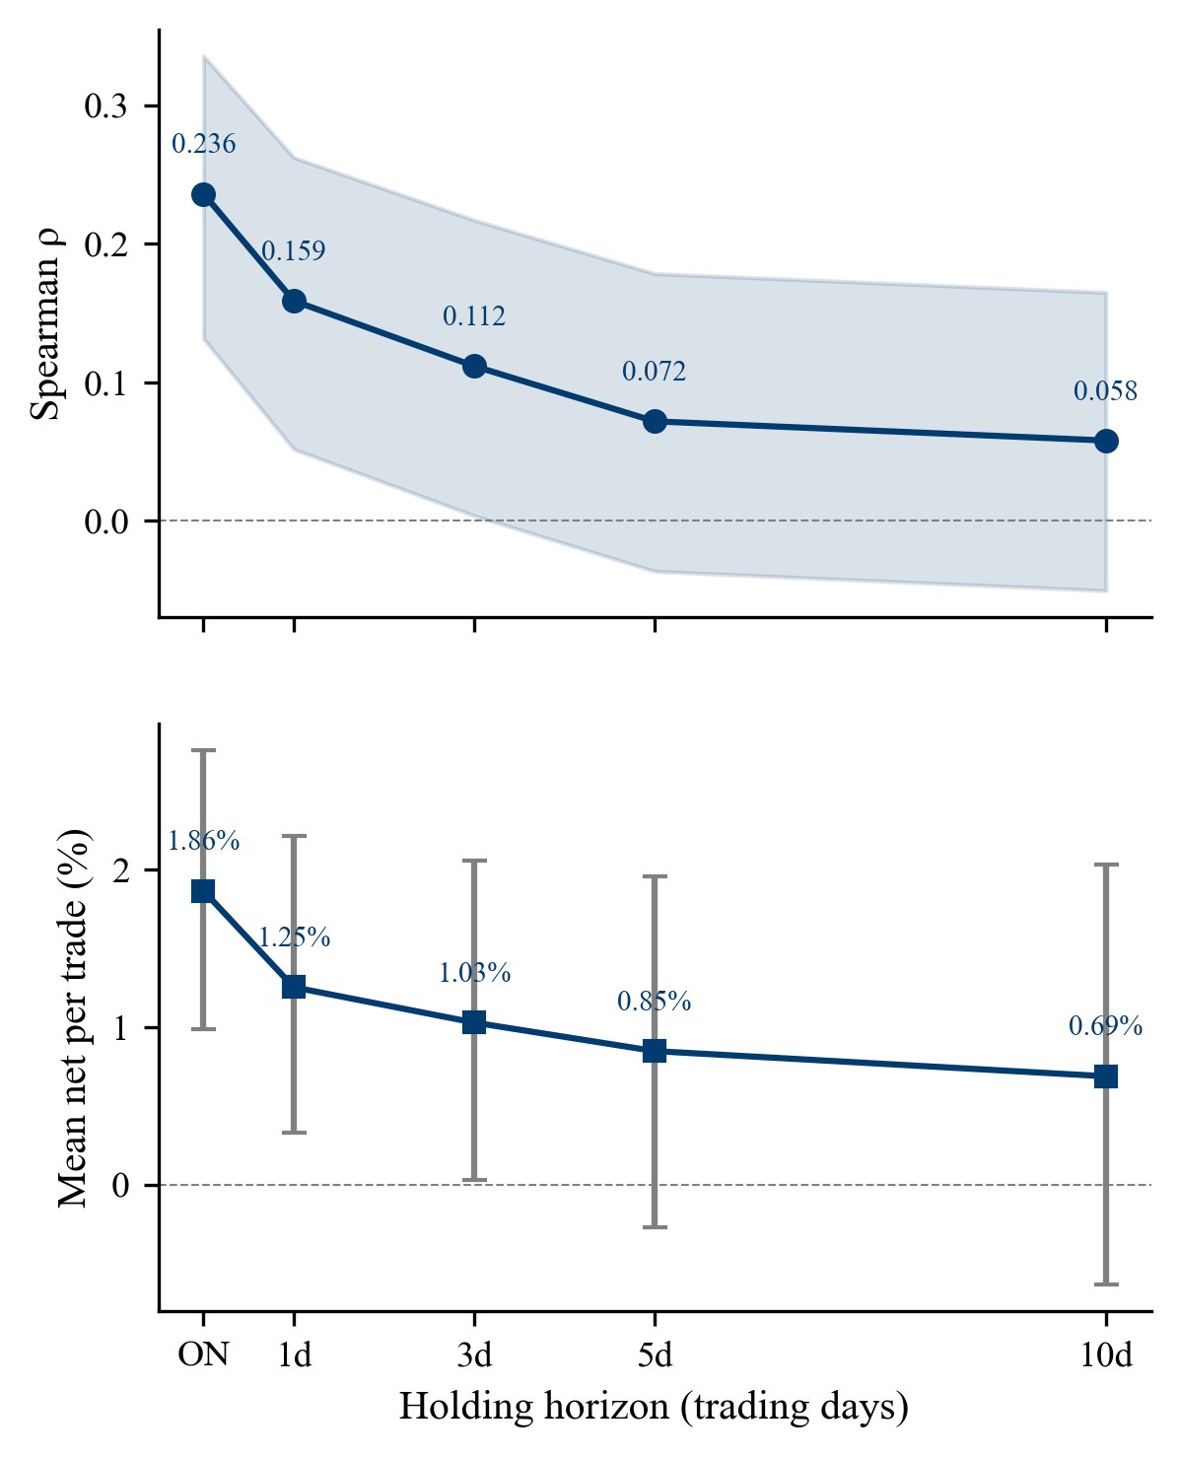
Rank correlation and mean net per trade against holding horizon. The upper panel is Spearman rho on raw direction-signed returns across all 233 clean events, with a Fisher-z 90% interval computed in the plot script rather than read from an output file. The lower panel is mean net per trade across 146 traded events with a bootstrap 90% interval read from source.

3.2 Accuracy, which cannot be reported one way
[265 words, plan 400, -135]
The same 62 correct calls produce two very different accuracy figures depending on the denominator, and both belong in the report.
Accuracy under the selectivity and coverage conventions
Convention | Figure | Denominator | Matched always-DOWN floor | Margin
Selectivity | 65.3% (62/95) | Model called a direction and the move breached $±$2% | 54.7% (52/95, always-DOWN) | +10.5 points, p = 0.024, MDE $±$10.8 points
Coverage | 42.2% (62/147) | Every event that moved more than 2%, whether called or not | 54.4% (80/147) | $-$12.2 points
Selectivity asks whether the model was right when it committed, and the answer is that it beat its matched floor by 10.5 points at p equals 0.024. Coverage asks whether it captured the directional information available in the corpus, and the answer is that it did not, sitting 12.2 points below its floor, because it held on 52 events that moved more than 2%.
Both figures describe the same 62 correct calls. They differ only in what sits underneath the line. Selectivity divides by the 95 events the model chose to call, so it measures precision when the model commits. Coverage divides by all 147 events that moved, so it measures how much of the available directional information the model captured. Reported alone, the first makes the system look selective and accurate and the second makes it look like it missed most of what was there. Both are true and the system is both.
Significance also deserves reading carefully. The margin is +10.5 points and the minimum detectable effect at 95 graded events is $±$10.8 points. The study was barely powered to find the effect it found. That does not make the result wrong, and p equals 0.024 is what it is, but it does mean the finding sits almost exactly at the detection limit of its own design, and a replication would not reliably reproduce it.
The selectivity figure carries one further qualification, set out in full in section 3.5. The 95-event denominator is itself a product of in-sample threshold selection, since the thresholds decide which events the model called and therefore which events are graded.

3.3 Where the accuracy sits, and what happens when the band moves
[254 words, plan 400, -146]
Accuracy concentrates in large moves.
Accuracy and return by size of the realised move
Realised move | Graded n | Accuracy | Mean net per trade
2 to 5% | 43 | 58.1% | +0.34%
5 to 10% | 36 | 63.9% | +1.92%
Above 10% | 16 | 87.5% | +11.45%  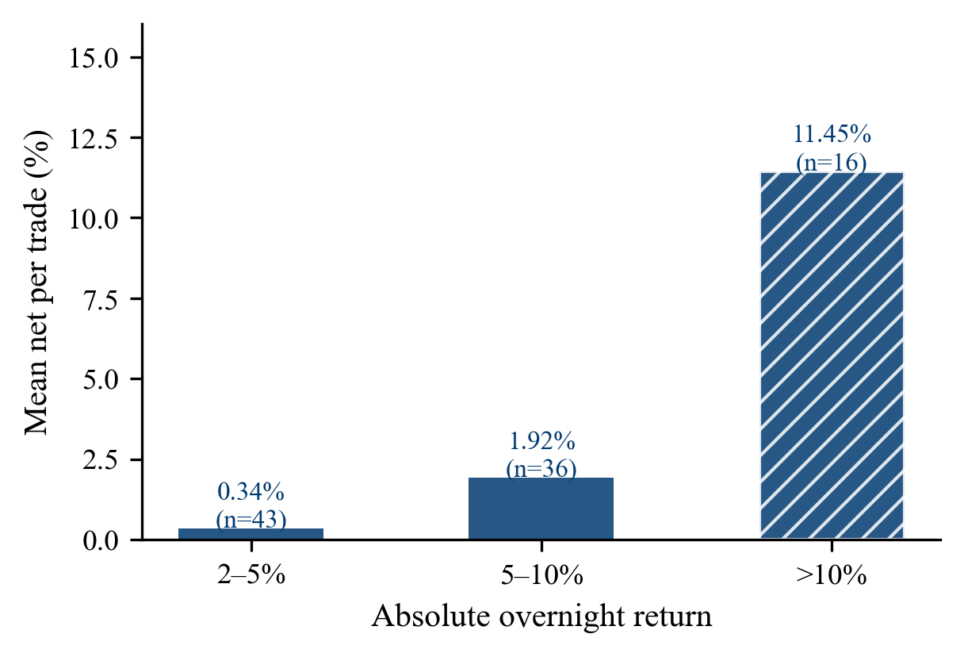  Mean net return per trade by the absolute size of the realised overnight move, frozen set. Almost all of the profit sits in the largest moves, at +11.45% on 16 events against +0.34% on 43 in the smallest bucket. The hatched bar marks the bucket whose sample is too small to carry a strong claim. Move size is not knowable when the decision is taken, so this is a reason to weight a call and not a rule for placing one.
The signal is most reliable precisely where the money is, and that is the most commercially interesting pattern in the study and the one most in need of restraint. Two caveats travel with it. Sixteen events cannot carry a strong claim about the top bucket. And the size of a move is not knowable at the moment the decision is made, so this is a reason to weight a call, not a rule for placing one. A desk cannot select into the large-move bucket in advance.
The band sweep answers the study’s largest weakness directly. The 2% band was set before any outcome was graded, but the HOLD thresholds inside the model were not, and the obvious objection is that the reported accuracy is a product of a favourable cut. Regrading the whole set at every band tests that.$±$
Accuracy across the neutral band sweep
Band | Graded n | Accuracy
$±$0% | 145 | 62.8%
$±$1% | 120 | 64.2%
$±$2% (band used for grading) | 95 | 65.3%
$±$3% | 71 | 67.6%
$±$4% | 61 | 68.9%
$±$5% | 52 | 71.2%
Accuracy rises monotonically as the band widens and coverage falls, which is what should happen if the score carries real information, since a wider band keeps only the larger and cleaner moves. The band actually used sits low on that curve. A 5% band would have produced a headline of 71.2% on 52 events, and a mean net return of 4.85% per trade against 2.81% at 2%.$±$
So the band chosen cost accuracy rather than manufacturing it. Showing the whole curve is a stronger answer to the overfitting objection than any argument about intent, because the shape holds at every threshold tested and the choice that was actually made is the conservative one.
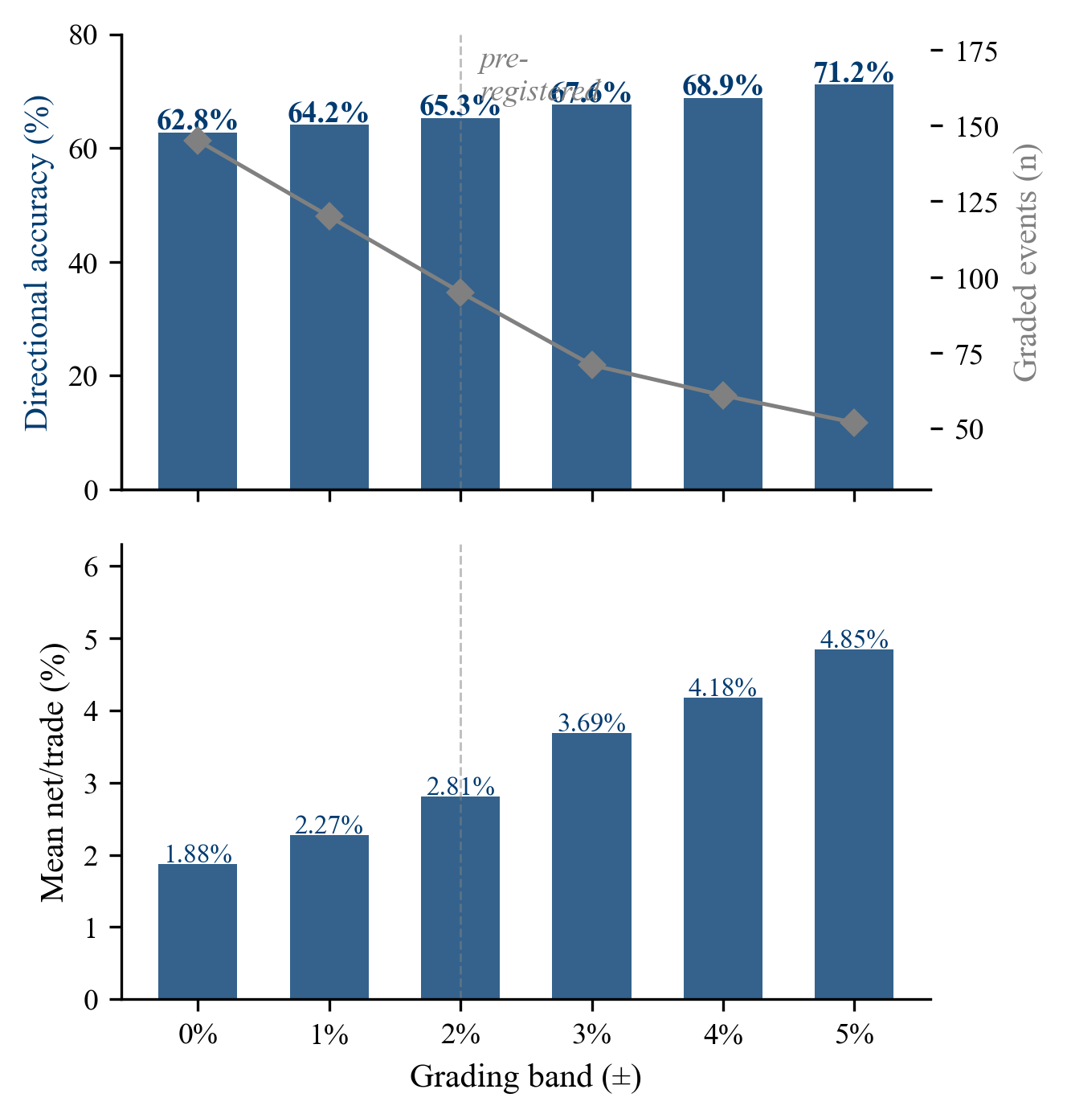
Neutral band sweep on the frozen set, strict inequality convention. Upper panel, bars show directional accuracy on the left axis and the grey line shows how many events remain gradeable on the right axis, falling from 145 at a 0% band to 52 at 5%. Lower panel, mean net return per trade at each band. The dashed vertical marks the 2% band used for grading throughout the report. Accuracy and profit per trade both rise as the band widens while the number of gradeable events falls.

3.4 Profit and loss, and its distribution
[259 words, plan 350, -91]
Profit and loss across the three event sets
Metric | Frozen | Extension | Combined
Trades | 146 | 32 | 178
Mean net per trade | +1.8617% | +1.2159% | +1.7456%
Population standard deviation | 6.554% | 5.051% | 6.315%
Information ratio | 0.2840 | 0.2407 | 0.2764
t-statistic | 3.4322 | 1.3618 | 3.6878
Summed total return | +271.81% | +41.46% | +313.27%
Two properties of this table need stating before any of it is read as performance.
The combined t-statistic, which measures how many standard errors the mean sits away from zero, of 3.6878 exceeds the frozen 3.4322 despite a lower mean net per trade, because the statistic scales with the square root of the sample. That is exactly the property that disqualified an earlier Sharpe ratio, and it is why the information ratio, which moves the other way at 0.2764 against 0.2840, is the sample-independent comparison. Where the two disagree the information ratio is cited.
The summed total return is an arithmetic sum of independent per-trade returns and is therefore order-independent and reportable. It is not an achievable balance and no equity curve is presented, because positions overlap when companies report in the same week. Section 4 sets out why a compounded figure was retired.
Distribution matters more than the mean.
Distribution of per-trade returns
Bucket | Trades
Worse than $-$10% | 2
$-$10% to $-$5% | 13
$-$5% to 0% | 41
0% to +5% | 55
+5% to +10% | 21
Above +10% | 14
The median is +1.144% against a mean of +1.862, so the average is pulled up by a right tail without being dominated by it, and removing the single best trade moves the mean only to +1.653%. Fifty-six of 146 trades lose money, or 38%. Any account of this as a profitable signal has to carry that number.
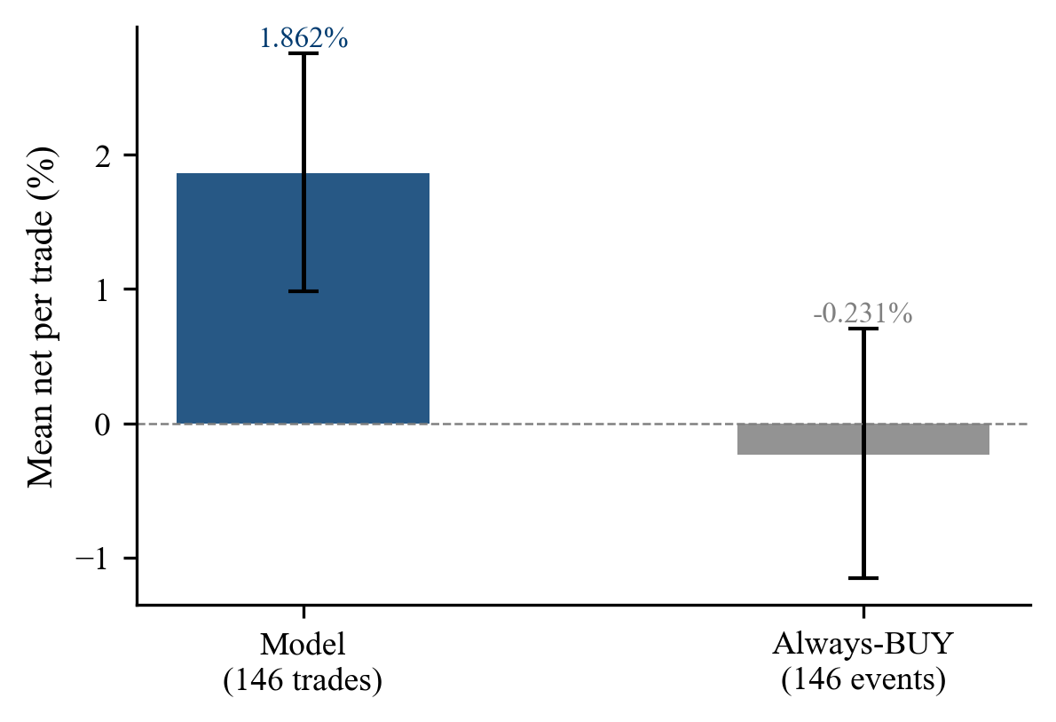
Mean net return per trade for the model against an always-BUY rule on the same 146 events, with 90% bootstrap intervals. Always-BUY returns minus 0.231% and its interval spans zero. This is a profit-and-loss floor and it is a different comparator from the always-DOWN accuracy floor used in Section 3.2, which answers a different question on a different denominator.
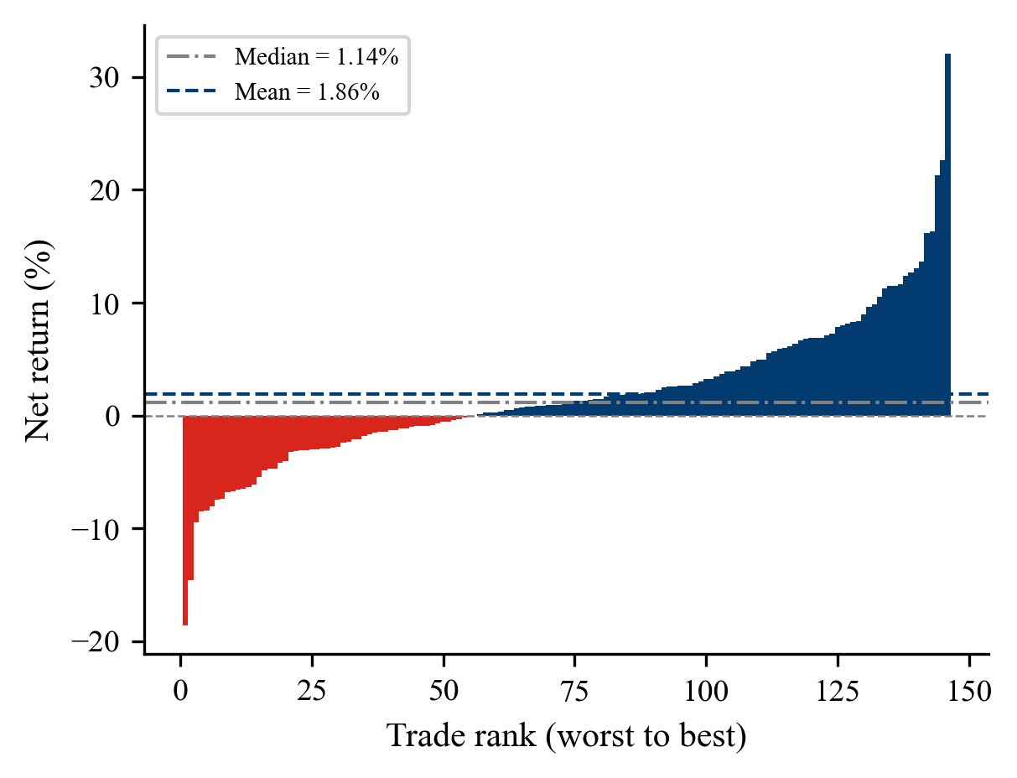
Net return for each of the 146 traded frozen events, ranked worst to best. Colour encodes the sign of the return, red for a loss and navy for a gain, and not the arm. Fifty-six trades lose money, the median is +1.14% against a mean of +1.86%, and the gap between them is a right tail rather than a small number of dominant trades, since removing the single best trade moves the mean only to +1.65%.
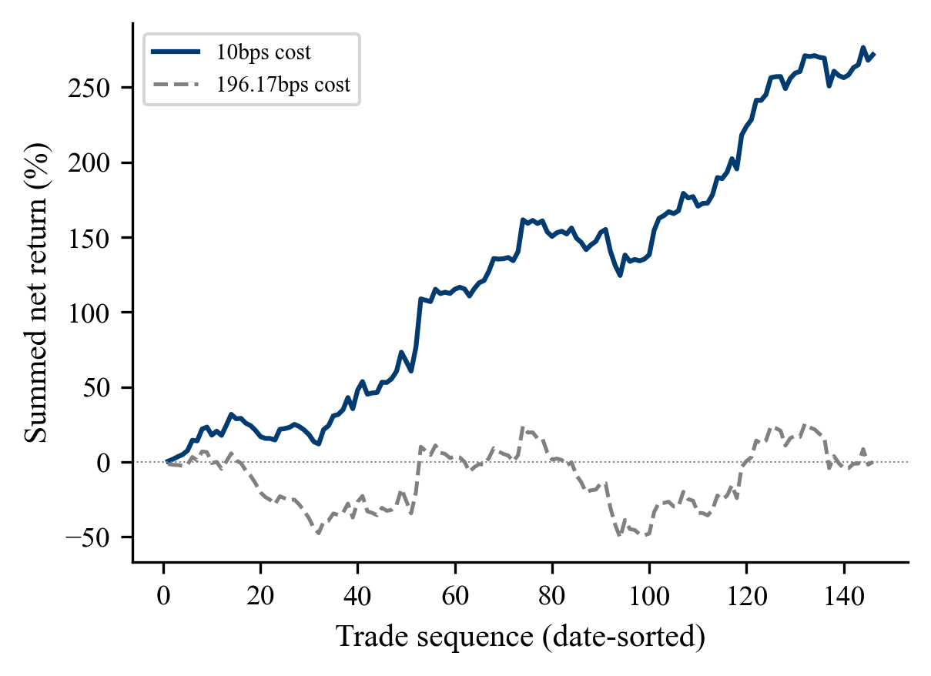
Running sum of net return per trade across the 146 traded frozen events in date order, at the 10 basis point cost assumption and at the 196.17 basis point break-even. This is an arithmetic running sum and not an achievable account balance, because positions overlap when issuers report in the same week. At the break-even cost the series spends most of its length below zero and ends flat, which is the same fact the mean expresses.
The break-even round-trip cost, meaning the round-trip trading cost at which the mean net return reaches zero, on the frozen set is 196.17 basis points against the 10 basis point assumption stated in section 2.3. One basis point is 0.01%, so 196.17 is 1.96% of position value across both legs, or about 196 dollars on a 10,000 dollar position against 10 dollars at the stated assumption. The more conservative reading uses the lower bound of the interval rather than the mean, which reaches zero at 108 basis points. Both are reported as arithmetic, for the reason given in section 2.3.
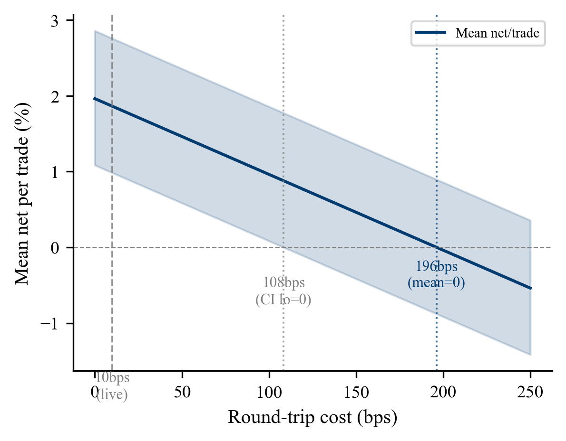
Mean net return per trade against round-trip trading cost, frozen set, with the 90% bootstrap interval shaded. The mean reaches zero at 196 basis points and the lower bound of the interval reaches zero at 108. The conservative reading is therefore 108, roughly ten times the 10 basis point assumption marked at the left. Neither figure is offered as evidence that the signal clears a real cost.

3.5 The decision layer does not survive honest replication
[475 words, plan 450, +25]
Section 3.2 flagged that the thresholds were fitted in sample. This section tests what happens when they are fitted honestly instead.
The deployed thresholds of +0.25 and $-$0.05 were selected by maximising compounded total return across the full dataset with every event visible, at N equals 161, with a Probabilistic Sharpe Ratio of 0.0 and a permutation p of 0.150. Refitting them on rolling windows, with each window’s thresholds chosen only on prior events and applied forward, was run under two objectives at both N equals 233 and N equals 326.
Walk-forward threshold refitting under two objectives
Objective | Degenerate at N=233 | Degenerate at N=326 | Behaviour
Mean net per trade | 3 of 4 windows | 3 of 4 windows | Fits the same extreme thresholds of +0.45 and $-$0.50 at 203, 271 and 321 training events. Not converging.
Directional accuracy, 15% minimum trade fraction | 2 of 4 windows | 1 of 4 windows | Improves with sample size. Pooled out of sample gives 37 trades, 17 of 25 graded correct at 68.0% against a 53.4% floor.
The two objectives fail for different reasons, and the separation is the finding.
Mean-net maximisation is structurally degenerate. It selects the same near-zero-trade thresholds whether trained on 203 events or 321, taking five to seven trades in training and none out of sample in three of four windows. This is mechanical rather than statistical. Trading rarely maximises a mean, so a very wide hold band that almost never acts tends to win in sample regardless of how much data is added. That objective will not become estimable by collecting more events.
Directional-accuracy maximisation is sample-limited rather than structurally broken. It improves from two degenerate windows to one as the sample grows from 233 to 326, and its pooled out-of-sample record clears its floor by 14.6 points with a 90% interval of +0.12 to +3.49% that just clears zero. On that trajectory full non-degeneracy would plausibly need somewhere around 400 to 500 events, which is an extrapolation from two points.
Two things must not be overstated. All 326 events had been seen before this analysis ran, so it is retrospective validation and not out-of-sample in any formal sense. And the pooled minimum detectable effect is roughly $±$30 points against an observed gap of 14.6, so the result is directionally consistent and underpowered.
A reconstructed cross-issuer subset, meaning a set of events assembled after the fact to stand in for a holdout the project never set aside, offers the only genuinely unseen figure available. 101 events across 29 issuers were scored after the threshold sweep with no issuer overlap, giving 33 of 52 graded correct at 63.5% against a 51.9% floor, a margin of +11.5 points at p equals 0.063 with an MDE of 20.8 points. Three caveats are material and none is presentational. Sweep membership is inferred rather than recorded, and 453 single-swap alternative subsets produce the same count. The two subsets are interleaved in time, so issuer effects and time effects cannot be separated. And p equals 0.063 does not clear 0.05. It is suggestive and it is not evidence of generalisation.$±$
The conclusion this section supports is narrow and useful. The score carries information independently of any threshold, as section 3.1 shows. The procedure that converts that score into a BUY or SELL call cannot be executed honestly at this sample size.

3.6 The model against the human arm
[682 words, plan 300, +382]
On 76 events where both arms committed to a direction, the human arm was correct on 44 and the model on 46, giving 57.9% against 60.5%. The difference is +2.6 points at p equals 0.754, against a matched always-DOWN floor of 55.3% and a minimum detectable effect of $±$23 points. Neither arm clears the floor by a testable margin and the gap between them is untestable rather than absent. Resolving it would need a substantially larger sample.
Two things complicate reading it as a gap at all. Excluding flat outcomes rewards whichever arm holds more often, because a hold on an event that barely moved is never counted against it. The model holds on 40.4% of events against the human arm’s 23.4%, so the exclusion lifts the model by 29.7 points and the human arm by 22.6, handing the model 7.1 points before either arm is read. The observed gap is 6.3 points. The apparent model advantage is smaller than the bias the metric introduces, so under neither convention can an advantage be claimed.
Cohen’s kappa, which measures agreement between two raters after subtracting the agreement expected by chance alone, where zero is chance and one is perfect, between the arms is 0.109 with a 90% interval of 0.030 to 0.190 on 171 paired events, with observed agreement of 38.0% against 30.4% expected. The two arms are close to independent. That is a finding in itself and it matters in Section 4, because two near-independent classifiers give no reason to expect their agreement to carry information.
One asymmetry is shared and worth reporting.
Directional asymmetry across the two arms
Arm | Call | Accuracy | Against 50% | Against base rate
Human | BUY | 50.9% (27/53) | +0.9pp, p = 0.500 | +7.5pp vs 43.4%, p = 0.167
Human | SELL | 73.9% (17/23) | +23.9pp, p = 0.017 | +17.3pp vs 56.6%, p = 0.069
Model | BUY | 55.6% (20/36) | +5.6pp, p = 0.309 | +12.1pp vs 43.4%, p = 0.097
Model | SELL | 65.0% (26/40) | +15.0pp, p = 0.040 | +8.4pp vs 56.6%, p = 0.181
Both arms clear chance on SELL and neither clears chance on BUY. Measured against the base rate, the margins soften in every cell, so the defensible statement is that neither arm reliably clears its base rate in either direction, with the pattern of relative SELL strength consistent across both. The human SELL cell holds 23 events and cannot carry weight on its own.
A mechanism for the asymmetry, from the raters’ own reasoning. An analysis of the human arm’s written rationales offers the only account available for why SELL behaves differently from BUY. Management tone is cited in 38% of SELL rationales and 17% of BUY ones, while revenue, earnings and forward guidance dominate the BUY rationales at 82 and 46%. Raters reach for tone when the reported numbers do not support a negative call, so a positive print delivered cautiously becomes a SELL. This rests on 49 rationales drawn largely from one rater, so it is descriptive and offered as a mechanism worth testing.
Optimism, which the notes cannot settle. The human arm called BUY on 56.1% of events against the model’s 24.6, and 41% of rationales code positive in tone against 22% negative. The obvious reading is rater optimism, and the notes cannot support it, because earnings releases carry positive framing even for mixed results and the two explanations are not separable in this corpus. As one of the six raters I would add that the framing does pull positive by default and holding a neutral line takes deliberate effort, which is consistent with both arms landing at their floors without distinguishing between the explanations. That is one rater’s account of the task and it is not evidence.
Evidence integrity, where the comparison is clean. The two arms can be compared directly on auditability and hallucination, both named in the brief, and this is the only place in the study where that comparison is unambiguous. A check of 174 quotes across 26 human worksheets found 172 exact matches, two near matches and no cross-company misattributions. The model arm produced one transcript belonging to a different company entirely and one confirmed fabricated quote. Two qualifications travel with it. 66 of 92 eligible rater files carry no formal citations, since freeform notes paraphrase, and the model’s evidence was screened separately at 267 of 272 passing. So this compares two screens and not two populations. On the criterion the brief actually names, the human arm comes out ahead.
All human figures here are aggregate. Per-rater results are not reported, for the reasons in section 2.5.

3.7 The baseline frontier, and two ways of failing
[189 words, plan 300, -111]
Every figure in this comparison uses the coverage convention, counting a HOLD on an event that moved as wrong, so the model reads 42.9% and not its 65.3% selectivity headline. Same predictions, different denominator.
How the model compares against cheap baselines under the coverage convention
Method | Frozen (119 graded) | Extension (31) | Combined-eval (150)
Majority direction (floor) | 54.6% | 48.4% | 53.3%
Deployed model | 42.9% (51/119) | 32.3% (10/31) | 40.7% (61/150)
FinBERT | 34.5% | 38.7% | 35.3%
Loughran-McDonald | 15.1% | 9.7% | 14.0%
No method clears the majority-direction floor under this convention, a real and unflattering result about the whole approach.
The reversal is the interesting part. FinBERT sits below the model on the frozen set and above it on the extension. It is not that FinBERT reads unfamiliar sectors better. FinBERT called SELL on 2 of 93 extension events while trading 71% of them, against the model’s 34.4% trade rate. It operates as a buy-or-hold system regardless of sector, which is a threshold artefact rather than a signal, and it happens to be rewarded when the period drifts up.
Both fall below the floor on the extension by opposite mechanisms, one overtrading and one holding. Two systems failing differently on the same corpus is more informative than either accuracy figure, because it locates the failure in the decision layer of each and not in the reading.

3.8 Section ablation, cost and speed
[452 words, plan 300, +152]
Four arms read the same events. The full document bundle, the press release alone, the prepared remarks alone, and the question and answer session alone. A fifth guidance arm was specified and proved mechanically infeasible, because forward guidance is not a structurally separate section in any observed document, appearing in the press release outlook paragraph, again in prepared remarks and again under questioning. Zero events were separable, and the stated expectation that guidance would carry more than its token share is recorded as untestable rather than deleted.
Section ablation, accuracy, cost and latency
Arm | Graded | Correct | Accuracy | Mean tokens | Cost per correct call | Median latency | Agreement with full bundle
Full bundle | 47 | 32 | 68.1% | 30,096 | $0.0358 | 15.31s | —
Press release | 37 | 24 | 64.9% | 13,030 | $0.0225 | 13.07s | 72.3%
Prepared remarks | 41 | 26 | 63.4% | 10,287 | $0.0208 | 13.99s | 85.7%
Q&A only | 38 | 26 | 68.4% | 13,163 | $0.0229 | 13.19s | 71.4%
Paired differences against the full bundle were computed two ways. Strict, counting only events both arms graded, gives exactly 0.0 points for the press release on 45 events, $-$1.9 for prepared remarks and $-$2.3 for Q&A. Inclusive, scoring an ungraded event at 0.5 so that events where one arm abstains are not discarded, gives $-$6.8 points at p equals 0.055 for the press release, $-$4.0 at p equals 0.201 for prepared remarks and $-$5.3 at p equals 0.269 for Q&A.
The inclusive test is the informative one and it changes the conclusion. The full bundle wins marginally, and it wins almost entirely by trading 17 events the press release passes on. The difference between arms is not in the quality of the calls but in whether an arm commits at all. Every accuracy difference here sits inside a paired MDE of approximately $±$12 points, so none is testable. The whole ablation cost 638 calls, 12.5 million tokens and $4.27.
Speed. Per-call latency was logged throughout. Across 624 micro-layer calls the median is 15.00 seconds with an interquartile range of 12.95 to 17.31 and a full range of 7.52 to 126.99 seconds. Against the human arm, which averaged 29.8 minutes per document among full-document readers, that is a per-document multiple of 103 to 138 times, stated as a range because latency varies by a factor of six. Per correct directional call the multiple is about 65 times, 145.3 human minutes against 133.8 model seconds, and that is the harder and fairer comparison because the model holds more often and therefore produces fewer correct calls per unit of time.
Latency barely tracks document length. The rank correlation with input tokens is 0.44 and the fitted slope is 0.077 seconds per thousand tokens against a 14.08-second intercept, so most of the baseline is network and queue overhead. A 30,000-token bundle is only about 1.5 seconds slower than a 13,000-token press release. Two consequences follow. The speed advantage does not erode as documents lengthen, so it holds for long filings. And the 2 to 3 second gap between section arms is a token-count effect.

3.9 The extension scoring run, and a coverage failure in unfamiliar sectors
[646 words, plan 450, +196]
The extension was not a separately designed arm. The human arm had read a wider corpus than the model arm was ever given, and the 93 events in question were scored in a second run once that gap was noticed. Method, prompt, conventions and thresholds were identical to the frozen run, and the model saw neither prices nor human scores, so the events were unseen by the threshold selection. What the extension is not is a confirmatory test. Nothing about its analysis was specified in a dated document before the outcomes existed, and the results below are therefore exploratory.
It did not give a second test of the headline. Extension accuracy is 71.4% on 10 of 14 graded events, nominally above the frozen figure, but the Wilson interval runs from 45.4 to 88.3%, the two-proportion test against the frozen figure gives p equals 0.649, and the MDE at 14 graded events is $±$31.6 points against an observed difference of 6.2. Detecting a six-point difference at 80% power would need roughly 377 graded events, so the extension is underpowered by a factor of about 27. The combined figure of 66.1% against the frozen 65.3 is a 0.8-point difference at p equals 0.905. Call that mild corroboration.
What it gave instead is a failure the frozen set was too concentrated to show. The extension trade rate is 34.4% against 63.1 on the frozen set. Document type was ruled out cleanly, since all three coverage types trade at roughly 35% despite very different lengths, and section 2.1 established before scoring that the extension is the better documented of the two sets.
The obvious explanation is that unfamiliar sectors are more volatile and therefore harder, and the data does not support it. The relationship runs the other way. Low-volatility sectors produce fewer graded events, because the band rarely breaches, and energy and utilities between them contributed 42 extension events and two graded outcomes. A sector can depress the graded count without the model performing worse on it.
The mechanism is score compression. Extension micro-score standard deviation is 0.216 against 0.360 on the frozen set, 40% narrower, and 68% of extension blended scores fall inside the HOLD band against 37% frozen.
The consequential part is what that does to events that actually moved.
Model behaviour on events that breached the band
Set | Model traded | Model held | Held share
Extension, moved more than 2% | 14 | 16 | 53%
Frozen, moved more than 2% | 85 | 49 | 37%
On unfamiliar sectors the model held on 53% of the events that moved, against 37% on the frozen set. And 56% of extension trades were placed on events that never breached the band, against 49% frozen. So it is not trading less because less was happening. It is trading in a way that is less correlated with actual movement, which is a coverage failure rather than appropriate caution. Those two numbers together are what make this a finding, because either alone is consistent with a quieter corpus.
The human arm settles whether this is the documents or the model. Inferring the answer from the model’s own scores would be circular, but the human arm read the same corpus under a common protocol, which gives an independent check.
Score dispersion and hold rates by sector. The universe is the paired extension subset of 83 events, being extension events where the first rater’s reading exists and was not presentation only, under raw GICS sector labels. The model dispersion column is the standard deviation of the micro score, not of the blended score used everywhere else in this report.
Sector | n | Human score sd | Human HOLD rate | Model score sd | Model HOLD rate
Energy | 21 | 0.230 | 67% | 0.049 | 86%
Consumer staples | 10 | 0.134 | 50% | 0.303 | 70%
Information technology | 15 | 0.375 | 7% | 0.222 | 60%
Materials | 3 | 0.153 | 0% | 0.448 | 67%
Industrials | 4 | 0.173 | 25% | 0.235 | 75%
In energy the content genuinely is more neutral. Humans held on 67% of energy events and their scores compressed too, so both arms independently read the material as unactionable. In technology, materials and industrials it is model behaviour. Humans traded 93% of information technology events while the model held 60% of the same events, and on materials humans called a direction on all three events while the model held all three.
So the model’s conservatism is content-driven in some sectors and behavioural in others, and the two are separable by asking whether the human arm agreed on the same documents. That separation is the methodological point worth keeping. Several cells sit below five events, so this is descriptive, a hypothesis with a mechanism and an independent check rather than a tested result.

4. What the checks found
This section reports two figures and refuses a third. Four inoperative-check instances, enumerated by the project’s corrections log. Six retracted findings. No total fault count, because the wider audit found faults that do not share the signature.

4.1 What failed, and the four that never ran
[approx. 640 words, 185 of which is the protected four-instance block]
The pipeline arrived complete, with 268 events scored and headline results already recorded. The first planned extension required verifying the measurement window against an independent price source, and that check failed. Everything here followed from it.
The faults group by mechanism. The entry anchor family shares one root cause, a timing convention settled in planning and never implemented, which shifted the anchor on 82 events once corrected. Verification compounded it, since 50 of 235 United States events, 21.3%, carried a stored report date disagreeing with the verified release. The contamination family centres on a prompt assembler with no document-type filter, which for 25 events, 9.3% of the dataset, fed the model a rater’s completed worksheet carrying their directional call and the realised move. Re-scoring those 25 with the filter active changed 12 predictions, 48%. The metric family holds a compounded profit figure, a reported Sharpe ratio that was a t-statistic by construction, and a naive baseline on the wrong denominator, which alone moved the headline margin from roughly 26 points to 10.5 with no accuracy changing.
The signature, stated once. In four instances a safeguard was visibly present and silently inoperative.[^log] The list is exhaustive.
- A constant naming the pre-market issuers, read by no code path.
- A block of manually re-priced values in the workbook, referenced by no formula.
- A verification script that crashed on its first input on every invocation.
- An ensemble consistency path whose command-line default was a single run, never overridden.
All four were non-executing from inception. Not one was a control that worked and later broke, and not one had been corrected downstream and reverted on a rebuild. They never ran at all.
Note. Membership of this set is defined by the project’s corrections log, section (k), which enumerates each instance with its mechanism and the date it was found. Other faults found across the audit are not members. The ticker-identity faults in the same log’s section (j) are excluded on the log’s own criterion, because the cross-arm price check there executed and caught them before scoring, which is the opposite of the signature.
Nothing ever failed loudly. Every one of these produced output that looked correct.

4.2 Six retracted findings
[approx. 105 words plus the retraction table]
The six retracted findings
Finding | As recorded | Corrected | Mechanism
Agreement filter, the project’s headline | 0.561 against 0.429 | $-$0.3 points, p = 0.959 | Not reproducible from any artefact, and the measured version sat on the stale anchor
Band capture, pre-market | 72.7% inside band | 42.4% | Wrong entry compressed returns
Sign-correct on ungraded trades | 61%, p = 0.064 | 56%, p = 0.480 | Stale anchor
Accuracy against P&L divergence | 70.8 against 65.1% | 64.6 against 65.9% | Inflated by extreme-only grading
Naive baseline | roughly 39% | 54.7% | Comparator on the wrong denominator
Zero per-direction margin | Presented as a finding | Tautological | Definitional rather than empirical
Four of the six share the entry anchor as their cause, one is a comparator error and one was never a result at all.
The agreement filter deserves the note, because it was the project’s headline and the anchor of the partner-facing summary. It appears only as prose in the implementation specification, described there as already computed, and no script or output producing it exists on any branch. Measured on the stale anchor it showed +17.3 points at p equals 0.029. On the corrected anchor the effect is absent, at 0.3 points with p equals 0.959, because the stale anchor had compressed returns for 82 pre-market events. Cohen’s kappa of 0.109 predicted exactly that.

4.3 What this implies for evaluation practice
[approx. 115 words]
Two observations generalise beyond this project.
Checking that a mechanism exists is not the same as checking that it runs. All four safeguards were reviewable, and a reader auditing the project would have found each one present. Closing that gap requires evidence of execution, an output file with a timestamp and a row count, rather than evidence of intent.
The four sat in four different kinds of artefact, a constant in a module, a column in a spreadsheet, a standalone script and a default on a command-line flag, so a review organised around where controls are expected to live would have found all four present and stopped. The default is hardest to notice, because a default is not a mistake.

5. Discussion

5.1 Reading and deciding
[approx. 530 words, plan 400]
The study asked whether a language model reading financial documents can produce judgements accurate enough to be relied on, and under what conditions. The answer separates into two parts, and keeping them apart is what makes it usable.
The reading carries information. The rank correlation between the model’s blended score and the realised overnight return is 0.236 at p equals 0.0003 across all 233 clean events, it needs no threshold and no band and no selection to compute, and it decays monotonically to 0.058 by ten trading days. A model reading an earnings document arrives at an ordering of events that has something to do with how the market subsequently ordered them. That relationship is modest, it is fragile, and it is there.
The decision rule does not survive. The layer that converts a continuous score into a BUY, HOLD or SELL call rests on two thresholds that were fitted in sample, on the full dataset with every event visible, against an objective the study has since retired. Refitting them honestly on rolling windows degenerates under both objectives tried, and the two fail differently. Maximising mean net per trade selects the same near-zero-trade thresholds whether trained on 203 events or 321, and will not become estimable by adding data. Maximising directional accuracy improves as the sample grows and would plausibly need somewhere around 400 to 500 events, an extrapolation resting on two observations. Neither is available at 233.
Reading and deciding are separable, and only one of them works here.
That sentence is the contribution stated as briefly as it can be, and it is worth being precise about what it does not say. It does not say the model cannot trade. It says this study cannot demonstrate that it can, because the demonstration requires a calibration step the sample size does not support, and every accuracy figure in Section 3 inherits that limitation while the correlation in 3.1 does not. Nor does it say the answer is simply more data. More data addresses one of the two failure modes and the mechanism behind the other suggests it will not, since that objective is drawn to a near-zero trade rate by construction.
One question the brief asked and this study cannot answer. Its fourth aim concerns whether analyst overrides improve outcomes, and the analysis that would have tested it was the agreement filter, retracted at 0.3 points with p equals 0.959. The question stays live for a specific reason. Cohen’s kappa between the arms is 0.109, so the two are near-independent readers, and near-independent readers are precisely the case where combining them might add what neither adds alone. This study establishes the precondition for a combination test without being able to run one.$-$
The practical reading for an institution is narrower than either an encouraging or a discouraging headline would suggest. A model’s reading of a document is worth extracting as a continuous signal and worth feeding into something that already has a calibration procedure behind it. Asking the same model to also decide, on thresholds fitted to a few hundred events, is asking it to do the part this study shows cannot be done at that scale.

5.2 What an institution should actually run
[approx. 460 words, plan 350]
Four things follow for anyone deciding what to deploy, and they are ordered by how much money rides on them.
Start with the cost the signal can absorb. Mean net return is 1.86% per trade across 146 trades and reaches zero at a round-trip cost of 196 basis points, or 108 on the lower bound of the interval, against the 10 assumed here. That is roughly ten times the assumed cost on the conservative measure. This is arithmetic about how much room the edge has and not evidence that it clears a real one, for the reason given in section 2.3.$±$
The cheaper read reproduces the expensive one. Prepared remarks alone agree with the full bundle on 85.7% of events at 42% lower cost per correct call. The accuracy difference sits inside a paired minimum detectable effect of roughly 12 points, so the full bundle cannot be shown to be better, while the cost difference is not in doubt because it is a property of the documents.
What the full bundle buys is commitment rather than quality. It wins by 6.8 points over the press release at p equals 0.055 and almost entirely by trading 17 events the press release passes on. Extra context makes the system more willing to act, not better when acting, which is not the advantage a cost-benefit case would assume.
Speed supports the case without carrying it. Against a human arm averaging 29.8 minutes per document the model runs at a median 15.00 seconds. Per correct directional call the multiple is about 65 times, which is the fairer figure because the model holds more often and so produces fewer correct calls per unit of time.
The cheapest read produced the worst calls, and this is the finding that qualifies every efficiency argument above. Raters working from the guidance section alone took 18.7 minutes per document against 29.8 for a full document and scored 15.0% coverage and 17.6% selectivity against floors above 50%. That is the fastest condition in the human arm and by a wide margin the least reliable. A reader working that way gets no signal that it is going badly, because an outlook section reads as sufficient on its own and produces a confident directional view without the evidence needed to size it. Cheaper is not uniformly safe, and where the saving comes from dropping evidence rather than dropping redundancy it reverses.
The signal is distributed rather than concentrated. The human arm read under seven different information sets and showed the same insensitivity across sections that the model showed across four arms, with coverage spanning 33 to 43% among the sets with usable counts. If directional information sat mostly in one section, neither arm found it.

5.3 The prototype, and what its constraints reveal
[223 words, plan 250, -27]
A replay-mode interface was built as a proof of concept, showing how a scored event would reach a desk. It runs against stored results with no live API calls, it is not a live tool and was never connected to one, and every element the evaluation cannot support is labelled unavailable rather than estimated. Figure [[INSERT PROTOTYPE SCREENSHOT]] shows the interface as it stands.
What matters is not that it works. It is what the evaluation forced it to withhold.
A system whose own validation shows that its decision layer cannot be calibrated at this sample size should not present a confident decision, and the prototype does not. It surfaces the continuous score, which section 3.1 shows carries information without needing a threshold. It surfaces the evidence quotes, which were screened at 267 of 272 passing and which let a reader verify a claim without rereading the document. It shows the model’s own uncertainty flags. It does not show a confidence percentage attached to a directional call, because there is nothing in this study that would let such a number be calibrated honestly, and a figure that looks calibrated and is not is worse than no figure at all.
That constraint is the finding the prototype contributes. An evaluation that comes back qualified should propagate into the interface as things the interface declines to say, and an interface built before the evaluation would almost certainly have shown a confidence score, because the field expects one.

5.4 Limitations
[532 words, plan 450, +82]
These are stated at full strength because several are stronger than the findings.
Sample. Every accuracy claim rests on 95 graded events in the frozen set and 14 in the extension, out of 361 documents scored. Almost nothing is testable at that size. Minimum detectable effects run from $±$10.8 points for the headline accuracy to $±$31.6 for the extension, $±$12 paired for the ablation, $±$23 for the direction-only human comparison and roughly $±$30 for the pooled walk-forward. Where a comparison in this report fails to reach significance, the design was too small to resolve it, which is a different claim from having found no effect.
Thresholds. The HOLD thresholds were fitted in sample on the full dataset against an objective the study has since retired. Every threshold-dependent figure inherits this, and so does the graded denominator itself, since the thresholds decide which events are graded. Only the rank correlation is clean of it.
Metric asymmetries. Accuracy and profit are computed on different samples, 95 against 146, which is a property of the metric pair, and it is what produced one of the retracted claims. The FLAT convention is not neutral between the arms, favouring the model by 7.1 points against an observed gap of 6.3, so no model advantage can be claimed under either convention.
Out-of-sample evidence. There is effectively none. The walk-forward is retrospective because all 326 events had been seen. The cross-issuer subset is reconstructed, with 453 alternative subsets producing the same count, is confounded with time, and does not clear 0.05 at p equals 0.063.
Provenance. Every document was saved by hand from a public web page with no per-document source or retrieval date, and that is precisely why a misattributed transcript, a contaminated prompt and two truncations remained invisible until audited. A single line recording source and retrieval date per document would have caught all four. Source concentration compounds it, with 58 documents from one aggregator across 23 issuers, and that aggregator produced two of the demonstrated faults.
Measurement. The raw band conflates market-wide with company-specific moves in turbulent periods, with 15 of 254 events disagreeing between raw and excess grading and that disagreement clustering at 16 and 17% in two stressed months against 3% elsewhere. Roughly one event in six would flip during market stress.
Consistency. Output stability was designed for and never measured. The ensemble path existed, was documented as critical for consistency measurement, and defaulted to a single run that was never overridden. No claim about the stability of this system’s output can be made from this study at all, for either set, on a criterion the brief names explicitly.
Human arm conventions and protocol compliance. Raters were allocated issuers by self-selection, each covering between 13 and 17 companies, so most events carry exactly one human reading and the arm is a pooled panel of single readers rather than a repeated-measures design. Self-selection also means raters may have chosen issuers they already followed, which confounds rater familiarity with issuer difficulty and is a further reason per-rater figures are reported in aggregate only. The protocol specified the same 2% band and substantially the same document bundle for both arms, and compliance was not audited, with 2.00% and 1.00% both appearing in individual worksheets. Nothing reported here is affected, because both arms are regraded from one returns matrix at one band, but worksheet-internal correctness flags cannot be pooled and none are used. My own readings followed the protocol throughout.
Cost. No externally cited desk cost exists, so no claim about clearing realistic trading costs is available.
The information set. Both arms read documents written and released by the issuer, so both were reading managed disclosure rather than neutral evidence. Earnings releases and prepared remarks are selected for emphasis by the company, which bounds what any reader working from them can recover. The ablation offers a partial test rather than an assertion, since the less scripted question and answer session reads 68.4% on 38 graded events against 63.4% on 41 for prepared remarks, a difference well inside the sample noise at those sizes but pointing in the direction the mechanism predicts.

5.5 What was delivered against the brief’s five aims
[165 words, plan 150, +15]
The brief sets five specific aims. Reading them in order is the fairest account of what this work delivered and what it did not.
The first aim, to design and implement an LLM-powered data product for analysing financial texts, was met by the group and is described in Section 2.4, with the replay interface in Section 5.3.
The second aim, to evaluate accuracy, robustness and cost-efficiency, was met on two of three. Accuracy is reported under both conventions in Section 3.2 and cost-efficiency through the ablation in Section 3.8. Robustness was not evaluated. The ensemble path that would have measured output stability across repeated reads existed in the code, was documented as critical for that purpose, defaulted to a single run and was never switched on, so every event in both sets was scored once and nothing is known about the stability of the system’s output.
The third aim, to develop evaluation frameworks for financial text understanding covering sentiment, risk signals and forward guidance, was met on one of three. Sentiment is what the rank correlation in Section 3.1 measures, as a continuous quantity though never against a rubric of its own. Risk-signal extraction was not evaluated. Forward guidance was attempted and proved mechanically infeasible, because guidance is not a structurally separate section in any document observed.
The fourth aim, human-in-the-loop design to augment analyst workflows, was not tested. The analysis that would have tested it was the agreement filter and it was retracted once the entry anchor was corrected.
The fifth aim, practical deployment considerations, is addressed in Sections 5.2 and 5.3 and in the cost figures, though without a cited desk cost it stops short of a deployment case.
Three of the gaps share a cause. The audit work described in Section 4 consumed the time allocated to robustness testing, to risk-signal evaluation and to the qualitative comparison of the structured summary against a human reader. That is a real cost of the verification pass and it is stated rather than absorbed.
The gaps have a shape worth stating. The outputs left unevaluated are the ones whose value lies in auditability, and the only evidence bearing on that criterion is the citation check in Section 3.6, where 172 of 174 human quotes matched their source against one confirmed fabrication on the model side. That is the closest this study comes to evaluating what it did not evaluate, and it runs against the model.

6. Conclusions and further research
This study asked whether a language model reading earnings documents produces judgements accurate enough to act on, and it arrives at an answer in two parts that do not point the same way.
The reading carries information. Across all 233 events in the frozen set, the rank correlation between the model’s blended score and the realised overnight return is 0.236 at p equals 0.0003. That figure needs no threshold, no neutral band and no selection of which events to count, which makes it the only headline in this study clean of the qualification that attaches to everything else. It decays monotonically as the holding period lengthens, reaching the zero boundary at three days and falling to 0.058 by ten. That is how an information-driven signal should behave and is not how post-earnings drift would behave. The decay also validates the overnight window empirically.
The decision rule does not survive. Converting that score into a directional call requires thresholds, and the deployed thresholds were fitted in sample on the full dataset against an objective the study has since retired. Refitting them honestly on rolling windows degenerates under both objectives tested, and they degenerate differently. Maximising mean net per trade selects the same near-zero-trade thresholds whether trained on 203 events or 321, and the mechanism behind that is structural. Maximising directional accuracy improves as the sample grows and would plausibly need somewhere in the region of 400 to 500 events, on a trajectory with two observations behind it. Every accuracy figure in this report inherits that limitation and the correlation does not.
The effective sample is smaller than the corpus. 361 documents were scored and every accuracy claim rests on 95 graded events in the frozen set and 14 in the extension. At those sizes the minimum detectable effect runs from $±$10.8 points to $±$31.6, so most comparisons in this report are underpowered, and that distinction is drawn each time it matters.
What it took to establish any of this is the part most likely to transfer. Four safeguards were found to have existed, appeared to be in force and never executed, each in a different kind of artefact, and six previously reported findings were retracted, four of them sharing a single measurement error as their cause. That record is not incidental to the results. It is why the surviving results can be relied on to the limited extent claimed.

6.1 Further research
[266 words, plan 250, +16]
Four directions follow from what this study could not do.
Sample size for the decision layer specifically. The walk-forward analysis suggests directional-accuracy threshold selection becomes estimable somewhere around 400 to 500 events. That is a testable proposition and testing it needs only more events. It is the single most useful next step.
Output consistency, which this study designed for and never measured. The ensemble path exists and defaulted to a single run throughout, so nothing is known about how stable this system’s output is across repeated reads of the same document. Robustness is a criterion the brief names directly and it remains entirely open.
Risk-signal extraction and the structured summary. Neither was evaluated, both are auditability outputs, and the fragmentary evidence available points away from the model, so both are worth testing against a human reader on a designed comparison.
Whether combining the arms helps. Section 5.1 sets out why this study cannot test it and why the near-independence of the two arms keeps the question open. A properly designed combination test on a larger sample is the obvious extension of the human-in-the-loop aim, and it is the one direction the brief asked for that this work leaves entirely unaddressed.
One closing observation. A study that reports a 21.3% anchoring error, a 48% contamination effect and four mechanisms that never ran produces a smaller and more heavily qualified set of claims than the version that preceded it. For an institution deciding what to deploy, that is the more useful document.

References
To be completed once the ten markers in Appendix A have been verified. No entries are listed here, because none has yet been checked against the claim it supports.

Appendix A. Citations to verify
Every one of the ten entries below is a pointer, not a reference. I have named what I believe is the right anchor for each claim and I have deliberately written no claim about what any of them argues. Pull each one, read enough to confirm it supports the sentence it is attached to, and write the reference yourself in Cite Them Right Harvard. Where a work turns out not to support the point, cut the sentence.
Citation markers to verify
Marker | Where to look | What the sentence needs it to support
1 | Loughran and McDonald on finance-specific sentiment dictionaries, Journal of Finance, around 2011 | That general word lists misclassify financial language, and that a finance-specific dictionary exists
2 | Araci, FinBERT, arXiv preprint around 2019 | The origin of the FinBERT model used as a baseline arm
3 | Huang, Wang and Yang on FinBERT, Contemporary Accounting Research, around 2023 | The peer-reviewed treatment of financial-domain transformer sentiment
4 | Lopez-Lira and Tang on whether ChatGPT can forecast stock movements, working paper around 2023 | That general LLMs have been tested for return prediction from text
5 | Kim, Muhn and Nikolaev on LLMs and financial statement analysis, around 2024 | A second, independent instance of the same line of work
6 | MacKinlay, event studies in economics and finance, Journal of Economic Literature, around 1997 | The standard formalisation of event-window abnormal return measurement
7 | Ball and Brown, Journal of Accounting Research, 1968 | The original announcement-drift observation
8 | Bernard and Thomas on post-earnings announcement drift, late 1980s | That the drift persists for weeks after announcement
9 | Bailey and López de Prado on the deflated Sharpe ratio | Why an in-sample performance figure must be adjusted for the search that produced it
10 | Bailey, Borwein, López de Prado and Zhu on backtest overfitting, or López de Prado’s 2018 book | The number-of-trials argument underlying the same point

Appendix B. Supplementary figures
These figures were produced during the verification pass described in section 4.1, and each was regenerated from the committed outputs rather than carried over from an earlier run. They are included so that the full evidence base can be read in one pass, and none of them is referenced in the body of the report.
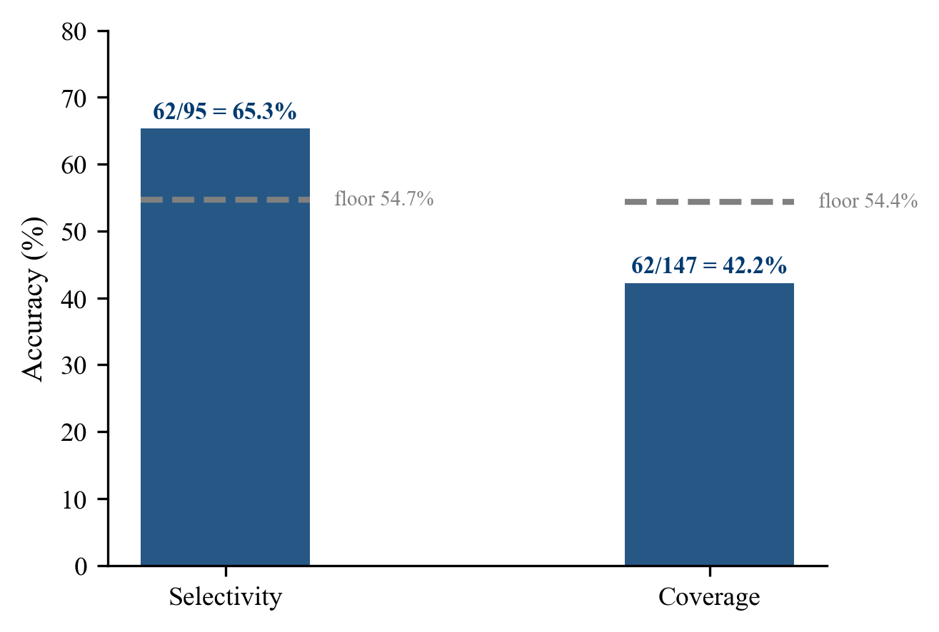
The same 62 correct calls under both accuracy conventions. Selectivity excludes HOLD events and rests on 95 graded events. Coverage counts a HOLD on a moving event as wrong and rests on 147. Plus or minus 2% overnight grading band. Sources are ext2_holding_curve.csv and results_three_sets.csv.
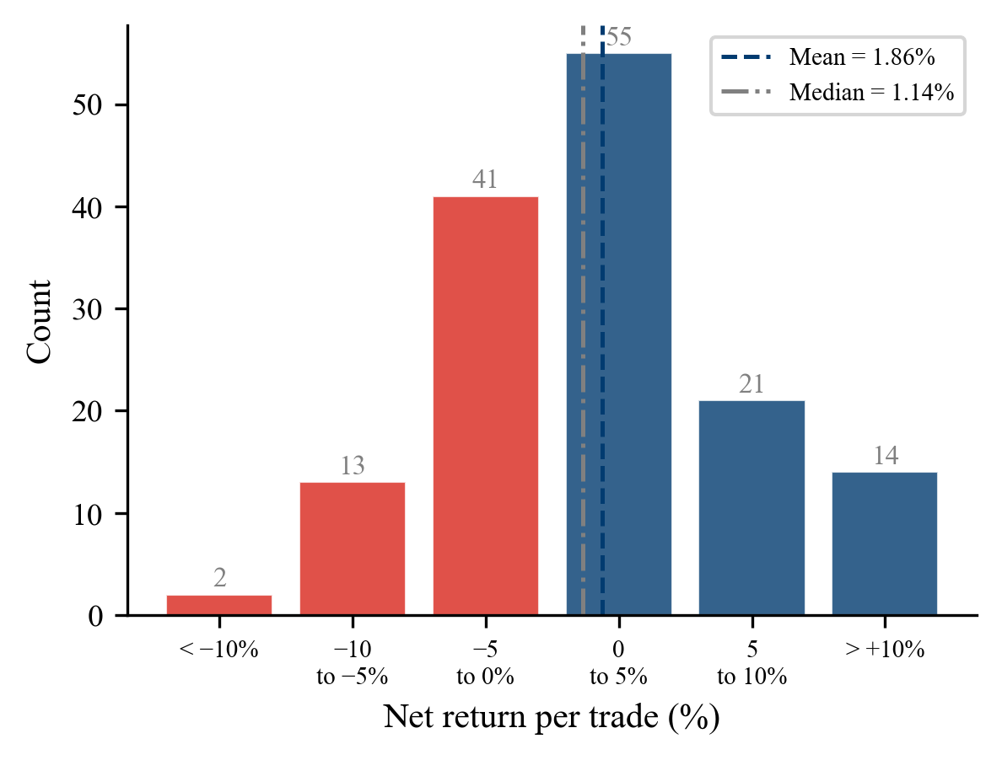
Distribution of net return per trade across 146 traded events on the frozen set. Colour encodes sign, red for a loss and navy for a gain, and not arm. Net returns recomputed in the plot script from returns_matrix.csv and global_outcome_calibration_phase2.csv.
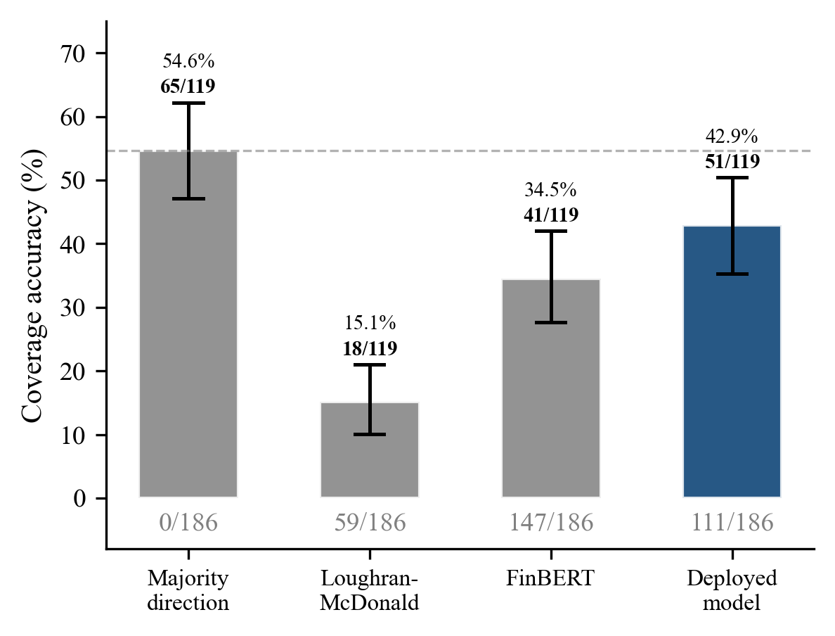
Coverage accuracy across the baseline frontier on the evaluation split of 186 events with 119 graded. The dashed line is the majority-direction floor at 54.6%. Bars carry 95% intervals and trade counts sit below each. Source is frontier_table.csv.
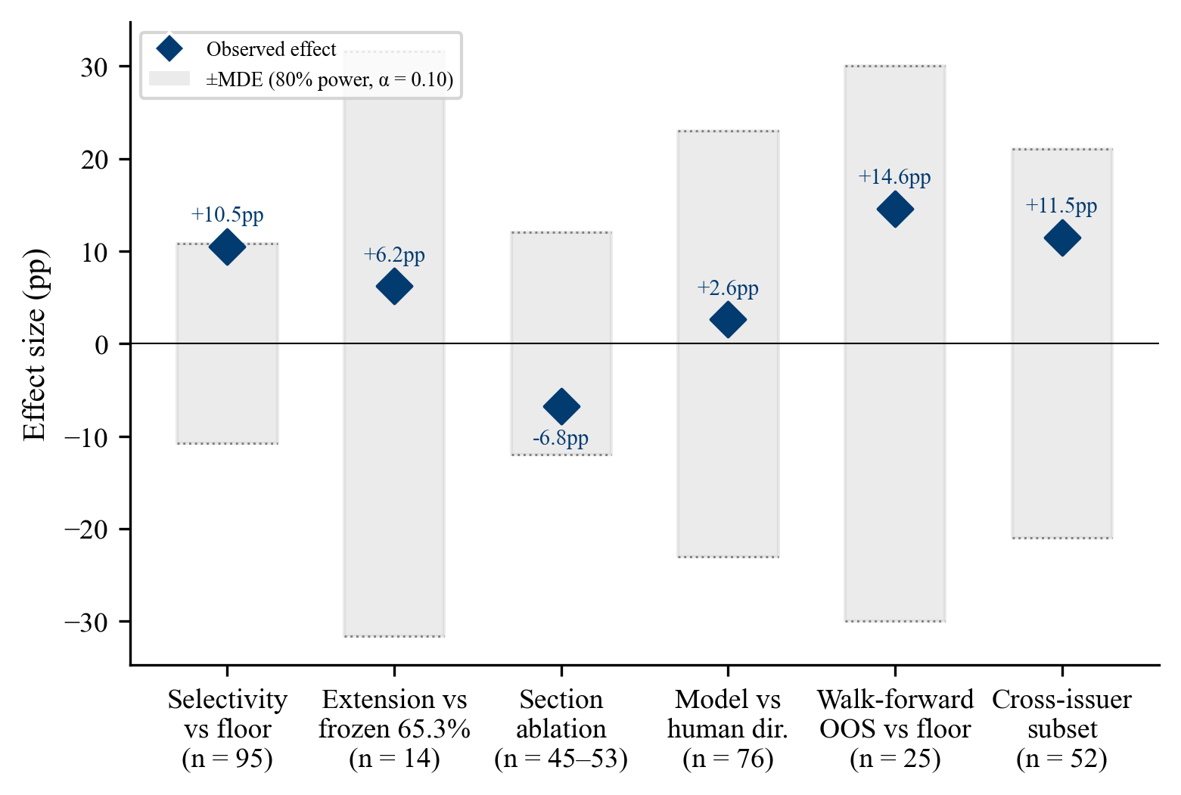
Observed effect against the minimum detectable effect at 80% power for the six comparisons in Table 3, with effective n printed under each. Where the diamond sits inside the shaded band the design could not have resolved the effect. Sources are results_three_sets.csv, surviving_findings.md, effective_sample_funnel.md and section_ablation_paired_diffs.csv.
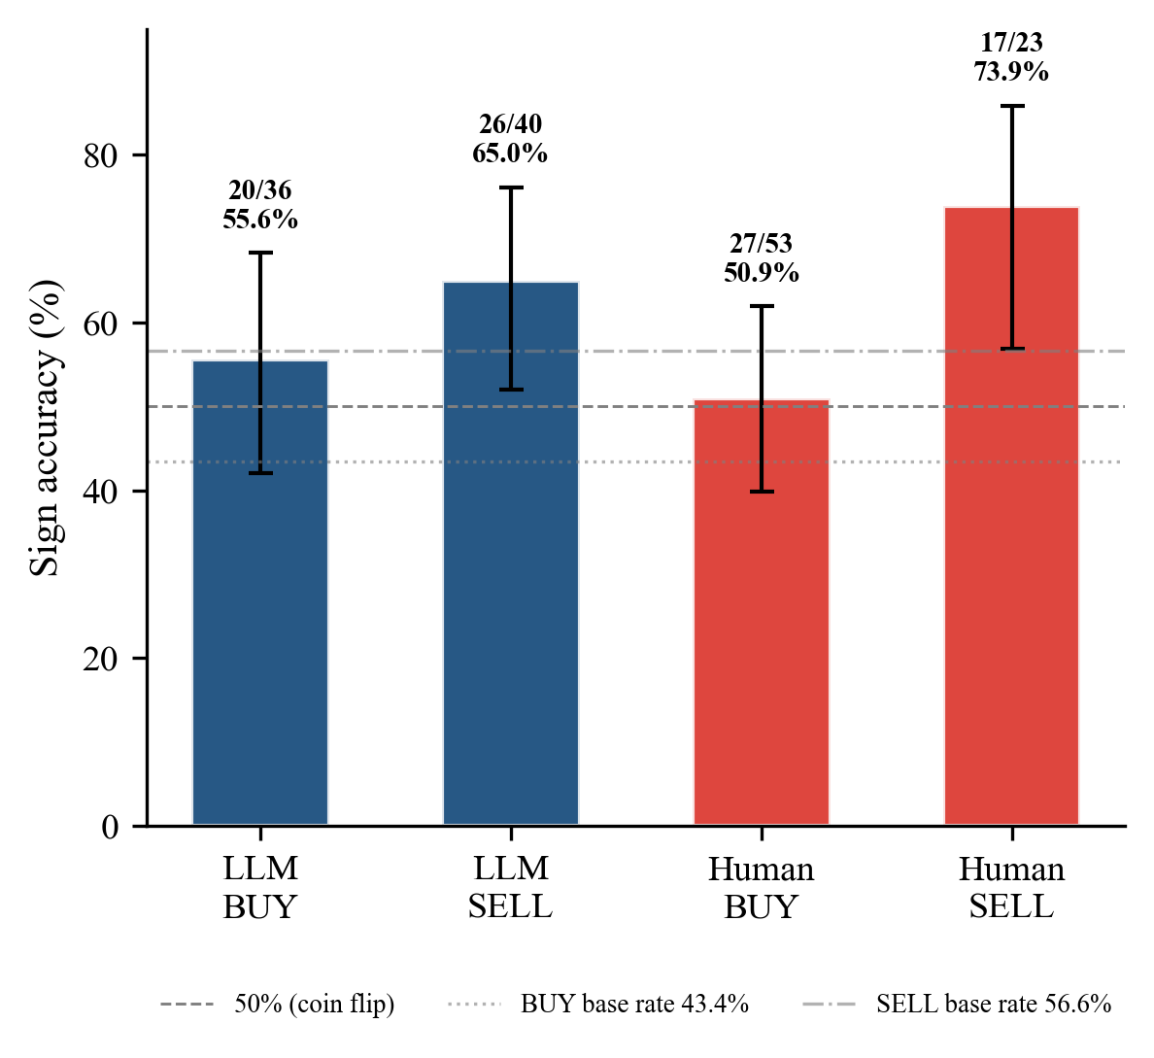
Sign accuracy by direction across 76 paired direction events, graded without a band. Wilson 90% intervals on each bar. Navy is the model arm and red the human arm. Base rates are 43.4% for BUY outcomes and 56.6% for SELL. Source is human_vs_llm_direction_decomposition.csv.
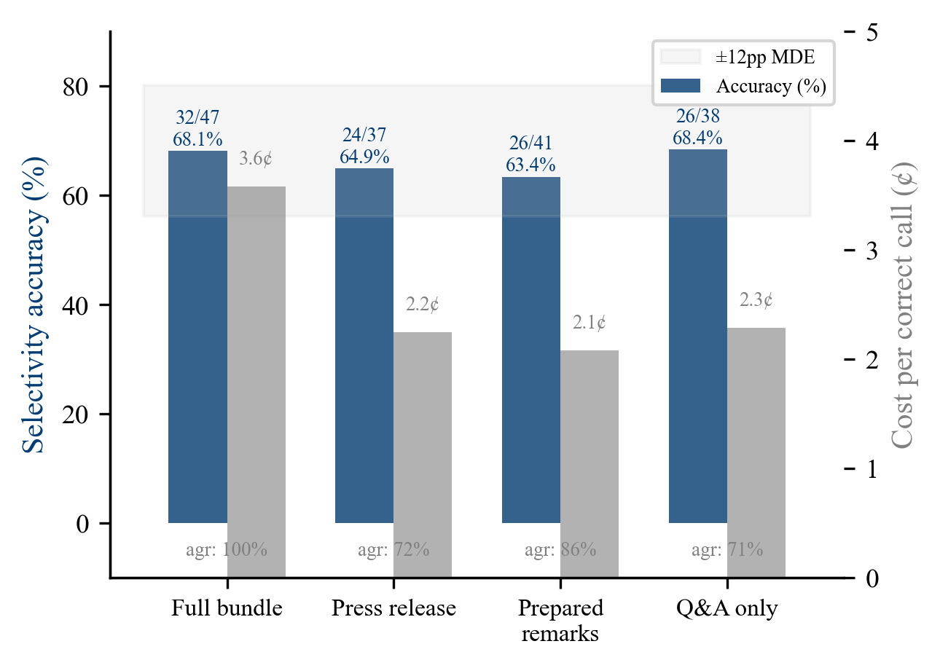
Selectivity accuracy and cost per correct call across the four ablation arms on the 119-graded four-arm set, with agreement against the full bundle printed below each. Strict paired n is 45 for the press release, 53 for prepared remarks and 43 for Q&A. All differences sit inside the plus or minus 12 point MDE. Sources are the three section_ablation output files.
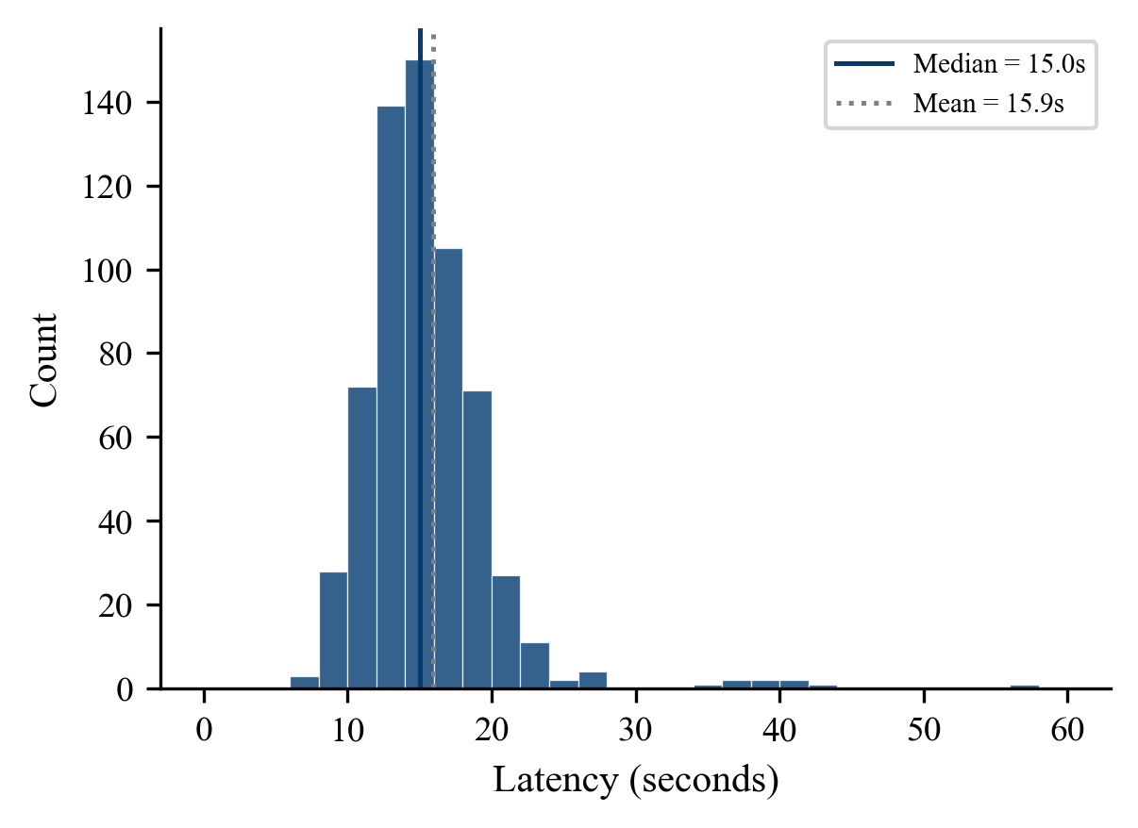
Per-call latency across 624 successful micro-layer calls. Q1 is 12.95 seconds, Q3 is 17.31 and the interquartile range is 4.36. Outliers above 60 seconds are clipped from the histogram. Source is first_run_costs.jsonl across all issuers carrying JSONL logs.
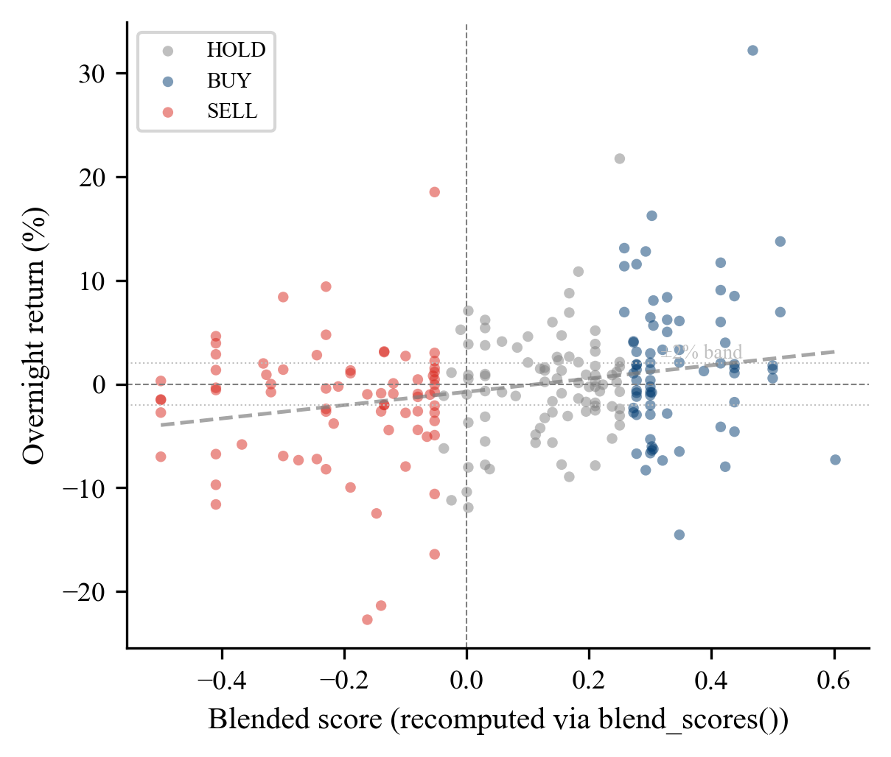
Blended score against realised overnight return for all 233 clean events. Spearman rho is 0.236 at p equals 0.0003. Scores recomputed in the plot script via blend.blend_scores() under the deployed weights. Colour encodes signal direction, navy for BUY, red for SELL and grey for HOLD, and not arm. The trend line is ordinary least squares and is for visual reference only.
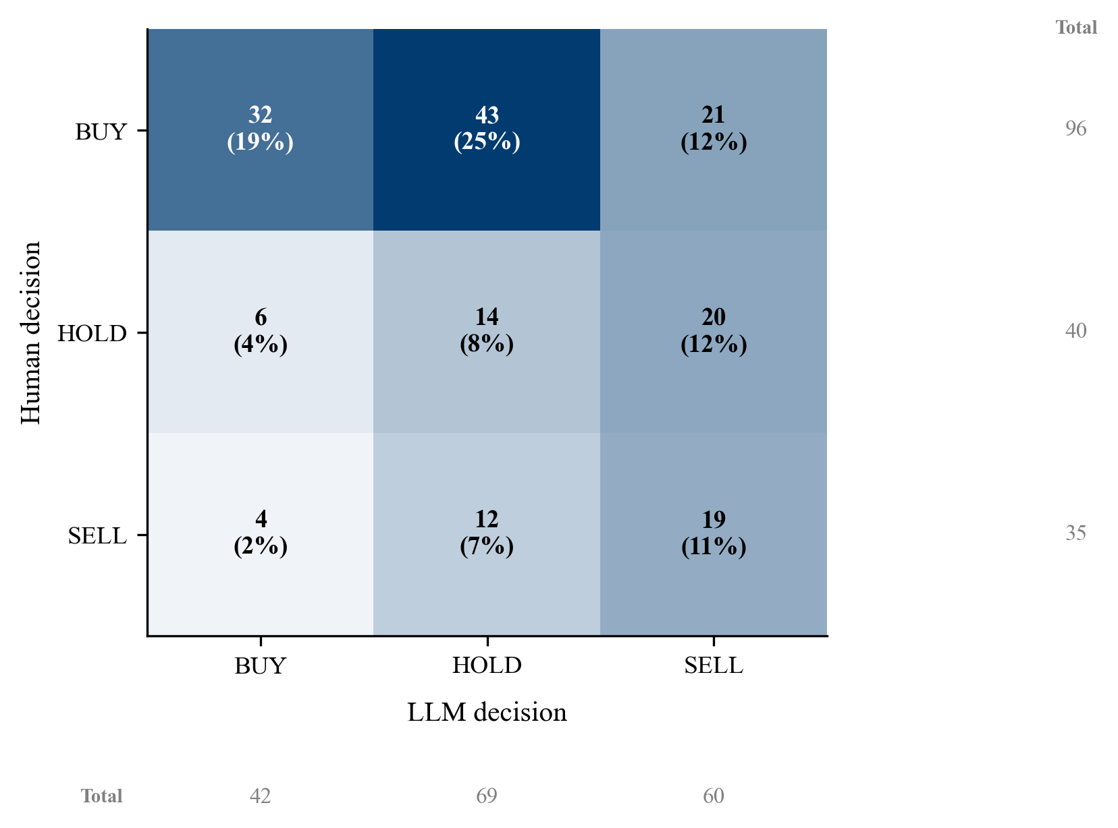
Joint distribution of human and model directional calls across 171 paired events. Cohen’s kappa is 0.109 with a 90% interval of 0.030 to 0.190. Source is kappa_near_independence.csv.
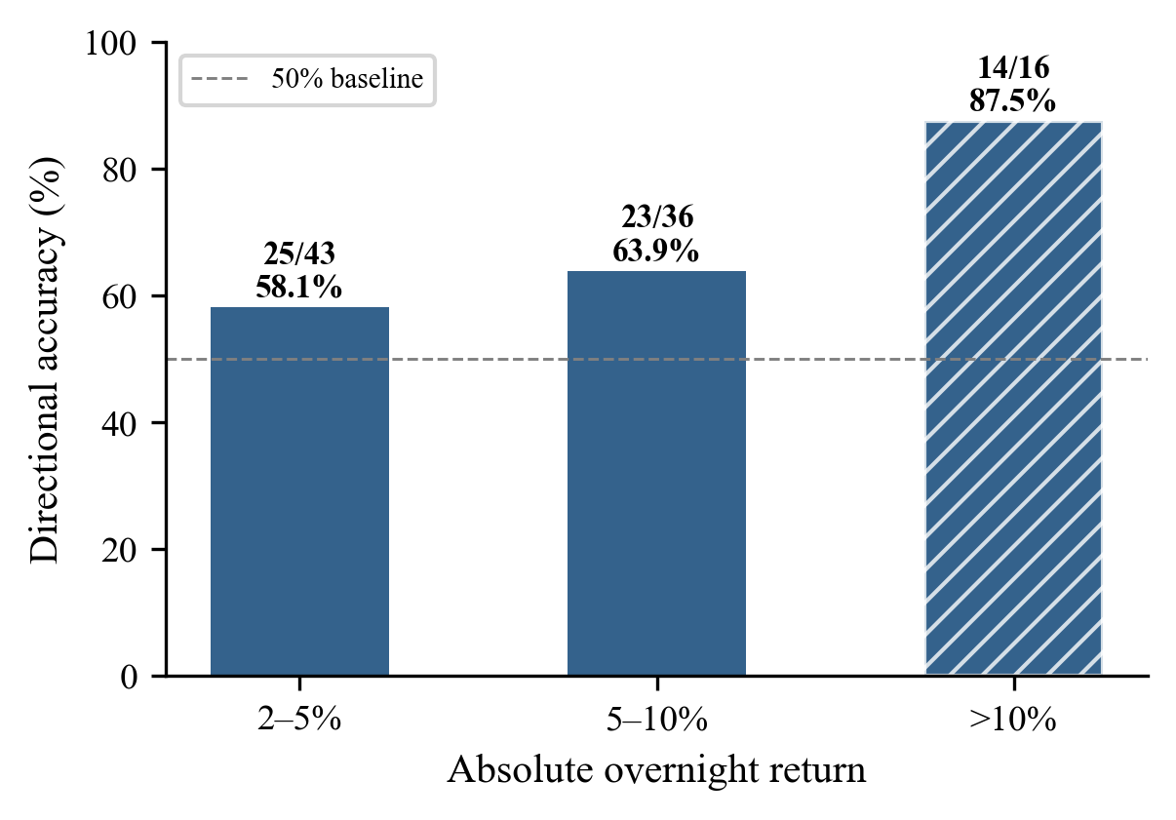
Directional accuracy by size of the realised overnight move across the 95 traded and graded events on the frozen set. The hatched bar rests on 16 events and should be read with caution. Recomputed in the plot script from returns_matrix.csv and global_outcome_calibration_phase2.csv.

