Design strategies for GUI items with touch screen based information systems

Matthew Gleeson

A dissertation submitted for the partial fulfilment of the requirements for the degree of Bachelor of Commerce (Honours) at the University of Otago, Dunedin, New Zealand

12 November 2004

Abstract

Touch screens are a popular method of interaction with information systems embedded in public kiosks and PDAs. Typical information systems are used on desktop PCs and therefore restricted to having a mouse as the selection device used to interact with the system. The purpose of this study is to investigate how effective a touch screen is in selecting typical GUI items used in information systems.
A series of tests were completed involving multi directional point and select tasks. A mouse, being the standard selection device, was also tested so the results of the touch screen could be compared and evaluated against. The GUI items tested were a button, check box, combo box and a text box. The touch screen used was a 17” Magic Touch USB overlay. During the test, data relating to movement time, error rate and throughput were captured.
The results showed that the touch screen overlay was not suitable in terms of selecting small targets with a size of 8mm or less. There was a significant difference between the touch screen and the mouse in terms of movement time and error rate. The touch screen overlay was 15% slower than the mouse and had a 61% error rate compared to the error rate of 2.7% for the mouse. There was no significant difference in throughput between a touch screen overlay and mouse. Both selection devices had throughput of 1.2 bps.
User satisfaction relating to each device was evaluated using responses to a device assessment questionnaire, completed by each participant at the conclusion of the test. The mouse was rated easier to use and easier to make accurate selections with. Both results were statistically significant (p < 0.05). The question regarding arm, wrist and finger fatigue was also statistically significant with the touch screen rated worse than the mouse.
The report concludes with some practical implications of the study; namely that a touch screen overlay used only with a finger is not a practical selection device to use with typical information systems.

Acknowledgements

First and foremost I would like to thank my supervisors, Elaine and Nigel. The field of human computer interaction was quite a new experience for us all and it was with your guys help that I was able to get through it. Nigel, your help and feedback throughout the year kept me on track and in the right direction and I thank you for your support. You also taught when to correctly use ‘affect’ and ‘effect’. Elaine, your help with organising the test and data analysis was invaluable as was your ideas and feedback with the entire study. Co supervising an information science honours student must surely be a first for a nutritionist lecturer.
I would like to thank the guys from the Technical Services Group (TSG), especially Brendon, for the help in setting up the experiments and acquiring the equipment needed. I would also like to thank them for their patience in letting me into the experiment room throughout the testing period. My frequent interruptions must have been frustrating.
To the 24 nutritionists who participated in the tests, I thank you for sitting through what must have been the most boring 45 minutes of your lives.
To the rest of the Info 480 guys, I gained a lot of comfort throughout the year knowing I had group of mates going through the same ordeal. The support and help from you guys should not be over looked and a big thanks goes out to you all.
Last, but not least I would like to thank my family, especially mum and dad. The decision to some back and do honours was not easy. After surviving the year I look back and realise the decision to come back was the right one. I have gained a lot of knowledge and new skills from the year but at the end of the day it was only possible through your constant support (both lovingly and financially).
Contents

I. Introduction 1
1.1 Statement of the Problem and Subproblems 1
1.2 Hypotheses 2
1.3 Delimitations 2
1.4 Definitions of Terms 3
1.5 Abbreviations 4
1.6 Assumptions 4
1.7 Importance of the Study 4
II. Review of the related literature 6
2.1 Introduction 6
2.2 General Information about Touch Screens 7
2.3 Target Sizes 9
2.4 Touch Screens and Target Sizes 12
2.5 Comparing Input Devices 14
2.6 Summary of the Literature Review 20
III. The Research Methodology 21
3.1 Target Size and Position 22
3.2 Participant sample size 27
3.3 Participant user profile 27
3.4 Participant allocation to groups 27
3.5 Ethical Considerations for Participants 28
3.6 Apparatus and Data Collection 28
3.7 Procedure 29
3.8 Questionnaire 31
3.9 Data Analysis 31
IV. Results 33
4.1 Subproblem 1 and 2. 34
4.2 Subproblem 3. 52
4.3 Subproblem 4 and 5. 61
4.4 Other Findings 63
4.5 Summary of Results 66
V. Discussion 68
VI. Conclusion 75
6.1 Hypotheses 76
6.2 Practical Implications 76
6.3 Future Work 77
References 78
Appendix A. Participant Pretest Information Sheet 81
Appendix B. Test Information Sheet 82
Appendix C. Mouse Device Assessment Sheet 83
Appendix D. Touch Screen Information Sheet 85
Appendix E. Ethical Approval Form 87

- List of Tables

Table 3.1 Possible combinations of target properties. 22
Table 3.2 Target sizes used in testing given in mm. 23
Table 3.3 Target sizes used in testing given in pixels. 23
Table 4.1 Statistical methods used in data analysis. 34
Table 4.2 Error rates for the touch screen and mouse across all sizes of combo box for both the one-click and two-click approach. 49

- List of Figures

Figure 2.1 Push button sizes 10
Figure 2.2 Text Box Sizes 10
Figure 2.3 Combination Box Sizes 11
Figure 2.4 Check Box Sizes 11
Figure 2.5 Target Re-entry 18
Figure 2.6 Task Axis Crossing. 18
Figure 2.7 Movement Direction Change. 18
Figure 2.8 Orthogonal Direction Change. 19
Figure 2.9 Movement variability. 19
Figure 3.1 Screenshot of the test with the target in the top left of the screen and the ‘go’ button in the centre. 21
Figure 3.2 Text box sizes used in testing. 24
Figure 3.3 Combo box sizes used in testing. 24
Figure 3.4 Button sizes used in testing. 25
Figure 3.5 Check box sizes used in testing. 25
Figure 3.6 Positions of targets tested. The black box represents the starting point and the red rectangles represent the target positions. 26
Figure 3.7 Screenshot of measurement data captured and stored in Excel. 28
Figure 3.8 The testing environment showing the touch screen, mouse and laptop used. 29
Figure 3.9 The action required to select the combo box. (a) Step 1- the combo box must be first selected to show the list of items. (b) Step 2 - the third item must be selected. 30
Figure 4.1 Mean movement time for the mouse and touch screen 35
Figure 4.2 Movement time for each target type with all devices. 36
Figure 4.3 Movement times for each size across both the mouse and the touch screen. 37
Figure 4.4 Movement times for each target with the mouse and the touch screen. 38
Figure 4.5 The overall throughput for the mouse and touch screen. 38
Figure 4.6 Throughput for each target with all sizes and devices. 39
Figure 4.7 Error rates for both the mouse and touch screen. The touch screen had a much higher error rate compared to the mouse. 40
Figure 4.8 Error rates for each target type with all devices. 40
Figure 4.9 Error rates across each size for the mouse and touch screen. 41
Figure 4.10 Error rates for each target across both the mouse and touch screen. 42
Figure 4.11 Movement times for the text box. 43
Figure 4.12 Throughput for the text box. 43
Figure 4.13 Error rates of the mouse and touch screen devices for text boxes. 44
Figure 4.14 Movement time for the Button. 45
Figure 4.15 Throughput for the button. 46
Figure 4.16 Error rates for the button with the mouse and touch screen devices. 47
Figure 4.17 Movement time for the combo box. 48
Figure 4.18 Throughput for the combo box. 48
Figure 4.19 Movement time for the check box. 50
Figure 4.20 Throughput for the check box. 51
Figure 4.21 Check box error rates for both the mouse and touch screen. 52
Figure 4.22 Learning is displayed for movement time and throughput by device and block for the combo box and check box. 53
Figure 4.23 Learning is displayed for movement time and throughput by device and block for the text box and button. 54
Figure 4.24 Movement time for the combo box adjusted for learning. 55
Figure 4.25 Throughput rates for the combo box adjusted for learning. 56
Figure 4.26 Adjusted error rates for the combo box using the single-click selection approach. 57
Figure 4.27 Adjusted error rates for the combo box using the two-click selection approach. 58
Figure 4.28 Adjusted movement time for the check box. 59
Figure 4.29 Adjusted throughput for the check box. 60
Figure 4.30 Adjusted error rates for the check box. 61
Figure 4.31 The standard deviation of final selection coordinates for the text box. Each graph shows the standard deviations of each distance for one combination of selection device and text box size. 65
Figure 4.32 The standard deviation of final selection coordinates for the combo box. Each graph shows the standard deviations of each distance for one combination of device and combo box size. 66

- Introduction

Today, users of information systems on desktop personal computers (PCs) are limited in their method of interaction with the system. Most information systems are designed to be used with a keyboard and mouse. Although the keyboard and mouse combination is the accepted method of interaction it doesn’t necessarily suit all information systems. Information systems with limited data entry may be more usable through the use of a keyboard and touch screen. Therefore is a mouse the most efficient selection device that can be used with a keyboard when interacting with an information system?
The purpose of this study is to investigate how effective a touch screen is in selecting typical GUI items used in information systems. Two selection devices will be compared; a mouse and a touch screen using three different target sizes. The targets tested are buttons, check boxes, combo boxes and text boxes which are typical of those found in an interface for an information system.
The information system the study will be working with is designed for a project currently being undertaken by the University of Otago Nutrition Department. This project is aiming to improve complementary food diets for toddlers in New Zealand through designing a program that will formulate population-specific food-based dietary guidelines for this high risk group.
The program being used is designed as a rapid assessment decision-making tool, created specifically for nutrition program planners and is developed to assist them in selecting appropriate, improved, home-based complementary foods (Ferguson and Gibson 2004). The testing for the study was run within this program environment.

1.1 Statement of the Problem and Subproblems
Research Problem
To what extent does target type and size affect the ability of a user to select a GUI target? How does this vary depending on selection device used, namely between a mouse and touch screen and what device has the highest user satisfaction when used with the GUI targets?
Subproblems
1. The first subproblem is to determine the effect different target types and sizes have on movement time and error rate when using a touch screen as the selection device.
2. The second subproblem is to determine the effect different target types and sizes have on movement time and error rate when using a mouse as the selection device.
3. The third subproblem is to determine the effect learning has in the study and account for it in the results.
4. The fourth subproblem is to determine the user satisfaction of using a touch screen with typical GUI targets.
5. The fifth subproblem is to determine the user satisfaction of using a mouse with typical GUI targets.

1.2 Hypotheses
The first hypothesis is that larger targets will have better throughput, movement time and error rates than smaller targets for both touch screen and mouse selection devices.
The second hypothesis is that a touch screen will have lower error rates and better speed than a mouse for all four targets and all sizes.
The third hypothesis is that a touch screen will have higher user satisfaction than a mouse for all four different targets studied.
The fourth hypothesis is that learning will occur with the touch screen in terms of improved movement time and accuracy over time.

1.3 Delimitations
Only one type of touch screen will be used as the touch screen input device, i.e. a touch screen overlay and not a monitor will be used in testing. Therefore the effect different touch screen types have on the usability of an information system will not be explicitly studied.
Only one type of mouse will be used as the mouse input device, i.e. an optical mouse will be used in testing. Therefore the effect different types of mouse have on the usability of an information system will not be explicitly studied.

The study does not intend to show how the usability of an information system using a touch screen as an input device can be affected by the amount of data entry required by the information system.

1.4 Definitions of Terms
Desktop PC. The desktop PC is intended for office or home use and supports the day-to-day activities of an organisation’s employees or needs of home users. These computers are fixed in position, they are not portable devices. The desktop PC is the most common type of computer and is found in most organisations.
Error Rate. The error rate is referred to as the number of selections made outside of the intended target. The rate is the number of incorrect selections made compared to the number of correct selections made. For example if there was a 200% error rate, on average there were 2 errors made for every correct selection.
Information System (IS). An Information System is a system that controls and manipulates digital data to produce information according to user needs. Information is gained from manipulation of input data which requires calculations and functionality.
Movement Time. The speed of performance is the time taken to successfully select a target within an information system.
Selection device. A selection device is a physical device that allows a user to point and position a cursor within a GUI and performs selected functions and options.
Targets. In the context of this study, targets are referred to as typical graphical user interface (GUI) items. In particular targets will be referring to text boxes, check boxes, buttons and combo boxes.
Throughput. Throughput is a composite measure of performance of a selection device. It takes into account both movement time and the level of difficulty in selection and is the recommended measure for evaluating selection devices by the standard set out in ISO 9241-9 (ISO 1998).
Touch screen. A touch screen is a computer screen that recognises touch events made on its surface. Thus a user can use touch as a selection device to make selections or move a cursor within a GUI.
Usability. Usability is defined as the extent to which a product can be used by specified users to achieve specified goals with effectiveness, efficiency and satisfaction in a specified context of use. This definition is taken from ISO 9241-9, Part 11 (ISO 1998). The definition is performance oriented which suits the purpose of this study. In particular for this study, usability refers to the number of errors made, task completion time and user satisfaction.

1.5 Abbreviations
Combo Box: combination list box
DPI: dots per inch
GUI: graphical user interface
HCI: human computer interaction
PDA: personal digital assistant
PC: personal computer

1.6 Assumptions
The first assumption. The most common GUI targets are buttons, list boxes, combo boxes and text boxes.
The second assumption. Most information systems have an interface that users can use to interact with the system.
The third assumption. For the purpose of this study, it is assumed that a typical information system requires only limited data entry using a keyboard.
The fourth assumption. Most information systems are used on desktop PCs.

1.7 Importance of the Study
Touch screens are typically used with information systems embedded in public kiosks and PDAs. The reason for choosing a touch screen as the selection device usually stems from the advantages touch screens have such as mobility, ease of use, a fast pointing device etc (Shneiderman 1991). But what about using touch screens with information systems on ordinary desktop PCs? Most current research is focused on using touch screens with computers with unique constraints such as mobility and public access as with PDAs. A real motivation for this study is that prior research (Sears and Shneiderman 1991; Bender 1999) involves testing the effect of target sizes with a touch screen on static arbitrary shapes such as rectangles. Typically findings from this prior research support Fitts’ Law, that larger target sizes have fewer errors and faster movement time to the targets. But findings from prior research performed on touch screen monitors, most of which was undertaken before 1995, cannot be assumed to apply with today’s information systems. Most information systems today are made up of screens containing a mixture of different target types.
In an information system, increasing the size of the targets in an interface containing many targets and many screens will have a drastic effect on screen layout and navigation. Very little research has been done on the use of touch screens with typical information systems on today’s desktop PCs. The focus of this study is on different target sizes and target types and comparing the results between using a touch screen and a mouse as the selection device. Most importantly, this study is performed in an information system environment. That is, testing will be done within a typical information system environment. It is intended that the results from this study will shed more light on how well a touch screen can be used with today’s information systems made up of typical GUI targets compared to a mouse.
Using a touch screen as a selection device for an information system on a desktop PC could have some beneficial implications. The usability of an information system could improve which could lead to improved productivity of employees using the system in an organisational setting. Touch screens could provide better user satisfaction and thus employees are more motivated to use the information system. Touch screens require less physical space and thus the workstation environment in an office setting could be improved, allocating more space to the employee and less to the computer.
It is commonly known that current techniques used with computers change regularly due to technological advancement. The mouse has been the standard selection device used with computers for over a decade now. Could a touch screen be the device to replace it?
This study in a sense is re-visitation of comparing a mouse with a touch screen but with two different important factors. The first is that a touch screen overlay will be used instead of a touch screen monitor. There has been little to no prior research evaluating the selection performance of a touch screen overlay. The second difference is that this study is in the context of today’s information systems and will therefore use typical GUI items in testing.
In the next Chapter the related literature is reviewed. Chapter 3 states the research methodology, Chapters 4 relates to the results of the study and Chapter 5 discusses the important findings from the results. Finally Chapter 6 draws on the conclusions of the study and in particular, the practical implications of the study.
- Review of the related literature

2.1 Introduction
The The literature review aims to cover four sections: (a) general information about touch screens, (b) target sizes, (c) touch screens and target sizes, and (d) comparing different pointing devices.
Section (a) gives an overview of the types of touch screens, touch screen strategies and some advantages and disadvantages of touch screens. Section (b) focuses specifically on current target sizes for today’s GUI interfaces. Section (c) looks at how target size is affected when using a touch screen as the selection device. Finally, section (d) will compare different pointing devices in terms of performance and also investigates relevant issues such as feedback, the ISO 9241 standard and different performance measurements.

2.2 General Information about Touch Screens

Touch screens are best used for point and select tasks (Mayhew 1992). Shneiderman (1991) argues that a touch screen is the most natural pointing device available to interact with computers. A touch screen is also very different to other pointing devices in that it doesn’t use (require) a foreign device. Shneiderman (1991) identifies some advantages a touch screen has to offer over mechanical devices.
- Touching a visual display of choices requires little thinking and is a form direct manipulation that is easy to learn.
- Touch screens have been shown to be the fastest pointing device.
- No extra workspace is required as with other pointing devices.
- Touch screens are durable in public access and in high volume usage.
- Touch screens have easier hand-eye coordination than mice or keyboards.
- Touch screens have high user satisfaction.
Shneiderman (1991) also describes some problems associated with touch screens.
- Users’ hands may obscure the screen.
- Some reduction in image brightness may occur.
- Screens need to be installed at a lower position and tilted to reduce arm fatigue.
- They cost more than alternative devices.
The last problem, cost, is no longer a problem to the extent it was ten years ago when Shneiderman thought of it. The cost today is still greater than other pointing devices but this is continually decreasing.
Another problem raised is that touch screens need frequent cleaning to remove smudges from it (Preece 1993). But there is wide belief that this is in fact not a problem with a touch screen and a study by Sears and Shneiderman (1991) reported that smearing was not a problem within the experiment. During the experiment the touch screen was never cleaned but there was no difference in performance between early subjects of the experiment than with the later subjects, suggesting that smudging and dust accumulation on the touch screen was not a problem.
Types of Touch Screens
A touch screen is an on-display direct pointing device. On-display means that the pointing device interacts with the computer on the computer screen and direct pointing devices are an interaction with the computer in the same three-dimensional plane as the screen (Bender 1999). Light pens are another example of a direct on-display pointing device.
Currently there are five different touch screen technologies available for commercial use. These technologies are capacitive, resistive, infra-red, acoustic and optical. Each technology has its own advantages and disadvantages.
Resistive technology uses a glass or acrylic panel that is coated with conductive and resistive layers. When the screen is operating, electrical currents pass through the screen. When pressure is applied to the screen a change in the electrical current occurs and therefore the touch is registered (Mass Multimedia 2002). The main types of overlay used are 4-wire, 5-wire and 8-wire with 5-wire and 8-wire being much more expensive but 4-wire providing lower image clarity.
Capacitive touch screens have a coating on the surface made up of capacitive material (Mass Multimedia 2002). Circuits are positioned in each of the four corners and measure the capacitance of a touch event using the change of frequency measured to determine the X and Y coordinates of the touch. Capacitive touch screens have very high image clarity but cannot be used with any non-conductive input devices such as pens.
Acoustic wave touch screens have acoustic waves sent over a clear glass screen that consists of transducers and reflectors (Mass Multimedia 2002). When the glass screen is touched, a disruption in the wave signals caused by the wave signals being absorbed cause a touch event to be registered. Acoustic wave touch technology has the highest image clarity and touch resolution but cannot be used by hard objects such as pens.
Infra-red touch screen technology uses the disruption cause by interference (touch) to an infra-red grid positioned in front of the screen to register a touch event. The infra-red grid is comprised of printed wiring boards, on which the opto-electronics are mounted, and is concealed behind an infrared-transparent bezel (a metal frame) (NextWindow 2001). A disadvantage of infra-red touch screen technology is that by using an infra-red grid that sits in front of the screen, the screen itself is completely sealed. But the positioning of the grid can cause touch events to be registered without actually touching the screen.
The optical touch screen technique is a new technology that uses optical imaging techniques to record a touch point (NextWindow 2001). It determines the coordinates of the touch by using an infra-red illuminated frame and custom line scan cameras. This new implementation has an advantage to the infra-red technology previously mentioned because it will register a touch to within 1mm of the screen. This minimises the amount of false touches registered.
Touch screen strategies
The strategy used for selecting targets on the touch screen can affect the number of errors made during this process and hence the accuracy of the touch screen. Three different touch screen strategies were proposed and tested. These were land-on, first-contact and take-off (Sears and Shneiderman 1991).
The land-on strategy only uses the initial touch and ignores any further contact with the touch screen until the finger is removed. Hence dragging is not possible. The second strategy, first-contact, allows dragging and the first object that the finger comes into contact with on the screen will be selected. This has a downfall in that if the finger touches another object in the path of the desired object, that (undesired) object will be selected instead. The third strategy, take-off, is designed to provide more feedback to the user by using a cursor that sits above the finger. To further enhance this strategy, a selection is not confirmed until the finger is removed from the selection.
Research has shown that the most accurate strategy of the three is take-off as the least number of errors is made with this strategy (Sears and Shneiderman 1991). But take-off did incur significantly longer completion times and therefore a trade-off between accuracy and speed in touch screen strategies is seen. Further research has also concluded that the land-on strategy provides better speed for touch screens and but showed there was no difference in accuracy (Bender 1998, as cited by Bender 1999).
The strategy used for a touch screen depends not only on such factors as speed and accuracy but also on the makeup of the screen. For example, an interface that only has large buttons may not benefit from dragging and therefore a strategy such as first-contact may be more appropriate.
2.3

Target Sizes
Since the 1980s much research has been put into developing human interface guidelines. Although the results of the research undertaken by Sears and Shneiderman (1991) showed that touch screens can be successfully used as a selection device and can have advantages over a mouse, even for small targets, these results cannot be simply applied to today’s information systems without further testing. The results from Sears and Shneiderman (1991) have laid the framework for the future potential use of touch screens.
Today’s interfaces are made up of a combination of different targets that could include text boxes, check boxes, combo boxes, list boxes, buttons, labels, tool bars etc. Apple has produced some guidelines for developers to follow when designing interfaces for software (Apple Computer 2004). In particular, for each target three different sizes are given corresponding to large, small and mini. All sizes are given in terms of pixels.

The size in height for push buttons as stated by Apple Computer (2004) for large, small and mini buttons are 20, 17 and 15 pixels respectively (see 1). The size of the width is dependent upon the length of the button’s label.
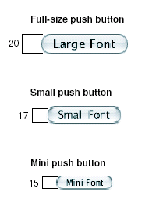
Figure 2.1 Push button sizes (Apple Computer 2004)

The size in height of text boxes for large, small and mini should be 22, 19 and 15 pixels respectively (see 2). The width size is not specified.

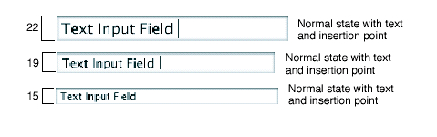
Figure 2.2 Text Box Sizes (Apple Computer 2004)

The size for height of combo boxes for large, small and mini should be 20, 17 and 15 pixels respectively (see 3). Again the width size is dependent upon the length of the longest word within the list.
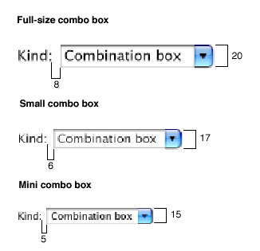
Figure 2.3 Combination Box Sizes (Apple Computer 2004)

The size in height of check boxes for large, small and mini should be 18, 16 and 15 pixels respectively (see 4). The size of the width of the box is usually the same as the height or is otherwise dependent upon the length of the label.
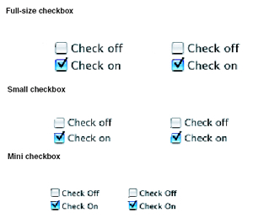
Figure 2.4 Check Box Sizes (Apple Computer 2004)

Bender (1999) cites seven studies supporting the statement that the size of a target will affect the movement time and accuracy in which a user is able to select it using some pointing device. Fitts’ Law, devised by Fitts in 1954, was based upon this theory. Under Fitts’ Law, the movement time between two objects is a linear function of the distance between the targets and the index of difficulty. The index of difficulty is defined as the logarithm of the ratio of twice the distance between two targets and the width of the two targets as illustrated in Equation 1 on page 21 (Bender 1999).
This has major implications for pointing devices such as mouse and touch screens in determining the best interface design for the pointing device used. This will affect both the size and location of buttons and the distance between them on the screen (Preece, Yvonne et al. 2002). Applying this to touch screen interface design will mean target objects of larger size and situated closer to each other will result in a reduction in the time it takes for a user to point to the target object.
A tool was developed by MacKenzie and Soukoreff (1995) based on Fitts’ law. The tool is used for running experiments using pointing devices in point and select tasks and then building Fitts’ law models. Although it is described as highly extensible by the authors, it is very limited is several ways. In relation to the proposed study, the tool only allows experimentation using a limited set of shapes including squares, circles, rectangles and text. Thus it is inadequate for testing on typical GUI items such as combo boxes, text boxes, check boxes and buttons. Combo buttons are vastly different in the method of interaction compared to selecting, for example, a square. Interaction with a combo box requires two steps. First, the combo box must be selected which causes a pull-down list of items to appear, and then an item from within the list must be selected. Test results using the other GUI items mentioned could also vary from testing on arbitrary shapes such as squares. When a button is clicked, the button appears visually to be depressed. When a check box is selected, the state of the check box is immediately changed and when a text box is selected, a cursor appears within the text box. Thus all these targets provide some kind of immediate feedback to the user and as shown by Bender (1999), feedback can have some positive influences upon accuracy when making selections using a touch screen.

2.4

Touch Screens and Target Sizes
It has been suggested by Sears and Shneiderman (1991) that Fitts’ law needs to be adjusted for selection with a touch screen. With a touch screen there is no time spent locating the external pointing device such as a mouse, but the time taken to place the user’s finger on the screen must be accounted for. This is calculated using the size of the target and the distance (in 3 dimensions) between the original position of the hand and the target object. The second modification of Fitts’ Law is the time taken to move the finger to the target, once the finger has been positioned on the screen. When these two modified factors are added together, the total time necessary to select an object using a touch screen is found. One drawback mentioned by Sears and Shneiderman (1991) is that it is difficult to accurately find the distance between a user’s hand and the target object. Therefore this adjusted formula may be hard to apply in practice and will be impractical for the proposed study.
Seven studies cited by Bender (1999) supported Fitts’ Law in that time taken to move to nearer, bigger targets is less than time taken to small, far targets. The findings from Wilson (1995) as cited by Bender (1999) provided further evidence that larger target sizes increased speed and accuracy. The study used two different touch screen target sizes (20 x 20mm and 14 x 14mm) in four different tasks with consistent results over all four tasks. Research conducted by Sears (1993) on the effect keyboard size has on typing rates for touch screen keyboards showed that larger target sizes (keyboard keys) resulted in improved typing rates. Four different keyboard sizes were used ranging from a small keyboard (5.7 x 5.7mm for each key) to a large keyboard (22.7 x 22.7mm for each key). The words typed per minute (WPM) were shown to vary according to keyboard size: 10 WPM for the smallest keyboard to 20 WPM on the largest keyboard. Users were also given the opportunity to express their preferred keyboard size. Users had an overwhelming preference for larger target sizes. Further study by Harada (1996) tested six different key sizes on a touch screen using data entry tasks. The key sizes ranged from 6mm to 39mm and the spacing between keys ranged from 0 mm to 21mm. Results showed the optimum size for keys on the touch screen was more than 21mm (large) and the inter-key spacing should be between 3mm and 6mm
Using larger targets may improve the speed of touch screens but it also consumes a lot of screen “real estate”. Additional windows may be required to display all the objects using larger sizes but this will increase navigation time and complexity. Therefore a trade-off arises between the target size and the number of objects that can be displayed. Wasted screen real estate can be a problem with large target sizes but implementing an effective navigation structure for navigating between screens can offset this drawback. Target sizes then depend completely on the size of the available screen and for devices such as PDAs, the target sizes will be seriously affected. In a study by Scholtz (1997), the design of a Personal Information Manager (PIM) was described. The PIM was the size of a credit card and used a touch screen as the method of input control. The very limited screen size meant that target sizes needed a sizing of about 5mm high by 4mm wide. In this case it was seen that users preferred using a single key-pad with small buttons and risk a high error rate compared to navigating through multiple keypads with bigger button sizes. It was shown in a study by Sears and Shneiderman (1991) that touch screens have advantages in selecting targets with a size of just 4 pixels (about 2mm). The study used touch screen monitors and showed touch screens can be used with small targets.
2.5
Comparing Input Devices
The International Standards Organisation has released a standard ISO 9241-9 called Ergonomic design for office work with visual display terminals (VDTs) (ISO 1998). In particular, part 9 of this standard describes different tests that can be used to evaluate one or more pointing devices. The standard describes a serial point and select task and recognises a dependent measure used with this test. The serial test includes moving the cursor back and forth between two targets using the pointing device and selecting each target by pressing and releasing a button on the pointing device. One disadvantage of this approach is that only two targets are used in the test and therefore interactions between more than two targets, which is usually the case in an information system interface, are not studied.
The dependent measure described by ISO 9241-9 is throughput. Throughput is noted by MacKenzie and Jusoh (2001) as being a very important measure as it reflects the efficiency of the user completing the task and it is a measure of both speed and accuracy. The formula for calculating throughput is given in Equation 1.

Throughput = ID_{e} / MT
where ID_{e} = log₂( D / W_{e}+ 1)
Equation 1. Formula for calculating throughput as specified in ISO 9241-9.

ID_{e} represents the index of difficulty and is defined in terms of bits whereas movement time (MT) is defined in terms of seconds. Therefore the throughput is measured in bits per second (bps). D represents the distance to the target. Throughput is used by the ISO 9241-9 standard as the performance measurement (ISO 1998).
W_{e} is the effective width and differs from the width of the target. It reflects the spatial variability in the sequence of trials. The formula for calculating effective width is given in Equation 2

W_{e} = 4.133 x SD_{x}
Equation 2. Formula for calculating effective width.

SD_{x} is the standard deviation of the selection coordinates measured along the path to the target. The standard doesn’t provide any explanation on what range of index of difficulty values should be used in testing and so MacKenzie (1999) have recommended using a range from 2 to 6 bits.
The standard also argues that this is not enough assessment for a full evaluation of a device and also recommends assessment of effort and comfort of the device through questionnaires MacKenzie (1999). However, effort measurement requires sophisticated equipment and a technician for measuring biomechanical load and therefore was left out of the study performed by MacKenzie (1999). For the same reasons it was also left out of this study. MacKenzie (1999) also state that the error rate, defined as the number of incorrect selections made, was left out of the ISO standard 9241-9 but recommend computing both movement time and error rate separately. This is reinforced by the fact that other studies include error rate as a separate dependent measure of accuracy (Sears and Shneiderman 1991; Sears 1993; Harada 1996; Bender 1999; MacKenzie 1999; MacKenzie and Jusoh 2001; Booth 2004).
Another problem with ISO 9241-9 as concluded by MacKenzie (1999) is that it does not take into account the effect due to learning. MacKenzie (1999) recommend that input device studies should apply a repeated measures paradigm and test for learning effects. The effects of learning have been shown to affect movement time and accuracy (MacKenzie 1999). In another study by MacKenzie (1991), the results from the first out of five sessions were removed from the results as the movement time was seen to be significantly higher with these first sessions. This can be explained as a result of learning and provides further evidence that studies should take into account and test for learning.
Prior to the ISO 9241-9 standard being released, much research was undertaken into pointing devices and comparing between them. Typically these studies compared speed and accuracy between different pointing devices. Research was undertaken by Sears and Shneiderman (1991) to evaluate the speed of performance, error rates and user preference between a touch screen and a mouse as selection devices. Four different target sizes were tested: 0.4 x 0.6 mm, 1.7 x 2.2 mm, 6.9 x 9.0 mm, and 13.8 x 17.9 mm respectively. The results showed that for targets that had a size of 1.7 x 2.2 mm (which is approximately one quarter the size of a character) or greater, a touch screen was faster than a mouse while the accuracy remained the same between the two. For the 0.4 x 0.6 mm target size, the mouse was better for both error rate and speed. Users had a preference for using the touch screen over the mouse. This has great implications for applications as a touch screen is faster than the traditional mouse for selection of targets that could be as small as single characters. The results from the study by Sears and Shneiderman (1991) provided the basis for the current study although this study will focus on specific GUI items rather than arbitrary shapes. As well, a touch screen overlay will be used instead of a touch screen monitor as was used in the study by Sears and Shneiderman (1991).
In contrast with these results, two desktop mice were tested against two remote pointing devices using three different target sizes and were shown to have both better speed and accuracy (MacKenzie and Jusoh 2001). Two different remote pointing devices were used, GyroPoint and RemotePoint. Both devices had the notion of pointing (similar to touch screens), allowing users to point to desired targets to make their selection but from a distance away from the screen. The results from the study showed that both desktop mice had better speed and better user preference compared to remote pointing. MacKenzie notes two important factors that could influence the results. Remote pointing and desktop pointing are very different in nature in terms of interaction styles and psychomotor issues. This problem does not exist to the same extent with touch screens as the notion of pointing and selection using only a finger comes very naturally to the user. The second issue is that testing using the remote devices meant the user had to be a certain distance away from the screen and therefore the user would not be able to see the targets as well as when testing using the desktop mouse. Again this would not be an issue when testing with touch screens as the user would always have to be close to the screen.
The results from the studies described above show contrasting results in terms of what pointing device offers best speed and accuracy. It is of great importance then that when comparing results from pointing device studies, the testing conditions within the studies are as similar as possible. The measure of throughput, described in equation 1, is becoming a more important measure as it accounts for different difficulty conditions in tests. In a study by MacKenzie (1999), a joystick had better throughput of 2.15 bps (2.33 bps taking into account learning) compared to a touchpad with 1.70 bps (1.94 bps taking into account learning). Three different target sizes were used (2, 5 and 10 mm) with three varying distances (40, 80 and 160 mm). One-direction and multi-directional tests were carried out. The results from this study showed that a joystick was 17% faster than a touchpad in terms of pointing time. Not only do we see the effects that learning can have on results but these throughput results can also be used as a base for comparison.
A mouse can have throughput of 4.15 bps as shown in a study by Douglas and Mithal (1994). Throughput for touch pads were found to be significantly lower compared to results on other input devices, including touch screens. Three different touch pad strategies were studied by MacKenzie and Oniszczak (1998) with throughput results ranging from 0.99 to 1.43 bps, significantly lower than throughput for a mouse, joystick and other input devices. Other studies also support these throughput ranges. A study by MacKenzie (1991) compared three devices (mouse, tablet and trackball) using four target sizes (8, 16, 32 and 64 pixels) over two different types of tasks: pointing and dragging. The results of the performance indices were 4.9 bps for tablet and 3.3 bps for trackball. A mouse had throughput of 4.5 bps which holds with the previous result of 4.15 bps from the study done by Douglas and Mithal (1994). Thus the results from this study support the results from Sears and Shneiderman (1991) that a touch device (i.e. a tablet) can have better performance than a mouse.
It must also be noted that the performance index (throughput) was calculated from the slope reciprocal in the regression model given in :.

MT = a + b x ID_{e}
Equation 3. Formula for calculating the regression model of movement time.

The formula in Equation 1 includes coefficients for the intercept, a in ms, and the slope, b in ms/bit (MacKenzie and Jusoh 2001).
According to MacKenzie and Jusoh (2001) this method of calculating throughput may weaken the results for comparing across studies and is not the calculation method as described in the ISO 9241-9 standard. This means that we may not be able to “compare apples with apples” and must be careful in comparing the results of this study with results from other similar studies.
A study by Booth (2004) also used the method Equation 3 for calculating throughput (Booth, Fisher et al. 2004) and therefore caution is needed again in comparing the results of this study. Part of the conclusion from the study was that physically direct interactions should be preferred over less direct interactions such as mouse pointing (Booth 2004). The study compared mouse and touch screen based selection of targets that were located in the upper visual field (UVF) and lower visual field (LVF), which are the two vertical hemi fields of the of human eye’s visual field. Again the study used four different target sizes (8x8, 16x16, 32x 32 and 64x64 pixels) and four distances between targets. The results were consistent with other studies showing that touch screen had better movement time and accuracy and that for both mouse and touch screen, targets with higher indices of difficulty were more difficult to select. Booth (2004) also states in the discussion of results that the user’s process perceived information differently depending upon the selection device used which means that perceived location of targets is more important for a touch screen than with a mouse.
The study was only conducted with 9 participants and therefore this must be taken into account when interpreting the results (twelve participants per test variable should be used (MacKenzie 1999).
More accuracy measures
While the most common performance measures in pointing device testing (movement time, error rate and throughput) may give a good indicator of pointing device performance, they do nothing for explaining the differences in results between devices. MacKenzie (2001) has proposed seven new accuracy measures that will provide more detailed information about the performance of pointing devices.
Target Re-entry (TRE) calculates how often the pointer enters the target region, leaves and then re-enters the target region as demonstrated in 5.
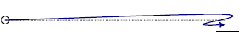
Figure 2.5 Target Re-entry (MacKenzie 2001)

Task Axis Crossing (TAC) measures the amount of times a pointer crosses the ideal path in selecting a target and is demonstrated in Figure 2.6.

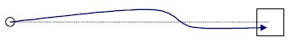
Figure 2.6 Task Axis Crossing (MacKenzie 2001).

Movement Direction Change (MDC) measures how much the pointer’s path changes in relation to the task axis and is closely correlated to TAC. MDC is demonstrated in Figure 2.7.
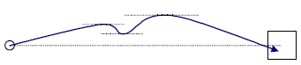
Figure 2.7 Movement Direction Change (MacKenzie 2001).

Orthogonal Direction Change (ODC) is a measure of the amount of direction change along the axis orthogonal to the task path. This measure is illustrated in Figure 2.8.

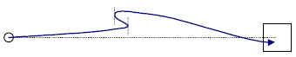
Figure 2.8 Orthogonal Direction Change (MacKenzie 2001).

The above four measure are used to calculate the pointer path accuracy. The following additional methods are continuous measures. Movement Error is the mean deviation of the pointer path from the task axis. This is irrespective of whether the points are above or below the axis. The second continuous measure proposed by MacKenzie (2001) is that of Movement Offset. Movement Offset measures the mean deviation of the pointer path from the task axis assuming the task axis is y = 0. The last continuous measure is that of Movement Variability (MV). It reflects how much deviation there is in the actual path taken away from the straight selection path to the target. This is demonstrated in 6


Figure 2.9 Movement variability (MacKenzie 2001).

These measures are the seven proposed by MacKenzie (2001) and could be of great value in this study in further explaining the differences in accuracy between the two selection devices. Accuracy measures can help explain why some input devices are more efficient than others. But due to their complexity in implementing they were not used in this study.
Feedback
The final aspect of past research that is applicable to the proposed study is that of feedback. Feedback is becoming a very important method of improving touch screen performance compared to mechanical keys such as a keyboard or mouse. When using a mouse, by physically clicking the mouse button the user knows a selection was made. It is similar with keyboards. By physically pushing down on a key, information is emanated from the body and the central nervous system is aware a selection was made. Interaction with a touch screen provides very little proprioceptic (immediate physical) feedback to the user, so other methods of feedback such as visual and auditory methods must be used. A study by Bender (1999) set out to determine the affect of auditory feedback and target size with touch screen performance using ten-key entry. Auditory feedback was defined as a 1000 Hz sine wave and presented at 65 dBA for durations ranging from 12.5 ms to 800 ms. Two target sizes (10 x 10 mm and 30 x 30 mm) were used along with the auditory feedback but no visual feedback was given. The results suggested that auditory feedback is not required with the use of large targets. Target acquisition can be easily verified with large targets by a quick visual check that the cursor is within the boundary of the target. This cannot be done with small targets. But auditory feedback between 50 and 400 ms can reduce the number of errors made with small targets. Contact time and movement time was largely unaffected by auditory feedback.

2.6 Summary of the Literature Review
Touch screens are best used for point and select tasks (Mayhew 1992).They provide many advantages over traditional mouse pointing devices such as less workspace required, easier hand-eye coordination and higher user satisfaction (Shneiderman 1991).
Fitts’ law is an accepted quantifiable model that states that larger targets will have less movement time for pointing devices to select them. Past research into pointing devices supports Fitts’ Law in terms of larger target sizes having increased speed and better accuracy, not only with touch screens but with all pointing devices. A touch screen can have better movement time and accuracy than that of a mouse for targets as little as 2mm (Sears and Shneiderman 1991). This provides the basis for the proposed study in that while touch screens have been shown to have better movement time and accuracy compared to a mouse, there has been very little testing with typical GUI items such as buttons, check boxes, list boxes and combination boxes. Feedback can have positive effects on accuracy with touch screens (Bender 1999). This has direct implications for the proposed study as all four GUI items to be tested in the proposed study (buttons, check box, text fields and combination boxes) provide immediate visual feedback.
The ISO standard 9241-9 provides methods for measuring and comparing different pointing devices (ISO 1998). Throughput is the measurement described by the standard and provides a sound basis for comparing results over different pointing devices, and different studies (assuming the study design and test conditions are similar). The standard does suffer from some flaws such as not accounting for learning and using only throughput as the quantitative measure of performance (MacKenzie 1999). But these limitations can be overcome by calculating movement time and error rate in the proposed study as well as designing the tests to be completed in blocks so the effects of learning can be adjusted for (MacKenzie 1999).
- The Research Methodology

An experiment was carried out from August 15 to September 10, 2004, to test the effect of size for different selection targets with different selection devices. The test consisted of completing a series of simple point and select tasks. Small, medium and large sizes were tested for a combo box, text box, check box and button. The selection devices tested were touch screen and mouse. The test was multi-directional meaning that the target appeared in more than one direction to the user. Thus targets appear on different angles from the initial position. Different sizes, angles and distances were used for each target position.
The test consisted of a screen containing a button in the middle and a target for the user to select as illustrated in Figure 3.1. When the participant clicks on the centre (‘go’) button, a trial is started and a target appears on the screen. The trial is ended when the participant successfully clicks the target, which causes the target to disappear. The time taken between clicking the go button and successfully clicking on the target is recorded as well as the number of errors made during the trial. The final coordinates of the successful click of the target are recorded in order to calculate the effective width used in the throughput measurement calculation as stated in Equation 1.
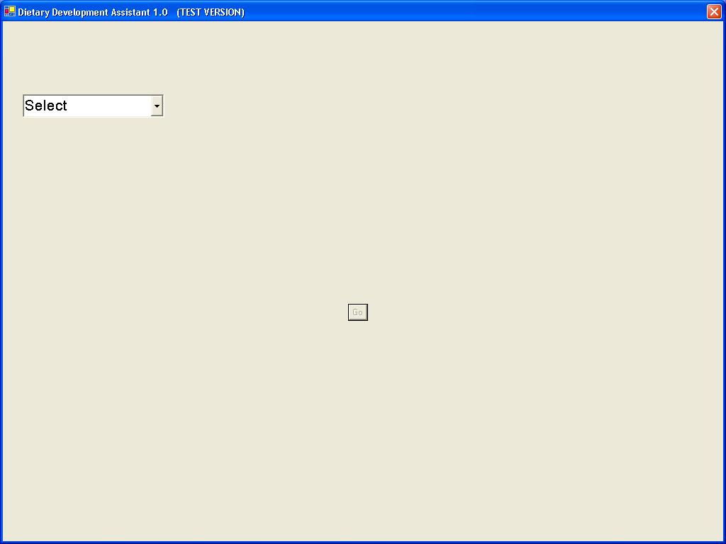
Figure 3.1 Screenshot of the test with the target in the top left of the screen and the ‘go’ button in the centre.

Combinations of target, distance and angle were presented randomly to the participant, as shown in Table 3.1. The ordering of the target size was deliberately set to large, medium and lastly small to compensate for learning.
Table 3.1 Possible combinations of target properties.
Target |  | Angle |  | Size |  | Distance
Combo Box |  | 45° |  | Small |  | 40 mm
Text Box |  | 135° |  | Medium |  | 80 mm
Button |  | 225° |  | Large |  | 160 mm
Check Box |  | 315°

Each target therefore had four angles, three sizes and three different distances giving a total of 36 different combinations per target type. Four angles were used so the target appeared in different areas of the screen. Using four angles meant that targets could be tested in 90 degree blocks and gives a good range of screen positions for the target. To mimic reality more closely, the angles were adjusted so they did not represent simple horizontal or vertical straight lines. The first angle was not 0 but instead 45°C with 90° increments used there-on. The aim of this was to mimic real life user interface target selection, where targets are situated in different areas of the screen and therefore selections are made in more than one direction. More angles could have been tested, such as eight angles used in MacKenzie (1999) but the number of combinations to be tested grows beyond what was feasible for the study. After careful consideration it was deemed that dividing the screen real estate into four equal areas would be sufficient for testing purposes.

3.1 Target Size and Position
The sizes of the different targets are adjusted values taken from the guidelines set out by Apple Computer (2004). The size has been given in both millimetres (mm) and pixels in Table 3.2. The primary unit of measure used in the study is millimetres because pixel sizes can vary depending on screen resolution. The sizes outlined in pixels in Table 3.3 below have been converted from millimetres using the formula given in Equation 4 and assuming a screen resolution of 81 dots per inch (DPI).

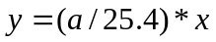
where:
y = size in pixels
x = size in millimetres
a = DPI
Equation 4. Formula for converting mm to pixels.

The three different target sizes that will be tested are given in mm and summarised in Table 3.2.
Table 3.2 Target sizes used in testing given in mm.
Target | Large (width x height) | Medium (width x height) | Small (width x height)
Text Box | 63mm x 11mm | 55mm x 8mm | 47mm x 6mm
Combo Box | 63mm x 11mm | 55mm x 8mm | 47mm x 6mm
Button | 28mm x 13mm | 24mm x 9mm | 17mm x 6mm
Check Box | 9mm x 9mm | 6mm x 6mm | 4mm x 4mm

shows the sizes of the targets in pixels based on a screen resolution of 81 dpi.

Table 3.3 Target sizes used in testing given in pixels.
Target | Large (width x height) | Medium (width x height) | Small (width x height)
Text Box | 200 pixels x 35 pixels | 175 pixels x 25 pixels | 150 pixels x 19 pixels
Combo Box | 200 pixels x 35 pixels | 175 pixels x 25 pixels | 150 pixels x 19 pixels
Button | 90 pixels x 41 pixels | 76 pixels x 29 pixels | 54 pixels x 19 pixels
Check Box | 29 pixels x 29 pixels | 20 pixels x 20 pixels | 12 pixels x 12 pixels

Figure 3.2 shows the actual sizes of text boxes that were tested.
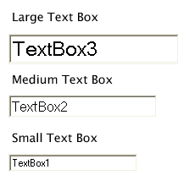
Figure 3.2 Text box sizes used in testing.

Figure 3.3 shows the actual sizes of combo boxes that were tested.
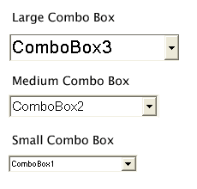
Figure 3.3 Combo box sizes used in testing.

Figure 3.4 shows the actual sizes of buttons that were tested.
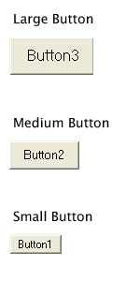
Figure 3.4 Button sizes used in testing.

Figure 3.5 shows the actual sizes of check boxes that were tested. The size of the tick box remains the same but the surrounding grey area is larger for the larger size check boxes. Clicking on the surrounding area has the same effect as clicking on the white tick box.
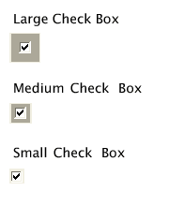
Figure 3.5 Check box sizes used in testing.

Three distances were used and again the sole purpose of using varying distances was to randomise the positioning of the target on the screen during testing. The distances of 40mm to 160mm were used because they represented target positions ranging from close to the initial go button to near the edge of the screen. Thus the distances represented very near and very far away from the initial starting point. Figure 3.6 illustrates the twelve different target positions of the targets tested.
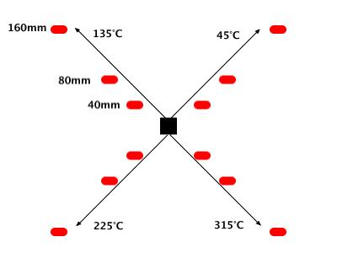
Figure 3.6 Positions of targets tested. The black box represents the starting point (“go” button) and the red rectangles represent the target positions.

The entire test was divided into six blocks. Each block contained every possible combination for every target type, so there were 144 trials in each block and the complete test consisted of a total of 864 trials (six blocks of 144 trials). The purpose of dividing the test into blocks was two-fold. Learning has been shown to affect the results of select and point tasks and should be adjusted for if need be. It also meant that the participant could rest in between blocks.
To summarise the test design, a mixed design was used with the selection device as a between-subjects factor. The independent (between-subject) variables were:
- Target Type (text box, combo box, button and check box)
- Target Size (large, medium and small respectively)
- Target Distance (40mm, 80mm and 160mm)
- Target Angle (45°C, 135°C, 225°C and 315°C)
The index of difficulty was ascertained for each task using the combination of the distance and width. This showed that the test had a range of Fitts’ Index of Difficulty values from 0.7 bits (63mm width and 160mm distance) to 5.4 bits (3mm width and 40mm distance). The index of difficulty was calculated using non-adjusted width.
The measurement data needed for analysis were extracted from each test and were stored in a Microsoft Excel worksheet. This included measurement time, number of errors made and final selection coordinates for each trial. Additional data about the selections made on the combo box were also stored to account for the selection approach of the user, whether it be a one-click or two-click approach. A one-click approach involves the user selecting the combo box and then the desired item within the popup list with one click. The two-click approach assumes the user takes one click to select the combo box and a second click to select the desired item in the popup list. The data from the results of the questionnaire are quantitative and will be used to assess user comfort and satisfaction with the selection device and the targets.

3.2 Participant sample size
A participant sample size of 24 was used for testing. Specifically, to perform usability testing where the goal is to identify problems within a system, 3-5 participants in each group is adequate (Dumas and Redish 1993). To perform inferential statistical tests of significance such as t-tests, more participants are needed (Dumas and Redish 1993). Twelve participants per testing device is required in order to achieve a reasonably tight confidence interval on the results (Neilsen 2001). Thus total participant size of 24 was required to test the mouse (n=12) and touch screen (n=12).

3.3 Participant user profile
Before participants were selected a participant profile was created. This included such factors as experience with programs similar to the one being tested, prior computer experience, whether or not the participant was a typical user of the system being tested, etc. (Dumas and Redish 1993). For this experiment, no age restriction was set, minimum previous computer experience was required and minimal experience with at least one of the selection devices was a condition of participation. The participants were also required to not have any disability that could impact on their results. Although the gender of the participants should ideally be half female and half male (Preece, Yvonne et al. 2002), results from gender differences were excluded from this study and therefore this requirement was ignored. Because the testing was done within the nutrition program environment described earlier, the participants were all nutritionists (typical users of the program). There were 87.5% female and 12.5% male participants with all having a university level of education.

3.4 Participant allocation to groups
The allocation of groups was based upon the results of a pre-testing questionnaire completed by each participant prior to testing (see Appendix A). The purpose of the questionnaire was to establish the level of computer, mouse and touch screen experience of each participant. A participant was allocated to a selection device group depending on what device they had the least amount of experience with. It was found that all participants had the most experience with a mouse and participants with least amount of experience with the touch screen were placed into the touch screen group.
The advantage of testing a participant with one device only is that ordering effects are eliminated in a participant using one device before another. Participant testing times were also shorter and the results cannot be biased by participants comparing one device with another when answering the questionnaire.

3.5 Ethical Considerations for Participants
The study was subject to several ethical considerations. The major ethical consideration included participant confidentiality and as such the study gained Level B ethical approval at the University of Otago’s Ethics Committee. Requirements for gaining ethical approval can be seen in the ethical approval form in Appendix E.
All participants signed consent forms after reading an information sheet detailing the aim of the study, the requirements of the participants, the data being collected and what the data would be used for. The consent also stated the participant’s right to withdraw from the study and confidentiality considerations relevant to the participants. Each participant was assigned a random number for ethical reasons. The participant numbers were taken from random number tables and assigned to each participant by a third party.

3.6 Apparatus and Data Collection
Software written in Visual Basic.Net with Microsoft Studio 2003 was used to implement the test. Each test was connected to a Microsoft Excel worksheet and the relevant measures (movement time and number of errors, etc.) were captured using the software and written to the worksheet as illustrated in Figure 3.7.

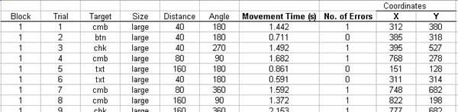
Figure 3.7 Screenshot of measurement data captured and stored in Excel.

The touch screen used in testing was a 17” Magic Touch USB overlay Model KTMT-1700-USB-M. This touch screen uses a lift-off touch strategy. It must be emphasised at this point that the touch screen used for testing was an overlay touch screen and not a touch screen monitor. A touch screen overlay is a piece of equipment external to the monitor. It sits in front of the monitor and behaves similarly to a touch screen monitor. Using an overlay results in a gap between the overlay and the screen itself, this causes a slight discrepancy between where the user touches the overlay and where the cursor is positioned on the screen.
The touch screen overlay was fitted to a Dell 15” Flat Panel Model E151FPb monitor. A flat panel monitor was chosen because it was noticed during pre-testing that typical CRT monitors with rounded screens caused a gap between where the users touched the screen and where the cursor gets positioned. A flat panel is less likely to suffer from this problem. The device used for testing the mouse was a Dell PS/2 Optical Mouse Model M071KC. Both devices were connected to a Dell Inspiron 7500 laptop computer which ran the testing software.
Testing took place in an isolated room so that the participants were free from any outside distractions. The room consisted only of a desk with the touch screen, mouse and computer situated on it as can been seen in Figure 3.8.
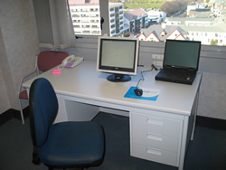
Figure 3.8 The testing environment showing the touch screen, mouse and laptop used.

3.7 Procedure
Testing was restricted to one participant at a time and therefore the day and time each participant carried out the test was pre-arranged. The participant was initially given an introduction to the test by the research observer. The introduction included a brief summary of the aims of the study and what the test involved. The participant was also given and instructed to read an instruction sheet which they had access to throughout the duration of the test (see Appendix B). After reading the instruction sheet the participant had the opportunity to ask questions or raise any issues.
Participants were instructed to complete each block as quickly as possible without losing accuracy. In between blocks, participants were given the opportunity to rest for as long as they wished. It was made clear to the participant that a trial was only complete once the target was successfully selected. Selecting the button, check box and text box required the participant to simply click on the target. The strategy required to select a combo box was different. A combo box is a two-step target compared to the other targets which were simple one-step targets. First the combo box must be selected in order to show the list of items and then an item from the displayed list must be selected. During the testing the participant was instructed to always select the third item in the list when selecting a combo box as illustrated in Figure 3.9.

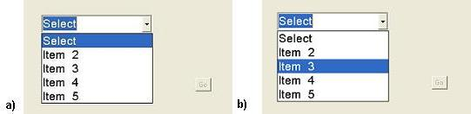
Figure 3.9 The action required to select the combo box. (a) Step 1- the combo box must be first selected to show the list of items. (b) Step 2 - the third item must be selected.

The participant was then instructed to complete a practice task involving fifteen random trials of the same point and select tasks used in the test. The aim of this practice task was to eliminate any effect prior experience could have on the test results as well as to familiarise each participant with their selection device. This brought all participants to a minimal level of experience with their selection device as well as interacting with the targets being tested, including how to make a correct selection for a combo box.
After completing the practice section, the random number assigned to the participant was entered into the system and the research observer left the room. At this point the participant began the test. When a block was completed a message appeared informing the participant that they could rest before continuing with the next block of trials. At the conclusion of the sixth block, another message appeared informing the user that the performance part of the test was finished. The total six block test was designed to take between 30-40 minutes to complete.
The final requirement of the participant after the test was to immediately fill out a questionnaire (described below) relating to the selection device used. The testing software automatically saved the data extracted from the test and therefore after completing the questionnaire, the participant had finished their involvement in the study.

3.8 Questionnaire
After completing the test the participants were required to fill out a questionnaire regarding their experience and comfort while using the assigned selection device (see Appendix C and D). The selection device assessment questionnaire consisted of sixteen questions, eight of which were taken from the ISO “Independent Questionnaire for Assessment of Comfort” (MacKenzie 1999). The remaining eight questions related specifically to the targets tested and the size of the targets tested.
In particular, the questionnaire aimed to assess the participants’ comfort in using the input device, the difficulty in accurately selecting each of the targets and the preferable size of each target using the input device.
The responses to twelve of the questions were based on a five point ordinal scale. The remaining four questions referred to the participant’s preferred size for each target and were based on a three point response corresponding to the sizes tested - small, medium and large.

3.9 Data Analysis
All data were captured, stored and prepared for analysis using Microsoft Excel. The data included movement time, error rate and throughput which was calculated for each trial. MANOVA and basic statistics were performed using SPSS 11.0.
Histograms for movement time, throughput and error rates were visibly examined. The distributions for movement time and throughput were skewed but deemed sufficiently normal for the use of parametric statistical analysis techniques. In contrast, the error rates were highly skewed and could not be normalised via data transformations. Hence, non-parametric statistical tests were used.
A mixed design repeated measures analysis of variance model was used for movement time and throughput, to examine within subject differences in target and size, as well as between subject differences in device. A Greenhouse and Geisser correction of the F-ratio was used whenever the Mauchly's test results showed that assumptions of sphericity were violated.
Mauchly’s Test is a test to see if the differences between conditions are equal. In the case of failing the test, it implies that there are significant differences between the variance of the differences and thus the F-ratios are invalid. The F-ratio is the ratio of between group variation and within group or error variation with the data.
Post hoc tests, for multiple comparisons, were made using the Bonferroni method.
Inter-device difference in error rates were assessed using the Mann-Whitney U Test.
All statistical analyses were performed using SPSS version 11.0. A p-value of <0.05 was considered statistically significant.

- Results

The results from the study are shown and explained in the following section. The results are shown in relation to the subproblem they relate to.
The first two subproblems look at how the type and size of target affects movement time and error rate when using a touch screen and mouse. The results relating to the first two sub problems are broken up into general results with the device and then more detailed results relating to each target type. The results for both subproblem 1 and subproblem 2 are stated together so comparisons can be made between the mouse and touch screen.
The third subproblem relates to finding the effect of learning in the study and accounting for it in the results. The fourth and fifth subproblems relate to user satisfaction with each target and target size when using a mouse and a touch screen as the selection device. Again the results relating to these two subproblems are stated together so comparisons can be made.
After detailing the results pertaining to each subproblem, a summary is given in relation to the research problem. Finally, other results arising from the study are given.
Justification of statistical methods used
The data from the movement time were positively skewed and did not demonstrate a normal distribution. Analysis of movement time was completed using repeated measures testing (mixed design ANOVA). One adjustment had to be made during the analysis. Results from the multivariate tests showed that combinations of target type, size and device had statistically significant differences (p < 0.05). But on further analysis it was seen that within-subject factors of size and target failed Mauchly’s Test of Sphericity.
In the analysis of movement time a Greenhouse and Geisser correction of the F-ratio was used instead of the normal F-ratio. The analysis of the throughput data showed similar findings to that of the movement time in that the data were somewhat skewed but did have a normal distribution about the mean. Analysis of throughput was conducted using the repeated measures testing. Size was the only within-subject variable that did not fail Mauchly’s Test of Sphericity. Therefore the Greenhouse and Geisser correction was used in reporting the F-ratios for target and target * size variables.
The error rate data were observed to be skewed considerably and did not fit a normal distribution. Therefore analysis for error rates was done using non-parametric testing as well as Mann-Whitney U comparisons. Due to a large skew in the error rate data, all the error rates reported will be in terms of the median as opposed to the mean. A good example of this is the error rates associated with the medium sized text box using a mouse as the selection device. The minimum and maximum values are 0% and 12.5% respectively. The error rate at the 25 percentile is 0% and this is also the case for the 50 percentile. The 75 percentile has a 3.5% error rate. This indicates a large skew of the data towards the 75 percentile range and also indicates a large number of zeros in the data. Therefore the median of 0% is used rather than the mean of 2.1%. The results of all dependent variables failed Mauchly’s Test and therefore all F-ratios related to the error rate are reported using the Greenhouse and Geisser correction. The methods used in statistical analysis with each measure are summarised in Table 4.1.

Table 4.1 Statistical methods used in data analysis.
Measure | Normal Distribution Fit | Method Used
Movement time | Yes | Parametric testing, repeated measure mixed design ANOVA
Throughput | Yes | Parametric testing, repeated measure mixed design ANOVA
Error rate | No, highly skewed | Non parametric testing and Mann-Whitney U Test

4.1 Subproblem 1 and 2.
The first subproblem is to determine the effect different target types and sizes have on movement time, throughput and error rate when using a touch screen as the selection device. The second subproblem is to determine the effect different target types and sizes have on movement time, throughput and error rate when using a mouse as the selection device. General results for each measurement are initially given and then the results are broken down for each device.
General Results: Movement Time
The overall mean movement time for the mouse was 1.318s. The touch screen had an overall slower movement time of 1.555s as illustrated in Figure 4.1. The differences in movement time due to different selection device were statistically significant F(1, 22) = 5.421, p < 0.05).

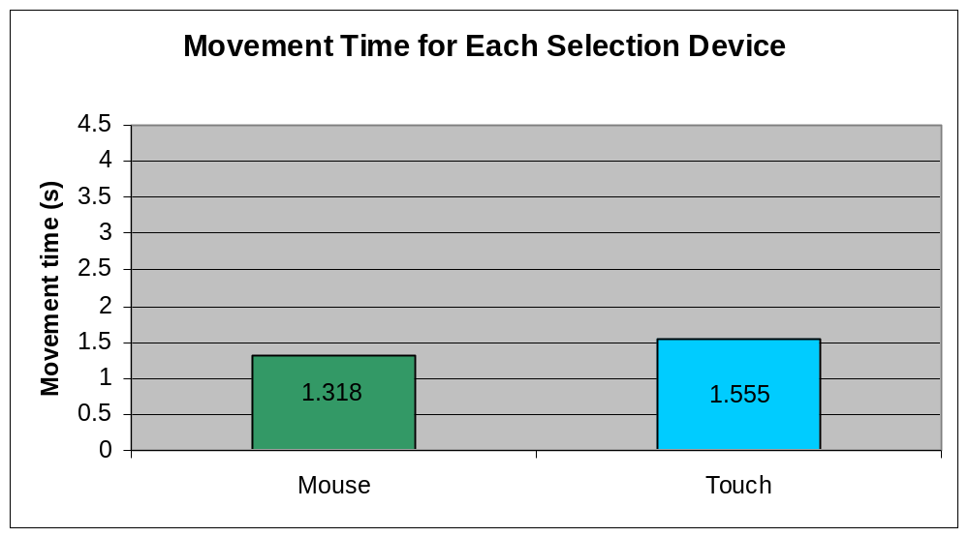
Figure 4.1 Mean movement time for the mouse and touch screen

The analysis of the movement times showed there was a significant interaction with target size and movement time (F(1.01, 22.17) = 14.57, p < 0.01). It is clear that size affects movement time. It is also clear from the analysis that there is a significant interaction between the size of the target and the selection device used (F(1.01, 22.17)
= 9.53, p < 0.01). Therefore, the size of the target being used has a different effect on movement time depending on what selection device is used.
The analysis showed that target type had a significant effect on movement time (F(1.12, 24.72) = 43.32, p < 0.001). There was also a significant interaction between target type and the selection device (F(1.12, 24.72) = 8.48, p < 0.01). It can be concluded the type of target will affect the movement time differently for each device.
The size and the type of target also had significant interaction with movement time (F(1.34, 29.41) = 9.56, p < 0.01). Therefore the size of the target affects the movement time for each different type of target. For example, a large button will have a different movement time to that of a small check box. This interaction between target and size was also seen to be significant across device (F(1.34, 29.41) = 8.12, p < 0.01). For example, a large button using a mouse will have a different movement time to that of a large button using a touch screen.
Size
The analysis found that the large targets had a mean movement time of 1.275s, the medium targets were 1.444s and the small targets had the longest movement time of 1.994s. Because these means are for all targets together, very little can be drawn from them except the results from the study followed Fitts’ Law in that smaller targets will have longer movement times. The results also showed that the differences between each size were statistically significant (p < 0.05). It was also seen from the results that the differences between each target type were statistically significant. This occurred for every combination of target type and therefore the differences between one target type with every other target type are significant (p < 0.05).
The analysis showed that the text box had the fastest overall movement time of 0.972s (sd = 0.024). Movement times for the button, check box and combo box were 1.035s (sd = 0.34), 1.638s (sd = 0.233) and 2.130 (sd = 0.113) respectively. These movement times, as illustrated in Figure 4.2, take into account learning which will be explained further on in this section.

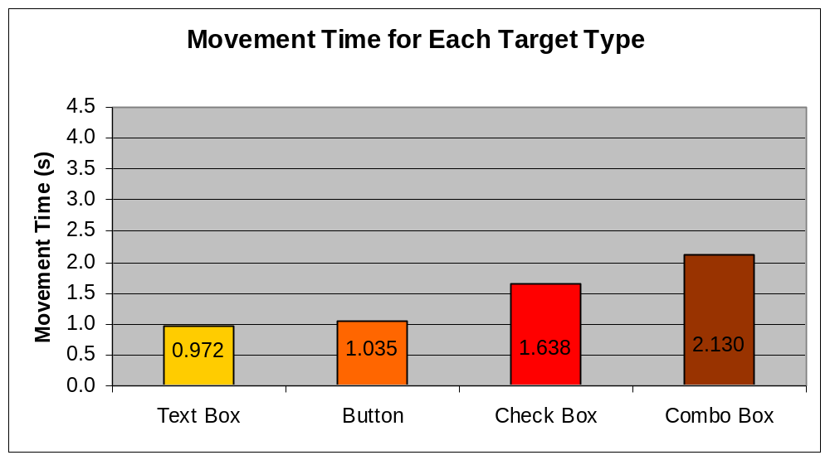
Figure 4.2 Movement time for each target type with all devices.

The results from size and device were also interesting. The mouse and touch screen had similar movement time for large and medium sized targets but for the small targets the touch screen had a far higher movement time compared to the mouse. The movement times are illustrated in Figure 4.3.

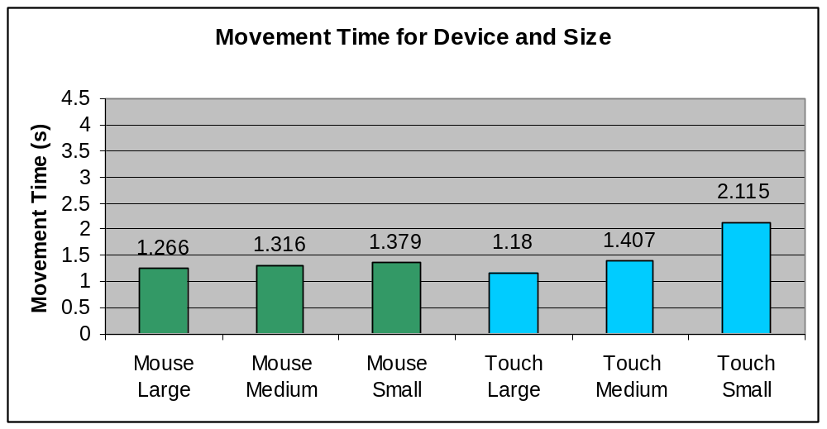
Figure 4.3 Movement times for each size across both the mouse and the touch screen.

For the mouse the movement times did not vary that much across size and in fact the movement time for the small target was only 9% slower than the movement time for the largest target. The movement times were 1.266s (sd = 0.034) for the large target sizes, 1.316s (sd = 0.042) for the medium target sizes and 1.379s (sd = 0.110) for the small target sizes. The movement times for the touch screen on the other hand varied considerably from the medium size to the small size. The movement time for the small targets was 2.115s (sd = 0.110) and this was 79% slower than the movement time of 1.180s (sd = 0.034) for the large targets.
The results for the movement time across device and target type showed that the movement times were very similar for the mouse and touch screen across all target types except the check box. The movement time for the check box with the touch screen was 2.06s (sd = 0.163), 69% higher than the movement time of 1.217s (sd = 0.163) with the mouse. The movement times for all target types for the mouse and for the touch screen are illustrated in Figure 4.4.

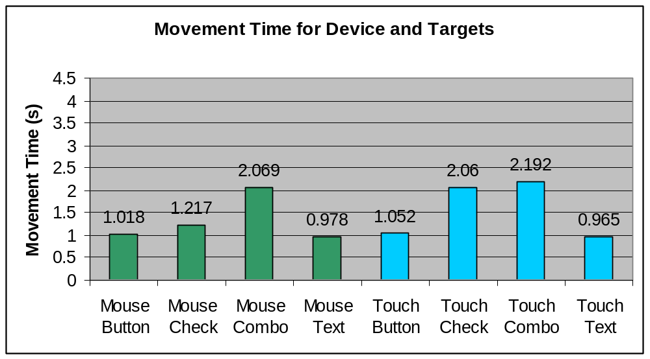
Figure 4.4 Movement times for each target with the mouse and the touch screen.

General Results: Throughput
The throughput for the mouse was 1.238 bps, slightly higher than the 1.215 bps throughput for the touch screen. These differences are illustrated in Figure 4.5.The device by itself was shown not to have a significant effect on throughput (F(1, 22) = 0.02, p > 0.05).

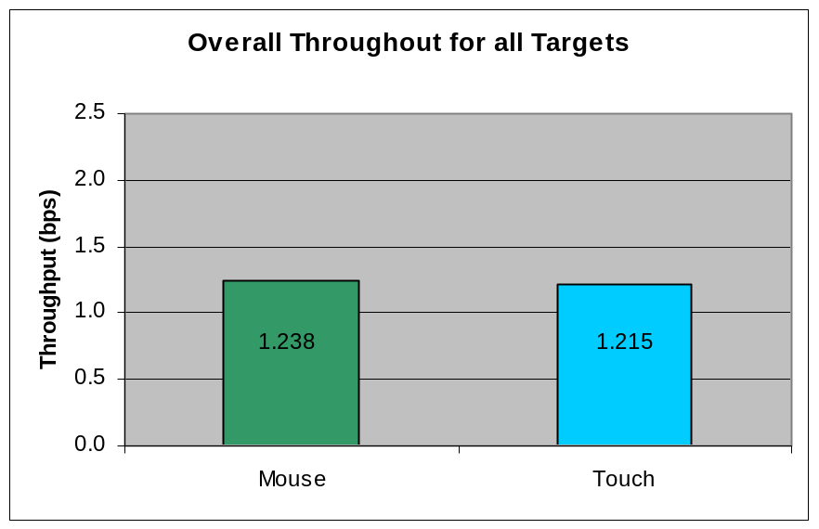
Figure 4.5 The overall throughput for the mouse and touch screen.

The analysis showed that interaction between the target type and throughput was statistically significant (F(2.07, 45.55) = 4.77, p < 0.001) using the Greenhouse and Geisser correction. Target type also had a significant interaction with throughput depending on the device (F(2.07, 45.55) = 157.36, p < 0.05). This means that the type of target and device being used had a different effect on throughput.
Size by itself was shown not to have a significant effect on throughput (F(2, 44) = 2.179, p > 0.05) but the interaction between size and device was shown to have significant effect on throughput (F(2, 44) = 43.57, p < 0.001). Therefore the combination of size and device will have an effect on throughput but size by itself will not.
The effect on throughput from the interaction between target type and size was shown to be statistically significant (F(2.52, 55.43) = 10.02, p < 0.001). Therefore the type of target used and the size of the target will affect throughput. This interaction is also observed depending on what device is used and hence the interaction between target type, size and device was also statistically significant (F(2.52, 55.43) = 10.05, p < 0.001).
The overall throughput for the large, medium and small targets was 1.221 bps (sd = .085), 1.224 bps (sd = 0.084) and 1.187 bps (sd = 0.082) respectively. There is very little difference observed in the throughput for the different sizes and this is consistent with the between size and throughput not being statistically significant.
The analysis showed that the check box had the highest throughput of 1.967 bps (sd = 0.720). The button, text box and combo box had overall throughput rates of 1.505 bps (sd = 0.111), 0.958 bps (sd = 0.081) and 0.501 bps (sd = 0.213) respectively. These throughput rates are illustrated in Figure 4.6.

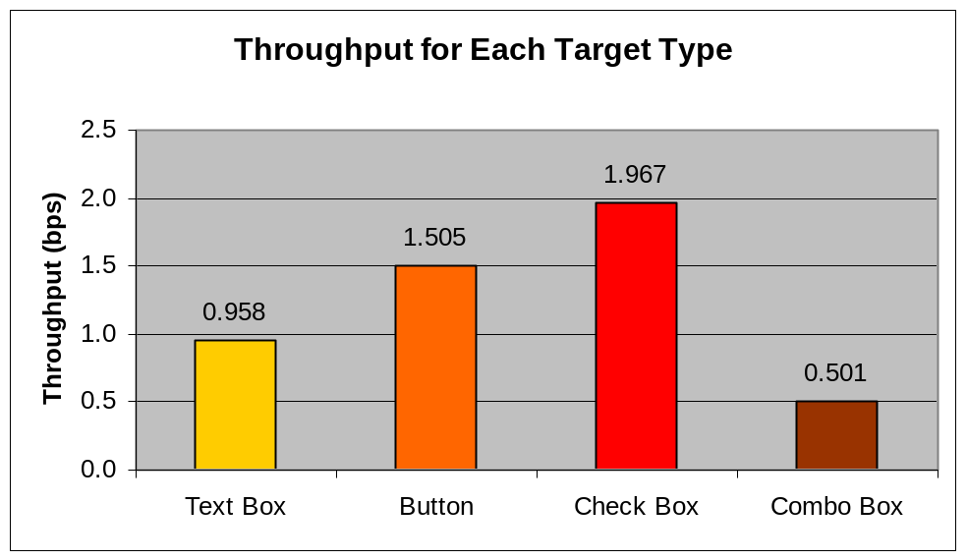
Figure 4.6 Throughput for each target with all sizes and devices.

General Results: Error Rate
The results showed that the touch screen had an overall error rate of 60.8%. This was far higher than the mouse which had an error rate of 2.7%. Device was shown to have a significant effect on error rate F(1, 22) = 31.776, p < 0.001). Figure 4.7 illustrates these results.

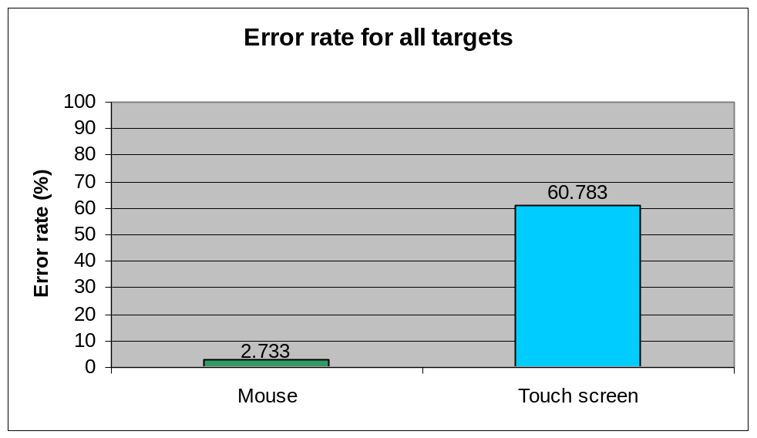
Figure 4.7 Error rates for both the mouse and touch screen. The touch screen had a much higher error rate compared to the mouse.

The error rates for each target type show a better breakdown of where the high error rates came from. The check box had an error rate of 78.5% and the combo box was 33.5%. The text box and button had low error rates of 7.8% and 7.3% respectively as illustrated in Figure 4.8. It can be said that the high error rates stemmed from the check box and combo box when used with the touch screen as further results will show.

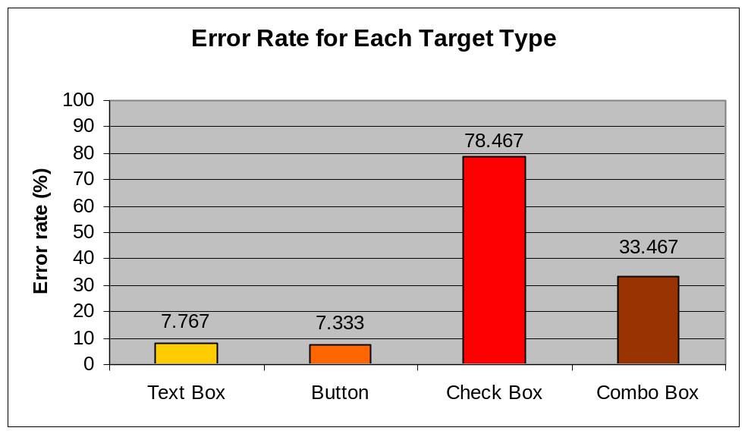
Figure 4.8 Error rates for each target type with all devices.

Differences in error rates due to different target types are significant F(1.592, 35.016) = 73.817, p < 0.001). Target type also had a significant interaction with error rate depending on the device used F(1.592, 35.016) = 23.426, p < 0.001). This means that the combination of target type and device had an effect on error rate.
Size by itself was shown to have a significant effect on error rate (F(1.052, 22.554) = 25.263, p < 0.001). The interaction between size and device was also shown to have a significant effect on error rate (F(1.052, 22.554) = 22.051, p < 0.001). Therefore the combination of size and device will have an effect on error rate as will just size by itself.
The effect on error rate from the interaction between target type and size was shown to be statistically significant (F(1.890, 41.576) = 18.316, p < 0.001). Therefore the type of target used and the size of the target will affect the error rate. This interaction is also observed depending on what device is used and hence the interaction between target type, size and device was also statistically significant (F(1.890, 41.576) = 15.687, p < 0.001).
The results from size and device also showed broad range of error rates for the mouse and the touch screen. These error rates are illustrated in Figure 4.9.

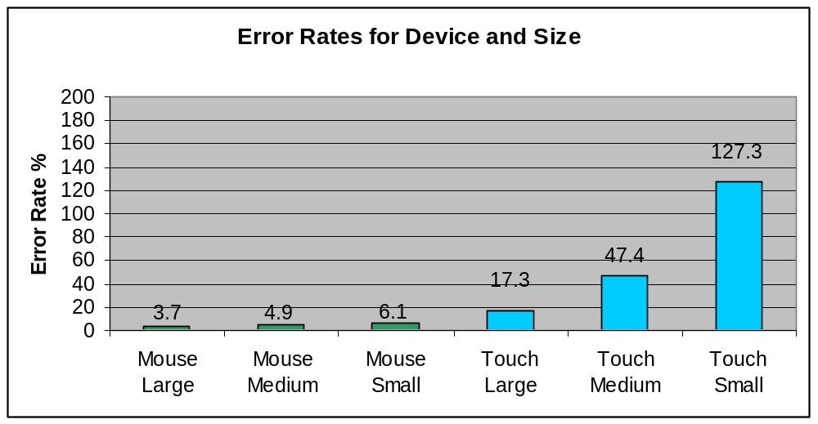
Figure 4.9 Error rates across each size for the mouse and touch screen.

The error rates for the mouse were 3.7% (sd = 2.2) for the large target sizes, 4.9% (sd = 5.4) for the medium target sizes and 6.1% (sd = 14.6) for the small target sizes. The error rates for the touch screen on the other hand varied considerably from the medium size to the small size. This was similar to the behaviour found with movement time and was therefore not surprising. The error rate for the small target was 127.3% (sd = 14.6) and this was 636% higher than the error rate of 17.3% (sd = 2.2) for the large targets.
The results for the error rate across device and target type showed that the error rates were much higher for the touch screen compared to the mouse across all targets, especially for the check box. This is again consistent with the findings that the check box had a much higher movement time with the touch screen compared to the mouse. The error rate for the check box with the touch screen was 173.2% (sd = 21.6), compared to the error rate of 5.7% (sd = 21.6) with the mouse. The error rates for all targets with the mouse and for the touch screen are illustrated in Figure 4.10.

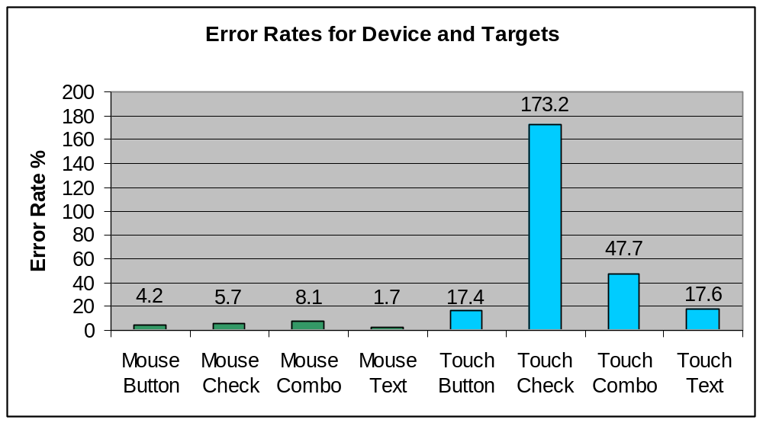
Figure 4.10 Error rates for each target across both the mouse and touch screen.
Results Per Target: Text box
Movement time
The text box had the slowest movement time of all the four targets with 0.972s. For the mouse, the large text box had a fastest movement time of the three sizes with 0.945s (sd = 0.095). The movement time for the medium and small text box for the mouse were 0.951s (sd = 0.096) and 1.023s (sd = 0.120) respectively. These movement times are illustrated in Figure 4.11. For the touch screen the movement time was 0.850s (sd =0.105) for the large text box, 0.914s (sd = 0.118) for the medium and 1.135s (sd = 0.202) for the small text box.

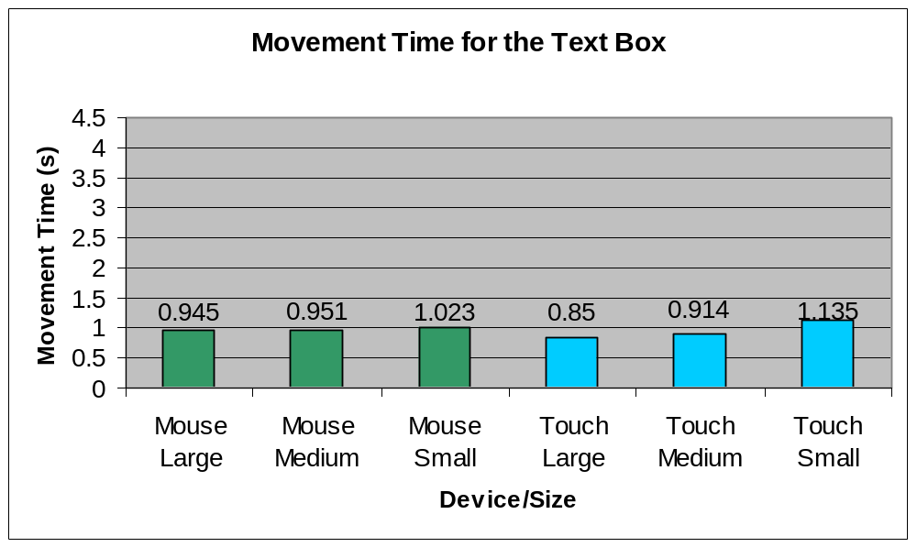
Figure 4.11 Movement times for the text box.
Throughput
The results from throughput showed that the touch screen had slightly higher throughput compared to the mouse. The results were interesting as they generally showed that throughput did not really vary across size for the text box for either device as shown in Figure 4.12. This supports the earlier statement that the interaction between size and throughput was not shown to be statistically significant.

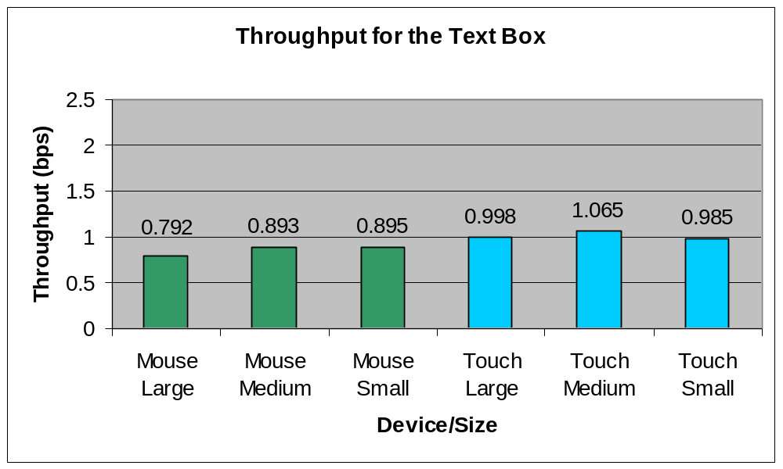
Figure 4.12 Throughput for the text box.

The throughput for the large text box with the mouse was 0.792 bps (sd = 0.397), 0.893 bps (sd = 0.375) for the medium text box and 0.895 bps (sd = 0.412) for the small text box. On the other hand, the touch screen had a throughput rate of 0.998 bps (sd = 0.402) for the large text box, 1.065 bps (sd = 0.435) for the medium text box and 0.985 bps (sd = 0.373) for the small text box.
Error rate
The error rates for the text boxes were very low for the mouse compared to a touch screen. The mouse error rates were 0% (sd = 2.1), 0% (sd = 3.8) and 0.7% (sd = 2.5) for large, medium and small text boxes respectively. Comparatively, the touch screen had larger error rates of 5.6% (sd = 5.1), 11.1% (sd = 11.0) and 29.2% (sd = 16.2) for large, medium and small text boxes respectively. The error rate differences from size and device are illustrated in Figure 4.143. These results were statistically significant (p < 0.01).

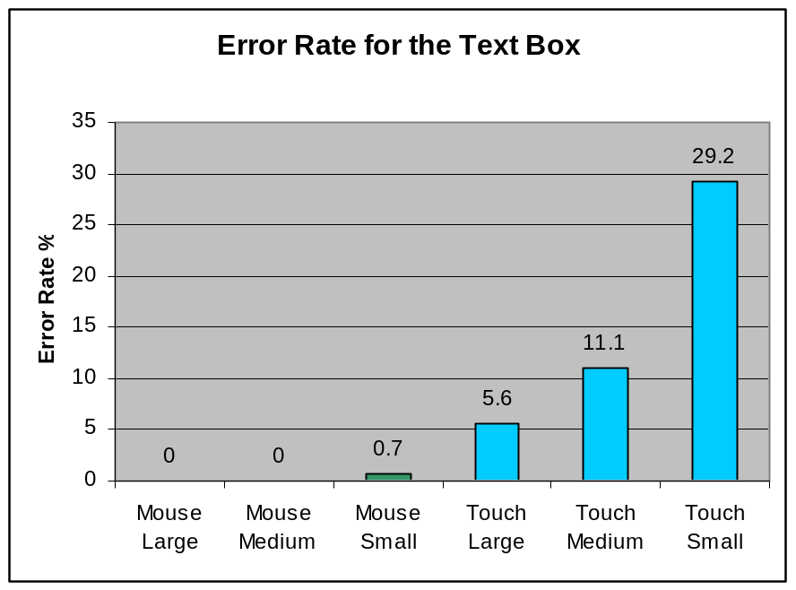
Figure 4.13 Error rates of the mouse and touch screen devices for text boxes.

The average error rate for text boxes with the mouse was 0.2%. The touch screen had a much larger error rate of 15.3%.
Results Per Target: Button
Movement time
The overall movement time for a large button with the mouse was 0.962s (sd = 0.088), 0.991 (sd = 0.100) for the medium button and 1.083s (sd = 0.103) for the small button.
The touch screen had similar movement times for the button. The large button had a movement time of 0.914 (sd = 0.123), the medium was 0.992s (0.252) and the small button had a movement time of 1.100s (sd = 0.286). These movement times are illustrated in Figure 4.14.

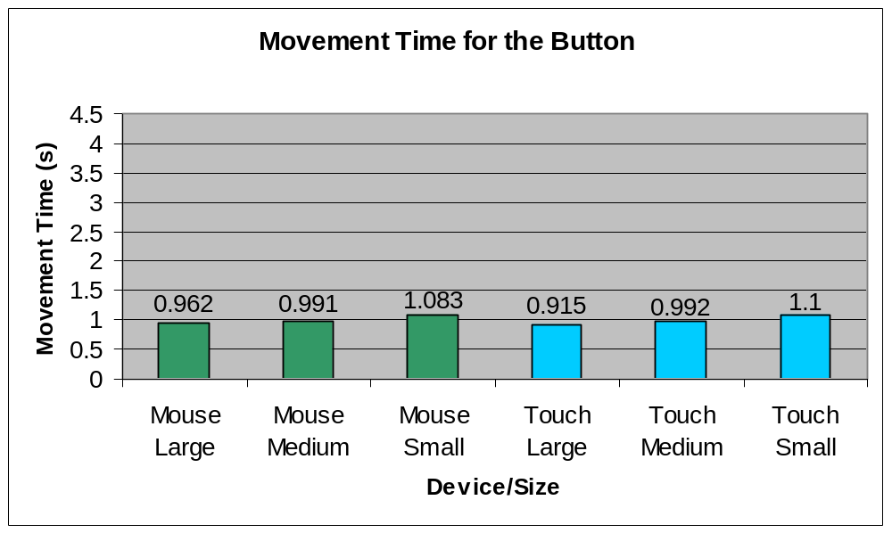
Figure 4.14 Movement time for the Button.

Throughput
The results from throughput showed that the touch screen and mouse had very similar throughput as is illustrated in Figure 4.15.

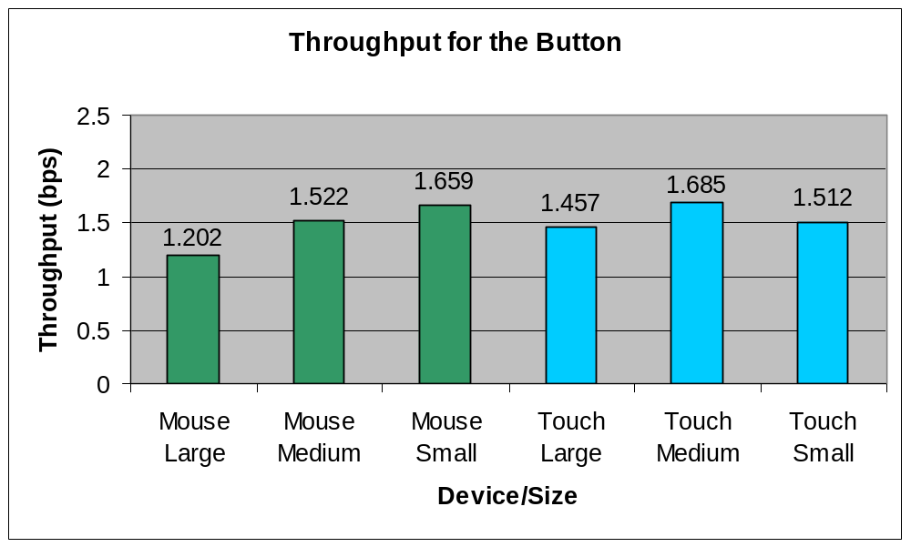
Figure 4.15 Throughput for the button.

The throughput for the large button with the mouse was 1.202 bps (sd = 0.591), 1.522 bps (sd = 0.583) for the medium button and 1.659 bps (sd = 0.601) for the small button. On the other hand, the touch screen had a throughput rate of 1.457 bps (sd = 0.504) for the large button, 1.685 bps (sd = 0.512) for the medium button and 1.512 bps (sd = 0.609) for the small button.
Error rate
Error rates for the button varied across selection device and size. For a large button, the mouse had a 0.7% (sd = 5.5) error rate and the touch screen had a 2.8% (sd = 4.8) error rate. These were the only differences not found to be statistically significant (p > 0.5). The error rates for the medium sized button were 2.1% (sd = 5.2) for the mouse and 10.4% (sd = 13.8) for the touch screen. These differences were statistically significant (p< 0.01). The error rates varied the most for the small size buttons. This is illustrated in Figure 4.16.

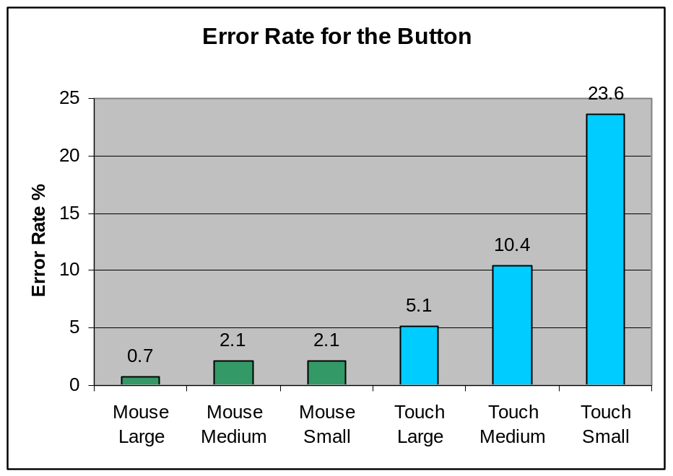
Figure 4.16 Error rates for the button with the mouse and touch screen devices.

A mouse had an error rate of 2.1% (sd = 5.2) and the touch screen had an error rate of 23.6% (sd = 25.7) with the differences being statistically significant (p<0.001).
Results Per Target: Combo box
Movement time
The movement time for the combo box was very different across each selection device. The overall movement time for the large combo box with the mouse was 2.096s (sd = 0.144), 2.103s (sd = 0.194) for the medium combo box and 2.179s (sd = 0.196) for the small combo box.
The touch screen had larger movement times for the combo box. The large combo box had a movement time of 2.018 (sd = 0.318), the medium was 2.245s (0.320) and the small combo box had a movement time of 2.785s (sd = 1.901). These movement times are illustrated in Figure 4.17.

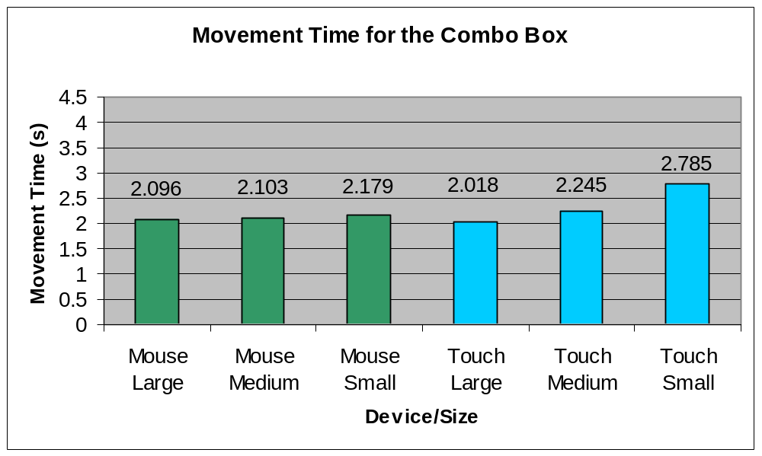
Figure 4.17 Movement time for the combo box.

Throughput
Due to the time required to make a selection and relative ease of use, the combo box had a very low throughput rate. The throughput did not vary across the selection device and only slightly across size as illustrated in Figure 4.18.

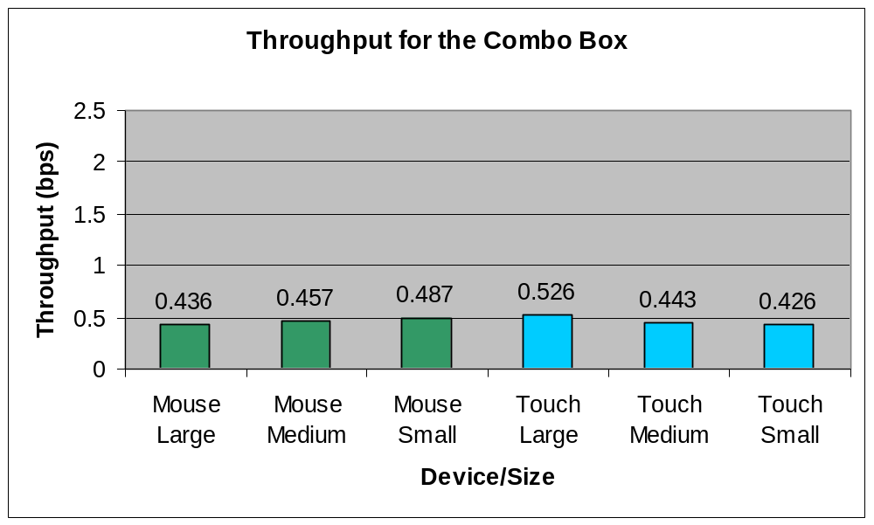
Figure 4.18 Throughput for the combo box.

It is important to note that the distance to the combo box was adjusted in the calculation of the index of difficulty (used in throughput) to take into account the distance to the combo box as well as to the list item. The throughput for the large combo box with the mouse was 0.436 bps (sd = 0.185), 0.457 bps (sd = 0.178) for the medium combo box and 0.487 bps (sd = 0.221) for the small combo box. On the other hand, the touch screen had a throughput rate of 0.526 bps (sd = 0.231) for the large combo box, 0.443 bps (sd = 0.214) for the medium combo box and 0.426 bps (sd = 0.190) for the small combo box.
Error rate
The error rate calculation used for a combo box depends upon which selection approach is of interest. For example, the error rate for the two-click approach to selecting a combo box would mean the first click is treated as a correct selection instead of being treated as an error. Each click made on the actual combo box (the area not including the drop-down list) is not treated as an error. This means that in the two-click approach, an error for a combo box is defined as an incorrect selection within the combo box list or a selection outside of the combo box area. Table 4.2 shows the differences in error rates across device for each size of combo box tested for both selection approaches.

Table 4.2 Error rates for the touch screen and mouse across all sizes of combo box for both the one-click and two-click approach.
 | One-click approach |  |  | Two-click approach
Device | Large | Medium | Small | Large | Medium | Small
Mouse | 100% | 106.7% | 106.3% | 2.1% | 5.6% | 6.3%
Touch | 132.6% | 160.4% | 236.8% | 20.1% | 49.3% | 117.4%

For the one-click approach, the error rates for the large combo box were 100% (sd = 39.9) for mouse and 132.6% (sd = 26.5) for the touch screen with differences being statistically significant (p < 0.001). The medium combo box had error rates 106.7% (sd = 43.0) for the mouse and 160.4% (sd = 30.7) for the touch screen. Again these differences were statistically significant (p < 0.001). The small size combo box had error rates of 106.3% (sd = 38.7) for the mouse and 160.4% (sd = 156.2) for the touch screen with the differences being statistically significant (p < 0.001).
For the two-click approach, not taking into account any clicks on the combo box (excluding the list box area) will obviously result in lower error rates. The large combo boxes had an error rate 2.1% (sd = 8.8) for the mouse and 20.1% (sd = 25.9) for the touch screen. These differences were statistically significant (p < 0.01). For the medium size combo boxes the mouse had a 5.6% (sd = 7.2) error rate and the touch screen had a 49.3% (sd = 21.8) error rate. These differences were statistically significant (p < 0.001). The error rates of the small combo box across the mouse and touch screen were 6.3% (sd = 8.6) and 117.4% (sd = 80.9) respectively. These differences were statistically significant (p < 0.001).
Results Per Target: Check box
Movement time
The movement time for the check box was very different across each selection device. Most importantly, the movement time using the touch screen with the small check box was much larger than the other movement times, indicating the difficulty participants had in selecting the target. The overall movement time for the large check box with the mouse was 1.176s (sd = 0.0.136), 1.222s (sd = 0.138) for the medium check box and 1.405s (sd = 0.144) for the small check box.
The touch screen had much larger movement times for the check box. The large check box had a movement time of 1.207 (sd = 0.241), the medium was 1.970s (0.100) and the small check box had a movement time of 4.492s (sd = 3.552). These movement times are illustrated in Figure 4.19.

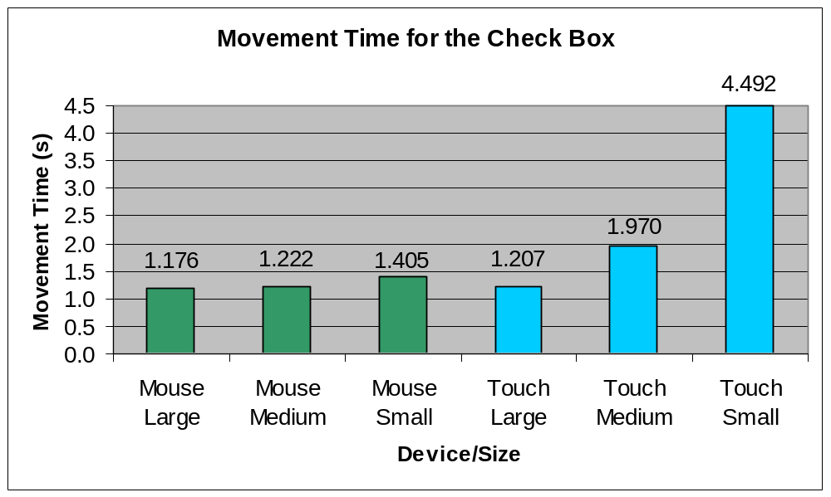
Figure 4.19 Movement time for the check box.

Throughput
The check box had the highest throughput of the targets. This would be due to the small size and relative difficulty of selecting it. But as the following results will show, the small check box for the touch screen had a relatively low throughput. This is consistent with the difficulty participants found in selecting this target.

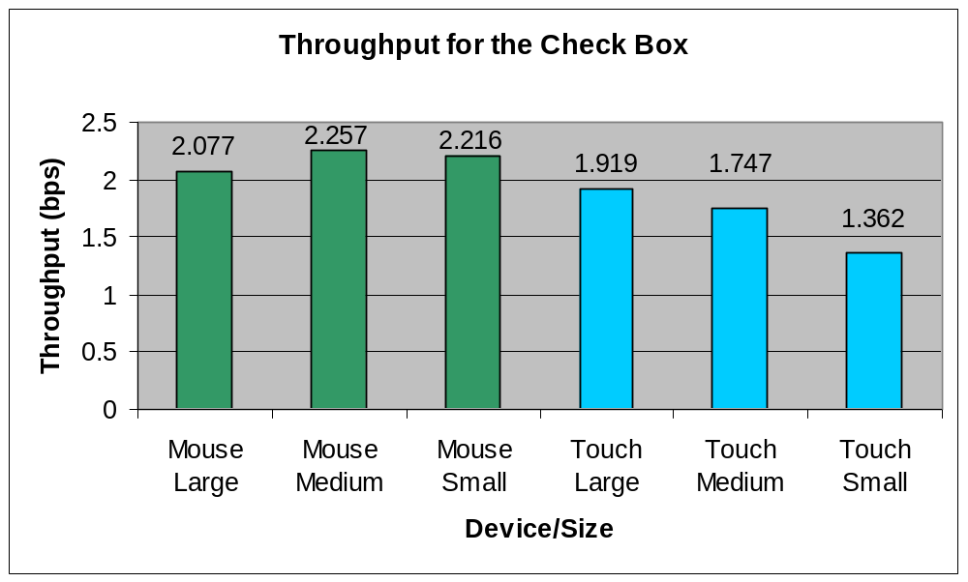
Figure 4.20 Throughput for the check box.

The throughput for the large check box with the mouse was 2.077 bps (sd = 0.514), 2.257 bps (sd = 0.571) for the medium check box and 2.216 bps (sd = 0.595) for the small check box. On the other hand, the touch screen had a throughput rate of 1.919 bps (sd = 0.823) for the large check box, 1.747 bps (sd = 0.658) for the medium check box and 1.362 bps (sd = 0.415) for the small check box. These throughput rates are illustrated in Figure 4.19.
Error rate
The differences in error rates between the mouse and touch screen over the different target types is the largest with the check box. The error rates for the check box can be seen in Figure 4.21.

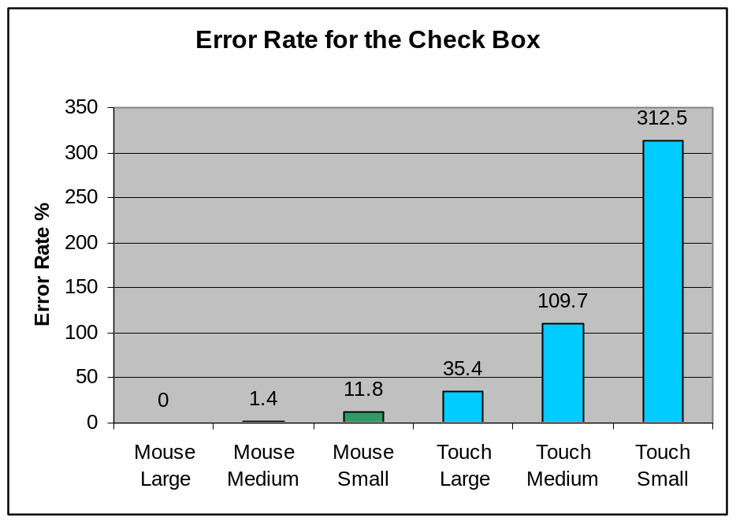
Figure 4.21 Check box error rates for both the mouse and touch screen.

For a large check box the mouse had an error rate of 0% (sd = 1.2) and for the touch screen the error rate was 35.4% (sd = 25.7). These differences were statistically significant (P < 0.001). The medium and large size check box had much larger error rates. The error rates for the medium size check box for the mouse and touch screen were 1.4% (sd = 51.1) and 109.7% (sd = 0.85) respectively. These differences were again statistically significant (p < 0.001). For the small size check box the mouse had an error rate of 11.8% (sd = 11.4). The touch screen had an error rate of 312.5% (sd = 225.9) indicating the participants had great deal of difficulty selecting the small check box with the touch screen. These error rates were statistically significant (p < 0.001).

4.2 Subproblem 3.
The third subproblem is to determine the effect learning has in the study and account for it in the results.
As shown in Chapter II, Review of the Related Literature, learning can affect the results of the analysis and should be taken into account. From analysing the results of movement time and throughput over each test block, it is clear for the combo box and check box that learning occurs from the first to second block with the touch screen. Due to prior experience, no learning is observed with the mouse. This is illustrated in Figure 4.22. From observing Figure 4.23, it can be seen that no learning takes place for either the button or the text box, most likely due to their large size and simple selection behaviour.

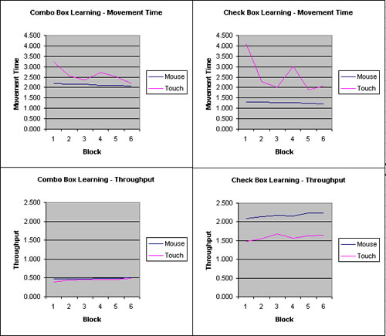
Figure 4.22 Learning is displayed for movement time and throughput by device and block for the combo box and check box.

To prove these observations, statistical analysis using a simple repeated measure ANOVA was carried out on movement time for both the check box and combo box. For movement time of the combo box, the effect of (block * device) was significant (F(1.549, 1335.219) = 4.373, p < 0.05). Helmhert contrasts show that the differences between blocks become non-significant after block 1 (p < 0.05).
For movement time of the check box, the effect of (block * device) was significant (F(1.608, 1385.960) = 4.763, p < 0.05). Using Helmhert contrasts, the differences between blocks become non-significant after block 1 (p < 0.05). This again shows that there was learning involved in block 1.
To account for learning with the combo and check box, results only from block 6 will be used to recalculate the relevant measures of measurement time, throughput and error rate. This is because the results from block 6 alone would give a good measure of performance.
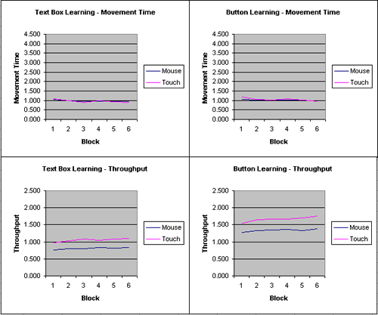
Figure 4.23 Learning is displayed for movement time and throughput by device and block for the text box and button.

Adjusted Combo Box results
Movement time
The movement time for the combo box was very different across each selection device. The overall movement time for the large combo box with the mouse was 2.040s (sd = 0.214), 2.057s (sd = 0.305) for the medium combo box and 2.108s (sd = 0.235) for the small combo box.
The touch screen had much larger movement times for the combo box. The large combo box had a movement time of 1.827 (sd = 0.316), the medium was 2.057s (0.445) and the small combo box had a movement time of 2.690s (sd = 0.235). These movement times are illustrated in Figure 4.24. On average, the movement times for the mouse were 2.7% lower than the movement times for the entire 6 blocks for the mouse. For the touch screen the movement times were on average 7.1% lower than the movement times for all blocks. Thus there was a dramatic learning effect for the combo box with the touch screen.

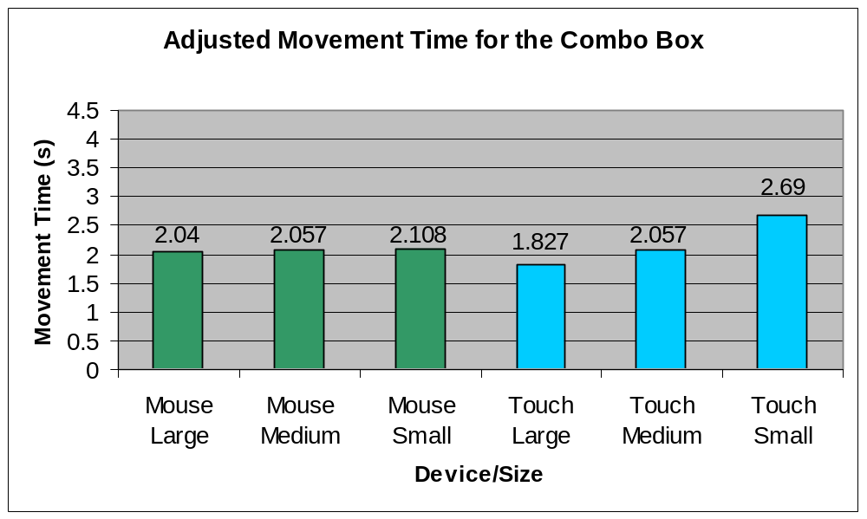
Figure 4.24 Movement time for the combo box adjusted for learning.

Throughput
The throughput rate for the combo box was very low overall. The throughput did not vary across the selection device and only slightly across size. The throughput for the large combo box with the mouse was 0.480 bps (sd = 0.196), 0.478 bps (sd = 0.194) for the medium combo box and 0.517 bps (sd = 0.221) for the small combo box. On the other hand, the touch screen had a throughput rate of 0.580 bps (sd = 0.237) for the large combo box, 0.521 bps (sd = 0.247) for the medium combo box and 0.434 bps (sd = 0.181) for the small combo box. These throughput rates are illustrated in Figure 4.25.

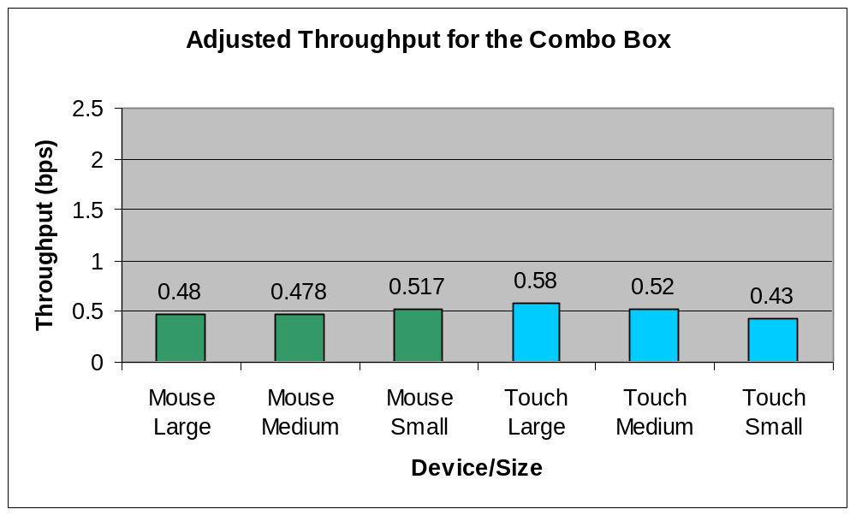
Figure 4.25 Throughput rates for the combo box adjusted for learning.

The adjusted throughput rates for the mouse were 6.9% higher than the throughput rates for all blocks with the combo box. For the touch screen, again there was a positive learning effect. The adjusted throughput rates were on average 9.5% higher than the rates for all data blocks.
Error rates: Single-Click Approach
The adjusted error rates for the combo box were smaller for the mouse compared to the touch screen. For the mouse the error rates were 97.2% (sd = 0.328) for the large combo box, 108.3% (sd = 0.233) for the medium combo box and 95.1% (sd = 0.183) for the small combo box. The touch screen had error rates of 117.4% (sd = 0. 347) for the large combo box, 137.5% (sd = 0.325) for the medium combo box and 195.1% (sd = 0.831) for the small combo box. These error rates are illustrated in Figure 4.26. The adjusted error rates for the mouse were 4% lower compared to the error rates for all the blocks. For the touch screen the error rates were 14.5% lower.
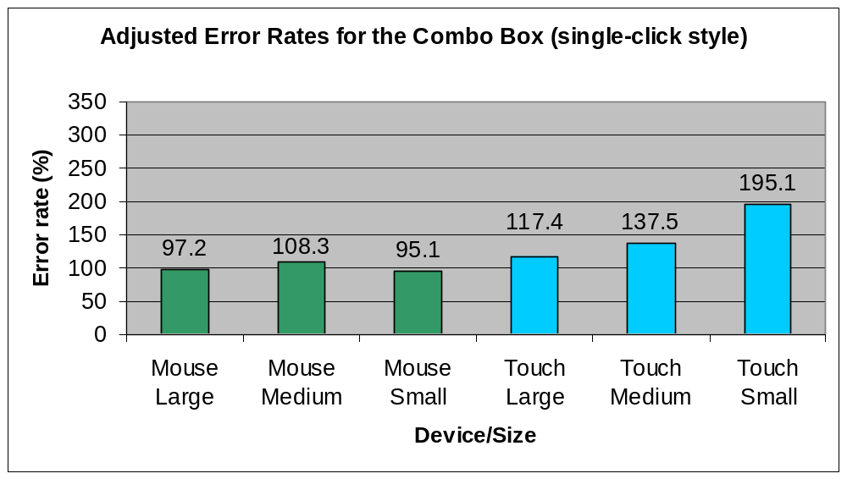
Figure 4.26 Adjusted error rates for the combo box using the single-click selection approach.

Error rate: Two-Click Style
Error rates for the combo box assuming that participants used the two-click approach were much lower for the mouse compared to the touch screen (similar to the unadjusted results). The mouse had error rates of 12.5% (sd = 0.215) for the large combo box, 13.2% (sd = 0.135) for the medium combo box and 7.6% (sd = 0.075) for small combo box. The touch screen had error rates of 17.4% (sd = 0.186) for the large combo box, 27.8% (sd = 0.217) for the medium combo box and 74.3% (sd = 0.461) for the small combo box. These error rates are illustrated in Figure 4.27.
The adjusted error rates for the combo box were 217.2% higher than the error rates from all blocks. For the touch screen, the error rates were 31.3% lower. These results were very peculiar, especially as the mouse reported a significant rise in the error rate from using only block 6 instead of all blocks. From further analysis it was noticed that two participants accounted for 89% of the errors for the large combo box with the mouse. This indicates a highly skewed error rate and thus the error rates for the combo box should be reported using the results from all blocks and not from just the 6th block.
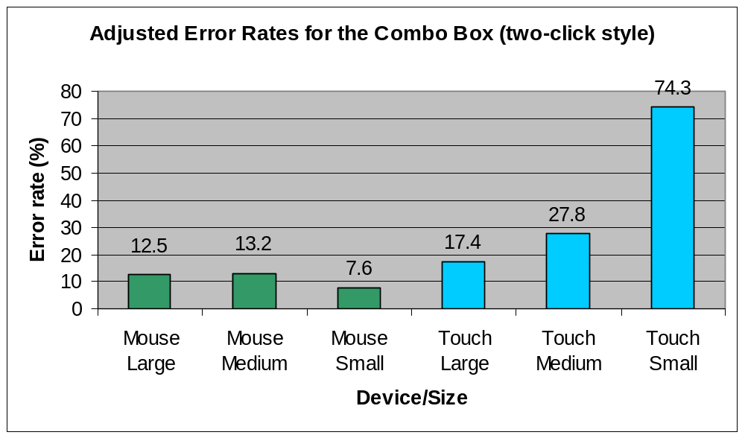
Figure 4.27 Adjusted error rates for the combo box using the two-click selection approach.

Adjusted Check Box Results
Movement time
The adjusted movement time for the check box was very different across each selection device. Most importantly, the adjusted movement time using the touch screen with the small check box was much larger than the other adjusted movement times, indicating the difficulty participants had in selecting the target. The overall adjusted movement time for the large check box with the mouse was 1.125s (sd = 0.139), 1.235s (sd = 0.146) for the medium check box and 1.290s (sd = 0.166) for the small check box.
For the touch screen, the large check box had a movement time of 1.137s (sd = 0.286), the medium was 1.588s (0.541) and the small button had a movement time of 3.454s (sd = 1.851). These movement times are illustrated in Figure 4.28. Compared to results from all of the blocks, the adjusted movement times for the check box were 3.8% lower for the mouse and 16.1% lower for the touch screen.
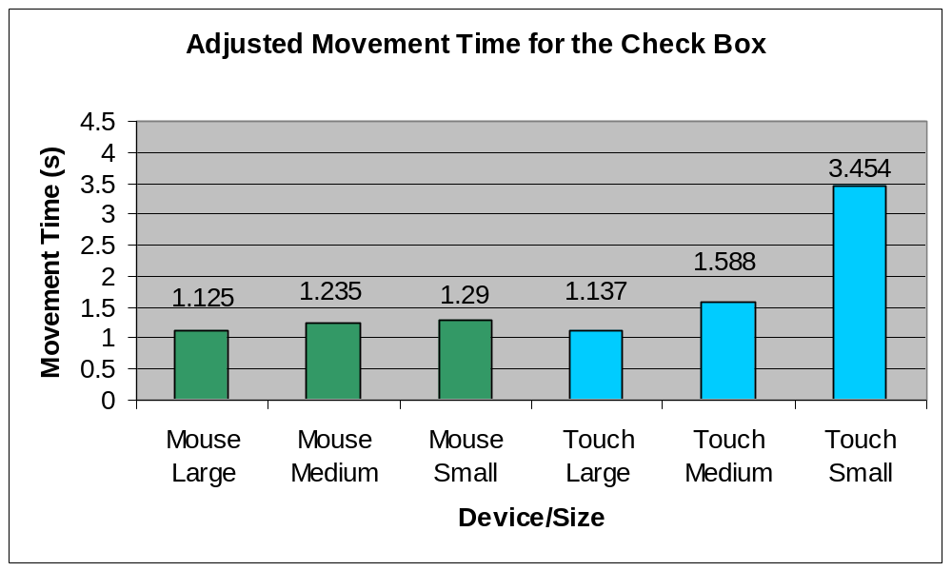
Figure 4.28 Adjusted movement time for the check box.

Throughput
The throughput for the large check box with the mouse was 2.111 bps (sd = 0.657), 2.077 bps (sd = 0.583) for the medium check box and 2.278 bps (sd = 0.727) for the small check box. On the other hand, the touch screen had a throughput rate of 2.146 bps (sd = 0.886) for the large check box, 1.897 bps (sd = 0.694) for the medium check box and 1.395 bps (sd = 0.512) for the small check box. These throughput rates are illustrated in Figure 4.29.
Compared to throughput rates from all of the blocks these results for the mouse were on average 1.2% lower for the mouse but 5.2% higher for the touch screen.

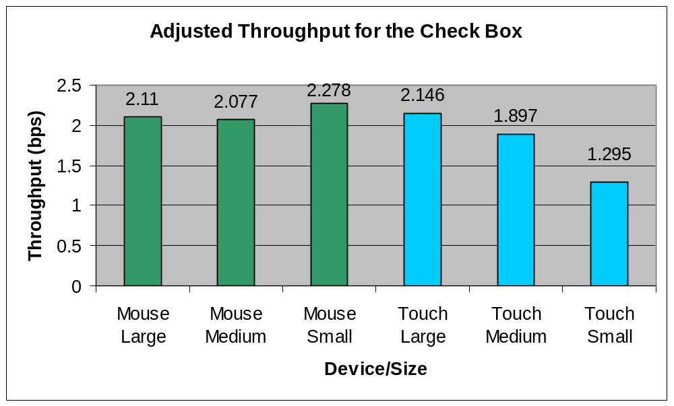
Figure 4.29 Adjusted throughput for the check box.

Error rate
The adjusted error rates for the mouse were much lower than that of the touch screen, as they were with the original results. For the mouse the error rates were 1.4% (sd = 4.8) for the large check box, 6.9% (sd = 8.6) for the medium check box and 11.8% (sd = 14.8) for the small check box. For the touch screen the error rates were 36.1% (sd = 34.9) for large check box, 106.3% (sd = 71.9) for the medium check box and 393.0% (sd = 387.5) for the small check box. These error rates are displayed in Figure 4.30.
Compared to the error rates from all of the blocks the adjusted results for the mouse were on average 177.6% higher for the mouse and 8.2% higher for the touch screen. Again the adjusted error rates for the check box were found to be highly skewed because of two participants and therefore the error rates from all blocks should be used in final reporting.

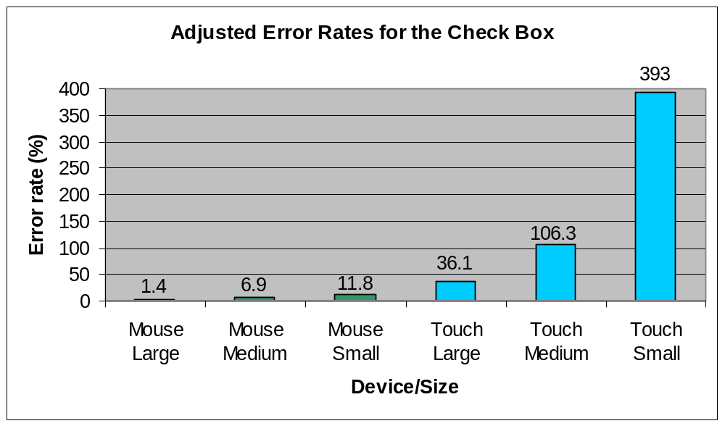
Figure 4.30 Adjusted error rates for the check box.

4.3 Subproblem 4 and 5.
The fourth subproblem is to determine the user satisfaction of using a touch screen with typical GUI targets. The fifth subproblem is to determine the user satisfaction of using a mouse with typical GUI targets.
General Device Results
The questionnaire was based on a five point ordinal scale. In general 5 indicated a bad rating. Because of the small data size, a Mann-Whitney (non-parametric) test was used. The data showed a good fit to the normal curve and thus the means are reported. The questionnaire showed that participants rated the touch screen worse than the mouse. In terms of accurate pointing the mouse (2.083) was rated easier than the touch screen (3.000). These differences were statistically significant (p < 0.01).
The responses from the two questions regarding mental and physical effort required by the selection devices showed both devices were rated in the same range with the touch screen (3.583) requiring slightly more physical effort than the mouse (3.250). The differences for these two questions were not statistically significant (p > 0.05).
Operational speed was rated the same for both mouse and touch screen with the differences in response not being statistically significant (p >0.05).
The responses to the questions regarding neck fatigue showed that the touch screen had worst fatigue compared to mouse. The touch screen had a rating of 2.500 with the mouse having a rating of 1.750. Both of these ratings were below the midpoint and therefore rated as low. The responses regarding the question on neck, wrist and arm fatigue showed that the touch screen had a high rating (4.083), whereas the mouse was rated in the midpoint range (3.167). The differences in response were not statistically significant for the neck fatigue question (p > 0.05) but were statistically significant for the question regarding arm, wrist and finger fatigue (p < 0.05).
Both devices were rated in the midpoint range for a question regarding general comfort of the device but the differences in response to the question were not statistically significant (p > 0.05).
The final question rated the overall difficulty in using the selection device. The mouse (4.250) was rated easier to use than the touch screen (3.333). These differences were statistically significant (p < 0.05).
User Satisfaction: Text Box
The questionnaire showed that 50% of the participants using the mouse preferred selecting large text fields, 50% medium sized text fields and no one preferred selecting a small text field. For the touch screen, 50% of the participants preferred selecting large text boxes, 42% preferred medium text boxes and 8% preferred selecting small text boxes. The text box was rated easy to use for both the mouse and the touch screen from responses to the questionnaire. The differences in response to the question were not statistically significant (p > 0.05).
User Satisfaction: Button
The results from the analysis of the questionnaire for the mouse showed that the largest size of the button was the most preferable for selecting (58%) and then the medium size (33%) with the small size being the least preferable (8%).
The responses from the participants using a touch screen were similar: 50% preferred to select large buttons, 42% medium and 8% preferred to select small buttons. A question regarding the difficulty in selecting a button showed that the button was very easy to select for both the mouse and touch screen. Differences in the response to this question were not statistically significant (p > 0.05).
User Satisfaction: Combo Box
The responses from the questionnaire showed that for the mouse, 50% of the participants preferred selecting large combo boxes, 50% medium combo boxes and no one preferred selecting small combo boxes with the mouse. For the touch screen, 75% of the participants preferred selecting large combo boxes and 25% medium combo boxes. No participants preferred selecting small combo targets with the touch screen.
For the question regarding the difficulty in selecting the combo box in the questionnaire, it was rated in the midpoint range (3.000) for both the mouse and the touch screen. The differences in response were not statistically significant (p > 0.05).
User Satisfaction: Check Box
The questionnaire showed that 92% of both the mouse and touch screen participants preferred selecting large check boxes, 8% medium and no one preferred selecting small check boxes. In response to the question regarding ease of selecting the check box, the touch screen was seen to be a lot more difficult (4.083) compared to a mouse (3.000). These differences were statistically significant (p < 0.05).
Other Feedback Regarding User Satisfaction
The questionnaire also provided the participant with the opportunity to give some general feedback or comments on the test. In general many of the participants expressed their dislike of selecting the small check box. Another common comment was that the participant’s arm often obscured part of the screen and prevented them from seeing the target. One participant noted the lack of arm support for targets at the top of the screen. This is an interesting comment because the nature of using a touch screen means the user’s arm might be raised off the desk and be self supporting when selecting items towards the top of the desktop screen. Another suggestion was making the target change colour when the cursor is located above it. This is a similar concept to that of interactive rollover items commonly used in web pages.

4.4 Other Findings
Effect of target location on the screen with the selection made
Upon calculating the standard deviation of the final selection coordinates on the screen, an interesting pattern was noticed. For the combo box and text box, there was considerable variation in final selection coordinates on the right hand side of the screen compared to the left hand side of the screen when using the mouse, but not when using the touch screen. This would mean that participants using the mouse were much more careful in making selections with large targets on the left side of the screen than with making selections with large targets on the right hand side of the screen. This observation is illustrated in Figure 4.31 which shows the standard deviation for each distance, and for each combination of text box size and selection device. The standard deviations are given stated for each angle. The angles 45 and 315 represent locations on the top and bottom of the left side of the screen and 135 and 225 represent locations on the top and bottom of the right side.
Even more interesting was that selections made on the combo box with the touch screen had the opposite affect. Selections made on the left hand side of the screen had very little variation compared to selections made on the right hand side. This phenomenon is illustrated in Figure 4.32.
The variation of selection coordinates for the smaller targets (the button and check box) were consistent across both the mouse and touch screen and for all sizes.
Preferred combo box selection approach
The test was designed so the selection approach of the combo box could be observed. This was done by counting the number of clicks a participant made on an item in the combo box list and on the combo box itself. Out of all 24 participants tested, only two used the single click approach to making a selection in the combo box. Both of these two participants were using the mouse. This showed an overwhelming support for the two-click approach to making selections with the combo box.
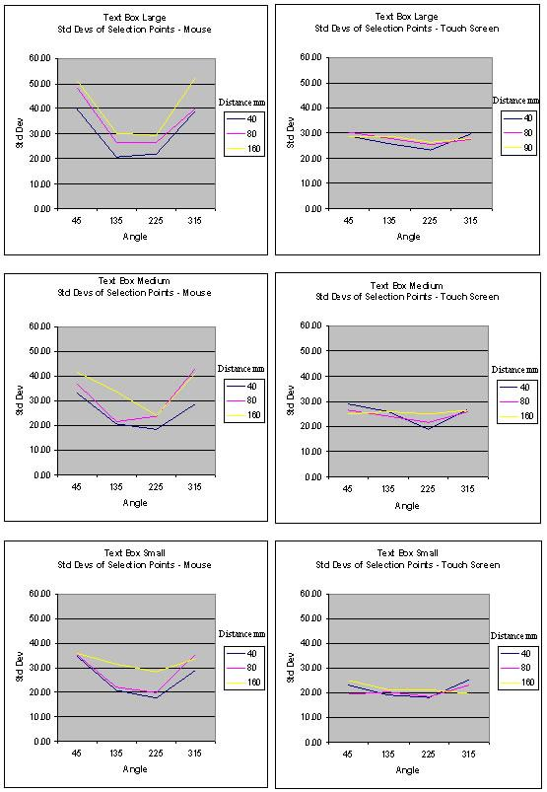
Figure 4.31 The standard deviation of final selection coordinates for the text box. Each graph shows the standard deviations of each distance for one combination of selection device and text box size.
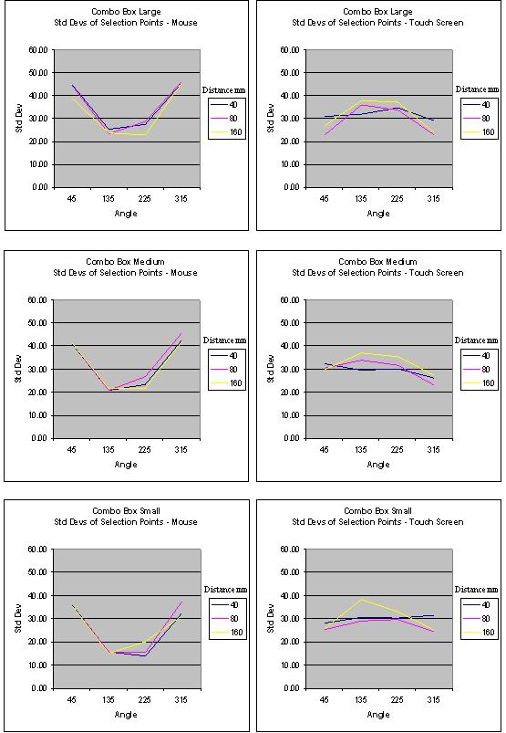
Figure 4.32 The standard deviation of final selection coordinates for the combo box. Each graph shows the standard deviations of each distance for one combination of device and combo box size.

4.5 Summary of Results
The results showed that the mouse had a faster average movement time of 1.318s compared to the movement time of 1.555s for the touch screen. There was a significant interaction between the device and movement time (F(1.01, 22.17) = 14.57, p < 0.01) as well as target size, selection device and movement time used (F(1.01, 22.17) = 9.53, p < 0.01). The analysis showed that the text box had the fastest overall movement time followed by the button, check box and last of all, the combo box. Movement times were very similar for the mouse and touch screen across all target types except the check box where the movement time for the touch screen was 69% slower than the movement time for the mouse.
For throughput, the touch screen and the mouse had a very similar throughput to that of the mouse, about 1.2 bps. The analysis showed that interaction between the target type and throughput was statistically significant (F(2.07, 45.55) = 4.77, p < 0.001). But throughput was not affected by selection device (F(1, 22) = 0.02, p > 0.05) or target size (F(2, 44) = 2.179, p > 0.05). For the targets, the check box had the highest throughput of 1.967 bps and this ranged to the combo box, which had the lowest throughput of 0.501 bps.
The results for the error rates followed the same pattern for the movement time results. The error rate for the mouse was 2.7%, considerably less than the 60.7% error rate for the touch screen. There was a significant interaction between target type and error F(1.592, 35.016) = 73.817, p < 0.001) as well as size and error rate (F(1.052, 22.554) = 25.263, p < 0.001). The check box, which was the smallest target type, had an extremely high error rate when making selections using the touch screen (312.5%) In general the touch screen had a high error rate of 127% with small targets.
Learning was shown to have occurred with the combo box and check. Helmhert contrasts show that the differences between blocks become non-significant after block 1 with both target types. To account for the learning, the results for the combo box and check box were recalculated using data only from block 6 expect with the error rate. The error rates in block 6 were highly skewed and so to get a better representation, the error rates were calculated using data from all of the blocks.
Results from the questionnaire showed that the mouse was rated easier to make accurate selections and easier to use compared to the touch screen with both of these results being statistically significant (p < 0.05). The touch screen was rated just as easy as the mouse to make accurate selections for all targets except with the check box. In this case the touch screen was rated more difficult to make accurate selections with and this was consistent with the findings for movement time and error rate.

- Discussion

The discussion section aims to relate the results of the data analysis with the research problem set out at the beginning of the document. The research problem was: to what extent does target type and size affect the ability of which a user takes to select a GUI target? How does this vary depending on selection device used, namely between a mouse and touch screen and what device has the highest user satisfaction when used with the GUI targets?
The study focused on four different target types namely a button, check box, combo box and text box and three different sizes were tested for each target. These sizes represented small, medium and large for each target. The performance of each of these targets and sizes were evaluated using multi-directional tasks. Although prior work on pointing devices has typically used one-directional tasks, multi-directional tasks better represent real life tasks involving GUI items in information systems and were therefore used in the study. The multi-directional tasks involved four different angles and three different distances to vary the position of the target on the screen.
It is important to reiterate the fact that the touch screen studied was a touch screen overlay and is different to a touch screen monitor. Most noticeably, the gap between the touch screen overlay and the monitor caused a loss in accuracy. Hence throughout the discussion and conclusion, the touch screen being referred to is a touch screen overlay and not a touch screen monitor.
The aim of this Discussion section is to explore and question the results and review the findings outlined in the Results section. The results relating to each subproblem will be discussed in relation to the research problem.
Finally, each of the hypotheses will be restated and discussed in terms of weather they were supported or not.
Movement time
The results showed that the mouse had a movement time of 1.318 seconds for all targets compared to 1.555 (s) for the touch screen. Therefore we can conclude that a mouse is on average 15.2% faster than a touch screen. This is interesting as Sears and Shneiderman (1991) found that the movement time between a mouse and touch screen was similar for rectangle targets larger than 2mm. Therefore the nature of the two types of touch screen (overlay and monitor) may affect the movement time associated with the type of touch screen. It is also likely that due to the loss of accuracy found with the overlay during testing, the touch screen monitor will have a lower movement time compared to the touch screen overlay.
The movement times for each target showed that the text box has the fastest movement time, follow by the button, the check box and then the combo box. These results follow Fitts’ Law in that the largest target (the text box) had the fastest movement. As expected, the combo box had the slowest movement time due to the two-click behaviour involved in making a selection. The sizes of the combo box were exactly the same as the text box but its movement time was 119% slower. Thus the extra movement of selecting an item from the drop down list increases the movement time involved with the combo box dramatically. It is acknowledged that the different visual feedback may affect the movement time between a text field and a combo box, but it is very unlikely that it will influence the movement time to such as an extent as shown in the study. As the distance to the list item is relatively short from the main combo box area, the significant increase in movement time is therefore most likely due to users making more errors.
A touch screen has similar movement time to a mouse for medium and large sized targets. But for the small targets, the touch screen (2.115s) was 67% slower than the mouse (1.266s). As the actual sizes of small targets varied depending on the target, a movement time of 2.115s is acceptable although the movement time for each small target varies considerably. The only time where the touch screen was found to be faster than the mouse was with the largest target type - the large text box.
The movement time for the small check box with the touch screen was 69% slower than that of the mouse. The small check box was the smallest item tested having a width of 4mm and height of 4mm. We can conclude that the touch screen overlay was not efficient for selecting targets as small as 4mm. Sears and Shneiderman (1991) showed that a touch screen monitor has similar movement time to the mouse for targets as small as 2mm. This shows that although a touch screen monitor can be used with targets as small as 2mm, a touch screen overlay should only be used for targets with a size of at least 8mm. The results from the error rate analysis also support this.
Error Rate
The results relating to the error rates provided some interesting findings. The error rate for the mouse was only 2.733% which is consistent with previous studies. The touch screen overlay on the other hand had an error rate of 60.7%. Sears and Shneiderman (1991) found that the touch screen monitor used in his study had an average error rate of 49% but this was across much smaller targets. This suggests there is a loss in accuracy from using a touch screen overlay compared to a touch screen monitor.
The check box had a significantly high number of errors; 78.5% overall and 312.5% for the small check box with the touch screen in particular. But it was with the touch screen that all of the errors arose. On average the mouse had an error rate of 4.4%. The touch screen had an error rate of 152.5%. The distinguishing factor of the check box compared to the other targets was its small size. We can conclude from this that the touch screens have inaccuracy in selecting small targets (8mm or less).
When the average error rate of the check box with the touch screen (152.5%) is compared to that of the mouse from a study by Sears and Shneiderman (1991) (49%), more support is given to the finding that touch screen overlays are less accurate than touch screen monitors. The target sizes were actually smaller in the test by Sears and Shneiderman (1991) than the sizes in this study which means that all things being equal, the study by Sears and Shneiderman (1991) should have had lower error rates. This dismisses any chance of differences in test conditions invalidating the findings that the touch screen overlay has less accuracy than the touch screen monitor. To add further weighting to this finding, none of the targets or target sizes with the touch screen overlay had the same or smaller error rate than the mouse. Whereas Sears and Shneiderman (1991) found that for targets of size of size 8mm and 16mm, a touch screen monitor had lower error rates than the mouse.
Buttons and text boxes had low error rates compared to that of the check box and combo box. As buttons and text boxes also had low movement times, we can conclude that these two targets have very good overall performance.
For all targets, the touch screen showed an average increase of 139.3% in error rate from large to medium text boxes and 188.7% from medium to small. These figures emphasise the loss of accuracy with the touch screen overlay.
Throughput
The touch screen and the mouse had very similar throughput although the differences were not statistically significant (F(1, 22) = 0.02, p > 0.05). The throughput was 1.238 bps for the mouse and 1.215bps for the touch screen. Remembering that throughput is a function of the level of difficulty in selecting the target and movement time, targets selected with the touch screen had a high index of difficulty. This was the reason for the touch screen having a similar throughput rate to the mouse.
Although differences in throughput were not statistically significant for target size (F(2, 44) = 2.179, p > 0.05) and device (F(1, 22) = 0.02, p > 0.05), throughput did vary depending on target type (F(2.07, 45.55) = 4.77, p < 0.001). Check boxes had the highest throughput rate of 1.967 bps (sd = 0.720). This is interesting as the check box was shown to have the second worst movement time and the worst error rate. Upon further investigation it was seen that the movement time was in fact in the middle range of all targets and due to its small size it had a high index of difficulty. Therefore these two factors are the reason for the check box having such a high throughput rate. The button had the second highest throughput of 1.505 bps (sd = 0.111), the text box third with 0.958 bps (sd = 0.081) and the combo box had the worst throughput of 0.501 bps (sd = 0.213). The index of difficulty was not very high for the combo box and so it was due to its high movement time that the combo box had such a low throughput rate.
In relation to subproblem 1, it is clear that different types of target have different movement time, error rates and throughput with a touch screen. In particular the text field and button had the lowest movement time and error rate due to its large size and simple selection behaviour. The combo box had the longest movement time due to its selection behaviour and both devices have high error rates with the combo box. Due to its small size, the check box had an extremely high error rate. When comparing these results to previous studies, it is clear that a touch screen overlay has less accuracy with smaller targets compared to touch screen monitors. The check box had the highest throughput rate due to its high level of difficulty and the combo box had the lowest throughput rate due to its low level of difficulty and high movement time. But throughput did not vary with target size or selection device and so a touch screen had a similar throughput rate compared to a mouse.
In relation to subproblem 2, the mouse had the lowest error rate and movement time. The combo box again had the highest movement time but the check box had a low movement time compared with the touch screen. As already stated, size and target type had a significant effect on error rate with device. For the mouse, there was a low error rate over all targets and target sizes. The combo box had the highest error rate with the check box being second worst. It has already been stated that selection device was shown not to have an effect on throughput and was the same for both mouse and touch screen (1.2 bps).
In relation to subproblem 3, accounting for learning, the test was divided into blocks so the results from each block could be compared and any learning could be observed and adjusted for. Learning occurred with the check box and combo box only. This will be further explained in relation to the hypothesis at the end of this section. To account for learning, movement time and throughput was adjusted for the check box and combo box and was calculated using only data from block 6. Block 6 was used as it was seen to have a good representation of the results. The error rates from block 6 for the check box and combo box were highly skewed and so the error rates were reported using the data from all the blocks to give a more true representation.
In relation to subproblem 4, user satisfaction with the touch screen, the text box was rated easy to accurately select and the preferred size was both the large size and the medium size. This feedback is consistent with the data collected in that text fields have short movement time and low error rates (easy to accurately select).
The button was regarded easy to accurately select with the touch screen and the most preferred size was again the large size (50%), although 42% preferred the medium size and 8% the small size. The combo box was rated in the midpoint range in terms of ease in accurately selecting. Thus the combo box was rated more difficult to select than the text box and button. The most preferred size was the large size (75%). The check box was rated very hard to accurately select and the most preferred size was the large check box (92%).
In relation to subproblem 5, user satisfaction with the mouse, the text box was rated the same as the touch screen. Participants rated the text box easy to accurately select and both the large and medium sized text boxes were the most preferred. The most preferred sized button for both devices was both the large and medium sizes.
The user preference results for the combo box varied a bit for the mouse compared to the touch screen. The combo box was still rated in the midpoint range for ease of accurately selecting and therefore rated more difficult to select than the text box or button with the mouse. As previously stated, the large size combo box was the most preferred size with the touch screen.
For the check box, like with the touch screen the mouse was rated hard to accurately select and the most preferred size was the large check box. Overall the mouse was rated easier to accurately select the check box than with the touch screen.
Other findings
The preferred selection style with the combo was the two-click style where a user would initially click the combo box to show the drop down list if items and then the user would select an item from the list. For both devices 92% of the participants used the two-click style of selection. It would have been interesting to be able to compare participants using the one-click style with participants using the two-click style selection with the combo box. Thus movement time and error rates could have been analysed to see which style gives the best performance although this is out of the scope of the study.
One really interesting finding that arose from the study related to the varying standard deviations of selection points depending on what side of the screen the target was in. This phenomenon was only found with the larger targets (text box and combo box). For these targets on the right hand side of the screen there was much more variance in the final selection points compared to the selection points on the left hand side of the screen. But this was only found with the mouse as the standard deviation remained consistent over all screen locations for the touch screen except for with the combo box. For the combo box used with the touch screen the opposite effect was noticed which is peculiar. The standard deviation of the final selection points was much greater on the left hand side of the screen compared to the right hand side of the screen.
In hindsight, one limitation of the study is that for each participant, whether they were left or right handed was not recorded. There may be a relationship between this piece of information and the variance in selection points for different sides of the screen. Several intriguing questions arise from this finding.
Why does this phenomenon not exist with the touch screen as it does with the mouse for the text box? Why were users much more careful in selecting the text field on the left hand side with the mouse compared to the right hand side? Were the movement times higher and error rates lower for the text boxes on the left hand side of the screen when using a mouse? And with the combo box, why is the phenomenon reversed with the touch screen?
The phenomenon found and the related questions asked are out of the scope of the study but future work into this finding may provide some interesting results. It is very likely issues raised with this finding will be related to cognitive issues.
Hypothesis
Each hypothesis set out will now be stated and discussed in terms of the findings of the study.
The first hypothesis is that larger targets will have better throughput, movement time and error rates than smaller targets for both touch screen and mouse selection devices. Results from the study supported this hypothesis. For all targets, larger sizes had better movement time and lower error rates than the small sizes and this was consistent across selection device. For the touch screen there was a 79.2% increase in movement time and 635.8% increase error rate from large to small target sizes. The mouse had a much smaller interaction with target size. There was an 8.9% increase for movement time and 64.9% increase in error rate from large to small target sizes. Size was shown to have a significant effect on movement time F(1.01, 22.17) = 14.57, p < 0.01). Device and size together were also shown to have a significant effect on movement time (F(1.01, 22.17) = 9.53, p < 0.01).
The second hypothesis is that a touch screen will have lower error rates and better speed than a mouse for all four targets. The results from the study did not support this hypothesis. The mouse had both better speed (1.355s) and error rate (2.7%) compared to the speed (1.555s) and error rate (60.8%) of the touch screen. Selection device was shown to have a significant effect on both movement time F(1, 22) = 5.421, p < 0.05) and error rate F(1, 22) = 31.776, p < 0.001).
The third hypothesis is that a touch screen will have higher user satisfaction than a mouse for all four different targets studied. Again this hypothesis was not supported by the results of the study. User satisfaction was assessed through a questionnaire based on an ordinal 5 point scale. The mouse had a higher rating for ease in accurate pointing than the touch screen. These differences were statistically significant (p < 0.01). The mouse also was also rated easier to use than the touch screen with the differences being statistically significant (p < 0.05). The touch screen has worse arm, wrist and finger fatigue but the differences were not statistically significant (p > 0.05).
In terms of the targets, the mouse and touch screen were rated about the same for ease in making selections except for with the check box. For the check box the mouse was rated easier to use for selecting compared to the touch screen.
The fourth hypothesis is that learning will occur with the touch screen. This hypothesis was supported by the results from the study. Learning was shown to take place with only the check box and the combo box, both of which were shown to be the harder targets to select in terms of movement time and error rate. The test involved with the study was split into six blocks so the results from each block could be studied. Helmhert contrasts for movement time showed that the differences between blocks become non significant after block 1 for both the combo box and check box. The interaction between block and device was significant for both the combo box (F(1.549, 1335.219) = 4.373, p < 0.05) and check box (F(1.608, 1385.960) = 4.763, p < 0.05). This indicates learning took place between the first and second block.

- CONCLUSION

The goal of the study was to assess the ability of a touch screen in selecting different targets commonly presented to users in an information system. In order to assess the ability of the touch screen, another selection device, a mouse, was assessed as well to allow comparisons in the results to be made. The research problem set out was: to what extent does target type and size affect the ability of which a user takes to select a GUI target? How does this vary depending on selection device used, namely between a mouse and touch screen and what device has the highest user satisfaction when used with the GUI targets.
To answer the research problem, a series of tests were held consisting of simple point and select tasks. Twenty four typical users of an information system participated in the study. The test was used to extract data pertaining to movement time, error rate and throughput for each device. These data were automatically extracted by software written for the test. User satisfaction relating to the device and targets and sizes was evaluated using a questionnaire taken from the international standard for assessing selection device ISO 9241-9. The touch screen tested was an overlay touch screen which differs to a normal touch screen monitor. The touch screen overlay sits over a normal monitor and results in a gap between the overlay and monitor itself. This gap was shown to decrease the accuracy of the touch screen.
The results showed that the touch screen was both slower and less accurate than the mouse. When comparing these results to previous studies which show a touch screen has very similar movement time and error rate to the mouse even with small targets, there is substantial reason to suspect that a touch screen overlay is less accurate than a touch screen monitor. The touch screen was found to have reasonable performance with buttons and text boxes. The touch screen had poor performance with a check box which can be put down to its small size. In general we can conclude that a touch screen overlay with no external device (i.e. pen) is not an effective selection device for targets having a size of 8mm or smaller. The touch screen overlay did have comparable movement times to the mouse for medium and large sized targets.
Throughput did not vary across device or size but did vary across target type. Throughput for the mouse was 1.238 bps and 1.215 bps for the touch screen. For the targets, the check box had the highest throughput of 1.967 bps, and then the button with 1.505 bps, the text box with 0.958 bps and finally the combo box had the lowest throughput of 0.501 bps.
Both selection devices had the same user preference except for the smallest target, check boxes, in which the mouse had a higher preference. The mouse was rated easier to make accurate selections with than the touch screen. The touch screen also has worse arm, wrist and finger fatigue compared to the mouse. From these results we can conclude that the mouse had higher user satisfaction than a touch screen.

6.1 Hypotheses
The hypothesis that larger targets will have better throughput, movement time and error rates than smaller targets for both the touch screen and mouse selection device was supported by the study.
The hypothesis that a touch screen will have lower error rates and better speed than a mouse for all four target types and all sizes was not supported by the results of the study. The study showed that compared to a touch screen overlay, a mouse had a better error rate and movement time for all target types except for the largest, a large text box. In this case the touch screen had the lowest movement time.
The hypothesis that a touch screen will have higher user satisfaction than a mouse for all four different target types studied was again not supported by the study. The results were found using a device assessment questionnaire. The findings showed that the preference for both selection devices was the same except for the smallest target type – the check box. In this case, users preferred to use a mouse.
The hypothesis that learning will occur with the touch screen was supported by the study. Learning occurred with both the check box and combo box, both of which were the two most difficult targets to select in terms of movement time and error rate.

6.2 Practical Implications
The findings from the study have at least one major implication. One of the motivations of study was that the mouse has been the standard selection device used with desktop PCs for over a decade. Therefore it is only a matter time before other selection devices become suitable for the desktop PC. The results from the study show that touch screen overlays used with the user’s finger are not suitable for desktop PCs because of their inaccuracy with small targets (8mm or less).
When designing interfaces that will be used with a touch screen overlay, selection will be more efficient if the items are larger than 8mm.
Users prefer to use the two-click style approach to making selections with combo boxes. This means that a user will first click the combo box and then make a second click on the item of interest from within the pull-down list of items. Therefore combo boxes should be designed to accommodate this style of selection, i.e. the pull down list should remain visible after the user has released the initial click and not disappear as with some combo boxes.

6.3 Future Work
Comparisons between the performance of a touch screen overlay and with a touch screen monitor was done by comparing the results of this study with previous studies that used a touch screen monitor. Testing explicitly between a touch screen monitor and overlay could better compare and evaluate the selection performance of the two selection devices.
Although the results showed that the touch screen overlay was neither efficient nor usable for selecting items with a size of 8mm or less, this may not be the case when a pen or some external device is used in conjunction with the touch screen overlay. In general there seems to a lack of research done in device assessment with touch screens and pens or other external devices. Further testing on touch screens used with an external device such as a pen may well show that a touch screen overlay is adequate and efficient for selecting small items (8mm or less).
Possibly the most interesting finding of the study was related to the variance of the selection points with large items using a mouse. For the text box and combo box, selection points made with the mouse had a higher variance on the right hand side of the screen compared to the left. This indicates that users were much more careful consistent in making selections on the left hand side of the screen compared to the right. The opposite phenomenon occurred when users made selections on a combo box using a touch screen. There was instead a higher variance of selection points on the left hand side of the screen compared to the ride hand side. Many questions arise from this finding and only further research will provide answers.
Finally, further research is needed to explore the effects of distance and angle in relation to selection device, target size and target type.

References

: 273-277.

(3): 157-161.

Apple Computer, I. (2004). "Apple Human Interface Guidelines." 155 - 192. Retrieved June 10, 2004, from http://developer.apple.com/documentation/UserExperience/Conceptual/OSXHIGuidelines/index.html

Bender, G. T. (1998). Touch selection strategies for touch screens. Unpublished raw data.

Bender, G. (1999). Touch screen performance as a function of the duration of auditory feedback and target size. Liberal Arts and Sciences, Wichita State University: 7.

Booth, K., Fisher, B., Po, B. (2004). "Mouse and Touchscreen Selection in the Upper and Lower Visual Fields." Human Factors in Computing Systems, CHI '2004 Conference Proceedings: 359-366.

Douglas, S. and A. Mithal (1994). "The effect of reducing homing time on the speed of a finger-controlled isometric pointing device." Human Factors in Computing Systems, CHI '94 Conference Proceedings: 411 - 416.

Dumas, J. and J. Redish (1993). A Practical Guide to Usability Testing. New Jersey, U.S.A, Ablex publishing Corporation.

Ferguson, E. and R. Gibson (2004). Development of an innovative tool to improve complementary feeding practices in the south-east Asian and pacific regions, University of Otago, New Zealand.

Harada, H., Katsuura, T., Kikuchi, Y. (1996). "Fundamental study on the size and inter-key spacing of numeric keys for touch screen." Journal of Human Ergology 25(2): 167-174.

ISO (1998). Ergonomic requirements for office work with visual display terminals (VDTs). Part 9 - Requirements for non keyboard input devices (ISO 9241-9). International Organization for Standardization.

MacKenzie, I., Sellen, A., & Buxton, W. (1991). A comparison of input devices in elemental pointing and dragging tasks. Proceedings of the CHI '91 Conference on Human Factors in Computing Systems (pp. 161-166). New York: ACM.

MacKenzie, S., Douglas, S., Kirkpatrick, A. (1999). "Testing pointing device performance and user assessment with the ISO 9241, part 9 standard."

MacKenzie, S. and S. Jusoh (2001). "An Evaluation of Two Input Devices for Remote Pointing." Proceedings of the Eighth IFIP Working Conference on Engineering for Human-Computer Interaction EHCI 2001: 235-249.

MacKenzie, S., Kauppinen, T., Silfverberg, M. (2001). "Accuracy measures for evaluating computer pointing devices."

MacKenzie, S. and A. Oniszczak (1998). "A comparison of three selection techniques for touchpads".

MacKenzie, S. and W. Soukoreff (1995). "Generalized Fitts' Law Model Builder." Mosaic of Creativity.

Mass Multimedia, I. (2002). Comparing touch technologies. Colorado Springs, U.S.A. Retrieved June 12, 2004, from http://www.touchscreens.com/intro-touchtypes.html.

Mayhew, D. (1992). Principles and guidelines in software user interface design, PTR Prentice-Hall, Inc.

Nielsen, J. (2001). Usability metrics, Retrieved June 30, 2004, from http://www.useit.com/alertbox/20010121.html.

NextWindow (2001). Competitive touchscreen technology. Auckland, New Zealand. Retrieved June 12, 2004, from http://www.nextwindow.com/technology/competitive.html.

Preece, J. (1993). A guide to usability: human factors in computing, Addison-Wesley.

Preece, J., Yvonne, R., Sharp, H. (2002). Interaction design: beyond human-computer interaction, John Wiley & Sons, Inc.

Scholtz, J., Salvador, T., Lockhart, P., Newbery, J. (1997). "Design: No job too small."

Sears, A., Revis, D., Swatski, J., Crittenden, R, Shneiderman, S. (1993). "Investigating touch screen typing: The effect of keyboard size on typing speed." Behaviour & Information Technology 12: 17-22.

Sears, A. and B. Shneiderman (1991). "High precision touchscreens: design strategies and comparisons with a mouse." International Journal of Man-Machine Studies 34: 593-613.

Shneiderman, B. (1991). "Touchscreens now offer compelling uses." IEEE Software 8(2): 93-94.

Wilson, K. S., Inderrieden, M., Liu, S. (1995). "A comparison of five user interface devices designed for point-of-sale in the retail industry." Proceedings of the Human Factors & Ergonomics Society 39th Annual Meeting 39: 273-277.

Appendices

Appendix A

Pre-Test Information

Name:

Please circle you choice.

- Have you used a computer before? Yes No

- If Yes, how often do you use a computer?

x x x x
daily weekly monthly less than once a month

- Have you used a mouse before? Yes No

- If Yes, how much experience have you had in using a mouse?

x x x x x
very little a lot

- Have you used a touch screen before (often used in public kiosks or with personal digital assistants (PDAs))?
Yes No

- If Yes, how much experience have you had in using a touch screen?

x x x x x
very little a lot

Thank you.

Appendix B

Information Sheet for Participants
The test is made up of a series of point and select tasks. Each task involves clicking on the ‘Go’ button in the centre of the screen at which point a target shall appear randomly on the screen. You must then point and select the target. Upon successful selection the target will disappear. The test will be divided into 6 blocks of tasks and will take approximately between 30 and 45 minutes to complete.

There are four possible targets of varying sizes:

- Button


- Text Box

- Check Box

- Combo Box

When selecting the combo box, always select the third item, ‘Item 3’, in the list.

- You should try not to stop during each block of tasks, but you may rest for as long you wish in between blocks. You will be told when you have completed a block and may rest.
- You should complete each task quickly while trying to be as accurate as possible.
- You will be told when all of the point and select tasks have been completed. At this time please immediately fill out the questionnaire and inform the research personnel that you have finished the study.
- If you have any questions, please ask the research personnel before the test begins.

You are reminded that this test is confidential and your results can in no way be associated with you. Your participation is voluntary and you may leave the test anytime if you wish.
Thank you for your time.

Appendix C

Mouse Device Assessment

Please circle the x that best reflects your answer to the comment.

- Accurate pointing was
x x x x x
easy difficult

- The physical effort required for operation was
x x x x x
too low too high

- The mental effort required for operation was
x x x x x
too low too high

- Operation speed was
x x x x x
too fast too slow

- Neck fatigue was
x x x x x
none very high

- Finger/Wrist/Arm fatigue was
x x x x x
none very high

- General comfort:
x x x x x
very uncomfortable very comfortable

How easy was it to accurately select each of the following targets?

- Buttons:
x x x x x
easy difficult

- Combo boxes:
x x x x x
easy difficult

- Check Boxes:
x x x x x
easy difficult

- Text Fields:
x x x x x
easy difficult

What size do you prefer selecting for each of the following targets?

- Buttons:
x x x
small medium large

- Combo boxes:
x x x
small medium large

- Check Boxes:
x x x
small medium large

- Text Fields:
x x x
small medium large

- Overall, the input device was
x x x x x
very difficult to use very easy to use

Other comments:

Thank you for your participation in the study:

Appendix D

Touchscreen Device Assessment

Please circle the x that best reflects your answer to the comment.

- Accurate pointing was
x x x x x
easy difficult

- The physical effort required for operation was
x x x x x
too low too high

- The mental effort required for operation was
x x x x x
too low too high

- Operation speed was
x x x x x
too fast too slow

- Neck fatigue was
x x x x x
none very high

- Finger/Wrist/Arm fatigue was
x x x x x
none very high

- General comfort:
x x x x x
very uncomfortable very comfortable

How easy was it to accurately select each of the following targets?

- Buttons:
x x x x x
easy difficult

- Combo boxes:
x x x x x
easy difficult

- Check Boxes:
x x x x x
easy difficult

- Text Fields:
x x x x x
easy difficult

What size do you prefer selecting for each of the following targets?

- Buttons:
x x x
small medium large

- Combo boxes:
x x x
small medium large

- Check Boxes:
x x x
small medium large

- Text Fields:
x x x
small medium large

- Overall, the input device was
x x x x x
very difficult to use very easy to use

Other comments:

Thank you for your participation in the study:


Appendix E

Form devised May 1995; updated May 1997; June 1998; May 1999, Dec 2000, June 2002

ETHICAL APPROVAL AT DEPARTMENTAL LEVEL OF A
PROPOSAL INVOLVING HUMAN PARTICIPANTS (CATEGORY B)

NAME OF DEPARTMENT: Information Science

TITLE OF PROJECT: Design strategies for touch screen based information systems

PROJECTED START DATE OF PROJECT: March 2004

STAFF MEMBER RESPONSIBLE FOR PROJECT: Nigel Stanger

NAMES OF OTHER PARTICIPATING STAFF: Matthew Gleeson, Elaine Ferguson

BRIEF DESCRIPTION OF THE PROJECT:

Today, users of information systems on desktop PCs are limited in their method of interaction with the system. Most information systems are designed to be used with a keyboard and mouse. Although the keyboard and mouse is the accepted method of interaction it doesn’t necessarily suit all information systems.
The purpose of the intended research is to investigate how target size affects usability of an interface for an information system. Two selection devices will be compared, namely a mouse and a touch screen using three different target sizes. The targets tested on are buttons, check boxes, combo boxes and text boxes which are typical of those found in an interface for an information system.
A series of tests will be conducted to investigate the effect of different target sizes in an interface using either a touch screen or mouse as the selection device. Data will be gathered from these tests along with data from a questionnaire focused on user satisfaction. This data can be analysed to show what selection device has the best speed, error rate and user satisfaction and with what target size.

The information system the project will be working with is designed for a project currently being undertaken by the University of Otago Nutrition Department. This project is aiming to improve complementary food diets for toddlers in New Zealand through designing a program that will formulate population-specific food-based dietary guidelines for this high risk group.

DETAILS OF ETHICAL ISSUES INVOLVED: Please give details of any ethical issues which were identified during the consideration of the proposal and the way in which these issues were dealt with or resolved:-

As this research involves measuring the performance of nutrition/dietician professionals in the performance of a task in their field of expertise, there is the possibility of data that directly associating individual participants with their performance scores being published or used in ways that might embarrass or disadvantage participants in the future. To prevent this possibility, the following data storage and identification procedures will be used.

- No personal identifying information will be collected such as names and contact details.
- Only the researchers will have access to the information collected. This is achieved through storing collected data immediately on a password protected personal computer that uses both start-up and screen saver password protection. Any raw data such as questionnaire papers will be destroyed immediately after being inputted into the computer.
- A random number will be assigned to each participant that in no way can be linked to the participant. The random number will be generated using MS Excel’s random number function (seeded from the system clock) and given to the participant upon starting the first test. The participant will then use this number for the second and third test and then for the questionnaire. The research personnel running the test will not be in the room while the users complete all three tests and the questionnaire. This ensures the research personnel can in no way see and link the random number with the participant.
- To avoid the possibility of duplicate participant numbers being randomly generated, any duplicate numbers will be discarded.
- Results of this project may be published but any data included will in no way be linked to any specific participant.

ACTION TAKEN

Approved by Head of Department Approved by Departmental Committee

Referred to University of Otago Human Ethics Committee Referred to another Ethics Committee
Please specify:

..................................................................

DATE OF CONSIDERATION: ..................................

Signed (Head of Department): ...................................................

Please attach copies of any Information Sheet and/or Consent Form

DESIGN STRATEGIES FOR TOUCH SCREEN BASED INFORMATION SYSTEMS

INFORMATION SHEET FOR PARTICIPANTS

Thank you for showing an interest in this project. Please read this information sheet carefully before deciding whether or not to participate.
Definition of terms
- Information system. For the context of this study an information system is defined as a system on a personal computer (PC) that manipulates data according to the users needs.
- Selection device. A selection device is a method used to control the cursor within a screen on a computer. For the purpose of this study the selection devices used will be a mouse and a touch screen.
- Target. For the context of this study a target is referred to as an item within an interface. Such targets used in this study include text boxes and buttons.

Brief introduction
- Computer information systems can be used to objectively design population specific dietary guidelines. These systems will only be useful to nutritionists if the program has a user-friendly interface.
- This study therefore aims to develop and evaluate features that will make a nutrition program interface more user-friendly. Specifically, we will evaluate and compare different target sizes and selection devices. The selection devices studied will be a mouse and a touch screen. The targets that will be studied are buttons, text boxes, combo boxes, and check boxes.
- Although touch screens have had success in public kiosks and for personal digital assistants (PDA’s), they have yet to be successfully implemented with information systems on desktop computers. The results from this study may help to improve design strategies for information system used with a touch screen and will provide nutritionists with a valuable “user-friendly” nutrition program.

What is the aim of the project?
- This project aims to design a user friendly interface for an information system to design food based dietary guidelines.
- This system will then be used to evaluate the effect of using different target sizes and different selection devices in an interface for an information system.

What type of participants are we looking for?
- Nutritionists / dieticians are needed to participate in this study, because they will be the end users of the program being tested.

What will you be asked to do?
Should you agree to take part in this project, you will be asked to ......
- Participate in completing three different tasks using a nutrition program and either a touch screen or mouse.
- Each participant will also be required to fill out a short questionnaire of no more than ten questions after completing all tasks.
- In total, the three tasks and the questionnaire should take no longer than 30 - 45 minutes to complete.

What data or information will be collected?
- The time taken to complete each task will be recorded along with the number of errors made during the task.
- The participant’s opinions relevant to both selection devices (touch screen and mouse) will be gathered through a questionnaire and analysed by the researcher.
- The participant’s opinions relevant to the target sizes used will be gathered through a questionnaire and analysed by the researcher.
- Details such as age group and gender will be recorded but no personal identifiers such as names will be recorded.

What use will be made of the data or information collected?
- It will be used to evaluate the usability of a touch screen for a nutrition information system compared to a mouse.
- It will also be used to evaluate the effect of using different target sizes with each selection device
- It will be used to help develop a user friendly nutrition program to help nutritionists design population specific food-based dietary guidelines.
Can participants change their mind and withdraw from the project?
- You may withdraw from participation in the project at any time and without any disadvantage to yourself of any kind.

How will the confidentiality of information collected in the questionnaire and tasks I complete be guaranteed?
- No personal identifying information will be collected such as names and contact details. Only the researchers will have access to the information collected.
- Results of this project may be published but any data included will in no way be linked to any specific participant.
- The data collected will be securely stored in such a way that only those mentioned above will be able to gain access to it.
You are most welcome to request a copy of the results of the project should you wish.

What if Participants have any Questions?
If you have any questions about our project, either now or in the future, please feel free to contact either:-

Elaine Ferguson
Department of Human Nutrition
Telephone Number:- 479-8374
Matthew Gleeson Nigel Stanger
Department of Information Science Department of Information Science
Telephone Number:- 025 367 395 University Telephone Number:- 479-8179

DESIGN STRATEGIES FOR TOUCH SCREEN BASED INFORMATION SYSTEMS

CONSENT FORM FOR PARTICIPANTS

I have read the Information Sheet concerning this project and understand what it is about. All my questions have been answered to my satisfaction. I understand that I am free to request further information at any stage.

I know that:-
1. My participation in the project is entirely voluntary;

2. I am free to withdraw from the project at any time without any disadvantage;

3. The data will be destroyed at the conclusion of the project but any raw data on which the results of the project depend will be retained in secure storage for five years.

4. The results of the project may be published and available in the library but every attempt will be made to preserve my anonymity.

I agree to take part in this project.

............................................................................. ...............................
(Signature of participant) (Date)

Performance index is the term Fitts originally used for what is now known as throughput.
Performance index is the term Fitts originally used for what is now known as throughput.

