Design strategies for GUI Items with touch screen based information systems
Assessing the ability of a touch screen overlay as a selection device
Matthew Gleeson, Nigel Stanger
Department of Information Science, Otago University, Clyde St, Dunedin, New Zealand
Email: matt_gleeson@xtra.co.nz, nstanger@infoscience.otago.ac.nz
Elaine Ferguson
Department of Human Nutrition, Otago Univeristy, Dunedin, New Zealand
Email: elaine.ferguson@stonebow.otago.ac.nz
Keywords: Touch Screen Overlay, Mouse, Pointing Devices, Fitts’ Law, Performance Evaluation, GUI Items
Abstract: Touch screens are a popular method of interaction with information systems embedded in public kiosks. Typical information systems are used on desktop PCs and therefore restricted to having a mouse as the selection device used to interact with the system. The purpose of this paper is to investigate how effective a touch screen overlay is in selecting typical graphical user interface (GUI) items used in information systems. A series of tests were completed involving multi-directional point and select tasks. A mouse, being the standard selection device, was also tested so the results of the touch screen could be compared. The GUI items tested were a button, check box, combo box and a text box. The results showed that the touch screen overlay was not suitable in terms of selecting small targets with a size of 4mm or less. The touch screen overlay was slower and had higher error rate compared to the mouse. There was no significant difference in throughput between a touch screen overlay and mouse. The mouse was rated easier to use and easier to make accurate selections with. The touch screen had higher arm, wrist and finger fatigue. This indicates that a touch screen overlay used only with a finger is not a practical selection device to use with interfaces containing small targets.

1 INTRODUCTION
Today, users of information systems on desktop personal computers are limited in their method of interaction with the system. Most information systems are designed to be used with a keyboard and mouse. Although the keyboard and mouse is the accepted method of interaction it doesn’t necessarily suit all information systems. Information systems with limited data entry may be more usable through the use of a keyboard and touch screen. Touch screens require less physical space and thus the workstation environment in an office setting could be improved, allocating more space to the employee and less to the computer.
The purpose of this paper is to investigate how effective a touch screen is in selecting typical graphical user interface (GUI) items used in information systems. Two selection devices will be compared; a mouse and a touch screen using three different target sizes. The targets tested on are buttons, check boxes, combo boxes and text boxes which are typical of those found in an interface for an information system.
The information system the project will be working with is designed for a project currently being undertaken by the University of Otago Nutrition Department. This project is aiming to improve complementary food diets for toddlers in New Zealand through designing a program that will formulate population-specific food-based dietary guidelines for this high risk group.
The program being used is a rapid assessment decision-making tool, designed specifically for nutrition program planners and is developed to assist them in selecting appropriate and improved home-based complementary foods (Ferguson and Gibson 2004). The testing for the study was run within this program environment.

2 GUI Targets
Since the 1980s much research has been put into developing human computer interface guidelines. Today’s interfaces are made up of a combination of different targets that could include text boxes, check boxes, combo boxes, list boxes, buttons, labels, tool bars etc. Results of research undertaken by Sears and Shneiderman (1991) showed that touch screens can be successfully used as a selection device and can have advantages over a mouse, even for small targets. But these results were based on selecting arbitrary shapes and not typical GUI items commonly found in today’s GUIs.
To accurately test the performance of each selection device within the experiment, varying sized targets were used. The sizes represent small, medium and large for each target.
Apple has produced some guidelines for developers to follow when designing interfaces for software (Apple Computer 2004). In particular, for each target three different sizes are given corresponding to large, small and mini. The sizes used in this experiment were based on these guidelines and are shown in Table 1.

Table 1: Target sizes are shown as width x height and are given in mm.
Target | Large (mm) | Medium  (mm) | Small  (mm)
Text | 63 x 11 | 55 x 8 | 47 x 6
Combo | 63 x 11 | 55 x 8 | 47 x 6
Button | 28 x 13 | 24 x 9 | 17 x 6
Check | 9 x 9 | 6 x 6 | 4 x 4

3 evaluation methods
Each selection device was assessed using a combination of performance and comfort measures.

3.1 Performance
The dependent measure described by ISO 9241-9 is throughput (ISO 1998). Throughput is noted by MacKenzie and Jusoh (2001) as being a very important measure as it reflects the efficiency of the user completing the task and it is a measure of both speed and accuracy. The formula for calculating throughput is given in the following equation:

throughput = ID_{e} / MT (1)

where
ID_{e} = log₂( D / W_{e}+ 1) (2)

ID_{e} represents the index of difficulty and is defined in terms of bits whereas movement time is defined in terms of seconds. Therefore throughput is measured in bits per second (bps). D represents the distance to the target. Throughput is used by the ISO 9241-9 standard as the performance measurement.
W_{e} is the effective width and differs from the width of the target. It reflects the spatial variability in the sequence of trials. The formula for calculating effective width is given in the following equation:

W_{e} = 4.133 x SD_{x} (3)

SD_{x} is the standard deviation in the selection coordinates measured along the path to the target
Due to the nature of making a selection within a drop-down list, the throughput for a combo box was adjusted to take into account the extra distance to the desired list item.
Movement time is defined as time taken to successfully select a target. Error rate is defined as the number of selections made outside of the intended target. The error rate is the ratio of incorrect selections to correct selections made, so an error rate of 100% means as many errors as correct selections.
Both movement time and error rate were left out of the ISO standard 9241-9 in terms of performance measurements but MacKenzie et al. (1999) recommend computing both measurements to give a more detailed performance analysis for the selection device.

3.2 Comfort
A questionnaire was used to assess comfort and user satisfaction of each selection device. The selection device assessment questionnaire consisted of sixteen questions, eight of which were taken from the ISO “Independent Questionnaire for Assessment of Comfort” (MacKenzie et al. 1999). The remaining eight questions related specifically to the targets tested and the size of the targets tested.
In particular, the questionnaire aimed to assess the participants’ comfort in using the input device, the difficulty in accurately selecting each of the targets and the preferable size of each target using the input device.
The responses to twelve of the questions were based on a five point ordinal scale. The remaining four questions referred to the participant’s preferred size for each target and were based on a three point response corresponding to the sizes tested - small, medium and large.

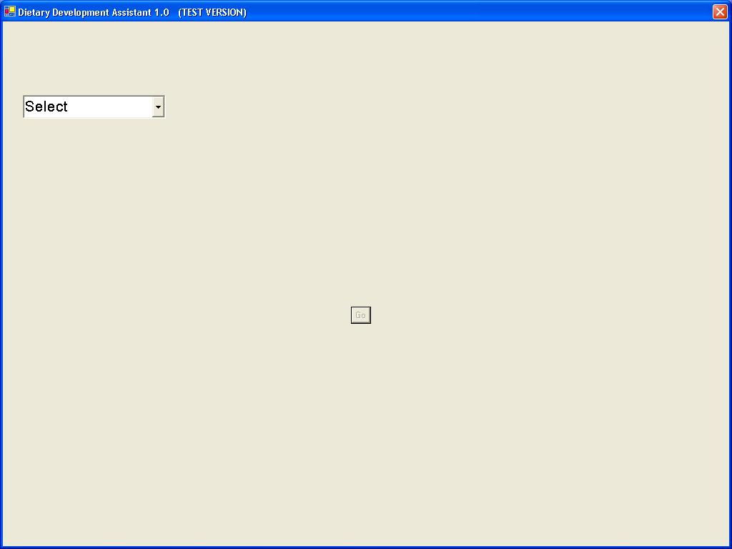
4 Method
An experiment was carried out to test the effect of size for different GUI targets with different selection devices. The experiment consisted of completing a series of simple point and select tasks. Small, medium and large sizes were tested for a combo box, text box, check box and button. The selection devices tested were a touch screen overlay and mouse. The test was multi-directional, meaning the target appeared in more than one direction to the user. A variety of different sizes, angles and distances were used for each target position.
Figure 1: Screenshot of the test with the target in the top left of the screen and the ‘go’ button in the centre.

4.1 Participants
A participant sample size of twenty four was used for the experiment. Each participant was allocated to one of two groups with each group using one selection device in testing.
The allocation of groups was based upon the results of a questionnaire completed by each participant prior to testing. The purpose of the questionnaire was to establish the level of computer, mouse and touch screen experience of each participant. A participant was allocated to a selection device group depending on what device they had the least amount of experience with.
Due to the testing being done within a nutrition program environment, the participants were all nutritionists (typical users of the program). There were 21 female and 3 male participants with all having a university level of education. All participants were unpaid volunteers.

4.2 Apparatus
Software written in Visual Basic.Net with Microsoft Studio 2003 was used to implement the test as illustrated in Figure 1. Each test was connected to a Microsoft Excel worksheet and the data corresponding to the relevant measures (movement time, number of errors and selection coordinates) were captured using the software and written to the Excel worksheet.
The touch screen used in testing was a 17” Magic Touch USB overlay Model KTMT-1700-USB-M. This touch screen uses a lift-off touch strategy. A touch screen overlay is a piece of equipment external to the monitor. It sits in front of the monitor and behaves similarly to a touch screen monitor. Using an overlay results in a gap between the overlay and the monitor itself, this causes a slight discrepancy between where the user touches the overlay and where the cursor is positioned on the screen.
The touch screen overlay was fitted to a Dell 15” Flat Panel Model E151FPb monitor. A flat panel monitor was chosen because it was noticed during pre-testing that typical CRT monitors with rounded screens caused a gap between where the users touched the screen and where the cursor gets positioned. A flat panel is less likely to suffer this problem. The device used for testing the mouse was a Dell PS/2 Optical Mouse Model M071KC. Both devices were connected to a Dell Inspiron 7500 laptop computer which ran the testing software.

4.3 Procedure
The participant was initially given an introduction to the test by the research observer. The introduction included a brief summary of the aims of the study and what the test involved. The participant was also given and told to read an instruction sheet which they had access to throughout the duration of the test. After reading the instruction sheet the participant had the opportunity to ask questions or raise any issues.
Participants were instructed to complete each block of tests as quickly as possible without losing accuracy. In between blocks of tasks, participants were given the opportunity to rest for as long as they wished. It was made clear to the participant that a task was only complete once the target was successfully selected. Selecting the button, check box and text box required the participant to simply click on the target. The strategy required to select a combo box was different. A combo box is a two-step target compared to the other targets which were simple one-step targets. First the combo box must be selected in order to show the list of items and then an item from the displayed list must be selected. During the testing the participant was instructed to always select the third item in the list when selecting a combo box as illustrated in Figure 2.
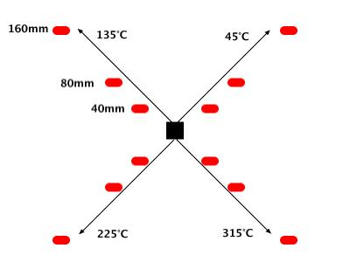
The participant was then instructed to complete a practice task involving fifteen random trials of the same point and select tasks used in the test. This brought all participants to a minimal level of experience with their selection device. This also meant each participant knew how to correctly select each device including the combo box.
Figure 3: Positions of targets tested. The black box represents the starting point and the red rectangles represent the target positions.
At the conclusion of the test the participant was required to fill out a questionnaire regarding comfort and user satisfaction with the selection device used.

4.4 Design
A mixed design experiment was used with the selection device as a between-subjects factor. The independent (between-subject) variables were:
- Target Type (text box, combo box, button and check box)
- Target Size (large, medium and small)
- Target Distance (40mm, 80mm and 160mm)
- Target Angle (45°C, 135°C, 225°C and 315°C)
- Trial (1 to 144)
- Block (1 to 6)

The entire test was divided into six blocks. Each block contained every possible combination of target type (4), size (3), angle from starting point (4) and distance (3). There were 144 trials in each block and the entire experiment per participant consisted of a total of 864 trials (six blocks of 144 trials).
The different combinations of target location on the screen are illustrated in Figure 3 and are a combination of distance and the angle from the starting point.

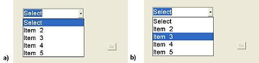
Figure 2: The two-step action required to select the combo box.
The dependent variables within the experiment were throughput (TH), movement time (MT) and error rate (ER).
The index of difficulty was ascertained for each task using the combination of distance and width. This showed that the test had a range of Fitts’ Index of Difficulty values from 0.7 bits (63mm width and 160mm distance) to 5.4 bits (4mm width and 40mm distance). The ordering of the target size presented to the participant within each block in the experiment was deliberately set to large, medium and lastly small to compensate for learning.

5 analysis
The data collected from the software included movement time, error rate and throughput and was used to evaluate selection device performance. A mixed design repeated measures analysis of variance model (MANOVA) was used for movement time and throughput to examine within subject differences in target and size, as well as between subject differences in device. A Greenhouse and Geisser correction of the F-ratio was used whenever the Mauchly's test results showed that assumptions of sphericity were violated.
Post hoc tests, for multiple comparisons, were made using the Bonferroni method. Due to the skew observed in the error rate data inter-device difference in error rates were assessed using the Mann-Whitney U Test.
The comfort questionnaire was based on a five point ordinal scale. In general five indicated a bad rating. Because of the small data size, a Mann-Whitney (non-parametric) test was used. All statistical analyses were performed using SPSS version 11.0.

6 Results and Discussion

6.1 Adjusting for Learning
MacKenzie et al. (1999) recommend that input device studies should apply a repeated measures paradigm and test for learning effects. The effects of learning have been shown to affect movement time and accuracy (MacKenzie et al. 1999).
From analysing the results of movement time and throughput over each test block, it is clear for the combo box and check box that learning occurs from the first to second block with the touch screen (as seen in Figure 4). Due to prior experience, no learning is observed with the mouse. No learning occurs with the text box or button most likely due to their large size and simple selection behaviour.
Statistical analysis using a simple repeated measure ANOVA was carried out on movement time for both the check box and combo box. For movement time of the combo box, the effect of block * device was significant (F(1.549, 1335.219) = 4.373, p < 0.05).
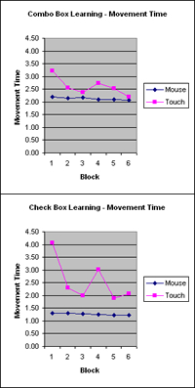
Helmhert contrasts show that the differences between blocks become non-significant after block 1 (p > 0.05). For movement time of the check box, the effect of block * device was significant (F(1.608, 1385.960) = 4.763, p < 0.05).

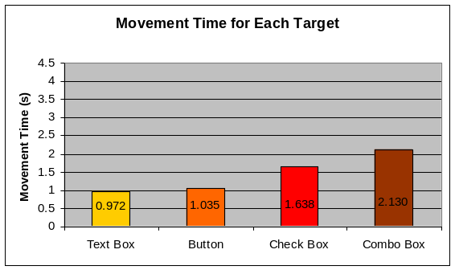
Figure 5: Movement time for each target across both devices and all sizes.

Figure 4: Learning is displayed for movement time by device and block for the combo box and check box.

Using Helmhert contrasts, the differences between blocks become non-significant after block 1 (p > 0.05). This again shows that there was learning involved in block 1.
To account for learning with the combo and check box, results from block 6 only will be used to calculate the performance measures of measurement time, throughput and error rate. The results from block 6 alone would give a good measure of performance.

6.2 Movement Time
The results showed that the mouse had an overall movement time of 1.3s for all targets compared to 1.6s for the touch screen. Therefore we can conclude that a mouse is on average 15.2% faster than a touch screen overlay. This is interesting as Sears and Shneiderman (1991) found that the movement time between a mouse and touch screen (monitor) was similar for rectangle targets larger than 2mm. Therefore the nature of the two types of touch screen (overlay and monitor) may affect the movement time associated with the type of touch screen. It is also likely that due to the loss of accuracy found with the overlay during testing, the touch screen monitor will have a lower movement time compared to the touch screen overlay.
The movement times for each target showed that the text box has the fastest movement time, followed by the button, the check box and then the combo box. These results are illustrated in Figure 5 and follow Fitts’ Law in that the largest target (the text box) had the fastest movement time.
As expected, the combo box had the slowest movement time due to the two-click behaviour involved in making a selection. The sizes of the combo box were exactly the same as the text box but movement time was 119% slower. Thus the extra
movement of selecting an item from the drop down list increases the movement time involved with the combo box dramatically. As the distance to the list item is relatively short from the main combo box area, the significant increase in movement time is therefore most likely due to users making more errors.
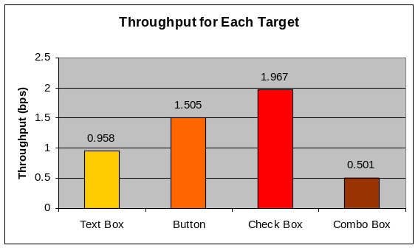
A touch screen has similar movement time to a mouse for medium and large sized targets. But for the small targets, the touch screen was 67% slower than the mouse. The only time where the touch screen was found to be faster than the mouse was with the largest target type - the large text box.
Figure 6: Throughput for each target type across both devices and all sizes.
The movement time for the small check box with the touch screen was 69% slower than that of the mouse. The small check box was the smallest item tested having a width of 4mm and height of 4mm. We can conclude that the touch screen was not efficient for selecting targets as small as 4mm. Sears and Shneiderman (1991) showed a touch screen has similar movement time to the mouse for targets as small as 2mm. Although a touch screen monitor can be used with targets as small as 2mm, a touch screen overlay should only be used for targets with a size of greater than 4mm. The results from the error rate analysis also support this

6.3 Throughput
Throughput for the mouse was 1.238 bps, slightly higher than the 1.215 bps throughput for the touch screen. The device by itself was shown not to have a significant effect on throughput (F(1, 22) = 0.02, p > 0.05). Throughput did not vary for size but throughput did vary depending on target type (F(2.07, 45.55) = 4.77, p < 0.001). Check boxes had the highest throughput rate of 1.967 bps (sd = 0.720). This is interesting as the check box was shown to have the second worst movement time and the worst error rate (see Figure 6).
Upon further investigation it was seen that the movement time for the check box was in fact in the middle range of all targets and due to its small size it had a high index of difficulty. Therefore these two factors are the reason for the check box having such a high throughput rate. The combo box had the worst throughput of 0.501 bps (sd = 0.213). The index of difficulty was not very high for the combo box and so it was due to its high movement time that the combo box had such a low throughput rate.
The overall throughput rate of 1.2bps for the mouse is much lower compared with previous research. A study by Douglas and Mithal (1994) showed a mouse had a throughput rate of 4.15 bps. MacKenzie et al. (1991) compared three devices

(mouse, tablet and trackball) using four target sizes (8, 16, 32 and 64 pixels) over two different types of tasks: pointing and dragging. The throughput for the mouse in this case was 4.5 bps. This may indicate the level of difficulty with selection within this experiment is a lot higher than within previous research. This could be due to the selection of GUI targets instead of arbitrary rectangle targets.

6.4 Error Rate
The error rate for the mouse was only 2.7% which is consistent with previous studies. The touch screen on the other hand had an error rate of 60.7%. Sears and Shneiderman (1991) found that the touch screen had an average error rate of 49% but this was across much smaller targets. This suggests there is a loss in accuracy from using a touch screen overlay compared to a touch screen monitor.
The check box had a significantly high amount of errors; 78.5% for all sizes and both devices and in particular, 312.5% for the small check box with the touch screen. A 100% error rate indicates one wrong selection made for every correct selection. The touch screen incurred the majority of the errors. With the check box the mouse had an error rate of 4.4% and the touch screen had an error rate 152.5%. The distinguishing factor of the check box compared to the other targets was its small size. We can conclude from this that the touch screen overlay has inaccuracy in selecting small targets (4mm or less).
Buttons and text boxes had much lower error rates compared to that of the check box and combo box (as seen in Figure 7). As buttons and text boxes also had low movement times, we can conclude that these two targets have very good overall performance.

6.5 COMFORT
In terms of accurate pointing the mouse (2.083) was rated easier than the touch screen (3.000). These differences were statistically significant (p < 0.01). The responses regarding the question on neck, wrist and arm fatigue showed that the touch screen had a high rating (4.083), whereas the mouse was rated in the midpoint range (3.167). These differences were statistically significant (p < 0.5). The final question rated the overall difficulty in using the selection device. The mouse (4.250) was rated easier to use than the touch screen (3.333). These differences were statistically significant (p < 0.05).
For user satisfaction with the touch screen, both the text box and button were rated easy to accurately select and the preferred size was both the large size and the medium size. This feedback is consistent with the data collected in that text boxes and buttons have short movement time and low error rates (easy to accurately select).
The combo box was rated in the midpoint range in terms of ease in accurately selecting with the touch screen and the check box was rated very hard to select. Three quarters of the touch screen users preferred to select the large size combo boxes and check boxes and this reflects the poor error rates and movement times associated with these two targets with the touch screen overlay.
The participants using the mouse rated the text box and button easy to accurately select with the medium and large sizes being the most preferred. Both the combo box and check box were rated harder to select than the button and text box with the check box having the worst rating. Like the touch screen overlay, the preferred size for the combo box and check box was large.
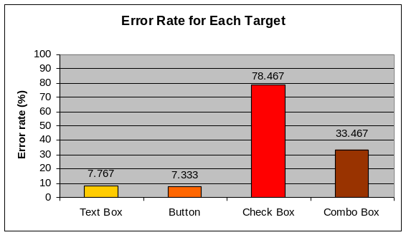
One participant noted the lack of arm support for targets at the top of the screen. This is an interesting comment because the nature of using a touch screen means the users arm might be raised off the desk and be self supporting when selecting items towards the top of the desktop screen.
Another suggestion was making the target change colour when the cursor is located above it. This is a similar concept to that of interactive rollover items commonly used in web pages. Auditory feedback has been shown to affect the speed and accuracy when making a selection (Bender 1999), and so it likely the visual feedback received from GUI targets will affect the selection performance. All the targets being tested provide some form of immediate visual feedback from the button being visually depressed it to a tick appearing in the check box. Future study is needed to assess how visual feedback affects selection performance and what the most effective method of providing feedback is.
Figure 7: Error rates for each target type across both devices and all sizes.

7 conclusions
The goal of the study was to assess the ability of a touch screen overlay in selecting different targets commonly presented to users in an information system. The touch screen overlay sits over a normal monitor and results in a gap between the overlay and monitor itself. This gap was shown to decrease the accuracy of the touch screen.
The results showed that the touch screen overlay was both slower and less accurate than the mouse. The touch screen was found to have reasonable performance with large GUI items but poor performance with a smaller GUI items. The touch screen overlay did have comparable movement times to the mouse for medium and large sized targets. Throughput did not vary across device or size but did vary across target. Both selection devices had the same user preference except with the smallest target, check boxes, in which the mouse had a higher preference. The mouse was rated easier to make accurate selections with than the touch screen. The touch screen overlay also has worse arm, wrist and finger fatigue compared to the mouse. From these results we can conclude that the mouse had higher user satisfaction than a touch screen.
In general we can conclude that a touch screen overlay with no external device (i.e. pen) is not an effective selection device for targets having a size of 4mm or smaller. When designing interfaces that will be used with a touch screen overlay, selection within the interface will be more efficient if the GUI items are larger than 4mm.
Although the results showed that the touch screen overlay was not efficient and usable for selecting items with a size of 4mm or less, this may not be the case when a pen or some external device is used in conjunction with the touch screen overlay. In general there seems to a lack of research done in device assessment with touch screens and pens or other external devices. Further testing on touch screens used with an external device such as a pen may well show that a touch screen overlay is adequate and efficient for selecting small items (4mm or less).

References
Apple Computer, Inc (2004). Apple Human Interface Guidelines. Pg. 155 - 192.
Bender, G. (1999). Touch screen performance as a function of the duration of auditory feedback and target size. Liberal Arts and Sciences, Wichita State University: 7.
Douglas, S., Mithal, A. (1994). The effect of reducing homing time on the speed of a finger-controlled isometric pointing device. Human Factors in Computing Systems, CHI '94 Conference Proceedings: 411 - 416.
Ferguson, E., Gibson, R. (2004). Development of an innovative tool to improve complementary feeding practices in the south-east Asian and pacific regions. Dunedin, Univeristy of Otago, New Zealand.
ISO (1998). Ergonomic requirements for office work with visual display terminals (VDTs). Part 9 - Requirements for non keyboard input devices (ISO 9241-9). International Organization for Standardization.
Douglas, S., Kirkpatrick, A., MacKenzie, I. (1999). Testing pointing device performance and user assessment with the ISO 9241, Part 9 standard. Proceedings of the ACM Conference in Human Factors in Computing Systems - CHI '99, New York: ACM, 1999.
MacKenzie, S., Jusoh, S. (2001). An Evaluation of Two Input Devices for Remote Pointing. Proceedings of the Eighth IFIP Working Conference on Engineering for Human-Computer Interaction EHCI 2001: 235-249.
MacKenzie, I., Sellen, A., & Buxton, W. (1991). A comparison of input devices in elemental pointing and dragging tasks. Proceedings of the CHI '91 Conference on Human Factors in Computing Systems (pp. 161-166). New York: ACM.
Sears, A., Shneiderman, B. (1991). High precision touchscreens: design strategies and comparisons with a mouse. International Journal of Man-Machine Studies 34: 593-613.

