SCLARA: linking paternal geography to dated archaeological landscapes reveals distinct lineage associations in Sweden
Nemanja Stanisic
Singidunum University, Danijelova 29, Belgrade, Serbia
Corresponding author: nstanisic@singidunum.ac.rs

Abstract
SCLARA (Spatial Concordance Between Paternal Lineages and Stratified Archaeological Records) connects modern Y-chromosome observations, mapped to reported paternal origins, with dated evidence of settlement, cultivation and production. It reconciles paternal records, measures the archaeological surroundings of their reported origins and compares lineage associations, with ancient genomes providing dated population context. The exploratory Swedish application combines genetic genealogy, a radiocarbon-linked heritage register and original archaeological reports. A common measurement of seven feature families permits comparison across four periods from the Late Neolithic to the Migration period. Among 1,335 reconciled paternal units, a balance of clearance and building contexts against combustion and heated stone, allocated to the Late Neolithic by material dates, distinguishes R1a‑Z284 from I1 and R1b‑U106 in the main fits. I1–Z284 posterior mean contrasts range from 0.470 to 0.532 across four model and grid specifications. The early contrast retains its direction under shared archaeological coverage and broader branch groupings, although relatedness and geographical clustering affect precision. The main fits distinguish this association from the Roman-period association; that temporal difference remains unresolved under shared-coverage and dependence analyses. Separate profiles distinguish I1‑L22 from I1‑Z58 in Viking-period records, and R1b‑U106 from R1a‑Z284 and R1b‑P312 in medieval records. Original reports give the profiles concrete meaning through cultivation horizons, cooking deposits, charcoal production and iron-working waste. A separate Migration-period reanalysis shows that adding archaeological records reduces the association much more than reallocating dates. Simulations show that counting each reconciled unit once reduces error from repeated records. SCLARA makes paternal geography archaeologically specific.
Keywords: archaeological landscapes; Y chromosome; Sweden; radiocarbon dating; spatial association; historical inference

Introduction
The formation of a regional paternal landscape is rarely a single event. Lineages introduced during one population movement can expand unevenly, persist in particular regions, or be redistributed through later settlement. Ancient DNA establishes dated observations of people and population change; archaeological reports describe the settings in which people lived and worked. Genetic genealogy adds a third geographical record: the reported ancestral localities of surviving paternal branches. Movement of individual families need not erase regional differences among lineages; SCLARA tests whether those differences correspond to dated archaeological landscapes. Connecting these records requires a method that preserves what each can establish.
In Scandinavia, ancient genomes reveal repeated Neolithic population turnovers and an I1-rich phase beginning during the Late Neolithic, before the conventional Nordic Bronze Age (Allentoft et al. 2024a). McColl et al. (2026) trace a population entering Sweden by around 2050 BCE and becoming widespread across Scandinavia by around 1550 BCE; much later, they identify northward movement into Denmark and southern Sweden during the Migration period. Rodríguez-Varela et al. (2023) document further regional ancestry changes over the last two millennia. These findings raise a further question: how do surviving paternal branches differ in their associations with archaeological evidence of cultivation, settlement and specialized production?
Earlier work related regional Swedish Y-chromosome variation to archaeological and historical differences (Karlsson et al. 2006). SCLARA (Spatial Concordance Between Paternal Lineages and Stratified Archaeological Records) develops this inquiry by comparing reported paternal origins with dated archaeological settings. It assesses the sources, reconciles repeated paternal records, measures the archaeological surroundings of each reported origin, and estimates differences among branches. The underlying records make these comparisons traceable. Original archaeological reports clarify the activities represented by the measurements, while ancient genomes provide the dated population context in which the associations can be interpreted.
The Swedish analysis asks which archaeological settings distinguish the reported paternal origins of I1, R1a‑Z284, R1b‑U106 and R1b‑P312, and how those distinctions vary across periods relevant to paternal formation and reorganization. I1 subdivisions are retained because a broad I1 label may conceal later differentiation. A common archaeological measurement permits direct comparisons from the Late Neolithic through the Migration period. Separate profiles describe the different activities recorded in the Viking and medieval periods. A northern case concerning trapping landscapes is also assessed.
The framework builds on spatial approaches to genetic differentiation and archaeological interpretation (Peter et al. 2020; Verhagen and Whitley 2012). In Sweden, it identifies a Late Neolithic land-use distinction between Z284 and both I1 and U106, and reveals finer branch differences around later settlement and production settings. A Migration-period comparison shows how broadening the archaeological record changes the inferred association (Table 1). These comparisons developed through exploratory analysis; their estimates are conditional on the selected models.
Table 1 Complementary approaches and the information added by SCLARA in Sweden
Related operation | What SCLARA adds | What Sweden shows
Genetic landscape inference summarizes spatial variation in genetic dissimilarity through estimated effective migration surfaces (Peter et al. 2020). | Estimate branch contrasts on a dated, source-interpretable archaeological measurement at represented paternal origins. | The Late Neolithic clearance/building balance differentiates Z284 from I1 and U106, while I1–U106 remains unresolved.
Theory-informed archaeological spatial modelling connects site distributions with hypotheses about landscape use (Verhagen and Whitley 2012). | Retain feature, date and recording decisions in the measured landscape, then test their consequences for paternal contrasts. | The inherited Migration association persists under date allocation within its original pool but attenuates after pool expansion.
Ancient genomics places sampled people and population changes in time and space (Allentoft et al. 2024a; McColl et al. 2026). | Compare modern branch geography with archaeological settings relevant to those changes, using compatible ancient calls as external evidence. | A common profile permits direct Late Neolithic–Roman comparison; distinct Viking and medieval profiles add later functional and branch detail.

The SCLARA framework

Begin with a historical contrast and its sources
SCLARA begins with a historical question and identifies observations that could distinguish among competing explanations (Fig. 1). Different histories of residence, resettlement and paternal family expansion may produce different relationships between lineage geography and archaeological settings. The historical question guides the choice of activities, periods and branches, and the independent evidence used to interpret the resulting association.
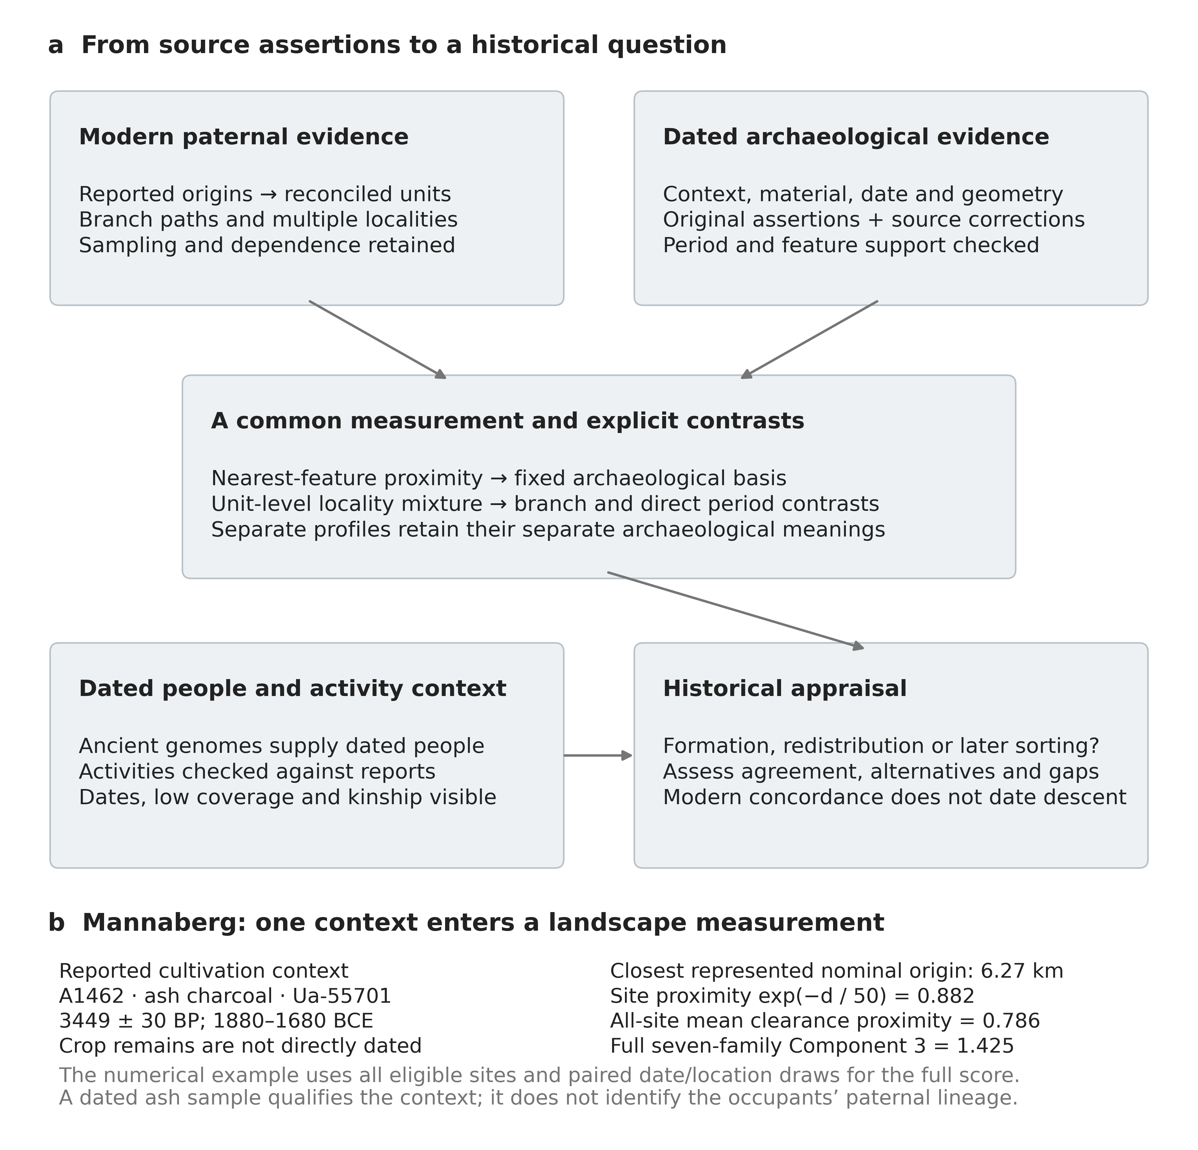
Fig. 1 The SCLARA framework and a source-to-history example. Paternal and archaeological records are assessed separately before landscape measurement and lineage comparison; published ancient evidence and original reports then inform historical interpretation. At Mannaberg, ash charcoal Ua-55701 belongs to the reported cultivation context A1462 (Nordin 2023). The example uses the nominal paternal-origin point closest to the site's representative point. This single-site proximity is distinct from the clearance-family value, which is calculated using all eligible sites across 64 paired date/location draws. The full seven-family score does not assign a lineage to the site occupants
The basic observation is a source assertion: a statement about an archaeological feature, activity or material in context. For each assertion, the archive retains the original wording, identifier, reference, location, chronology and uncertainty. Construction, occupation, reuse and deposition remain separate where the source permits. Corrections preserve the original assertion and supporting evidence. The record is grouped by chronological phase. Repeated references to one feature or determination do not provide independent support.
Each paternal assertion records a branch label and its source and phylogenetic version, the meaning of the reported locality, and any accompanying genealogical statement. Records are reconciled using exact identifiers and documented family relationships. Source records, reconciled paternal units, alternative localities and broader groups used to assess dependence remain distinct, according to the available evidence.
The framework documents the sampling and recording processes that shape the evidence. When only the most downstream observed branches are retained, more detailed testing of descendants can remove upstream labels from the analytical sample. Excavation and radiocarbon selection vary among regions and activities. Retaining withheld records and original assertions makes these choices examinable.

Measure an archaeological setting with a defined meaning
Eligible source assertions are grouped by archaeological feature and period. Eligibility rules, chronological allocation, spatial measurement and minimum support are specified before fitting the proposed association. Recorded absence remains distinct from historical absence. A site can contribute several features or phases, but geographical support is counted at the appropriate site or source level rather than by repeated catalogue rows. For radiocarbon-dated evidence, assertions based on the same determination receive the same date draw.
Proximity measurements describe the archaeological surroundings of a paternal origin at a stated distance scale. The framework distinguishes absolute proximity to recorded sites, relative proximity to different feature families, and the amount of archaeology recorded nearby. An origin can have a balance near zero either because it lies close to several feature classes or because it lies far from all of them. Measures of recording intensity and opportunity accompany the relative balance. For a nearest-feature kernel with distance scale h, proximity in period t, family f and realization r is
$P_{tfr}(x)=exp(\frac{−d_{tfr}(x)}{h})$
Here d is the distance from origin x to the nearest eligible point representing an archaeological site. The scale h stays fixed across comparisons; proximity is zero when no eligible site is recorded in that realization.
Components summarize shared geographical patterns among archaeological features without using lineage labels. For each component, the analysis retains the full transformation, its orientation and the feature families at either end of the axis. Original contexts clarify the activities represented by those poles, including the relationship between postholes and interpreted households (Bukkemoen 2025). The resulting score describes the relative regional distribution of recorded activities; either pole may encompass several economic practices.
To compare periods directly, SCLARA holds the archaeological measurement constant across their dated records. Direct temporal comparisons therefore use the same feature definitions, reference centring, scales, loadings and orientation, with adequate support in each period. Separately estimated profiles can add different archaeological information to a historical synthesis, but their coefficients describe different quantities and cannot form one temporal curve.

Separate discovery from focused estimation
Exploration can identify distinctions that existing historical categories overlook. SCLARA documents this process, including the candidate comparisons, alternative representations and results that challenge the emerging interpretation. Components are calculated without lineage labels, but selecting a component after examining its lineage associations still depends on the observed results. The subsequent analysis therefore records what was already known, specifies the comparisons to be made and reports every estimate. Its posterior intervals describe uncertainty conditional on those comparisons; they do not include uncertainty introduced by the preceding search.
Profiles are retained for their archaeological meaning, supporting data and contribution to the historical question. Comparing branches within a broad paternal label can expose a useful archaeological question even when their contrast remains unresolved. Archaeological interpretation and coherent comparisons determine the value of a profile; whether the interval for a lineage contrast excludes zero is only one part of that assessment.

Estimate lineage contrasts
The Swedish implementation assigns each paternal unit one likelihood contribution. For the unit's observed lineage category, the model averages the category probabilities across all represented origins and then takes the logarithm. Several origins may refer to different ancestors represented by the same branch, so they need not be competing locations for one person. Each distinct origin receives equal weight within its unit. Treating origins as independent observations, averaging their log probabilities, or substituting a mean coordinate would give different analyses.
With observed category yᵢ and mᵢ represented origins for each unit i, the log likelihood is
$ℓ(β)=\sum_{i}{log[}\sum_{j}{\frac{1}{m_{i}}}p(y_{i}|x_{ij},β)]$
Here p is the fitted category probability at locality profile xᵢⱼ under coefficients β. Summation over origins therefore occurs inside each unit’s logarithm. The Swedish models use multinomial-logit probabilities, with their category contrasts and priors specified in the supplement.
Adjustments define which part of a lineage–landscape association is being compared. Geographical trends, recruitment density, recording opportunity, terrain and regional intercepts may account for part of the observed association. Their use follows the historical question and the processes through which paternal and archaeological records were collected. Each application therefore requires a justification for its controls and distance scales.
Distinct uncertainty analyses examine the model, measured landscape and concentration of evidence. Posterior intervals describe the fitted specification; date/location scenarios alter measurements; block and spatial reweighting assess dependence; site and neighbouring-site omissions assess archaeological influence. These outputs are labelled separately because they describe different sources of uncertainty.
Temporal contrasts are calculated from the joint coefficient draws, preserving the covariance between periods. Published ancient observations provide dated locations and paternal assignments, together with the source qualifications needed for historical interpretation. Their sampling, kinship and dating qualifications remain attached to the observations.

Swedish materials and methods

Paternal geography and represented branches
The cohort combines archived snapshots of three public sources: Visual DNA, the FamilyTreeDNA Sweden project and Leif Boström's southern Norrbotten compilation (Kinnunen undated; FamilyTreeDNA 2026; Boström undated). Visual DNA supplies the broad geographical base; the other sources contribute ancestral statements, dates, branch detail and exact identifiers where available. Modern Y-chromosome classifications are linked to the reported locations of paternal ancestors. The FamilyTreeDNA map uses project members’ earliest known direct paternal ancestors as its geographical reference. Dated ancient individuals form a separate contextual inventory. The reconciled dataset retains the original source statements and records any disagreements. The source union contains 6,785 records, of which 3,633 meet the geographical and branch-screening rules. Selecting the most downstream observed, non-nested labels excludes 1,986 records with upstream assignments from the primary analysis. Family reconciliation leaves 1,647 records represented by 1,339 units at 1,404 distinct positions and 246 sample-defined dependence blocks.
The common-period analysis excludes four whole units lacking usable terrain at an eligible locality, leaving 1,335 units, 1,641 source records and 1,594 unit-locality rows at 1,399 distinct positions. Its eight categories contain 236 I1‑L22, 206 I1‑Z58, 95 other I1, 154 R1a‑Z284, 157 R1b‑U106, 144 R1b‑P312, 125 N and 218 remaining-lineage units. The later profiles use the original 1,339-unit cohort and retain its controls for missing terrain data. These are represented branches and reconciled families, not independently verified pedigrees or random samples of the Swedish population.
Among the 1,335 common-period units, 743 have at least one source-reported ancestral birth year. The 846 date-bearing records have a median birth year of 1724 (interquartile range 1665–1786); 816 (96.5%) predate 1900. These summaries describe reported ancestors, with no uniformly verified link between the birth year and the mapped locality. Dates are uncertain or conflicted in 163 units, and 30 have an exact link to the curated genealogical compilation; categories overlap. Of the fitted units, 240 have several origins, with maximum within-unit separation exceeding 100 km in 75 units and 200 km in 50. The model retains that heterogeneity. Fig. 2 and the supplementary cohort tables (Online Resource 1) distinguish records, units, localities and dependence groups.

Archaeological assertions and source qualification
The archaeological record links Kulturmiljöregistret (KMR), maintained by the Swedish National Heritage Board (Riksantikvarieämbetet 2026), to Strucke C14 Sweden version 2 (Strucke 2026). KMR provides identifiers, geometries and recorded site attributes; the radiocarbon catalogue provides 30,296 assertions, laboratory identifiers, context descriptions, dates and report references. The dataset retains the original register records for 6,107 linked sites. Source reconciliation adds corrected site information while preserving the originally linked records. Coordinates represent the documented geometry or its representative point, with their meaning, source and available uncertainty recorded in the supplementary coordinate inventory (Online Resource 2).
A feature dictionary and dating rules determine which assertions are eligible, unmatched or withheld. The common-period measurements allocate dated material probabilistically using IntCal20 (Reimer et al. 2020); a material’s entire 95.4% dating envelope need not fall within one period. The four windows are the Late Neolithic (2300–1700 BCE), Bronze Age (1700–500 BCE), Roman Iron Age (AD 1–400) and Migration period (AD 400–550), implemented with fixed half-open numerical bounds. These windows differ in duration and leave chronological gaps. They compare dated records rather than a continuous excavated sequence at the same settlements.
The seven families are building traces, combustion features, pits and occupation deposits, heated stone, clearance and cultivation, burial, and water features. A family requires at least ten distinct sites with period probability at least 0.1 and representation in three counties. Every family passes in all four primary panels. Count support is assessed separately from spatial coverage and source validity. The corrected pool comprises 14,566 assertions at 3,640 sites. Each family contains varied reported contexts, so a material date does not automatically date the activity named by that family.
The review covered the 15 sites that initially qualified as Late Neolithic clearance evidence and three additional sites that contributed substantially to the measurement. Fourteen received substantive assessment from their original contexts; the other four remained unresolved because source information was insufficient. The review distinguished cultivation, grazing-oriented clearance, older ground horizons and residual material. It also identified catalogue/report disagreements, including 35 Öjaby context identifiers, feature assignments and selected date or site links. Corrections, conflicting-date holds and retained disagreements were recorded before updated lineage fits. A separate review of seven reports examined the activities on both sides of the later production-related profiles. These targeted reviews test interpretation and influential links; they do not estimate a national catalogue error rate.

Common and period-specific landscape measurements
At each reported origin, proximity to a feature family is calculated from the great-circle distance to its nearest eligible site, using the 50 km exponential kernel defined above. Distances are measured to the retained representative geometry points, not the nearest polygon boundaries. Sixty-four paired realizations propagate calibrated material dates and archaeological positional uncertainty, with shared draws for shared laboratory determinations or positions. Subtracting the within-period mean across the seven families gives relative family proximity. All four periods then use the original Late Neolithic/Bronze Age reference: the same centring, scales, three component loadings, eigenvalue normalization and orientation. The primary posterior fits condition on measurements averaged across the 64 realizations. Separate conditional fits for each realization assess allocation sensitivity under the two linear grid specifications.
The basis was constructed without lineage labels; Component 3 became the substantive focus after earlier results were inspected. All three components remain in the joint model. The supplement reports explained variation, support, score ranges and transfer of the fixed basis. One predefined source check omits nine reviewed determinations whose dated material may be older than the activity inferred from its context. Complete common-period estimates for all three components and all seven lineage contrasts, including every direct period difference, are provided in Online Resource 4; Figure S4 displays the I1–Z284 comparison across all three components.
Separate preferred profiles and companion representations describe the Viking (AD 750–1050) and medieval (AD 1050–1520) windows. They use the original rule that each material’s 95.4% dating envelope must fall within the period, and retain their original transformations, distance kernels, scales and orientation. The Viking balance contrasts charcoal pits and slag heaps with postholes and hearths; the medieval balance contrasts ovens, wells and postholes with tar kilns and charcoal pits. All original five-position/three-source-group support rules are satisfied.
The analyses developed from an exploratory screen of 74 feature classes in thirteen period panels, comprising 1,664 axis representations, 1,352 distinct fitted designs and 9,984 lineage contrasts. All screen-wide Holm-adjusted values were 1. Twelve profiles received focused archaeological review. The common posthole–hearth comparison, the seven-family prehistoric basis and the later profiles emerged from that process and do not constitute an independent discovery sample. Source corrections and the Roman/Migration extension were specified before their updated effects were fitted. The paper reports conditional estimates and every comparison in the specified families; these estimates do not account for uncertainty introduced by the preceding search.
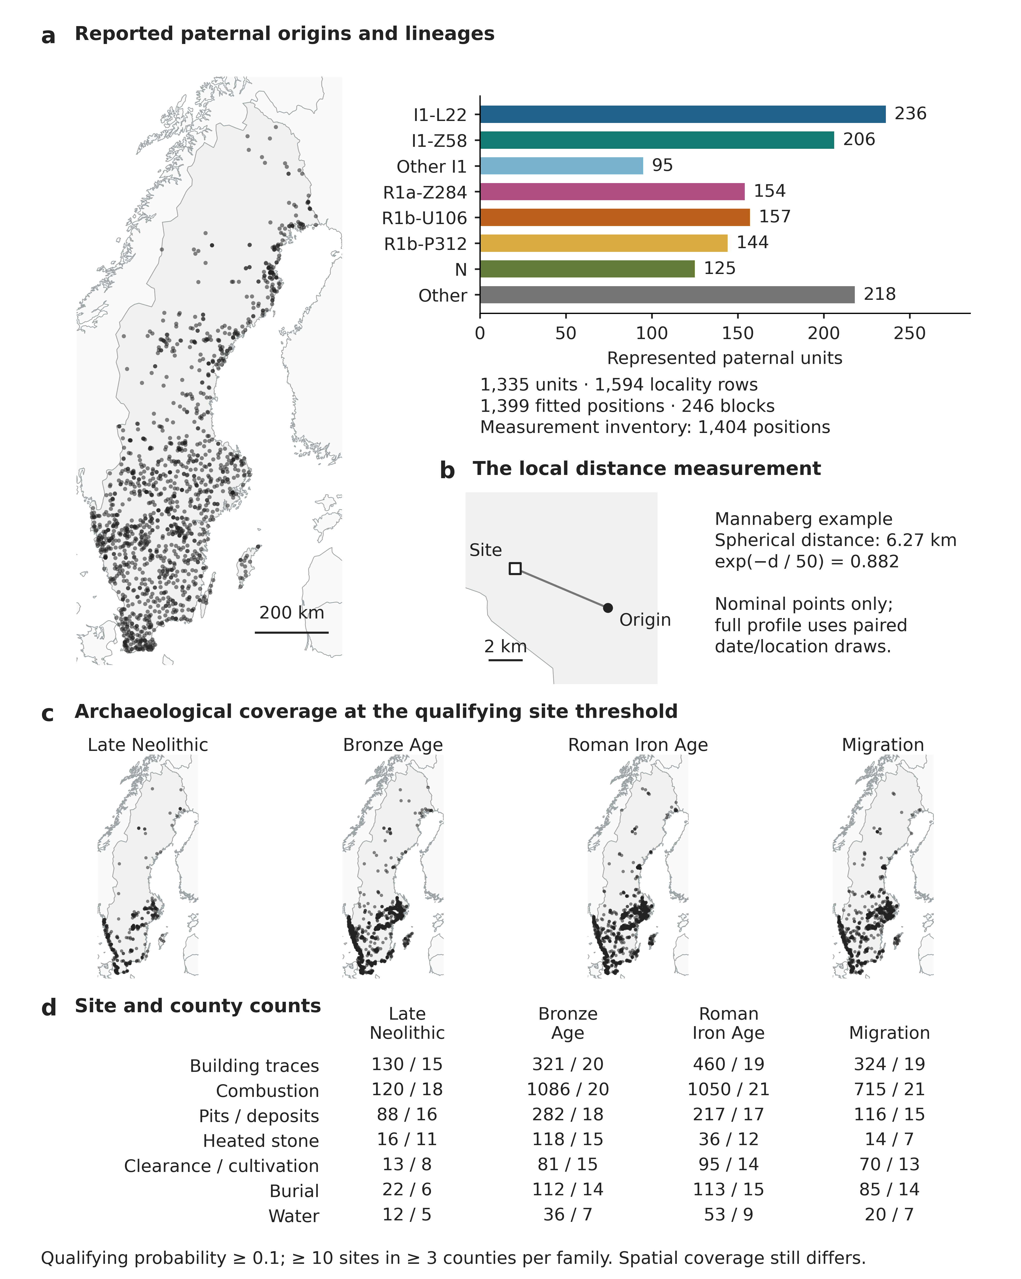
Fig. 2 Reported paternal origins, archaeological support and a local measurement. a The inventory contains 1,404 positions; bars describe the 1,335-unit common cohort, whose 1,594 locality rows use 1,399 positions after four whole-unit terrain exclusions. b Mannaberg and its nearest represented nominal origin, selected without lineage labels (Fig. 1). c Sites with family membership probability ≥ 0.1. d Qualifying sites and counties. Count support and spatial coverage are distinct. Maps use SWEREF 99 TM and describe represented sources; archaeological coordinates accompany Online Resource 2; paternal coordinates are supplied for confidential review. National outlines: Natural Earth (undated)

Joint inference and sensitivity analyses
The model jointly relates eight lineage categories to twelve archaeological scores: three components in each of four periods. It adjusts for period-specific recording and opportunity, geographic coordinates, registry density, elevation and relief derived from HydroSHEDS (Lehner et al. 2008). Regional category intercepts and archaeological scores centred within cells use projected grids with 200 km cells. Four national specifications pair the original and 100 km-shifted grid origins with linear or quadratic geography. Symmetric Gaussian priors give pairwise coefficient differences standard deviations of 2 for intercept and regional terms, 0.5 for controls and 1 for archaeological slopes. Composite I1 uses the fixed 237:207:95 category weights in both common and later models; these weights remain unchanged after terrain exclusions or omissions. The later models retain their original adjustment variables and model structure.
Seven contrasts are retained: I1–Z284, I1–U106, L22–Z58, U106–P312, Z284–U106, N–I1 and I1–P312. For the common basis, every within-period contrast and all six direct period differences are calculated from aligned joint draws for each component. Positive values indicate the larger slope for the first named lineage. Composite I1 contrasts are weighted coefficient differences, not pooled binary odds ratios. Four chains initially provide 1,000 warmup and 1,000 retained draws each; one prespecified numerical extension is permitted only after diagnostic failure. Coefficient draws, equal-tail 95% intervals and Monte Carlo diagnostics are retained (Vehtari et al. 2021).
The common-period family includes date/location allocations, crossed block/cell weights, archaeological and paternal omissions, regional restrictions and location scenarios. Archaeological omissions were nominated from measurement contribution before updated effects were inspected. All 976 common-period and 1,652 later conditional fits are retained (Online Resource 1).
Crossed reweighting multiplies independent positive weights for lineage blocks and unit-centroid cells, then normalizes the total unit weight while holding priors and measurement scales fixed (Owen and Eckles 2012). Its empirical 2.5–97.5% ranges are dependence sensitivities, not calibrated confidence or posterior intervals. Conditional-mode intervals use the inverse Hessian. Assumed 25 and 50 km origin disks change archaeological measurements while retaining nominal geographic and environmental controls; they are neither empirical error bounds nor a complete latent-location model. All these quantities are labelled separately in the figures and supplement.
Two additional sensitivity comparisons examine paternal representation and shared archaeological recording opportunity. The first uses branch cuts capped at two or five observed descendant labels, retaining the eight outcome categories and fixed archaeological transformations. For each cut, the full cohort is compared with a companion cohort containing only baseline source records. This separates branch aggregation from the addition of previously unrepresented origins. The current profiles receive 32 conditional fits, eight focal posterior fits and 2,400 crossed-weight fits.
The second comparison retains a whole unit only when every reported locality has recorded sites within 75 km in at least half the date/location draws in both the Late Neolithic and Roman periods. Its four conditional fits and 798 crossed-weight fits use the existing basis, centres and contrasts. Both extensions were specified after the original results were known and are interpreted as sensitivities, not independent confirmation.

Dated people and method evaluation
Ancient evidence is reconciled from retained published workbooks, source-version Y-chromosome calls and explicit same-person identifiers (Margaryan et al. 2020; Rodríguez-Varela et al. 2023; Allentoft et al. 2024a, b; Speidel et al. 2025; McColl et al. 2026). The source review checked 1,001 assertions against 837 original table rows and reconciled them into 275 identity groups. Relatives remain distinct, with published relatedness flags attached. Original and reservoir-corrected date variants, contextual dating, low coverage and uncertain placements are preserved. Broad R1b-L51, L11 or M269 calls do not become U106 or P312; upstream R1a does not become Z284. The inventory is source-selected and is not presented as an exhaustive census of ancient Sweden.
Versioned Y-chromosome placement data are credited separately to Pinotti and McColl (2025). The supplement identifies the nomenclature dictionaries, geographic references and original report sources, with file-level citations and checksums in SOURCES.tsv.
The earlier posthole–hearth comparison separates the effect of reallocating dates from the effect of adding archaeological records. Sixty-four paired allocations are applied to the original 1,309-assertion recording pool and an expanded 12,179-assertion pool under both grids. Shared determinations use the same dates; each allocation rebuilds feature membership, proximity, recording and opportunity. The resulting 256 conditional fits and two original-panel checks preserve the distinction between changing dates within a fixed record and changing the record being measured.
Two simulations evaluate the earlier posthole–hearth designs (Morris et al. 2019). The first uses five conditions and 200 datasets each to compare regional and simpler spatial models. The second uses 5,800 datasets and matched geographical, pooled-archaeology and four-period models to assess period discrimination, selective recording and paired predictive scores. All conditions and measures are retained in the supplement.
A third simulation evaluates how the current four-period model represents paternal units and their origins. It compares three methods: the unit-level locality mixture, averaging covariates before fitting, and weighting a unit by its source-record count. Four designs are each evaluated under a null or 0.4 Late Neolithic–Roman contrast, giving eight conditions with 200 datasets per condition. The first design uses covariates averaged within each unit and one record per unit; successive designs introduce observed alternative localities, source-record multiplicity and block dependence. Each dataset contains one generated outcome per unit, and duplicated records repeat that outcome. All methods use the same covariates, controls and priors. Bias, inverse-Hessian coverage, interval width and paired predictive scores measure their performance under these simulated conditions.

Assistance disclosure
GPT-family models (OpenAI) assisted with organizing and preparing the reproducible repository from existing code, numerical checks, language editing, and preparation of figure-generation code. The author takes full responsibility for the analyses, interpretations and final manuscript.

Results

Early differentiation in settlement and land-use landscapes
The clearest archaeological distinction appears among records containing material dated to the Late Neolithic (Fig. 3). Component 3 combines seven feature families: clearance and building traces have the largest positive loadings, opposed chiefly by combustion and heated stone. Table S14 records how securely each clearance context links the material date to an activity. The fixed three-component basis represents 61.5% of reference Late Neolithic/Bronze Age variation, 57.6% of Roman and 55.4% of Migration within-period standardized variation. Only 0.075% of Migration locality weight lies outside the reference Component 3 range. Spatial coverage remains uneven, particularly for Migration heated-stone and water features.
I1 and U106 have higher adjusted slopes than Z284 on the Late Neolithic clearance/building balance in all four national specifications (Fig. 3). I1–Z284 posterior means and 95% intervals are 0.470 [0.087, 0.864] and 0.532 [0.190, 0.877] under linear geography, and 0.481 [0.110, 0.862] and 0.529 [0.172, 0.894] under quadratic geography, with original then shifted grids. Z284–U106 means are −0.569, −0.543, −0.562 and −0.489, with all four intervals excluding zero. I1–U106 remains unresolved on this measured balance.
Mannaberg gives both poles recognizable archaeological content (Nordin 2023). Horizon A1462 is interpreted as probable cultivation soil containing charcoal, brushwood and an unidentified cereal grain. Its ash charcoal dates to 3449 ± 30 BP, reported as 1880–1680 BCE; the grain is undated. Cooking oven A645 contains abundant barley and several wheats, while its oak charcoal is reported as 2200–1920 BCE. Pottery from earlier or later periods and evidence of repeated use complicate the dating of these activities. Mannaberg shows that both sides of the balance can contain evidence of agriculture. Kråkhult instead supports clearance compatible with grazing (Hellgren 2023), while Kölbygärde contains older charcoal beneath later land use (Ring et al. 2001).
The worked example connects those contexts to the regional measurement. A source assertion links reported activity, sampled material and registered location. Across paired draws of dates and locations, eligible contexts contribute to the proximity measure for each family. The fixed transformation then combines all seven families into the regional score. At the illustrated origin near Mannaberg, Component 3 is 1.425. Relatively low heated-stone proximity contributes 0.862, clearance 0.493 and building traces 0.273; the remaining terms complete the total (Fig. 3c). The score describes the relative distribution of recorded activities around that origin. The lineage contrast is then estimated across the whole cohort, rather than assigned to the excavated occupants.
Omitting the nine reviewed determinations leaves eight qualifying Late Neolithic clearance sites, compared with thirteen in the primary panel and below the required ten. The resulting positive I1–Z284 estimate is retained as a source-sensitivity result. The primary measurement includes dated material from cultivation, clearance and older deposits.
Uncertainty in the early contrast depends on how relatedness and spatial clustering are represented. Crossed-weight I1–Z284 ranges are −0.189 to 1.070 and −0.090 to 1.114 under the two grids. Omitting block B-26258, containing twenty Z284 units, gives conditional modes 0.304 [−0.079, 0.686] and 0.374 [0.019, 0.729]. The block is one of three tied for largest size. Selected site and neighbouring-pair omissions preserve the positive direction, as do the reviewed phase omission and paternal-location scenarios. The result is stable across the four main geographical specifications but remains sensitive to how concentrated paternal and spatial information is weighted.
Across all 64 paired date/location allocations under each linear grid specification, the Late Neolithic I1–Z284 and Z284–U106 conditional estimates retain their respective positive and negative directions; the direct Late Neolithic–Roman I1–Z284 difference also remains positive. The numbers of allocation-specific intervals excluding zero vary by contrast and grid (Table S24). These are separate fits to the realized measurements, not independent replications.
The early point estimates remain positive when paternal branches are grouped more broadly, although some intervals include zero (Tables S18–S20). On the original grid, the full-cut Late Neolithic I1–Z284 posterior is 0.443 [−0.026, 0.917] at cap 2 and 0.668 [0.003, 1.349] at cap 5; both crossed-weight ranges include zero. Companion fits restricted to baseline source records give larger conditional modes than the corresponding full-cut fits, 0.507 versus 0.396 and 0.785 versus 0.632. Adding previously unrepresented origins changes both the estimated association and the number of records. With the archaeological measurement held fixed, these comparisons show how the choice of paternal units affects the estimated association and its precision.
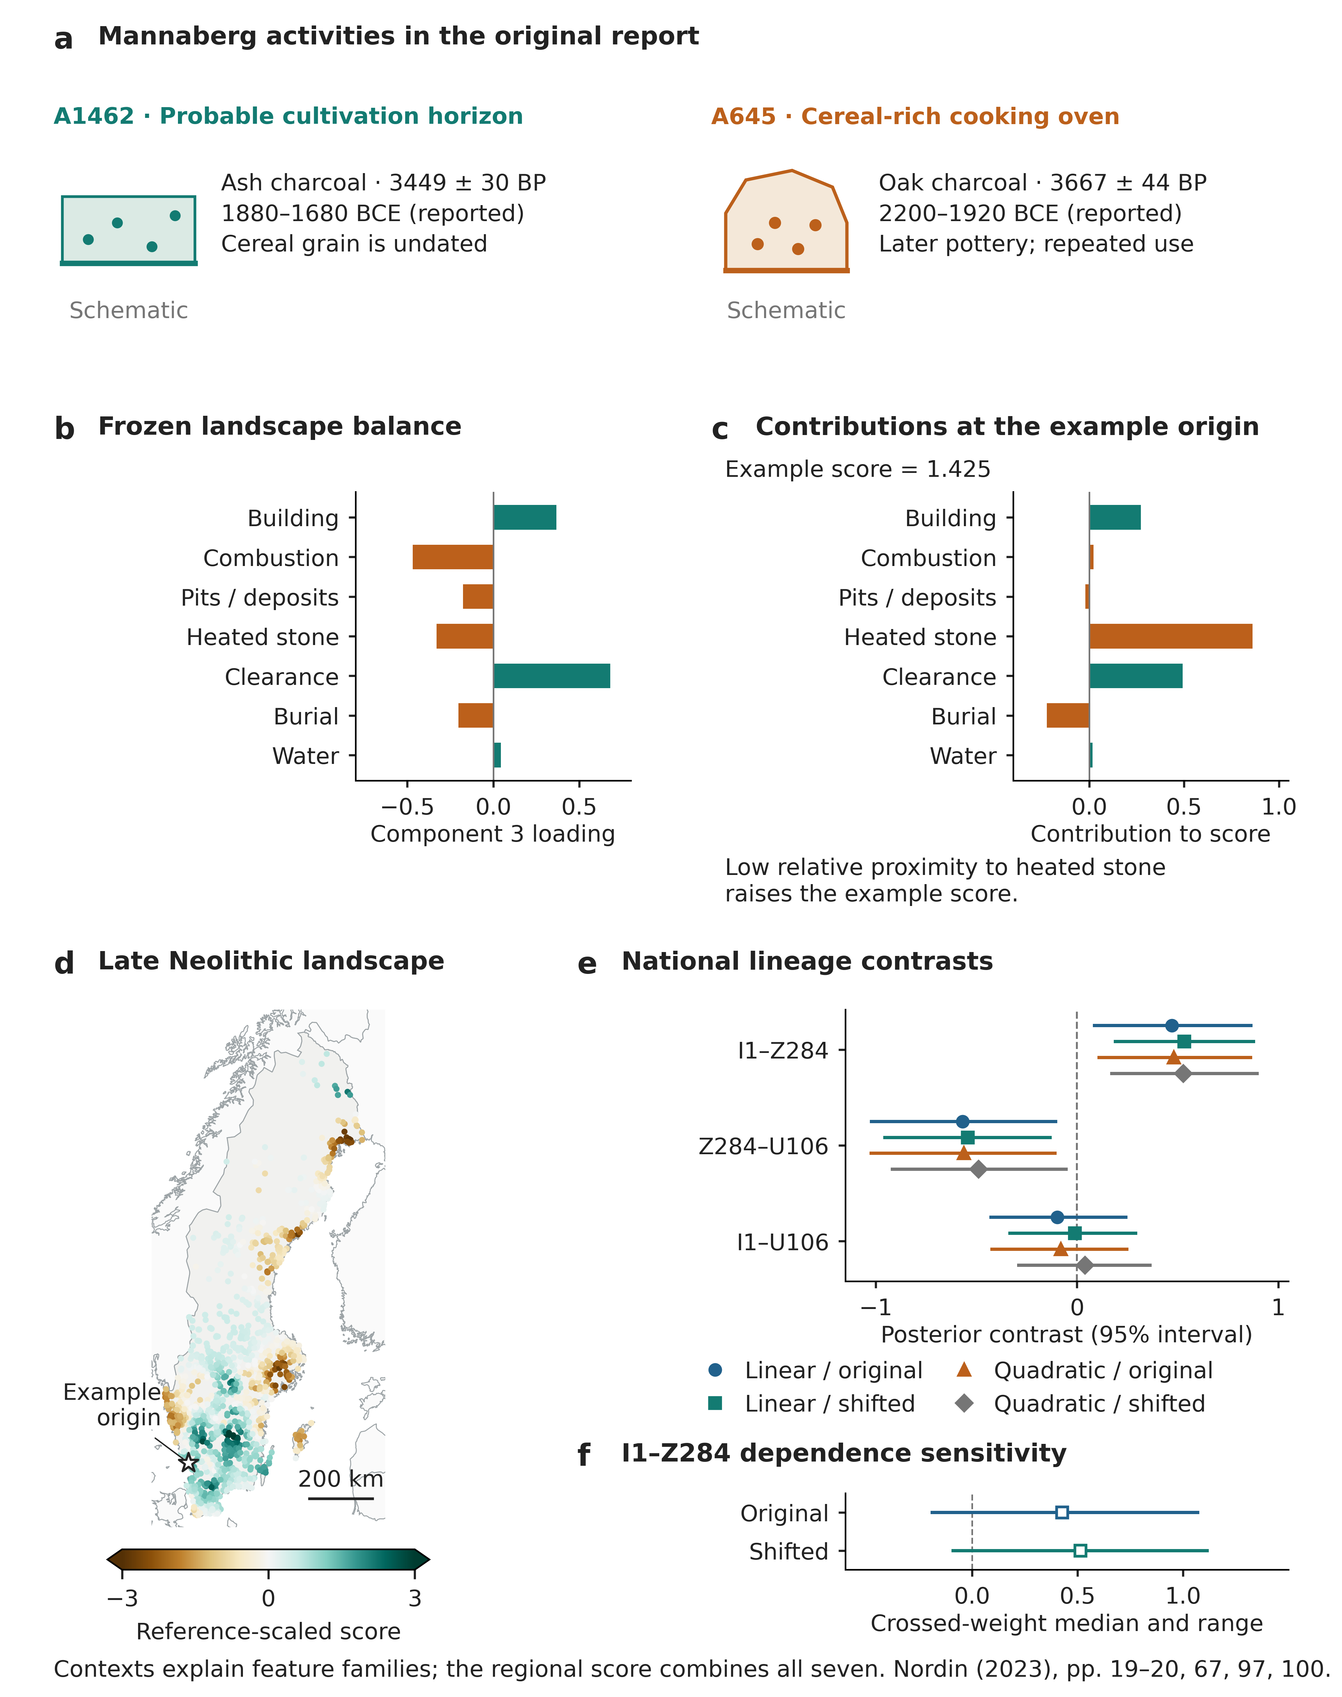
Fig. 3 Archaeological contexts, regional measurement and the early lineage distinction. a Activity schematics keyed to Mannaberg A1462 and A645; dates refer to sampled charcoal, and cereal evidence belongs to both settings (Nordin 2023). b All seven frozen loadings; colour identifies the positive and negative sides of the balance. c Full-precision family contributions reconstruct the illustrated origin’s score; low heated-stone proximity contributes positively. d Scores at the 1,399 common-period positions. e Conditional posterior means and 95% intervals for four model/grid specifications. f Crossed-weight medians and empirical 2.5–97.5% ranges for I1–Z284, distinct from posterior intervals. Omission estimates are reported in the text and supplement. National outlines: Natural Earth (undated)
Regional estimates provide a geographical breakdown of the comparison (Fig. S1). Late Neolithic I1–Z284 is positive in eastern central and western Sweden (SE12, SE23), negative in the Småland and Islands region (SE21), and near zero in the northern aggregate (SE3). Most intervals include zero. Stockholm and southern Sweden have limited category support; 71 mixed or unassigned units lie outside these restrictions. B-26258 spans central to northern Sweden, with median locality latitude 63.18° N. Regional definitions follow Eurostat GISCO NUTS 2024 (Eurostat 2024; © EuroGeographics for the administrative boundaries).

Comparing the same landscape balance across periods
The clearest estimated temporal difference is between the Late Neolithic and Roman records (Fig. 4). Their I1–Z284 differences are 0.728 [0.100, 1.339], 0.712 [0.119, 1.322], 0.744 [0.138, 1.351] and 0.702 [0.097, 1.316] across the four specifications. These jointly estimated slope differences compare periods directly on the same archaeological scale. As for the early contrast, crossed-weight ranges include zero, so the precision of the temporal estimate depends on the treatment of relatedness and spatial clustering.
Restricting the analysis to whole units with shared local archaeological coverage in the two periods retains 1,086 of the 1,335 units (Fig. S2). The Late Neolithic I1–Z284 modes remain positive, 0.448–0.565, with inverse-Hessian intervals excluding zero in all four specifications. The direct Late Neolithic–Roman modes are 0.589–0.623, but all four intervals now include zero. Crossed-weight ranges also include zero. The early distinction therefore persists in this restricted population, while its temporal separation is less securely resolved. The restriction changes the represented geography; it does not by itself remove environmental confounding.
Late Neolithic–Migration differences are also positive, with means 0.548–0.615, but lower posterior limits lie only 0.003–0.021 above zero. Their proximity to zero, Monte Carlo uncertainty and dependence sensitivity make them weaker evidence than the Late Neolithic–Roman comparison. The direct Late Neolithic–Bronze Age and Roman–Migration differences remain unresolved.
Two secondary comparisons reveal additional branch differences whose resolution varies between grid specifications. Bronze Age I1–P312 is positive with intervals excluding zero in the original-grid linear and quadratic fits, but remains unresolved in both shifted-grid fits. Migration L22–Z58 shows the analogous grid sensitivity in the negative direction. Their complete estimates are retained alongside all components and all seven contrasts. They qualify a broad I1-versus-R1b interpretation, but their dependence on the grid specification does not support attributing them to a separate historical event.
All four common-period posterior fits meet the convergence criteria without an extended sampling run: maximum R-hat is 1.0068, minimum bulk/tail effective sample sizes are 1,114/1,618, and there are no divergences or tree-depth hits. All 976 conditional sensitivities pass gradient and curvature checks.
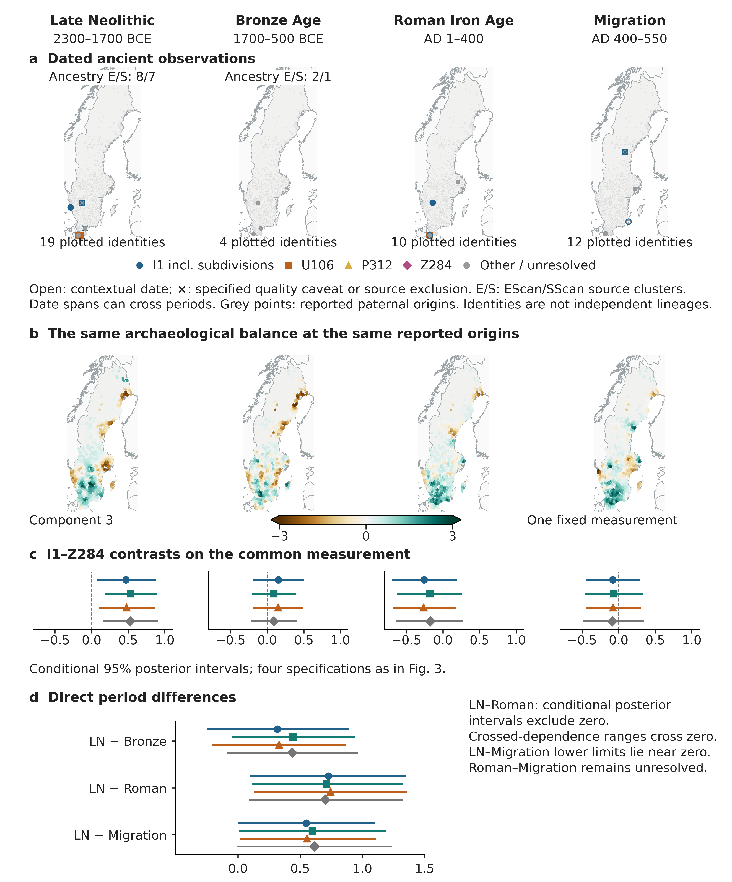
Fig. 4 Early historical triangulation on a common measurement. a Reconciled ancient identities whose reported calendar bounds overlap each window; a point date is included when it lies within the window. Open symbols indicate context dating; crosses indicate structured quality caveats or source exclusion. E/S denotes published EScan/SScan ancestry clusters. Grey background points are reported paternal origins. b The same fixed archaeological profile at 1,399 paternal-origin locations. c Within-period I1–Z284 conditional posterior means and 95% intervals; d direct period differences, using the four specifications in Fig. 3. Crossed-weight ranges include zero. The shared-support restriction also leaves the Late Neolithic–Roman difference unresolved. Repeated individuals across windows do not constitute independent temporal samples. National outlines: Natural Earth (undated)

Ancient genomes place the landscape comparisons in time
Dated ancient individuals place the landscape comparisons in historical context. NEO220, an I1 observation, has a published calibrated range of 2137–1940 BCE and a separately retained reservoir-corrected range of 2140–1932 BCE (Allentoft et al. 2024b). NEO223 retains date variants and a low-coverage qualification. Öllsjö oll009 carries the original tentative I1 assignment (Malmström et al. 2019). These observations document early I1-bearing individuals at the level of branch resolution supported by each source.
In the source-selected McColl et al. (2026) geographical layer, sixteen Swedish observations with nominal dates between 2300 and 500 BCE belong to the two ancestry clusters examined here. The Migration-period collection from Rodríguez-Varela et al. (2023) contains nine context-dated candidates, seven retained after applying the published source exclusions. Three retained individuals carry broad I1 assignments and come from two locations. The Roman panel contains ten individuals at three coordinate pairs; five have reconciled I1 assignments and occupy two of those pairs. These source-selected distributions provide historical context but lack overlapping, resolved branch comparators for an independent fitted replication. Medieval focal R1b and Z284 observations also overlap the Viking window (Fig. 5).
The northern assessment examines trapping and occupation landscapes. Its Swedish source assertions link to 105 register objects, but the available phase and comparator evidence is insufficient for the proposed historical connection. The two existing contrasts concern different evidence and branches: N–I1 in the broad Iron Age occupation record and L22–Z58 in Neolithic trapping contexts. The supplement presents the evidence and interpretation for each northern comparison.

Viking and medieval profiles add distinct later comparisons
In the preferred Viking profile, higher scores indicate greater proximity to charcoal pits and slag heaps relative to postholes and hearths. The adjusted slope is higher for I1‑L22 than for I1‑Z58, with a contrast of 0.373 [0.060, 0.681] (Fig. 5). The corresponding U106–P312 estimate is −0.305 [−0.666, 0.056]. The latter is unresolved but historically useful: the broad R1b category would conceal a potentially informative difference between its major branches. Neither result establishes that those branches performed particular occupations.
The Viking archaeological pole has concrete production evidence. Färila documents charcoal production and repeated use, without local iron-production remains around the sampled pit (Altner 2016). Harbo-Smedsbo documents iron-production waste (Kjellberg 2006). Fyrislund documents the hearth used in the analysis, but the houses in the same report do not meet the strict Viking dating rule and cannot stand in for the included posthole evidence (Lucas and Lucas 2013). The Selånger posthole determination is excluded because the source descriptions disagree. These checks support a production-related regional contrast while preventing charcoal and slag from being treated as one integrated industrial complex everywhere.
The preferred L22–Z58 crossed-weight range is −0.200 to 0.849. The conditional modes remain positive when each selected largest block or cell is omitted; the two assumed origin-displacement scenarios give modes of 0.405–0.408. A companion component gives a larger L22–Z58 estimate, 0.917 [0.430, 1.397], with a crossed-weight range remaining positive. Its positive pole also includes cultural layers, stone settings and other features, however, and lacks the preferred profile's clear opposing pole. This component describes a broader additive archaeological pattern. Its larger coefficient concerns a different measurement and does not independently confirm the preferred contrast, which is retained for its clearer archaeological meaning.
In the medieval profile, positive scores indicate the balance of ovens, wells and postholes against tar and charcoal contexts. U106 has a higher adjusted slope than either Z284 or P312: Z284–U106 is −0.501 [−0.816, −0.196], and U106–P312 is 0.332 [0.030, 0.633]. Their crossed-weight ranges retain those directions, −1.083 to −0.098 and 0.051 to 0.787, as do all selected block- and cell-omission modes and paternal-location scenario modes. I1–U106 is −0.258 [−0.492, −0.020] in the sampled posterior, but its crossed-weight range crosses zero. The companion representation gives the same directions for the principal U106 contrasts, although it summarizes a different combination of archaeological features.
The medieval Z284–U106 and U106–P312 point estimates retain their directions when branches are grouped more broadly, but the crossed-weight U106–P312 ranges include zero at both caps: −0.197 to 0.951 and −0.388 to 0.902. The Z284–U106 range reaches −0.001 at cap 2 and extends to 0.291 at cap 5. The medieval setting remains historically informative; its apparent precision depends on how closely related source records are represented.
The medieval contexts prevent a simple domestic-versus-industrial label. Leksand supports medieval tar production, while an adjacent charcoal pit is substantially later (Holmqvist 2021). Nifsarp documents charcoal production with reversed radiocarbon and stratigraphic ordering (Wennerberg 2008). The Uppsala oven example is a brick kiln (Fagerlund 2016). Production occurs on both poles. The result distinguishes regional combinations of settlement and production features; it does not identify U106 with urbanization or a particular social estate. All four later posteriors and all 1,652 conditional sensitivities pass the specified numerical checks.
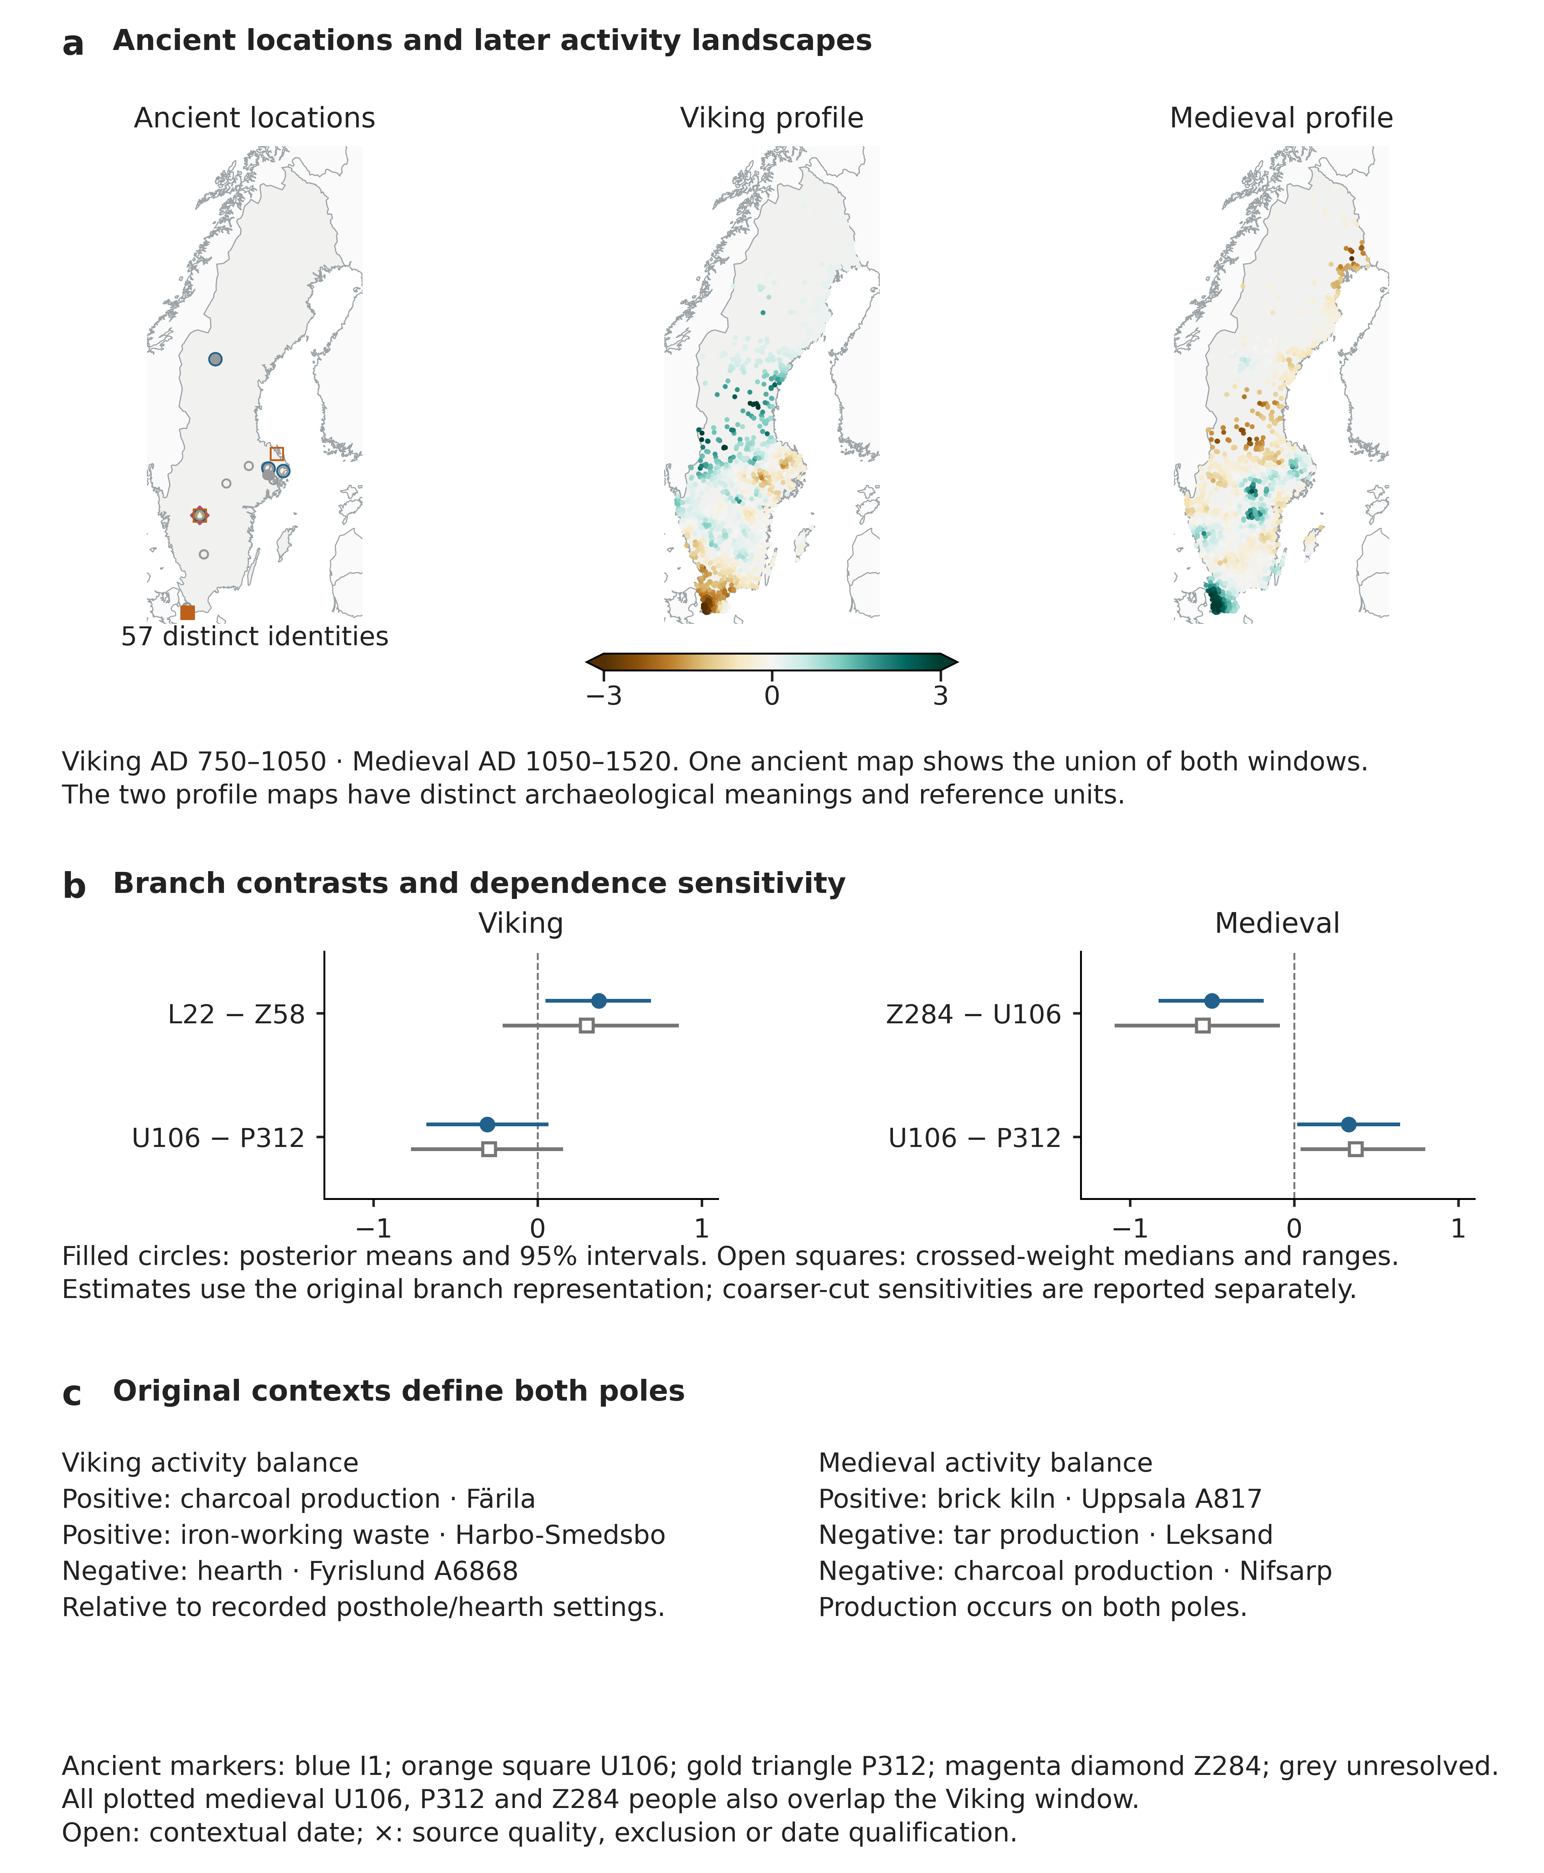
Fig. 5 Later branch differentiation in distinct activity landscapes. a One map shows ancient individuals whose dates overlap either the Viking or medieval window; the two landscape maps use period-specific archaeological profiles, each with its own reference scale. b Preferred-profile posterior means and 95% intervals, with crossed-weight medians and empirical ranges for the original branch representation. Coarser-cut results qualify medieval precision. c Reported contexts identify charcoal production, iron-working waste, hearth, brick-kiln and tar-production settings. All plotted medieval U106, P312 and Z284 people also overlap the Viking window; the ancient map displays each identity once. National outlines: Natural Earth (undated)

Archaeological inclusion changes the Migration-period interpretation
Most of the reduction in the Migration-period I1–Z284 association follows expansion of the archaeological record (Fig. 6). The earlier posthole–hearth analysis, which required complete containment of dating envelopes within periods, gave posterior contrasts of 0.368 [0.100, 0.643] and 0.429 [0.178, 0.684]. Reallocating material dates within the original assertion pool preserves median conditional contrasts of 0.349 and 0.412, close to the original modes of 0.350 and 0.412. After expansion of the archaeological and recording pool, the corresponding medians are 0.047 and 0.062. Shared determinations use the same allocation streams. The comparison therefore distinguishes the effect of adding archaeological and recording evidence from reallocating dates within a fixed record.
The original contexts remain informative. At Kvarnbacken, annual wheat and barley samples from roof-supporting postholes qualify for AD 400–550, although other material from the same posthole or building is earlier (Helander 2013). Dating annual cereal grains reduces inbuilt-age uncertainty, but does not uniquely date construction. In a nearest-feature measurement, another nearby site can become the closest source of the same feature after a site is removed. Omitting either Kvarnbacken site alone changes the original-grid mode little, whereas omitting both reduces it from approximately 0.350 to 0.244. This example separates three influences on interpretation: which records are included, what event the dated material represents, and how nearby sites affect the spatial measurement.
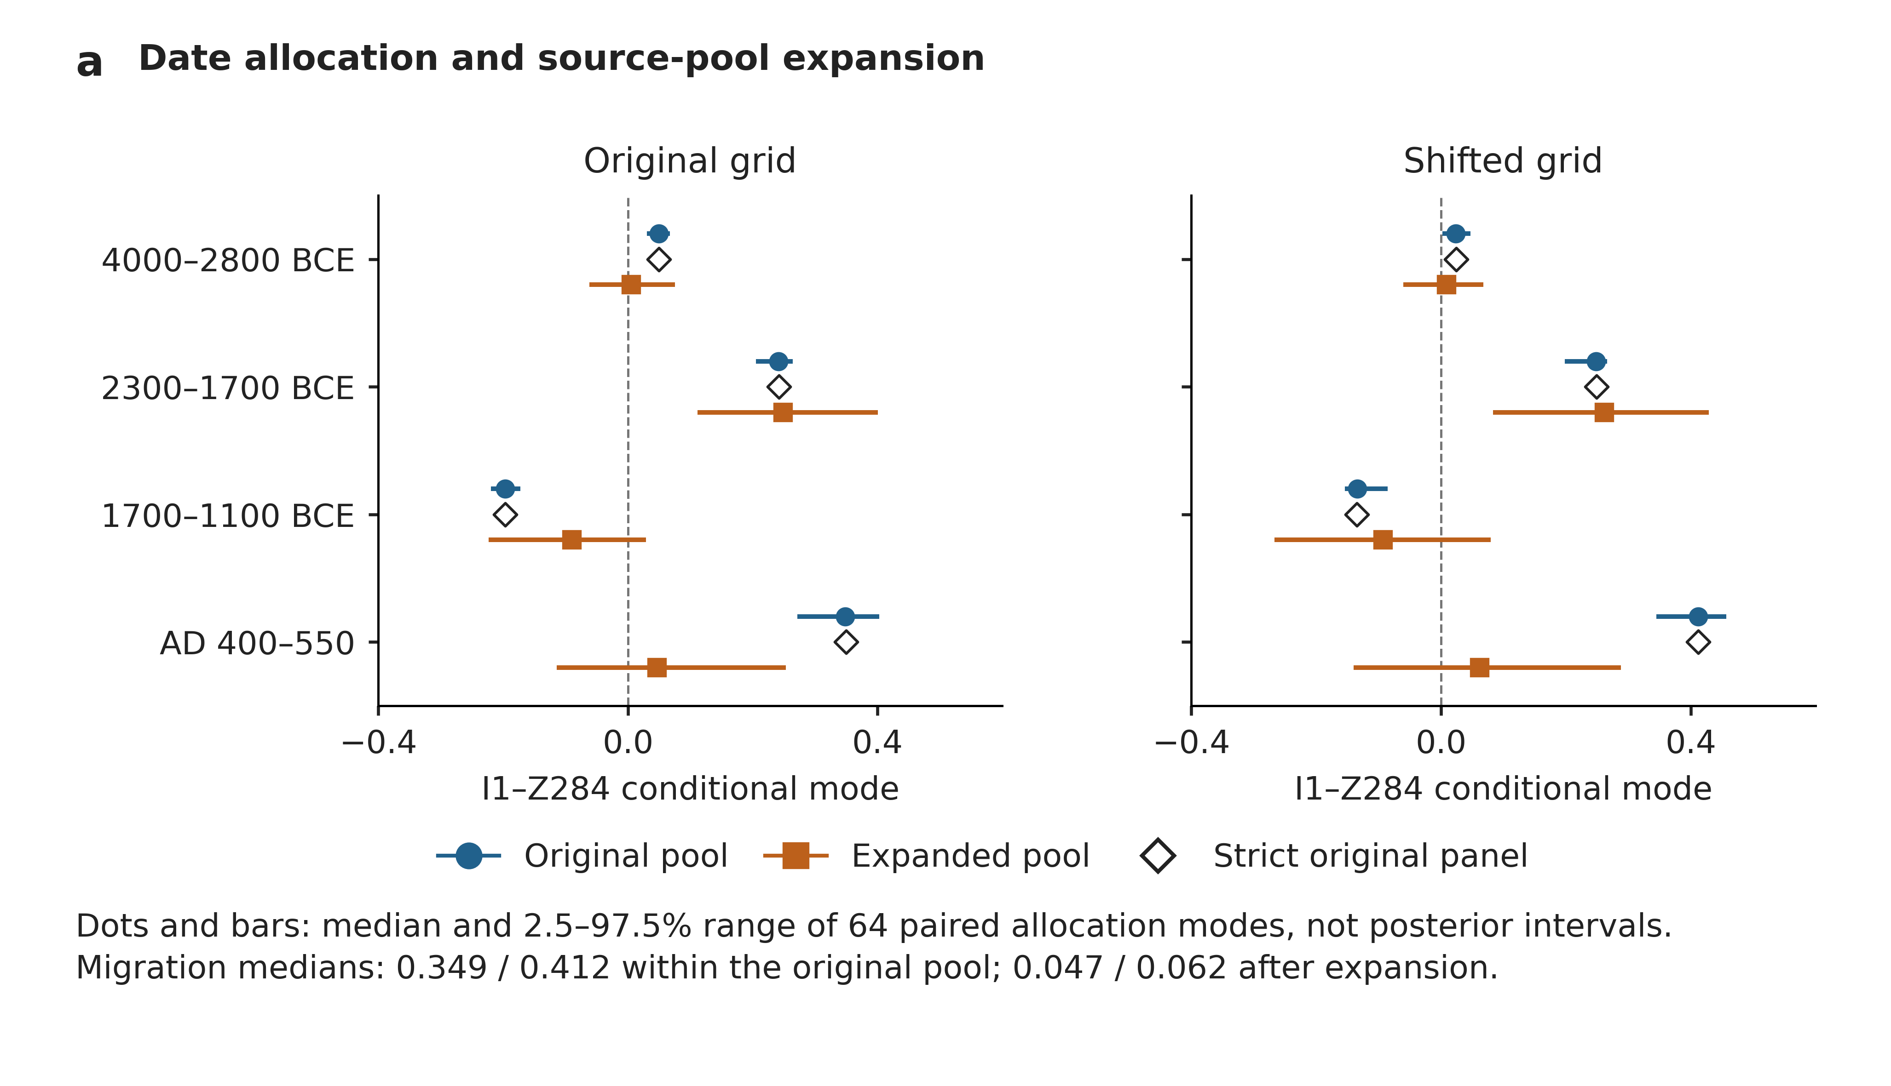
Fig. 6 Paired date allocation and source-pool comparison. The earlier posthole–hearth measurement retains four windows and two grids. Filled symbols show median conditional modes with empirical 2.5–97.5% ranges across 64 allocations per pool/grid; open diamonds show strict original-panel modes. Shared determinations use matched dates. Migration attenuation accompanies expansion of the admitted archaeological and recording pool. These empirical ranges are not posterior intervals. Chronological and predictive benchmarks for this measurement are shown in Fig. S3
The simulations of the earlier model distinguish recovery of an association from identification of its period (Fig. S3; Tables S10–S12). An injected 0.4 contrast is recovered with means 0.396 under independent sampling and 0.411 under specified dependence. With a 0.4 effect in one period, the correct period is uniquely identified in 5.8–14.8% of simulations, and in none under selective Migration recording. Across all thirteen conditions, the four-period model has worse mean expected log and Brier scores than both simpler comparators.

Reconciliation improves representation of paternal units
Counting each reconciled paternal unit once reduces the distortion caused by repeated source records in the multiplicity simulations (Fig. 7; Tables S21–S23). Late Neolithic RMSE is 0.163 rather than 0.180 under the null and 0.149 rather than 0.163 under the injected effect. Null interval coverage is 97.5% rather than 93.5%. Expected predictive log-score gains over record weighting are 0.0134–0.0144 per unit in the multiplicity and block-dependence conditions. All 1,600 datasets were evaluated with all three methods. The 4,800 method-specific results are retained, with no optimization failures.
Averaging covariates within each unit produces similar estimation errors and interval coverage, with a small predictive advantage over the probability mixture: log-score differences are −0.00034 to −0.00049 per unit when alternative origins are present. All methods coincide in clean single-origin conditions. For the probability-mixture method, interval coverage of the direct Late Neolithic–Roman difference ranges from 93.0% to 99.5%. The experiment evaluates conditional modes and inverse-Hessian intervals at the fixed covariates and block effects; full posterior calibration and geographical extrapolation are outside that design.
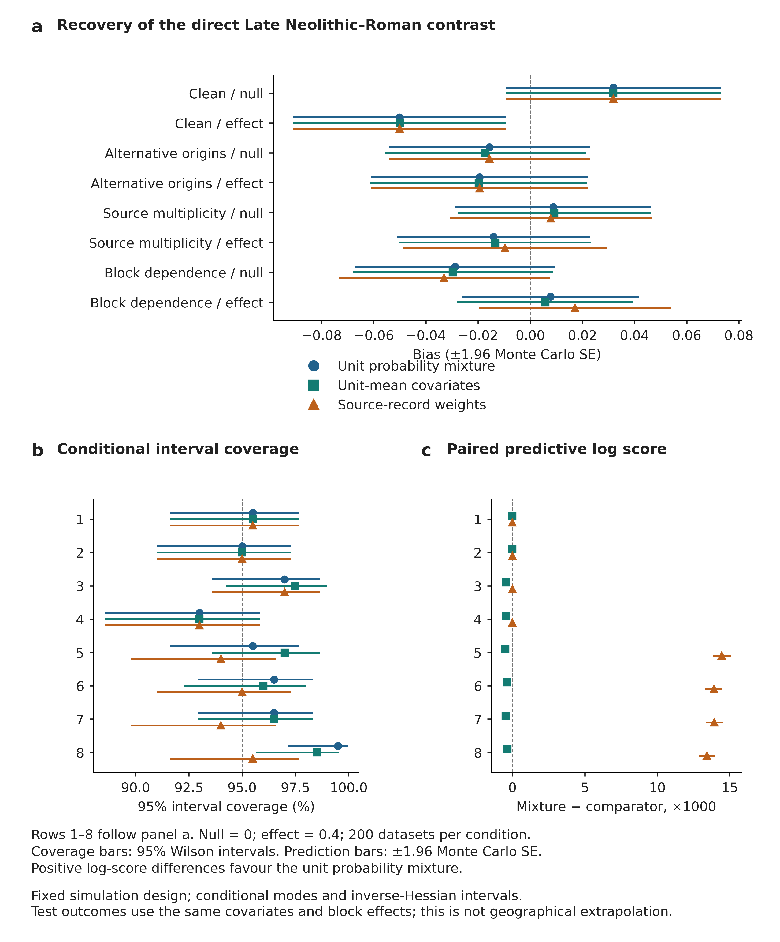
Fig. 7 Comparison of three methods for representing paternal units. All eight conditions compare the unit-level probability mixture, unit-mean measured covariates and source-record weights on the same generated outcomes, controls and priors. a Bias in the direct Late Neolithic–Roman contrast, with ±1.96 Monte Carlo standard errors. b Coverage of conditional inverse-Hessian 95% intervals, with Wilson intervals. c Paired expected log-score gains of the probability mixture over each comparator, multiplied by 1,000, with ±1.96 Monte Carlo standard errors. Positive gains favour the mixture. Conditions use 200 datasets each; null truth is zero and effect truth is 0.4. Predictions share generating covariates and block effects. This experiment assesses the specified operations, not historical validity or unseen-region performance

Discussion

The archaeological contribution of SCLARA
SCLARA makes paternal geography archaeologically specific. In Sweden, a Late Neolithic balance of clearance and building traces against combustion and heated stone distinguishes Z284 from I1 and U106. The same measurement allows this contrast to be compared with later dated records; separate Viking and medieval profiles reveal further differences within I1 and between R1b branches. The comparisons are reproducible because their paternal units, archaeological measurements and joint estimates are explicitly defined. Their historical value comes from the activities and materials that can be examined in the original reports.
The regional estimates give the national result geographical structure. The Late Neolithic I1–Z284 point estimate is positive in eastern central and western Sweden, negative in the Småland and Islands region, and close to zero in the northern aggregate. Although imprecise, these estimates identify places where branch histories can be examined against specific archaeological records.
Ancient genomes provide dated population context (Allentoft et al. 2024a; Rodríguez-Varela et al. 2023; McColl et al. 2026); archaeological reports identify activities and materials; SCLARA tests how those settings relate to reported paternal origins. Read together, these records allow accounts of paternal differentiation to be assessed against identifiable places, dates and activities.

Formation and later differentiation in the Swedish sequence
The clearest early association distinguishes Z284 from both I1 and U106. It gives accounts of paternal formation during the Late Neolithic and Bronze Age a concrete archaeological comparison. The R1b-L51-rich and I1-rich phases identified in ancient genomes motivate an encounter-and-expansion hypothesis. Broad ancient L51 assignments do not identify U106, however, and the measured I1–U106 and Late Neolithic–Bronze Age contrasts remain unresolved. A proposed I1 bottleneck remains a question for phylogenetic and dated demographic evidence.
The Roman-period record extends the comparison while keeping the archaeological measurement unchanged. Restriction to shared archaeological coverage leaves the estimated Late Neolithic–Roman difference positive, with intervals that now include zero. For the Migration period, a separate reanalysis of the earlier posthole–hearth profile shows how adding archaeological records changes the association. These comparisons give the early result a temporal and geographical context while showing how the underlying record shapes its interpretation.
The later profiles show why distinctions within broad haplogroups matter. In Viking-period records, I1‑L22 has a more positive adjusted association than I1‑Z58 with charcoal and slag relative to postholes and hearths. The Viking U106–P312 contrast remains unresolved. In medieval records, U106 has a more positive adjusted association than Z284 or P312 with ovens, wells and postholes relative to tar and charcoal contexts. Broader branch groupings retain the principal estimated directions but alter their precision. These are separate measurements of different archaeological settings at the same reported paternal origins.

Original contexts give the profiles physical meaning
The original contexts explain what the landscape balance means. At Mannaberg, cultivation soil and cereal-rich cooking deposits fall on opposite sides of the balance, so both sides can contain evidence of agriculture. Kråkhult adds clearance compatible with grazing, while older charcoal beneath later land use at Kölbygärde shows why the age of dated material can differ from the age of an activity. The early contrast therefore concerns the regional distribution of several activities within settled landscapes. At the illustrated origin, low relative proximity to heated stone contributes more to the score than proximity to clearance evidence.
Later contexts provide equally concrete distinctions. Färila documents charcoal production, Harbo-Smedsbo iron-working waste, Uppsala a brick kiln and Leksand tar production. In the medieval balance, production occurs on both sides: the contrast concerns different combinations of settlement and production features. The profiles describe regional activity patterns rather than the organization of individual households (Bukkemoen 2025).
The Migration-period comparison shows why archaeological source selection matters to historical interpretation. Reallocating dates within the original record largely preserves the association; adding records substantially reduces it. This separates uncertainty in dates from the effects of source inclusion, which changes feature geography, recording and opportunity together.

Applying SCLARA beyond Sweden
Applying SCLARA elsewhere requires defined paternal units, preserved source evidence, archaeologically meaningful measurements and joint estimation of the relevant contrasts. The simulation demonstrates the practical value of reconciliation: when several records repeat one outcome, counting the unit once reduces estimation error and improves prediction. Retaining alternative origins preserves the geographical variation reported for that unit; averaging its covariates gives slightly better predictive scores under the tested conditions. These choices determine how the available paternal evidence enters the comparison with archaeology.
Each application requires a justification for its period definitions, feature dictionary, distance scale and environmental controls. The supplementary transfer guide and compact synthetic example show which choices must be made for a new application and which measurement and likelihood code can be reused.
Reported ancestral localities give modern genetic observations a historical geographical reference. In the dated Swedish subset, the middle half of reported birth years (1665–1786) predates the rapid urban growth beginning in the later nineteenth century (Statistics Sweden 2016, p. 6). Using ancestral localities reduces the influence of descendants’ later places of residence on the geographical comparison. SCLARA tests whether this ancestral geography remains associated with archaeological settings after the specified spatial and dependence adjustments.
Interpretation depends on the sources represented in the study and on the documented process by which the comparisons were selected. Voluntary genetic testing and uneven branch resolution shape the represented paternal geography; excavation and dating choices shape the archaeological record. The ancient individuals are unevenly sampled; some are related, dated by context or assigned only to broad branches. Targeted source reviews do not estimate catalogue-wide error. The reported dependence and support sensitivities show where concentration of evidence changes precision.
The archaeological profiles make competing explanations testable. Early persistence would be supported by corresponding branch differences among securely dated ancient individuals from comparable regions, together with occupation histories linking the archaeological settings through time. Later redistribution offers another route to the observed associations. Unequal family expansion would concentrate the pattern within related branches; recording effects would align it with the geography of excavation and dating. The existing source and dependence analyses indicate where those explanations can be examined most closely.
The Swedish demonstration identifies an early settlement and land-use distinction, compares it with later dated records, and reveals finer branch distinctions around Viking and medieval activities. Original reports establish the physical meaning of these settings, while ancient individuals place them in population history. SCLARA thus gives the study of paternal differentiation a reproducible connection to the places and activities preserved in the archaeological record.

Statements and Declarations

Funding
No funding was received for this study.

Competing interests
The author has no financial or non-financial competing interests to declare.

Author contributions
Nemanja Stanisic is the sole author and is responsible for the study conception, methodology, data curation, analysis, interpretation and manuscript. Computational and editorial assistance is described in the Methods.

Ethics and consent
This study is a secondary analysis of existing published and publicly available records. Ethics approval was not required by the author’s institution for this type of study. It involved no new participant recruitment, biological sampling or direct participant contact, and no new participant consent was collected. Third-party data remain subject to their original access and reuse conditions. Potentially identifiable genealogical records are excluded from the public repository.

Data and code availability
The public SCLARA distribution (Stanisic 2026; version 2026.11.09.4) is identified by https://github.com/nstanisic1/SCLARA and https://doi.org/10.5281/zenodo.24088352. It contains code, reconstruction instructions, a synthetic example, aggregate comparisons and diagnostics. The source catalogue (SOURCES.tsv, Online Resource 3) gives citations, versions, source URLs and input roles. Potentially identifiable paternal records and third-party snapshots without established redistribution permission are excluded. The separate complete computational archive preserves exact inputs, retained coefficient draws and comparison families. Access can be requested from the corresponding author at nstanisic@singidunum.ac.rs, subject to source-provider conditions and appropriate protection of personal information. Online Resource 2 contains public archaeological coordinates, geographical meanings, reliability limits and source locators. The full coordinate inventory, including participant-linked paternal origins, is supplied separately as confidential reviewer material and is excluded from the public supplements and code package.

Supplementary information
Online Resource 1 Supplementary methods, complete comparison tables, source reviews and transfer guide (supplement.pdf)
Online Resource 2 Archaeological coordinates with decimal and DMS values, geographical meanings, reliability limits and source locators (archaeological_coordinates.tsv)
Online Resource 3 File-level data citations, versions, acquisition URLs, checksums and source roles (SOURCES.tsv)
Online Resource 4 Complete common-period coefficient comparisons for all three components, seven lineage contrasts and four national model specifications (common_period_comparisons.tsv)

References
Allentoft ME, Sikora M, Fischer A et al. (2024a) 100 ancient genomes show repeated population turnovers in Neolithic Denmark. Nature 625:329–337. https://doi.org/10.1038/s41586-023-06862-3
Allentoft ME, Sikora M, Refoyo-Martínez A et al. (2024b) Population genomics of post-glacial western Eurasia. Nature 625:301–311. https://doi.org/10.1038/s41586-023-06865-0
Altner A (2016) Förhistorisk kolning i Färila. Arkeologisk utredning och undersökning. Rapport Länsmuseet Gävleborg 2016:12. https://pub.raa.se/dokumentation/b4552c3f-27e6-4416-b778-9f591e09f059/original
Boström LA (undated) Y-DNA-haplogrupper i södra Norrbotten. Source compilation, snapshot 3 November 2026. https://familjenbostrom.se/genealogi/dna/nobo/
Bukkemoen GB (2025) Beyond the Longhouse: On the Heterogeneity, Spatiality and Temporality of Scandinavian Iron Age Households. Cambridge Archaeological Journal 35:241–252. https://doi.org/10.1017/S0959774324000313
Eurostat (2024) GISCO territorial units for statistics (NUTS), 2024 edition, level 2, 1:1 million, EPSG:4326. https://gisco-services.ec.europa.eu/distribution/v2/nuts/
Fagerlund D (2016) För bröder, präster och kungar. En medeltida tegelindustri i Uppsala. Upplandsmuseets rapporter 2016:03. https://www.upplandsmuseet.se/globalassets/publikationer/rapportserien/rapporter-2016/rapport-2016_03-akademiska-sjukhusomradet.pdf
FamilyTreeDNA (2026) Sweden DNA project and public Y-DNA haplotree. Source snapshots 2 November 2026. https://www.familytreedna.com/public/Sweden?iframe=ydna-results-overview
Helander C (2013) Kvarnbacken. UV Rapport 2013:88. Riksantikvarieämbetet. https://pub.raa.se/dokumentation/531a3159-530d-4e13-a9a4-fa6b7a787f54/original
Hellgren M (2023) Röjningsrösen i Kråkhult. Arkeologisk förundersökning. Göta Arkeologi rapport 2023:10. https://files.builder.misssite.com/b9/9b/b99b7a16-f2d7-4bca-a589-c1655779deb8.pdf
Holmqvist S (2021) Kolningsgrop och tjärdal i Leksand. Rapporter från Arkeologikonsult 2021:3435. https://www.arkeologikonsult.se/rapporter/2021.3435%20Kolning%20och%20tj%C3%A4rdal%20i%20Leksand.pdf
Karlsson AO, Wallerström T, Götherström A, Holmlund G (2006) Y-chromosome diversity in Sweden – A long-time perspective. European Journal of Human Genetics 14:963–970. https://doi.org/10.1038/sj.ejhg.5201651
Kinnunen J (undated) Fennoscandia – Y-DNA haplogroup I1,I2, N and R1a,R1b. Visual DNA, interactive map and source description. Snapshot 3 November 2026. https://www.visual-dna.net/visualized-data-articles
Kjellberg J (2006) Harbo-Smedsbo. Järnframställning och boplatslämningar i Heby. Kulturmiljövård Mälardalen rapport 2006:1. https://pub.raa.se/dokumentation/6a6569e2-3aa7-4289-9777-47f1652d5580/original
Lehner B, Verdin K, Jarvis A (2008) New global hydrography derived from spaceborne elevation data. Eos, Transactions American Geophysical Union 89:93–94. https://doi.org/10.1029/2008EO100001
Lucas M, Lucas R (2013) Gårdar och hästoffer. Järnålder och tidig medeltid i Fyrislund. Upplandsmuseets rapporter 2013:02. https://www.upplandsmuseet.se/globalassets/publikationer/rapportserien/rapporter-2013/hellby1217_lagupplost.pdf
Malmström H, Günther T, Svensson EM et al. (2019) The genomic ancestry of the Scandinavian Battle Axe Culture people and their relation to the broader Corded Ware horizon. Proceedings of the Royal Society B 286:20191528. https://doi.org/10.1098/rspb.2019.1528
Margaryan A, Lawson DJ, Sikora M et al. (2020) Population genomics of the Viking world. Nature 585:390–396. https://doi.org/10.1038/s41586-020-2688-8
McColl H, Kroonen G, Moreno-Mayar JV et al. (2026) Tracing the spread of Germanic languages using ancient genomics. Nature. https://doi.org/10.1038/s41586-025-09064-1
Morris TP, White IR, Crowther MJ (2019) Using simulation studies to evaluate statistical methods. Statistics in Medicine 38:2074–2102. https://doi.org/10.1002/sim.8086
Natural Earth (undated) Admin 0 – Countries, 1:10 million. Public-domain map data; retained snapshot identified by checksum. https://www.naturalearthdata.com/downloads/10m-cultural-vectors/10m-admin-0-countries/
Nordin P (2023) Sju hus från yngre stenålder vid Mannaberg i Skrea. Arkeologerna rapport 2023:130. Statens historiska museer. https://pub.raa.se/dokumentation/62c34985-614d-48bc-9e7b-ae9297fb59ba/original
Owen AB, Eckles D (2012) Bootstrapping data arrays of arbitrary order. Annals of Applied Statistics 6:895–927. https://doi.org/10.1214/12-AOAS547
Peter BM, Petkova D, Novembre J (2020) Genetic Landscapes Reveal How Human Genetic Diversity Aligns with Geography. Molecular Biology and Evolution 37:943–951. https://doi.org/10.1093/molbev/msz280
Pinotti T, McColl H (2025) Y-chromosome data from “Steppe Ancestry in Western Eurasia and the Spread of the Germanic Languages”, McColl et al. 2025. Zenodo. https://doi.org/10.5281/zenodo.15163112
Reimer PJ, Austin WEN, Bard E et al. (2020) The IntCal20 Northern Hemisphere radiocarbon age calibration curve (0–55 cal kBP). Radiocarbon 62:725–757. https://doi.org/10.1017/RDC.2020.41
Riksantikvarieämbetet (2026) Kulturhistoriska lämningar. Kulturmiljöregistret geodata, national snapshot 3 November 2026. https://www.raa.se/hitta-information/oppna-data/oppna-data-portal/
Ring C, Pedersen EA, Gurstad-Nilsson H et al. (2001) Kölbygärde. Bronsåldersboplatser i ett fossilt odlingslandskap. E22-projektet rapport 2001:10. Kalmar läns museum. https://kalmarlansmuseum.se/wp-content/uploads/2022/05/kolbygarde.pdf
Rodríguez-Varela R, Moore KHS, Ebenesersdóttir SS et al. (2023) The genetic history of Scandinavia from the Roman Iron Age to the present. Cell 186:32–46.e19. https://doi.org/10.1016/j.cell.2022.11.024
Speidel L, Silva M, Booth T et al. (2025) High-resolution genomic history of early medieval Europe. Nature 637:118–126. https://doi.org/10.1038/s41586-024-08275-2
Stanisic N (2026) SCLARA: Spatial Concordance Between Paternal Lineages and Stratified Archaeological Records. Version 2026.11.09.4 [Software]. Zenodo. https://doi.org/10.5281/zenodo.24088352
Statistics Sweden (2016) Tätorter 2015: befolkning och arealer. Statistiska meddelanden MI 38 SM 1601, corrected 19 June 2017. https://www.scb.se/contentassets/55b2d3dbe48a4dcc85f93f4db599d868/mi0810_2015a01_sm_mi38sm1601.pdf
Strucke U (2026) Strucke C14 Sweden, version 2. Zenodo. https://doi.org/10.5281/zenodo.21932353
Vehtari A, Gelman A, Simpson D, Carpenter B, Bürkner PC (2021) Rank-normalization, folding, and localization: an improved R-hat for assessing convergence of MCMC (with Discussion). Bayesian Analysis 16:667–718. https://doi.org/10.1214/20-BA1221
Verhagen P, Whitley TG (2012) Integrating Archaeological Theory and Predictive Modeling: a Live Report from the Scene. Journal of Archaeological Method and Theory 19:49–100. https://doi.org/10.1007/s10816-011-9102-7
Wennerberg R (2008) 1000 år av kolning i Nifsarp. Jönköpings läns museum, arkeologisk rapport 2008:17. https://jonkopingslansmuseum.se/wp-content/uploads/2018/01/2008_17.pdf

