**Midterm Exam REM429 – Landscape Ecology, March 2, 2018 Total: 100 pt**

**Name:__Nelson Stauffer_____**

**Multiple choice. Select ONE answer per question (3 p per question)**

1. **What is considered a “landscape” in Landscape Ecology (one is correct)**
2. A biotic community
3. A uniform area
4. An area composed of dissimilar patches
5. An ecosystem
6. None of the above
7. **What are the two main components of scale that we have discussed during lectures and identified in Turner et al. 2001 (and other literature)?**
8. Patch and edge
9. Vector and raster
10. Grain and extent
11. Stationarity and autocorrelation
12. None of the above
13. **Thematic scale can be defined as:**
14. The size of pixel represented on a vegetation map
15. The smallest size object that can be correctly mapped
16. The ratio of the distance on a map to the distance on the earth’s surface
17. The number of classes, either spatial or temporal, represented on a map or graph
18. None of the above
19. **What are consequences of landscape fragmentation?**
20. There is less habitat area and the remaining habitat patches are often disconnected
21. Habitat patches become larger in size
22. It is easier for species to move between habitat patches because corridors develop
23. The landscape is easier to quantify using software such as FRAGSTATS
24. None of the above

1. **What statement best describes hierarchy theory as discussed in class, lab and in Turner et al. 2001 (book for this class)**
2. Hierarchy theory describe the number of classes in a map legend
3. Hierarchy theory describe forces that contribute to forming landscape patterns
4. Hierarchy theory suggests that for each focal scale of study, you should also consider a broader scale to give context and a finer scale to provide explanation and variability
5. Hierarchy theory describes how an organism moves through habitats
6. None of the above
7. **Theoretically, percolation through a landscape represented by pixels of “friendly” and “non-friendly” habitats would be easier using the 4-cell rule compared to the 8-cell rule.**
8. True
9. False

**7. Landscape metrics for two maps of the same landscape are compared. Map A has a finer grain (smaller pixel size) than Map B. What one statement is most likely true?**

1. Interspersion indices are likely higher in Map B
2. Small patches are lost in Map A
3. The patch richness is likely to be higher in Map A
4. Shape index is likely lower in Map A
5. Total edge is longer in Map B
6. ~~The patch richness is likely to be higher in Map A~~

**8. How is a deterministic model different from a stochastic model?**

1. The model yields the same outputs for a given set of inputs each time the model is run
2. The model is a spatial model
3. The model includes a probabilistic component that produces variable results
4. Random processes within the model generates slightly different results each time the model is run
5. None of the above

**9. What statement best describes diversity indices used in quantifying landscape patterns?**

1. Diversity indices can be calculated at the patch type level but not at the landscape level
2. Diversity is maximized when one patch type dominates the landscape
3. Diversity indices describe the proportional distribution of area between different patch types in the landscape
4. Diversity indices describe the spatial arrangements of patch types within the landscape
5. None of the above

**10. The concept of source and sink habitats has been used to describe the way organisms use landscapes. What is true about source and sink habitats?**

1. Extinction is likely in both source and sink habitats
2. Mortality exceeds reproduction in source habitats while the opposite is true in sink habitats
3. Reproduction and mortality is equal in the source and sink habitats
4. Reproduction is higher than mortality in source habitats while the opposite is true in sink habitats
5. All of the above

**Short answer (7 p per question)**

**11. What are three reasons why Landscape Ecology developed as a science?**

Growing awareness of large-scale patterns on the landscape coming from comparison of more local vegetation studies (the traditional form of data collection/consideration)

Increased availability of remote sensing data, particularly aerial imagery, making it easier to even think about landscapes at larger scales, much less begin to quantify them.

Dramatic increases in computational power making calculating landscape metrics a reasonable task. Calculating anything on a meaningful scale by hand is a nightmarish proposition fraught with potential for errors.

**12. The plant community in a relatively large area (several hectares) has been depleted and is in need of rehabilitation. You have been asked to identify plant species that may be suitable for re-vegetation of the area. What are the first three questions you would ask about the site conditions before you start selecting plant species for rehabilitation? Briefly describe why the answer to those questions are important for the success of the rehabilitation project. (There will of course be many more questions, but for the sake of this exam, only list three).**

*What are the geographic/abiotic factors here?*

It’s critical to know what the landscape can support. Factors like soil properties, moisture availability, slope, aspect, elevation, disturbance regimes, *etc*. act as limiting factors on the survival success of organisms. If the ecological potential of the area doesn’t include the conditions for a species, attempting to introduce it would be pointless.

*What populations existed before the depletion?*

This is most relevant if you’re attempting to recreate a specific community or association of communities of plant species in the area. In that case, knowing what species were there can be used to directly inform what species to introduce.

*What are the management goals?*

It might be that either the historic communities cannot be achieved again due to dramatic changes on the landscape or that they’re undesirable. In that case, the question of what’s being attempted with the reseeding is important: species that are more drought tolerant than historic populations might be favored because climate projections suggest that long-term drought will be the norm and less drought-tolerant species that existed there previously would not survive or thrive.

**13. Match the following patch and landscape metrics with the correct description. Write the correct letter on the line in front of the metric.**

|  |  |
| --- | --- |
| **Metric** | **Description** |
| A__ Mean patch size | **A.** ~~The average size of the patches in the landscape~~ |
| D__ Edge density | **B.** ~~Diversity or evenness of patch adjacencies~~ |
| F__ Shape index | **C.** Can be described as the length of the measuring stick used to estimate the length of a boundary such as a coastline. |
| C__ Fractal dimension | **D**. ~~The length of edge per unit area of the landscape~~ |
| G__ Landscape evenness | **E.** ~~Diversity or evenness of pixel adjacencies~~ |
| B__ Interspersion juxtaposition index | **F.** A measure of the perimeter to area ratio for the patches in the landscape |
| E__ Contagion | **G**.  ~~A measure of the proportion of patch types corrected for the number of patch type present~~ |

**14. Many approaches have been developed to quantify landscape patterns, many landscape metrics for example. Briefly describe three reasons why quantifying landscape patterns is important to scientists and land managers.**

*Epistemology*

Most of the need for landscape metrics boils down to the fact that western science and bureaucracies both have a very specific set of epistemologies that prioritize and require quantitative measures. They are both configured so that qualitative descriptions are comparatively useless, in the case of management often because they are “legally indefensible”. However, this is not to place a negative value judgment on emphasizing quantitative data because those are the only way to answer some classes of questions.

*Identifying the current state of the systems*

Understanding and describing the arrangement and relationships of the systems on the landscape is critical for even beginning to make a decision. This includes just knowing about the presence of factors and communities as well as the interactions between them

*Identifying possible responses to disturbance/stress*

Without landscape metrics, it’s impossible to mathematically model the responses that the landscape might have to various disturbances or stresses. They run the gamut of natural and anthropogenic, but in order to decide where, how, and when to intervene to get specific results requires a more numerically rigorously described set of interactions.

**15. If it was possible to remove all disturbances from the landscape, would there be patterns of patches on the landscape? Justify your answer.**

There would absolutely be patterns in the absence of disturbance. For one, there would still be stressors influencing the systems and communities. The only case in which a stressor would not differentially influence the landscape is if it were completely uniform across the full extent. Also, removing disturbances would not undo the historic influence of disturbance as a driver of landscape patterns, leaving the remnant patterns to continue to play out. And unless the landscape is something out of a physics textbook in which there can exist a perfectly featureless and uniform plane the underlying abiotic factors would continue to dictate varied ecological potentials.

**16. The conceptual model below describe the interaction between successional development, fire disturbance, and prescribed burning management in a sagebrush steppe ecosystem affected by juniper woodland expansion. It is similar to the model we used in the VDDT lab in class.**

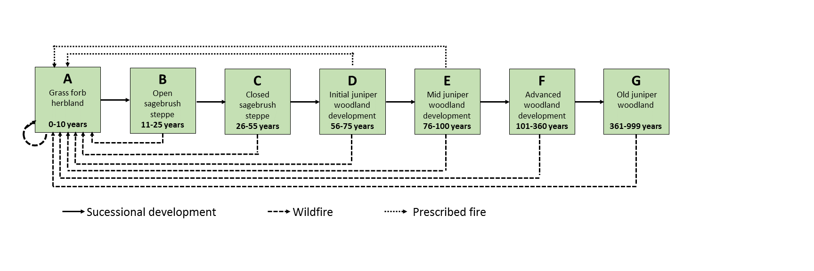

**List three assumptions that this model is based on. For each assumption, make a suggestion for what data you would collect to improve the accuracy of the assumption (data can be collected in the field, maps, photos, from people etc.).**

The only disturbances are fires. Combing through historical records and talking to locals who have lived knowledge will likely turn up other relevant disturbances to account for.

The effects of prescribed burns are only described for two communities and are single-outcome. Experimental prescribed burns preceded and followed by monitoring may reveal additional pathways.

Succession happens at a hard age break. Combining long term monitoring with local knowledge and historical records, it’s likely that this would be more accurately modeled with the potential for succession to be treated probabilistically rather than deterministically.

**17. The landscape below is composed of Young (Y), mature (M), and Old (O) forest at three different periods in time. According to the “Shifting-Steady-State-Mosaic Model” of landscape composition, is this landscape at the equilibrium state over the given time period? Justify your answer. Include in your discussion how equilibrium can be maintained and discuss forces that impact the equilibrium composition. Also describe a situation where the “Shifting-Steady-State-Mosaic Model” may not be a good model for understanding landscape change.**

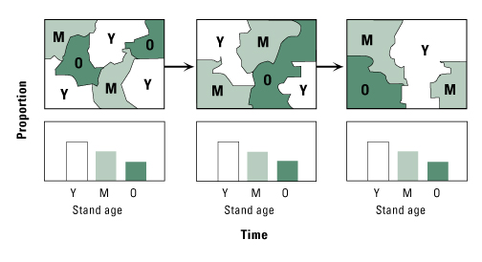

The landscape is at equilibrium. The landscape is a *mosaic* of different community ages, the spatial distribution of which *shifts* over time, and the proportional distribution of which holds *steady* over that same temporal extent and grain.

Equilibrium can be maintained in this situation because our thematic classes are successional. So, if there is a disturbance with an interval similar to the spacing of the thematic classes and that primarily effects the oldest age class, it means that we’d likely see a pattern like this where we get a steady-state cycling. There need to be factors that can act on the classes to convert one to another to prevent the conversion from being totally linear in order for a steady-state to exist.

These kinds of approaches are inappropriate for landscapes where equilibrium is not expected to exist. For example, based on our knowledge of post-fire recovery, we would not expect to apply a shifting, steady-state mosaic approach with a fine thematic grain and long temporal extent because the earliest seral stages are not likely to persist through extended time despite dominating the early recovery.

**18. Identify and briefly describe five terms that contribute to describing a disturbance regime. Example: Rotation period – the average time needed to disturb an area equivalent to the study area.**

Extent: The spatial size and/or temporal duration of the disturbance

Intensity: The effect per unit time of the disturbance. For example, a fire might be measured in kilojoules released per hour or a flood in acre-feet per minute.

Severity: The combination of extent and intensity, measuring the impact of the disturbance on the landscape

Recovery Interval: The amount of time the system needs to return to its pre-disturbance state

*A fifth one that I can’t think of right now*

**19. Disturbances are natural parts of many ecosystems. Based on discussions in class and your own thoughts, when does a disturbance become extreme and undesirable from an ecological perspective? From a societal/human perspective?**

**Why might the differences between your two definitions prove problematic for natural resource managers?**

A disturbance is undesirable from an ecological perspective when it pushes the systems hard enough to break their “natural” (recognizing that there are no undisturbed systems left outside of maybe deep sea vent communities) function, possibly identified by the disturbance preventing the communities from the state and transition model described for the area from existing in those relationships again on human timescales.

From a human perspective, a disturbance is extreme when it causes severe human hardship or loss of life or destruction of valued resources (which might be those exploited, like lumber, or those valued for other reasons, like protected species) or dramatically reduced productivity.

These two things can come into conflict easily. For example: wildfire suppression is common as a practice because it can cause damage to property, loss of human life, and decreases forestland productivity for timber harvest on the timescales relevant to most humans. However, those fires are not extreme for ecosystems that coevolved with them and may even require them for things like recruitment.

**20. MacArthur and Wilson described the theory of island biogeography, a theory for predicting species richness on islands or isolated patches. According to their theory:   
a) What are the most important factors that determine the species richness on an island? b) What factors impact the immigration rates of species to the island?   
c) What factors impact the extinction rates on the island?**

A) Availability of resources, proximity to species sources, island heterogeneity, island extent

Factors which affect the influx of species, the mortality and recruitment rates of species, and the carrying capacity of the island as a landscape.

B) Species source proximity, difficulty of passage through non-source habitats

Factors that will affect the frequency of species arriving at the island from other sources. Proximity is hugely important, but longer distances matter less when the difficulty of crossing them is lower.

C) Availability of resources, disturbance regime, stresses, interspecific interactions, immigration rates

Basically, any factors that might push the mortality rates above the replacement (recruitment either through reproduction or immigration) rates