Fragstats: Spatial Granularity and Time

Nelson Stauffer

March 23, 2018

## Introduction

Landscape metrics are important to ecology because they provide quantitative measures for otherwise abstract concepts which are relevant to understanding the organisms and systems that make them up. These questions in landscape ecology are often framed broadly in terms of structure, function, and change. (Forman and Godron, 1986) While it is useful to speak to conceptual particulars within those frameworks regarding properties of landscapes like connectivity, heterogeneity, and patch dynamics, it's difficult to develop or provide specific, accurate predictions of landscape behavior over time without quantifying those ideas.

In order to facilitate the calculation of landscape structure metrics for its own management purposes, the USDA Forest Service developed the software FRAGSTATS to calculate landscape metrics from categorical landscape data, driven through a graphical user interface for accessibility. (McGarigal and Marks, 1994) This was the software used to calculate all landscape metrics for this lab.

The reason to calculate the metrics was to explore the changes in landscape metrics over time (three records with a spatial resolution of 30 m and a temporal resolution of 100 years) and with changes in spatial granularity (three records with spatial resolutions of 30, 50, and 100 m from the same timeslice).

## Methods

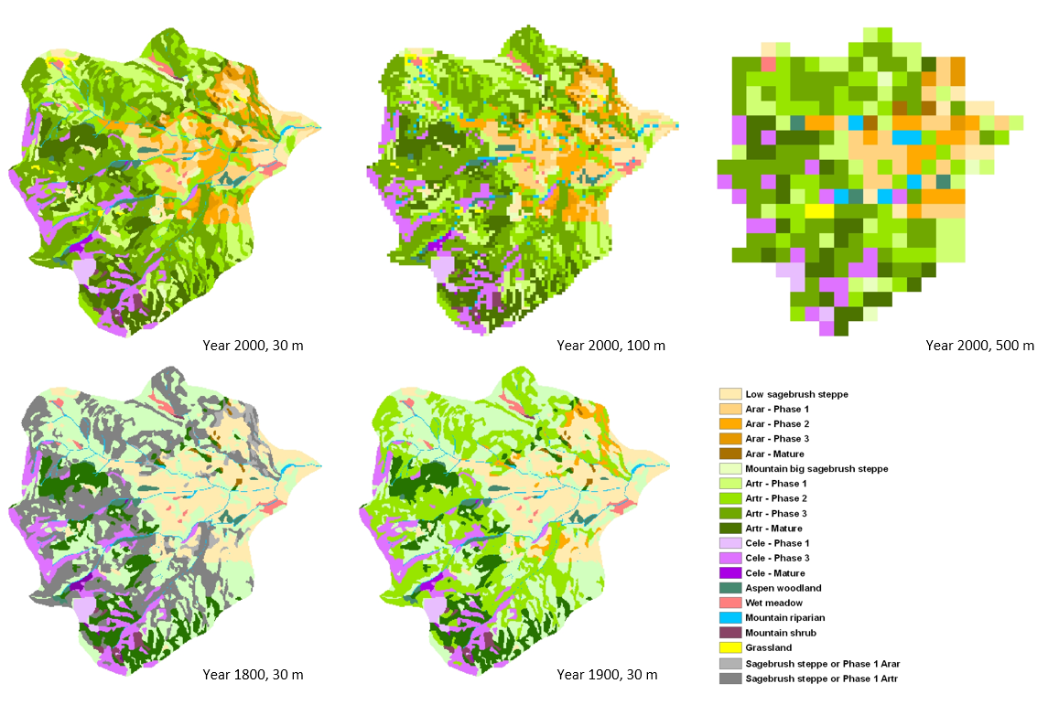

*Figure 1: Rasters of the Owyhee, Idaho landscape described in vegetation community classes at different points in time and at different spatial resolutions. These were the data used for the calculation of landscape metrics.*

The data used in this lab come from the Owyhee region of Idaho (Figure 1). The metrics were both landscape and patch class scale and selected both to highlight potential changes due to the changes in time and granularity and to complement one another in interpretation.

FRAGSTATS was used to calculate the following landscape and class metrics for the vegetation data:

* Shannon's Diversity Index (SHDI)
* Shannon's Evenness Index (SHEI)
* Mean patch shape index
* Patch count
* Percent of landscape (by patch type)
* Patch count (by patch type)
* Mean patch area (by patch type)
* Mean edge:area ratio (by patch type)

SHDI was included to provide a measure of diversity of patch-to-patch interfaces and SHEI to contextualize how evenly distributed across the landscape those relationships were. Mean patch shape index provides a measure of the complexity of patch-to-patch boundaries.

Patch counts, both per-class and across the landscape, can help make it clear whether other metrics are skewed by singular, oddball patches or if the properties are more consistent.

Calculating the percentage of the landscape by class demonstrates the relative spatial influence of a class. The mean edge:area ratio, like mean patch shape index, gets at the complexity of interfaces on the edges of patches, but also the potential interiority of patches.

Taken together, the interactions between these metrics can be used to resolve some of the actual changes that occur when shifting spatial resolution or looking at differences over time, *e.g.* detecting fragmentation of patches despite relatively consistent total area of the class by comparing patch count and mean patch area.

## Results

|  |  |  |  |  |  |  |  |  |  |  |  |  |
| --- | --- | --- | --- | --- | --- | --- | --- | --- | --- | --- | --- | --- |
|  | **Mean Patch Area** | | | **Landscape Percentage** | | | **Patch Count** | | | **Mean Edge:Area Ratio** | | |
| **Cover Class** | **30 m** | **100 m** | **500 m** | **30 m** | **100 m** | **500 m** | **30 m** | **100 m** | **500 m** | **30 m** | **100 m** | **500 m** |
| Aspen woodland | 8 | 8.3 | 25 | 1.3 | 1.2 | 1.1 | 11 | 10 | 3 | 279.5 | 250.6 | 80 |
| Grassland-Artr | 4.8 | 4.7 | 50 | 0.6 | 0.6 | 0.7 | 8 | 9 | 1 | 368.3 | 271.3 | 60 |
| Low sagebrush steppe-Arar | 9.4 | 9.5 | 45 | 4.5 | 4.4 | 3.2 | 33 | 32 | 5 | 289.6 | 255.9 | 74 |
| Low sagebrush steppe with young juniper-Arar | 13.8 | 18.6 | 100 | 7.2 | 7.2 | 8.6 | 36 | 27 | 6 | 337.7 | 238.8 | 64.5 |
| Mountain big sagebrush steppe-Artr | 3.7 | 6 | 25 | 1.5 | 1.6 | 1.4 | 28 | 18 | 4 | 617.5 | 278.7 | 80 |
| Mountain riparian | 0.3 | 1.4 | 30 | 1.6 | 1.8 | 2.1 | 364 | 85 | 5 | 1172 | 379.4 | 76 |
| Mountain shrub | 5.9 | 6 | 0 | 0.6 | 0.6 | 0 | 7 | 7 | 0 | 441.7 | 295.1 | 0 |
| Old multi-story juniper woodland-Arar | 2 | 2.4 | 25 | 0.4 | 0.4 | 1.1 | 12 | 11 | 3 | 419.4 | 330.3 | 80 |
| Old multi-story juniper woodland-Artr | 16.4 | 18.2 | 72.5 | 10.5 | 10.5 | 10.4 | 44 | 40 | 10 | 308.9 | 265.5 | 70.3 |
| Old multi-story juniper woodland-Cele | 3.5 | 4.8 | 0 | 0.4 | 0.3 | 0 | 7 | 5 | 0 | 725 | 354 | 0 |
| Open young juniper woodland-Arar | 9.5 | 10.1 | 75 | 5.6 | 5.6 | 5.4 | 41 | 38 | 5 | 325.5 | 241.4 | 64 |
| Open young juniper woodland-Artr | 8.9 | 10.3 | 68.8 | 14.3 | 14.2 | 15.7 | 111 | 96 | 16 | 360 | 267.7 | 73 |
| Sagebrush steppe with young juniper -Cele | 20.5 | 22 | 50 | 0.9 | 1 | 1.4 | 3 | 3 | 2 | 412.8 | 291.7 | 66.7 |
| Sagebrush steppe with yourng juniper-Artr | 9.2 | 10.4 | 43.2 | 13.2 | 13 | 13.6 | 99 | 87 | 22 | 364.8 | 279.8 | 73.9 |
| Wet meadow | 7.4 | 6.6 | 25 | 1 | 1 | 0.4 | 9 | 10 | 1 | 342.9 | 306.3 | 80 |
| Young multi-story juniper woodland-Arar | 4.7 | 5.9 | 33.3 | 2.2 | 2.3 | 1.4 | 33 | 27 | 3 | 432.8 | 306.8 | 73.3 |
| Young multi-story juniper woodland-Artr | 35.2 | 39.2 | 142.3 | 27.4 | 27.2 | 26.4 | 54 | 48 | 13 | 318.1 | 241 | 59.2 |
| Young multi-story juniper woodland-Cele | 18.8 | 18.9 | 45.5 | 7.1 | 7.1 | 7.1 | 26 | 26 | 11 | 304 | 253.6 | 73.9 |

*Table 1: Class-based landscape metrics for a single timeslice, calculated at three different spatial granularities.*

|  |  |  |  |  |  |  |  |  |  |  |  |  |
| --- | --- | --- | --- | --- | --- | --- | --- | --- | --- | --- | --- | --- |
|  | **Mean Patch Area** | | | **Landscape Percentage** | | | **Patch Count** | | | **Mean Edge:Area Ratio** | | |
| **Cover Class** | **30 m** | **100 m** | **500 m** | **30 m** | **100 m** | **500 m** | **30 m** | **100 m** | **500 m** | **30 m** | **100 m** | **500 m** |
| Aspen woodland | 8 | 8.3 | 25 | 1.3 | 1.2 | 1.1 | 11 | 10 | 3 | 279.5 | 250.6 | 80 |
| Grassland-Artr | 4.8 | 4.7 | 50 | 0.6 | 0.6 | 0.7 | 8 | 9 | 1 | 368.3 | 271.3 | 60 |
| Low sagebrush steppe-Arar | 9.4 | 9.5 | 45 | 4.5 | 4.4 | 3.2 | 33 | 32 | 5 | 289.6 | 255.9 | 74 |
| Low sagebrush steppe with young juniper-Arar | 13.8 | 18.6 | 100 | 7.2 | 7.2 | 8.6 | 36 | 27 | 6 | 337.7 | 238.8 | 64.5 |
| Mountain big sagebrush steppe-Artr | 3.7 | 6 | 25 | 1.5 | 1.6 | 1.4 | 28 | 18 | 4 | 617.5 | 278.7 | 80 |
| Mountain riparian | 0.3 | 1.4 | 30 | 1.6 | 1.8 | 2.1 | 364 | 85 | 5 | 1172 | 379.4 | 76 |
| Mountain shrub | 5.9 | 6 | 0 | 0.6 | 0.6 | 0 | 7 | 7 | 0 | 441.7 | 295.1 | 0 |
| Old multi-story juniper woodland-Arar | 2 | 2.4 | 25 | 0.4 | 0.4 | 1.1 | 12 | 11 | 3 | 419.4 | 330.3 | 80 |
| Old multi-story juniper woodland-Artr | 16.4 | 18.2 | 72.5 | 10.5 | 10.5 | 10.4 | 44 | 40 | 10 | 308.9 | 265.5 | 70.3 |
| Old multi-story juniper woodland-Cele | 3.5 | 4.8 | 0 | 0.4 | 0.3 | 0 | 7 | 5 | 0 | 725 | 354 | 0 |
| Open young juniper woodland-Arar | 9.5 | 10.1 | 75 | 5.6 | 5.6 | 5.4 | 41 | 38 | 5 | 325.5 | 241.4 | 64 |
| Open young juniper woodland-Artr | 8.9 | 10.3 | 68.8 | 14.3 | 14.2 | 15.7 | 111 | 96 | 16 | 360 | 267.7 | 73 |
| Sagebrush steppe with young juniper -Cele | 20.5 | 22 | 50 | 0.9 | 1 | 1.4 | 3 | 3 | 2 | 412.8 | 291.7 | 66.7 |
| Sagebrush steppe with young juniper-Artr | 9.2 | 10.4 | 43.2 | 13.2 | 13 | 13.6 | 99 | 87 | 22 | 364.8 | 279.8 | 73.9 |
| Wet meadow | 7.4 | 6.6 | 25 | 1 | 1 | 0.4 | 9 | 10 | 1 | 342.9 | 306.3 | 80 |
| Young multi-story juniper woodland-Arar | 4.7 | 5.9 | 33.3 | 2.2 | 2.3 | 1.4 | 33 | 27 | 3 | 432.8 | 306.8 | 73.3 |
| Young multi-story juniper woodland-Artr | 35.2 | 39.2 | 142.3 | 27.4 | 27.2 | 26.4 | 54 | 48 | 13 | 318.1 | 241 | 59.2 |
| Young multi-story juniper woodland-Cele | 18.8 | 18.9 | 45.5 | 7.1 | 7.1 | 7.1 | 26 | 26 | 11 | 304 | 253.6 | 73.9 |

*Table 1: Class-based landscape metrics for a single timeslice, calculated at three different spatial granularities.*

|  |  |  |  |  |  |  |  |  |  |  |  |  |
| --- | --- | --- | --- | --- | --- | --- | --- | --- | --- | --- | --- | --- |
|  | **Mean Patch Area** | | | **Landscape Percentage** | | | **Patch Count** | | | **Mean Edge:Area Ratio** | | |
| **Cover Class** | **1800** | **1900** | **2000** | **1800** | **1900** | **2000** | **1800** | **1900** | **2000** | **1800** | **1900** | **2000** |
| Aspen woodland | 8 | 8 | 8 | 1.3 | 1.3 | 1.3 | 11 | 11 | 11 | 279.5 | 279.5 | 279.5 |
| Grassland-Artr | 0 | 0 | 4.8 | 0 | 0 | 0.6 | 0 | 0 | 8 | 0 | 0 | 368.3 |
| Low sagebrush steppe-Arar | 36.2 | 36.2 | 9.4 | 17.3 | 17.3 | 4.5 | 33 | 33 | 33 | 346 | 346 | 289.6 |
| Low sagebrush steppe with young juniper-Arar | 0 | 0 | 13.8 | 0 | 0 | 7.2 | 0 | 0 | 36 | 0 | 0 | 337.7 |
| Mountain big sagebrush steppe-Artr | 14.1 | 14.1 | 3.7 | 29.5 | 29.5 | 1.5 | 145 | 145 | 28 | 397.7 | 397.7 | 617.5 |
| Mountain riparian | 0.3 | 0.3 | 0.3 | 1.6 | 1.6 | 1.6 | 364 | 364 | 364 | 1172 | 1172 | 1172 |
| Mountain shrub | 5.9 | 5.9 | 5.9 | 0.6 | 0.6 | 0.6 | 7 | 7 | 7 | 441.7 | 441.7 | 441.7 |
| Old multi-story juniper woodland-Arar | 2 | 2 | 2 | 0.4 | 0.4 | 0.4 | 12 | 12 | 12 | 419.4 | 419.4 | 419.4 |
| Old multi-story juniper woodland-Artr | 16.4 | 16.4 | 16.4 | 10.5 | 10.5 | 10.5 | 44 | 44 | 44 | 308.9 | 308.9 | 308.9 |
| Old multi-story juniper woodland-Cele | 3.5 | 3.5 | 3.5 | 0.4 | 0.4 | 0.4 | 7 | 7 | 7 | 725 | 725 | 725 |
| Open young juniper woodland-Arar | 0 | 4.7 | 9.5 | 0 | 2.2 | 5.6 | 0 | 33 | 41 | 0 | 432.8 | 325.5 |
| Open young juniper woodland-Artr | 0 | 35.2 | 8.9 | 0 | 27.4 | 14.3 | 0 | 54 | 111 | 0 | 318.1 | 360 |
| Open young woodland-Cele | 18.8 | 18.8 | 0 | 7.1 | 7.1 | 0 | 26 | 26 | 0 | 304 | 304 | 0 |
| Sagebrush steppe or sagebrush with young juniper-Arar | 4.7 | 0 | 0 | 2.2 | 0 | 0 | 33 | 0 | 0 | 432.8 | 0 | 0 |
| Sagebrush steppe or sagebrush with young juniper-Artr | 35.2 | 0 | 0 | 27.4 | 0 | 0 | 54 | 0 | 0 | 318.1 | 0 | 0 |
| Sagebrush steppe with young juniper -Cele | 20.5 | 20.5 | 20.5 | 0.9 | 0.9 | 0.9 | 3 | 3 | 3 | 412.8 | 412.8 | 412.8 |
| Sagebrush steppe with young juniper-Artr | 0 | 0 | 9.2 | 0 | 0 | 13.2 | 0 | 0 | 99 | 0 | 0 | 364.8 |
| Wet meadow | 7.4 | 7.4 | 7.4 | 1 | 1 | 1 | 9 | 9 | 9 | 342.9 | 342.9 | 342.9 |
| Young multi-story juniper woodland-Arar | 0 | 0 | 4.7 | 0 | 0 | 2.2 | 0 | 0 | 33 | 0 | 0 | 432.8 |
| Young multi-story juniper woodland-Artr | 0 | 0 | 35.2 | 0 | 0 | 27.4 | 0 | 0 | 54 | 0 | 0 | 318.1 |
| Young multi-story juniper woodland-Cele | 0 | 0 | 18.8 | 0 | 0 | 7.1 | 0 | 0 | 26 | 0 | 0 | 304 |

*Table 2: Class-based landscape metrics for a single area calculated at three different time slices using the same spatial granularity.*

|  |  |  |  |  |  |  |
| --- | --- | --- | --- | --- | --- | --- |
|  | **30 m** | **100 m** | **500 m** | **1800** | **1900** | **2000** |
| **Patch Count** | 926 | 579 | 110 | 748 | 748 | 926 |
| **SHDI** | 2.2685 | 2.2778 | 2.2318 | 1.8059 | 1.8059 | 2.2685 |
| **SHEI** | 0.7848 | 0.7881 | 0.805 | 0.7041 | 0.7041 | 0.7848 |
| **Mean Shape Index** | 1.5347 | 1.368 | 1.1559 | 1.5155 | 1.5155 | 1.5347 |

*Table 3: Landscape-scale metrics for a single area. Calculated for a single timeslice at three different spatial resolutions and for three different timeslices at a single spatial resolution.*

## Discussion

#### Changing Spatial Resolution

Not surprisingly, there were pronounced differences when increasing grain size by more than an order of magnitude. Mean patch area dramatically increased with coarser grain because the theoretical minimum patch size went from 900 m2 to 250,000 m2 meaning that as long as a patch registered at the 500 m scale, it was going to be huge by the standards of 30 m resolution. (Table 1)

Likewise, the edge:area ratio plummeted with coarser granularity because the crenellations possible at 30 m resolution become long, straight lines at 500 m. (Table 1) The mean shape index, which uses the square root of the area (rather than simply the area, unmodified) and compensates better for the differences in linear versus exponential scaling in length and area of patches, also shows a consistent decrease, but is more stable. (Table 3)

This of course went hand in hand with decreasing patch counts—not only were there fewer cells at coarser grain, capping the theoretical maximum patch count, the cells were classed by majority composition, meaning that diversity was lost with multiple classes disappearing entirely. (Table 1, table 3)

Interestingly, the percentage of the landscape that the classes made up did not change wildly, which suggests that perhaps the distribution was uneven enough that few classes were “washed out” at coarser resolutions by being overwhelmed within any given cell. (Table 1) This is born out in the stable SHDI and SHEI values across resolutions. (Table 3)

#### Change Over Time

Mean patch size was relatively stable, although juniper encroachment clearly occurred between 1900 and 2000, likely to do with human use and possibly fire suppression facilitating their invasion. During the same time, mountain sagebrush steppe and woodlands virtually disappeared. (Table 1) Despite the loss of some patch classes, the addition of several more pushed up the SHDI, especially between 1900 and 2000. (Table 3)

The gains in juniper coverage weren’t due to singular, large patches—they also took over dramatic swaths with one class of juniper woodland jumping from 0% to 27.4% of the landscape in a century—while also having relatively high patch counts. (Table 2) The overall patch counts on the landscape also increased from 1900 to 2000, which fits with the expected result of increased human use driving fragmentation. (Table 3)

Curiously, the shape of patches did not change. Although there might be the expectation that fragmentation would result in lower edge complexity as narrow or more tenuous connections along more linear patches were severed, neither mean edge:area ratios nor mean shape index saw much meaningful change, outside of patch classes that had previously scored 0 due to not being detected. (Table 2, table 3)

## Literature Cited

Forman, R. T. T., and M. Godron. 1986. Landscape Ecology. John Wiley & Sons, New York.

McGarigal, Kevin and Barbara J. Marks. 1994. FRAGSTATS Spatial Pattern Analysis Program for Quantifying Landscape Change. Forest Science Department, Oregon State University, Corvallis, OR.