# General findings

* So far, weight categories (also known as post-stratification using sampling design information) are the highest performing option in most scenarios
  + Weight categories perform best when the strata partition the variability on the landscape, regardless of whether the sampling is allocated to strata proportionally by stratum area. When strata are random they do poorly
  + Paired Wilcoxon ranked sign testing shows over and over that weight categories are consistently the least likely to be distinguishable from the true value (that is, have the null hypothesis rejected) which is not the case for the other two weighting approaches
* Weighting using Thiessen polygons is the second highest performing and performance appears to directly correlate with the number of Thiessen polygons used
  + Thiessen polygons perform better when points are not spatially distributed evenly (e.g., when there is an intensification or points are not allocated to strata proportionally by stratum area)
* There are no scenarios in which an unweighted approach provides the best results of the three options
* When there are strata with points allocated proportionally by area without an intensification Thiessen polygon performance *decreases* with polygon count. Best guess is that they introduce spatial bias that’s avoided in the original design by allocating points proportionally by area.
  + This drop in performance is not seen when there is an intensification (which introduces initial spatial bias in the design).
* Finding random Thiessen polygons that contain enough points each slows dramatically as the number of Thiessen polygons increase
  + A ratio of one Thiessen polygon for every five points with a minimum of two points in each polygon can result in over an hour of random draws (more than 25,000 attempts) before a solution is found for a sampling design
* Something interesting is going on with scenarios where there are nonproportional allocations to random strata with an intensification, but some simulations will need to be rerun before they can be dug into.

# Next steps

* Varying stratum counts (3 to 6?) constant Thiessen polygon count (6 or 8?)
  + Random strata
    - Intensified
    - Not intensified
  + Partitioned strata
    - Intensified
    - Not intensified
* Categorical analyses for all scenarios
* Combining results of many Thiessen polygon draws for a single sample design to get a single result?

# Continuous landscape; 3 strata partitioning variability; allocation to strata proportional by area; intensification

## Bias

Bias does not appear to vary greatly across Thiessen polygon counts and doesn’t obviously over- or underestimate the mean consistently.

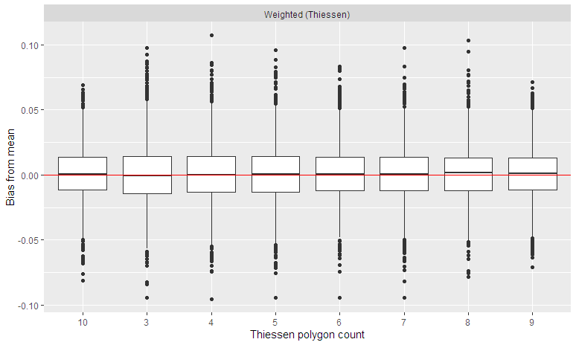

## Confidence intervals

The confidence intervals are of consistent magnitude although they are very slightly larger than the unweighted or weight category approaches’. Note that there is no randomness to the unweighted or weight category approaches and therefore no change in either approach’s results with Thiessen polygon count.

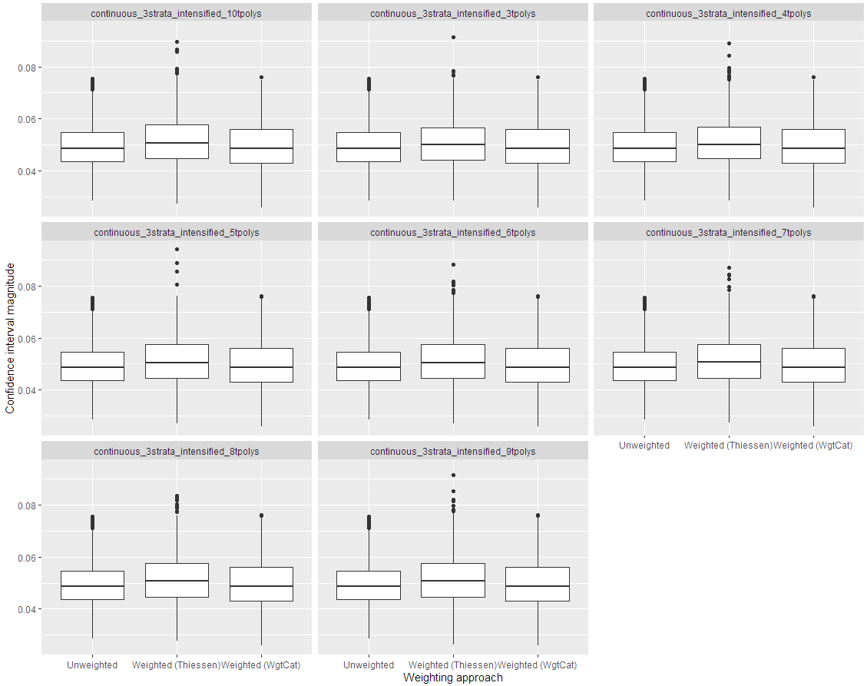

## Coverage

The lowest alpha for which coverage meets the expected proportion of 1 – alpha for *any* weighting approach is 0.15. This plot shows the proportion of simulations in which the confidence interval overlapped the true value with the red line showing the expected proportion. Note that there is no randomness to the unweighted or weight category approaches and therefore no change in either approach’s results with Thiessen polygon count.

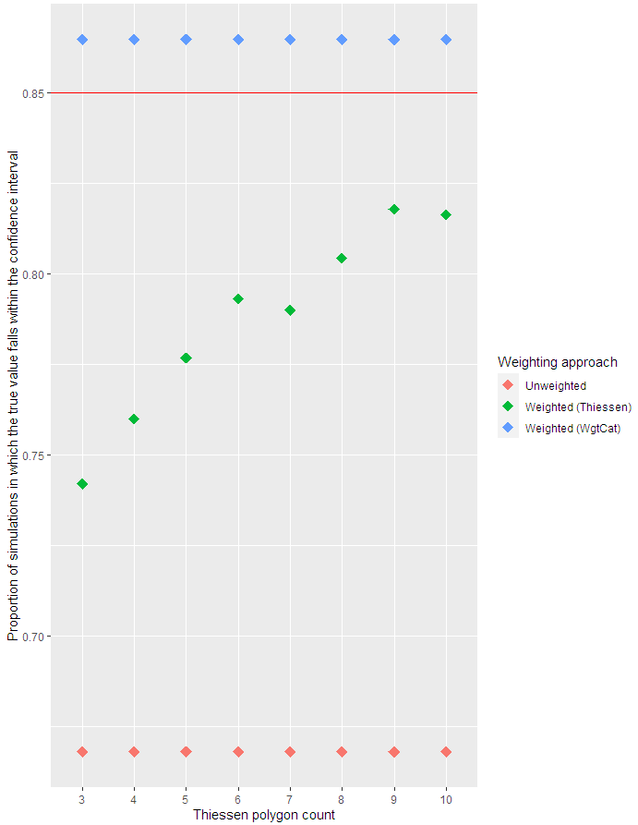

## Tolerance threshold

Calculating the proportion of the results which are within a tolerance (5% or 10% of the true value) as a measure of accuracy shows weight categories outperforming Thiessen polygons outperforming an unweighted approach. Accuracy increased as the number of Thiessen polygons increased. Note that there is no randomness to the unweighted or weight category approaches and therefore no change in either approach’s results with Thiessen polygon count.

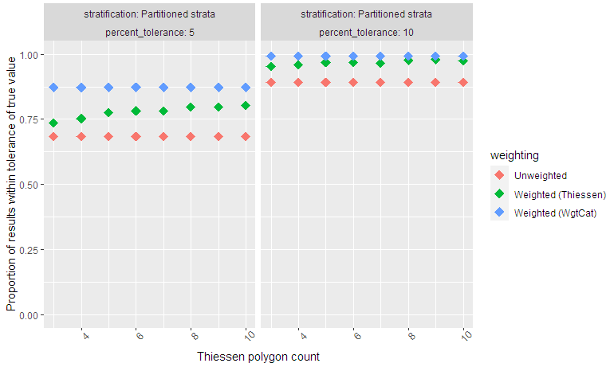

## Wilcoxon ranked sign test

The majority of results for weighting with weight categories have a p value > 0.05 for a paired WRS test, indicating that that majority of results cannot be distinguished from the true values. This is true for the minority of results using Thiessen polygon weighting and none of the unweighted results.

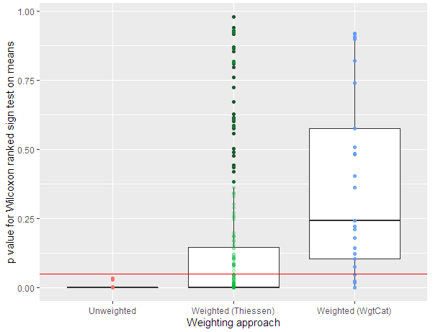

# Continuous landscape, 3 strata partitioning variability; allocation to strata proportional by area

## Bias

Bias does not appear to vary greatly across Thiessen polygon counts and doesn’t obviously over- or underestimate the mean consistently.

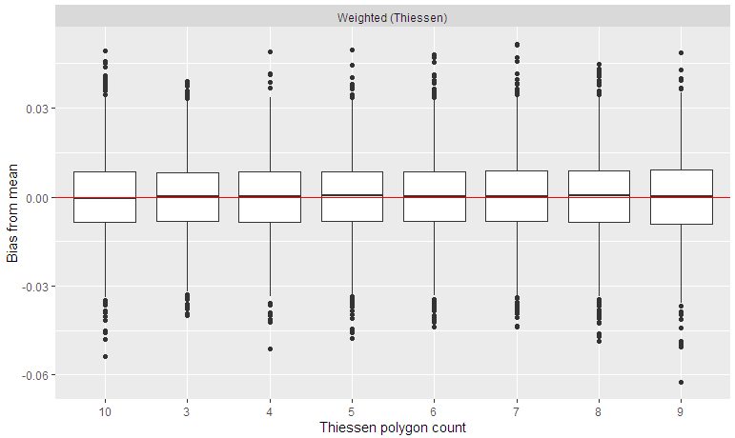

## Confidence intervals

The confidence intervals are of consistent magnitude although they are *very* slightly larger than the weight category approach’s. Note that there is no randomness to the unweighted or weight category approaches and therefore no change in either approach’s results with Thiessen polygon count.

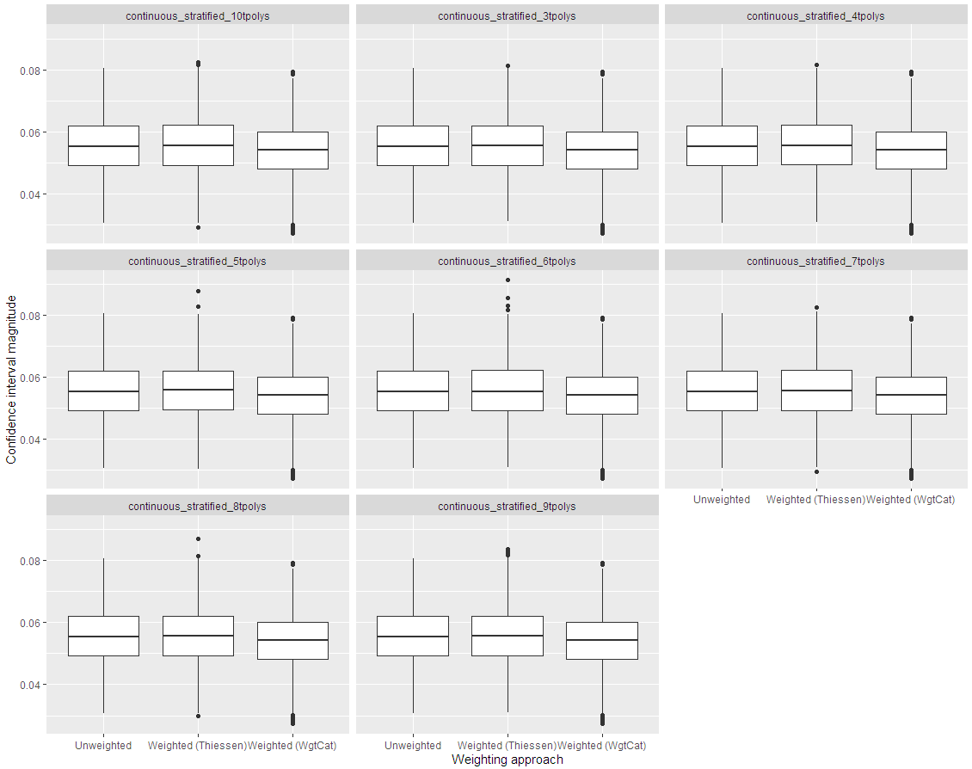

## Coverage

All weighting approaches show near total coverage for alpha values at least as small as 0.05.. This plot shows the proportion of simulations in which the confidence interval overlapped the true value with the red line showing the expected proportion. Thiessen polygon performance drops as the number of polygons increases. Note that there is no randomness to the unweighted or weight category approaches and therefore no change in either approach’s results with Thiessen polygon count.

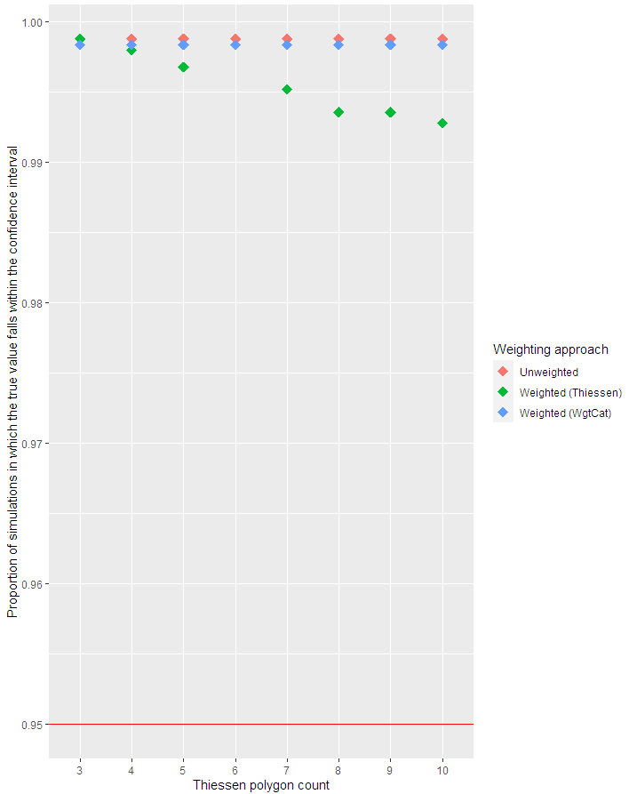

## Tolerance threshold

Calculating the proportion of the results which are within a tolerance (5% or 10% of the true value) as a measure of accuracy shows both weight categories and an unweighted approach outperforming Thiessen polygons. Accuracy decreased as the number of Thiessen polygons increased. Note that there is no randomness to the unweighted or weight category approaches and therefore no change in either approach’s results with Thiessen polygon count.

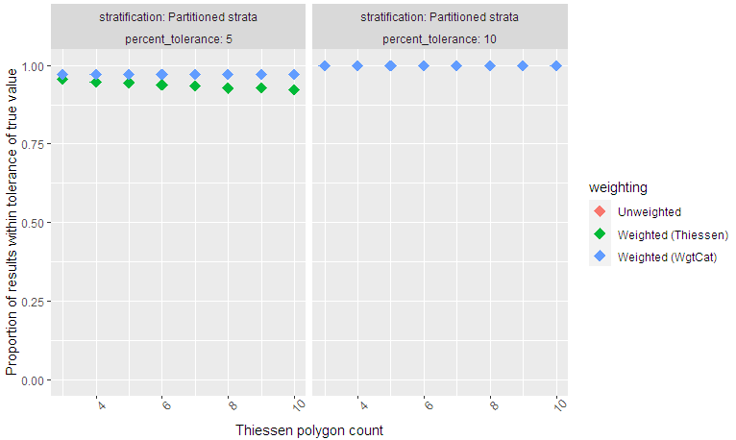

## Wilcoxon ranked sign test

The majority of results for all three approaches have a p value > 0.05 for a paired WRS test, indicating that that majority of results cannot be distinguished from the true values.

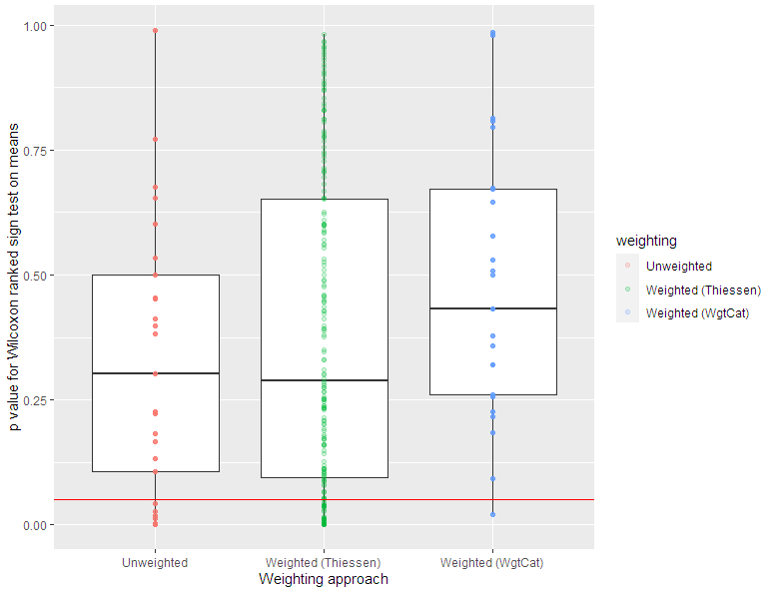

# Continuous landscape, 3 strata partitioning variability; random allocation to strata

NOTE: Due to the time it takes to solve Thiessen polygons, only counts 3 through 9 were completed when these figures were made.

## Bias

Bias does not appear to vary greatly across Thiessen polygon counts and very slightly overestimates the mean consistently, albeit with a longer tail of underestimates.

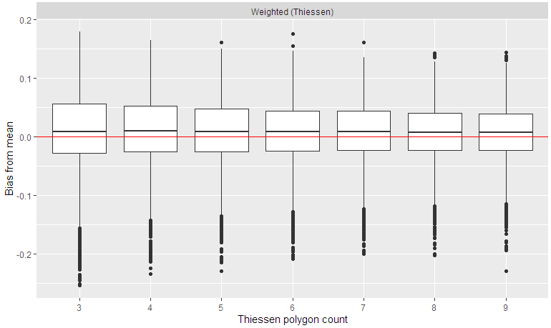

## Confidence intervals

The confidence intervals are of consistent magnitude although they are slightly larger than the weight category approach’s. Note that there is no randomness to the unweighted or weight category approaches and therefore no change in either approach’s results with Thiessen polygon count.

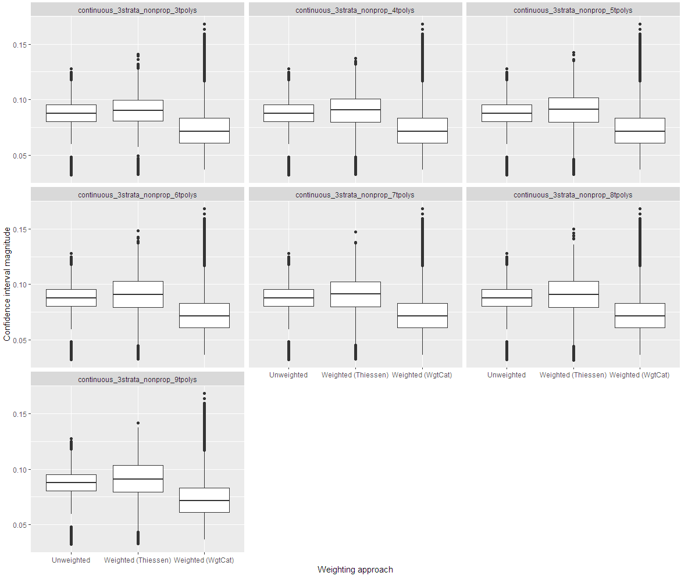

## Coverage

The lowest alpha for which coverage meets the expected proportion of 1 – alpha for *any* weighting approach is 0.15. This plot shows the proportion of simulations in which the confidence interval overlapped the true value with the red line showing the expected proportion (alpha = 0.05). Note that there is no randomness to the unweighted or weight category approaches and therefore no change in either approach’s results with Thiessen polygon count.

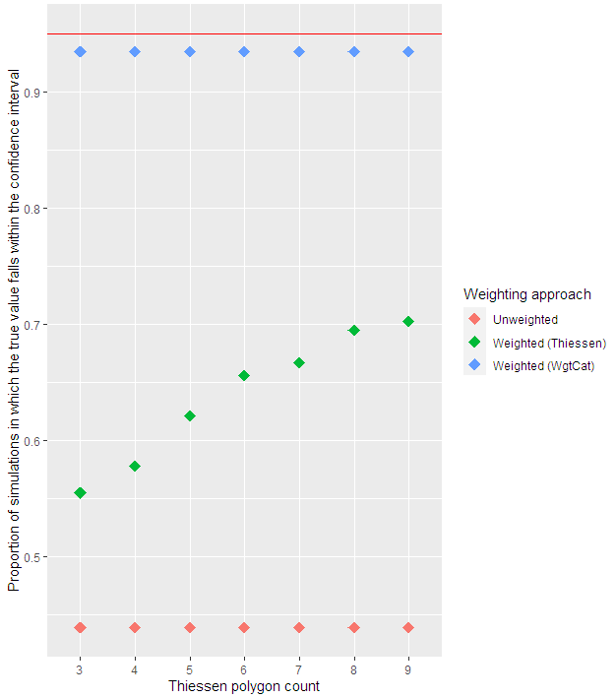

## Tolerance threshold

Calculating the proportion of the results which are within a tolerance (5% or 10% of the true value) as a measure of accuracy shows weight categories outperforming Thiessen polygons outperforming an unweighted approach. Accuracy increased as the number of Thiessen polygons increased. Note that there is no randomness to the unweighted or weight category approaches and therefore no change in either approach’s results with Thiessen polygon count.

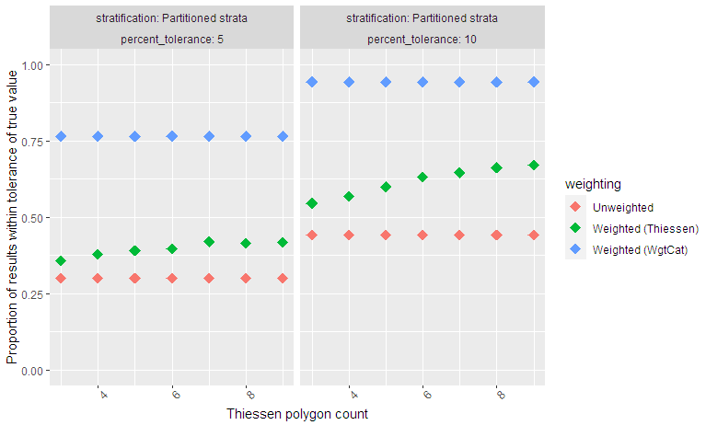

## Wilcoxon ranked sign test

Nearly all results for weighting with weight categories have a p value > 0.05 for a paired WRS test, indicating that that no results cannot be distinguished from the true values. This is true for a small the minority of results using Thiessen polygon weighting and none of the unweighted results.

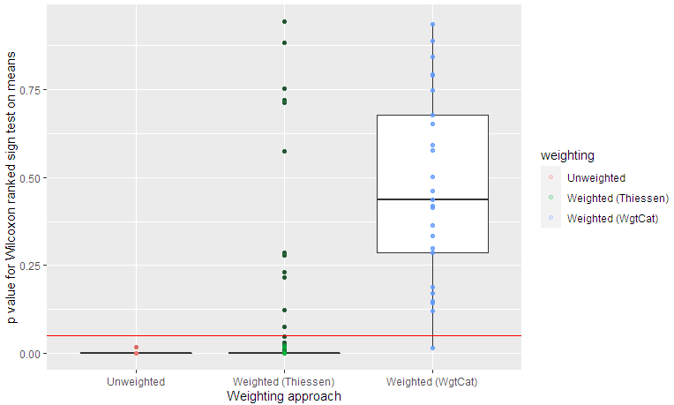

# Continuous landscape, 3 random strata; proportional allocation to strata

## Bias

Bias does not appear to vary greatly across Thiessen polygon counts and doesn’t obviously over- or underestimate the mean consistently.

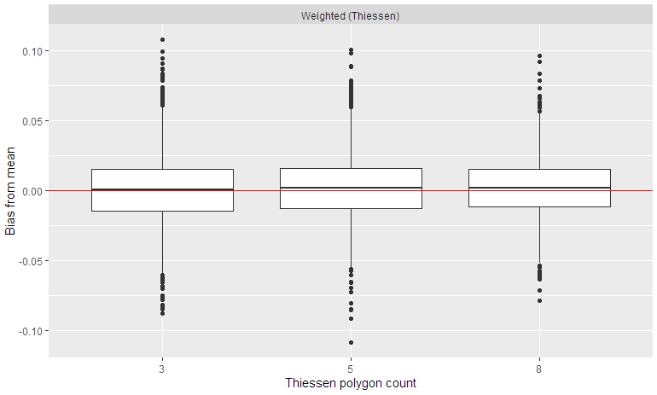

## Confidence intervals

The confidence intervals are of consistent magnitude. Interestingly, weight categories have the most extreme confidence interval ranges, likely due to the implicit assumption that strata have partitioned variability. Note that there is no randomness to the unweighted or weight category approaches and therefore no change in either approach’s results with Thiessen polygon count.

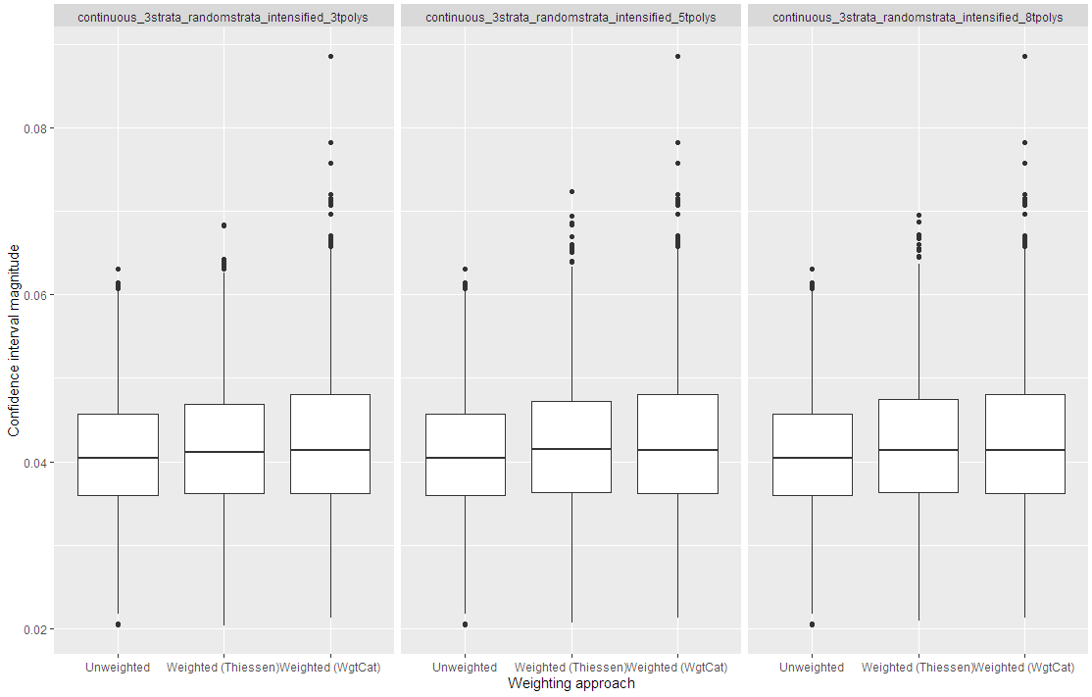

## Coverage

No weighting approaches show expected coverage for alpha values at ranging from 0.05 to 0.2. This plot shows the proportion of simulations in which the confidence interval overlapped the true value with the red line showing the expected proportion. Thiessen polygon performance improves as the number of polygons increases. Note that there is no randomness to the unweighted or weight category approaches and therefore no change in either approach’s results with Thiessen polygon count.

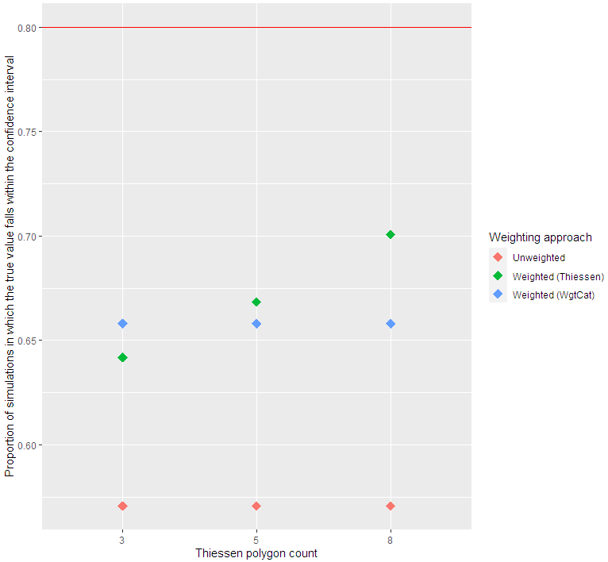

## Tolerance threshold

Calculating the proportion of the results which are within a tolerance (5% or 10% of the true value) as a measure of accuracy shows increasing Thiessen polygons as the highest-performing approach. Accuracy increased as the number of Thiessen polygons increased. Note that there is no randomness to the unweighted or weight category approaches and therefore no change in either approach’s results with Thiessen polygon count.

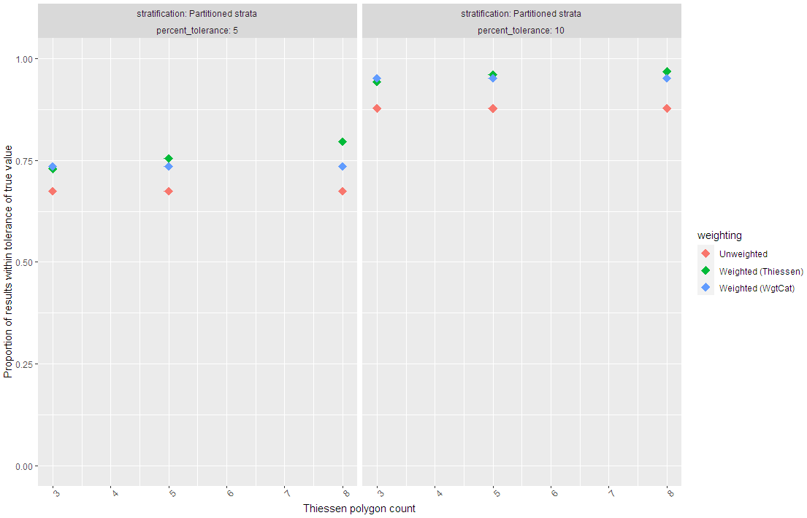

## Wilcoxon ranked sign test

All results for weighting with weight categories have a p value > 0.05 for a paired WRS test, indicating that that no results cannot be distinguished from the true values. This is true for a small the minority of results using Thiessen polygon weighting and three of the unweighted results.

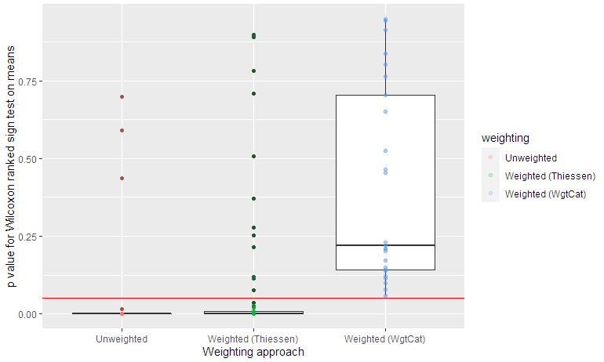

# Continuous landscape, 3 random strata; nonproportional allocation to strata; intensified

NOTE: There appear to be issues with the simulation runs with fewer than 6 Thiessen polygons

## Bias

Bias does not appear to vary greatly across Thiessen polygon counts and slightly underestimates the mean consistently, although that effect diminishes with increased Thiessen polygon counts.

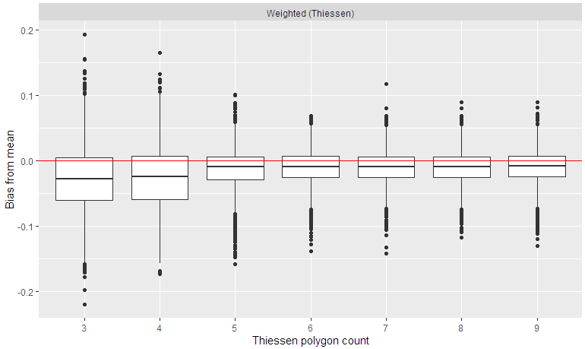

## Confidence intervals

The confidence intervals are of consistent magnitude. Note that there is no randomness to the unweighted or weight category approaches and therefore SHOULD BE NO CHANGE in either approach’s results with Thiessen polygon count. The simulations will need to be rerun for Thiessen polygon counts below 6.

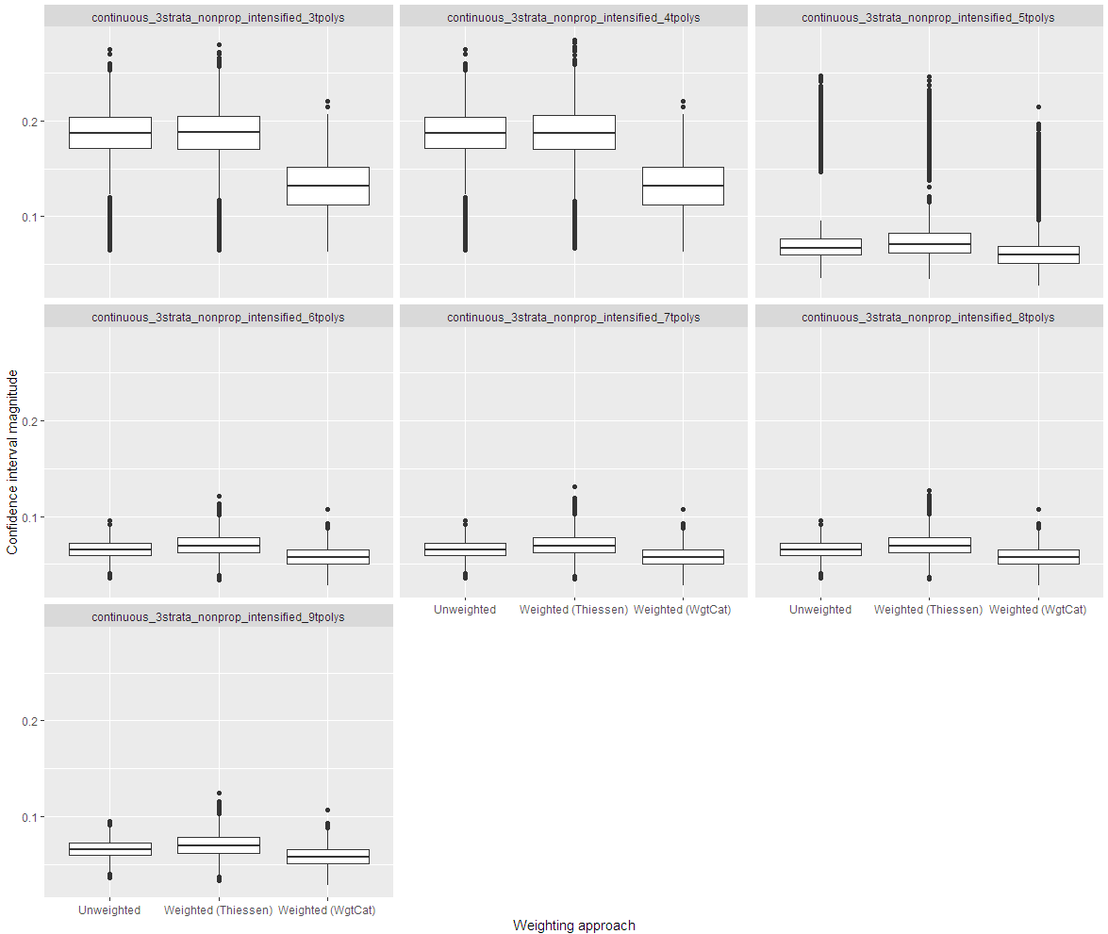

## Coverage

This plot shows the proportion of simulations in which the confidence interval overlapped the true value with the red line showing the expected proportion. Thiessen polygon performance improves as the number of polygons increases, but not entirely consistently. Note that there is no randomness to the unweighted or weight category approaches and therefore SHOULD BE NO CHANGE in either approach’s results with Thiessen polygon count. Simulations will need to be rerun for Thiessen polygon counts below 6.

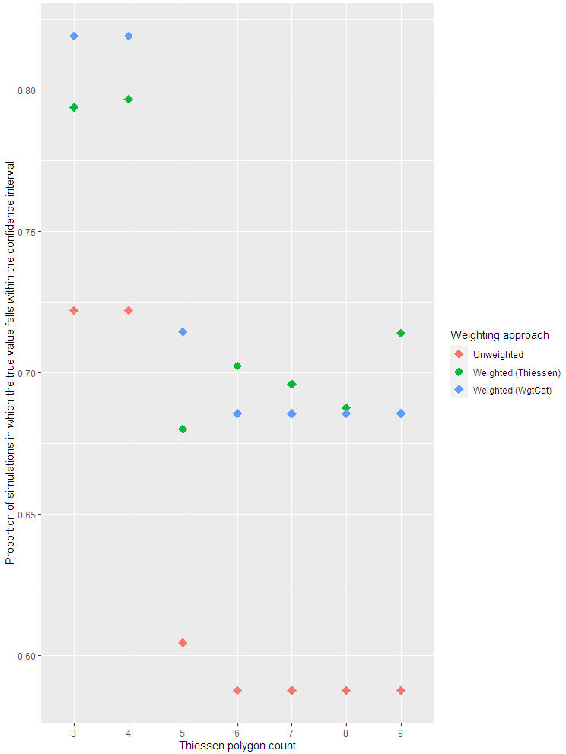

## Tolerance threshold

Calculating the proportion of the results which are within a tolerance (5% or 10% of the true value) as a measure of accuracy shows increasing Thiessen polygons as the highest-performing approach. Accuracy does not vary dramatically with Thiessen polygon count. Note that there is no randomness to the unweighted or weight category approaches and therefore no change in either approach’s results with Thiessen polygon count. Simulations will need to be rerun for Thiessen polygon counts below 6.

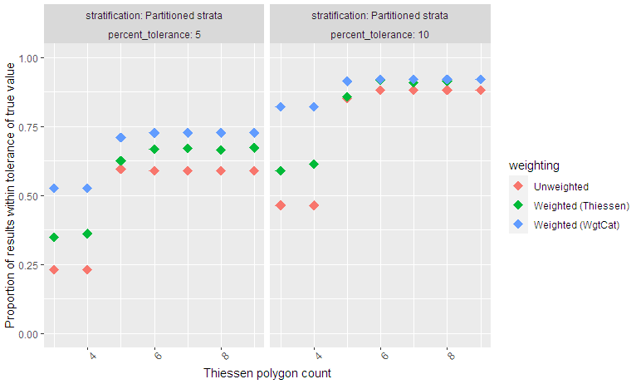

## Wilcoxon ranked sign test

Nearly all results for weighting with weight categories have a p value > 0.05 for a paired WRS test, indicating that that few results cannot be distinguished from the true values. This is true for a small the minority of results using Thiessen polygon weighting and three of the unweighted results.

