Data:

# Overview:

In order to test the accuracy of this algoritm, 3 different sets of data were taken, with points identified as corners marked in blue.

Note that the corners identified on the first and last points in each scan are invalid. This is an artifact of the algorithm requring a point directly before and after in the array, and can be resolved by checking if the first or last point is used and using the data from array position 360 instead of 0 and 1 instead of 361. This problem will be fixed for future usage, but for now these points should be ingored.

# Measurements:

The three scans taken are shown in figures 1-3. The LIDAR was placed into the approximate center of the environment at a semi-random angle. The curvature of the sides of the scan is due to the natural flex in the material used to make it. Each scan is an array of 360 different clusters of values constituting a point on the plot and consisting of the raw data from the sensor indicating the location of that point (magnitude in mm and phase in degrees), as well as the calculated angle between that point and its adjecent points, and a boolean identifying whether or not this angle is a corner. Points identified as corners are also hilighted blue on the scans. These figures show the box which the Lidar was placed in. Figure 4 shows two different examples of clusters of data.

Figure 1: A scan taken, with an unexplained gap in the bottom of the environment.

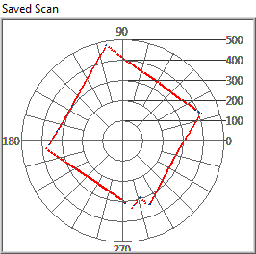

Figure 2: Scan taken in a non-square environmet.

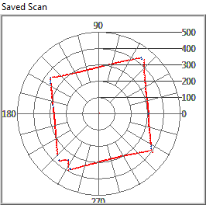

Figure 3: Scan taken with a large gap in the corner.

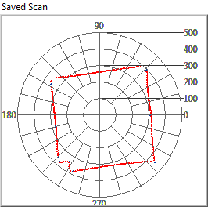

Figure 4: Two different sets of data, one identified as a corner.

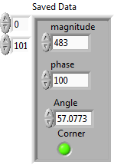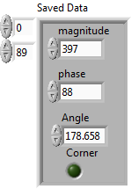

# Calcualted Data:

In order to test the robustness of this method, the number of corners that were detected that were not part of actual corners (corners detected – actual number of corners (6)) will be compared to the number of points taken by the scan to calucate the regularity of false positives. Figure 5 shows an annotated list of all of the points in Figure 1.

Figure 5: Corners identified in Figure 1

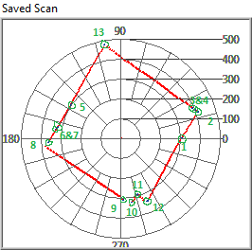

1. This point is invalid, as discussed earlier in the section, and will be subtracted from the total number of detected points.
2. Valid corner.
3. Invalid corner, created by a gap between 3&4.
4. Invalid corner, created by a gap between 3&4
5. Invalid corner, created due to unknown circumstances
6. Invalid corner, created by a gap between 6&7
7. Invalid corner, created by a gap between 6&7
8. Valid corner, although not the center point of the corner. This will be investigated
9. Valid corner, in conjunction with 10
10. Valid corner, in conjuction with 9
11. Valid corner
12. Valid corner
13. Valid corner

Table 1: Number of Corners Detected

|  |  |  |
| --- | --- | --- |
| Scan | Corners | False Positives Rate |
| 1 | 12 | 1.67% |
| 2 | 13 | 1.94% |
| 3 | 9 | 0.833% |

In all three scans, there are examples of invalid corners which were created on the sides of the environment. The exact cause of this is unknown, and needs further investigation.