Methods:

Overview:

A 360 degree two-dimensional LIDAR range finder will be mounted on a robot, and used to generate a coordinate grid of objects in the environment. The robot will scan its surroundings, and save a scan as a set of coordinates. These coordinates will be analyzed in order to determine key points in their environment based on the angle of secant lines between points and the distance between points. Scans taken at different times will be overlain on top of each other, and the key points will be aligned with each other, creating the lowest possible average distance between key points.

Phase zero of testing the sensor involves the sensor being placed in a large cardboard box (Illustration 1). The accuracy of scans will be measured based on any change in successive scans with the system stationary. For phase 1, a hole will then be cut into the box, creating an edge in the environment, and two scans will be taken at different positions. These scans will be compared to each other and used to determine the position of the sensor, then tested for accuracy against measurements using a ruler.

Phase two of testing involves the full assembly of the robot and sensor to be placed in a hallway (Illustration 2). The robot will move 10 meters down the hallway at 1 m/s, and take a scan every second. The start and end locations of the robot will be recorded using a tape measure. The scans will again be compared to each other to calculate an initial and final position for the robot. The calculated values will be compared to the actual values and used to determine the final accuracy of the system.
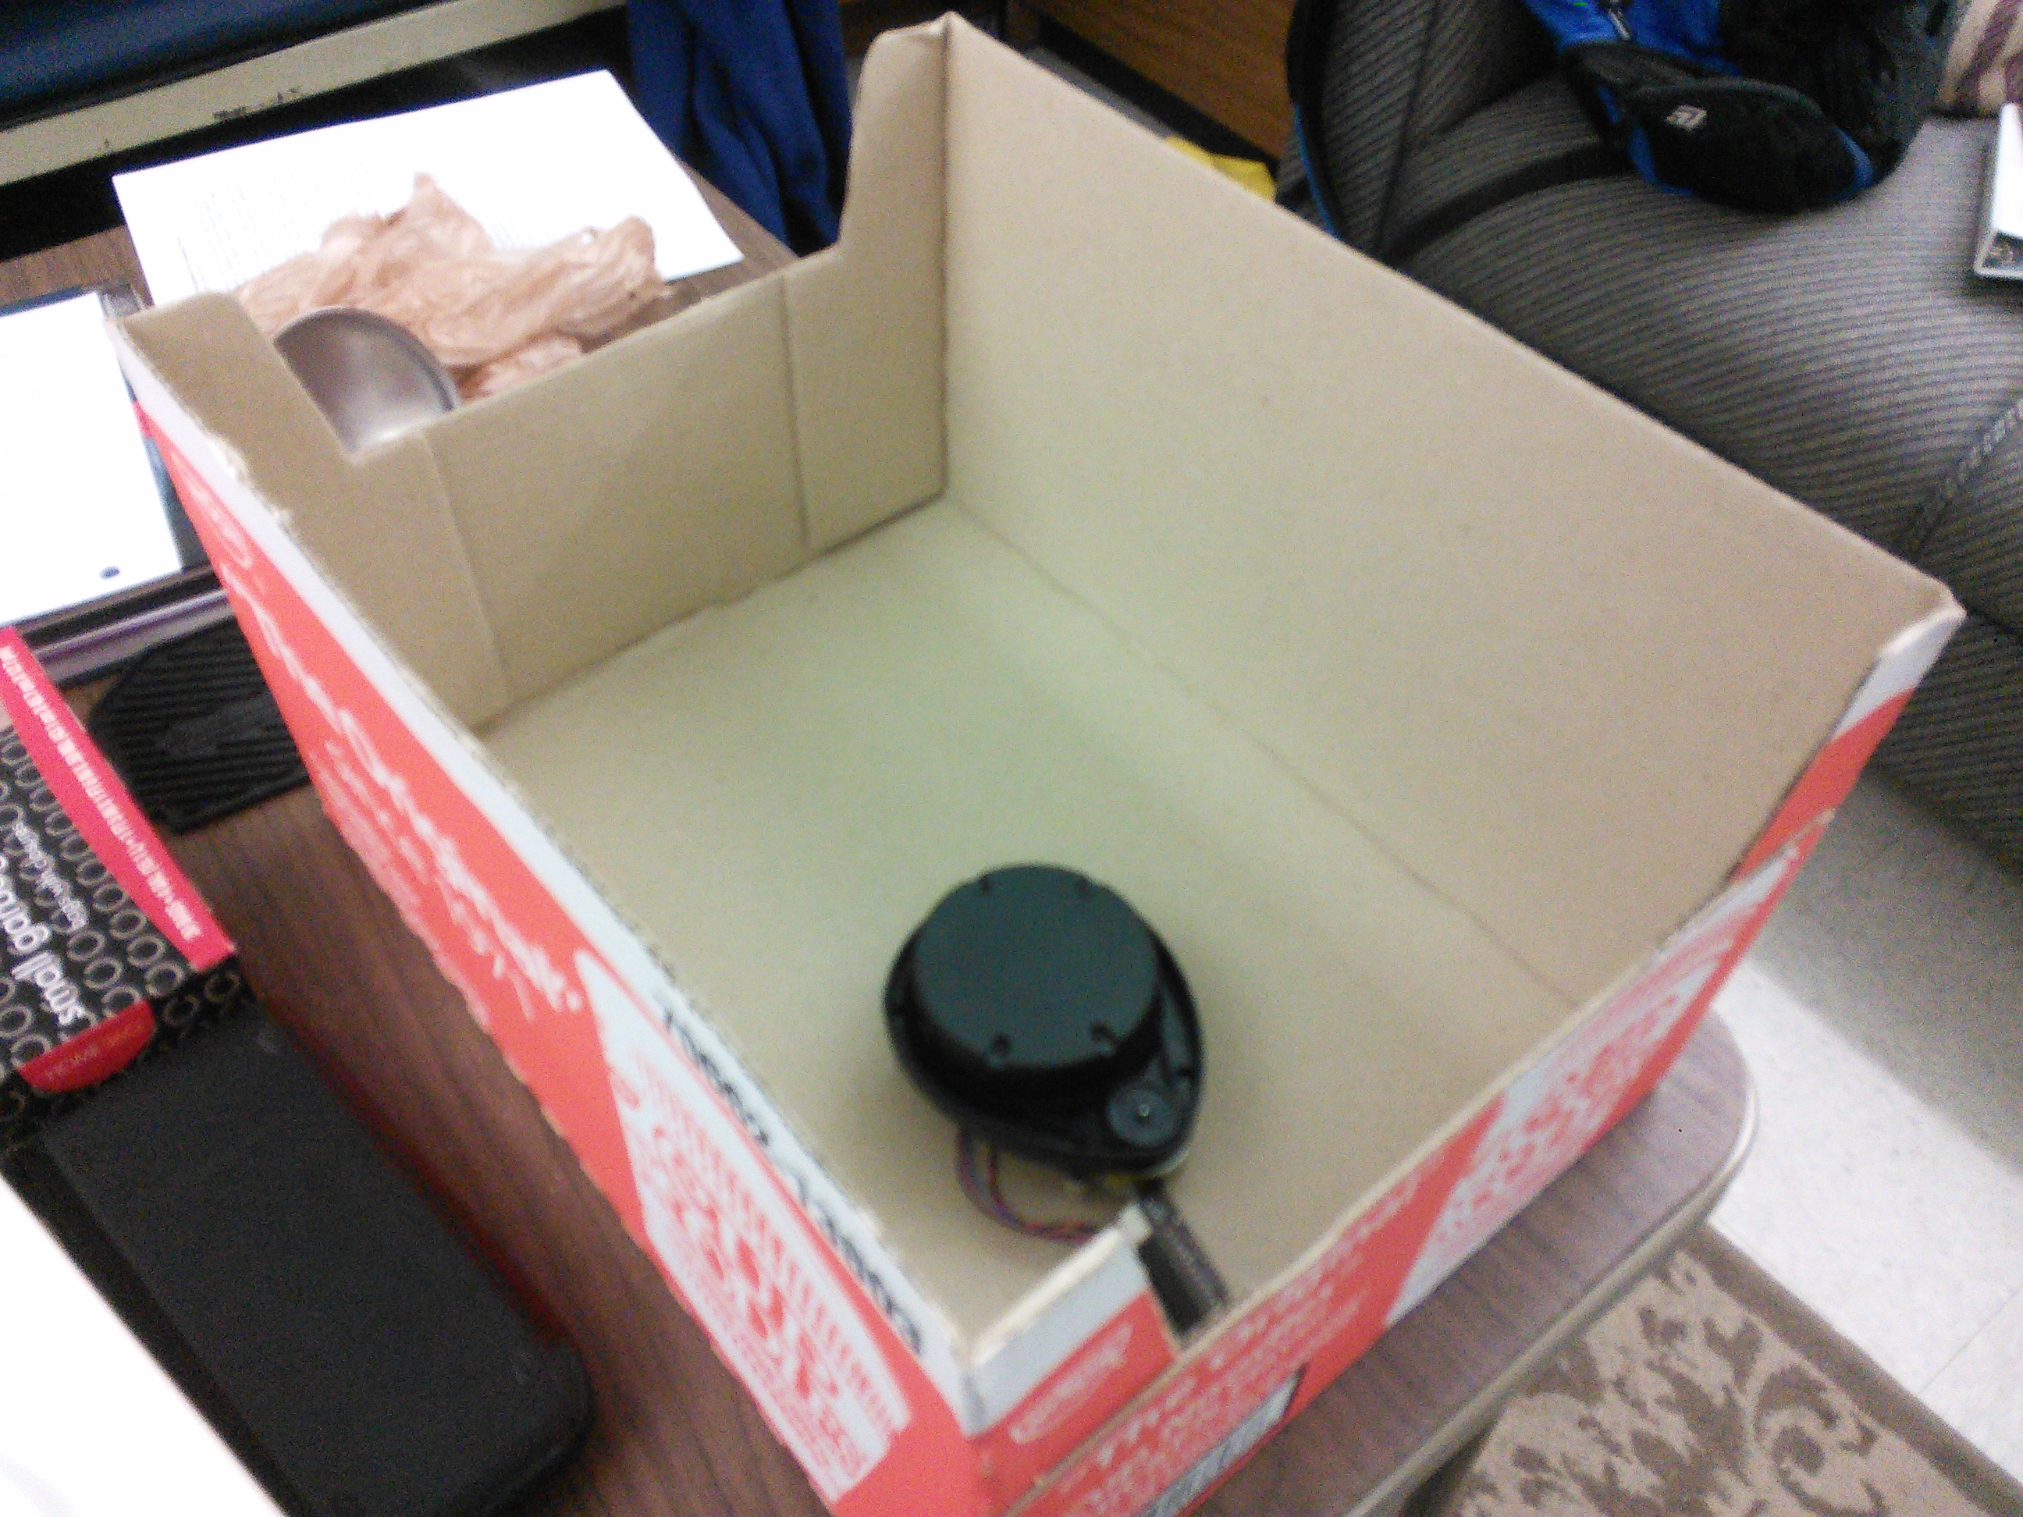Illustration 1: LIDAR in a Box

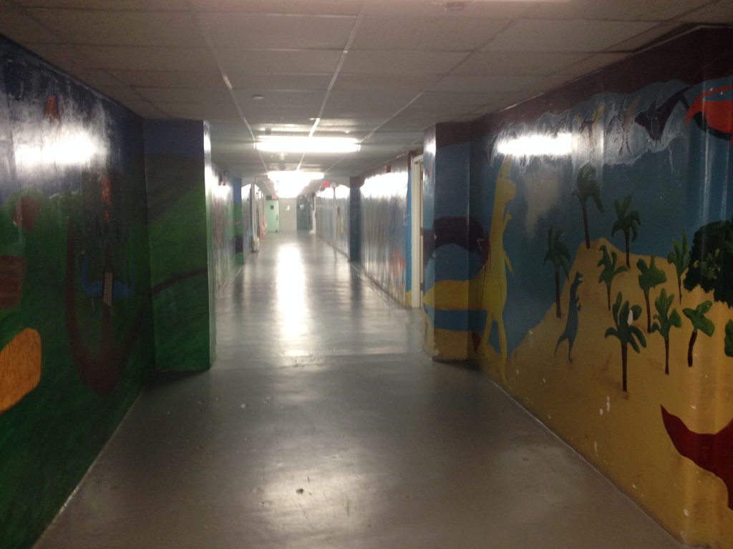Illustration 2: Ground Reynolds Breezeway

Measurements:

The robot will scan its surroundings, and save a scan as a set of coordinates. These coordinates will be analyzed in order to determine key points in their environment based on the angle of secant lines between points and the distance between points. Scans taken at different times will be overlain on top of each other, and the key points will be aligned with each other, creating the lowest possible average distance between key points.

Two different types of key points will be identified, corners and edges. Edges will be measured by distance to surrounding points. If the distance between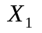and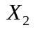is greater than .1 Meters. Corners are defined as places where the angle created by 3 consecutive points is significantly greater (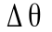> 10 degrees) than the angle created by surrounding 3 point sets. One point () is defined as the origin, with two vectors originating at that point and going through the other two points. According the dot product rule, 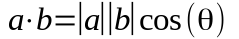. Thus:

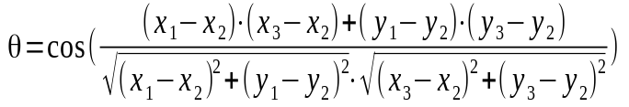

Overlain scans will be rotated and shifted such that the average distance between key points is lowest. Key points identified as edges are interchangeable with corners, but in order for two corners to be considered the same they must have the same value for 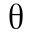.

The accuracy of this system will be given by an average percent difference between the actual position measured with a measuring tape and the derived final position of the robot. The expected percent error is within 10%.

Experimental Design:

Tests will be repeated 5 times to get the most data. Conditions will not vary in phase two, but in phases zero and one the starting position of the sensor will be varied in order to calibrate the sensor.

Experimental Procedure:

Phase 0:
- The sensor will be placed in the cardboard box.
- Multiple scans will be recorded
- The change in each of the scans will be compared to determine the accuract of the sensor
Phase 1:
- The sensor will be placed in the cardboard box with the hole in it.
- The position will be recorded
- A scan will be recorded
- The sensor will be moved and the new position recorded.
- A second scan will be recorded
- The change in position will be calculated and compared against the actual change in position.
Phase 2:
- The robot will be placed in the hallway.
- The position of the robot will be recorded.
- The robot will move 10 meters, taking a reading every meter.
- The final position of the robot will be recorded.
- The scans will be processed to calculate the final position of the robot
- The final position will be calculated and compared against the actual change in position.

