Traditional Four Part Vocal Harmony

Notes by V. Lakeman

Scale Degree Names – Major and Harmonic Minor scales.

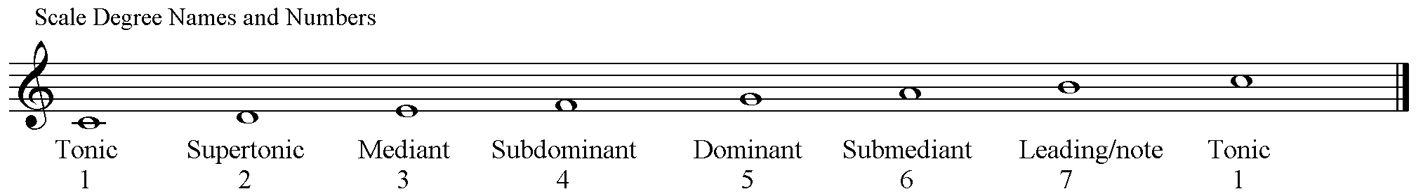

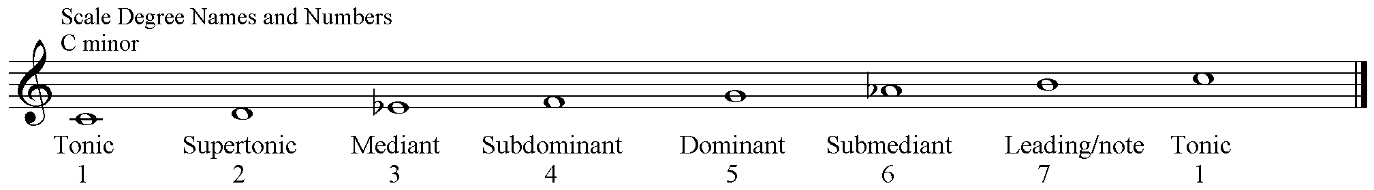

Chords
Chords may be built on every degree (or pitch/note) from the scale.
All of the following chords are written in close position – the notes are as close as possible – and in root position – the lowest note is the note the chord is built upon.

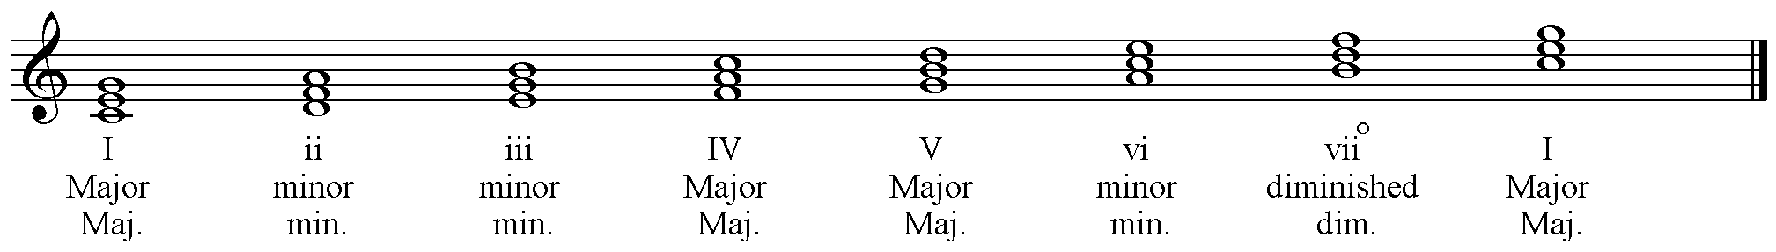

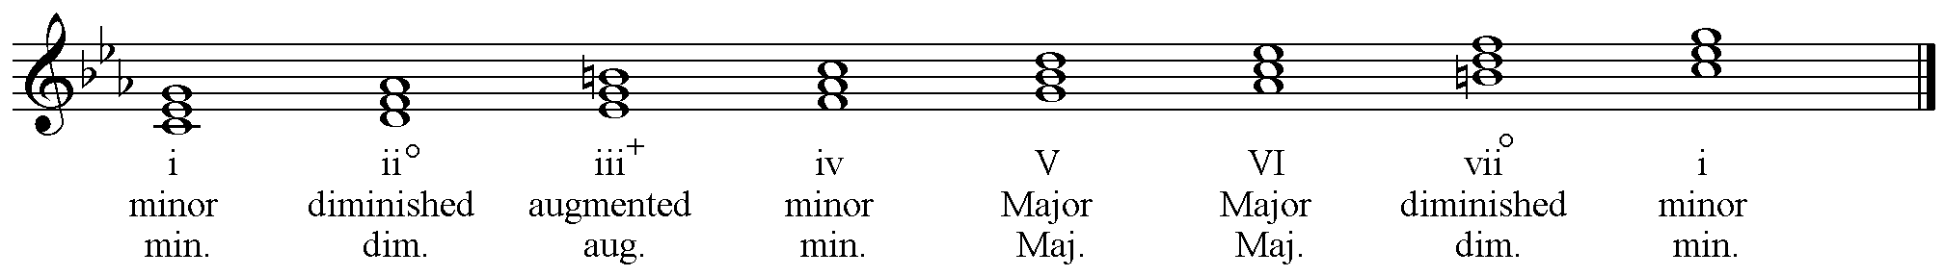

Notice that all notes belong to the respective scales. Check the intervals that make each type of chord.

Triad Type | Root – 3rd | 3rd – 5th | Root – 5th | Abbreviation
Major | Major 3rd | Minor 3rd | Perfect 5th | Maj.
Minor | Minor 3rd | Major 3rd | Perfect 5th | Min.
Diminished | Minor 3rd | Minor 3rd | Diminished 5th | Dim. OR o
Augmented | Major 3rd | Major 3rd | Augmented 5th | Aug. OR +

The following chords are written in close position and in 1st Inversion indicated by the ‘b’. Each chord could also be indicated by the numbers
6
3

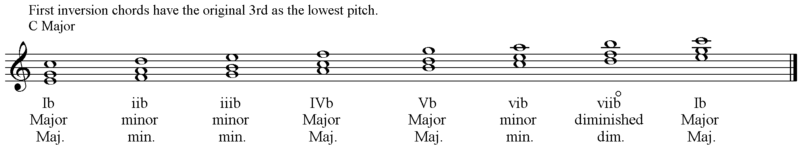

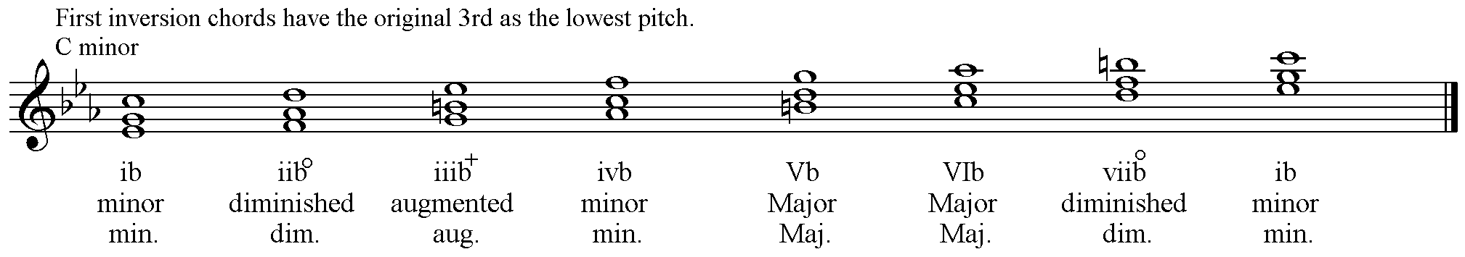

What Inversion to use and what note to double?

Chords are generally used in either root position or first inversion. Second inversion chords can only be used under certain conditions. These will be discussed later.

For four part vocal harmony four notes are required. This means that one note must be doubled in each chord.

The choice of inversion and the note to double is determined by the type of chord.

Diminished triads should only be used in First Inversion with the original 3rd of the Root position chord – now the lowest pitch – doubled.

Augmented triads should not be used.

Major triads can be used in Root position and 1st Inversion freely. Either the original Root or 5th may be doubled in Root position chords. For 1st Inversion chords the same pitches may be doubled.
Take care of doubling the 3rd of a Major triad. It is better not to double the 3rd of a Major triad except the 3rd in chord VI, which is the Tonic of the key and may be doubled.
NEVER double the leading note of the key. (The 3rd of the Dominant chord.)

Minor triads can be used in Root position and 1st Inversion freely. Either the original Root, 3rd or 5th may be doubled in Root position chords. For 1st Inversion chords the same pitches may be doubled.

Vocal Ranges

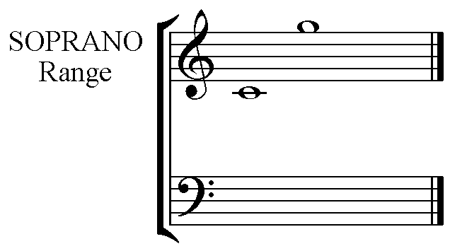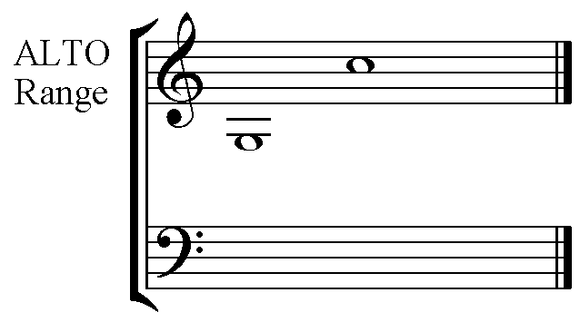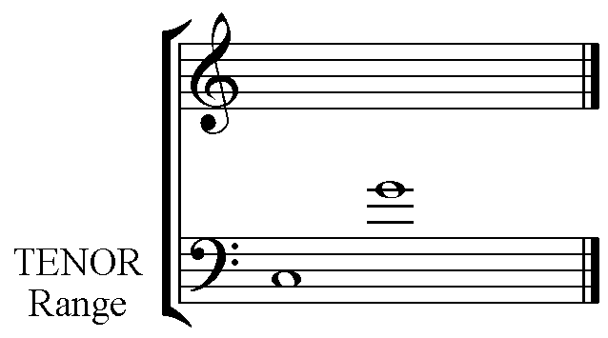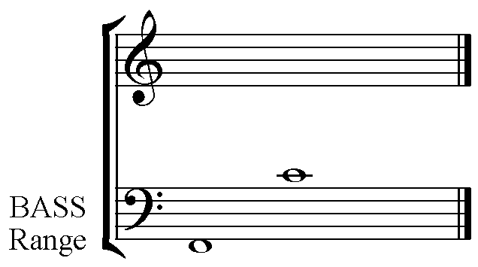

The ranges given here are approximate for particular voice types, however for choral writing they are considered absolute.

Soprano C to G Alto G to C
Tenor C to G Bass F to C

Note the similarity of pitches between the high female and male voices - Soprano and Tenor - and the low female and male voices - Alto and Bass. Notice that the Bass voice is considered to be able to produce one pitch lower than the ‘pattern G to C’.

Chord Voicing

There are many ways to voice a chord. The pitches of the triad do not need to be assigned in close position nor in pitch order.

Generally the largest interval is found between the Bass and Tenor pitches.
High Soprano pitches need support from the other parts with notes that are high in either /or both the Alto & Tenor ranges.
Do not exceed an octave between Tenor and Alto, OR Alto and Soprano. Keeping the Tenor part high in the range will usually be most effective.

Note the stem directions for each part when writing 4 part Vocal Harmony on two staves:-

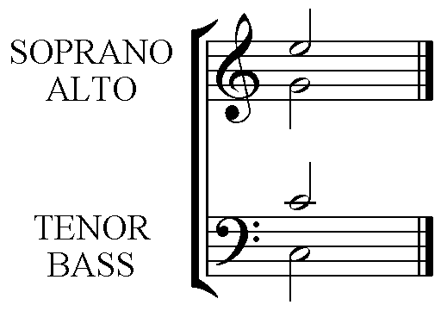

Stems up for Soprano and Tenor, and Stems down for Alto and Bass.

Smooth Voice Leading

When writing successive chords in 4 Part Vocal style always aim to move each of Soprano, Alto and Tenor part smoothly to the note in the next chord. The Bass part will leap if chords in Root position are generally used. The only exception to this comes when successive 1st Inversion chords are used. See Parallel 1st Inversion Sequences below. Always avoid awkward leaps, crossing and overlapping parts.

Cadences
Cadences are musical punctuation.
There are two Cadence types that act as Full Stops in music. The Perfect Cadence (Generally V to I) and the Plagal Cadence (IV to I) or Amen.
The second type of Cadence acts as Musical commas:- Imperfect and Interrupted. These will be explained fully below.

The following is a Perfect Cadence in C Major. Note that the Soprano has the common note to each chord, the Alto and Tenor move smoothly by step and the Bass leaps to the root note of the new chord. The accent pattern is always weak to strong.

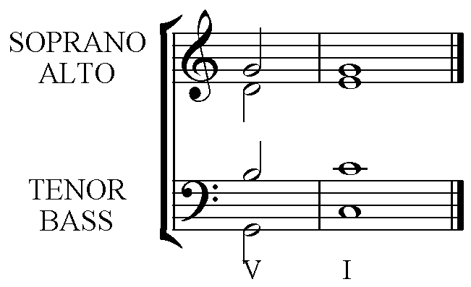

5 1 The top three can be in any upper part. The lines
2 5 indicate smooth voice leading. Note that the
7 3 Leading note rises to the Tonic.

5 1 The Bass has the root notes of the chords in Cadences.
Chords V I

The alternative Voice leading for a Perfect Cadence, used only when the melody notes are:- 2 to 1.
Notice that the Tonic has been used three times and that there is a leap from note 5 in the Alto in chord V to the third of the Tonic chord. The 3rd of the chord is required to define the chord as Major or minor, and must not be omitted.
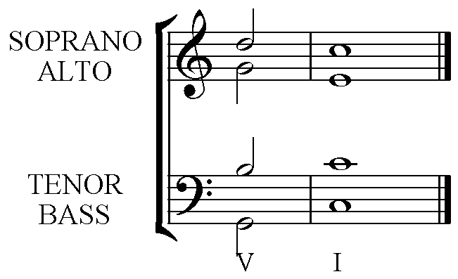
5 1 The top three can be in any upper part. The lines
2 3 indicate smooth voice leading. Note that the
7 1 Leading note rises to the Tonic and the 5th has been
omitted in the Tonic chord.
5 1 The Bass has the root notes of the chords in Cadences.
Chords V I
Plagal Cadence

Frequently used as the ‘Amen’ after a Perfect Cadence. The chords in this cadence should also be accented weak to strong.
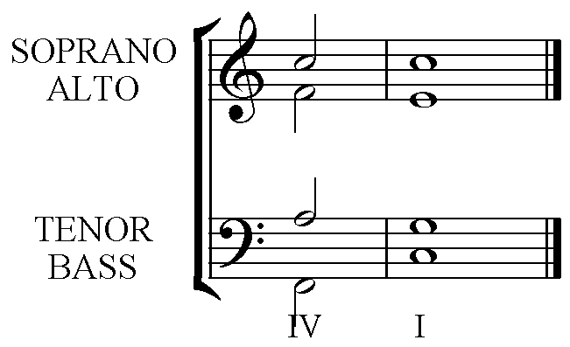

4 1 The top three can be in any upper part. The lines
1 5 indicate smooth voice leading.
6 3

4 1 The Bass has the root notes of the chords in Cadences.
Chords IV I

Imperfect Cadences

These are intermediate phrase endings that always sound unfinished.
There are several chord combinations that give this effect. In each, chord V is the second/final chord. Note the dashed bar line, indicating that the cadence chords can either be weak to strong, or strong to weak.

I – V
This cadence should follow the pattern of a Perfect Cadence in reverse.
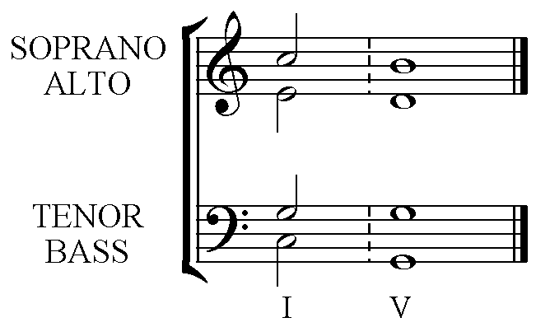

ii – V
This cadence should follow the pattern of a Perfect Cadence in the Dominant key.

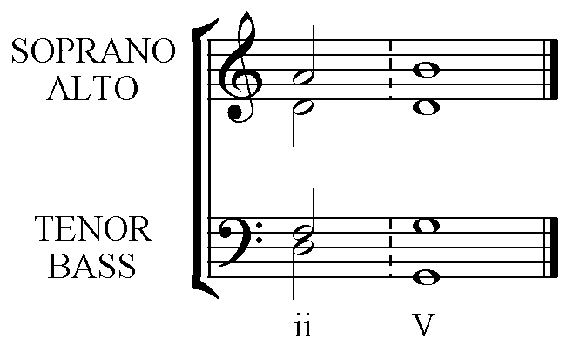

IV – V
The chords in this cadence have their root notes side by side in the scale. This presents some problems, in particular the possible parallel 5^{ths} or octaves. The problems can be avoided by completing the cadence with:-
All upper parts moving in contrary motion to the Bass.

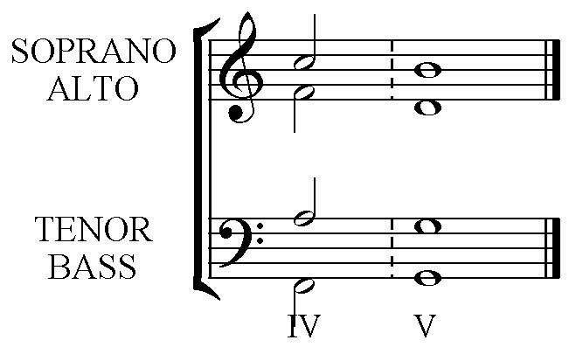
The Soprano, Alto and Tenor lines descend, this is in contrary motion to the ascending Bass pitches.

vi – V
The chords in this cadence also have their root notes side by side in the scale, presenting the same problem of possible parallel 5^{ths} or octaves, AND in the case of the cadence in the minor key:- the possibility of an Augmented 2nd between the two notes in one of the upper voices. The problems can be avoided in both Major and minor keys with:-
Double the 3rd in chord vi (the Tonic of the key) and moving from the doubled 3rd by step in contrary motion.

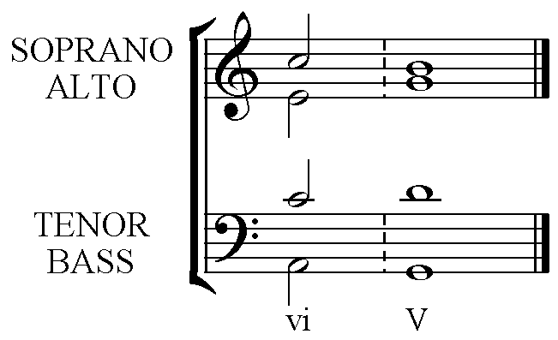
C, the 3rd in chord vi, is doubled with the Soprano C moving down to B and the Tenor C moving up to D for chord V.

The Interrupted Cadence

V – vi
This cadence is completed in the same manner as the vi – V but in reverse. It sounds almost as though the cadence will be a Perfect Cadence as it begins on chord V (the Dominant). The listener is expecting the Tonic or chord I to follow, but hears chord vi the Tonic of the Relative minor scale. This sounds unfinished.
Double the 3rd in chord vi (the Tonic of the key) and moving to the doubled 3rd by step in contrary motion.

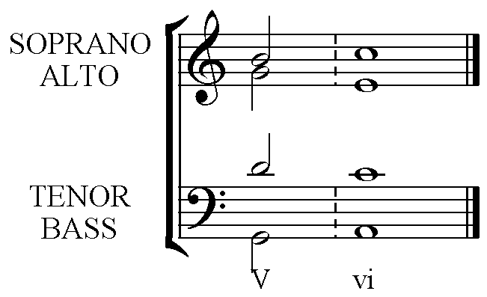

Parallel 5^{ths} and Octaves – Why the fuss?

Acoustics

Every musical sound is a mixture, in a particular pattern, of musical pitches. For almost all instruments the pattern is the same, however the relative loudness of each pitch is different allowing us to recognise the particular sounds of each instrument.
This pattern is:-

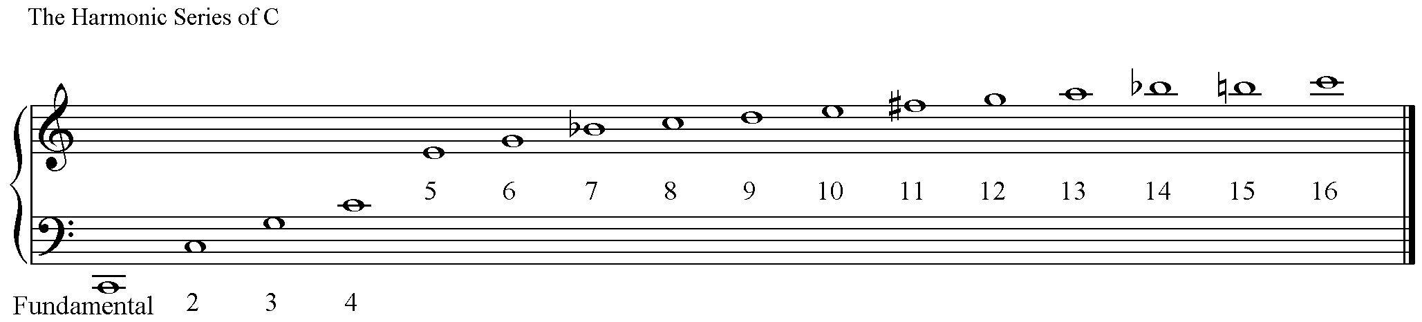

Notice:-

- The largest interval between successive pitches is a Perfect Octave between the fundamental and 2nd note in the series, (often called the 1st harmonic.)
- The interval between the 2nd and 3rd pitches is a Perfect 5th.
- That pitches 1, 2, 4, 8, & 16 are the note C. (In vibrations per second, measured in Hertz 1 = 64, 2 = 128, 4 = 256, 8 = 512, 16 = 1024.)
- Double the number of the harmonic or the number of vibrations per second and you have a pitch one Octave higher.
- The Bb’s, F# and B natural are all out of tune in our ‘equal temperament’ tuning system. (String players bow a 7th of the distance of the string away from the bridge to cancel this out of tune Bb, leaving a purer and more melodious sound/timbre.
- More harmonics are produced on some instruments. The next octave moves upwards by steps of approximate semitones.
- The higher harmonics are closer together in pitch.
- The relative volumes of each of these pitches creates the ‘timbre’ or instrumental/vocal tone colour.

Equal Temperament was first used in J.S. Bach’s day. It is a compromise system of tuning. It divides the octave into equal semitones, which the Harmonic Series does not. For the first time it was possible to play fixed pitched instruments, such as keyboard instruments, in all keys. Bach demonstrated this with his two sets of 24 Preludes and Fugues – one in each of the 12 Major and 12 minor keys.

What does this mean?

Perfect 5^{ths} and Perfect Octaves. To our ears these intervals, when sounded together, blend so ‘perfectly’ that the resulting sound seems like one single pitch with a slightly different timbre.

When two voices move in parallel Perfect 5^{ths} or Perfect Octaves the two voices for that moment sound like one voice. This reduces the harmony from a 4 Part sound to a 3 Part sound, reducing the texture to something that sounds just a bit empty.

Chord Voicing
The large intervals in the Harmonic Series are at the bottom. When voicing chords the largest interval between pitches should be at the bottom between the Bass and Tenor voices. It can be more than an octave.

Note that there is no 3rd of the C Major triad in the first octave of the Harmonic Series. Low 3rds sound very muddy and gruff to our ears. Avoid low 3^{rds} in your harmony. In general avoid 3^{rds} between Bass and Tenor if the Bass has a note lower than the G in the 4th space.

Pitches in the Harmonic Series become closer together the further up the series. In Chord Voicing the higher the pitch the closer the supporting pitches should seem either in the Alto or the Tenor part. A high tenor pitch can support a high soprano pitch just as effectively as an Alto part a 3rd lower than the Soprano even though the Tenor pitch is in a register an octave lower than the Soprano register.
Steps in Completing Cadences.

- Name the key and type of cadence and check the correct method for completing that particular cadence.

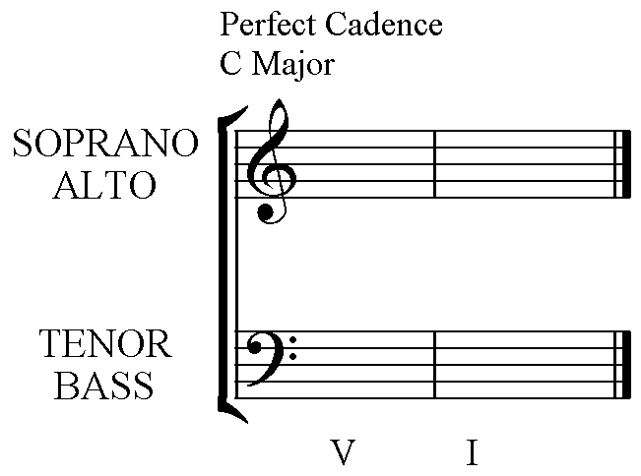

5 1 The top three can be in any upper part. The lines
2 5 indicate smooth voice leading. Note that the
7 3 Leading note rises to the Tonic.

5 1 The Bass has the root notes of the chords in Cadences.
Chords V I

- Write the letter names of the notes in each chord to be used.

G C
D G
B E

G C
Chords V I

- Put the root notes of each chord in the Bass part. These notes will be the lowest pitches in your completed cadence.

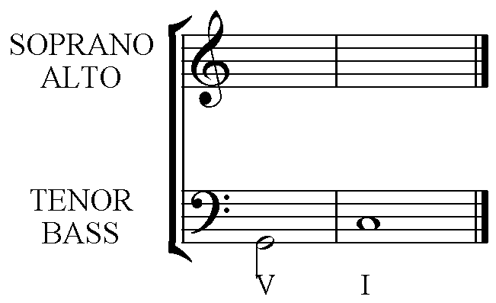

- Voice one of the chords completely. (It does not matter which one you choose.) Keep the largest interval between the Bass and Tenor, and keep the Tenor fairly high. The Alto and Soprano should be fairly close with both pitches higher than the Tenor note.

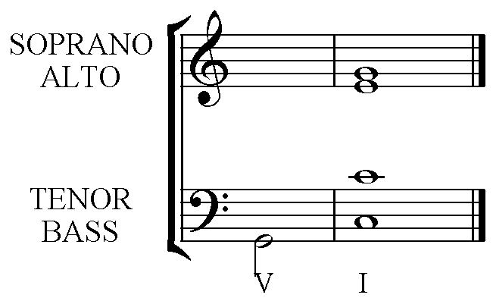

- Find the pitch that is common to each chord and put that pitch in the same voice in your second chord.

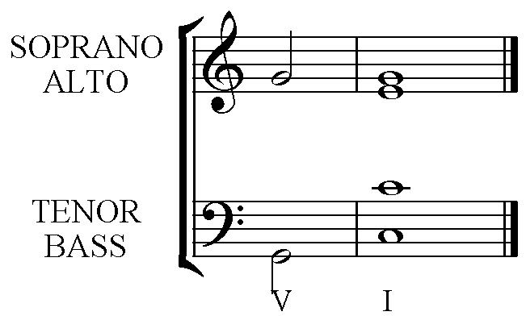

- Work out the best way to make each of the remaining two voices move smoothly by step then put these notes on the stave in your second chord.

- Check that each chord is spelt correctly. Especially check that you have raised the Leading note in Chord V of a minor key.

- Check that the order of pitches in each chord from lowest to highest is:- Bass, Tenor, Alto, Soprano. This avoids the error ‘Overlapping parts’.

- Check that you haven’t taken one voice below or above the pitch that another voice has just sung from the first chord to the next. This avoids the error of ‘Crossing Parts’. Pitching a note that is lower or higher than your neighbour has just sung is quite difficult to do accurately.

- If you have followed the pattern you should not need to check for Parallel Perfect 5^{ths} or Perfect Octaves that are an error.

- Check that your Soprano part moves by step to a note that makes a Perfect 5th or Perfect Octave with the Bass pitch. If it doesn’t this will also be a weakness in your harmony – Exposed Perfect 5th or Perfect Octave.

The chord before a Cadence

For Perfect Cadences

There are a few appropriate chords to choose from but the Final Chord of the cadence should NOT be used in either Root Position or 1st Inversion as this weakens the cadence by anticipating the ending ahead of time.

Consider all of the following:-

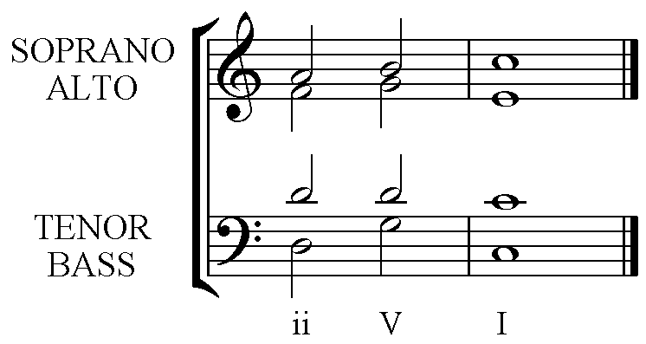 | 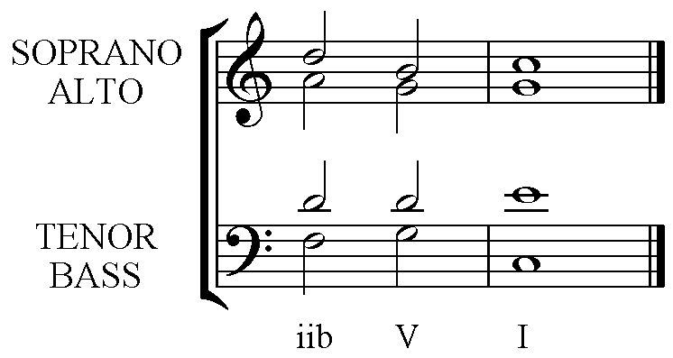
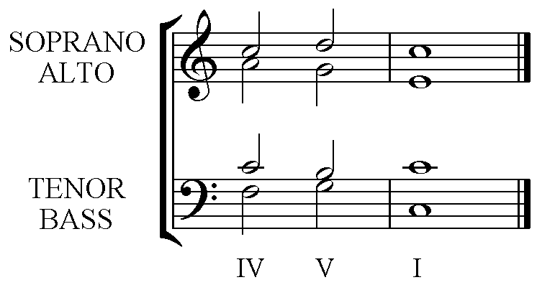 | 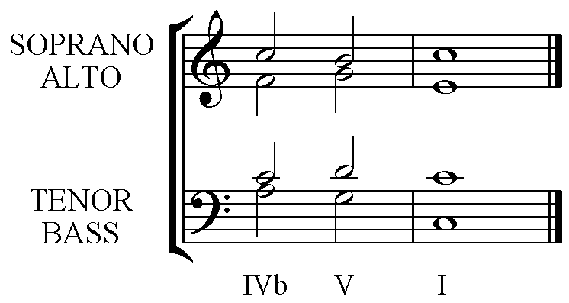
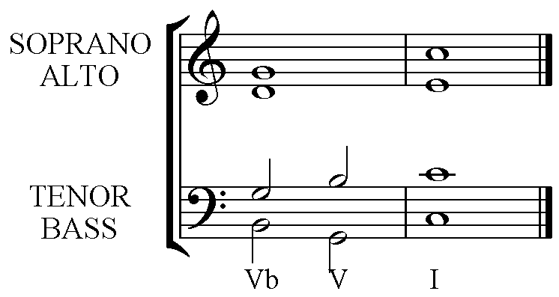 | 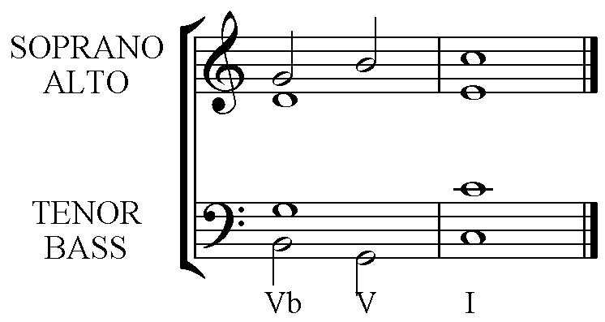

ii – V – I has a strong Bass line due to the leaps. This gives a bold harmonic change.

iib – V – I has a smoother Bass line as does IVb – V – I as the initial movement is by step, similarly IV – V – I.

Vb – V – I is just a rearrangement of the chord allowing some movement, decorating the long note. Note that this can be used for a sustained soprano note just as effectively as a moving one.

There are more possibilities for the chord before the Perfect Cadence, but these give the best results at this stage.

Stock Phrases

Melody moves by a 3rd.
Using the same chord for both pitches is frequently the best solution. Make sure that the 3rd of the chord is present in both chords, and that if the chord is Major that the 3rd is not doubled at any moment.

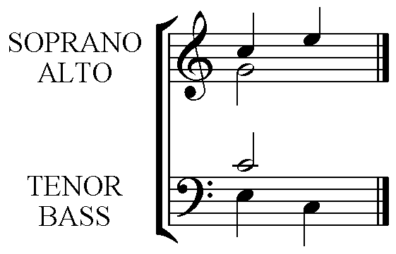

Or

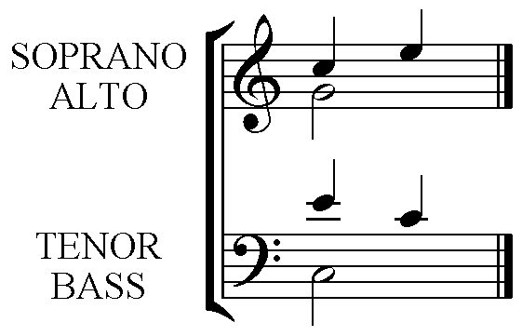

The use of chord viib in a three-chord sequence.

Examine the following:-

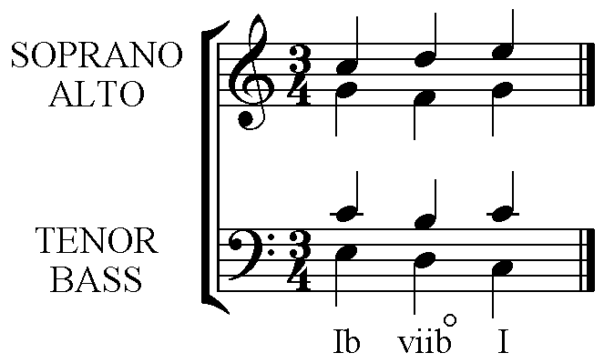
Notice:-
- All voices are moving smoothly by step.
- The diminished chord is used correctly in 1st Inversion and with the D (the 3rd of the Root position chord and now the Bass note) doubled.
- Two voices are moving by step in contrary motion – the Soprano and Bass voices in this example.
- Two voices, Tenor and Alto, are moving by step in 5^{ths} quite correctly as the 5th between B and F is a Diminished 5th and not a Perfect 5th as those between C and G.
- This sequence or its reverse can be used if the melody is any of the following:- Scale degrees:- 1 2 3 or 3 2 1 or 1 7 1 or 5 4 5. The Bass will either be 3 2 1 or 1 2 3. See below.

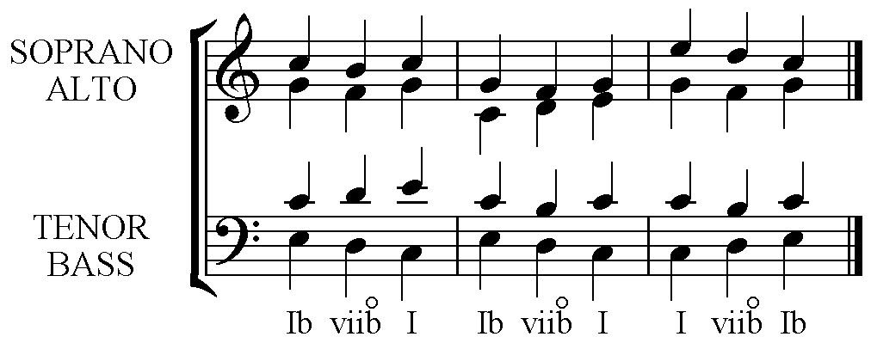

Parallel 1st Inversion Sequence

A scale or a scale fragment can be harmonised using entirely 1st Inversion chords in the following manner.

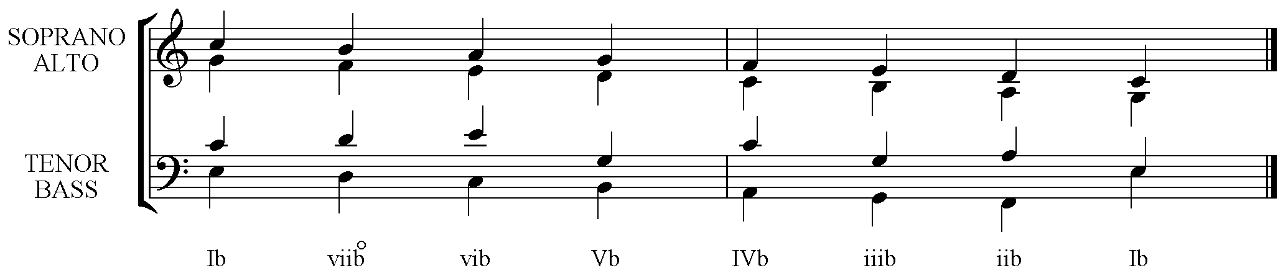

Steps:-
- The Soprano pitches are the Root notes of the chords.
- The Bass notes are the 3rds of the chords and descend or ascend in parallel motion with the Soprano.
- The Alto takes the 5th of each chord, again in parallel motion with the Soprano.
- To complete the harmony, and maintain the 4 part sound, the Tenor part must not make parallel Perfect 5^{ths} or Perfect Octaves with any other part so different notes must be doubled in successive chords. A good pattern, though not entirely used here, is one that alternately doubles the Root then 5th throughout.

Note there are slight weaknesses in the example above in that the Tenor has the same pitch as the Alto on 3 occasions forcing the Alto to pitch a note lower in the next chord. Since the Alto is moving smoothly by step this is a better sounding solution than one that would have these three Tenor notes taken down an octave to make a low 3rd with the Bass in each case.

Scale segments that are higher in pitch than the one given and those that are only 3 or 4 notes long work the best.
Passing Notes or Unessential notes.
Passing notes or unessential notes are notes that are not member notes of a harmonising chord. There are three main diatonic types.

Passing Notes
A passing note comes between two chord notes where the pitches in the three-note pattern rise or fall by step in the same direction. There can only be one non-chord note in the sequence. Examine the following and notice that passing notes can be on or off the beat. Accented passing notes are more obvious than non-accented passing notes. They propel the melody onwards with more drive because they create dissonance.
Notes that belong to the harmonising chord are Concordant.
Notes that do note belong to the harmonising chord are Dissonant or create dissonance if they make a 2nd, 4th or 7th with the Root note of the chord.
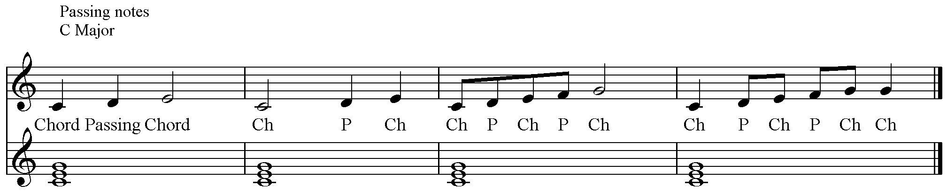

Neighbour Notes or Auxiliary notes
Again it is a three-note pattern this time with the same chord note first and last and a non-chord note between these repeated pitches. The movement is either up or down but always by step. Neighbour notes can be accented or unaccented.
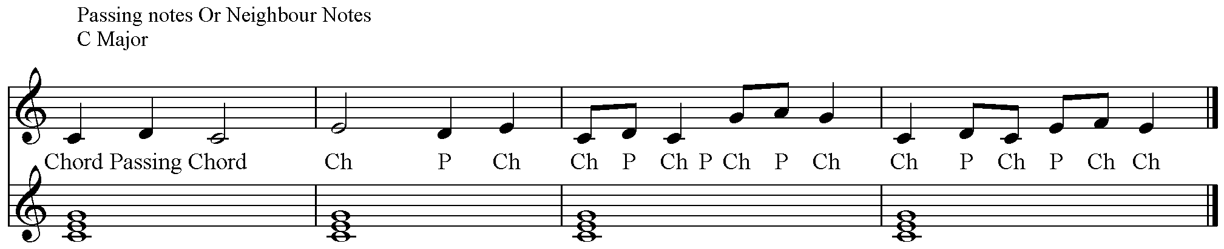

Chords in 2nd Inversion

Primary triads only can be used in 2nd Inversion.
There are only two contexts in which a 2nd Inversion can be used successfully, either as the initial dissonant chord in a Cadence, referred to as a
Cadential.
6
4

When using a 2nd Inversion chord ALWAYS double the Bass note. (The 5th of the Root position chord.)

The 2nd Inversion chord must be accented when used in Cadences.

Perfect Cadence
Here the 2nd Inversion of the Tonic chord gives the cadence a great deal of forward motion because of the 4th (a dissonant interval) that occurs with the bass note. The 4th is resolved downwards by step. The 4th occurs between the G in the Bass and the C in the Ic chord. Notice that the G has been doubled in the Ic chord.

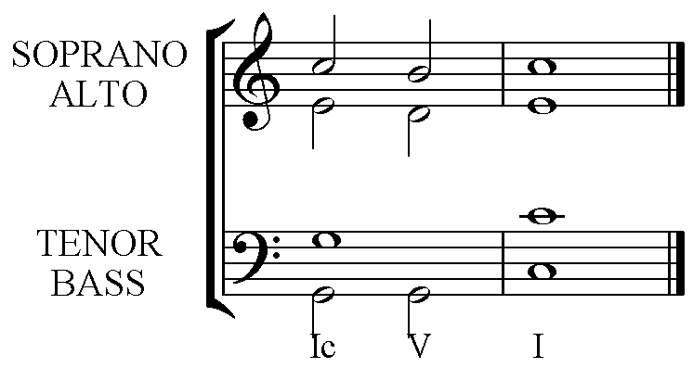

Plagal Cadence
Again the interval of the 4th gives this cadence drive. Here are two possible versions. The first version is the strongest sounding because of the 4th between the Bass and Soprano. The 4th in the second is still active though a little more hidden in the Alto voice by the Soprano. Both are effective Plagal Cadences. Frequently the repeated Tonic is found in the Soprano part.

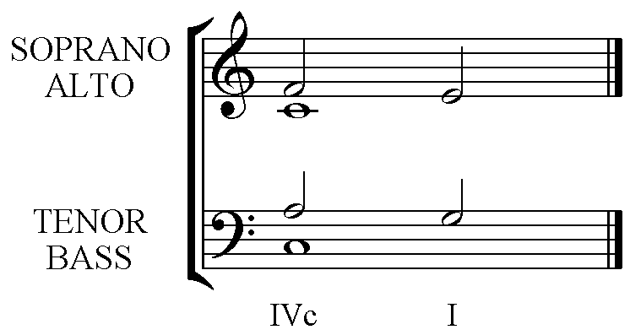 | 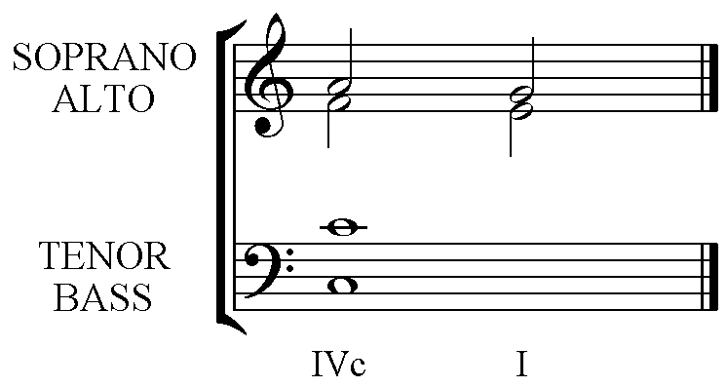

Imperfect Cadence
This is similar to the start of the Perfect Cadence, but is left incomplete without the following chord.
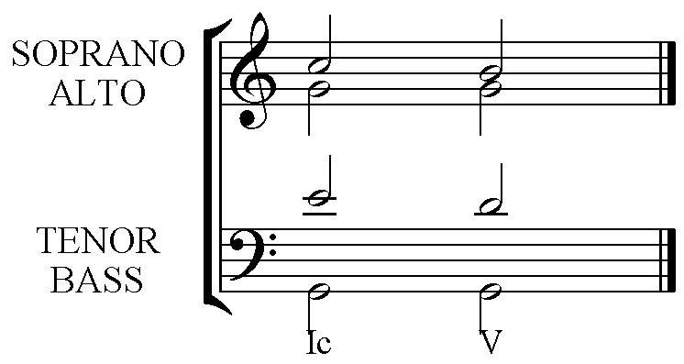

Interrupted Cadence
This cadence begins the same way as both the Imperfect and Perfect and concludes with the Submediant (chord vi).
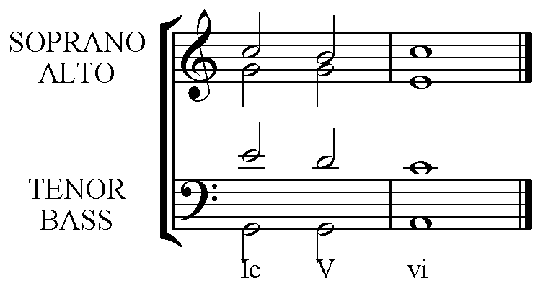

The chord before a 2nd Inversion chord should be chosen with care.

Choose
A chord that has a Bass note a step or 2nd away from the Bass note for the 2nd Inversion chord.
IV – Ic – V – I
IV b – Ic – V – I
iib – Ic – V - I

OR
The Bass leaps from a Root position or 1st Inversion of the same chord as the 2nd Inversion.
Ib – Ic – V – I
I – Ic – V – I

There are other possibilities but those listed above should always be considered first.
Passing 2nd Inversions

- Only Primary Triads can be involved in the 3-chord sequence that uses a 2nd Inversion chord as a Passing Chord.
- The Bass must move smoothly by step.
- All upper parts must move by step with the common note remaining in the same voice throughout as either repeated notes or a long sustained note.
- The same chord must be on either side of the 2nd Inversion chord. One will be in Root position, the other in 1st Inversion.

The following are the only possible uses of the 2nd Inversion chord as a Passing Chord. (Obviously these can be transposed to any key.)

The Dominant or chord Vc as a Passing 2nd Inversion chord.
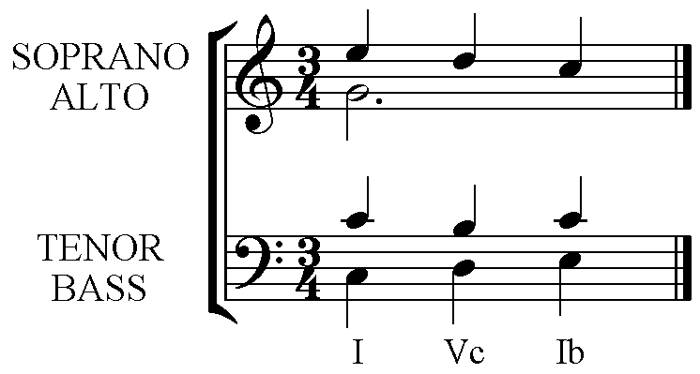 | 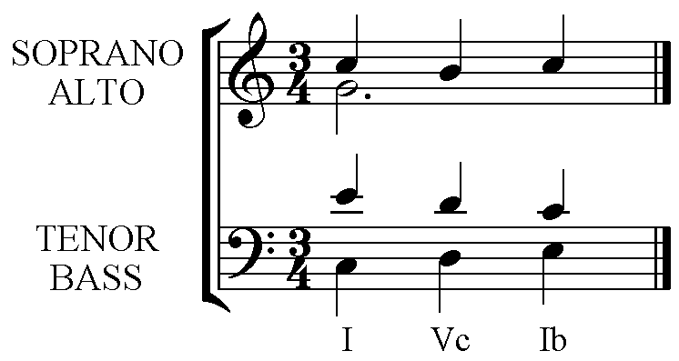
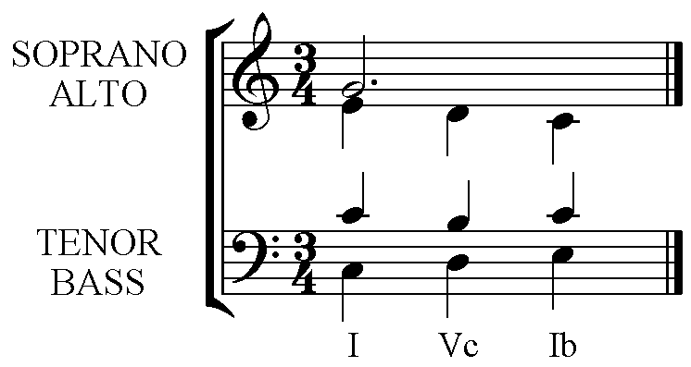

The Tonic or chord Ic as a Passing 2nd Inversion chord.
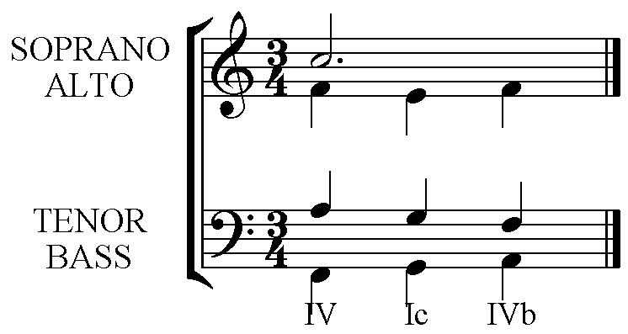 | 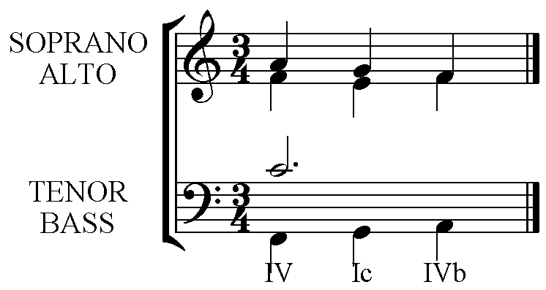
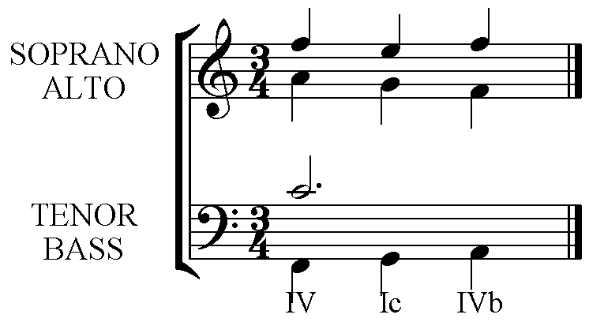

Dealing with Repeated Notes in the given Melody.
Aim to use a variety of chords under each note to give forward motion.

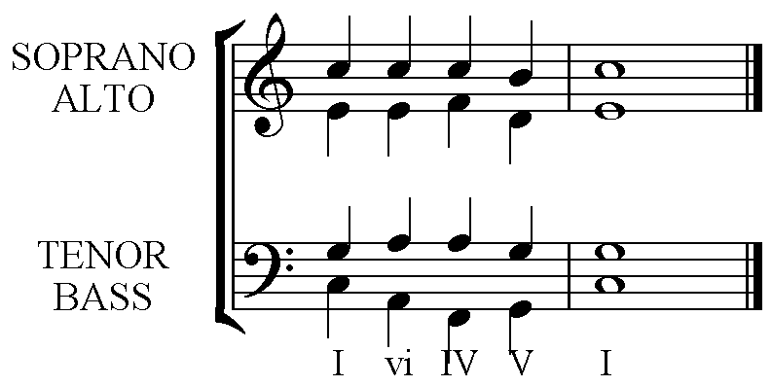

Dealing with a Musical Sequence in the given Melody.
All parts should be a sequence in the completed harmonisation.
The best chord sequences to use are recognised cadences. Eg. Vb – I followed by vib – ii then viib to iii. The initial choice of the 1st inversion was made because the final needed a Diminished chord used properly in 1st inversion.

A simple Sequence using an imperfect (I – V) cadence repeated up a 2nd, becoming ii – vi. The first inversion is used to allow for the fall of the 3rd in the melody. (See Stock Phrases – Melody moves by a 3rd.)

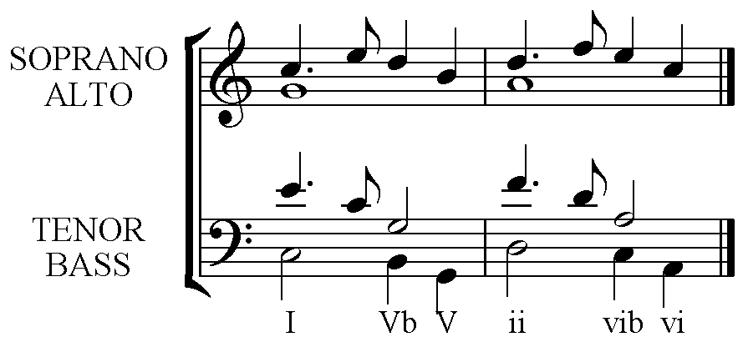

Other chord progressions.
Standard chord progressions in traditional four part vocal harmony other than those stock phrases can be decided upon by using the following flow diagrams.
The pull of the tonic increases from left to right in the tables below. Those in the same column have a similar pull towards the tonic.

Major keys:-

iii | vi | IV | viiº | I
 |  | ii | V
iii to vi or IV
vi to IV or ii
IV to ii
Either IV or ii to viiº or V
Either viiº or V to I
Chord I can be followed by any chord.
Of course cadences IV – I, V – iv are also possible.

Minor keys:-
VII | III | VI | iv | viiº | i
 |  |  | iiº | V

The listings for Major progressions also apply. Note the changes of chord quality:- VII, III & VI are used as major chords.
The Dominant 7th chord

What are its features?

Built on the Dominant note in a key, it is the only Major triad with a minor 7th in both Major and Harmonic Minor keys.

Triad Type | Root – 3rd | 3rd – 5th | Root – 5th | Root – 7th | Abbreviation | Chord in Key
Dominant 7th | Major 3rd | minor 3rd | Perfect 5th | minor 7th | 7 | 5

It is the only chord that includes the Augmented 4th between notes 4 (Subdominant) and 7 (Leading Note- raised in a minor key).

It is this Augmented 4th that makes the chord sound unstable and in need of resolution. This interval is also known as a Tritone (3 tones) it is half of the octave distance of 6 semitones. It is a Diminished 5th when inverted.

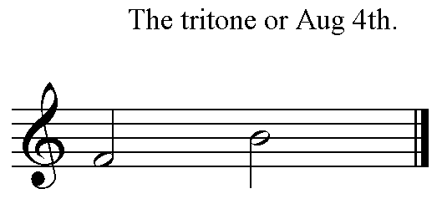 | 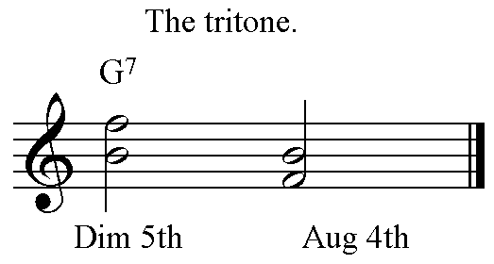

The resolution of the Tritone will always be by semitone steps in contrary motion.

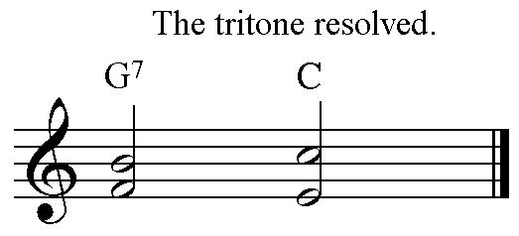 | 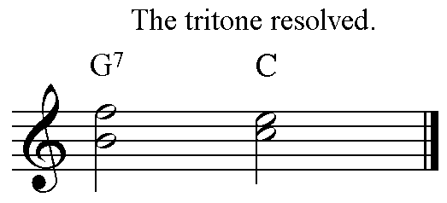

The dominant 7th chord resolves onto a chord that contains the Tonic and 3rd of the key. These notes belong to both the Tonic and the Submediant chords. If the Tonic chord is used a Perfect (5 – 1) cadence is created. If the Submediant follows the Dominant then an Interrupted (5 – 6) cadence is formed.

To imply a Dominant 7th chord only the notes making the Tritone are required.

Using the Dominant 7th in Traditional Harmony.
This is a 4-note chord so no doubling is required still the 5th could be omitted and the Root note doubled if necessary.
This chord has a ‘powerful engine’ (discussed above), the Tritone between the subdominant and the leading note of the scale, the 3rd and 7th of this chord. The subdominant falls to the mediant and the leading note rises to the tonic.
It is built on the Dominant triad (Major in both Major and minor keys) with an added minor 7th. It is the only chord of its kind in any given key.
It is best not to overuse the Dominant 7th within one harmony exercise. The best places to use the chord are at the beginning to harmonise the anacrusis and in the final Perfect cadence. Both will be completed in this manner:-

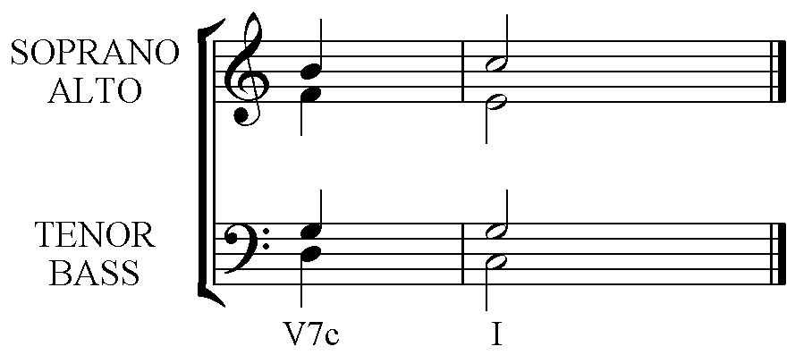 | 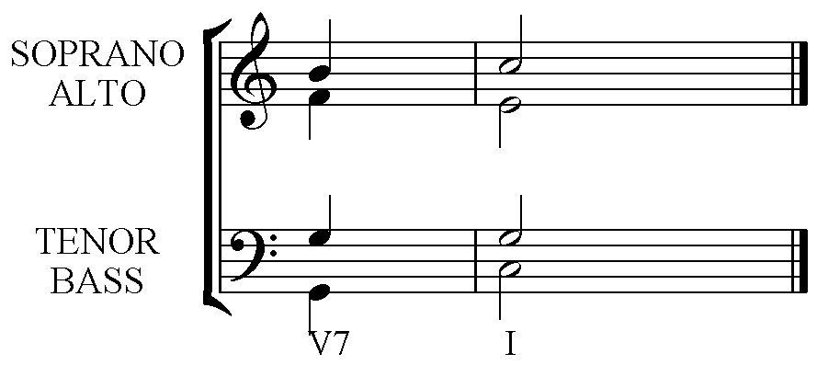

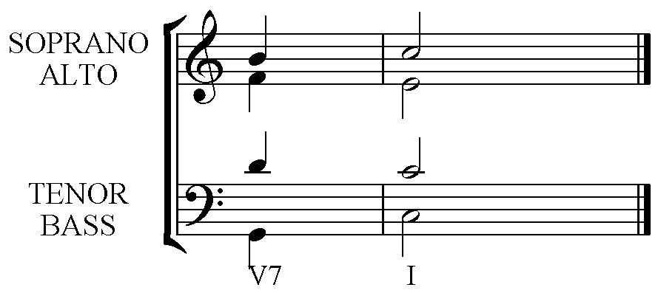 | 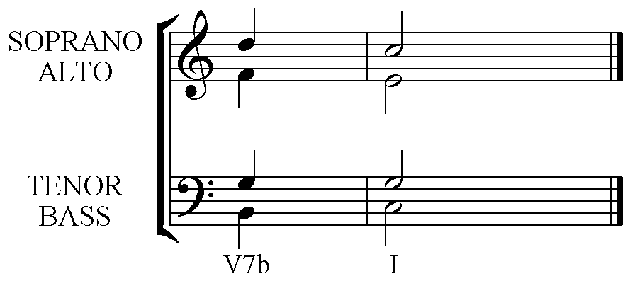
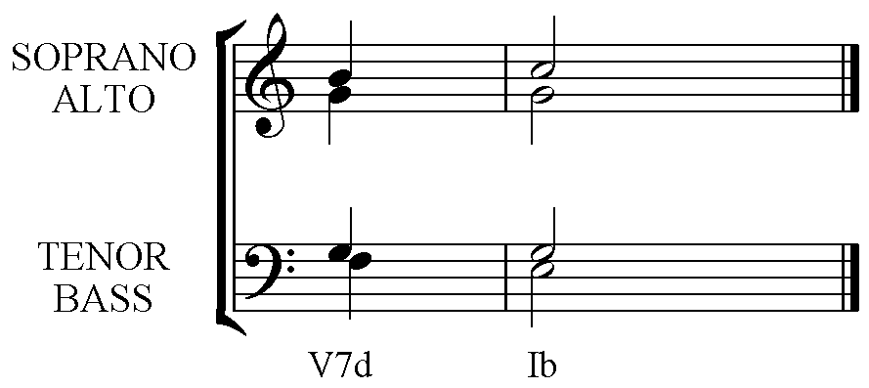 | 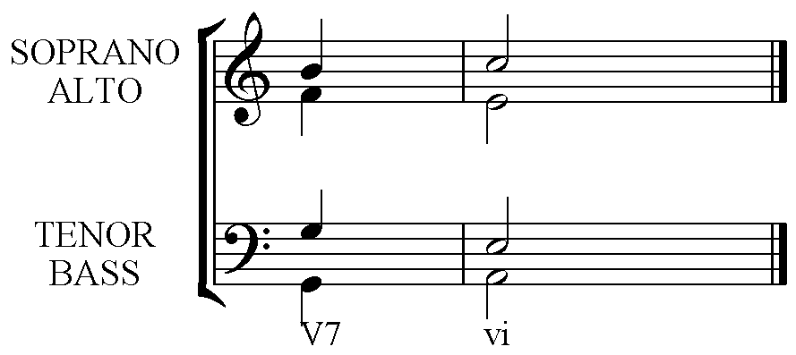

Notice that the Dominant 7th chord can be used freely in any inversion, and that either the Tonic or Submediant chords should follow it.

Scale Degrees
4 to 3
7 to 1
on every use.

Occasionally when the Dominant 7th chord uses all 4 pitches then the following tonic may only require the Root tripled and the 3rd. The reverse is sometimes required:- A complete Tonic chord (with root, 3rd & 5th) may need an incomplete Dominant 7th chord preceding it. The 5th of the Dominant 7th is the one to omit.

Occasionally:-
Incomplete Dominant 7th (omit the 5th) Complete Tonic
Complete Dominant 7th Incomplete Tonic (Omit the 5th)

Completing longer pieces of Harmony
- Name the key and write out the scale and chords.
- Examine the phrasing and put phrase markings in if not given. This will show the cadence points.
- Begin with any of the cadences and the opening bar.
  - The opening bar should establish the key in some way, a V – I cadence with one of the chords in first inversion is the best if there is an anacrusis, otherwise begin on the tonic chord if possible.
  - Aim to use a variety of cadences, but always end with a Perfect Cadence.
- Put in the chord before each cadence.
- Look for places to put ‘stock phrases’ and complete these.
- Finally fill in the gaps by first listing the possible chords with inversions and choosing the one that completes the passage without errors. Avoid using chord ii – I as it is not an effective chord sequence. It is best to consider the Bass first.
- Check.
- Add passing notes or auxiliary notes. Check that these do not make 5ths or 8ves with other parts. Remember that non chord notes such as passing or auxiliary notes do not hide errors such as parallel 5ths or 8ves, and can make errors. Passing notes or auxiliary notes must be a major 2nd or minor 2nd from their neighbours on both sides.

