Nathan Christensen-Padilla

Adrianna Holden-Gouveia

Linux Administration

12/12/2021

Firewalls Ubuntu

I installed apache2 for my server:



Then I made an iptables.conf file so I can save my rules.

Then I transferred my file I made in CentOS over using WinSCP and copied the iptables to my current one.



Then I checked the status of my firewall then enabled it:

All of the rules are the same as the CentOS server, but I just split up the screenshots into their own documents for easier readability. (All of my comments and stuff are in the CentOS file)

1. Deal with web server

Commands:

:80

1. Deal with MySQL service

Port 3306:

1. Deal with SSH service

Connected to the server using SSH port 22 with the WinSCP app:

1. Deal with Email service

Tried connecting to 25,465,587 and 2525 ports:

1. Script to allow/block specific hosts, MAC addresses

1. A script/command to block telnet, block ping

Testing ping before and after I implement the block command

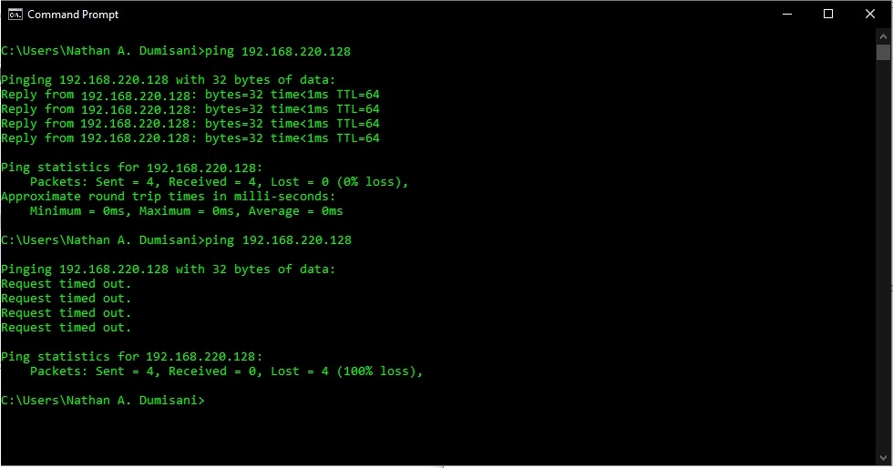

Original Iptables:

Sources:

[iptables: The Default Linux Firewall (opensourceforu.com)](https://www.opensourceforu.com/2015/04/iptables-the-default-linux-firewall/)

[Linux firewalls: What you need to know about iptables and firewalld | Opensource.com](https://opensource.com/article/18/9/linux-iptables-firewalld)

[Ubuntu: Stat / Stop / Restart Iptables Firewall Service - nixCraft (cyberciti.biz)](https://www.cyberciti.biz/faq/ubuntu-start-stop-iptables-service/)

[❤ 💻 Linux - iptables redirect port 80 to 8080 - Dirask](https://dirask.com/posts/Linux-iptables-redirect-port-80-to-8080-pO7kwp)

<https://danielmiessler.com/blog/professional-firewall-iptables/>

[How to Start/Stop and Enable/Disable FirewallD and Iptables Firewall in Linux (tecmint.com)](https://www.tecmint.com/start-stop-disable-enable-firewalld-iptables-firewall/)

<https://www.tecmint.com/linux-iptables-firewall-rules-examples-commands/>

[Linux IPTables: Incoming and Outgoing Rule Examples (SSH and HTTP) (thegeekstuff.com)](https://www.thegeekstuff.com/2011/03/iptables-inbound-and-outbound-rules/)

[Configure MAC based Filtering using Iptables in Linux (tecadmin.net)](https://tecadmin.net/mac-address-filtering-using-iptables/)

[How to Block Ping ICMP Requests to Linux Systems (tecmint.com)](https://www.tecmint.com/block-ping-icmp-requests-to-linux/)