Nathan Christensen-Padilla’s Portfolio Draft

Github link: <https://github.com/nstormx>

About Me and How I Got Into IT

Hello everyone, my name is Nathan and I have always been interested in technology ever since I was young, like how I’ve never really liked playing with toys even as a kid. Also, I’ve only recently in the past few years have started to seriously dive into the IT field and the reason for this was when I came out of high school, I wasn’t too sure what I wanted to do for a career. But a few influences that helped find this new path was my dad, and the reason being is he used to work in the IT field and has always helped solve my family’s technical issues and it inspired me to want to do the same. Also, a little out of the ordinary one would be Modded Minecraft, and the reason it helped me go into the IT field was that they had mods where you could write scripts to get machines to work and it was pretty cool to try it out although I really wasn’t that good at it. Overall, I’ve been enjoying the experiences I’ve had in learning about IT related stuff especially with programming languages like Python which is my favorite so far.

Some of My Linux Administration Work

One project that I was pretty happy with the way it turned out was creating a bash script that collect some network information and then outputs it into a .log file. Below is the Github link and a screenshot of the code.

Github Link: <https://github.com/nstormx/Nathan_NetworkScript>

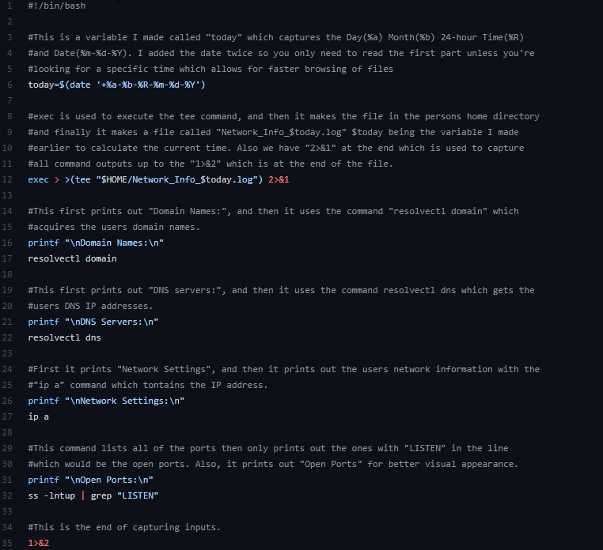

At first I had some troubles with outputting all the commands to a new file that also contains the date, but in the end I got it to work the way I wanted it to and it logs pretty well.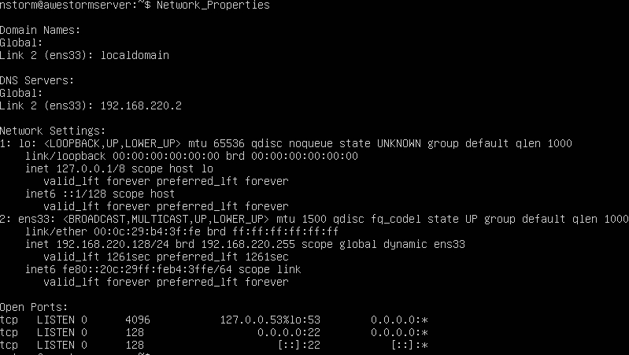

The biggest challenge I had was capturing all of the output of the commands while also printing it but that’s where the tee command came in handy at the 12th line and not only that but using 2>&1 to output to itself. Also, a honorable mention is that when formatting the date command in the today variable I didn’t realize you couldn’t use %D when making a new file so I got stuck on that for a little bit, but I eventually figured it out and wrote out the date individually.

The next piece of work I am proud of is my Sed and Awk scripts that I had to write, and I wasn’t the best at making bash scripts at first, but I was able to create some pretty good and compact scripts in the end . The first two screenshots are Sed and the others are Awk

The biggest challenge in making these scripts was translating the terminal commands into the script files so they could run properly, like how in the Sed script I had to use “sed -f LiteraryCharacters.sh datebook >> datebook_output” to run the command and didn’t have to put Sed in the lines themselves. The same goes for Awk, but overall, I’m glad I was able to figure this out and get them working properly.

Lastly, I was happy that I figured out how to download repositories that I made on Github to my virtual machines because it saved me a lot of time being able to write my script in their and then get the repository. I did this by using the command “sudo wget [https://raw.githubusercontent.com/nstormx/Nathan_NetworkScript/main/Network_Properties](https://raw.githubusercontent.com/nstormx/Nathan_NetworkScript/main/Network_Properties%E2%80%9D)” Text

Honorable Python Mention

Finally, I made a pretty good text-based rpg game that I would like to add, I made it all with Python and it’s probably one of the biggest projects I’ve done so far. The game took me a little over a week to finish and works great.

Github Link: <https://github.com/nstormx/Nathan_Text_Adventure_Game_Final_Project>

That’s the Github Link if you wanted to check it out but this is the end of the Portfolio for now but there are still many more things to come!