William Spaulding, Robert DeCrescentis, Norman Brandon, Nathan Strawhand, Khanh Nguyen

CIS 470 Senior Project

Deployment plan

TPS eCommerce Website

|  |  |
| --- | --- |
| **Team:** | **Team F** |
| **Team Members:** | **William Spaulding, Robert DeCrescentis, Norman Brandon, Nathan Strawhand, Khanh Nguyen** |
| **Date:** | **2/21/2018** |
| **Project Tile** | **TPS eCommerce Website** |

CIS 470 Deployment Plan

**Introduction**

The purpose of the deployment plan is to discuss how the project will be deployed and executed. The plan will cover steps on how it will be delivered to the target system environment. The plan will cover the following areas: Required hardware, required operating system environment, software installation/deployment, migration plan and post implementation activities. Each area will provide in-depth information which would allow users to understand the requirements needed for deployment.

**Required Hardware**

The required hardware for the TPS eCommerce Website is any standard computer with processors which can handle internet browsing. This is a web-based project and does not need special hardware to operate. Any browser with the capability to view .aspx files will be able to complete this requirement. A standard graphics card is needed to assist with viewing the website.

Developers will need to use Visual Studio to code, compile and test the TPS eCommerce Website. Visual Studio is a IDE (individual developer environment) which allows developers to build dynamic webpages such as the TPS eCommerce Website. A computer with at least an Intel Core i5 is required to run Visual Studio due to heavy processor usage. A standard graphics card is required to view images through the Visual Studio developer environment.

**Required Operating System Environment**

The required operating system environment is Windows 7, 8, or 10. The website can be viewed on Mac OS X 10.5 and above. Any previous version may degrade viewing due to browser capabilities. These operating systems have the appropriate browsing features to run the TPS eCommerce Website.

**Software Installation/Deployment**

The TPS eCommerce Website is web-based and does not need special end-user software to run. However, users will need an internet connection to execute the website. Any internet connection faster than DSL will be able to load the website without any issues. Users can view the website through Internet Explorer, Google Chrome, Safari and Microsoft Edge browsers.

Developers will need to upload the website to any hosting provider. Hosting providers allow uploading to secure servers. However, if TPS has access to secure web servers, the website will be uploaded and deployed on them. TPS will need a domain name service to provide an internet web address if the website is allowed for public access. Internal access will need a private ethernet server and internal address to host the website.

There are a few tasks that need to be completed before you can use this project application properly. It is important to make sure you name any folders and files exactly as explained in the instructions below. If the folder or file is named incorrectly, the program will not work. You can always rename either of them if you made a mistake by right clicking on the folder or file and click the “Rename” selection. Now on to setting up for the programs 1st use.

1. The first step is to create a folder in your file directory IIS Express. You can find this directory folder by click on your file explorer.

A screenshot of a computer

Description generated with very high confidence

1. Now navigate to “This PC”

A screenshot of a computer

Description generated with very high confidence

1. Then click “Local Disk (C:)”

A screenshot of a cell phone

Description generated with very high confidence

1. Next click on “Program Files (x86)”A screenshot of a cell phone

   Description generated with very high confidence
2. Now click on “IIS Express”,

A screenshot of a cell phone

Description generated with very high confidence

1. Once inside the IIS Express folder you need to create a new folder and name it “TPSDatabases” (Without quotations).

A screenshot of a social media post

Description generated with very high confidence

1. You need to set the permission for this folder so that everyone can Read and or Write to it. This is done by right clicking on the TPSDatabases folder then selecting properties.A screenshot of a cell phone

   Description generated with very high confidence
2. Click on the “Security” tab at the top.

A screenshot of a social media post

Description generated with very high confidence

1. Now click “Edit”.

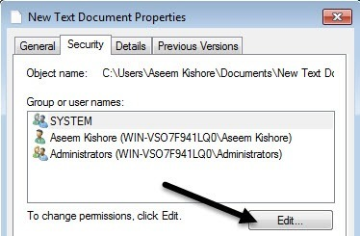

1. Here you click “Add”.

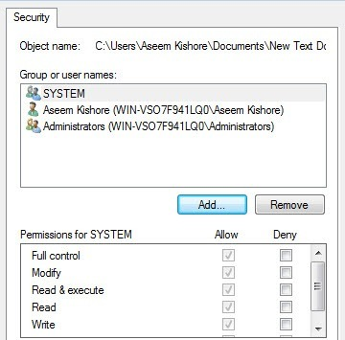

1. In the box named “Enter the object names to be select” type “Everyone” (without quotation), then click “Check Names”. Once it is done the name “Everyone” will be underlined and at that point you can click “OK”.

A screenshot of a cell phone

Description generated with very high confidence

1. Highlight the name “Everyone” by clicking on it and in the box below, click on the “Read” and “Write” box if there are no check marks.

A screenshot of a cell phone

Description generated with very high confidence

1. Once both boxes are checked, you can click “Apply” at the bottom of the tab and then click on OK”.

A screenshot of a cell phone

Description generated with very high confidence

1. You should be back to the properties page again. Click “OK”A screenshot of a social media post

   Description generated with very high confidence
2. Now double click on the TPSDatabases folder to open it.

A screenshot of a cell phone

Description generated with very high confidence

1. Once inside the folder, you will add a (click on) “New Item”. The item to add (click on) is a Microsoft Access Database file. Name the file “database” and press enter.

A screenshot of a cell phone

Description generated with very high confidence

1. You are done setting up the database and can close the file explorer.

A screenshot of a social media post

Description generated with very high confidence

**Migration Plan**

The migration plan will include information explaining how data from the website will be converted so that users can view the website. Programming interfaces such as API’s and IDE’s are used to build the website. Once the old TPS website has been fully migrated to the updated website, users will have the ability to complete staffing requests, search for staff, and update resumes and pictures through the website. The possibility of falling back to the old website temporarily can occur so that the new site can undergo updates (if necessary).

Data will be converted through proper server backup. Creating a server backup will allow for the old website to be saved if TPS needs to fallback temporarily. Additionally, backing up data will ensure that nothing will be lost during the migration. After backup, data will be converted from the old platform to the new.

Migrating the old website to the new will take place after regular business hours. This is important because the team can fix issues that may happen during migration so that end-users are not affected. Once migrated, the team will inform end-users how to use the new website through tutorials. End-users will also be provided a user’s manual explaining step by step processes for operation.

**Post-Implementation Activities**

Post-implementation for deployment will occur after the migration plan has completed. There are three key post-implementation activities: System support, system maintenance and project assistance. System support allows for assistance to be provided to the end-users. For example, the team will provide support through hands-on training to ensure questions and comments are addressed on how to operate the website.

System maintenance occurs when the system is improved, and bugs are fixed. The team will be responsible for fixing any potential issues with the website. System issues are problematic and will cause productivity issues if not stopped immediately. Once errors are fixed, a new website release will be deployed to ensure users will have the most up-to-date information.

Project assessment will occur as the last stage in post-implementation activities. Lessons learned are analyzed and evaluated based on information gathering. For example, Team F will evaluate post-implementation activities through how successful system support and system maintenance was. Project assessment also allows the team to evaluate how the overall deployment plan was initiated and if there are any corrections to take for future launches.