Univerzitet u Sarajevu

Elektrotehnički fakultet Sarajevo

Odsjek za računarstvo i informatiku

PROJECT SPECIFICATION

Embeded systems

Name and surname: *Nejla Subašić*

Index number: *18620*

Name and surname: *Matej Marinčić*

Index number: *18729*

**4 IN A ROW**

4 in a row is a game in which two players compete in who can place four pieces in a row (horizontally, vertically or diagonally) on a 6x7 board. Players place their pieces interchangeably and the game is over when one player has four of their pieces in a row.

Our app will allow the user to choose between single player mode and multiplayer mode.

Single player mode is played against a computer opponent, the player plays first.

In multiplayer mode, the yellow player always puts the first piece. At the end of the game a message appears declaring the winner with an animation of fireworks or a draw if such happens.

In any moment of the game, a player can press the pause button that then allows him to choose to quit the game and go back to the home page, restart a new game in the same mode or resume the current game.

Here are some of our sketches for the UI of the app:

Homepage

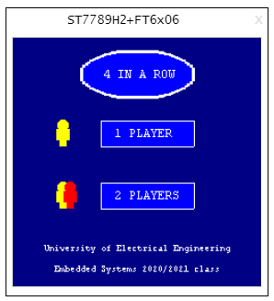

Single player mode

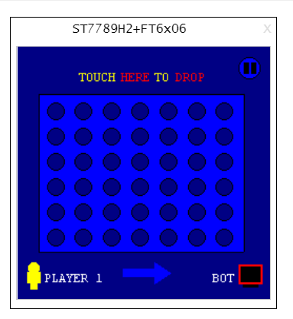

Multiplayer mode

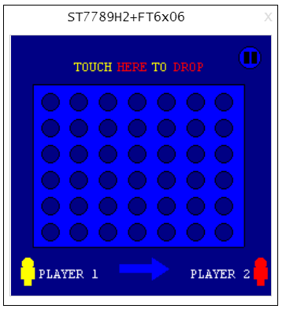

Game finished, fireworks

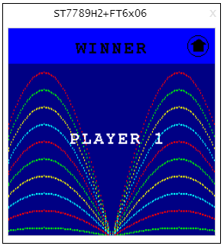

Game paused

