Datathon 2019

Team: Initiable

**Solution Target 1**

**From the correlation heatmap matrix:**

1. We were able to find that **Q3** contributes the **most** to the total followed by Q1 and Q2
2. We were able to find that **Q4** contributes the least to the total

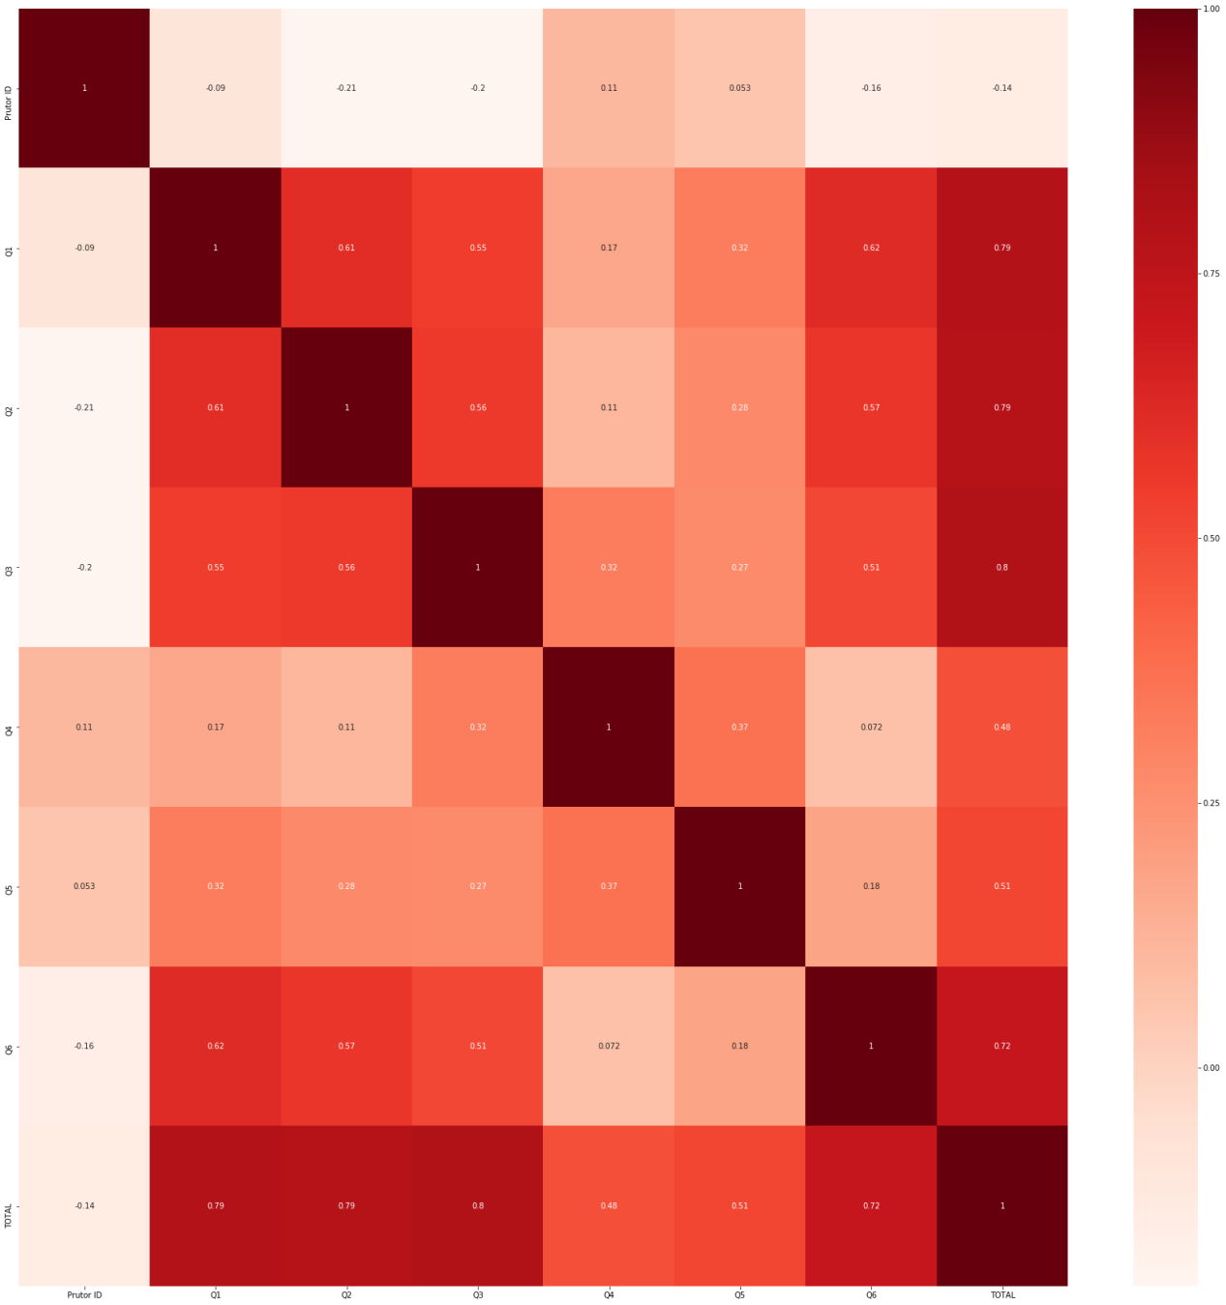

1. Histrogram

