Datathon 2019

Team: Initiable

**Solution Target 3**

**Explanation:**

1. We merged together the scores and pre test scores

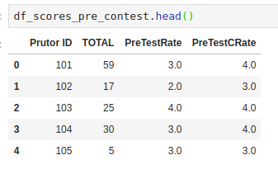

1. We merged together the scores and post test scores

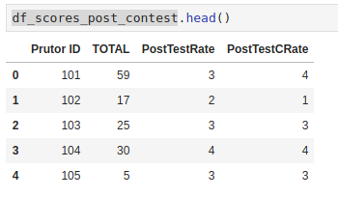

1. Then we got the pre-test and post-test scores in one place

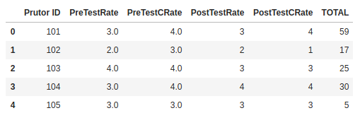

1. Count of absolute difference of pre test and post test scores of overall test and in C programming reveal the changes in scores on average.
2. It is observed that **65 people out of 124** did not change their scores in overall rating and **57 people** did not change their scores in C programming
3. It is observed that **46 people out of 124** changed their scores by **1** in overall and **53 people** changed their scores by **1** in C programming
4. It is observed that **10 people out of 124** changed their scores by **2** in overall and **11 people** changed their scores by **2** in C programming
5. Also people who rated themselves more performed well in the contest