Datathon 2019

Team: Initiable

**Solution Target 4**

**Explanation:**

1. From the below inspection and the histogram (next page) we can see that most people rate themselves as close to the average

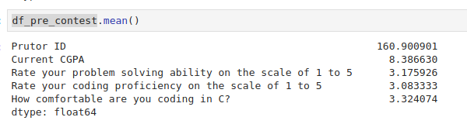

1. From the below inspection, we can see that more people are beginners in programming. Very few people are with more than 4 years of experience exist.

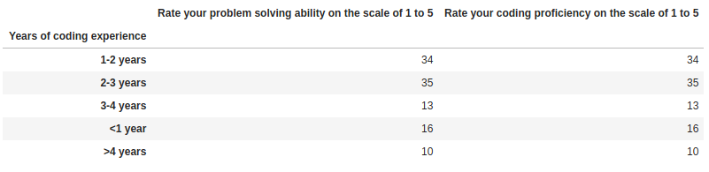

1. Notice that people with more years of experience tend to have higher ratings (comparatively). Although we cannot come to a conclusion that people with more experience are good in programming

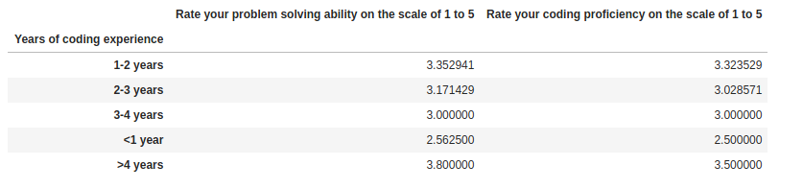

**Histogram for point 2**

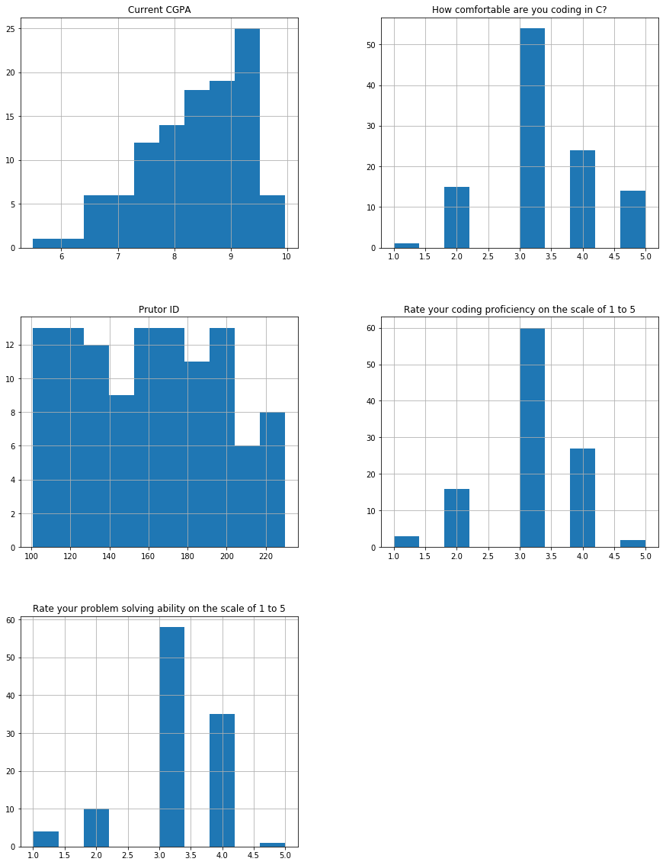

1. Years of experience vs Proficiency, Ratings

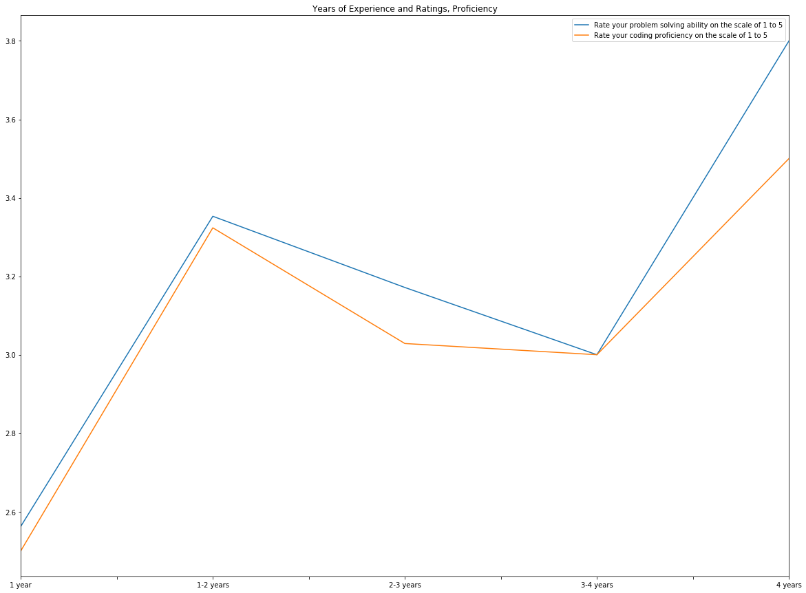

* Clearly, it is visible that people with more experience tends to rate themselves good in programming on average.
* Notice how people with 1-2 years of experience also tend to rate themselves high compared to other years of experience.
* People in the range 3-4 years have low ratings when compared to 1-2 years because of less samples

1. Also we noticed that students from B Tech (CS, Electronics) tend to score more than students from M Tech/MCA from the below inspection of averages of GPAs, Total scores and ratings

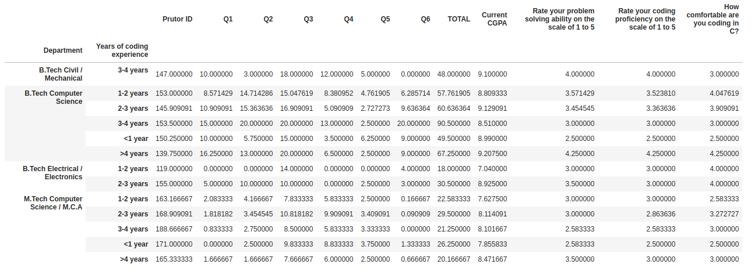

1. Also, total score and cgpa are highly correlated from the plot below

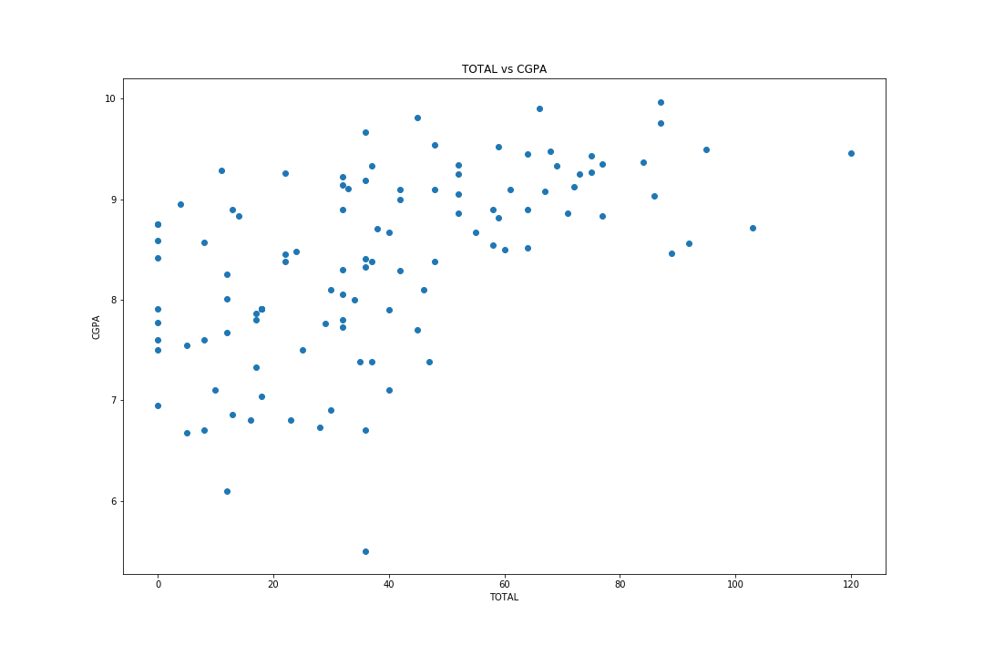

**Conclusion**

1. Students from **Btech** performed significantly better than students from **Mtech/MCA**
2. Students with higher CGPA scored more in the test compared to others
3. Also, students from **Btech** had significantly higher GPA, and hence higher test scores
4. Also, students from **Mtech/MCA** had significantly lesser GPA, and hence lesser test scores