Datathon 2019

Team: Initiable

**Solution Target 5**

**Final Conclusion:**

Students of Mtech/MCA stated that they have average programming experience, good problem solving skills but scored less in the programming test than BTech students. Also, they had significantly less GPAs compared to BTech students who scored more in par with their GPAs. This might be because there is a high correlation between GPAs and Total Scores

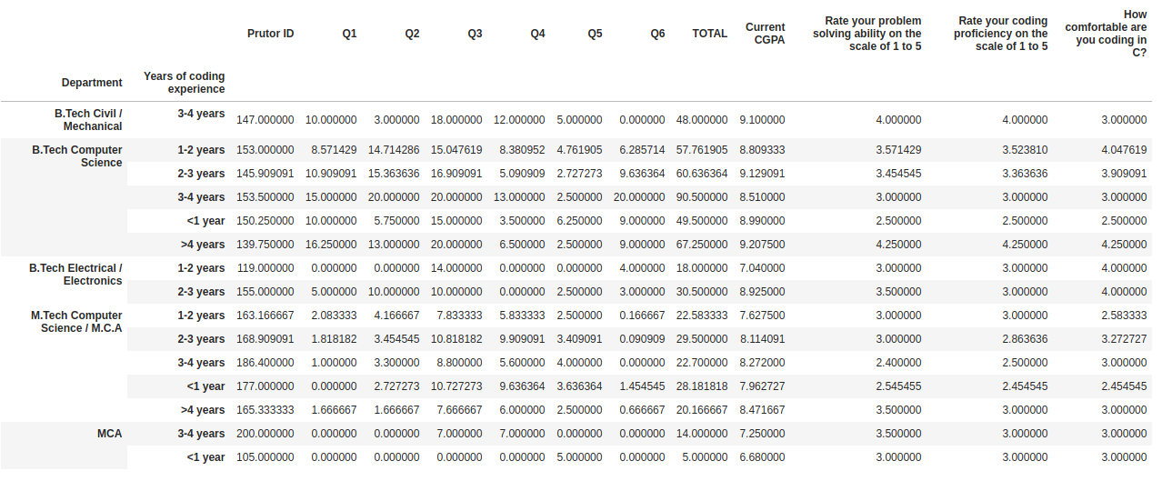

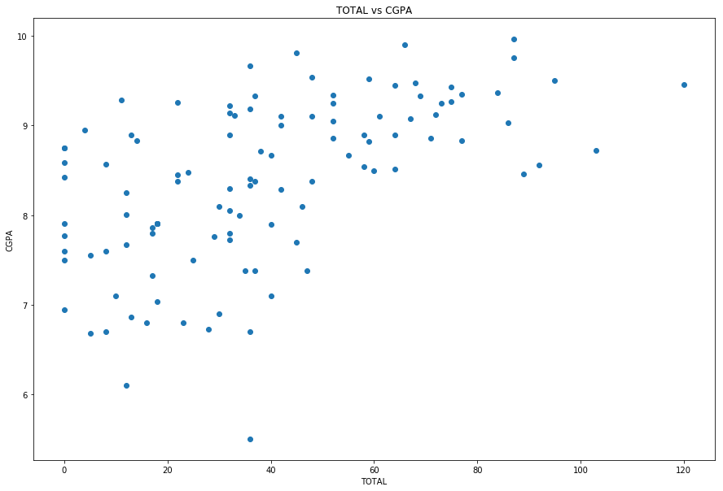

**Distribution of all data**

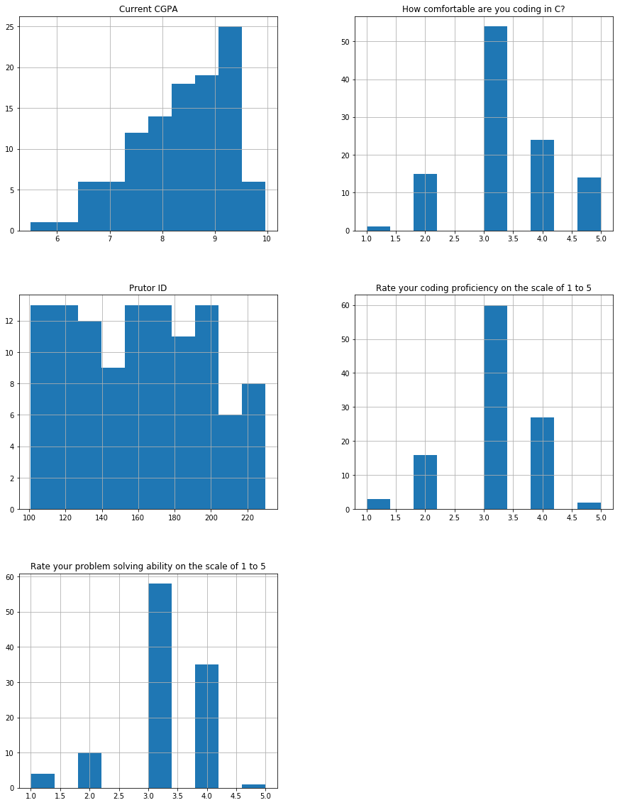

**Years of experience vs Ratings and Proficiency**

