**INTRODUCTION**

**OVERVIEW**

This report discusses the result of the work done in development of “Chatter” on Android Studio using Kotlin. The project aims at the development of an application to allow users to login securely into the application and post in their thoughts and ideas using messages known as “tweets”. Later on, the user can like the tweets, retweet, follow users, follow hashtags and news feed.

**BACKGROUND AND MOTIVATION**

**Applications like Facebook do not have the concept of tweeting. So on analysing the need for users to put in their thoughts and ideas immediately on the social media using short notes, we came up with the innovation of “Chatter” application.**

**OBJECTIVE**

The final goal of the project is:

1. Once the user signs up and logs into the Chatter application, he/she can create new tweets, like tweets, retweet, follow hashtags, follow users and see news feed.
2. Once other users start following each other, they can see each other’s post, like them, retweet them, follow hashtags and can see their own as well as others newsfeed.

**METHODOLOGY**

To implement the above goals, the following methodology needs to be followed:

1. Specifying the application and various components of the architecture.
2. Specifying the bindings between the various modules and Kotlin packages.
3. Analysis: Extracting the required data for analysis and then doing the analysis.

**TECHNOLOGIES USED**:

**SOFTWARE REQUIREMENTS**:

* **Android Studio 3.5v**
* **Front end: Kotlin 1.3v**
* **Database: Firebase 17.x**

**TOOLS AND TECHNOLOGIES**:

**This product is built using Android Studio, Kotlin and Firebase.**

Android Studio is the official integrated development environment for Google's Android operating system, built on JetBrains' IntelliJ IDEA software and designed specifically for Android development.

Kotlin is a cross-platform, statically typed, general-purpose programming language with type inference. Kotlin is designed to interoperate fully with Java, and the JVM version of its standard library depends on the Java Class Library, but type inference allows its syntax to be more concise.

Firebase is a mobile and web application development platform developed by Firebase, Inc. in 2011, then acquired by Google in 2014.

**DESIGN**

**ARCHITECURE DIAGRAM**

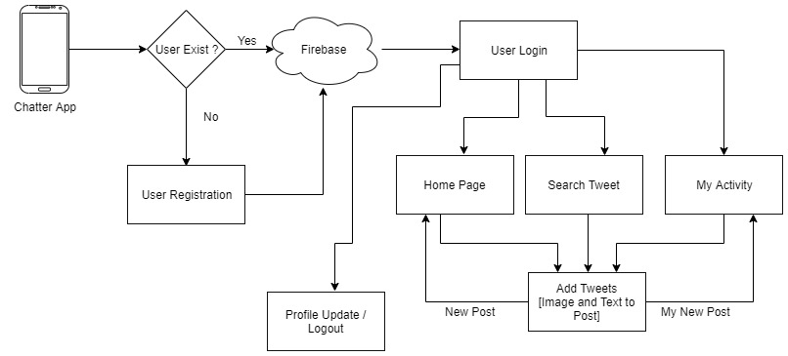

**SCREENSHOTS**

**SIGNUP PAGE**

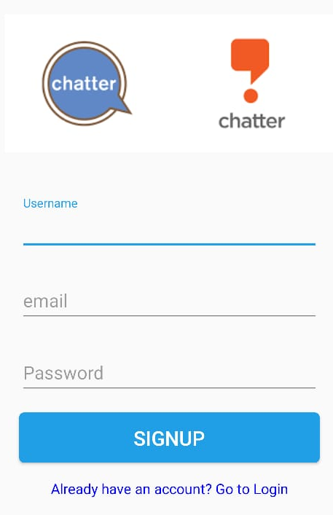

**LOGIN PAGE**

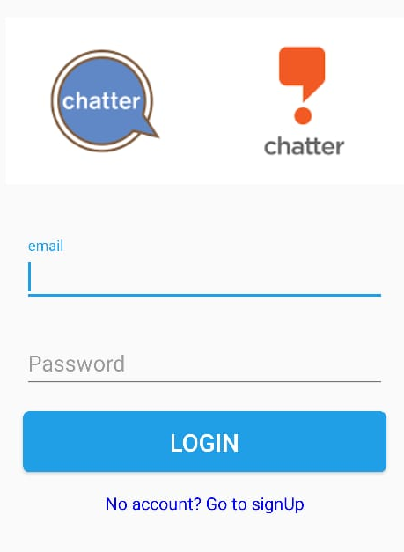

**CHANGE PROFILE PICTURE**

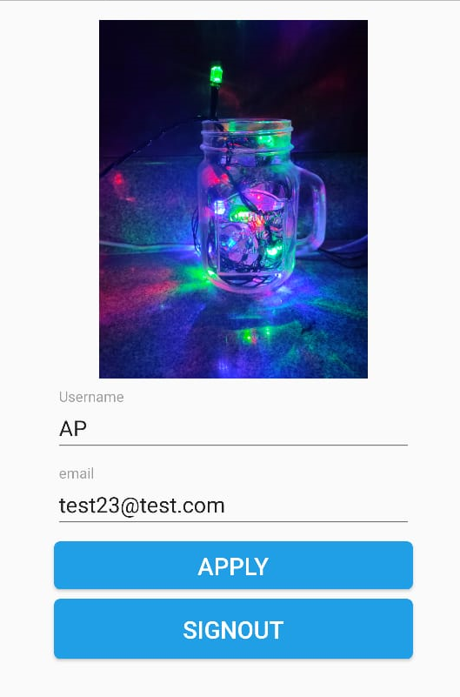

**HOMEPAGE**

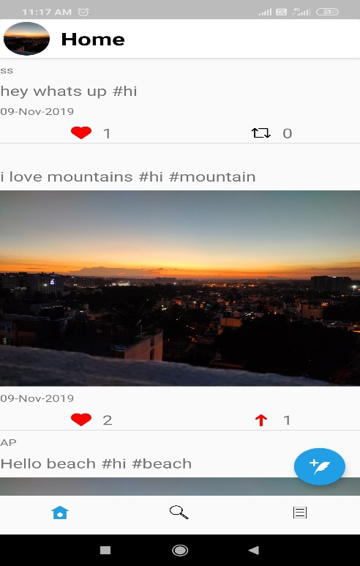

**MY ACTIVITY**

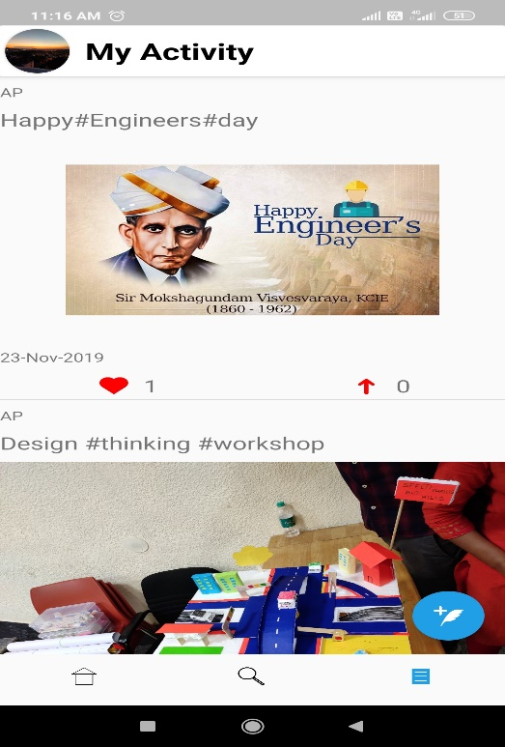

**SEARCH TWEET**

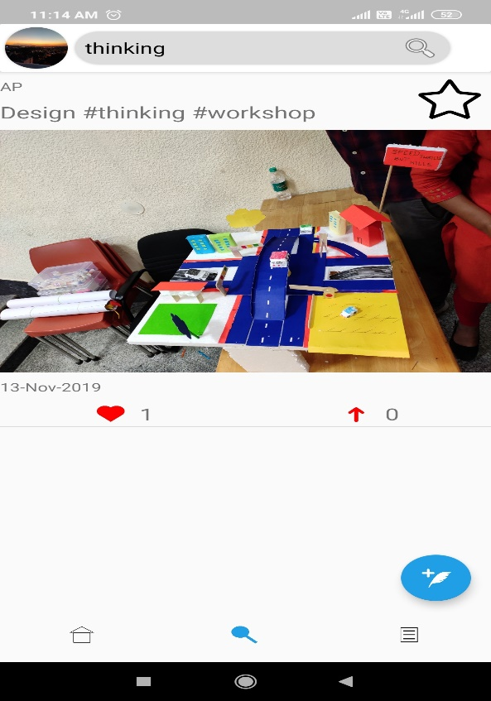

**TWEET CREATION**



**USER PROFILE**

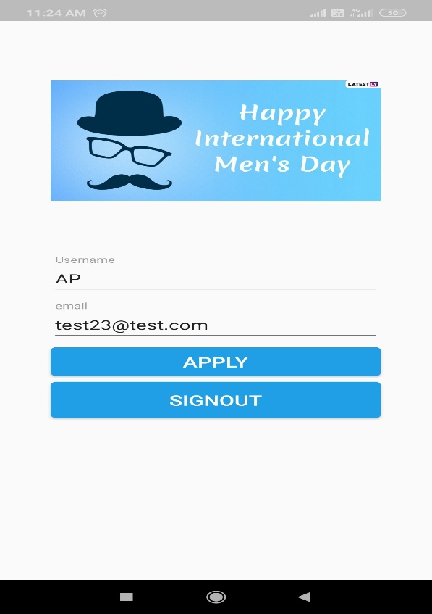

**CONCLUSION**

After analyzing the need of posting short messages with or without images as other social media apps like Facebook do not have such features. Hence we came up with this idea.

Therefore, with the help of our application called “Chatter”, the user can login securely and start microblogging by posting short messages known as “tweets”. Also the user can like his/her tweets, retweet, follow hashtags, follow users and see news feed. Moreover, once the user start following other, he can see their tweets too, retweet them and like them.

**BIBLIOGRAPHY**

1. <https://www.udemy.com/>
2. <https://kotlinlang.org/docs/reference/>
3. <https://kotlinlang.org/docs/books.html>
4. <https://firebase.google.com/docs>
5. <https://firebase.google.com/docs/android/setup>
6. <https://firebase.google.com/docs/reference/android/packages>
7. <https://firebase.google.com/docs/libraries>