**OOMD Lab Practice /Assessment**

**Use Case diagram**

**Step1**: Given the following flow diagram identify actors and use cases and draw an usecase diagram for Hospital Management system.

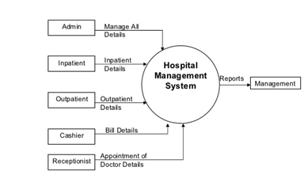

**Step2:** Fine tune the above level-1 DFD of Hospital management system with additional functionalities. Refer the given level-2 DFD and draw more detailed use case diagram

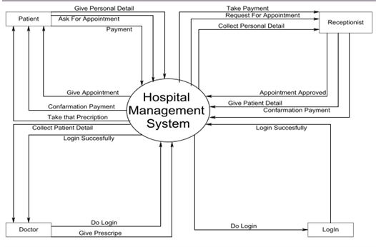

2. For the below given context diagram of Library Management System, identify actors and use cases and draw an use case diagram and further refer level-1 and level-2 DFD and improvise your use case diagram with additional functionalities.

**Context diagram (0-level DFD):**

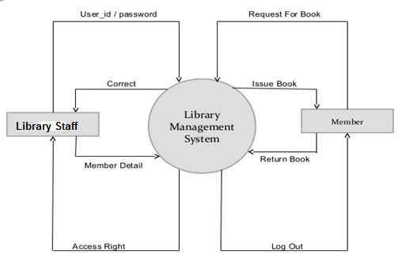

**Level-1 DFD:**

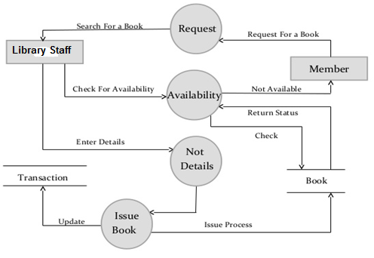

**Level-2 DFD**

