**Assignment 2 - Sudhanva**

**sales.csv**



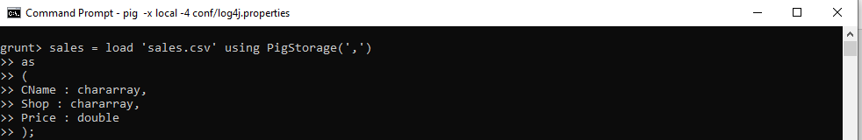



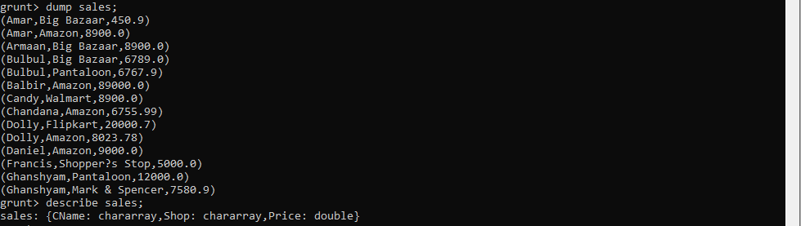



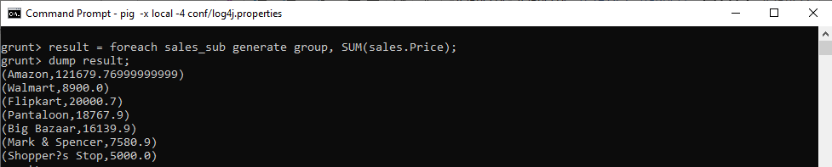

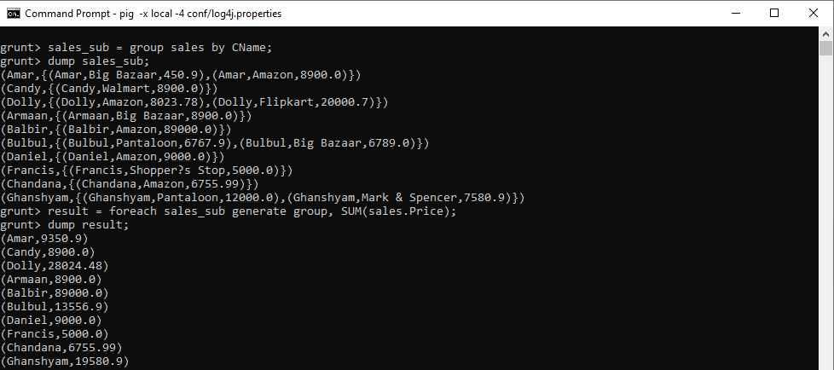

1. **emp.csv**
2. **dept.txt**

