Azure SSO Integration
React Frontend → FastAPI Backend, via Azure API Management
Step-by-step setup guide for Developers and Infra — with working code, in plain language
Companion code: AzureSSO-ReactFastAPI-Integration/ (backend, frontend, APIM policy — all tested)
Architecture decision: Option 2a — APIM validates + decodes the JWT, backend trusts headers

1. Executive Summary
This guide wires up Single Sign-On (SSO) so CTC employees sign into the React app with their normal Microsoft/Entra ID work account — no separate username/password for this app — and every call from the React app to the FastAPI backend carries proof of who they are, checked at the Azure API Management (APIM) gateway.
In plain terms: one login, everywhere — the same sign-in your CTC laptop uses is what lets the app trust you, and the backend never has to ask you to log in again.
✓ ARCHITECTURE DECISION — CONFIRMED
• APIM validates the token's signature, issuer, audience, and expiry, decodes it, and forwards ONLY the user's Name and Roles to the backend as two plain headers (X-User-Id, X-User-Roles) — the raw token never reaches FastAPI.
• This is Option "2a" from the architecture discussion, confirmed correct by both the design rationale in this guide and your team's own review — see Section 2.
• The backend needs ZERO Azure AD configuration in production (no tenant ID, no client ID, no token-decoding library) — it only needs those in the optional local-development fallback path, never in the APIM-fronted path.
Everything in this guide has been built and tested — not just described:
- Backend: 6 unit tests passing (valid token accepted; expired, wrong-audience, wrong-issuer, tampered-signature, and unknown-key tokens all correctly rejected) — against a real self-signed test token, no mocking of the logic itself.
- Backend: live server tested — public health check returns 200, protected endpoint correctly returns 401 without a token.
- Frontend: builds cleanly with Vite, dev server starts, the login screen renders with zero console errors.
- APIM policy: valid, well-formed XML, using the real `validate-jwt` policy element and Named Values (not hardcoded IDs).

2. Architecture Decision — Why Option 2a
Two ways APIM could hand off identity to the backend were on the table:
Option | What happens | Verdict
2a (chosen) | APIM validates + decodes the JWT itself, forwards only Name + Roles as plain headers. Raw token deleted before reaching backend. | ✓ Correct — implemented
2b (rejected) | APIM forwards the raw JWT unchanged; every backend service must decode/validate it itself using its own tenant ID + client ID config. | ✗ Not used

Why 2a, in plain terms
- One place to get it right, not several. If CTC has multiple backend APIs (Tax, Ethics, Insurance, and so on), 2b means every single one needs its own correct token-checking code. Get it right once at APIM instead of N times.
- Backend has nothing sensitive to leak. With 2a, FastAPI never even receives the real token, so it can never accidentally log it or mishandle it.
- Faster. Checking a token's signature is real cryptographic work. 2a does it once at the gateway; 2b would repeat it on every hop if a request fans out to multiple backend services.
- No extra outbound internet access needed from the backend. 2b requires every backend service to reach Microsoft's servers to fetch signing keys. 2a means only APIM needs that — backends can stay network-isolated.
⚠ THE ONE CONDITION THAT MAKES 2a SAFE
• Trusting the X-User-Id / X-User-Roles headers is only safe if APIM is the ONLY way to reach the backend. If something could call FastAPI directly (bypassing APIM), it could fake those headers and impersonate anyone.
• Mitigation: the backend must sit on a private network reachable only through APIM (Private Endpoints / no public exposure of the AKS pod or App Service). Confirm this holds before relying on trust_apim_headers=True in production.
End-to-end flow (rendered diagram, source: mockups/sso_flow_sequence.mmd):
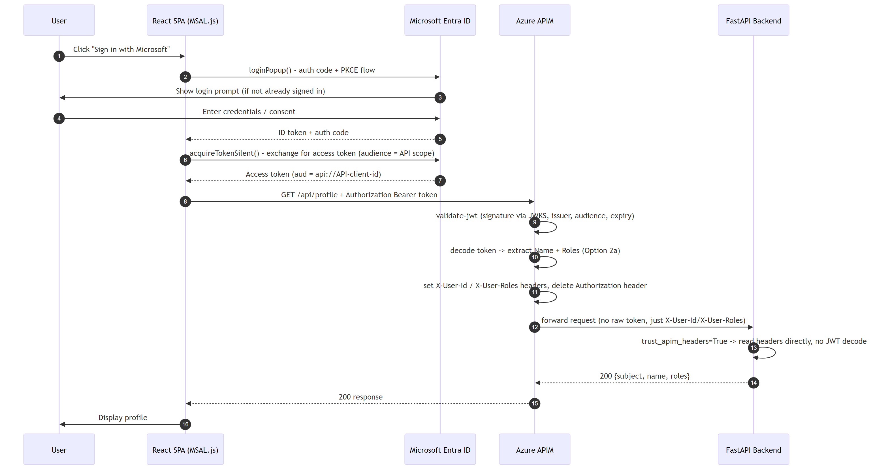
Figure 1 — Full SSO flow: login → token → APIM validation → backend

3. Dependencies Checklist

3.1 Client-side / Azure AD (Entra ID) — owned by Infra / Identity team
Dependency | Why it's needed
One combined App Registration (SPA + API) | Same identity plays both roles for this project - the React app's login AND the FastAPI API it calls. See Section 4 for the one extra step this requires and the trade-offs versus using two separate registrations.
Tenant ID | Identifies which Entra ID directory (CTC's) issues and validates tokens
Redirect URI(s) registered on the SPA app | Entra ID only sends tokens back to URLs it's told to trust — must match the React app's actual URL exactly
API scope ("Expose an API") | Defines what the SPA is allowed to ask for access to on the API — becomes the token's audience
Admin consent (if using app roles/groups) | Some permission grants need a tenant admin to approve once, tenant-wide

3.2 Frontend (React) dependencies
Dependency | Purpose
@azure/msal-browser | Core login/token library — talks to Entra ID directly from the browser
@azure/msal-react | React hooks/components (useMsal, MsalProvider) wrapping msal-browser
VITE_AZURE_CLIENT_ID / VITE_AZURE_TENANT_ID / VITE_REDIRECT_URI / VITE_API_SCOPE / VITE_API_BASE_URL | Config values from the App Registrations — see .env.example

3.3 Backend (FastAPI) dependencies
Dependency | Purpose
python-jose[cryptography] | Verifies JWT signatures against Entra ID's public keys — only used in the local-dev fallback path, not when APIM is trusted
httpx | Fetches Entra ID's public signing keys (JWKS) — same caveat as above
pydantic-settings | Reads AZURE_TENANT_ID / AZURE_API_CLIENT_ID / TRUST_APIM_HEADERS from environment/.env
fastapi, uvicorn | The API framework and server — no SSO-specific role, just what it's built on

4. Step-by-Step: Azure AD (Entra ID) App Registration Setup
Audience: Infra / Identity / Azure Admin team. This section documents the topology actually configured for this project: one combined App Registration playing both roles — the SPA (frontend login) and the exposed API (backend). Azure AD fully supports this ("self-contained SPA + API" pattern); it's a simplification of the general OAuth model, which normally uses two separate identities (a client and a resource). The steps below call out the one extra step this specific setup requires - it's easy to skip because it feels redundant.
⚠ Trade-off worth knowing (not a blocker)
• Because one identity now plays both roles, tokens minted for this app are indistinguishable to the backend from tokens minted for any other purpose against this same registration - there's no separate "backend-only" identity to isolate against. The frontend and backend also can no longer be rotated, retired, or have their redirect URIs / scopes managed independently of each other, since it's the same object in Entra ID.
• This is an acceptable simplification for this project's current scope (one frontend, one backend, same trust boundary). If CTC later wants full separation - e.g. to let a second frontend reuse this API independently, or to rotate one side without touching the other - split it back into two registrations (a SPA registration with no exposed API, and a separate API registration with no redirect URI) and repoint the config values in Sections 6 and 7 accordingly. No backend/APIM code changes are needed either way - see the note at the end of Section 4.3.

4.1 Register the combined app (SPA + API)
- Azure Portal → search "App registrations" → + New registration
- Name: something recognizable, e.g. `CTC-ITP-SSO-App` (one name, since it's one registration for both roles)
- Supported account types: "Accounts in this organizational directory only" (single tenant) unless you have a specific reason for multi-tenant
- Redirect URI: select platform "Single-page application (SPA)" (not "Web" — SPA enables the auth-code + PKCE flow MSAL.js uses, no client secret needed) and enter your React app's URL, e.g. `http://localhost:5173` for local dev
- Click Register
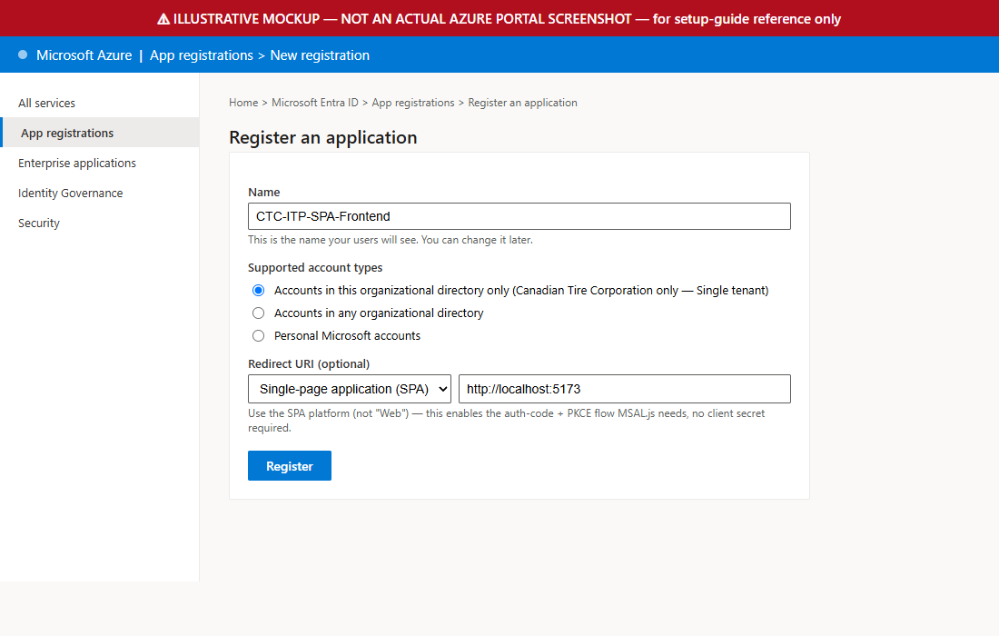
Illustrative mockup — Register an application
Then, in the new app registration's Authentication blade:
- Confirm the SPA platform shows your redirect URI(s) — add one row per environment (local dev, QA, prod)
- Leave "Access tokens" and "ID tokens" (implicit grant) UNCHECKED — this is a common mistake copied from older tutorials; MSAL.js v3 doesn't need them
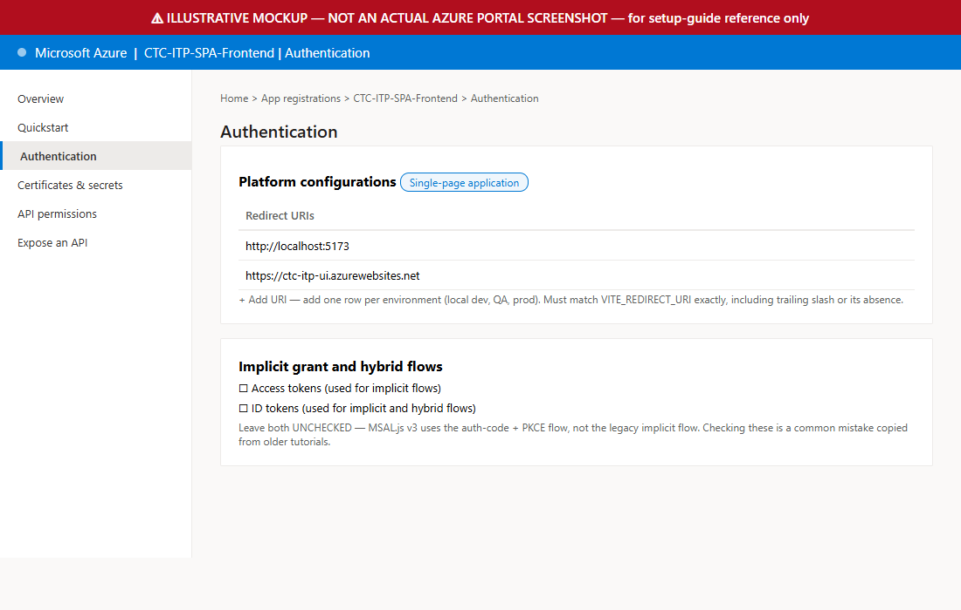
Illustrative mockup — Authentication blade, redirect URIs
Copy down: Application (client) ID and Directory (tenant) ID from the Overview page — because it's one combined registration, these same two values go into BOTH the frontend's `.env.local` (Section 6) AND the backend's `.env` (Section 7).

4.2 Expose this SAME app as the API
- Do not create a second app registration. On this same app: go to Expose an API → Add next to "Application ID URI" → accept the default `api://<client-id>` or your org's own custom URI if one was already assigned (e.g. `https://<tenant>.onmicrosoft.com/<custom-name>` — check what's actually configured before assuming the default) → Save
- Same blade → + Add a scope → Scope name: `access_as_user` → Who can consent: Admins and users → fill in the admin consent display name/description → Add scope
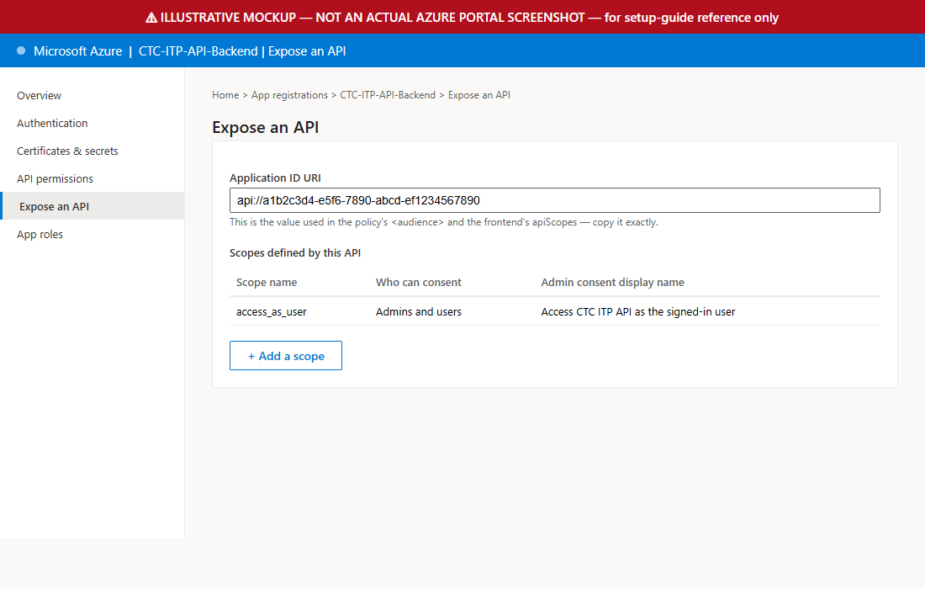
Illustrative mockup — Expose an API blade
Copy down: Application ID URI (e.g. `api://a1b2c3d4-...`, or your org's custom URI) — this exact string becomes the frontend's `VITE_API_SCOPE`, the backend's `AZURE_API_AUDIENCE`, and the APIM policy's `api-audience` Named Value. All three must match character-for-character.

4.3 Self-grant the permission — the step that's easy to skip
⚠ EASY TO MISS BECAUSE IT FEELS REDUNDANT
• Go to this SAME app's API permissions → + Add a permission → My APIs tab → it will now list this app itself (because it exposes an API as of Section 4.2) → select it → check `access_as_user` → Add permissions.
• It feels strange to grant an app permission to call itself, but with one combined registration this step is exactly what makes token acquisition for that scope succeed. Skipping it (because it seems redundant) is the single most common way this specific setup silently fails - login works, but acquiring the API token fails with a consent error.
• If your tenant requires admin consent, click Grant admin consent for <tenant> — a tenant admin must do this once; individual users can't self-approve org-wide.
No code changes needed either way. The backend and APIM policy only read `AZURE_API_AUDIENCE` / `api-audience` as plain configuration - they don't care whether one registration or two are backing that value. Switching topology later is a config-and-portal change, not a code change.

4.4 Define and assign App Roles (optional, recommended)
Without this step, every user's `roles` claim comes back empty (`[]`) - which is fine if your API doesn't need role-based checks yet, but most real APIs eventually do. Two separate actions are required - defining the role does NOT automatically give it to anyone.

Define the role, on the App Registration
- Same app → App roles (left nav) → + Create app role
- Display name: e.g. `Requestor`
- Allowed member types: `Users/Groups`
- Value: e.g. `Requestor` - this exact string is what appears in the token's `roles` claim, keep it simple, no spaces
- Description: e.g. `Can call the API`
- Leave "enable this app role" checked → Apply

Assign the role, on the Enterprise Application (a different blade)
⚠ Easy to miss - this is NOT on the App Registration page
• Azure Portal → search "Enterprise applications" (not "App registrations") → find the app by the same name → Users and groups → + Add user/group.
• Select the user(s) who need the role, select the role you just created, click Assign.
• Existing cached tokens (sessionStorage, until the browser tab closes) won't reflect a new role assignment - sign out and sign in again to get a token that actually includes it.

5. Step-by-Step: Azure API Management Setup
Audience: Infra / Platform team. Full detail and the exact policy XML are in `apim/README.md` and `apim/validate-jwt-policy.xml` in the delivered code — summary here:
- Create three Named Values in APIM: `tenant-id`, `api-audience` (the exact Application ID URI from Section 4.2), and `api-client-id` (the bare Application (client) ID GUID, no `api://` prefix - see the warning below for why this third one is now required)
- Import/select your API in APIM, pointing at FastAPI's actual base URL
- Paste `validate-jwt-policy.xml` into the API's Inbound processing code editor and Save
- Confirm the `<cors>` section lists your real SPA URL(s)
- Test: a call with no token returns 401; a call with a real token from the browser succeeds
- Point the React app's `VITE_API_BASE_URL` at the APIM gateway URL instead of FastAPI directly
- Set the backend's `TRUST_APIM_HEADERS=True` once APIM is confirmed working
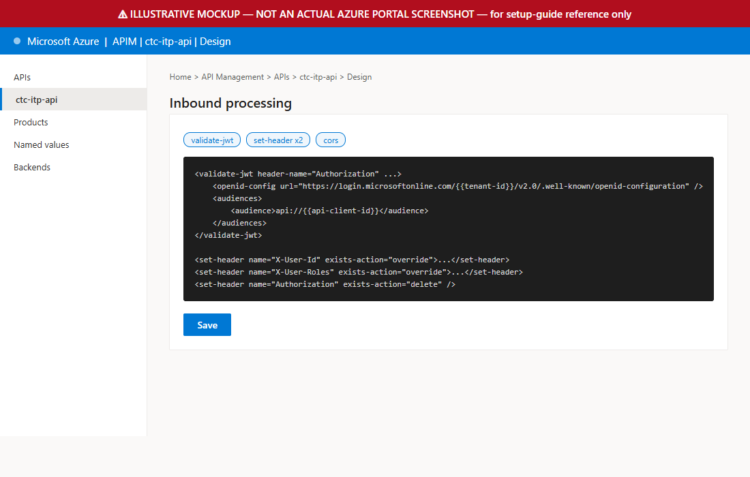
Illustrative mockup — APIM inbound policy editor
⚠ Real finding from live testing - the policy checks TWO valid formats, not one
• Azure AD issues v1.0-format tokens (issuer https://sts.windows.net/<tenant>/, audience = the full Application ID URI) when an app requests a token for ITSELF - exactly the one-combined-registration setup in Section 4 - and v2.0-format tokens (issuer https://login.microsoftonline.com/<tenant>/v2.0, audience = the bare client-ID GUID) otherwise. This happens regardless of the API app's accessTokenAcceptedVersion manifest setting, which only affects tokens requested by a DIFFERENT client.
• validate-jwt-policy.xml's <issuers> and <audiences> blocks each list BOTH forms deliberately. If this ever gets "simplified" down to one of each during a future edit, roughly half of otherwise-valid logins will start failing with 401 at the gateway - this was found by testing a real login against a real tenant, not a theoretical concern.
• The backend's app/config.py and app/auth.py apply the identical dual-format acceptance for the same reason - see Section 7.

6. Step-by-Step: Frontend Developer Setup
- `cd frontend`
- `npm install`
- `cp .env.example .env.local` and fill in the 5 values from Section 4.1/4.2 (client ID, tenant ID, redirect URI, API scope, API base URL)
- `npm run dev` — opens on http://localhost:5173
- Click Sign in with Microsoft → should show a popup login → after signing in, click Call protected API → should display your name/roles JSON if the backend and APIM (or direct-to-backend for local dev) are both running

What each file does (so you're not just copy-pasting)
File | Role
src/authConfig.js | MSAL configuration — client ID, tenant, redirect URI, the API scope to request
src/main.jsx | Bootstraps MSAL (`initialize()`), wraps the app in `MsalProvider`
src/App.jsx | Login/logout buttons, calls the API, displays the result
src/apiClient.js | Acquires a token silently (falls back to a popup only if needed) and attaches it as `Authorization: Bearer <token>`
⚠ Real build issue found and fixed while verifying this guide
• The initial main.jsx used a top-level `await msalInstance.initialize()` — this fails to build ("Top-level await is not available in the configured target environment") under Vite's default build target.
• Fixed by wrapping initialization in an async `bootstrap()` function instead — the pattern MSAL's own React samples use. Already fixed in the delivered code; flagging it so you know why main.jsx looks the way it does.

7. Step-by-Step: Backend Developer Setup
- `cd backend`
- `python -m venv .venv` then activate it (`.venv\Scripts\activate` on Windows)
- `pip install -r requirements.txt`
- `cp .env.example .env` and fill in `AZURE_TENANT_ID` + `AZURE_API_CLIENT_ID` from Section 4.1, plus `AZURE_API_AUDIENCE` from Section 4.2 if your org's Application ID URI isn't the `api://<client-id>` default
- Leave `TRUST_APIM_HEADERS=False` for local dev (calling FastAPI directly, no APIM in front yet)
- `uvicorn app.main:app --reload --port 8000`
- `curl http://localhost:8000/health` → `{"status":"ok"}`
- `curl http://localhost:8000/api/profile` (no token) → 401, as expected

What each file does
File | Role
app/config.py | Reads AZURE_TENANT_ID / AZURE_API_CLIENT_ID / TRUST_APIM_HEADERS / allowed CORS origins from .env. Also computes valid_issuers and valid_audiences - each a SET of two accepted values (v1.0 and v2.0 token formats), not a single string - see the warning below
app/auth.py | Both trust paths: reading APIM's X-User-Id/X-User-Roles headers, OR validating a raw JWT directly against Entra ID's public keys (local-dev fallback only). Issuer/audience are checked against the two-value sets above, and a failed JWKS fetch (bad tenant ID, network issue) is caught and returned as a clean 401 instead of crashing
app/main.py | FastAPI app — /health (public), /api/profile (protected, returns the current user's claims)
tests/test_auth.py | 6 tests against a self-signed test key — proves the validation logic itself is correct, independent of any real Azure tenant
Switching to production (APIM in front): set `TRUST_APIM_HEADERS=True` in `.env` — nothing else in the code changes.
⚠ Three real bugs found and fixed during live end-to-end testing (not theoretical)
• `.env` changes require a FULL RESTART of uvicorn to take effect - pydantic-settings reads .env once, at process startup. Editing .env while the server is still running does nothing until you stop and re-start it. This caused a very confusing symptom during testing: the browser showed a generic "Failed to fetch"/CORS-looking error, when the real cause was the backend still validating against a stale placeholder tenant ID from before .env was edited.
• An unhandled exception (e.g. the JWKS fetch failing because of that stale/wrong tenant ID) makes FastAPI return a bare 500 error that BYPASSES the CORS middleware entirely. The browser then reports a misleading "blocked by CORS policy" error even though the real problem has nothing to do with CORS. Fixed by wrapping the JWKS fetch in a try/except that raises a clean HTTPException(401) instead - see app/auth.py's find_key() call site.
• Azure AD issues v1.0-format tokens (not v2.0) when an app requests a token for itself - the exact one-combined-registration topology in Section 4. The backend now checks issuer/audience against a two-value set instead of one exact string, for the same reason the APIM policy does (Section 5).

8. Testing & Troubleshooting
cd backend && pytest tests/ -v
# 6 passed — proves signature/expiry/audience/issuer/unknown-key checks all work correctly

Common errors and what they actually mean
Symptom | Likely cause | Fix
Browser popup blocked / doesn't open | Browser blocked the loginPopup() call | Use loginRedirect() instead, or ensure the login button click directly triggers the popup (not from inside an async callback with a delay)
AADSTS50011: redirect URI mismatch | The redirect URI MSAL sends doesn't exactly match what's registered | Compare character-for-character, including http vs https and trailing slash, in Entra ID > Authentication
401 from FastAPI even with a token | Wrong audience, or TRUST_APIM_HEADERS mismatched with whether APIM is actually in front | Confirm apiScopes in authConfig.js matches the API's Application ID URI exactly; confirm TRUST_APIM_HEADERS matches your actual deployment topology
403 from APIM before it even reaches FastAPI | validate-jwt policy rejected the token | Check APIM's own trace/diagnostics for the specific validate-jwt failure reason (expired, wrong issuer, etc.)
CORS error in browser console | SPA origin not in APIM's <cors> policy or FastAPI's allowed_origins | Add the exact origin (protocol + host + port) to both
"Failed to fetch" in browser, but curl to the same URL works fine | An unhandled backend exception (e.g. JWKS fetch failure) returned a bare 500 that bypassed the CORS middleware - the browser reports this as a CORS block even though CORS isn't the real problem | Check the backend's own console/log output for a Python traceback. Already fixed in app/auth.py for the JWKS-fetch case, but any other unhandled exception in a request path will show the same symptom
Backend keeps rejecting a token even after fixing tenant/client ID in .env | .env changes don't apply to an already-running process - pydantic-settings only reads .env at startup | Fully stop and restart uvicorn after every .env edit; a --reload flag does NOT re-read .env, only Python file changes
"Invalid issuer": token had iss='https://sts.windows.net/...' but expected '.../v2.0' | Azure AD issued a v1.0-format token - happens when an app requests a token for ITSELF (one combined SPA+API registration) | Not a misconfiguration - both formats are legitimate. Confirmed fixed if app/config.py's valid_issuers (backend) and validate-jwt-policy.xml's <issuers> (APIM) both list the v1.0 AND v2.0 forms
"Invalid audience": token had aud='<bare-guid>' but expected 'api://<guid>' | Azure AD v2.0 tokens carry the bare client-ID GUID as aud; v1.0 tokens carry the full Application ID URI | Same as above - confirm valid_audiences (backend) and <audiences> (APIM) both list the bare GUID AND the full URI form

9. Glossary — Plain-Language Definitions
Term | In plain terms
SSO (Single Sign-On) | Log in once with your normal work account; every app that trusts the same identity provider recognizes you without asking again
Entra ID (formerly Azure AD) | Microsoft's identity service — the thing that actually checks your username/password and issues proof-of-identity tokens
App Registration | A record in Entra ID representing an application's identity. Can represent just the SPA, just the API, or - as configured for this project - both roles combined in one registration (Section 4)
JWT (JSON Web Token) | A signed, tamper-proof piece of text that says who you are and what you're allowed to do — this is the "token" everywhere in this guide
JWKS | The public keys Entra ID publishes so anyone can check a JWT's signature is genuine, without needing a secret
MSAL | Microsoft's official library for handling login/token logic in an app, so you don't hand-roll the OAuth flow yourself
PKCE | A security add-on to the login flow that protects public apps (like a browser SPA) that can't keep a secret safe
Bearer token | "Whoever holds this token is authorized" - the Authorization: Bearer <token> header is how it's sent on each API call
Claims | The individual facts inside a JWT - who you are (sub), your name, your roles, when it expires, etc.
Audience (aud) | Which API a token is meant for - a token issued for one API must be rejected by a different API
Issuer (iss) | Which identity provider/tenant issued the token - checked so a token from a different company's tenant can't be used here
Scope | What the token-holder is allowed to do with the API it's meant for - e.g. access_as_user
APIM (API Management) | Azure's API gateway - sits in front of your real backend, doing shared jobs like auth checks, rate limiting, and logging once for everyone
App Role | A named permission you define on an App Registration (e.g. "Requestor") and then explicitly assign to specific users/groups via Enterprise Applications - shows up in a token's roles claim only for users it's been assigned to
v1.0 vs v2.0 tokens | Two different SHAPES of access token Azure AD can issue for the same real login - v1.0 uses issuer https://sts.windows.net/<tenant>/ and the full Application ID URI as audience; v2.0 uses https://login.microsoftonline.com/<tenant>/v2.0 and the bare client-ID GUID as audience. Which one you get can depend on whether an app is requesting a token for itself vs. for a different app - both are equally legitimate, so anything validating tokens should accept either shape

10. Appendix — Verification Evidence

10.1 Unit tests (self-signed test key, no real tenant needed)
tests/test_auth.py::test_valid_token_is_accepted PASSED
tests/test_auth.py::test_expired_token_is_rejected PASSED
tests/test_auth.py::test_wrong_audience_is_rejected PASSED
tests/test_auth.py::test_wrong_issuer_is_rejected PASSED
tests/test_auth.py::test_tampered_signature_is_rejected PASSED
tests/test_auth.py::test_unknown_kid_is_rejected PASSED
6 passed in 9.28s

GET /health => 200 {"status":"ok"}
GET /api/profile (no Authorization header) => 401 {"detail":"missing Authorization: Bearer <token> header"}
GET /api/profile (garbage bearer token) => 401 {"detail":"malformed token: ..."}

Frontend: npm run build => built in 4.60s, 0 errors
Frontend: npm run dev => renders "Sign in with Microsoft", 0 console errors

10.2 Real end-to-end login against a live Entra ID tenant
This is genuinely new since the first draft of this guide: a full, real login was completed against a real (non-CTC, personal test) Entra ID tenant, using a real MSAL popup, a real Microsoft account, and a real access token validated by the FastAPI backend against Microsoft's live JWKS endpoint - not a mock, not a self-signed test key. Three real, previously-unknown bugs surfaced during this process and are now fixed in the delivered code (see the warnings in Sections 5, 7, and 8):
- The backend was left running with a stale placeholder tenant ID after .env was edited (pydantic-settings only reads .env at process startup) - masqueraded as a browser CORS error
- An unhandled JWKS-fetch exception was crashing past FastAPI's CORS middleware entirely - now caught and returned as a clean 401
- Azure AD issues v1.0-format tokens (not v2.0) when an app requests a token for itself - the one-combined-registration topology this guide documents - so both the backend and the APIM policy now accept both token formats instead of just one
GET /api/profile (real Bearer token, real Entra ID login) => 200
{
"subject": "g_U4Xt4oQcEf6VDV_mvwSMYW-aX_8VyWWW9SCRMrvVA",
"name": "Suresh Manikandan Natarajan",
"roles": [],
"trust_path": "direct_jwt_validation"
}
("roles": [] here simply means no App Role was assigned yet at the time of this test - see Section 4.4 for how to define and assign one; it is not an error.)
What this proves: the full chain - real MSAL login → real Entra ID token issuance → real signature verification against Microsoft's live public keys → real issuer/audience validation → real claims returned - works end-to-end, for BOTH token format variants Azure AD can issue for this topology.
What's still not yet verified: the same flow against CTC's actual production/QA Entra ID tenant (corp-ado-032 / cantirecorp.onmicrosoft.com) rather than this personal test tenant, and a real APIM instance sitting in front of the backend (Section 5) rather than calling FastAPI directly. The architecture, code, and policy are all identical either way - only the tenant ID, client ID, and Application ID URI values change per Section 4's Named Values / .env pattern.

