**North South University**



**Project Proposal**

**Online Job Vacancy Web application**

**Course: CSE 299**

**Section: 02**

**Faculty: SAS3**

**Semester: Spring 2019**

**Group no: 03**

**Group members:**

Name ID

1.Md. Rayyan Zaman 1510452042 rayyan.zaman@northsouth.edu

2.Anika Ferdausy 1512232042 anika.ferdausy@northsouth.edu

3.Hasib Mahmud 1621065042 hasib.mahmud@northsouth.edu

**Topic: Web application for online Job market**

**Description:**

Main purpose of our web app is to make it easier for mass people to find jobs easily. Our web app will have different kinds of job sectors like IT, Corporate, Teaching etc. People can browse through different jobs of different categories. Our web app will going to have three kinds of users: **Admin**, **employer** and **job seekers**. Admin will hold the power to control it. Employer is going to post job circulars to hire employee, manage job posts. Job seekers will scroll through their desired jobs and apply. And this web app will be able to maintain connection between the company/employer and job seekers.

**Problems:**

Now a days finding a job is one of the biggest problem. Also the unemployment rate is increasing day by day. We don’t really have so many job related websites that actually works. Other website has so many bugs in it. They don’t really work well. Their User Interfaces (UI) are complex. This is the main reason people lose interest on their websites just after surfing few minutes.

**Problem solving:**

We are going to solve all these problems we mentioned. Our web app will provide a good simple user interface. And also the system will make it easier for the job seekers to find their desired jobs.

**Technology Used:**

**Backend:**

*Framework*- Laravel

*Language- PHP*

*Database- MySQL*

**Front End:**

*Framework*- Bootstrap

*Language*- Javascript , CSS

Home Page

Sign up

Register as a Candidate:

Candidates needs email address and password to register.

Register as Job board:

Companies will have to provide email address and password to create their job post.

Sign in:

Whenever the candidate or job board sign in with their email and password they will be redirected to the corresponding account home page.

FAQ:

It will contain generally asked questions on how to sign up, upload and download.

Account Home

Candidate Profile:

It will contain specific information about the candidate .Candidate will be able to upload resume.

Job Board Profile:

It will contain information about the company, there will be option to post vacancy and another option to view the candidate resume who had applied for the job. Candidates can also see the provided information of a certain company.

Account Information:

This will contain personal information and account related information. Hence there are two different user Candidate and Job board so there will be two different account information.

Edit Account Information:

Candidates and Job boards will able to edit their account information. Also there will be option to delete account.

Job Board view:

It will contain the following options.

1.Post Vacancy:

Companies will be able post job vacancy in this option. Also if the company wants to put their recruitment at the top of the list they will be able to pay the web app authority through mobile banking .

2.View applied candidate profile:

Job board can see the applied candidate profile at anytime.

3.Send confirmation message:

Companies can send messages to the applied candidate.

4.Edit account information:

Companies can edit their information and update their profile. Also they will be able to delete their account.

5.Log Out:

Job board can log out any time from the web application.

6. Password Reset:

Job board can reset their password with the mail address they have registered

Candidate view:

It will contain the following options.

1.Upload resume/CV:

Candidate can upload their CV and resume and update it.

2.New message:

Candidate can get recent message notifications

3.View message:

Candidate can view their message history.

4.Search Job:

Candidate can search jobs according to their choice.

5.Log Out:

Candidate can log out any time from the web applications.

6.Password Reset:

Candidate can reset their password with the mail address they have registered

Public view:

Home page:

Whenever anyone hits this web application they will see the following options.

Information:

It will have a detail information about the web application and how to use it.

Log in:

It invokes the log in module for the registered users.

Register:

It redirects the user to the following pages depending of their type.

1.Job Board register

2.Candidate Register

Revenue Model:

Problems To Find Job:

Now a days finding job is much more stressful since politics dominates in every sector. Most of the other web sites do not give user friendly experience .But this web app will provide sufficient information about job vacancy from every job sector according to the candidates qualifications.

Creating Customer Value:

This web app’s first concern is to satisfy existing needs of the user. Candidates will be reportedly updated with the new Job postings. Hence there will be categories of Jobs that will match the candidate’s qualification and will show those jobs first.

There will be new option added in future progress of the application to satisfy according to user needs.

Public View Advertising:

Ads per minute served:1$

Ads per hour served:20$

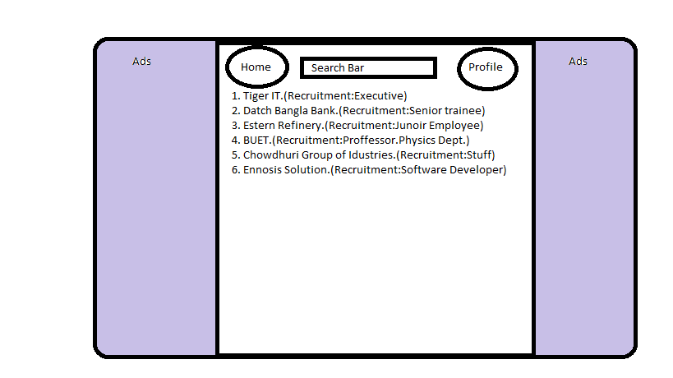

Paid Job ads:

Companies will have to pay to promote their circular top of the Job list.

Per Week payment: 50$

Per Month:70$