

Project Proposal on

**“Pizza Ordering App”**

Prepared by: <**Group-7**>

**Limon Motin** – **1620902042**

[limon.motin@northsouth.edu]

**Md. Golam Rabby Shuvo** – **1620044042**

[golam.shuvo@northsouth.edu]

Submitted to:

**Shaikh Shawon Arefin Shimon (SAS3)**

**CSE299 – Junior Design Course**

**Spring 2019**

Section: **4**

**19.03.2019**

**Abstract**

A pizza restaurant also known as quick service restaurant (QSR) within the food service industry is a specific type of restaurant characterized both by its pizza cuisine and by minimal table service. Food served in pizza restaurants is offered from a limited menu, cooked after ordering, packaged for order and is usually available ready for pickup or to be delivered though seating may also be provided. Some restaurants have the provision of customers making a call to the restaurant in advance to order a pizza to be ready for them for pick or to be delivered to them.

This project is aimed at developing a complete online ordering system app for use in the food service industry which will allow the restaurants to quickly and easily manage an online menu which customer can browse and use to place orders with just a few clicks. The customers will have to choose whether they want the food to be delivered to them and the payment method will be upon delivery or online payment.

The development of this system will be based on Android Studio with JAVA as the programming languages while Firebase Database as the database of the system.

**Table of Contents**

**1. Introduction……….…………………………………………………….1**

**2. Literature Overview……………………….….……………….……...2**

**2.1 Motivation****…………………………….……………………......2**

**2.2 Objectives……….……....…….……………………………....2**

**2.3 User Justification…….……....…….……….….…………....2**

**2.4 Project Scope………………………………….………….…...3**

**2.5 Project Limitation****……………………………….….….….….4**

**3. Methodology…………………….…….….……….…………………….5**

**3.1 How This System Works………………….….………………5**

**3.2 Project Diagram…………….………….…………………......5**

**4. Requirements………………….….…………………………………….6**

**4.1 Hardware Requirements………….………………….………5**

**4.2 System Requirements……………….……………..............6**

**5. Planning………………………………………………….....................7**

**5.1 Gantt Chart………………….….……………………………….7**

**5.2 Process Model………………….….……………………………8**

**6. Conclusion………………….….……………………………………….8**

**7. References………………………….………….….……………………8**

**1. Introduction**

Life in the 21st century is full of technological advancement and in this technological age it is very difficult for any organization to survive without utilizing technology. In today’s age of fast food and take-out, many restaurants have chosen to focus on quick preparation and speedy delivery of orders rather than offering a rich dining experience. Until very recently, all of these delivery orders were placed over the phone call.

This Pizza Ordering App is based on a concept of making pizza orders and payments. Here, the user can login, select pizza sets, quantity and proceed towards payment. Other features include viewing full payment receipt which includes each and every detail. Prices will be displayed in BDT currency. This mini project contains limited features, but the essential ones.

Talking about the features of the Pizza Ordering System, a user can view all the sizes in the order menu with their respective prices and select among them. Then the user has to make custom pizza to proceed towards payments. The system displays the total amount and the user has to pay the amount equivalent to his/her total cost or more than that via online or cash on delivery. After all these, the system asks whether to display payment receipt or not. If the user presses yes then the payment receipt is displayed which includes date, phone number, order number, cashier’s name and description with total quantity, price and amount.

In this system, the user can place an order by selecting the Pizza size, Crust, and various Toppings. The layout design will be simple and it can be used in different gadgets like tablets, smartphones & even smart televisions. This mini project is not difficult to use, operate and understand by the users. We will develop this Pizza Ordering App using Java Programming Language and different software tools will also be used for the development of it.

Moreover, this project will provide the simplest system for managing pizza orders and payment in a restaurant.

**2. Literature Overview**

**2.1 Motivation**

With the rapid development of information technology, web application and

Android application have been increasing in recent years. Compared with the

Desktop application, the advantages of the Android application are as follows:

- Mobile application is convenient to carry

- Global partnerships and large install base

- Powerful development framework

- Open marketplace for distributing apps

Based on the advantages of android applications, we motivated ourselves to develop a project on Android application.

The whole world is in love with pizzas. The billions of dollars earned by different pizzerias across the globe just prove this. Meanwhile, with the number of customers increasing, the new problem occurs. Because the space of the restaurant is limited, the restaurant can only serve a certain number of customers at the time.

Therefore, the full customer resource cannot be utilized. Mobile Pizza Ordering Application is the key to solve this problem. Using this application, the customers need not go to the restaurant by themselves, but they can order the pizzas through Android mobiles anywhere. As the internet users are increasing exponentially, many companies have introduced Online Pizza ordering system for taking orders from customers.

This system also greatly lightens the load on the restaurant’s end, as the entire process of taking orders is automated. This system not only improves customer’s experience but also eases the workload on the staff of pizzerias. This allows restaurant stuffs to quickly go through the orders as they are placed and produce the necessary items with minimal delay and confusion.

**2.2 Objectives**

**Build your own pizza -** This system will help customers in ordering custom pizzas. So, the customer will pick exactly the things which he/she wants in his/her pizza. This will surely enhance the image of the pizzeria and customer satisfaction will be more.

**Online Payment -** This system will give the option to the customer for online payment. This will make pizza buying experience cash free.

**Better Knowledge -** This system will provide customer all the details of his order before making the order. This confirmation will help customers to check the items ordered with their prices.

**Know Delivery Time -** This system will show the time by which the order will be delivered to the customer. For pick-ups, customers can fix the time by which they will pick their order.

**Reduce Paper Work -** As most of the things will be performed online, it will reduce the usage of paper for the pizzeria.

**Improves Efficiency -** This system will make things easier for staff as whole ordering process is done by the customer only.

**2.3 User Justification**

The system will be designed to be user friendly. The user friendly and interactive interfaces design help to achieve this by enabling customers to easily browse through the menu and place orders with just a few clicks. The system will be simple to use. The user can increase efficiency by shortening the purchasing time and eliminating paper work like receipts through online transaction. This system will increase customer satisfaction by speeding up food delivery.

**2.4 Project Scope**

The scope of the proposed system will be based on the features and functionalities proposed for pizza restaurant which is located in Bashundhara R/a. Online pizza ordering system will be an android based application whose main language of programming will be Java. Its main aim is to simplify and improve the efficiency of the ordering process for both customer and restaurant, minimize manual data entry and ensure data accuracy and security during order placement process. Customers will also be able to view product menus and their ingredients and be able to have a visual confirmation that the order was placed correctly.

Since the Internet is booming, having an online ordering system can boost sales to some extent as it eases customers to place an order for the company's services. Customers can place orders from their home as long as they have an android phone with Internet connection. Customer can order pizza online once he signs in if it is the first time to use the service, and his or her information will be saved in the database. For the other times he or she will only use the same information to order.

**2.5 Project Limitation**

* Requires internet connection and also the user must be android phone literate.
* The set back of the system is that the customers targeted are adults with access to android phone while the minors might have to go physically to the restaurant to purchase the pizza that they want or order pizza with the help of an adult.
* The other limitation is that the system will only be convenient to people with a small geographical region, basically just around the restaurant i.e. can only help a small area.
* Time also falls among the challenges of completing this system, because only few months are provided to complete this project, i.e. just about three months which makes it tough because other courses are also needed to be taken care of. Therefore, time limit is one of the major challenges for this project.

**3. Methodology**

**3.1 How This System Works**

Whenever a customer visits the mobile application of the pizza ordering system, he/she will have to sign-up/ login. The customer has to provide his/her details like name, phone number, address into the registration field. After successfully logging in, the menu will be visible to the customer with the pizza customizations and other non-pizza products on offers. All the ingredients will be shown along with their prices.

Next, the customer will customize his pizza and make changes in the ingredients if he wishes for and select the quantity for it. After selecting the items to be ordered, the customer will select the type of drop-off process whether it will be a home delivery or a pick up.

Lastly, the payment option will be shown to the customer. He/she will choose from the various online payment methods or cash on delivery option. After this process, the order is made and the customer is notified about the time by which the pizza will be delivered to them.

**3.2 Project Diagram**

The proposed ER diagram for online pizza ordering system is shown below.

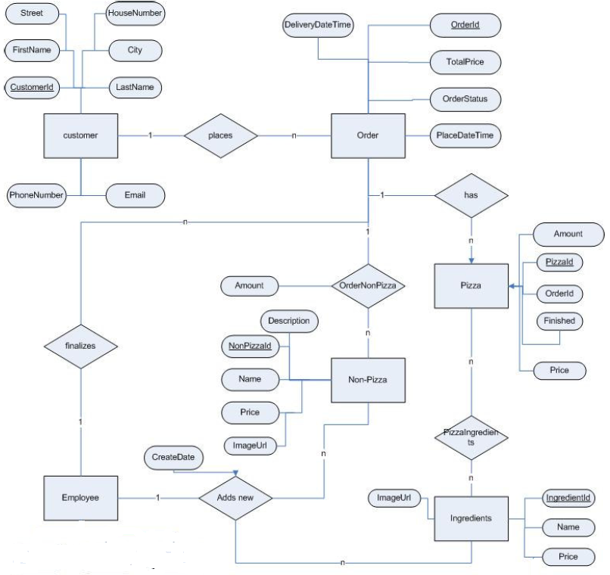

**4. Requirements**

**4.1 Hardware Requirements**

* **Processor:** Intel dual core or above
* **Processor Speed:** 1.0GHZ or above
* **RAM:** 1 GB RAM or above
* **Hard Disk:** 20 GB hard disk or above
* **Mobile:** Android phone
* USB flash disk (At least 2GB)

**4.2 Software Requirements**

* **Operating system:** Windows XP / windows 7 and Android
* **Technology:** Java language
* **Database:** Firebase
* Java sdk
* Android studio
* Github
* Slack
* Trello

**5. Planning**

**5.1 Gantt Chart**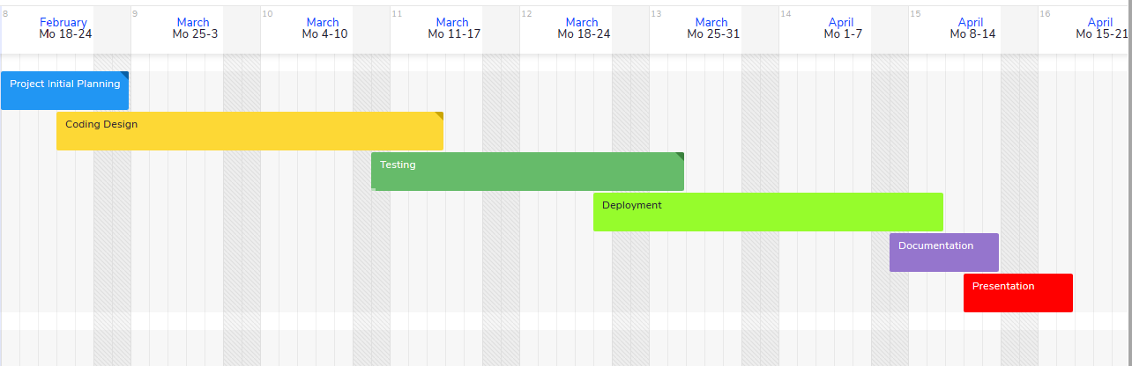

**5.2 Process Model**

For this project we have planned to use waterfall as a process model. The waterfall model is a sequential design process, often used in software development processes, in which progress is seen as flowing steadily downwards (like a waterfall) through the phases of Conception, Initiation, Analysis, Design, Construction, Testing and Maintenance.

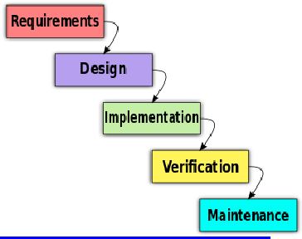

**6. Conclusion**

This was all about online pizza ordering system. Everyone may know the importance of this system in our day-to-day lives as we all prefer online ordering over ordering on phone.

This system greatly lightens the load on the restaurant’s end as the entire process of taking orders is automated. Once an order is placed on the app, it is entered into the database and then retrieved, in pretty much real-time. The restaurant can quickly go through the orders as they are placed and produce the necessary items with minimal delay and confusion.

This project is not difficult to use, operate and understand by the users. Design of this project is pretty and responsive so that user won’t find it difficult to understand, use and navigate. This project provides the simplest system for managing pizza orders.

**7. References**

* Landau, Peter. “Project Scope 101.” ProjectManager.com, ProjectManager.com, 1 Feb. 2019, Redirecting from <https://www.projectmanager.com/blog/project-scope>.
* “Project Proposal Template Sample”, MyCourses, Redirecting from <https://mycourses.aalto.fi/mod/page/view.php?id=26348>.
* Waliaula, Brian. “ONLINE ORDERING SYSTEM PROJECT PROPOSAL.” Academia.edu - Share Research, Redirecting from <https://www.academia.edu/4935972/ONLINE_ORDERING_SYSTEM_PROJECT_PROPOSAL>.