**NORTH SOUTH UNIVERSITY**

**CSE 299 Section 08**

**Orange**

Project Feature Description

**Instructor**SHAIKH SHAWON AREFIN SHIMON (SAS3)

**Due Date  
2nd** May 2019, **Thursday**

**Group Members**

SYEDA SUMIA JABIN NOWRIN **151 1392 042**syeda.jabin@northsouth.edu

ISRAT JAHAN **162 0565 042**israt.jahan03@northsouth.edu

TANZIM AL DIN AHMED **162 1203 042**tanzim.din@northsouth.edu

**Links to Repositories**

**GitHub Repository**

<https://github.com/nsuspring2019cse299sec8/Group3>

**Slack Channel**

<https://nsusp19cse299s08g03.slack.com/messages/CG96RBC1G/>

**Trello Board**

<https://trello.com/b/XVLhbz4u/nsusp19cse299s08g03>

**Gantt Chart**

<https://prod.teamgantt.com/gantt/schedule/?ids=1489616&onload=highlight-task,54409356#&ids=1489616&user=&custom=&company=&hide_completed=false&date_filter=&color_filter=>

(we could not integrate this feature properly)

**Online Fashion Store**

In this growing world of technology, it is now a matter of seconds for a company to reach out to their customers with their brand-new line of products. Online shopping is now a key part of the business industry because of its popularity among the customers in the national and international market, and also how easy it is for a company to display their products to a customer sitting anywhere around the globe. Many companies have more than doubled their revenues just by integrating ecommerce into their business. Customers, on the other hand, not only gets attracted because online shopping is convenient, but also because they can now have broader selections, can view and compare the pricing, or can easily have access to much more information about a product.

Our hypothetical company is also taking its step towards this modern era of marketing by introducing their first ecommerce website, an Online Fashion Store, where they would showcase their latest fashion wears, like apparels, traditional, formal wears etc. to the millions of customers worldwide. Since this is a highly competitive market, to attain a sustainable position in the market and mark itself as a reputative brand with their high-quality products, our task would be to guide the company so that it can provide a seamless, unique and immersive shopping experience to its customers.

The website would be open for any customer to view the products and pricing but only allow registered users to perform any purchase. To register, customers would have to provide with their basic information and phone numbers and passwords for their new accounts. Their phone numbers, with certain modification, would be set as their user id to log into their accounts. Once registered, customers can enjoy the full shopping experience the website would provide by simply logging into their respective accounts.

The administration would have complete access to the website (except confidential data of the customers). They can add or remove administrators, can modify the contents of the website, would be able to reset the password of a customer in case of forgotten password, can view the financial statement, the monthly / yearly revenues; thus, would be able to monitor the whole system.

**Feature Description**

**Home Page**

The homepage showcases some of the latest fashionwear offered by the company; and links to Register of Login are displayed in the middle of the page to prompt the new users that they must login to experience all the features provided by the website.

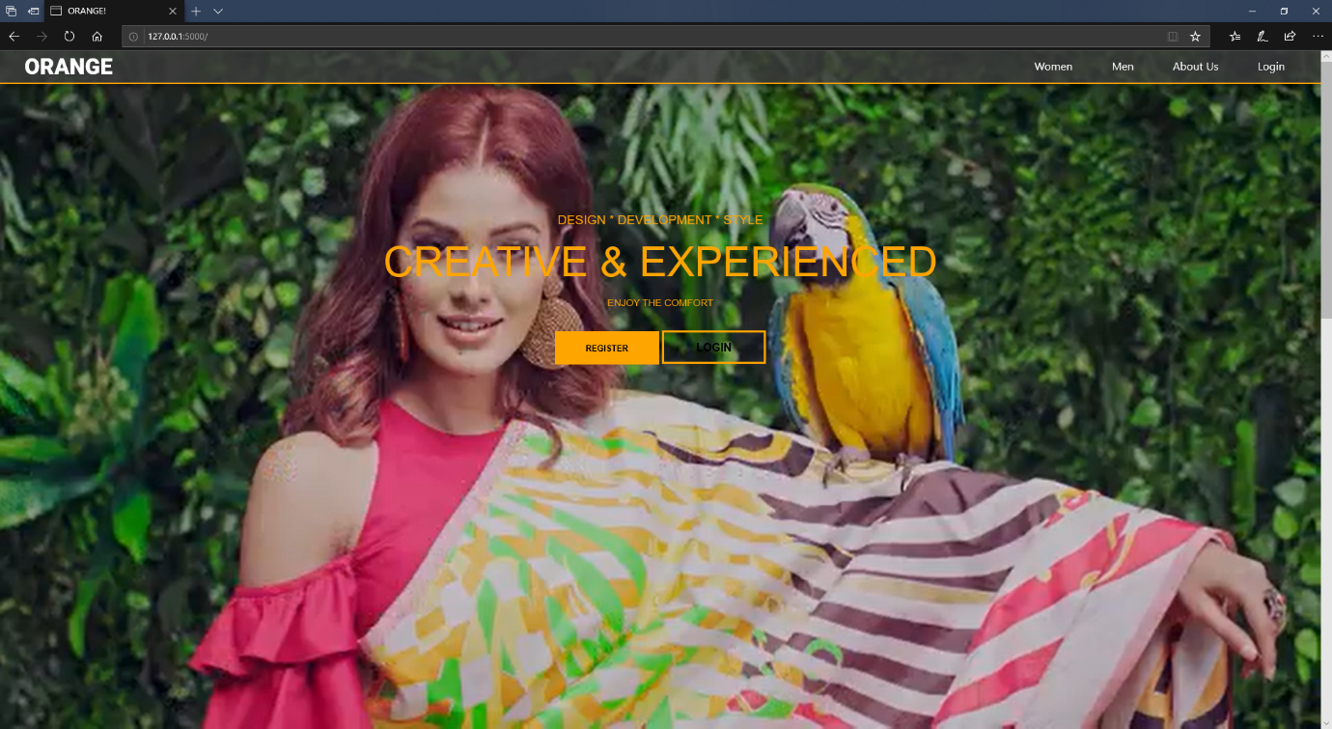

**Navigation Bar**

User can access the desired pages by on the links displayed in the navigation bar. It is to be noted that some of the features are available only when a user has logged in.

**Before Login:**



**After Login:**



**User Authentication**

**Registration**

To register to the service, a user must provide the necessary details requested by the registration form that is in the register link.

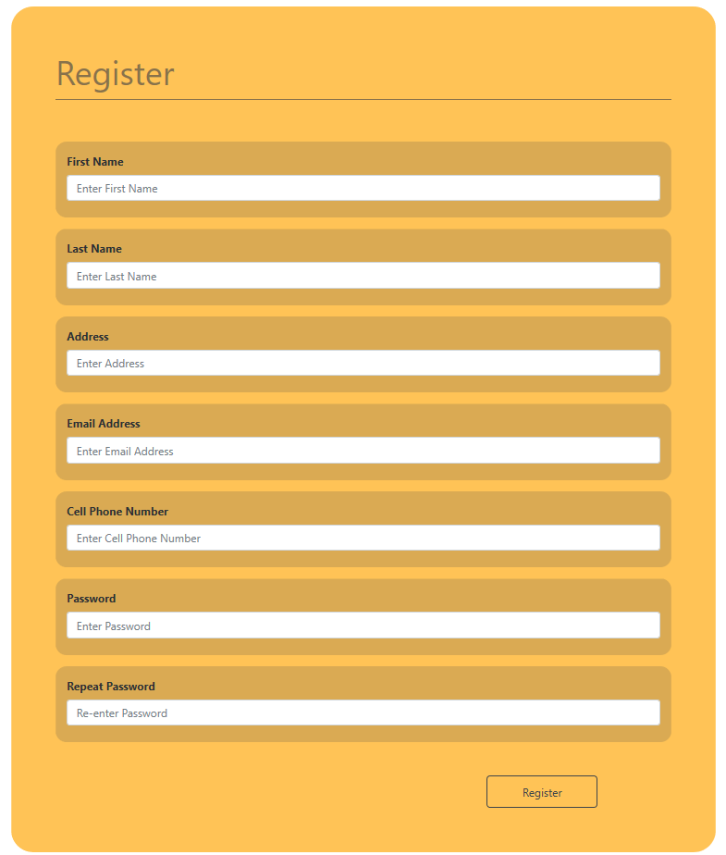

**Login**

Only after a successful registration process, a user is allowed to login. For the users’ convenience, the cell phone number is used as their usernames.

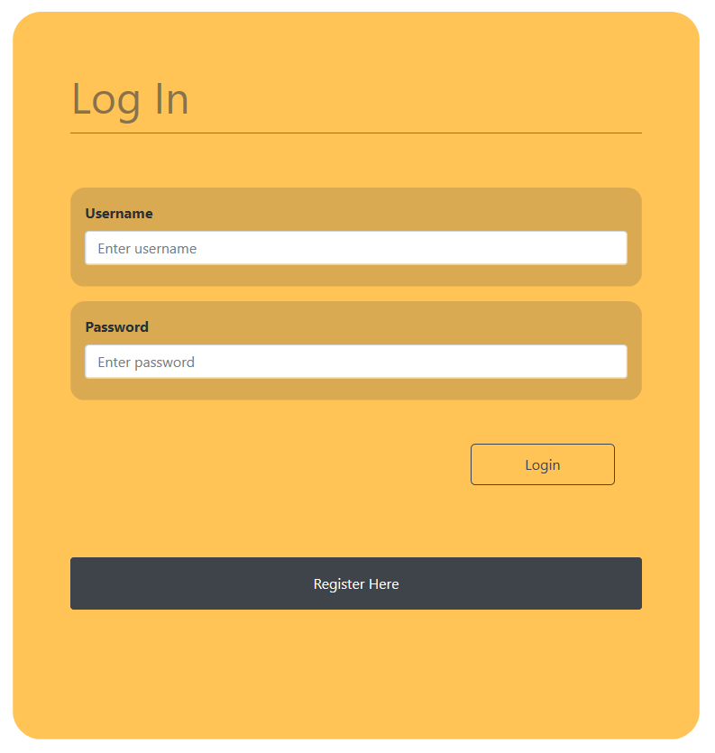

The user can log out by clicking on the logout link anytime.

**Products Pages**

Users can click on the products pages links to view all the available products showcased by the website. The products are arranged according to their categories for the user convenience. The add to cart option is only available after a user has logged in.

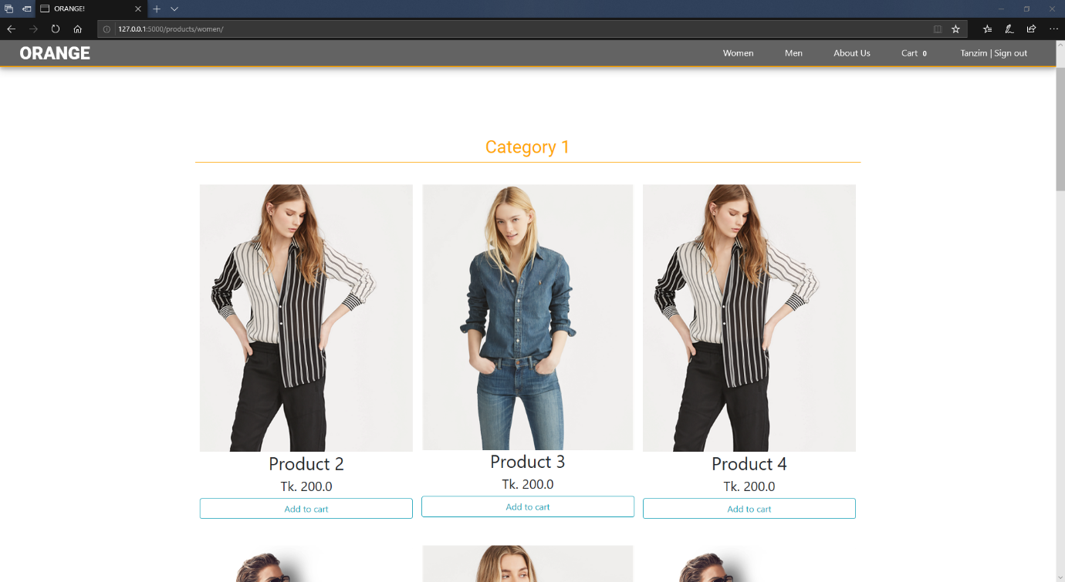

Each product card contains the product’s name, price and an add to cart button. The add to cart button adds a product into the cart, and if the product is already in the cart it increments the quantity of the product by 1 unit. The user will be prompted if the product is unavailable.

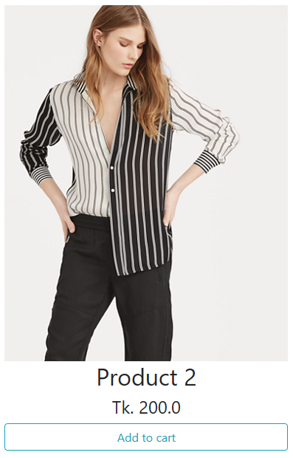

**Cart**

Users can view the cart by clicking the link on the navigation bar after logging in. Each cart item displays the name, the quantity of the selected product, the subtotal, i.e. quantity multiplied by the price of the respective product, and a remove button to remove the product from the cart.

The bottom of the cart displays the total price of the products added in the cart and a checkout and cancel cart button. The cancel cart removes all the items in the cart, and the checkout button proceeds the user to the payment methods.

Each time an item is added into the cart, the number beside the cart link in the navigation bar also increments displaying the total number of contents in the cart.

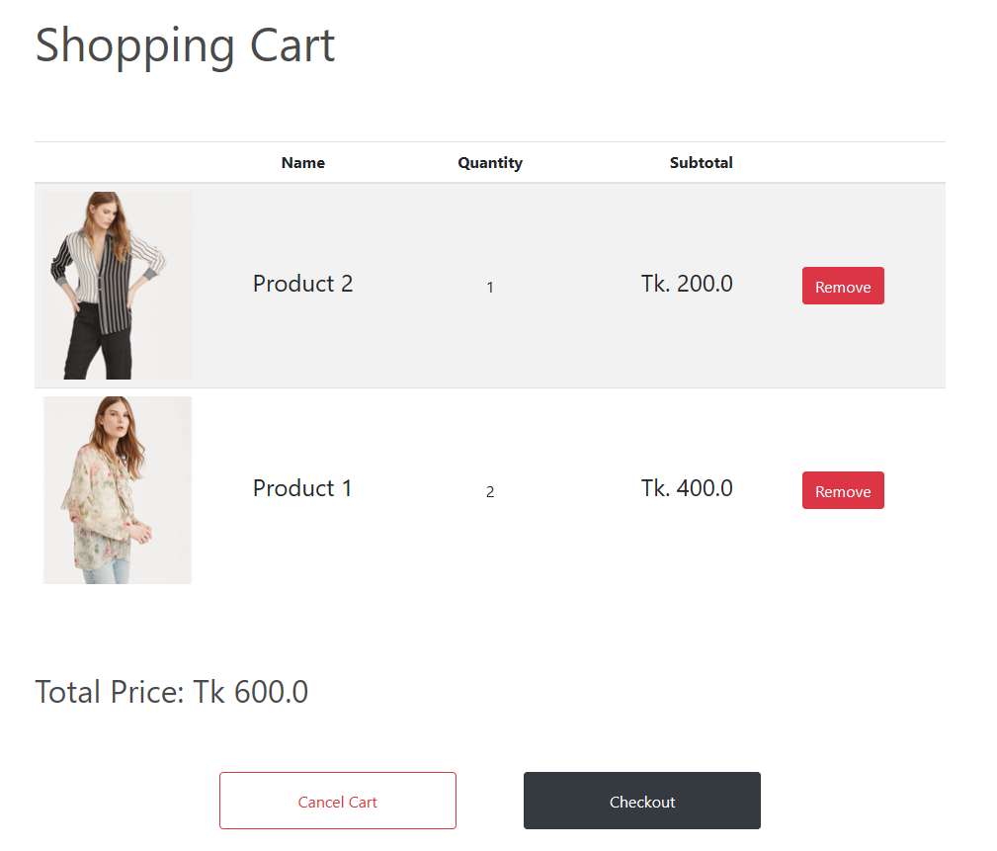

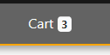

Total items in the cart:

**Payment**

The user can select from a list of payment method to make the purchase. The methods included paying from PayPal Account, VISA or MASTERCARD etc. The user can go back and continue shopping, without paying at this point.

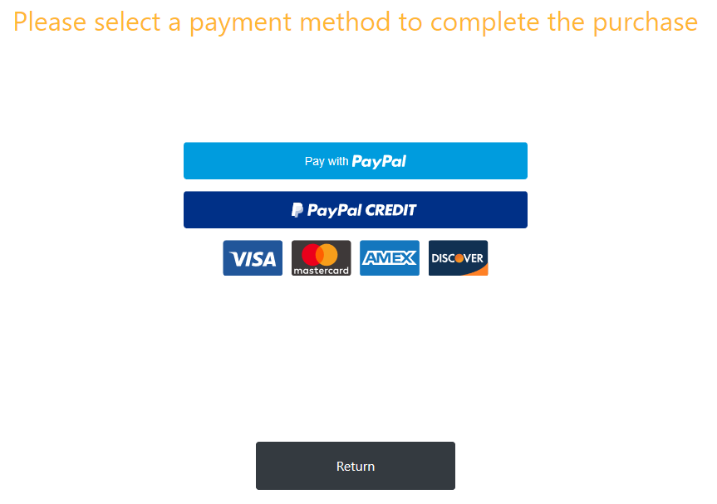

After a successful transaction process, the user is shown an alert and also a greeting text. And the user now can press return or any other link to continue using the website. It is to be noted that, after a successful transaction, the cart is made empty.

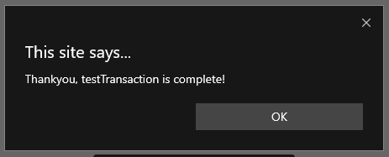

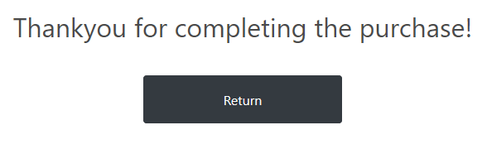

**User Dashboard (New Feature)**

A user can click on his/her name displayed on the navigation bar to view all the purchases made from this website. The page will be empty if no purchase was made.

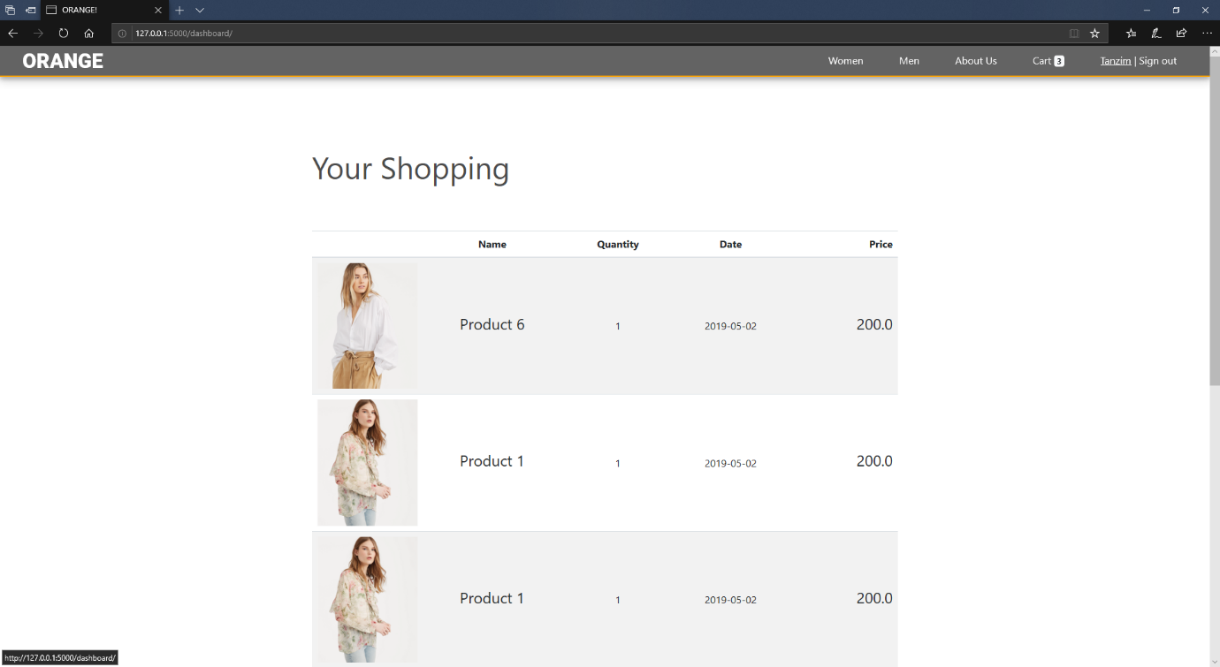

**Administrative Users**

Administrative users can view, add or update the product details showcased in the website. They have a separate link to access these features. They can then access these features by clicking on the links displayed in the navigation bar.

**View and Update all the products in the website**

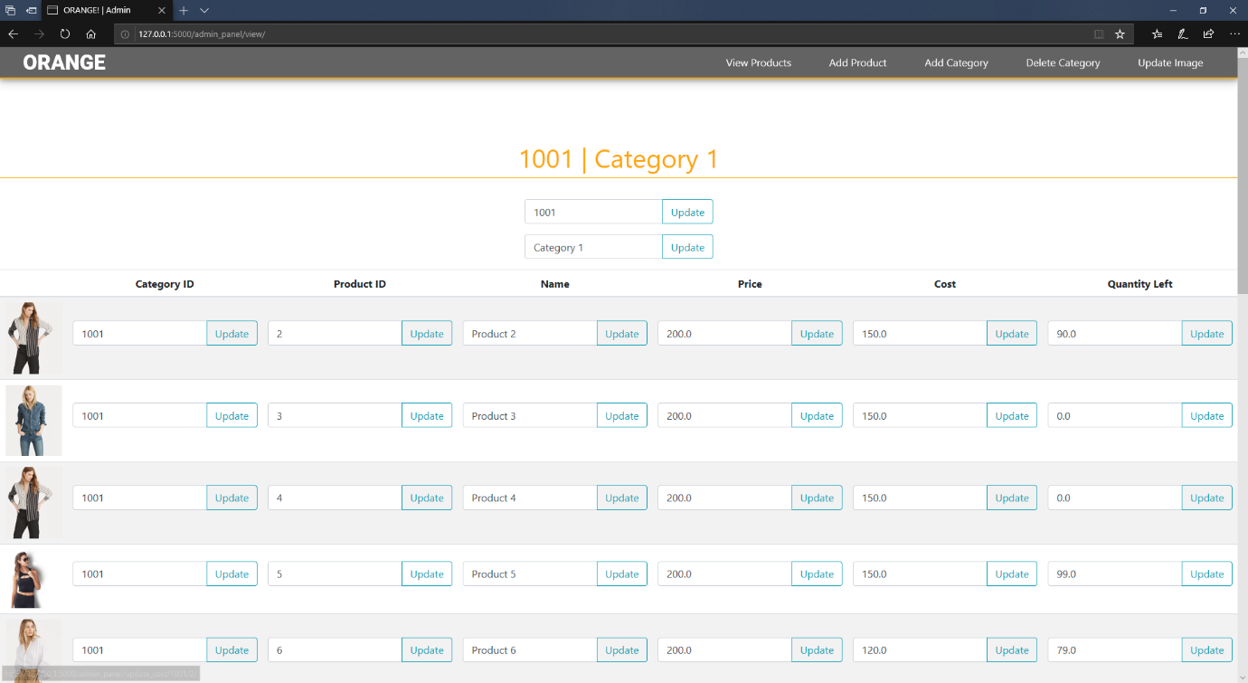

**Add New Product**

(The product category number starting from 1000 to 1999 is allocated for women and 2000 to 2999 in allocated for men)

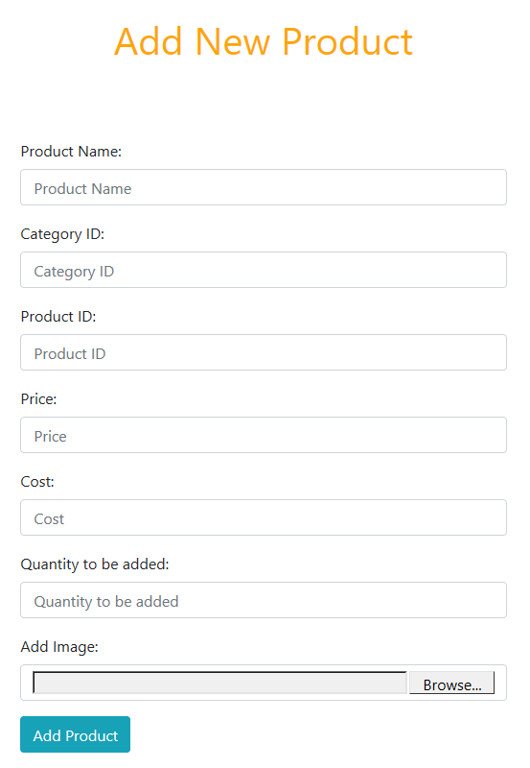

**Add New Category**

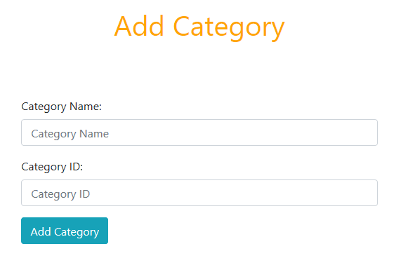

**Delete Category**

Category deletion is permitted only if the requested category has no product in it.

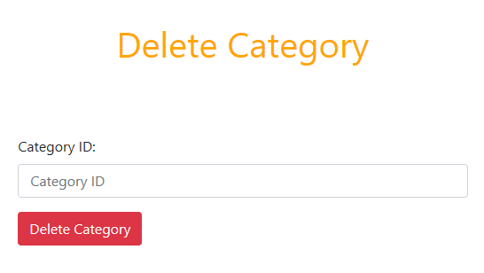

**Update Image**

The image of any particular product can be updated.

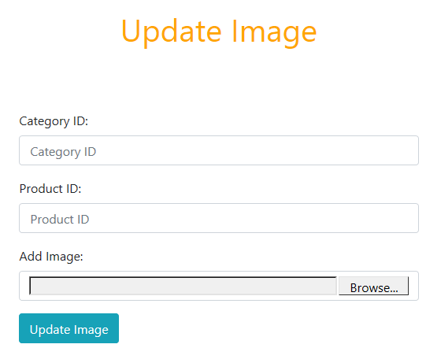

**Deleting Existing Product**

The website restricts product deletion to maintain the integrity of the records. The sales record would become corrupted if products were allowed to be deleted.

A way around this process is to create a new Category called Deleted Products where all these outdated products would be stored. This category would not be displayed in the actual website.

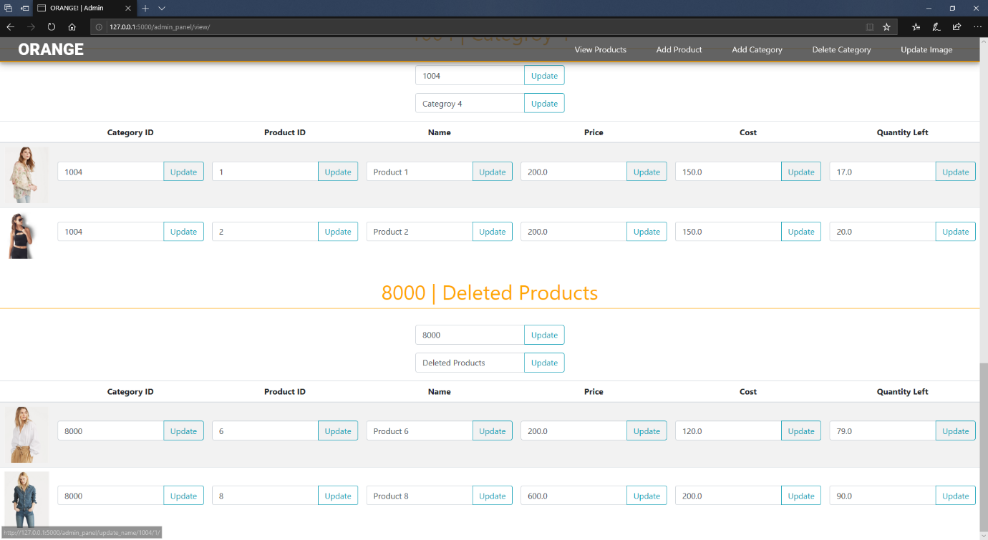

**Payment Method**

The website uses PayPal payment method integration.

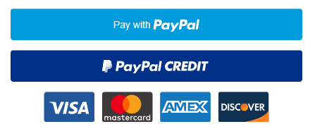

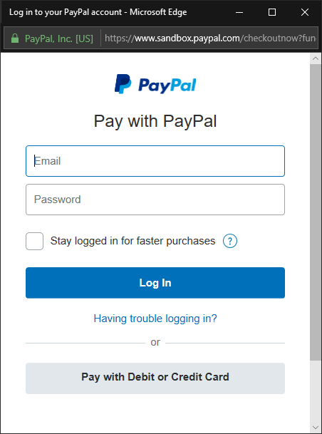

**Technologies Used**

* The website is built with FLASK, a PYTHON Micro-Framework.
* HTML
* CSS
* BOOTSTRAP
* JAVASCRIPT
* MySQL Database

The website uses WTFORMS Python Package to manage the forms and JINJA2 Templating Engine to render the front end of the website.

**Challenges Faced**

Since we learnt Python and FLASK this semester, getting used to with the Framework and its conventions was bit of an issue. Another was during generating an interface for the administration to update the individual features, which was solved by dynamically generating a form-input field for each property of the products.

Currently we are working to make the website more secure, and also working on to get this project live on the Internet.

**Reference to Online Resources**

**Product Images**

Ralph Lauren UK: <https://www.ralphlauren.co.uk/>  
Aarong Bangladesh: <https://www.aarong.com/>

**BOOTSTRAP 4, jQUERY, AJAX**

https://maxcdn.bootstrapcdn.com/bootstrap/4.3.1/css/bootstrap.min.css

https://ajax.googleapis.com/ajax/libs/jquery/3.3.1/jquery.min.js

https://cdnjs.cloudflare.com/ajax/libs/popper.js/1.14.7/umd/popper.min.js

https://maxcdn.bootstrapcdn.com/bootstrap/4.3.1/js/bootstrap.min.js