|  |  |  |  |
| --- | --- | --- | --- |
| **PROJECT TITLE** | Tenant’s Aid |  |  |
|  |  |  |  |
| **SUBMITTED TO** | Shaikh Shawon Arefin Shimon | **CLIENT** | Landlords and tanants |
|  |  |  |  |
| **PHONE** |  | **EMAIL** | Sheikh.shimon@northsouth.edu |
|  |  |  |  |
| **SUBMITTED BY** | Group-5 | **institution** | North South University |
|  |  |  |  |
| **PHONE** | +8801620605284 | **EMAIL** | Touhidul.nayeem@northsouth.edu |
|  |  |  |  |
|  | |  |  |
| **Introduction** | |  |  |
|  | |  |  |
| **ABOUT US** | |  |  |
|  |  |  |  |



*Touhidul Raquib Nayeem - 1530941042  
 Syed Ahmmed - 1521054642*

*Tanvir Hossain - 1521797642*

**OUR VISION**

Our goal is to provide a user friendly application

where the landlord and the tenants will have

equally important and interesting features to

work on. We are looking forward to create

something that is easy to use and that

does not crash.

**OUR CLIENTS**

Our application is intended to be used by the

Landlords and tenants in order to resolve their

Reluctance while communicating with one

another.

**OUR TEAM**

We are a group of three students.   
We have been assigned to group-5.

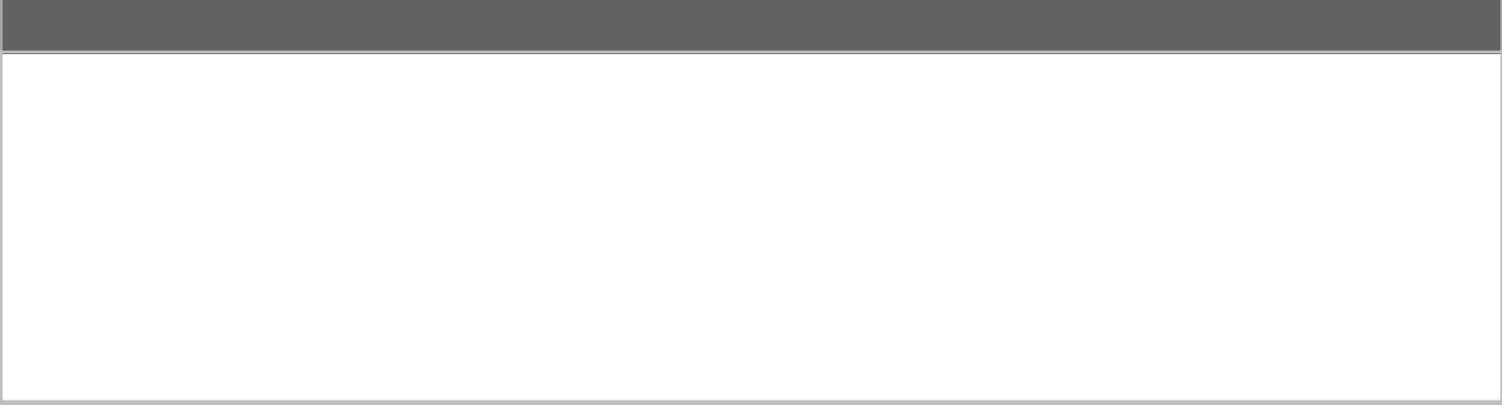**PROJECT SUMMARY**

We will be creating an application on android platform that will enable the landlords and the tenants to keep a track of their monthly bills and accommodate them by interacting in times of need. Our application mainly focuses on management. In order to do so, it will open fields for the landlords to alert the tenants while the tenants can also invoke any sort of actions that has to be taken by the landlord regarding the house. The application will provide a user friendly environment both in terms of the interface and user usability.

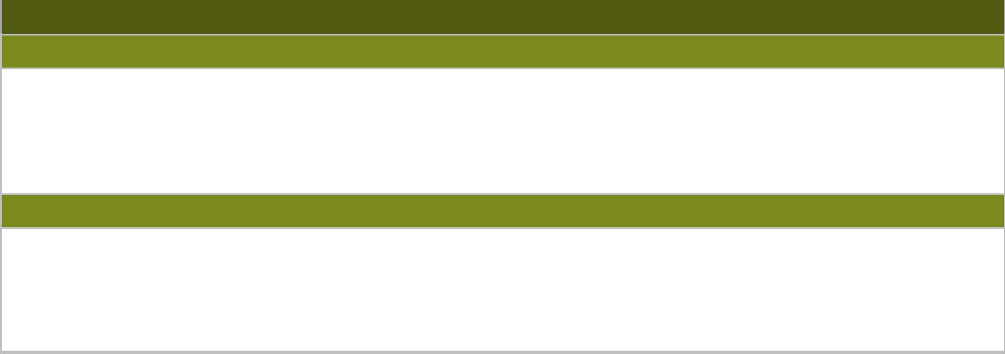

**OUR NEEDS**

Not associated.

**IMPACT OF CURRENT PROBLEMS**

Our application looks forward to resolve the landlord vs tenants issues which includes lack of communication or misunderstanding due to lose of prevision transaction history.

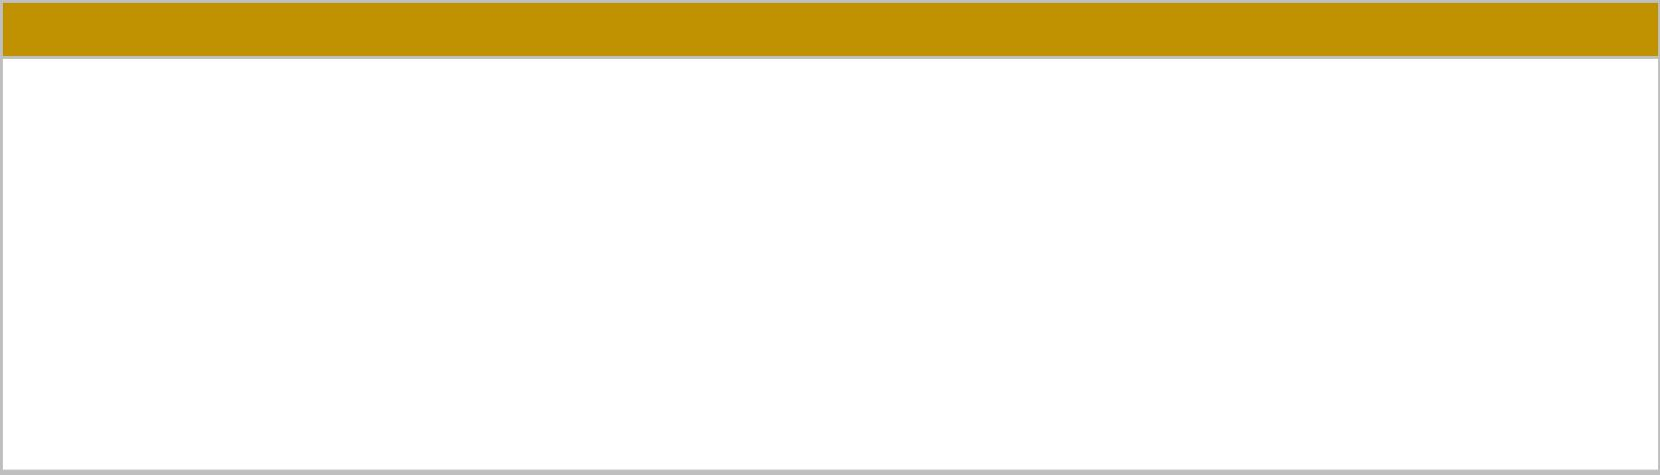

**Our goals**

As students, our goal for now is to set up a working application that will be a demo of what is about come in the future. We feel that there is a broader aspect of this application. The need for a rental management application is definitely growing in a developing country like ours

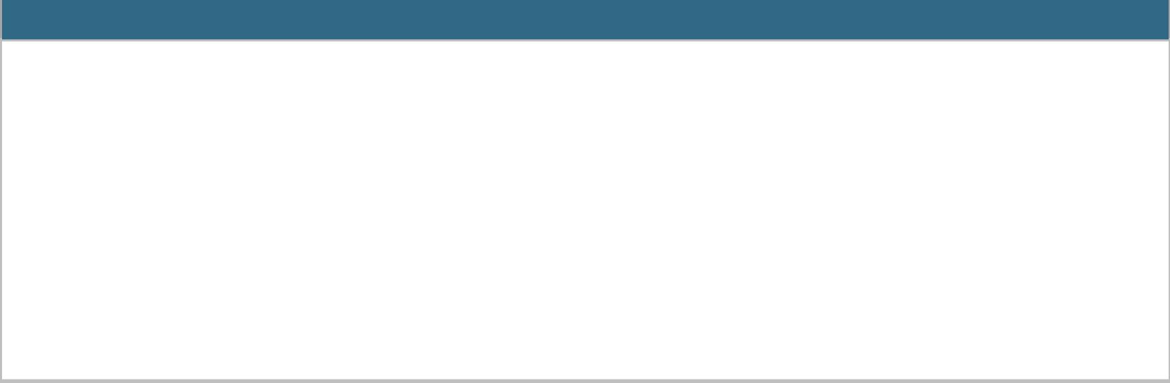

**Scopes for the project.**

* Our application will help the landlords to clearly identify his/her tenants with access to all the information associated with the tenant.
* the landlords can keep track of the bills that are cleared and check on history.
* Landlords can Invoke alerts to the tenants if the bills aren’t cleared for a given month. He/she will have the access to send personal messages through this application.
* Tenants can also keep track of his/her payment history.
* Tenants will have the opportunity to make complains regarding household utility or others