Selenium Web-driver Architecture Simplified:

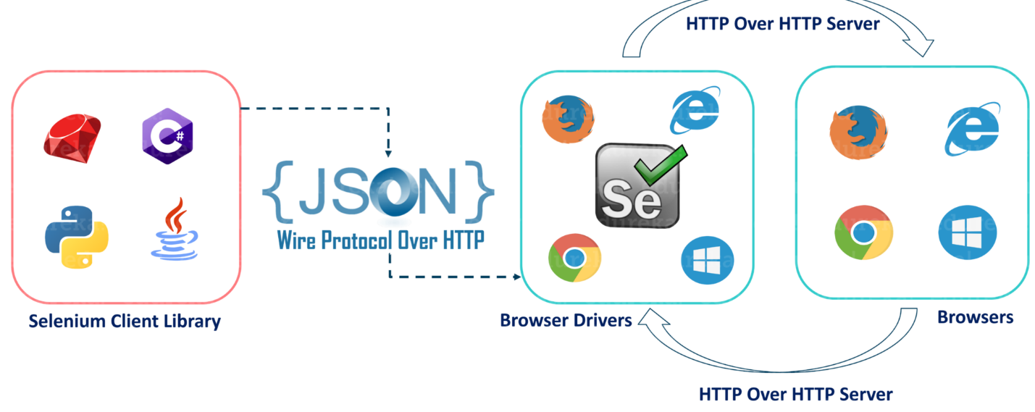

* After you trigger the Test, complete Selenium code (Client) which we have written will be converted to Json format
* Generated Json is sent to Browser Driver (Server) through http Protocol

Note: Each browser contains a separate browser driver

* . Browser drivers communicate with its respective browser and executes the commands by interpreting Json which It received on the browser.
* Browser Driver receives responses back from the browser and it sends Json response back to Client.