Exercise 3: DOM Scripting

Level Attempted: (100)

Nathan Swaim

CpS 404

April 8, 2020

# Program Report

Time Designing, Writing, and Debugging: _7.25_ hours

## Requirements Implementation Summary

The following requirements have been implemented:

* Adventure.html
  + EnterRoom()
  + Take() and drop()
  + Hyperlink exits and items
* AdventureJQ.html
  + Remove event handlers from html
  + Replace document.getElementById( ) with $( ) calls.
  + fadeIn() and fadeout()

The following requirements have not been implemented:

* None

## Bug Summary

1. No known bugs

## Academic Integrity Report

By affixing my signature below, I certify that the accompanying work represents my own intellectual effort. Furthermore, I have received no outside help other than what is documented below and/or in program source code comments.

______Nathan Swaim______________________  
Signature

|  |  |  |  |
| --- | --- | --- | --- |
| **Date** | **Name / Email / URL** | **Nature of help** | **Time spent** |
| 4.7.2020 | https://stackoverflow.com/questions/5767325/how-can-i-remove-a-specific-item-from-an-array | splicing | 5 minutes |
| 4.7.2020 | https://www.w3schools.com/jsref/jsref_operators.asp | Array help | 20 minutes |
| 4.8.20 | [Zac](https://stackoverflow.com/questions/26871522/how-to-change-default-layout-in-express-using-handlebars) Hayes | fadein/fadeout clarification  .click and span issues with directions | 1 hour |

# Official Test Results

**Google Chrome**

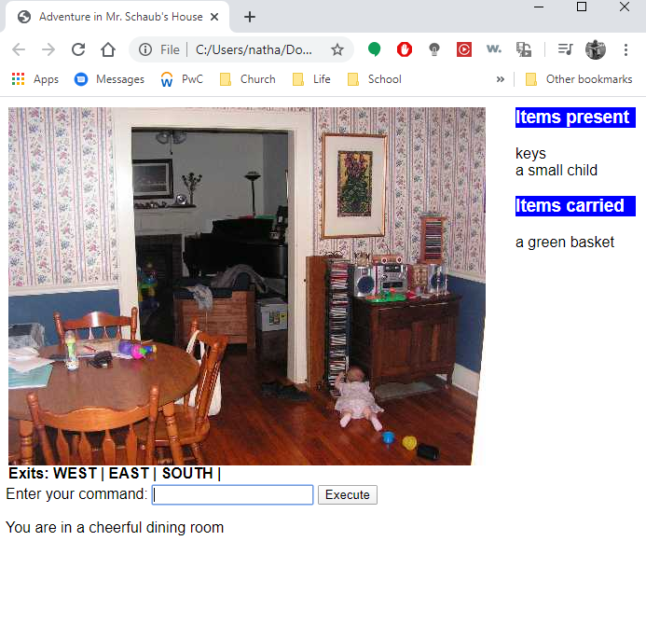

**FireFox**

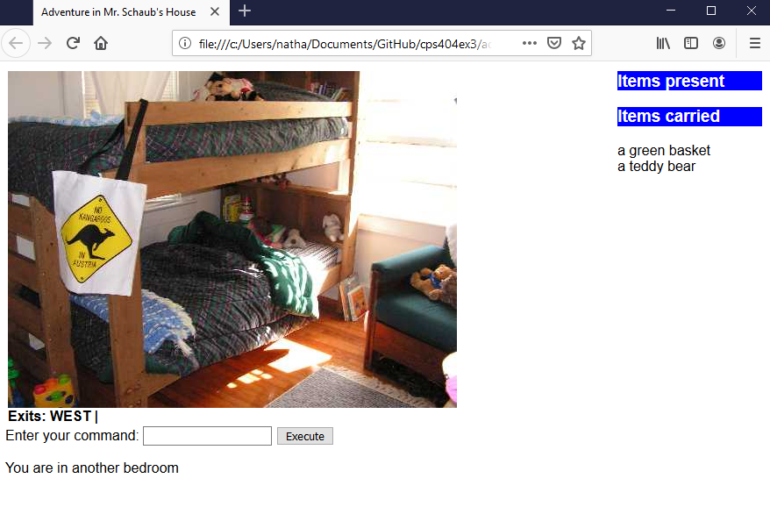

**Microsoft Edge**

