NFL Database Project

Nicholas Wichman  nswichma@buffalo.edu | Faiyaz Rafee faiyazra@buffalo.edu

I. PROBLEM STATEMENT
This project aims to create a well-rounded NFL database that allows for a large variety of statistical comparisons between players, coaches, general managers and owners. Currently getting this information requires directly going out and searching for individual statistics and comparing them manually where we wish to make the comparisons automatically through the use a relation database.
- Why Not Excel?
Using excel would still require manually looking through multiple sheets and comparing them manually. Additionally updating relations would require manually changing multiple sheets, which is prone to human error especially when dealing with large datasets such as ours. Finally, using a database allows us to ensure there are no duplicate records along with other constraints we wish to add.
- Background
As both of us are stat nerds when it comes to the NFL the idea of a database implementation to allow us, and others, to find and compare information about various statistics across the league

II. Target User
The target users of this database are primarily NFL fans, analysts and sport researchers who may want to compare teams, players , coaches, managers, owners and stadium information in an efficient way without having to do pain-staking manual searches across an awful number of webpages or excel files. Instead they will easily be able to use basic SQL queries to find connected information, such as being able to compare offensive and defensive production across players or identify which team a player belongs to, and figure out the coach and general manager of said team in the process, and be able to connect the resulting information to the team’s stadium. This makes the database very useful for any form of comparison and analysis.

The database would be administered by the developers, which is us in this case, who would be responsible for maintaining the schema, updating the data as needed, and ensuring the integrity of said data between relations. In a real-world use case though, there would be a team with proper connections to the NFL datasets so that it could be updated and maintained in real time thus any interested party like say a sports media group or a content creator would be able to find up to date information easily, without having to have much technical knowledge. The admins would manage the data imports and updates so that the end users can focus on their queries to answer any questions and find the patterns they were looking for that could be very tedious to find otherwise, making it so NFL information becomes much easier to access, compare, and analyze through a full relational database.

III. Relation Schema
Entity | Primary Keys | Foreign Keys
Teams | TeamID | StadiumID  CoachID  GMID
Coaches | CoachID | TeamID  TeamName
Players | PlayerID | TeamID  TeamName
Offensive Stats | OffensiveID | PlayerID  PlayerName
Defensive Stats | DefensiveID | PlayerID  PlayerName
General Managers | GMID | TeamID  TeamName
Stadiums | StadiumID | TeamID  TeamName  CityName
Owners | OwnerID | TeamId  TeamName  CityName

- Teams
Name | Type | Notes
TeamID | INT | Primary Key
TeamName | VARCHAR | N/A
City | VARCHAR | N/A
StadiumID | INT | Foreign Key from Stadiums
CoachID | INT | Foreign Key from Coachs
GMID | INT | Foreign Key from GeneralMangers

- Coaches
Name | Type | Notes
CoachID | INT | Primary Key
CoachName | VARCHAR | N/A
TeamID | INT | Foreign Key from  Teams
TeamName | VARCHAR | Foreign Key from Teams
Salary | INT | N/A
YearHired | INT | N/A

- Players
Name | Type | Notes
PlayerID | INT | Primary Key
Position | VARCHAR | N/A
PlayerName | VARCHAR | N/A
TeamID | INT | Foreign Key from Teams
Salary | INT | N/A
YearJoined | INT | N/A

- Offensive Stats
Name | Type | Notes
OffensiveID | INT | Primary Key
PlayerID | INT | Foreign Key from Players
PlayerName | VARCHAR | Foreign Key from  Players
PassYards | INT | N/A
PassTDs | INT | N/A
RushYards | INT | N/A
RushTDs | INT | N/A
ReceivingYards | INT | N/A
ReceivingTDs | INT | N/A

- Defensive Stats
Name | Type | Notes
DefensiveID | INT | Primary Key
PlayerID | INT | Foreign Key from Players
PlayerName | VARCHAR | Foreign Key from  Players
Tackles | INT | N/A
Sacks | INT | N/A
Interceptions | INT | N/A
TDs | INT | N/A
TacklesForLoss | INT | N/A
GamesPlayed | INT | N/A

- General Managers
Name | Type | Notes
GMID | INT | Primary Key
Name | VARCHAR | N/A
TeamID | INT | Foreign Key from Teams
TeamName | VARCHAR | Foreign Key from Teams
Salary | INT | N/A
YearHired | INT | N/A

- Stadiums
Name | Type | Notes
StadiumID | INT | Primary Key
TeamName | VARCHAR | Foreign Key from Teams
City | VARCHAR | Foreign Key from Teams
StadiumName | VARCHAR | N/A
YearBuilt | INT | N/A
Cost | INT | N/A

- Owners
Name | Type | Notes
OwnerID | INT | Primary Key
TeamID | INT | Foreign Key from Teams
TeamName | VARCHAR | Foreign Key from Teams
Name | VARCHAR | N/A
NetWorth | INT | N/A
YearBought | INT | N/A

IV. Attribute Information

In this section we will cover default values and nullability of each attribute along with foreign key deletion impacts for each table.

- Teams
There are no default values any of the attributes in this entity as TeamID is a Primary Key for the entity and StadiumID, CoachID and GMID are all Foreign Keys that are Primary Keys in their respective entities. TeamName and City also should not have a default value as there is no situation where these should be unknown.

Upon deletion of the foreign key attributes the following changes will be made: StadiumID -> Set Null, CoachID -> Set Null and GMID -> Set Null.
- Coaches
There are no default values for CoachID, CoachName, TeamName and TeamID. Salary will have a default value of 0 and YearHired will have a default value of the current year.

The foreign keys TeamName and TeamID should never be deleted so if they are set to null.

- Players
There are no default values for PlayerID, PlayerName and TeamID. Postion and salary have default values of null and YearJoined has a default value of the current year.

Upon deletion TeamID should be set to null.

- Offensive Stats
There are no default values for OffensiveID, PlayerID and PlayerName. The rest of the attributes have a default value of 0.

Upon deletion of PlayerID or PlayerName the tuple should be deleted.

- Defensive Stats
There are no default values for DefensiveID, PlayerID and PlayerName. The rest of the attributes have a default value of 0.

Upon deletion of PlayerID or PlayerName the tuple should be deleted.

- General Manager
There are no default values for GMID, TeamID, Name and TeamName. Salary will have a default value of 0 and YearHired will have a defulat value of the current year.

The foreign keys TeamName and TeamID should never be deleted so if they are set to null.

- Stadiums
There are no default values for StadiumID, TeamName and City. StadiumName has a default value of null, YearBuilt has a default value of the current year and Cost has a default value of 0.

The foreign keys TeamName and City should never be deleted so if they are set to null.

- Owners
There are no default values for OwnerID, TeamID, Name and TeamName. NetWorth has a default value of 0 and YearBought has a default value of the current year.
The foreign keys TeamName and TeamID should never be deleted so if they are set to null.

V. BCNF Verification
In this section we will cover each table adhering to the BCNF standard
- Teams
FD: TeamID -> TeamName, City, StadiumId, CoachID, GMID
Super Key: TeamName

Since the left side of the functional dependency is a super key this table adheres to BCNF

- Coaches
FD: CoachID -> CoachName, TeamID, TeamName, Salary, YearHired
Super Key: CoachID

Since the left side of the functional dependency is a super key this table adheres to BCNF

- Players
FD: PlayerID -> Positon, PlayerName, TeamID, Salary, YearJoined
Super Key: PlayerID

Since the left side of the functional dependency is a super key this table adheres to BCNF

- Offensive Stats
FD: OffensiveID -> PlayerID, PlayerName, PassYards, PassTDs, RushYards, RushTDs, RecievingYards, RecievingTDs
Super Key: Offensive

Since the left side of the functional dependency is a super key this table adheres to BCNF

- Defensive Stats
FD: DefensiveID -> PlayerID, PlayerName, Tackles, Sacks, Interceptions, TDs, TacklesForLoss, GamesPlayed
Super Key: DefensiveID

Since the left side of the functional dependency is a super key this table adheres to BCNF

- General Manager
FD: GMID -> Name, TeamID, TeamName, Salary, YearHired
Super Key: GMID

Since the left side of the functional dependency is a super key this table adheres to BCNF

- Stadiums
FD: StadiumID -> TeamName, City, StadiumName, YearBuilt, Cost
Super Key: StadiumID

Since the left side of the functional dependency is a super key this table adheres to BCNF

- Owners
FD: Owner -> OwnerID, TeamName, Name, NetWorth, YearBought
Super Key: OwnerID

Since the left side of the functional dependency is a super key this table adheres to BCNF

VI. ER Diagram

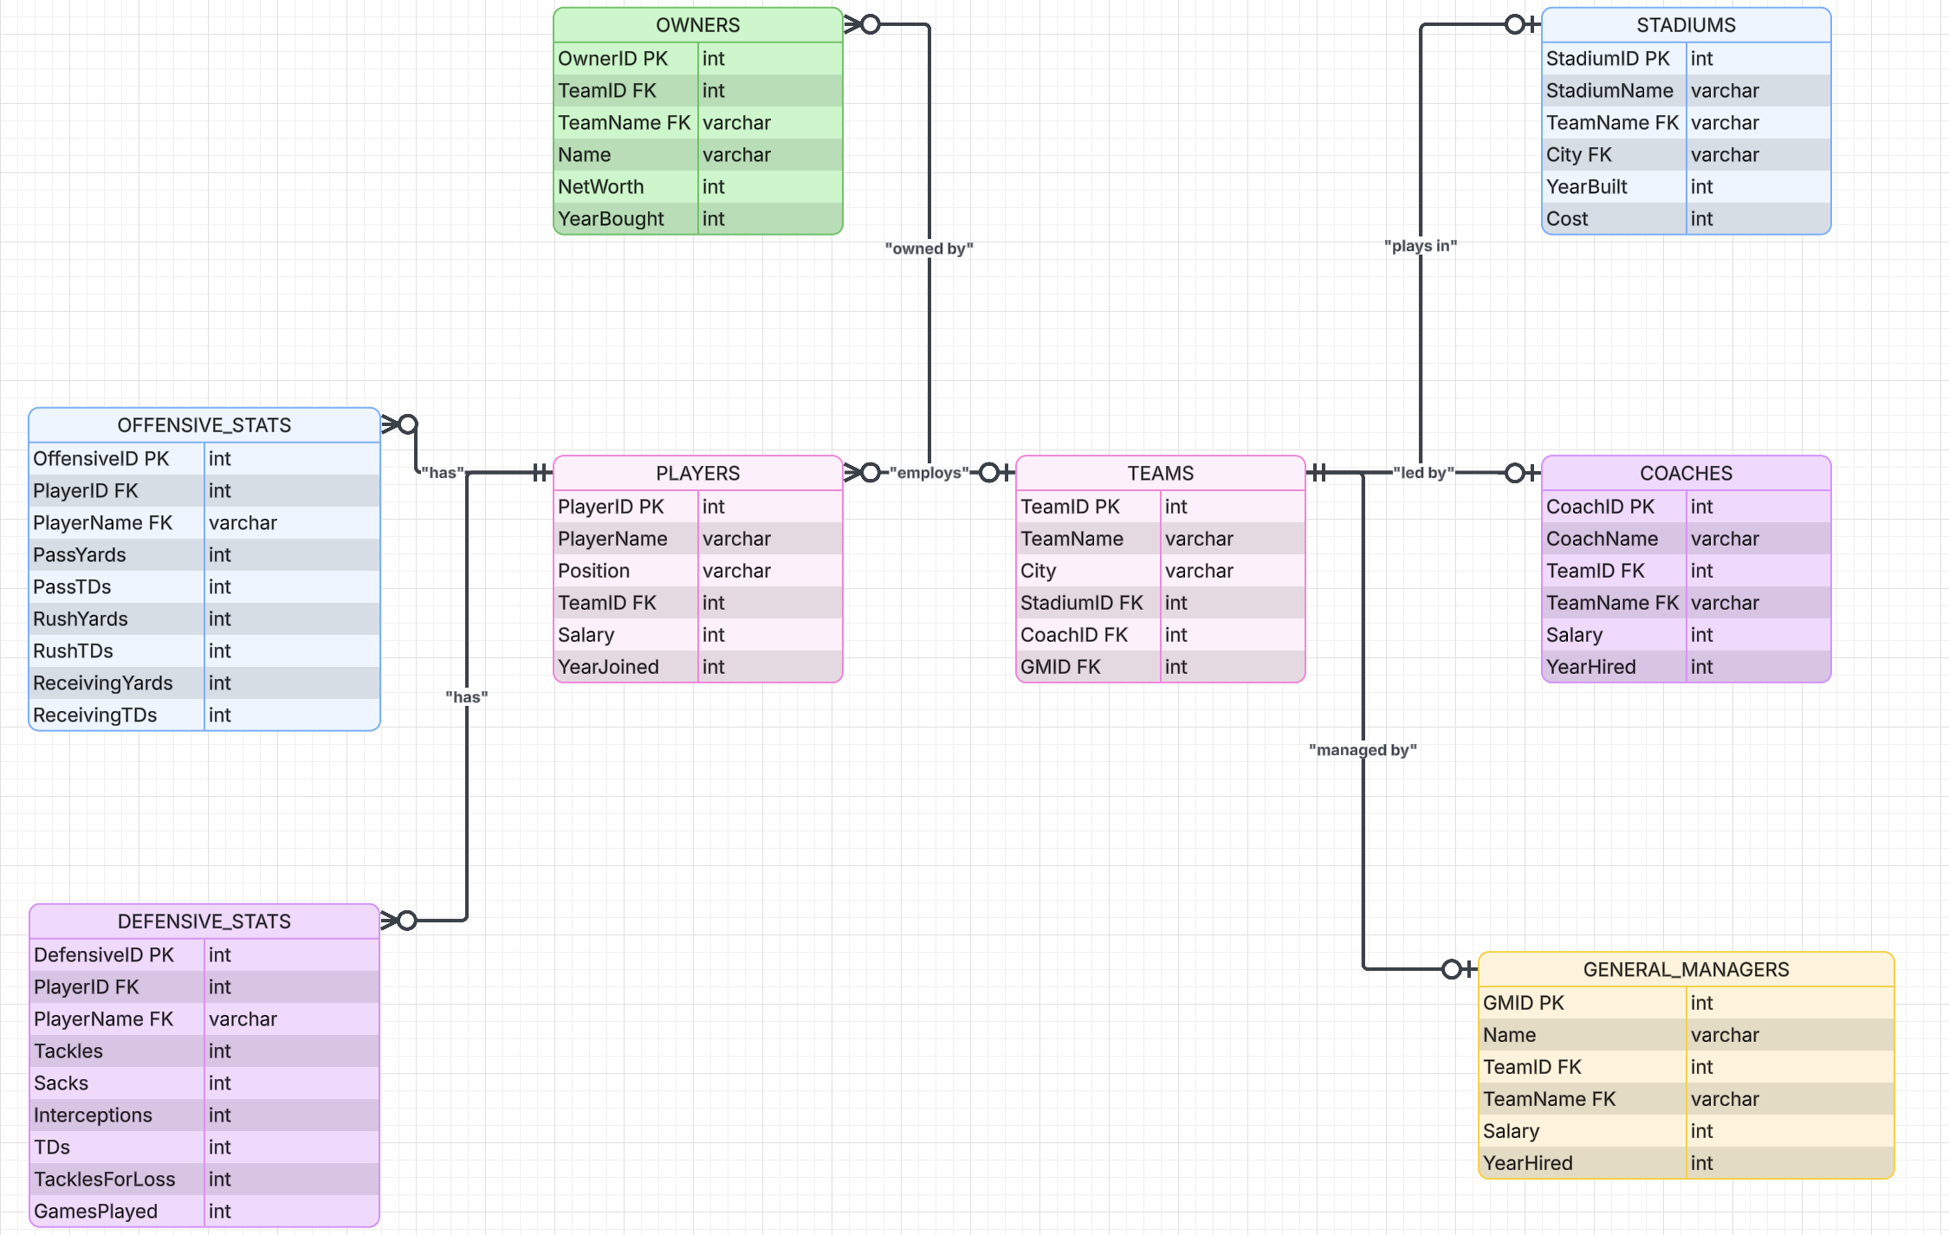

VII. Relations

In this section we will outline the relationships between our entity sets along with their type.

- One-To-One relationships
- Team to Coaches: Only one coach per team and a coach can only coach one team.
- Team to Owner: Only one owner can own a team and only one team can be owned by a single owner.
- Team to Stadiums: Teams only have one home stadium, and stadiums only have one home team
- Team to General Managers: Teams can only have one general manager, and a general manager can only be employed by one team.
- Players to Offensive Stats: Each player has only one offensive stats record associated with them.
- Players to Defensive Stats: Each player has only one defensive stats record associated with them.
- One-To-Many Relationship
- Team to Players: One team can employ many players and players can only play for one team.

VIII. Database

In order to better fit our schema we will be generating our data through an AI model that will get the information from Pro Football Reference. We will download the data into CSV files and then add a few aspects like identification numbers starting from one.

