八.利用定时器产生乐曲
［实验任务］
利用单片机的I/O口演奏乐曲。
［硬件电路图］
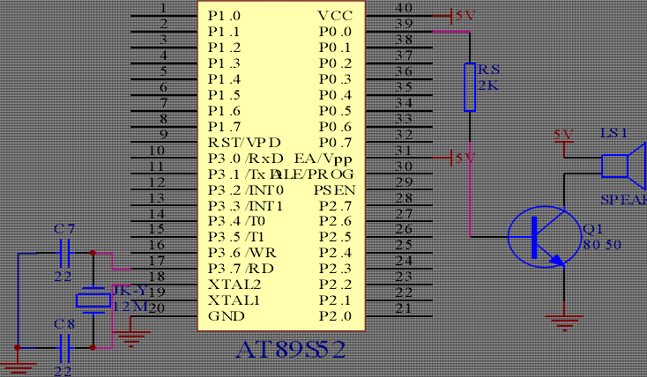
［实验原理］
乐曲是按照一定的高低，长短和强弱关系组成的关系，在一首乐曲中，每一个音符与频率有关。所以我们只要把有关频率的占空比数据做成表格，在通过查表，在I/O口输出相关乐曲的方波，便产生了乐曲。
[C语言源程序]
#include "reg52.h"//这样用双引号也可以。
unsigned char Count;
sbit _Speak =P0^0 ; //讯响器控制脚
unsigned char code SONG[] ={ //祝你平安
0x26,0x20,0x20,0x20,0x20,0x20,0x26,0x10,0x20,0x10,0x20,0x80,0x26,0x20,0x30,0x20,
0x30,0x20,0x39,0x10,0x30,0x10,0x30,0x80,0x26,0x20,0x20,0x20,0x20,0x20,0x1c,0x20,
0x20,0x80,0x2b,0x20,0x26,0x20,0x20,0x20,0x2b,0x10,0x26,0x10,0x2b,0x80,0x26,0x20,
0x30,0x20,0x30,0x20,0x39,0x10,0x26,0x10,0x26,0x60,0x40,0x10,0x39,0x10,0x26,0x20,
0x30,0x20,0x30,0x20,0x39,0x10,0x26,0x10,0x26,0x80,0x26,0x20,0x2b,0x10,0x2b,0x10,
0x2b,0x20,0x30,0x10,0x39,0x10,0x26,0x10,0x2b,0x10,0x2b,0x20,0x2b,0x40,0x40,0x20,
0x20,0x10,0x20,0x10,0x2b,0x10,0x26,0x30,0x30,0x80,0x18,0x20,0x18,0x20,0x26,0x20,
0x20,0x20,0x20,0x40,0x26,0x20,0x2b,0x20,0x30,0x20,0x30,0x20,0x1c,0x20,0x20,0x20,
0x20,0x80,0x1c,0x20,0x1c,0x20,0x1c,0x20,0x30,0x20,0x30,0x60,0x39,0x10,0x30,0x10,
0x20,0x20,0x2b,0x10,0x26,0x10,0x2b,0x10,0x26,0x10,0x26,0x10,0x2b,0x10,0x2b,0x80,
0x18,0x20,0x18,0x20,0x26,0x20,0x20,0x20,0x20,0x60,0x26,0x10,0x2b,0x20,0x30,0x20,
0x30,0x20,0x1c,0x20,0x20,0x20,0x20,0x80,0x26,0x20,0x30,0x10,0x30,0x10,0x30,0x20,
0x39,0x20,0x26,0x10,0x2b,0x10,0x2b,0x20,0x2b,0x40,0x40,0x10,0x40,0x10,0x20,0x10,
0x20,0x10,0x2b,0x10,0x26,0x30,0x30,0x80,0x00,
//路边的野华不要采
0x30,0x1C,0x10,0x20,0x40,0x1C,0x10,0x18,0x10,0x20,0x10,0x1C,0x10,0x18,0x40,0x1C,
0x20,0x20,0x20,0x1C,0x20,0x18,0x20,0x20,0x80,0xFF,0x20,0x30,0x1C,0x10,0x18,0x20,
0x15,0x20,0x1C,0x20,0x20,0x20,0x26,0x40,0x20,0x20,0x2B,0x20,0x26,0x20,0x20,0x20,
0x30,0x80,0xFF,0x20,0x20,0x1C,0x10,0x18,0x10,0x20,0x20,0x26,0x20,0x2B,0x20,0x30,
0x20,0x2B,0x40,0x20,0x20,0x1C,0x10,0x18,0x10,0x20,0x20,0x26,0x20,0x2B,0x20,0x30,
0x20,0x2B,0x40,0x20,0x30,0x1C,0x10,0x18,0x20,0x15,0x20,0x1C,0x20,0x20,0x20,0x26,
0x40,0x20,0x20,0x2B,0x20,0x26,0x20,0x20,0x20,0x30,0x80,0x20,0x30,0x1C,0x10,0x20,
0x10,0x1C,0x10,0x20,0x20,0x26,0x20,0x2B,0x20,0x30,0x20,0x2B,0x40,0x20,0x15,0x1F,
0x05,0x20,0x10,0x1C,0x10,0x20,0x20,0x26,0x20,0x2B,0x20,0x30,0x20,0x2B,0x40,0x20,
0x30,0x1C,0x10,0x18,0x20,0x15,0x20,0x1C,0x20,0x20,0x20,0x26,0x40,0x20,0x20,0x2B,
0x20,0x26,0x20,0x20,0x20,0x30,0x30,0x20,0x30,0x1C,0x10,0x18,0x40,0x1C,0x20,0x20,
0x20,0x26,0x40,0x13,0x60,0x18,0x20,0x15,0x40,0x13,0x40,0x18,0x80,0x00,};
void Time0_Init()
{ TMOD = 0x01;
IE = 0x82;
TH0 = 0xD8;
TL0 = 0xEF; //12MZ晶振，10ms
}
void Time0_Int() interrupt 1
{ TH0 = 0xD8;
TL0 = 0xEF;
Count++; //长度加1
}
void Delay_xMs(unsigned int x) //1MS 延时子程序
{ unsigned int i,j;
for( i =0;i < x;i++ )
{for( j =0;j<3;j++ );}
}
void Play_Song(unsigned char i) //:歌曲播放子程序i 为播放哪一段曲目
{ unsigned char Temp1,Temp2;
unsigned int Addr;
Count = 0; //中断计数器清0
Addr = i * 217;
while(1)
{ Temp1 = SONG[Addr++];
if ( Temp1 == 0xFF ) //休止符
{TR0 = 0; Delay_xMs(100); }
else if ( Temp1 == 0x00 ) //歌曲结束符
{return;}
else {Temp2 = SONG[Addr++];
TR0 = 1;
while(1)
{ _Speak = ~_Speak;
Delay_xMs(Temp1);
if ( Temp2 == Count )
{Count = 0;
break;
} } } } } //请注意写程序时的格式规范，此处是为了节省空间
void main() //主程序
{Time0_Init(); //定时器0 中断初始化
while(1)
{Play_Song(0);} //播放
}

