十七、串口下载线
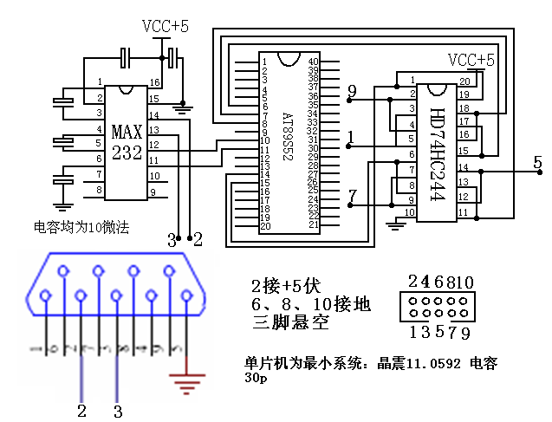
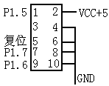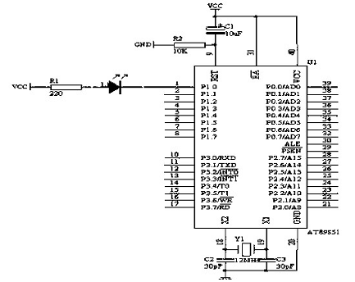
十八步进电机控制程序：
原理图参考：单片机控制实训书44页
#include<reg52.h>
#define uchar unsigned char
uchar a,b;
int k;
uchar zdzt=0x0c;
uchar zsgw=0x02;
uchar zsdw=0x00;
uchar yxsj=0x11;
uchar zs=20;
uchar zsscgw=0x1f;
uchar zsscdw=0x00;
void key(void);
void delay();
void delays();
code uchar tab[13]={0x3f,0x06,0x5b,0x4f,0x66,0x6d,0x7d,0x07,0x7f,0x6f,0x77,0x7c,0x39};
code uchar zssc[2]={0x1f,0x00};
main()
{
while(1)
{key();
if(zdzt==0x0c)
P1=0xff;
else if(zdzt==0x0a)
{P1=yxsj;
deleys();
yxsj=yxsj<<1|yxsj>>7;
}
else if(zdzt==0x0b)
{P1=yxsj;
delays();
yxsj=yxsj<<7|yxsj>>1;
}
}
}
void key(void)
{
if(!(P2&0x01))
{delay();
while(!(P2&0x01))
zdzt=0x0a;
}
else if(!(P2&0x02))
{
delay();
while(!(P2&0x02))
zdzt=0x0b;
}
else if(!(P2&0x04))
{
delay();
while(!(P2&0x04))
zdzt=0x0c;
}
}
void delay()
{
for(k=0;k<1200;k++);
}
void delays()
{
a=zssc[0];
while(a--)
{b=zssc[1];
while(b--);
}
}

#include<reg52.h> /*闪烁灯*/
int k;
void delay()
{
for(k=0;k<2000;k++);
}
main()
{
while(1)
{
P1=0x01;
delay();
P1=0x04;
delay();
P1=0x02;
delay();
}
}

#include<reg52.h>
#define uchar unsigned char
code uchar zz[]={0x08,0x01,0x04,0x02};
code uchar fz[]={0x08,0x02,0x04,0x01};
sbit start=P3^0;
sbit stop=P3^2;
void delay(uchar a)
{
uchar b,c;
for(b=0;b<a;b++)
for(c=0;c<100;c++);
}
void run(uchar a)
{
uchar b,c;
for(b=0;b<6;b++)
for(c=0;c<4;c++);
{if(a==1) P1=zz[c];
else P1=fz[c];
delay(0x10);
}
}
in0()interrupt0 using 1
{P1=0xff;
while(start);
}

void main(void)
{IE=0x81;
while(start);
while(1)
{
uchar a=4;
uchar b=3;
while(a--)
run(1);
while(b--)
run(2);
}
}

