class04.R

nicholasyousefi

2022-10-06

# This is a comment  
x <- 1:50  
plot(x, sin(x))

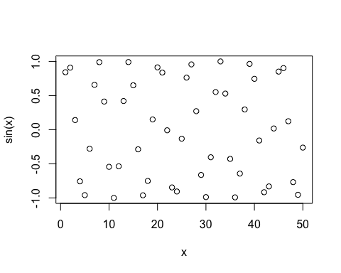

# Add more input arguments to get this how we want it  
plot(x, sin(x), typ="l", col="red", lwd="3")

