★★★☆☆
題組：Problem Set Archive with Online Judge
題號：10066: The Twin Towers
解題者：黃俊騫
解題日期：2013年5月23日
題意：
求兩數列的最長相同子數列 (LCS) 之長度。
題意範例：
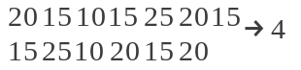

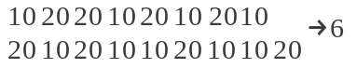
解法：
令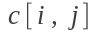表示兩數列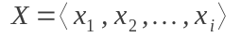和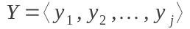最長相同子數列長度,則:
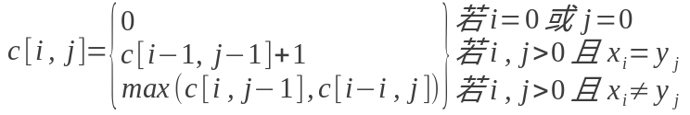
動態規劃，從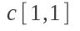開始算。
解法範例：
 |  | 20 | 15 | 10 | 15 | 25 | 20 | 15
 | 0 | 0 | 0 | 0 | 0 | 0 | 0 | 0
15 | 0 | 0 | 1 | 1 | 1 | 1 | 1 | 1
25 | 0 | 0 | 1 | 1 | 1 | 2 | 2 | 2
10 | 0 | 0 | 1 | 2 | 2 | 2 | 2 | 2
20 | 0 | 1 | 1 | 2 | 2 | 2 | 3 | 3
15 | 0 | 1 | 2 | 2 | 3 | 3 | 3 | 4
20 | 0 | 1 | 2 | 2 | 3 | 3 | 4 | 4

討論：
- 暴力法的時間複雜度：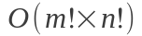

- 動態規劃的時間複雜度：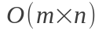

- m,n為兩數列的長度。

程式：
/*
* 10066 - The Twin Towers
* http://uva.onlinejudge.org/external/100/10066.html
*
* Created on: 2013/5/23
* Author: shiaobin
*/
#include <stdio.h>
#include <string.h>
#define N1_MAX 100
#define N2_MAX 100

int max(int a, int b);
int lcs(int tower1[], int tower2[], int n1, int n2, int lcsTable[][N2_MAX + 1]);

int main(int argc, char *argv[])
{
int i; /* index for loop */
int t; /* twin towers #t */
int n1, n2; /* the number of tiles respectively in the two towers */
int tower1[N1_MAX + 1], tower2[N2_MAX + 1]; /* the tiles respectively in the two towers */
int lcsTable[N1_MAX + 1][N2_MAX + 1]; /* the length of LCS */

/* input N1 and N2 */
scanf("%d%d", &n1, &n2);

t = 1;
/* the input file terminates with two zeros for N1 and N2 */
while (n1 != 0 || n2 != 0)
{
/* print a blank line after the output of each data set */
if (t != 1)
{
printf("\n");
}

/* check the range of N1 and N2 */
if (n1 > N1_MAX || n1 < 0 || n2 > N2_MAX || n2 < 0)
{
return 1;
}

/* reset tower1 and tower2 */
memset(tower1, 0, sizeof(tower1));
memset(tower2, 0, sizeof(tower2));

/* input tower1 and tower2 */
for (i = 1; i <= n1; ++i)
{
scanf("%d", &tower1[i]);
}
for (i = 1; i <= n2; ++i)
{
scanf("%d", &tower2[i]);
}

/* output the twin tower number followed by the number of tiles
* (in one tower) in the highest possible twin towers that can be
* built from them */
printf("Twin Towers #%d\n", t);
printf("Number of Tiles : %d\n", lcs(tower1, tower2, n1, n2, lcsTable));

/* input N1 and N2 */
scanf("%d%d", &n1, &n2);
++t;
}

return 0;
}

/* find the maximum value between two numbers */
int max(int a, int b)
{
return (a > b) ? (a) : (b);
}

/* find the length of LCS between two sequences */
int lcs(int tower1[], int tower2[], int n1, int n2, int lcsTable[][N2_MAX + 1])
{
int i, j; /* indices for loop */

/* reset lcs table */
memset(lcsTable, 0, sizeof(lcsTable[0][0]) * (N1_MAX + 1) * (N2_MAX + 1));

/* fill the lcs table with dynamic programming */
for (i = 1; i <= n1; ++i)
{
for (j = 1; j <= n2; ++j)
{
if (tower1[i] == tower2[j])
{
lcsTable[i][j] = lcsTable[i - 1][j - 1] + 1;
}
else
{
lcsTable[i][j] = max(lcsTable[i - 1][j], lcsTable[i][j - 1]);
}
}
}

return lcsTable[n1][n2];
}

