How to Generate Your Paper in 1 Day? *

John Doe and Mary Smith
Department of Fiction Science
University of Nonsense, Some City, Some State
{jd,ms}@fs.un.edu

Abstract

This paper shows how to generate a paper in 1 day for absolutely no effort required. The paper contains nothing but nonsense.

1 Introduction

This paper shows a great improvement in writing junk papers. While the paper [1] advises readers to write a junk paper in 1.2 days, this paper proposes a methodology of junk paper writing for only 1 day. Another related work [2] takes writers also 1 day for writing a paper, but the result is not so junk as ours. In Section 2, the definition of junk paper is introduced. A novel approach of junk paper writing is presented in Section 3. Section 4 presents the results of experiments and compares the results with other approach. Finally, a conclusion is in the last section.

2 What is a Junk Paper?

A junk paper is a paper of no value in any aspect. The only purpose of its publication is to consume natural resources, like paper and electricity, and to create jobs.

3 How to Write one?

- Find a hot topic.
- Find a paper.
- Claim something is a problem.
- Claim have a better solution. Otherwise, give it to students. Wait for one day to collect papers.
- Find an old file, edit it only where necessary.

* This is the footnote of this paper.

- Send to a conference you are in the committee or you never heard of.

4 Experiments

- Case 1. Dr. Joe Doe.
Write 10 papers in the topic of real-time parallel mobile high bandwidth multimedia neural object, each with improvement.
- Case 2. Professor Mary Smith. Write 10 papers in 10 different topics in 1 year.

5 Conclusion

In this paper, we have shown a great improvement in writing junk paper in 1 day. Currently, we are still working on the issues of writing an even more junky paper within a shorter time.

References

- John Doe and Mary Smith. How to write a junk paper in 1.2 days. Journal of Junk Papers, 1995.
- Bart Simpson and Joe Isuzu. A not so junk paper in 1 day. Journal of Junk Papers, 1994.

Appendix

Instructions for Authors

Please follow the steps outlined below when submitting your final draft to the workshop.
- All manuscripts can be in either English or Chinese.
- Page limits The page limit is set to 4--10 pages.

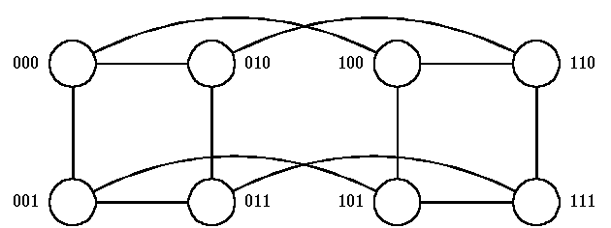

Figure 1. An example across both columns.

- Page format All texts and graphs will be printed on A4 papers using laser printer. All printed materials, including text, illustrations, and charts, must be kept within the page limits. The page number should be removed in your file.
- Column width and height The pages should be arranged in TWO-COLUMN form. Columns are 3-inches wide, with a 0.3-inch space in between. The height of text on any page should not exceed 9 inches. Margins are of an inch on the sides, 1 inch on the top, with the author's name and affiliation beneath the title as shown on the sample page. On the first page, the abstract and first column of text should begin 3 inches from the top of the paper.
- Type style and size of text Text is to be typed SINGLE-SPACED in a two-column format. (We suggest 10-point Times-Roman with 12-point interline spacing.) The entire text should be justified. Please do not place additional line spacing between paragraphs.
- Abstract Preferably, the abstract will be italicized. Please leave two spaces between the abstract and the title of your first section.
- Title and headings The main title should be boldface typed (e.g. 14-point Times-Roman), and centered over both columns. In main titles, please initially capitalize nouns, pronouns, verbs, adjectives, and adverbs; do not capitalize articles, coordinate conjunctions and prepositions (unless the title begin with such a word). Please initially capitalize only the first word in other titles, including section titles and first-, second-, and third-order heading. Leave two blank lines before author/affiliation bylines.
Author name(s) and affiliation(s) The author name(s) should be nonboldface type, initially capitalized, and centered. Leave two blank lines before your abstract.
Abstract titles The heading over your abstract (for example, Abstract) should be boldface, initially capitalized, and centered.
Section title, first- second- and third-order headings These titles or headings (For example, 1 Introduction) should be boldface, initially capitalized, flush left, with two blank lines before, and one blank line after.
- Illustrations, graphs and photographs Illustrations, graphs, and photographs my fit across both columns if necessary. Figure 1 shows an example.
- Footnotes Use footnotes sparingly and place them at the bottom of the column in which they are referenced (but not full width across two columns).
- References List and number all bibliographical references at the end of your paper. When referenced within the text, enclose the citation number in square brackets (for example, [1]). Where appropriate, include the name(s) of editor of referenced books.
NOTE: We provide you with a standard Latex format and a Microsoft Word format as specified above. You can get them from http://par.cse.nsysu.edu.tw/~algo2002.

