Sequence Similarity

Scoring Function
Alignment
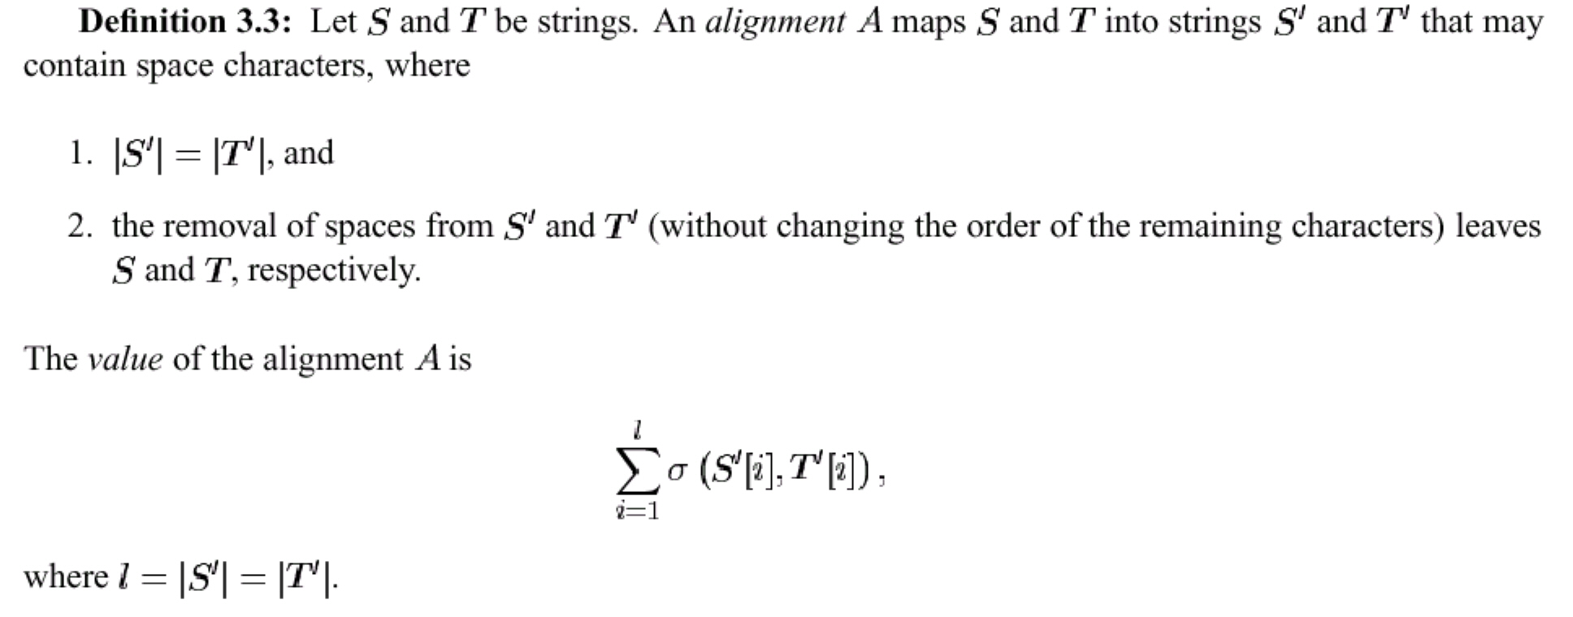
Ex.
S₁ = ACBCDB
S₂ = CADBD
Alignment
S₁ = A C – B C D B
S₂ = C A D B – D –

match score +2 , mismatch and spaces score –1
then the alignment above has score
3．(2) + 5．(-1) = 1

Optimal Alignment
- Optimal ( Global ) Alignment

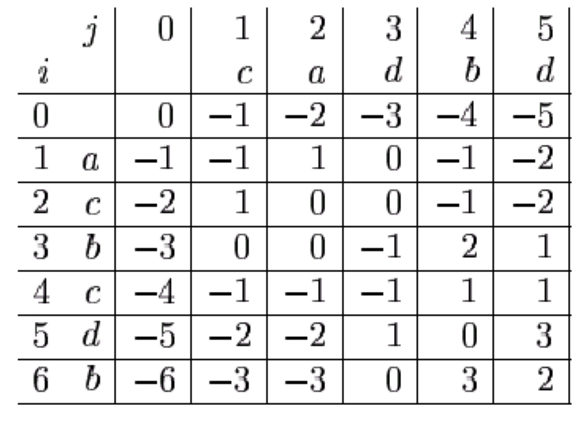
Match score +2
Mismatch and Spaces score -1
Recovering the Alignment
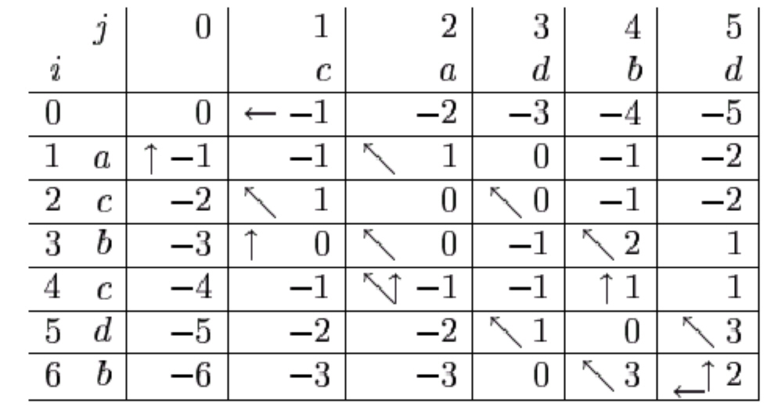
The optimal alignment Corresponding to these three paths are
Time Analysis
The dynamic programming algorithm computes an optimal alignment in time O(n m) .
- Optimal Local Alignment
For example, let S = abcxdex. The prefixes of S include ab. The suffixes of S include xdex. The empty string λ is both a prefix and a suffix of S .

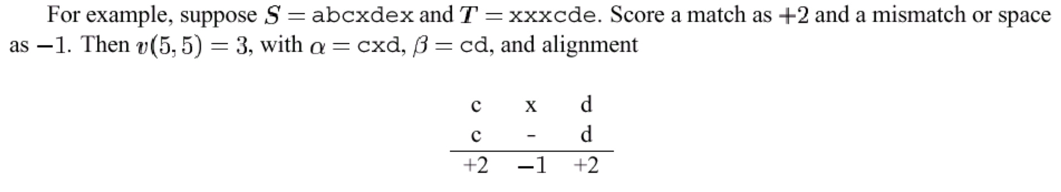
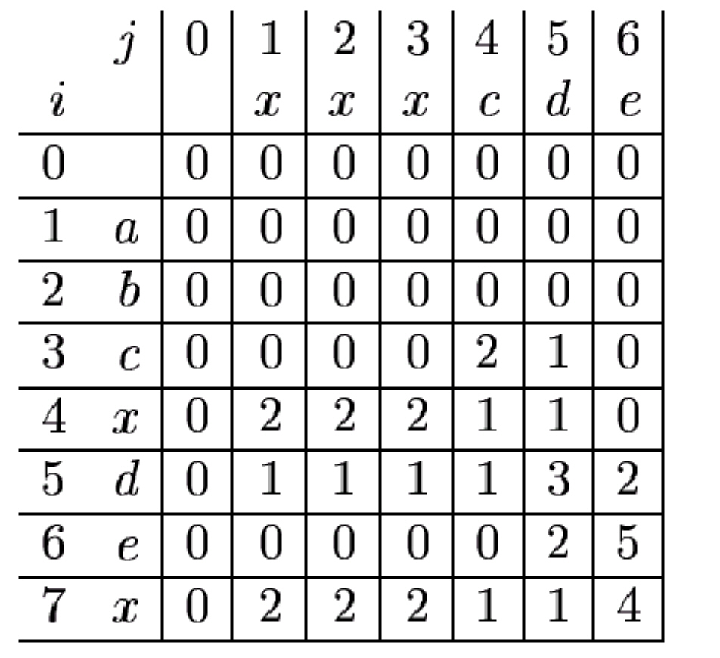
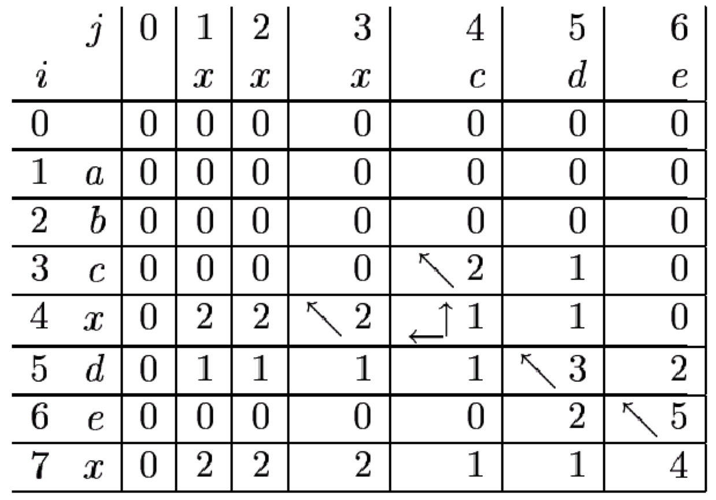
The value of the optimal local alignment is v(6,6) = 5 .
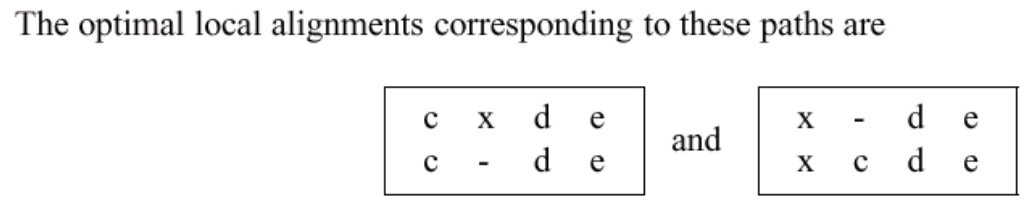
Time Analysis
The dynamic programming algorithm computes an optimal local alignment in time
O(n m) .

Space Analysis
The space required for either the global or local optimal alignment is O(n²) .

- General Gap Penalty Functions
- Affine Gap Penalty Functions
- Multiple Sequences Alignment
S₁=ACAT
S₂=AGT
S₃=ACTG
S₄=ACG
σ(a,a)=1 , σ(a,b)=-1 , σ(a,-)=-2 , σ(-,-)=0

SP Measure
If A_{i,j} is the score of the alignment implied for sequences pair ( i , j ) ,then the total score is :
SP= Σ_{i,j} A_{i,j}

Total Score = -4

ACAT
AG–T
ACTG
AC–G
ACAT
AG–T
Score:-1
ACAT
ACTG
Score:0
ACAT
AC–G
Score:-1
AG–T
ACTG
Score:-3
ACTGAC–G
Score:1

Time Analysis
The algorithm runs in time O((2n)^{k}) when given k strings each of lengths at most n .
Star Alignment
 | S₁ | S₂ | S₃ | S₄
S₁ |  | -1 | 0 | -1
S₂ | -1 |  | -1 | -1
S₃ | 0 | -1 |  | 1
S₄ | -1 | -1 | 1
ACAT
AGT–
ACTG
AC–G
Time Analysis
The algorithm runs in time O(k²n²) when given k strings each of lengths at most n .

Tree Alignment
It is assumed that an evolutionary tree for the sequences is known , and the sequences are leaves in the tree.

ACAT
ACTG

ACG

AGT
ACG

ACT

We have a score of 7

- Consensus String
A C–C G T–
–C–A G T G
A–T C G A G

The consensus string is AC–CGTG
- Database Search
一般評估資料庫搜尋程式是根據靈敏度(sensitivity)，選擇性(selectivity)與速度(speed)等三方面來討論的。靈敏度(sensitivity)不夠，就會誤將有親緣關係的序列判斷為雜訊，而選擇性(selectivity)太低則會誤將不相干的特性，例如序列組成的相似性或是疏水性等特性判斷為有親緣關係。

FastA
Dynamic programming 能有系統地尋找同源的序列，可是它的速度太慢。在資料庫搜尋上通常是利用經驗法則( rules of thumb ) 先挑出值得仔細分析的片段，再做 Needleman - Wunsch 的最佳化排列。像 FastA 這樣利用序列片段的相似性來推測可能有親緣關係的區域，再將少量找到的區域做嚴謹的區域性並列分析，可以節省許多計算的時間。這種利用法則加速搜尋的方法，稱之為「heuristic algorithm」。

Blast
Blast ( Basic Local Alignment Search Tool ) 是根據統計理論所設計的，雖然它也是一種 heuristic 運算法，其計分方式卻與像 dynamic programming 一樣，能模擬找出突變最少的狀況的過程。這種 heuristic 運算法 的計算速度約比 FastA 快一個數量級以上

