Dept. of Computer Science and Engineering, Graduate
National Sun Yat-sen University
Bioinformatics, Final Exam., June 12, 2003, 9:10—11:00

Part I
- Explain each of the following terms. (20%)
(a) ATP (b) gene (c) meiosis (d) mutant (e) tRNA
(f) rRNA (g) anticodon (h) transcription (i) pre-mRNA (j) promoter
- Describe how DNA is synthesized in the cell. (7%)
- Describe how protein is synthesized in the cell. (8%)

Part II
- (a) What is the longest common subsequence (LCS) problem? Give an example to explain it. (5%)
  - What is the relationship between the LCS problem and the two-sequence alignment problem. Explain it with your above example. (5%)
  - How do you solve the LCS problem with dynamic programming? (5%)
- Suppose there are four species s₁, s₂, s₃, s₄ and their best unrooted evolution tree topology is shown in the following figure. A distance matrix is also given, where d_{ij} denotes the distance between s_{i} and s_{j}. Please determine the optimal weights for the tree edges by using linear programming. (12%)
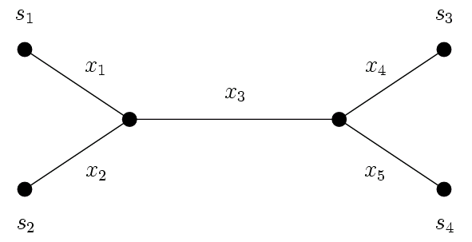

- What is a suffix tree? Please explain it with the string”ATCACATCA”. (8%)

Part III
- What are the five major goals of the human genome project? (10%)
- Why reverse genetics? (5%) (Hint: starting from molecular markers and genome map)
- (a) What is the Holy Grail of Bioinformatics? (5%)
  - Give some approaches and their accuracies that are currently used to do protein structure prediction. (15%)

