An Orthogonal Simulated Annealing Algorithm for Solving Large Parameter Optimization Functions∗

Shinn-Ying Ho☆ and Li-Sun Shu
Department of Information Engineering, Feng Chia University,
Taichung, Taiwan 407, Republic of China

Abstract–In this paper, we proposed an orthogonal simulated annealing algorithm (OSA) with an intelligent generation step of SA based on orthogonal experiment design (OED). The OED-based generation can systematically generate a high-quality search point by reasoning from uniformly sampling relatively few representative search points in the neighborhood of a current solution instead of the conventional generate-and-test and random search methods. It is shown empirically that OSA has high performance in solving benchmark functions comprising many parameters, as compared with the traditional genetic algorithm and simulated annealing algorithm.

Keywords: Genetic algorithm, orthogonal experiment design, simulated annealing algorithm
1. Introduction
Simulated annealing is a well-known, high-performance optimization technique for combinatorial problems. Simulated annealing algorithm (SA), one of the most popular global optimization methods, is widely applied for solving engineering problems. To solve many intractable engineering problems using SA, these problems are formulated as optimization problems which require optimizing a function comprising lots of parameters [1]-[3]. SA applies randomized perturbation to generate search points and determine the best one as the next candidate solution. The more the parameters, the larger the search space. The performance of SA would be greatly degraded when applied to large parameter optimization problems (LPOPs). Nowadays, conventional SA is difficult to effectively solve LPOP.
To improve performance of SA, a number of techniques, such as self-regulatory strategy [4], and combined strategies of SA with search methods [5], [6] and genetic algorithm (GA) [7] are effectively adopted. These generation steps of the above-mentioned improved SAs randomly generate and test search points to explore the neighborhood of a current solution, which is difficult to cope with LPOP for generating a high-quality move.
Genetic algorithms (GAs) have been shown to be effective for exploring NP-hard or complex non-linear search spaces as efficient optimizers relative to computer-intensive exhaustive search [8]. GA utilizes collective learning process of a population of individuals. Usually, each individual represents a search point in the space of potential solutions to a given problem. Descendants of individuals are generated by randomized process intended to model mutation and crossover. Mutation corresponds to an erroneous self-replication of individuals, while crossover exchanges information between two or more individuals. By means of evaluating individuals, a measure of quality or objective values can be assigned to individuals. According to the measure, the selection process favors better individuals to reproduce more often than those that are relatively worse.
Both SA and GA are computation intensive. However, GA has some intrinsic features which, if exploited properly, can result in significant savings. One difference is that SA operates on only one solution at a time, while GA maintains a large population of solutions which are optimized simultaneously. In this paper, we proposed an orthogonal simulated annealing algorithm (OSA) with an intelligent generation (IG) step of SA based on orthogonal experiment design (OED). The OED-based IG can systematically generate a high-quality search point by reasoning from uniformly sampling relatively few representative search points in the neighborhood of a current solution instead of the conventional generate-and-test and random search methods. The auxiliary techniques such as local search, various combined strategies, and problem-dependent heuristic strategies, which can improve performance of SA, can also improve performance of OSA. It is shown empirically that OSA has high performance in solving benchmark functions comprising many parameters, as compared with the traditional GA and SA.

2. Orthogonal Experiment Design
OSA uses IG to achieve an efficient generation step based on orthogonal experimental design (OED). OED which is a representative method of quality control [9]-[11] also can work to facilitate IG in achieving an efficient generation step of OSA. The conventional generation step of SA randomly perturbs the current solution to generate a candidate solution in the neighborhood of the current solution. The systematic reasoning ability of OED is incorporated in IG to uniformly sample relatively few search points in the neighborhood of a current solution and determine the best one as the next move. The superiority of IG to the conventional generation step of SA arises from that IG replaces the generate-and-test search for a new solution with a systematic reasoning method to effectively cope with LPOP.
The three-level OA used in IG is described as follows. Let there be N factors with three levels for each factor. The number of total experiments is 3^{N} for the popular “one-factor-at-once” study. All the optimization parameters are generally partitioned into several groups. Generally, levels 1, 2 and 3 of a factor represent the selected groups of parameters from three candidate solutions, including a current solution and two perturbed ones of the current solution. To use an OA of N factors with three levels, we obtain an integer 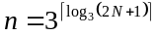, build a three-level OA L_{n}(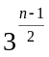) with n rows and (n-1)/2 columns, use the first N columns, and ignore the other (n-1)/2-N columns. Table 1 illustrates an example of OA L₉(3⁴). OA can reduce the number of experiments for factor analysis. The number of OA experiments required to analyze all individual factors is only n. An algorithm of constructing OA can be found in [12].
After proper tabulation of experimental results, the summarized data are analyzed using factor analysis to determine the relative effects of levels of various factors as follows. Let y_{t} denote an objective function value of the combination corresponding to the experiment t, where t = 1, …, n. Define the main effect of factor j with level k as S_{jk} where j = 1, …, N and k = 1, 2, 3:
S_{jk}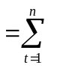y_{t} ∙ F_{t} , (1)
where F_{t} = 1 if the level of factor j of experiment t is k; otherwise, F_{t} = 0. Considering the case that the objective function is to be maximized, the level k of factor j makes a better contribution to the objective function than the other two levels of factor j do when S_{jk}=max{S_{j1,} S_{j2,} S_{j3}} and 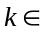{1, 2, 3}. On the contrary, if the objective function is to be minimized, the level k is better when S_{jk}=min{S_{j1,} S_{j2,} S_{j3}}.
After the best one of three levels of each factor is determined, an intelligent combination consisting of all factors with the best level can be easily derived. OED is effective for development design of efficient search for the intelligent combination of factor levels, which can yield a high-quality objective value compared with all values of 3^{N} combinations, and has a large probability that the reasoned value is superior to those of n representative combinations.

3. Orthogonal Simulated Annealing Algorithm OSA
OSA uses an OED-based intelligent generation (IG) step to cope with LPOP. IG divides all optimization parameters into an adaptive number of groups representing partial solutions. IG uses OED to identify the good partial solutions from all current partial solutions and the perturbed ones of the current solutions. Consequently, the systematical reasoning ability of OED incorporated in IG is used to efficiently combine all the selected good partial solutions to form a good solution of the next iteration.
3.1 Intelligent Generation IG
Let L be the number of optimization parameters. Using the same division scheme with/without prior knowledge, partition all the parameters into M non-overlapping groups with sizes l_{i}, i=1,2, …, M, such that
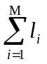= L . (2)
According to a current solution P₁, IG generates two temporary solutions P₂ and P₃ form perturbing P₁. Let P₁=[S₁, …, S_{M}] where S_{i} is a partial solution consisting of parameter values of the ith group. P₂=[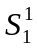, …, 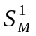] and P₃=[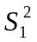, …, 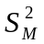] where 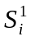 and 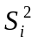 are generated from S_{i} by disturbing using a step value 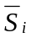 as follows:
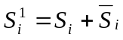 and 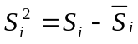 i=1, …, M. (3)
Let N be the number of parameters and M be the associated number of groups for each IG operation, where M=(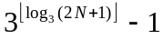)/2 and the used OA is L_{2M+1}(2^{M}). The M-1 cut points are randomly specified from the N-1 candidate cut points which separate individual parameters. The average number N_{v} of participant variables in one segment is N_{v}=N/M and one IG operation takes 2M+2 objective evaluations.
  - The step value plays an important role in controlling the convergence speed of SA. The larger the step value, the larger the distance of one move. To efficiently search an optimal solution, it is better to adaptively specify using a coarse-to-fine strategy [13]. In the coarse phase, a large step value is used for exploring the search space. While the iteration proceeds, the step value is gradually decreased. In the fine phase, a small step value is used for exploiting the neighborhood of a current solution to seek for an optimal solution.
IG aims to efficiently combining good partial solutions of parameter groups from solution P₁, P₂ and P₃ to generate a good solution C₁. How to perform an IG operation of OSA is described as follows:
- Adaptively divide the three solutions into N groups of optimization parameters where each group is treated as a factor.
- Use the first N columns of an OA L_{n}(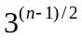) where 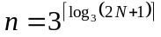.
- Let levels 1, 2 and 3 of factor j represent the jth partial solutions of group parameters coming from solutions P₁, P₂ and P₃, respectively.
- Evaluate the objective value y_{t} of the combination corresponding to the experiment t, where t = 1, …, n.
- Compute the main effect S_{jk} where j = 1, 2, …, N and k = 1, 2, 3.
- Determine the best one of three levels of each factor based on the main effect.
- The solution of C₁ is formed using the combination of the best partial solutions from the derived solutions P₁, P₂ and P₃.
- Verify that C₁ is superior to the n combinations according to the objective value. If it is not true, select the best solution from the n candidate solution not equal to the current solution as C₁.
3.2 Orthogonal simulated annealing algorithm (OSA)
Without lose of generality, consider the case that the objective function f is to be minimized. The simple OSA is described as follows:
Step 1: (Initialization) Generate a starting point P₁ with/without piror knowledge. Set starting temperature T=T₀, cooling rate C and the number N_{T} of trials per temperature.
Step 2: (Generation) Perform IG operation to generate a new solution C₁.
Step 3: (Acceptance criterion) Accept C₁ to be the new P₁ with probability P_{T}(C₁) which is given by
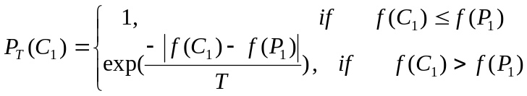. (4)
Step 4: (Iteration) If the number N_{T} of iterations is not reached, go to Step 2.
Step 5: (Reduction) Reduce the temperature by T=C×T and the step value =C×, where i=1, …, N.
Step 6: (Termination test) If a stopping condition is satisfied, end the algorithm. Otherwise, go to Step 2.

4. Performance Comparisons
To evaluate the efficiency of IG for solving optimization problems with various dimensions, twelve benchmark functions gleaned from literature are tested in the experimental study. The test function, variable domain and global optimum for each function are listed in Table 2.
In order to show that the proposed OSA is effective for solving LPOP, the performance of a simple OSA is compared with those of the simple simulated annealing algorithm (SSA) and simple genetic algorithm (SGA). The control parameters of SGA are as follows: population size = 10, selection rate = 0.2, crossover rate = 0.8 and mutation rate = 0.05. SGA employs one-point crossover operation with elitist strategy. Each parameter is encoded using 10 bits for all test functions except that functions f₉ and f₁₂ use 24 bits. For SSA and OSA, the cooling rate C is 0.99 and the iteration number N_{T} is 5. The stopping condition uses 10,000 objective function evaluations for all algorithms. Since OSA takes more objective function evaluations than SSA per temperature value, the temperature value of OSA should be smaller. Therefore, the temperature values of OSA and SSA are 10 and 100, respectively.
The comparisons of average performance using 30 independent runs for test functions with dimension D=10 and D=100 are listed in Tables 3 and 4, respectively. From Table 3, it reveals that SGA has the best performance for solving these functions with 10 parameters. However, the performance of OSA is very close to SGA and superior to SSA. Therefore, OSA works well for solving these functions with few parameters. In Table 4, OSA is almost the best one for all test functions with many parameters.
To illustrate the performance comparisons on various numbers of parameters, we use a distance function Dist(D) for describing the mean distance between the optimal solution f_{opt}(D) and the obtained best solution f_{best}(D) for one variable as follows:
Dist(D)=|f_{opt}(D)-f_{best}(D)|/D. (5)
The results of average Dist(D) for all test functions with D=10, 20, …, 100 are shown in Fig. 1. From Fig. 1, it reveals that OSA is superior to SGA and SSA, especially for test functions with many parameters.

5. Conclusions
In this paper, we proposed an orthogonal simulated annealing algorithm (OSA) with a novel intelligent generation (IG) step to solve LPOP. Based on orthogonal experimental design, IG adaptively divides the current solution into N partial solutions, disturbs each partial solution to generate two temporary candidate solutions, uniformly samples relatively few search points by orthogonal array from all the possible combinations of partial solutions, and systematically combines these N better partial solutions to reason a good solution. OSA can be widely applied to solve applications of LPOP. The auxiliary techniques such as local search, various combined strategies, and problem-dependent heuristic strategies, which can improve performance of SA, can also improve performance of OSA. It is shown empirically that OSA has high performance in solving benchmark functions comprising many parameters, as compared with the traditional GA and SA.

References
- S. Yang, J.M. Machado, G. Ni, S.L. Ho and P. Zhou, “A self-learning simulated annealing algorithm for global optimizations of electromagnetic devices,” IEEE Trans. Magnetics, vol. 36, pp. 1004-1008, July 2000.
- K. Kiyota and K. Fujiyosh, “Simulated annealing search through general structure floorplans using sequence-pair,” in Proc. IEEE Int. Conf. Circuits and Systems, vol. 3, 2000, pp. 77-80.
- T. Renyuan, S. Jianzhong and Li Yan, “Optimization of electromagnetic devices by using intelligent simulated annealing algorithm,” IEEE Trans. Magnetics, vol. 34, no. 5, pp. 2992-2995, 1998.
- A. Corana, M. Marchesi, C. Martini and S. Ridella, “ Minimizing multimodal functions of continuous variables with simulated annealing algorithm”, ACM Trans. Math. Software, vol. 13, pp. 262-280, 1987.
- A. Drago, C. Manella, M. Nervi, M. Repetto, and G. Secondo, “Combined strategy for optimization in non-linear magnetic problems using simulated annealing and search techniques, IEEE Trans. Magnetics, vol. 28, no. 2, pp. 1541-1544, 1992.
- J. Simkin and C. W. Trowbridge, “Optimization electromagnetic dives combining direct search methods with simulated annealing,” IEEE Trans. Magnetics, Vol. 28, No. 2, pp. 1545-1548, 1992.
- T. Renyuan, Y. Shiyou, Li Yan, “Combined strategy of improved simulated annealing and genetic algorithm for inverse problem,” IEEE Trans. Magnetics, vol. 32, no. 3, pp. 1326-1329, 1996.
- D. E. Goldberg, Genetic Algorithms in search, Optimization and Machine Learning, Addison – Wesley Publishing Company, 1989.
- S. H. Park, Robust Design and Analysis for Quality Engineering. Chapman & Hall, 1996.
- T. P. Bagchi, Taguchi Methods Explained: Practical Steps to Robust Design. Prentice-Hall, 1993.
- M. S. Phadke, Quality Engineering Using Robust Design. Englewood Cliffs. NJ: Prentice-Hall, 1989.
- Y. W. Leung and Y. Wang, “An orthogonal genetic algorithm with quantization for global numerical optimization,” IEEE Trans. Evol. Comput., vol. 5, no. 1, pp. 41-53, Feb. 2001.
- S.-Y. Ho and H.-L. Huang, “Facial modeling from an uncalibrated face image using a coarse-to-fine genetic algorithm,” Pattern Recognition, vol. 34, pp. 1015-1031, 2001.

Table 1. Orthogonal array L₉(3⁴)
 | Factors
Experiment  no. | 1 | 2 | 3 | 4 | Observed Response
1 | 1 | 1 | 1 | 1 | y₁
2 | 1 | 2 | 2 | 2 | y₂
3 | 1 | 3 | 3 | 3 | y₃
4 | 2 | 1 | 2 | 3 | y₄
5 | 2 | 2 | 3 | 1 | y₅
6 | 2 | 3 | 1 | 2 | y₆
7 | 3 | 1 | 3 | 2 | y₇
8 | 3 | 2 | 1 | 3 | y₈
9 | 3 | 3 | 2 | 1 | y₉

Table 2. Benchmark functions

Test functions  domain Optimum
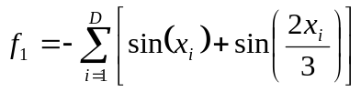 [3, 13] 1.21598D(max)
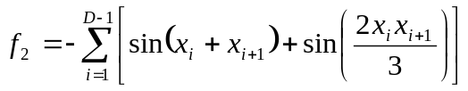 [3, 13] 2D (max)
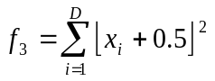 [-100, 100] 0 (min)
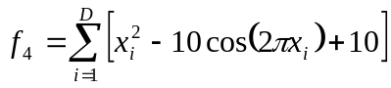 [-5.12, 5.12] 0 (min)
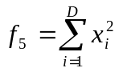 [-5.12, 5.12] 0 (min)
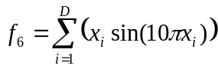 [-1.0, 2.0] 1.85D (max)
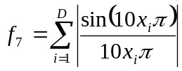 [-0.5, 0.5] 0 (min)
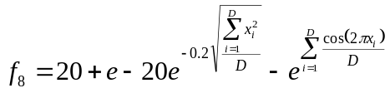 [-30, 30] 0 (min)
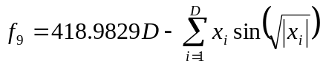 [-500, 500] 0 (min)
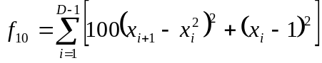 [-5.12, 5.12] 0 (min)
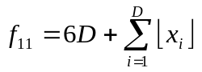 [-5.12, 5.12] 0 (min)
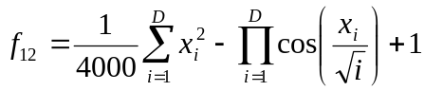 [-600, 600] 0 (min)

Table 3. The objective values and ranks for functions with D=10 for SGA, SSA and OSA.
Test  functions | SGA | SSA | OSA
f₁ | 12.119(1) | 11.6016(2) | 8.3210(3)
f₂ | 16.19(1) | 13.5637(3) | 15.6808(2)
f₃ | 5.53(2) | 188.1333(3) | 0.0333(1)
f₄ | 8.94(1) | 46.9416(3) | 42.624(2)
f₅ | 0.0004(1) | 0.5415(3) | 0.0018(2)
f₆ | 15.82(1) | 7.68(3) | 11.53(2)
f₇ | 0.035(2) | 0.102(3) | 0.015(1)
f₈ | 0.23(1) | 6.47(3) | 0.46(2)
f₉ | 848.1(1) | 1887.1(3) | 1730.1(2)
f₁₀ | 41.39(2) | 54.41(3) | 6.39(1)
f₁₁ | 0.03(2) | 0.00(1) | 1.50(3)
f₁₂ | 1.001(1) | 2.901(3) | 1.006(2)
Rank average | 1.33 | 2.75 | 1.92
Final rank | 1 | 3 | 2

Table 4. The objective values and ranks for functions with D=100 for SGA, SSA and OSA.

Test  functions | SGA | SSA | OSA
f₁ | 90.52(1) | 68.99(3) | 80.87(2)
f₂ | 94.59(2) | 52.15(3) | 133.23(1)
f₃ | 55027(3) | 31959(2) | 301(1)
f₄ | 795.75(2) | 1372.43(3) | 521.85(1)
f₅ | 145.52(3) | 92.32(2) | 1.08(1)
f₆ | 76.72(2) | 23.37(3) | 111.36(1)
f₇ | 3.86(2) | 5.47(3) | 1.56(1)
f₈ | 16.93(3) | 16.63(2) | 6.52(1)
f₉ | 24645(2) | 33735(3) | 18663(1)
f₁₀ | 96556(3) | 37519(2) | 1465(1)
f₁₁ | 159.90(3) | 113.03(2) | 17.77(1)
f₁₂ | 511.93(3) | 304.41(2) | 3.91(1)
Rank average | 2.42 | 2.50 | 1.08
Final rank | 2 | 3 | 1

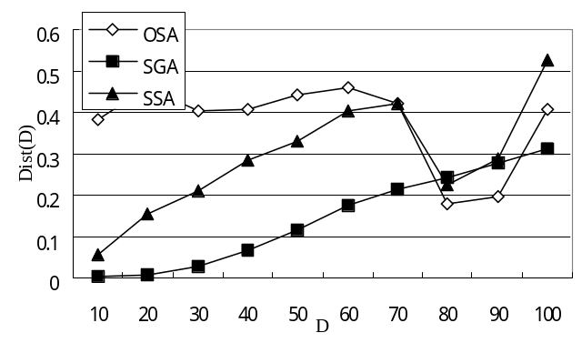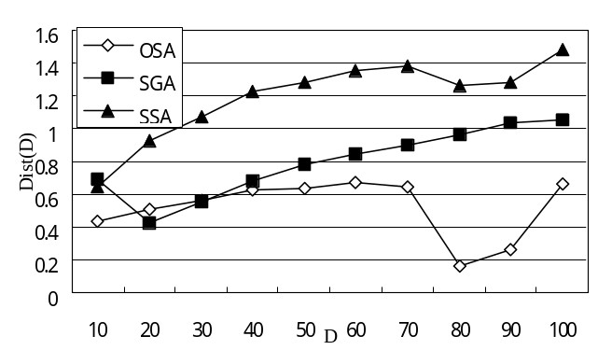
OGA
(a) (b)
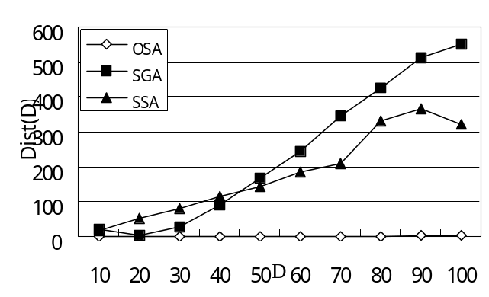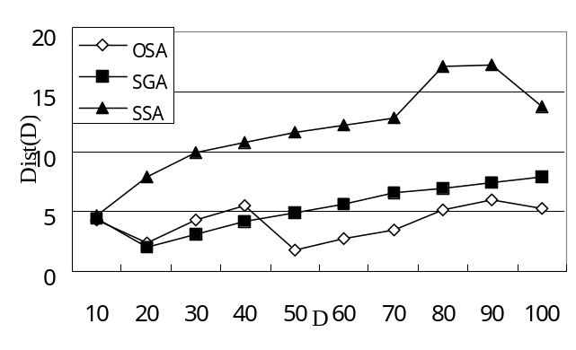
(c) (d)
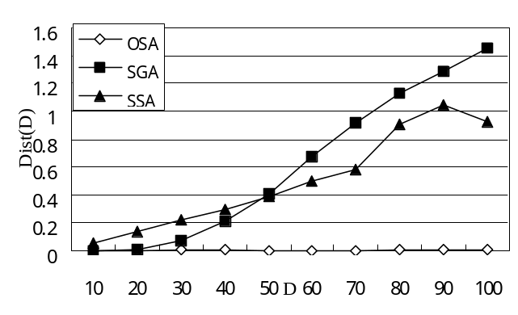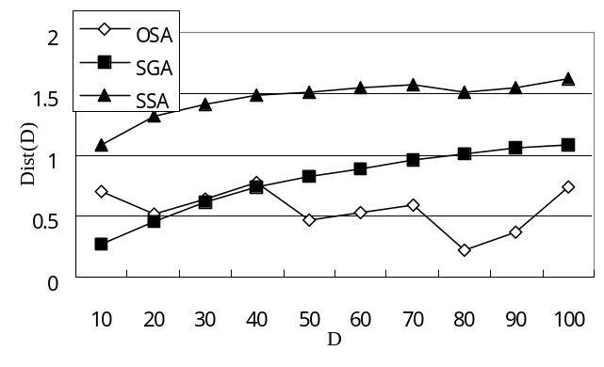
(e) (f)
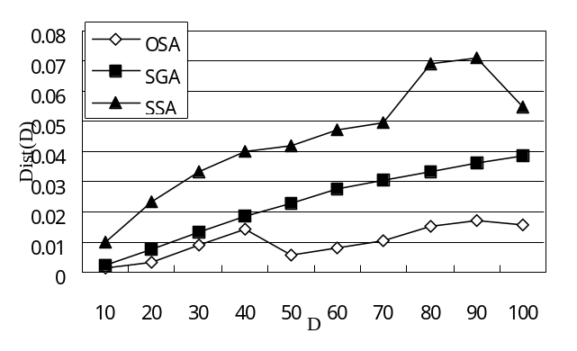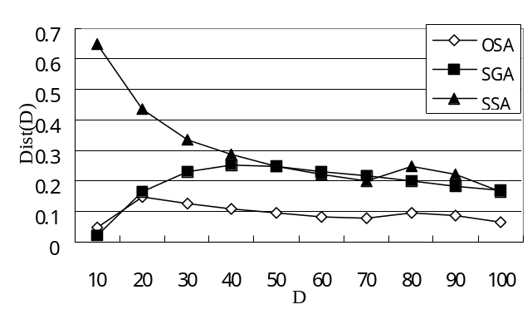
(g) (h)
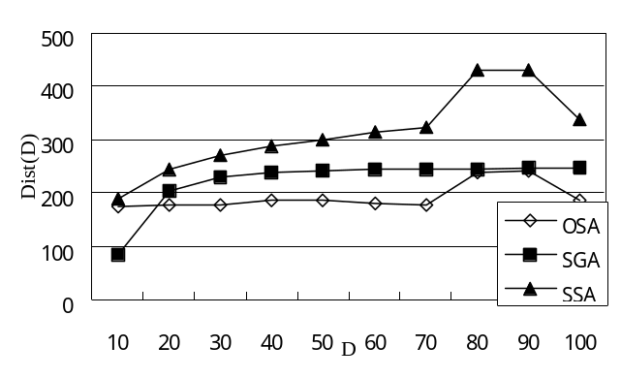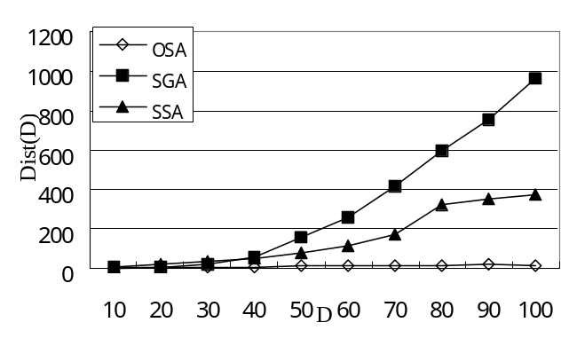
(i) (j)
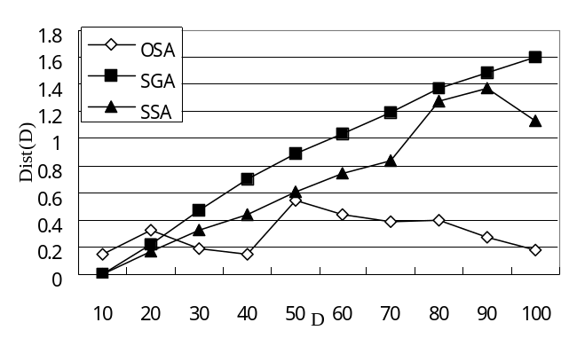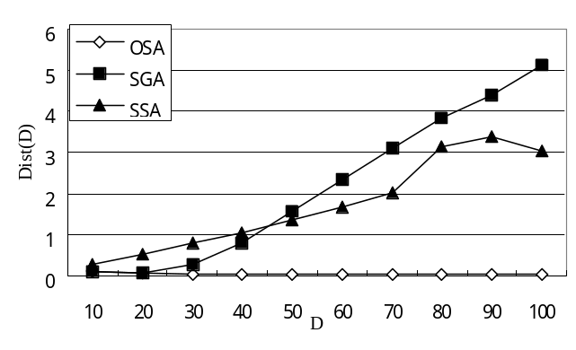
(k) (l)
Fig. 1. The comparisons of various algorithms using dist(D) curves for functions f₁, f₂, …, and f₁₂ in (a), (b), …, and (l), respectively.

 The work of this paper was supported by the National Science Council of R.O.C. under the contract NSC 90-2213-E-035-013.
☆ Corresponding author. Fax: +886-4-24516101. E-mail address: syho@fcu.edu.tw

