The 19th Workshop on Combinatorial Mathematics and Computation Theory

A Note on the Generalized Fresnel’s Integrals

Yeong-Jeu Sun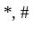

* Department of Electrical Engineering, I-Shou University, Kaohsiung 840, Taiwan
# Department of Applied Mathematics, National Sun Yat-Sen University, Kaohsiung 804, Taiwan
Tel: 886-7-6577711 ext. 6626; Fax: 886-7-6577205; Email: yjsun@isu.edu.tw

Abstract
In this note, the generalized Fresnel’s integrals of the first kind and that of the second kind are introduced. A simpler alternative proof of the Fresnel’s integrals is provided, which is also applicable to that of the generalized Fresnel’s integrals.

Key words and phrases: Generalized Fresnel’s integrals, Fresnel’s integrals.

1. Problem formulation and main results
As we know, the Fresnel’s integrals are first arose in optics and the formula of the Fresnel’s integrals is provided as follows.
Lemma 1 [1].
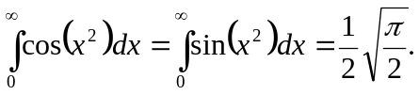
Note that the proof of Fresnel’s integrals [1] is based on integrating 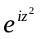 over the closed path bounding the sector 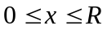, 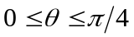 with Cauchy’s theorem and Jordan’s lemma. In this note, the generalized Fresnel’s integrals of the first kind and that of the second kind are introduced. Our objective is to investigate the formula of such generalized Fresnel’s integrals. For convenience, in this note, 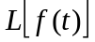 denotes the Laplace transform of the function .

Definition 1.
The generalized Fresnel’s integrals of the first kind is defined by
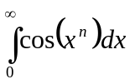,
which converges for 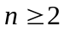. The generalized Fresnel’s integrals of the second kind is defined by
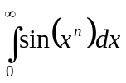,
which converges for .

Now we present the formula for the generalized Fresnel’s integrals as follows.
Theorem 1. For any , one has
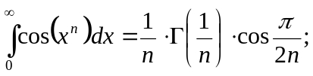
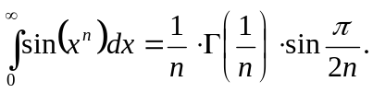
Proof. Define
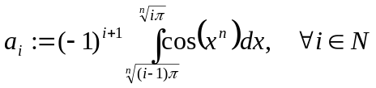 and 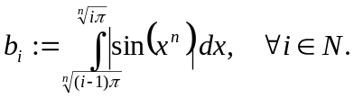
Clearly, both of the sequences of 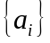 and 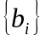 are positive and strictly decreasing sequences. Furthermore, it can be readily obtained that
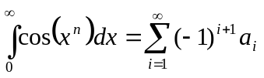 and 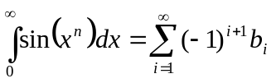.
Consequently, we conclude that the generalized Fresnel’s integrals are positive and of existence by the alternating series test. Using the technique of integration by substitution, one has
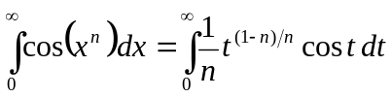 and 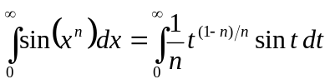.
Define 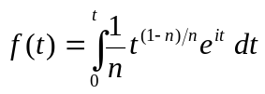. Obviously, one has
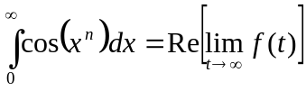 and 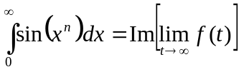.
Moreover, by the final-value theorem of Laplace transform [2], it yields
which implies
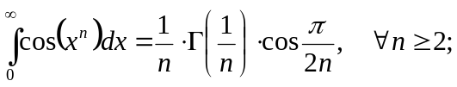
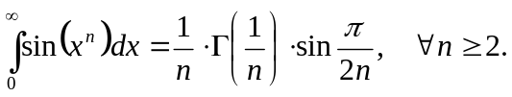
This completes our proof. █

Conclusion
In this note, the generalized Fresnel’s integrals of the first kind and that of the second kind have been introduced. A simpler alternative proof of the Fresnel’s integrals has been provided as above, which is also applicable to that of the generalized Fresnel’s integrals.

REFERENCES
- P. V. O’Neil, Advanced Engineering Mathematics, 4th ed., Brooks/Cole Publishing Company, New York, 1995.
- J. J. D’Azzo and C. H. Houpis, Linear Control System Analysis and Design: Conventional and Modern, 3rd ed., McGraw-Hill, New York, 1988.

