The 19th Workshop on Combinatorial Mathematics and Computation Theory

A note on the generalized gamma function

Yeong-Jeu Sun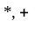
Department of Electrical Engineering, I-Shou University, Kaohsiung, Taiwan 840, R.O.C.
Phone: 886-7-6577711 ext. 6626; Fax: 886-7-6577205; E-mail: yjsun@isu.edu.tw
Department of Applied Mathematics, National Sun Yat-Sen University, Kaohsiung, Taiwan 804, R.O.C.
Phone: 886-7-5254139; Fax: 886-7-6577205; E-mail: yjsun@isu.edu.tw

Abstract
In this note, the generalized gamma function of the first kind and that of the second kind are introduced. Simple proofs and iterative formulas are provided to guarantee the properties of such functions.

Key words and phrases: Generalized gamma function, gamma function, special function.

1. Introduction
As we know, the gamma function first arose in regard to the interpolation problem for factorials [3]. In conjunction with the factorial function, the gamma function is a generalization of the factorial function [1]. In this note, the generalized gamma function of the first kind and that of the second kind are introduced. It can be proven that the generalized gamma function of the first kind is a generalization of the gamma function. Our objective is to investigate the iterative formulas of such generalized gamma function. Finally, a numerical example is provided to illustrate the use of our main result.

2. Problem formulation and main results
Before presenting our main result, let us introduce generalized gamma function.
Definition 1. The generalized gamma function of the first kind 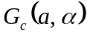 is defined by
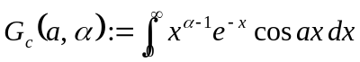,
which converges for 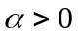. The generalized gamma function of the second kind 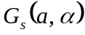 is defined by
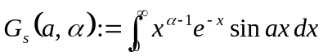,
which converges for .

Remark 1. Note that the gamma function [2], defined by 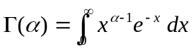, can be regarded as a special case of the generalized gamma function of the first kind in view of 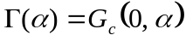.

Lemma 1. For any 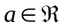, one has
- 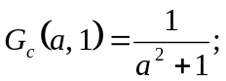
- 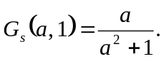
Proof. Two cases are separately discussed as follows.
Case 1: 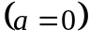
In this case, one can obtain
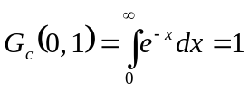 and 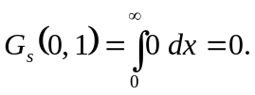 (1)
Case 2: 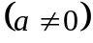
Using the integration by parts, it can be obtained that
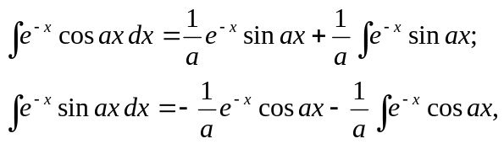
which implies
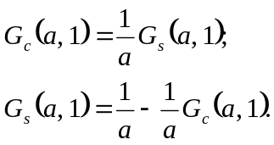
It yields
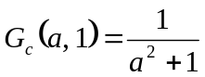 and 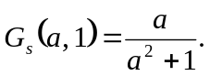 (2)
In summary, from (1) and (2), we conclude that
and
This completes our proof. █

Now we present the recursive formula for the generalized gamma function.
Theorem 1. For any and , one has
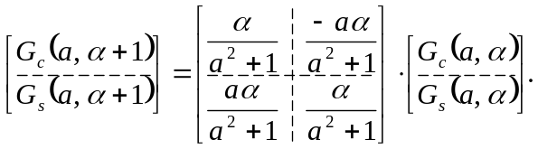
Proof. Two cases are separately discussed as follows.
Case 1:
In this case, using the integration by parts, one can obtain
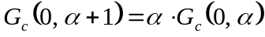 and 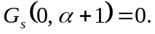 (3)
Case 2:
Using the integration by parts, it can be obtained that
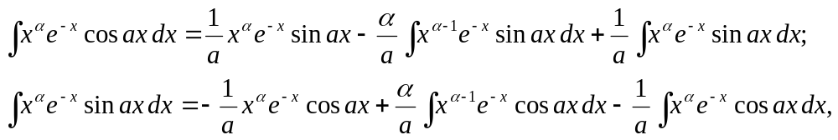
which implies
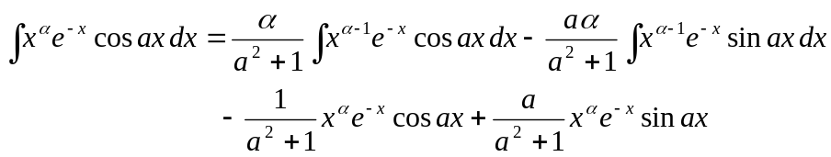
and
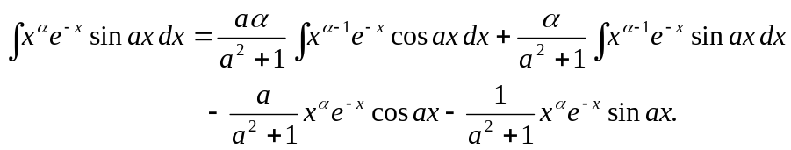
It follows
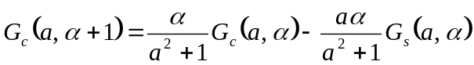 (4a)
and
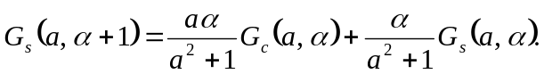 (4b)
This completes our proof in view of (3) and (4). █

Based on Lemma 1 and Theorem 1, we may readily obtain the following result.
Corollary 1.
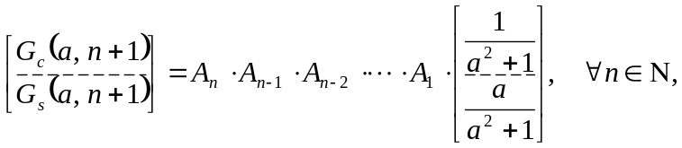
where
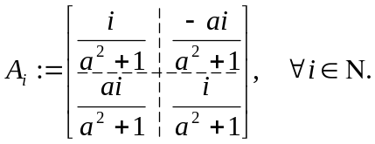

Example 1. Consider the following definite integrals:
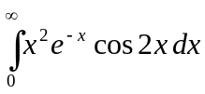 and 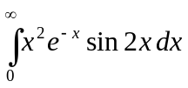.
Thus, by Corollary 1 with 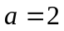, it can be deduced that
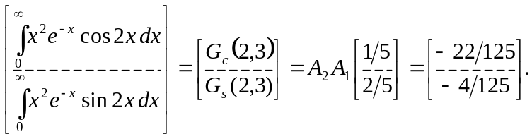

3. Conclusion
. In this note, the generalized gamma function of the first kind and that of the second kind have been introduced. Simple proofs and iterative formulas have been provided to guarantee the properties of such functions.

REFERENCES
- E. Kreyszig, “Advanced Engineering Mathematics,” John Wiley & Sons, New York, 1993.
- K.F. Riley, M.P. Hobson, and S.J. Bence, “Mathematical Methods for Physics and Engineering,” Cambridge University Press, Cambridge, 1998.
- C.R. Wylie and L.C. Barrett, “Advanced Engineering Mathematics,” McGraw-Hill, New York, 1995.

