Design a Morphological De-ringing Filter of Ultrasound Images

Shen-Chuan Tai, Yen-Yu Chen, and Shin-Feng Sheu
Institute of Electrical Engineering
National Cheng Kung University
Tainan, Taiwan

ABSTRACT - In recent years, still image compression technique plays an important role in many applications such as data transmission and data storage. For speeding up image propagation and reducing image storage efficiently, there are many image compression techniques were proposed. Among them, JPEG2000 is a new generation technique, which can encode images at very low bit-rate with acceptable quality. Because its coder is based on wavelet transform, there will be some ringing artifacts in the reconstructed image. In order to improve the image quality, some de-ringing algorithm must be applied to it. In this paper, a set of morphological filters to reduce the ringing artifacts of ultrasound images is presented. It uses 8 predefined morphological operations, including 4 structuring elements (SE) with both dilation and erosion. By the voting strategy, the most suitable morphological filter for each block is selected. To decrease the filter selection information, the side information must be further compressed without any loss. We can get a more acceptable image by applying the proper morphological filter in each block. Experimental results show that the proposed technique improves the quality of the reconstructed ultrasound image in both PSNR and perceptual result when compare to JPEG2000 at the same bit rate.
Key words: JPEG2000, wavelet transform, ringing artifacts, morphological filter

Introduction
With the development of digital image processing and network technology, various image have been stored and transmit in digital format, including the medical images. However, the limit of network bandwidth and storage capacity makes compression scheme becomes the necessary procedure to store and transmit the digital image. In general image compression case [1], we can tolerate much loss in fidelity, i.e. compression ratio about 40:1 or even 100:1. As to medical images [2][3][4][5][6][7][8], compression ratio is limited because of the diagnostic acceptability.
Digital medical images now have played an important role in the diagnosis. Ultrasound images, a popular medical image modality, have distinguishing feature that need to be preserved when compressing. A typical ultrasound image consists of an ultrasound-scanned area, which is often nonrectangular, and background that contain text and limited graphics. Speckle texture is an important feature of ultrasound image. Due to fact that speckle is blurred at low bit rate by SPIHT, the tradeoff between preservation of these speckle and compression ratio become a core problem. Speckle preservation is also important for the radiologists since they are accustomed to it so that noticeable distortion to image should be averted.
Recently, algorithms based on the wavelet transform [9] represent the current state of the art in image compression. One of the most representative algorithms of wavelet-based image coding is set partitioning in hierarchical trees (SPIHT)[10], which is a refined version of embedded zero-tree algorithm (EZW)[11]. In [12], they conclude that wavelet-based methods such as SPIHT are subjectively superior to JPEG compressed at moderately high bit rate. However, the SPIHT developed ringing artifacts at rates above 12:1, which impact the diagnostic acceptability. The new still image compression standard JPEG2000 [13], another wavelet-based image coding algorithm, provide us the better quality at low bit-rate and gives superior performance to SPIHT. Images coded at low-bit rate suffer from the loss of details and sharpness, as well as various coding artifacts. Ringing, one of the coding artifacts, appears as small ripples around edge. In order to attain sufficient image quality for low bit-rate wavelet-based image coding, post-processing is an efficient technique for improving compression result. Also, for the fidelity of the medical image, our post-processing method will take original image into concern.
A few de-ringing algorithms have been proposed recently and detailed descriptions of the topics can be found on Ref. [14][15][16]. In [14], Aase and Ramstad proposed heuristics to extract information about shade regions of an image. With this as side information, the subband decoder reduces ringing artifacts by using low-pass projection operators. Computation load is heavy and inseparable part of the coder, which is undesirable since it is of high chance that JPEG2000 is not going to include their heuristics in the standard.
In a recent article [15], Yang and Galatsanos presented an iterative image restoration method, which is based on projection onto convex sets (POCS), to remove blocking and ringing artifacts. It was designed primary for DCT based coder and therefore, not suitable for being a post-processor of JPEG2000. This is another computationally intensive post-processing approach, which requires the availability of the entire decoded image. It also requires a large storage to save the whole image since the POCS requires the availability of the entire image.
The de-ringing algorithm proposed by Shen and Kuo [16], which is also described in JPEG2000 VM 5.2 [1], is considered to be suitable for being a post-processor for JPEG2000. The de-ringing algorithm replaces each pixel value with a function of the values of neighboring pixels that are within a specified window. To avoid conflict with the aforementioned goal, i.e., smooth at shade regions and sharpen at edges, the de-ringing algorithm uses a number of adaptive noise reduction algorithms. Essentially, the de-ringing algorithm attempts to detect edges in the image in a different way in order to preserve them. Shen and Kuo also introduce the idea of image ringing artifacts reduction through nonlinear filtering by using different kinds of potential functions. It is clear that modeling the compression noise in the space domain is a difficult problem, in particular for ringing artifacts. Although it is hard to characterize the exact probabilistic model of the ringing artifacts, it is quite natural to assume that a threshold, which is based on the subject visual quality, bounds the amplitudes of these artifacts. The disadvantage is that most edges, as well as ringing artifacts will be removes.

The Proposed Post-processing Method
Due to the quantization effect of compression scheme, the fidelity of reconstructed image is reduced in terms of PSNR. In some image compression application, e.g. medical image compression, fidelity is important for transmission and preservation. Thus, medical image compression ratio is usually low and it may take a lot of time to process and transmit the huge amount of image data in medical image processing system. Hence, we proposed a post-processing algorithm to suppress the compression artifact of the ultrasound images and promote compression ratio and image fidelity as high as possible. The proposed post-processing algorithm consists of the quad-tree decomposition, and the morphology based filtering, as described in the following subsections.

Quad-tree decomposition
Since the ringing artifacts appear mostly in the edge and texture area, we need a criterion to classify the compressed image into smooth or texture region. We adopt the quad-tree partition scheme, which is efficient and block-based, to pre-process the compressed image. The main purpose of the quad-tree partition is to make the post-processing method can focus the local feature of the compressed image so that global image quality can be promoted. At first, a threshold is needed to classify the smoothness of the current block and set a value of minimum block size so that the partition will stop. For the smoothness property of a block, we simply calculate the absolute difference between maximum and minimum gray value in a block. If the absolute difference value of a block is larger than the pre-defined threshold, the block is divided into four half-sized sub-blocks. The partition processing in each block is repeated respectively until the smoothness is under criterion or the block size is the same as the minimum size value we previously defined.
After quad-tree partition processing is complete, the image is divided into blocks of different sizes according to its feature. In the blocks with large size, i.e. 8 x 8 pixel block and larger one, we can see the gray-scale value of the block is almost the same. What we concern more about is the blocks with small size i.e., 4 x 4 and 2 x 2; the feature of these blocks may be important information of ultrasound image, like edge, texture region, and the ringing artifacts. Then, morphology based filter applied on these blocks with small size would reduce the ringing effect around edge meanwhile try to maintain and reconstruct the edge detail.

Morphology based filtering
Once we have divided the compressed medical image into various sized blocks, the main operation of our post-processing algorithm can be performed efficiently. In each blocks with various size, morphology based filter is performed to enhance the image quality. The most helpful SE and morphology operation is evaluated by means of the absolute difference between the filtered image block and the original image block. The most helpful type of morphological operation means that the absolute difference between filtered image block and the original image decreased more than other types. In the gray scale morphology, we define the gray scale dilation as an operation that selects the largest pixel value from the mask window (the same dimension as the SE) provided that the corresponding element in the SE window is 1. Similarly, the gray scale erosion is defined as an operation that selects the smallest pixel value from the mask window provided that the corresponding element in the SE window is 1. They are represented as the following formulas:
(1)
(2)
In order to reduce the complexity and computation time, we only consider 3x3 SEs here. Figure 1 shows some typical SEs. They have the function of change the shape of an image by applying morphological operations with these SEs. The eight SEs with the dilation or the erosion stand for eight different orientations.
The post-processing algorithm can be summarized as follows:
At the encoder end:
- Define the smoothness threshold and minimum size of block. Apply quad-tree partition to compressed image.
- Assume that the compressed image is divided in to N Block_{current_blk_num} blocks; current_blk_num represents the index. current_blk_num is initialized as 1;
- For the Block_{current_blk_num}, calculate the absolute difference of each pixel in the block between the compressed image and original image.
- Perform eight types of morphological operation for the Block_{blk_num}. Choose the most helpful morphological filter type from 1 to 8 for the reduction of the absolute difference. If no morphological filter can improve the quality of the block, we leave it unchanged by store filter type of the block as 0.
- current_blk_num ++; If the current_blk_num < N, go to step (3);
- Finally, every blocks of compressed image is assigned a type from 0 to 7; the type number is sent as side information to the decode end. The side information will
At the decoder end:
- Decode the side information to get the partition threshold and minimum size of block for the quard-tree partition, and the filter type numbers for the morphological filtering.
- Apply quad-tree partition to reconstructed image. Assume that the reconstructed image is divided in to N Block_{current_blk_num} blocks; current_blk_num represents the index. current_blk_num is initialized as 1;
- For the Block_{current_blk_num}, perform the exact type of filtering operation based on the type number decided at encoder end.
- current_blk_num ++; If the current_blk_num blk_num< N, go to step (3);
- Finally, every blocks of reconstructed image is filtered for the better fidelity.
The flowchart of de-ringing encoder and decoder is shown in Figure 2 and Figure 3 respectively.

Simulation Results
In this section, we will demonstrate some simulation results of our post-processing algorithm. As described in the previous section, we use the quad-tree partition as the pre-processor of the proposed post-processing algorithm. And there are 2 parameters that have great influence on the quad-tree partition in our system. One parameter is the partition threshold; the smaller the threshold is, the more blocks the image is divided. The other parameter is the minimum size of these blocks. In general, smaller blocks can capture the feature of the image. However, the side information, the type numbers of morphological filter for each block, will increase heavily.
We make some experiments on the 512 x 512 grayscale ultrasound image with 8 bits per pixels. The ultrasound image is compressed by JPEG 2000 at bit-rate from 0.1 to 0.6. We totally use 8 types of morphological filter. The minimum size of block is set to 2 for partition threshold 60 and 4 for the partition threshold 20. The two parameters of the quad-tree decomposition are determined by empirical experiment with respect to the size of side information and the performance of the morphological filter. The side information will be compressed by the adaptive Huffman coding for the further reduction of the total bit-rate. As we know, we can obtain a better artifact-free image when using a small partition threshold and minimum size of block. But on the other hand, the side information is a heavy load. Therefore, we choose the partition threshold and minimum size as 20, 4, and 60, 2 respectively for the whole experiment.
We display some filtered images in the proposed method. For a clearer view, we only show the most complicated quarters of the whole images, i.e. we truncate the images to figures of 256 by 256. From Fig. 4(a) to Fig. 4(d), they are the original image, the ringing image (compressed by JPEG2000), and the reconstructed image. We can see the improvement in the visual quality of the ringing images.
For the purpose of making comparisons, we also list the related compression results of JPEG2000 in Table 1. We recalculate the totally consumed bit-rate in the process such that the side information is included. We analyze the total bit-rate and PSNR in the following tables. As the result shows that the ultrasound image can be compressed at near low bit-rate meanwhile preserve the important detail by using the post-processing algorithm. The side information can successfully provide a solution for the problem of ultrasound images when compressed at near low bit-rate. Besides, the fidelity of the total bit-rate compared to the same bit-rate compressed by JPEG 2000 will be more acceptable with respect to the diagnosis.

Conclusion
Wavelet transform-based image compression algorithm now gives the superior performance to JPEG. The new still image compression standard, JPEG 2000, provides us more capability to deal with the transmission and storage of various images. Reducing storage requirements and making data transfer more efficiently are two motivations for applying compression to ultrasound images. However, the ultrasound images have some distinguishing features that needed more attention to perform compression procedure. Ultrasound images compressed at medium bit-rate, about 0.3 to 0.6, by the JPEG 2000, the quality is near distortion free and no noticeable alteration to the images. As the compression ration above 25:1, the compressed images develop the ringing artifacts, which impacted the diagnostic acceptability. In this work, we design the post-processing algorithm, which successfully improve the quality of ultrasound image coded at near low bit-rate. With the side information, the ultrasound images coded at near low bit-rate can also have acceptable quality.
Although the computational complexity at both the encoder end and decoder end increased, the diagnostic fidelity is more important for the medical images system. Also, the side information data need a better entropy coding for the further reduction of total bit-rate. The future work will continue to deal with other kind of medical images and choose the most suitable partition threshold and helpful morphological filter.

REFERENCES
[1] A. K. Jain, “Image data Compression: A review,” in Proc. IEEE, vol. 69, pp. 349-389, 1981
[2] Digital imaging and communication in medicine (DICOM), version 3, American College of Radiology (ACR) / National Electrical Manufacturers Association (NEMA) Standards Draft, Dec. 1992.
[3] R. C. Gonzalez and R. E. Woods, Digital Image Processing, Addision-Wesley, Reading, MA, 1992
[4] S. Wong, L. Zaremba, D. Gooden, and H. K. Huang, “Radiologic Image Compression - a review,” Proc. IEEE vol. 83 NO.2, pp. 194-219, 1995
[5] Y. G. Wu and S. C. Tai, “Medical Image Compression by Discrete Cosine Transform Spectral Similarity Strategy,” IEEE Trans. Information Technology in Biomedicine, vol. 5, No. 3, pp. 236-243, September 2001
[6] J. Wang, and H. K. Huang, “Medical Image Compression by Using Three- Dimensional Wavelet Transformation,” IEEE Tran. Med. Imag. vol.15, No 4, August 1996
[7] A. Baskuet, H. Benoit-Cattin, and C. Odet, ”On a 3-D medical image coding method using a separable 3-D wavelet transform,” SPIE Med. Imag. 95, vol. 2431, pp. 173-183
[8] S. C. Lo, J. Xuan, H. Li, M. T. Freedman, and S. K. Mun, “Arithetic Wavelete Decompositions in Radiological Image Compression,” Proc. SPIE Medical Imaging Conference, Vol. 3031, 1997
[9] M. Antonini, N. Barlaud, P Mathieu and I. Daubechies, ”Image coding using wavelet transform”, IEEE Trans. Image Processing, vol. 1, pp.205-220, 1992
[10] A. Said and W. A. Pearlman, “A new, fast, and efficient image codec based on set partitioning in hierarchical trees,” IEEE Trans. Circuits and System for Video Technology, Vol. 6, No. 3, pp. 243-250, Jun. 1996.
[11] J. Shapiro, “Embedded image coding using zerotrees of wavelet coefficients,” IEEE Trans. Signal Processing, vol. 41, pp. 3445-3462, Dec. 1993.
[12] Ed Chiu, Jacques Vaisey, and M. Stella Atkins, “Wavelet-based space-frequency compression of ultrasound images,” IEEE Trans. Information Technology in Biomedicine, vol. 5, No. 4, pp. 300-310, Dec 2001
[13] “JPEG2000 Verification Model 5.2”, ISO/IEC JTC 1/SC 29/WG 1 N1422, August 27, 1999.
[14] S. O. Aase and T. A. Ramstad, “Ringing reduction in low bit rate image subband coding using projection onto a space of paraboloids,” Signal Processing: Image Communication, 1993.
[15] Y. Yang and N. P. Galatsanos, “Removal of compression artifacts using projections onto convex sets and line process modeling,“ IEEE Trans. Image Processing, vol. 6, pp. 1345-1357, Oct. 1997.
[16] Mei-Yin Shen and C.-C. Jay Kuo, “Artifact reduction in low bit rate wavelet coding with robust nonlinear filtering,” IEEE Second Workshop on Multimedia Signal Processing, pp. 480-485, 1998.

Figure Captions
Fig. 1. SEs for 4 different orientations.
Fig. 2. The flowchart of de-ringing encoder.
Fig. 3. The flowchart of de-ringing decoder.
Fig. 4 ( a ) Original sonogram.
( b ) Ringing image compressed by JPEG2000 (bit rate = 0.24, PSNR=32.68 dB).
( c ) Ringing image compressed by JPEG2000 (bit rate = 0.2, PSNR=31.91 dB).
( d ) After de-ringing (bit rate=0.24 PSNR=32.56 dB).

Table list:
Table 1: The experiments on total bit-rate and PSNR with sonogram.

0 | 1 | 1
0 | 0 | 1
0 | 0 | 0
1 | 1 | 0
1 | 0 | 0
0 | 0 | 0
0 | 0 | 0
1 | 0 | 0
1 | 1 | 0
0 | 0 | 0
0 | 0 | 1
0 | 1 | 1

(a) SE1 (b) SE2 (c)SE3 (d) SE4
Fig. 1. SEs for 4 different orientations.

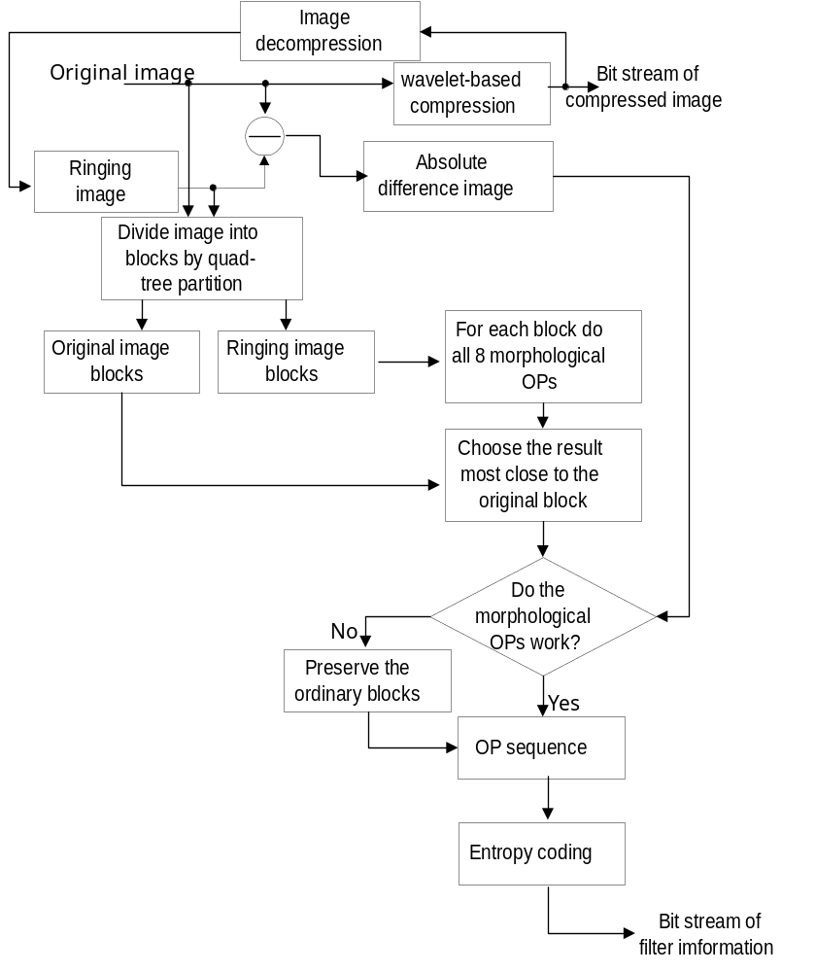
Fig. 2. The flowchart of de-ringing encoder.
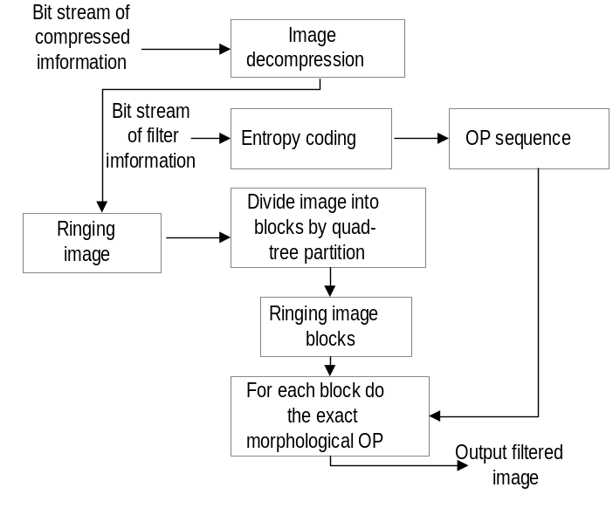
Fig. 3. The flowchart of de-ringing decoder.
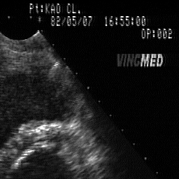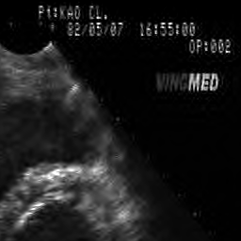
4 ( a ) Original sonogram 4( b ) Ringing image (0.25 bpp)
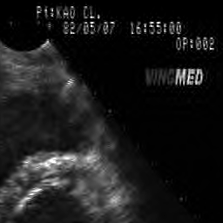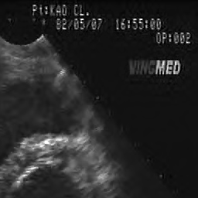
4( c ) Ringing image (0.2 bpp) 4( d ) After deringing at 0.25 bpp

Bit-rate of The Compressed  Image (bpp) | PSNR of The Compressed  Image (bpp) | Partition  Threshold | Minimum  Block size | Total Bit-rate  (bpp) | PSNR After  De-ringing (dB) | PSNR  of  JPEG2000
0.1 | 28.77 | 60 | 2 | 0.1531 | 30.18 | 30.21
0.1 | 28.77 | 20 | 4 | 0.1452 | 29.64 | 29.71
0.2 | 31.91 | 60  100 | 2 | 0.2506 | 32.65 | 32.71
0.2 | 31.91 | 20 | 4 | 0.2431 | 32.56 | 32.68
0.3 | 33.88 | 60  100 | 2 | 0.3442 | 34.44 | 34.39
0.3 | 33.88 | 20 | 4 | 0.3401 | 34.45 | 34.30
0.4 | 35.19 | 60 | 2 | 0.4392 | 35.60 | 35.46
0.4 | 35.19 | 20 | 4 | 0.4366 | 35.63 | 35.44
0.5 | 36.14 | 60 | 2 | 0.5353 | 36.45 | 36.42
0.5 | 36.14 | 20 | 4 | 0.5321 | 36.49 | 36.31
0.6 | 36.92 | 60 | 2 | 0.6314 | 37.22 | 37.04
0.6 | 36.92 | 20 | 4 | 0.6292 | 37.21 | 37.00
Table 1: The experiments on total bit-rate and PSNR with sonogram.

