Critical Percolation Phenomenon through Sites analysis for a Finite System
Bih-Shan Lin¹ , Cheng-Haw Lee²
1. Kao Yuan Institute of Technology, KaoHsiung, Taiwan.
2. Department of Resources Engineering, National Cheng Kung University, Tainan, Taiwan

Abstract
This paper presents the derivation of the percolation frequency at absolutely critical sites density for an orthogonal finite system. According to our analysis, percolation is determined by not only the occupation probability, but also structures formed by sites. The binominal probability distribution function is extended to articulate that an exact critical occupation probability does not exist when a system is finite.
I. Introduction
Groundwater flows through fissured medium is called “percolation”. Percolation is a complex process and is hard to be analyzed. But we are very sure that all the possible analyses are base on the conductivity of the media, especially for the fracture systems. In fact, a fracture system is always distinguished as either “percolative” or “non-percolative”. Therefore, the line, or said the percolation threshold, between “percolative” or “non-percolative” is very concerned.
Traditionally, a “percolation threshold” is defined to demarcate whether a medium is infinitely percolative or non-infinitely percolative. The determination of the percolation threshold is often based on the percolation theory. Reviews of the percolation theory have been given by Stauffer[1985] and Berkowitz and Balberg [1993]. In brief, the percolation theory tabulates an important expression
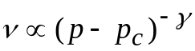 (1)
where ν and 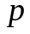 are two related physical observation quantities; 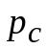 is the critical value of .
Generally speaking, there are two manners to analyzed percolation phenomenon: one is “site analysis” and another is “bond analysis”. The manner used by this article is the former since it is easy to understand. To match for the need of this article, we directly assign ν to be the percolation probability, and p to be the probability of a site to be blocked. However, the same definitions can be seen in Shante and Kirkpatrick’s article published in 1971. But we interpret p as the probability for a site to exist at a certain position in a system and call “p” as an occupation probability.
It is reported that, for an infinite system, there exists a critical occupation probability 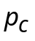. If 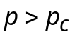, the system is infinitely percolative; if 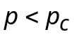, the cluster is non-infinitely percolative [Shante and Kirkpatrick,1971, Englman, 1983, Stauffer,1985].
Figure 1 is a schematic diagram of sites and clusters in a square lattice. A cluster is the lattice formed by connecting neighbored sites (cross corner sites are not included). The number of sites in a unit area is called density,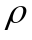. A site entails its own occupation probability, 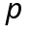. Figure 2 provides an example of the percolation cluster. Most sites could be connected and reached all boundaries of the studied lattice
It is clear that the value plays a significant role in percolation theory. In other words, two related physical quantities could be approximated as
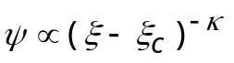 (1)
where 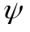 and are two physical quantities; 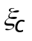 is the critical value of ; κ is an exponent depending only on the dimensionality of the system. Formula as equation (1) appears from time to time in the most of previous studies mentioned above. These researches provide a great help for those who are interested in such a phenomenon. Formula (1) can be analog to the relation between cluster size 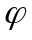 and as
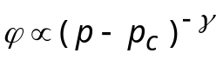 (2)
where γ is also an exponent like κ. The reference value γ is 43/18 for a two-dimensional system. For a square lattice, 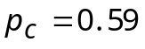[Berkowitz and Balberg , 1993]. There are some other values reported by Golden [1980]. It should be noted that articulating exact values is not the focal point of our research. Formula (1) and (2) are approximated expressions, which imply that these two formulas are not exact and precise enough to reflect every phenomenon constituted by those two physical quantities. In fact, the estimation of is often fallen within a range of values (Watson and Leath, 1974, Golden, 1980, Englman, 1983].
One precise method to estimate 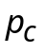 is to introduce a new property: the coordination number, 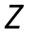, which is treated as the maximum number of bonds belonging to a sites. Consequently,
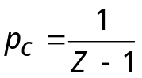 [Golden, 1980, Stauffer, 1985] (3)
A Bethe lattice has been mentioned by both researchers, Golden and Stauffer. However, it seems that mentioned by them is similar to a “fraction” instead of a probability. If is a fraction, indeed an infinite cluster can be formed, when 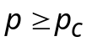; the cluster is finite when . But if is a probability, results appear to be different. This difference will be discussed in the following passage.
Robinson [1984] introduced the critical density 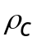 in order to reflect the above phenomenon. Since is proportional to the occupation probability, we have
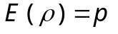 (4)
where 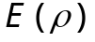 is the expect value of sites density. There is no unique way to define the finite size critical density. A definition provided by Robinson [1984] is the following. “Take a fixed size square region and generate fractures in and around it until a cluster which makes contact with all the sides has been formed. …We would take the critical density to be the density at which half the squares had a cluster joining all four sides”. According to his definition, the percolation frequency should be first acquired in order to obtain . But it is also known that the percolation frequency increases rapidly at a so-called “critical density”. In addition, the critical density obtained by the definition at the percolation frequency 0.5 is no much different from that at 0.1. In other words, it does not seem to be significant to define the critical density at the percolation frequency 0.5. As a result, our research does not follow Robinson’s definition of the critical density. A new definition is formulated by taking a fixed size square lattice and generate sites in until a cluster which makes contact with all the sides has been formed. We would regard the critical density to be the minimum density at which squares had a cluster jointing all four sides.
This research is based on our new definition of the critical density. First, this paper mathematically derives the percolation frequency at the critical density. Furthermore, our observations benefit us to develop further inferences on the percolation frequency at densities beyond the critical density.
II. Percolation at the Critical Density
Base on graphical observations, an 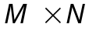(let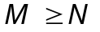) rectangular lattice requires at least 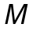 sites jointing one side with its opposite side, and at least 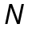 sites jointing the third side with the fourth side. If all four sides can be connected (that is, the lattice is percolative), the required least sites number is 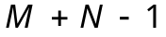.
Basic relations among percolation frequencies 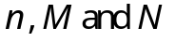are:
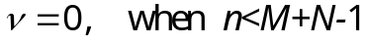 (5)
(6)
where is the percolation frequency as “the number of percolation samples/ total samples”. Equations (5) and (6) point out that, when the sites number is less than , percolation does not exist. As long as is equal or greater than 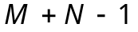, percolation can possibly exist. In addition, it has been observed that
(7)
Equation (7) indicates that when the sites number is greater than 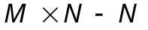, percolation certainly exists.
The sites density is called the critical density, 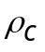, when 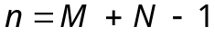, that is,
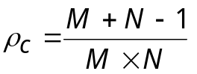 (8)
When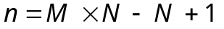, the sites density is called the percolation-determined density, 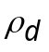, and
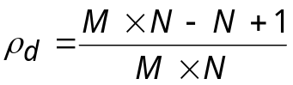 (9)
As shown in Figure 3, there are total 9 samples. Among them, (a), (b), (c), (d) are percolation samples and yield a percolation frequency 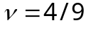. It is noticed that (a) and (b) are at the critical density. It is noticed that both (a) and (b) are at the critical density. For both conditions, percolation cannot occur as long as one site is missing. This situation tells us that the occurrence of percolation depends not only the amount of sites but also the structure formed by sites. That is, it is not adequate only introducing occupation to explain the occurrence of percolation. Since the percolation at the critical density is essential and easy to be certified, mathematical expressions below are given to the condition at the critical density.
Through the designed tree analysis, all of the percolation structures at the critical density can be found. First we defined the coordination as shown in Figure 4. The tree starts at point 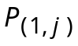 and branch directions are constrained to right or down or both. When there are no more branches, the number of total ends of branches, which forms a set of percolation samples, amount 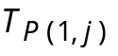, is obtained. In figure 5, there is an example of a set of 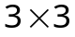 lattice percolation samples where 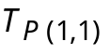 is 11. A percolation sample represents a percolative structure.
At the beginning we take an 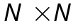 lattice into consideration. Due to the symmetry, here comes
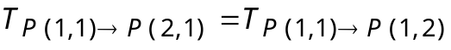=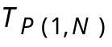 (10)
where is 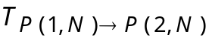 (since only one branch direction is selected), and the arrow here means “by way of”. We acquire
(11)
If we start at 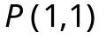, the corner, two possible branching directions exist, 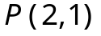 and 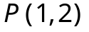. We only take 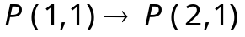 into consideration for the sake of convenience. At first, the condition that only branch-right or branch-down is taken into account. These two branching types are called the “single-direction branching”. Branching 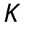 time obtains 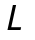 time single branch with an amount 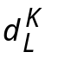. When the branching is terminated, all percolation samples, 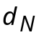, of this branching type are discovered. Table 1 contains some research results for N=2, 3, 4, 5 and 6. Percolation samples and are found in following equations:
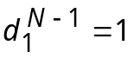 (12)
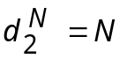, 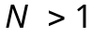 (13)
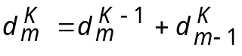, 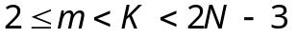 (14)
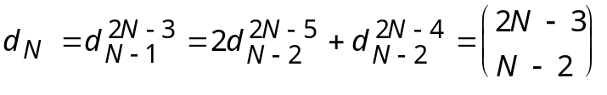 (15)
Consequently, it can be identified that the tree developed by is in the condition where at least one branching is in both right and down directions (double-direction branching). The total sample is 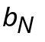, as shown in Table 2. It is formulated as
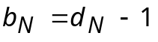 (16)
For an lattice, 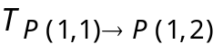 and 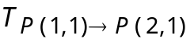 are denoted as 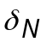, and
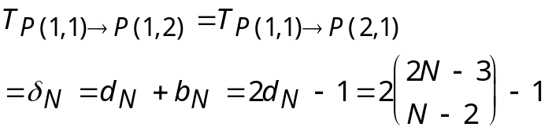 (17)
Take equation (17) into equation (11), we obtain
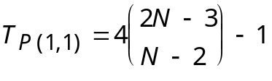 (18)
For an 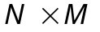 lattice, 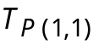 is denoted as 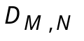. Some examples are shown in Table 3. It is found that 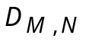 is a symmetric matrix, and its rules are formulated in the following equations:
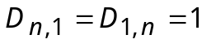 (19)
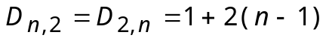 (20)
(21)
Equation (21) is a recursive function.
Since is at the last column of lattice, thus
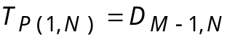 (22)
An lattice at the critical density entails total percolation samples 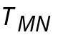. That is,
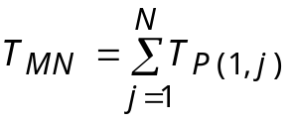 (23)
where 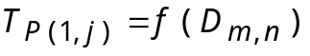 when 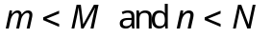 can be calculated as follows:.
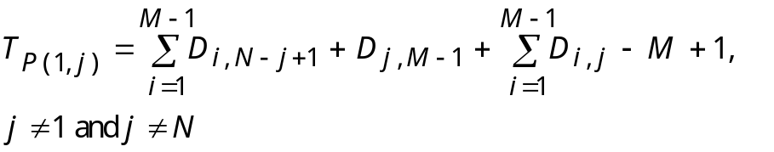 (24)
Equation (24) is the induction result from Table 4. Even though Table 4 belongs to an lattice, is an independent variable so that equation (24) is still valid for an lattice.
is obtained through introducing 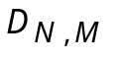 and into equation (23).
A lattice with sites entails a total sample number,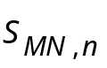,
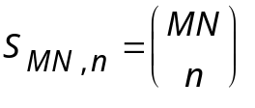 (25)
The percolation frequency at the critical density, 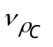, can be calculated as
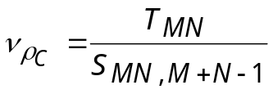 (26)
III. Occupation Probability and Percolation Frequency
There is a common experience shared by those who have attempted to simulate percolation: by given an input which is significantly lesser than 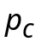, percolation can still be found. However, this phenomenon is not theoretically anticipated, nor is it properly explained by scholars.
In previous researches, a was assigned instead of a sites number n. If the system is infinite, a exists, and
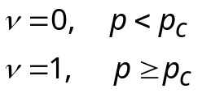 (27)
Equation (27) is based on random appearances of sites. However, the structure factor is neglected even though it drastically influences percolation. In fact, the structure is a critical factor when sites are sparse. Since percolation can occur under such a small critical density, it is difficult for people to believe that percolation cannot occur under the condition where density is larger than the critical density.
For a lattice with occupation probability, the expected frequency is,
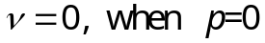 (28)
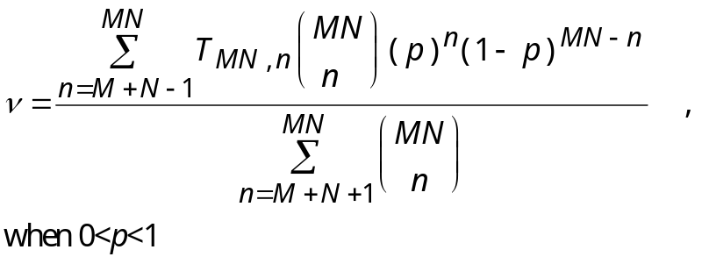 (29)
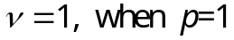 (30)
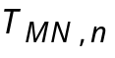, as the structure factor, is the number of total percolation samples in an lattice with sites. 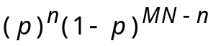 , as the probability factor, is the probability that sites exist simultaneously. The percolation frequency is controlled by these two factors. Equation (29) illustrates that it is possible to have no percolation when is large, and percolation can happen at random even though the value of is small. Thus, the percolation frequency indicates the risk of percolation. The numerical estimation of the critical occupation probability is always in a range of values rather than a fixed one. Equation (29) also provides an explanation. In fact, as long as is not equal to 0, is not absolutely equal to 0. Also, as long as is not equal to 1, is not absolutely equal to 1. Equation (29) does not support the idea that when 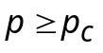, 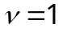, or that when 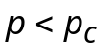, 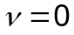, Due to the following two reasons, why equation (29) does not support the above two situations can be explained. Equation (29) is a positive and monotonically accumulated probability function. Hence, first of all, it cannot yield a value 0 unless p us equal to 0. Second, it cannot yield a value 1 unless it covers all of the percolation and non-percolation samples.
Based on the above two reasons, we conclude that it is impossible to define an exact which makes on condition that , and that when 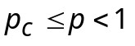. This conclusion is in conflict with that of previous researches. However, our conclusion is partially supported by Wong et al. [1984] who argue for a geometrical feature of rocks which does not appear a finite percolation threshold. Our explanation is illustrated by Figure 6. Sites in Figure 6 possess 4 bonds; that is, the coordination number Z=4 and 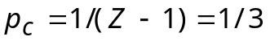. A white circle indicates that one position entails one site. However, no site actually exists. Black dots refer to existing sites. Assume =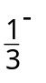( the superscript “-” means “very close but less than”). Applying Stauffer’s [1985] analysis to Figure 6(a), we have
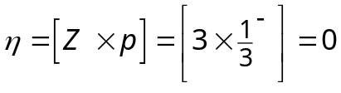 (31)
where “[ ]” means an integer is taken , 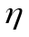 is the expected site(s) number. is regarded as a fraction, not a probability. Since the number of sites must be an integer, is zeroing in this case. That is, when is less than , the critical probability, there are no sites around. As a result, no percolation occurs. Figure 6(b) shows what is presented in this article. S2, S3 and S4 together entail an average occupation probability of 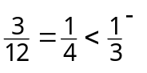. However, S2, S3 and S4 entail the same branch potential as S1. This indicates that the condition of branching of S1 is repeated, and it could simultaneously happen in a branch step. Thus, even though the average occupation probability is less than the critical occupation probability, percolation can still occur. In brief, processes are recursive. The more the sites exist, the higher the possibility that recursive processes can happen. Meanwhile, the percolation probability is increased.
Does the critical density exist above which the percolation frequency is 1 and below which the percolation frequency is 0? Here is the answer: 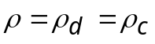, that is
(32)
The solutions of equation (32) are M=2 and N=1 when ; N = M = 1 or N = M = 2 when M = N. Indeed, the critical density does exist, but only in finite systems.
IV Calculation and Simulation
The relation between and of an × lattice is shown in Figure 7. When is large, percolation happens at small . Since is proportional to the occupation probability, it further indicates that, when is large, percolation happens at small p. In general, this phenomenon could not be present by simulation because simulation only exhibits the apparent parts.
Figure 8 depicts the percolation frequency at the critical density in different lattice. Theoretical values and results of 10,000 cases of each lattice size are compared. It is shown that percolation decreases rapidly with at the critical density. That is, when the density is closer to the critical density and is larger, it is more difficult to locate percolation. However, it is necessary to point out that, even though no percolation can be found through simulation, it does not imply that percolation does not occur in reality. In addition, when 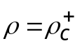 (the superscript “+” means the site number is 1 more than that of the critical density), the situation changes greatly. Figure 9 shows the result of 100,000 simulation cases for vs. 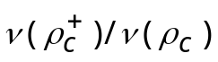. It is indicated that, when is large, percolation increases rapidly with a slight increase of the site density.
V. Conclusion
Our research investigates the percolation frequency at the critical density through conducting sites analysis. Relations among the percolation frequency, occupation probability, and structure factor and lattice size are clarified. Conclusions for this research are made as followings:
1. The percolation frequency at the critical density could be derived mathematically.
2. It is possible that media can be percolated, unless the density is less than the critical density, or the occupation probability is zero. In contrast, it is possible that media cannot be percolated, unless the density is greater than a specified density, or the occupation probability is 1.
3. The percolation frequency at 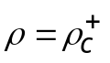 is significantly greater than that at 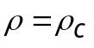. The significance is increased with the increase of the lattice size.
4. When the lattice shape is orthogonal and bounded, it is impossible to define an exact which makes on condition that , and that when 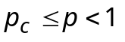..
5. For finite systems of 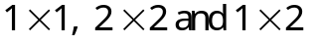 lattices, there exist a critical density 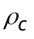 which makes on condition that 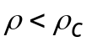 , and that when 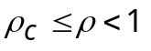.
Theoretically, it is possible to identify all of the percolation samples of the lattice. That is, the percolation frequency can be obtained by the mathematical method. Nevertheless, the process to derive such a mathematical function is challenging. Before this achievement is reached, the numerical simulation is the best way to acquire the percolation frequency. The task fulfilled by our research is just the beginning.
References
Balberg, I., B. Berkowitz, and G.E., Drachsler, Application of a percolation model to flow in fractured hard rocks, J. of Geophysical Research, 96(B6), 10015-10021, 1991.
Berkowitz, B., and C., Breaster, Dispersion in sub-representative elementary volume fracture networks: percolation theory and random walk approaches, Water Resources Research, 27(2), 3159-3164, 1991.
Berkowitz, B., and I., Balberg, Percolation theory and its application to groundwater hydrology, Water Resources Research, 29(4), 775-794 ,1993.
Bour, O., and P., Davy, Connectivity of random fault networks following a power law fault length distribution, Water Resources Research, 33(7), 1567-1583, 1997.
Bour, O., and D. Phili, On the connectivity of three-dimensional fault networks, Water Resources Research, 34(10), 2611-2622, 1998.
Englman, R., Y. Gur, and Z., Jaeger, Fluid flow through a crack network in rocks, J. of Applied Mechanic, 50, 707-711, 1983.
Ewing, R. P., and S. C., Gupta, Modeling percolation properties of random media using a domain network, Water Resources Research, 29(9), 3169-3178, 1993.
Golden, J.M., Percolation theory and models of unsaturated porous media, Water Resources Research, 16(1), 201-209, 1980.
Lee, C.H., B. S. Lin and J. L. Yu, Dispersion and Connectivity in flow through fractured networks. Journal of Chinese Institute of Engineers, 17(4), 521-535, 1994
Lin, B. S., C. H. Lee and J. L. Yu, Analysis of mass transport through fracture networks using percolation theory approach. Journal of Chinese Institute of Environmental Engineering, 7(1), 1-11, 1997.
Wong, P. Z., J. Koplik and J.P. Tomanic, Conductivity and permeability of rocks. Physical Review B, 30(11), 6606-6614, 1984.
Renshaw, C.E., Influence of subcritical fracture growth on the connectivity of fracture networks, Water Resources Research, 32(6), 1519-1530, 1996.
Robinson , P. C., Connectivity, flow and transport in network models of fractured media, Ph. D. thesis, Oxford University, 1984.
Sahimi, M., Hydrodynamic dispersion near the percolation threshold: scaling and probability densities, J. of Phys. A: Math. Gen., 20, L1293-L1298, 1987.
Shante, V. K., and S., Kirkpatrick, An introduction to percolation theory ," Advances in Physics, 20, 325-356 ,1971.
Stauffer, D., Introduction to percolation theory, Taylor and Francis, London, 1985.
Watson, B.P. and P. L., Leath, Conductivity in the two-dimensional-site percolation problem, Physical Review B, 9(11), 4893-4896, 1974.

Figures
Figure 1. Schematic definitions of sites and clusters
Figure 2. Clusters at existing probability 0.6 of 60×60 lattice (after Stauffer, 1985).
Figure 3. Nine cluster samples of a 3×3 lattice.
Figure 4. Coordinates definition.
Figure 5. A set of percolation samples 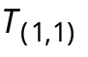 of a 3×3 lattice in tree structure. Total 11 paths. Blocked numbers indicate a double-direction branching procedure is taken.
Figure 6. (a) Branched by an fraction less than 1/3; (b) branched by an averaged probability of 1/4 (an example).
Figure 7. Rough relations between percolation frequency and sites density.
Figure 8. Comparison between theoretical and simulated percolation frequency. (No simulated percolation is found when N>6.)
Figure 9. Relations between 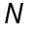 vs. 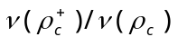

 |  |  |  |  |  |  |  | •
 |  |  |  |  |  |  | • |  | •
 |  |  |  |  |  | • |  |  | •
 |  |  |  |  |  |  | • |  |  | •
 |  |  | site |  |  |  | • | •
 |  |  | (a)
 |  |  |  |  |  |  |  | •
 |  |  | cluster |  |  |  | • |  | •
 |  |  |  |  |  | • |  |  | •
 |  |  |  |  |  |  | • |  |  | •
 |  |  |  |  |  |  | • | •
 |  |  | (b)
Figure 1. Schematic definitions of sites and clusters

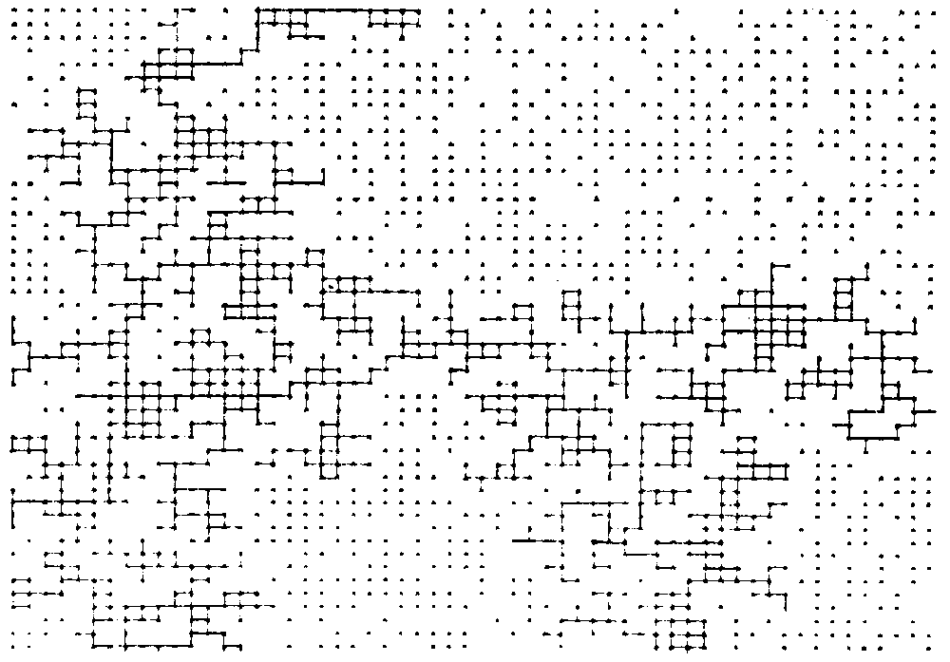
Figure 2. Clusters at occupation probability 0.6 of 60×60 lattice (after Stauffer, 1985).
• | • | • |  | • |  |  |  | • |  | •
 |  | • |  | • | • | • |  | • | •
 |  | • |  |  |  | • |  | • | • | •
(a) |  |  |  | (b) |  |  |  | (c)
• | • | • |  | • |  | • |  | • | • | •
• |  | • |  |  | • |  |  |  | •
• |  |  |  | • |  | • |  | • |  | •
(d) |  |  |  | (e) |  |  |  | (f)
• |  |  |  | • |  | • |  | • | • | •
 |  |  |  | • |  | • |  | • | • | •
• | • |  |  | • |  | •
(g) |  |  |  | (h) |  |  |  | (i)

Figure 3. Nine cluster samples of a 3×3 lattice.
P(1,1) | P(1,2) | P(1,3) | …. |  | P(1,N)
P(2,1) | P(2,2) | P(2,3) | ….. |  | P(2,N)
P(3,1) | P(3,2) | P(3,3) | ….
. |  |  | P(i,j)
.
P(M,1) | P(M,2) | P(M,3) | …. |  | P(M,N)
Figure 4. Coordinates definition.
1 | 2 | 3 |  |  |  |  |  |  | 1
4 | 5 | 6 |  |  |  |  |  | 2 |  | 4 |  |  |  |  | 2,4
7 | 8 | 9 |  | 3,5 | 3 |  |  | 5 |  | 5 |  |  | 7 | 5,7
 |  |  |  |  | 6 |  | 6 | 8 |  | 8 | 6 |  | 8
 |  |  |  | 8 | 9 | 6,8 | 9 | 9 |  | 9 | 9 | 6,8 | 9 | 6 | 3,7
Figure 5. A set of percolation samples of a 3×3 lattice in tree structure. Total 11 paths. Blocked numbers indicate a double-direction branching procedure is taken.

Figure 6. (a) Branched by an fraction less than 1/3; (b) branched by an averaged probability of 1/4 (an example).
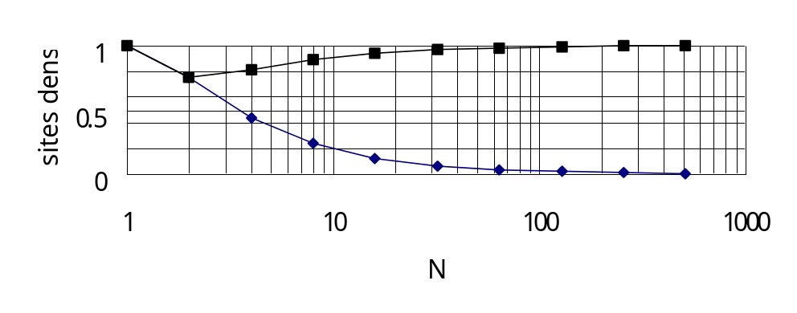
Figure 7. Rough relations between percolation frequency and sites density.
S1
S0
S2
S3
S4
(a)
(b)
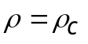
0≤ν≤1
ν=0
ν=1
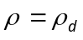

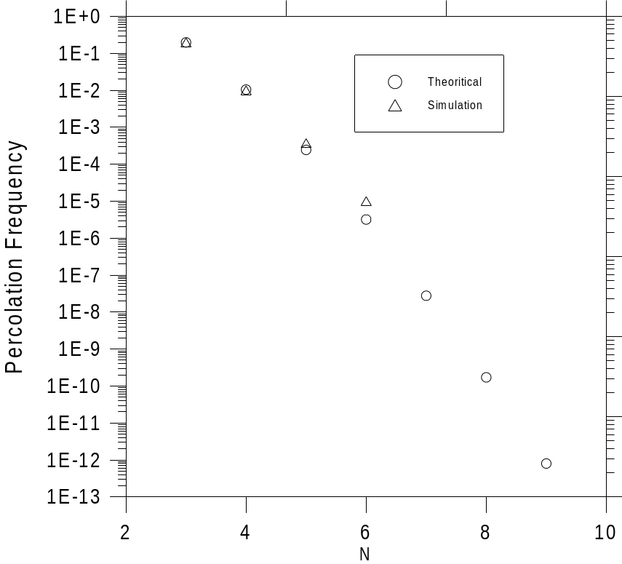
Figure 8. Comparison between theoretical and simulated percolation frequency. (No simulated percolation is found when N>6.)
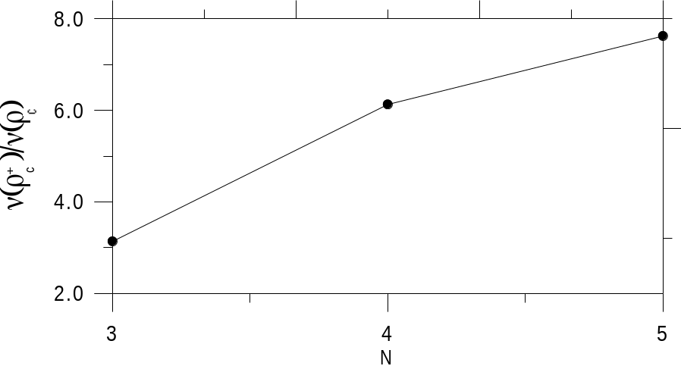
Figure 9. Relations between vs. .
Table 1. 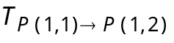 of single-direction branching. The last column with number of each raw is .
 | L=1 | L=2 | L=3 | L=4 | L=5
N=2 | 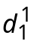=1
N=3 | 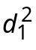=1 | 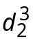=3
N=4 | 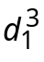=1 | 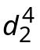=4 | 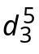=10
N=5 | 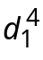=1 | 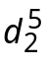=5 | 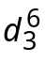=15 | 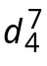=35
N=6 | 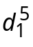=1 | 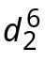=6 | 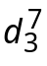=21 | 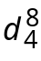=56 | 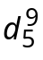=126

Table 2. The 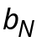 of double-direction branching.
Times  Paths  N | 1 | 2 | 3 | 4 | 5 | 6 | 7 | 8 | 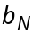
2 | 1 |  |  |  |  |  |  |  | 1
3 | 1 | 1 |  |  |  |  |  |  | 2
4 | 1 | 2 | 3 | 3 |  |  |  |  | 9
5 | 1 | 2 | 4 | 7 | 10 | 10 |  |  | 34
6 | 1 | 2 | 4 | 8 | 15 | 25 | 35 | 35 | 125

Table 3. 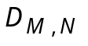 of and .
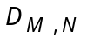 | N=1 | N=2 | N=3 | N=4 | N=5 | N=6 | N=7
M=1 | 1 | 1 | 1 | 1 | 1 | 1 | 1
M=2 | 1 | 3 | 5 | 7 | 9 | 11 | 13
M=3 | 1 | 5 | 11 | 19 | 29 | 41 | 55
M=4 | 1 | 7 | 19 | 39 | 69 | 111 | 167
M=5 | 1 | 9 | 29 | 69 | 139 | 241 | 419
M=6 | 1 | 11 | 41 | 111 | 251 | 503 | 923
M=7 | 1 | 13 | 55 | 167 | 419 | 923 | 1847

Table 4. 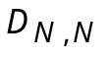 and 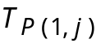 for different .
 | N=2 | N=3 | N=4 | N=5
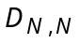=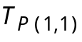 | 3 | 11 | 39 | 139
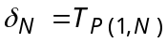 | 1 | 5 | 19 | 69
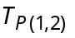 | - | 9 | 28 | 85
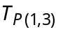 |  | - | 34 | 87
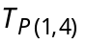 |  | - | - | 117
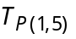 |  | - | - | -
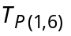 |  | - | - | -
TOTAL |  | 25 | 120 | 497

