Embedding of Tree Machines into Hypercubes

Chui-Cheng Chen
Southern Taiwan University of Technology
Department of Information Management
ccchen@mail.stut.edu.tw

Abstract
In this paper, we present that a tree machine can be embedded into incomplete hypercube with expansion 1, load 1, dilation 2 and congestion 2. This result is better than the expansion (2^{h+1}+2^{h})/(2^{h+1}+2^{h}-2) in [14]. Then we consider how to embed a large tree machine into a hypercube for considering load-balance. We have shown that a tree machine TM_{h} (h≥1) can be embedded into a hypercube H_{h+1} with dilation 1, congestion 2 and load 2, and a tree machine TM_{h} can be embedded into H_{n} (h≥n≥1) with dilaton 1, congestion 3 and load 2^{h-n+1}+2^{h-n}. The load of these embeddings is well balanced.

1. Introduction

The hypercubes [1, 2] is one of the most popular architectures for a variety of parallel computations. The architectural features are its low diameter, rich bandwidth, regular structure, easy routing, fault tolerance [3, 4] and, more importantly, many computational structures can be simulated by the hypercubes with only small constant factor slowdown, such as array, binary tree and mesh of trees [5].

One restriction of the hypercube topology is that its size has to be an integer power of two. Hence, two consecutive dimensional hypercubes leave a large gap. To overcome this restriction, incomplete hypercubes provide more flexibility in the size [6]. An incomplete hypercube can be obtained from a complete hypercube where some nodes/links fail. Extensive study on the incomplete hypercube has been studied in [7-9].

The tree machine can permit efficient algorithms for searching problems [10, 11] and for graph problems [12]. Efe [13] has shown that a tree machine of dimension h is a subgraph in an (h+2)-dimensional hypercube. Öhring and Das [14] have described how to embed a tree machine of dimension h into an incomplete hypercube which comprises an (h+1)-dimensional hypercube and an h-dimensional hypercube with load 1, dilation 2 and congestion 2.

The purpose of this paper is to present how to embed a tree machine into an incomplete hypercube and a hypercube. First, we discuss how to embed a tree machine into an incomplete hypercube with load 1, dilation 2, congestion 2 and expansion 1, then discuss how to embed a large tree machine into a hypercube with optimal load.

The remaining sections are organized as follows. Section 2 gives the notations and definitions of this paper. In Section 3, we present how to embed a tree machine into an incomplete hypercube with the same node size (expansion 1). In Section 4, we present how to embed a large tree machine into a hypercube. Finally, the conclusion is given in Section 5.

2. Preliminaries

We let H_{n} denote the n-dimensional hypercube which has 2^{n} nodes. These nodes of H_{n} are labeled {0, 1, 2, …, 2^{n}-1} as binary number. Let (1*^{n-1}) denote a sub-hypercube with the most significant bit labeled 1, where * is a don’t care symbol assuming 0 or 1. There is an edge between two nodes in the hypercube if and only if their binary numbers differ by a single bit. The Hamming distance between two nodes is defined as the number of their different bits. To conveniently describe the embedding, we use two color, black and white, to correspond to the binary number of each node in H_{n}. If a node has even number of 1’s, we color it black. Otherwise we color the node white. Since the hypercube has a perfect matching, H_{n} has 2^{n-1} black nodes and 2^{n-1} white nodes. Figure 1 depicts the four-dimensional hypercube, H₄. However, the size of the hypercube has to be a power of 2, whereas it is more interesting to design an architecture with an arbitrary number of nodes.

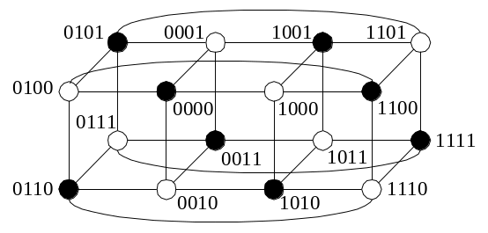
Figure 1. H₄.

A complete hypercube can become incomplete if it misses some certain nodes [6-9]. Let IH(n1, n2, …, ni) denote the incomplete hypercube comprising i complete hypercubes: H_{n1}, H_{n2}, …, H_{nj}, …, H_{ni}, nj>ni≥0, which can be obtained by deleting the largest 2^{n1}-(2^{n2}+…+2^{ni}) nodes (in binary representation) and their neighboring edges from an (n1+1)-dimensional hypercube. For example, Figure 2 depicts IH(3, 2, 1).

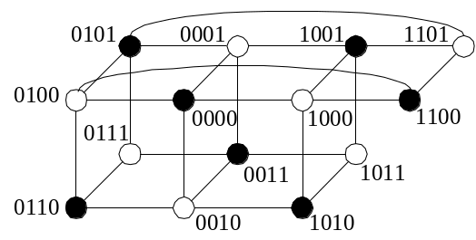
Figure 2. IH(3, 2, 1).

A double-rooted complete binary tree of height h, denoted by DT_{h}, is a complete binary tree of height h with the root replaced by a path of length two [5]. We denote leaf nodes of left-subtree of the roots of DT_{h} as {x₁, x₂, …, x₂h-1} from left to right, likewise, we denote leaf nodes of right-subtree of the roots of DT_{h} as {y₁, y₂, …, y₂h-1} from left to right. For example, Figure 3 depicts DT₃. A tree machine of dimension h, TM_{h}, is the graph comprising two complete binary trees of height h, connected back to back to share the leaf nodes, The total number of TM_{h} is 2^{h+1}+2^{h}-2 nodes. For example, Figure 4 depicts TM₃.

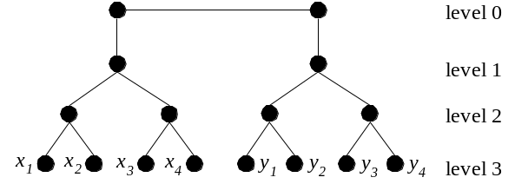
Figure 3. DT₃.

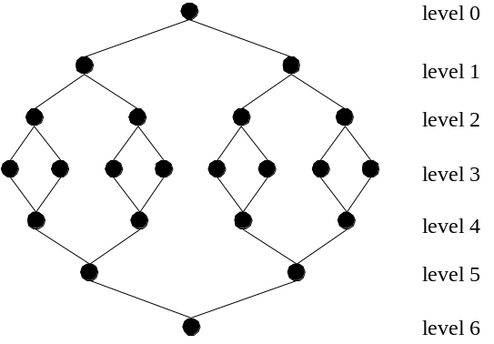
Figure 4. TM₃.

The cost of an embedding of a guest graph into a host graph is measured in terms of dilation, congestion, load and expansion [15]. The dilation of an edge of the guest graph is the length of embedded path of the host graph, and the dilation of an embedding is the maximum dilation over all edges of the guest graph. The congestion of an edge of the host graph is the number of edges of the guest graph that are embedded using the same edge of the host graph, and the congestion of an embedding is the maximum congestion over all edges of the host graph. The load of a node of the host graph is the number of nodes of the guest graph that are embedded into the same node of the host graph, and the load of an embedding is the maximum load over all nodes of the host graph. The expansion of an embedding is the ratio of the number of nodes of the host graph to the number of nodes of the guest graph. Hence, we need to consider the tradeoff among dilation, congestion, load and expansion of an embedding.

3. Embedding of Tree Machines into Incomplete Hypercubes with
Expansion 1

Öhring and Das [14] have shown that TM_{h} can be embedded into IH(h+1, h) with load 1, dilation 2 and congestion 2, and TM_{h} is not a subgraph of IH(h+1, h). In this section, we discuss how to embed a tree machine into an incomplete hypercube with the same node size (expansion 1), considering the dilation and congestion when doing the embedding. For the embedding, we need the following lemma.

Lemma 1. In IH(h+1, h), all nodes of H_{h} are placed on the outer level and all nodes of H_{h+1} are placed on the inner level. Each node of the outer level can link to two son nodes on the inner level with dilation 2 and congestion 2

Proof. We use h+2 bits to label each node of IH(h+1, h). IH(h+1, h) can be partitioned into three sub-hypercube H_{h}’s by the leftmost two bits of the incomplete hypercube, and the binary numbers of the leftmost two bits of the three sub-hypercubes correspond to 00, 01 and 10 (see Figure 5).

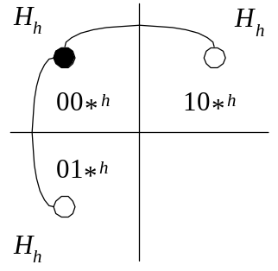
Figure 5. IH(h+1, h) is partitioned into three sub-hypercube H_{h}’s by the leftmost two bits of the incomplete hypercube.
.
We place all nodes labeled 10*^{h} on the outer (upper) level and all nodes labeled 0*^{h+1} on the inner (lower) level. Each node labeled 10*^{h} has an edge with dilation 1 to link to one node labeled 00*^{h} and an edge with dilation 2 to link to one node labeled 01*^{h}. The congestion of edges between sub-hypercube 00 and 10 are 2. Therefore. The lemma is proved. □

One example is shown as follows.

Example 1. All the nodes of H₂ are placed on the outer level and all the nodes of H₃ are placed on the inner level in IH(3, 2). Each node of the outer level can link to two son nodes on the inner level with dilation 2 and congestion 2 (see Figure 6).

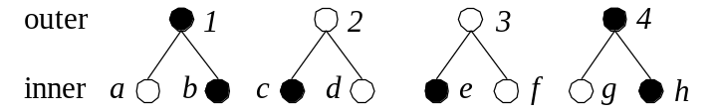

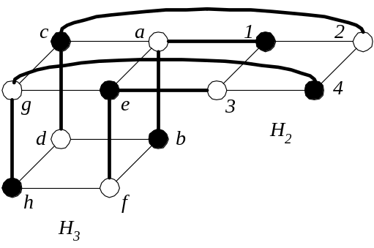
Figure 6. All nodes of H₂ and H₃ are placed on the outer level and the inner level, respectively. The dilation of edges (1, b), (2, d), (3, f) and (4, h) are 2 between the outer level and the inner level. The congestion of edges (1, a), (2, c), (3, e) and (4, g) are 2 in IH(3, 2).

Theorem 1. The tree machine TM_{h} (h≥1) can be embedded into the incomplete hypercube IH(h+1, h-1, h-2, …, 3, 2, 1) with load 1, dilation 2, congestion 2, congestion 2 and expansion 1.

Proof. First, H₁ is partitioned into two H₀’s, the nodes being placed on level 0 and 2h of TM_{h}. Next, we partitioned H_{i+1} into two sub-hypercube H_{i}’s by linking respectively to the two sub-hypercube H_{i-1}’s of H_{i}, the nodes on level i and 2h-i of TM_{h} being placed the two sub-hypercube H_{i}’s, respectively, 1≤i≤h-1. Hence, the nodes between 0 and h-1, and between level 2h and h+1 of TM_{h} can be embedded into IH(h, h-1, h-2, …, 3, 2, 1) with dilation 2 and congestion 2 by Lemma 1. Here, H_{h+1} is partitioned into two H_{h}’s and one of them, called front H_{h}, is used to embed the nodes on level h-1 and h+1 of TM_{h}.

We use a similar method to embed the nodes on level h of TM_{h} as follows. The nodes on level h of TM_{h} are embedded into the other H_{h}, called back H_{h}, The back H_{h} is partitioned into two H_{h-1}’s by linking respectively to the two sub-hypercube H_{h-1}’s of front H_{h}, then the links between level h-1 and h as well as between level h+1 and h of TM_{h} are as the same as Lemma 1, but the congestion of edges between two sub-hypercube H_{h-1}’s of back H_{h} are 2. Therefore, TM_{h} is embedded into IH(h+1, h-1, h-2, …, 3, 2, 1) with load 1, dilation 2, congestion 2 and expansion 1. □

One example is shown as follows.

Example 2. The tree machine TM₂ can be embedded into IH(3, 1) with load 1, dilation 2, congestion 2 and expansion 1 (see Figure 7).

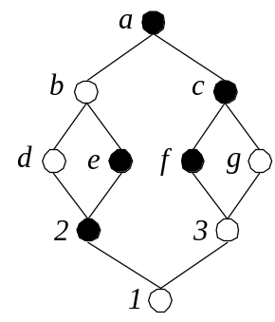
TM₂

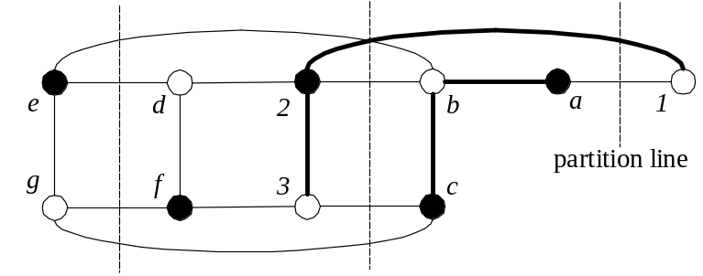
back H₂ front H₂ H₁
Figure 7. Dilation of edges (1, 3), (a, c), (2, e), (3, g), (b, d) and (c, f) is 2 in TM₂. Congestion of edges (1, 2), (a, b), (b, e), (c, g), (2, d), (3, f), (e, d) and (g, f) is 2 in IH(3, 1).

4. Embedding of Large Tree Machines into Hypercubes

Efe [13] has shown that TM_{h-1} is a subgraph of H_{h+1}. In this section, we discuss how to embed a large tree machine into a hypercube, considering the load, dilation and congestion while doing the embedding. First, we embed TM_{h} into H_{h+1}, and a lemma is thus required as follows.

Lemma 2. Embedding DT_{h} (h≥1) into H_{h+1}, each leaf node x_{i} (1≤i≤2^{h-1}) of DT_{h} has an edge to link to a leaf node y_{i} of DT_{h} in H_{h+1}.

Proof. We prove the lemma by induction on h.

Hypothesis: Embedding DT_{h-1} into H_{h}, each leaf node x_{i} (1≤i≤2^{h-2}) of DT_{h-1} has an edge to link to a leaf node y_{i} of DT_{h-1} in H_{h}.

Basis step: When h=1 and 2, it is trivial. Figure 8 depicts the links of embedding DT₂ into H₃.

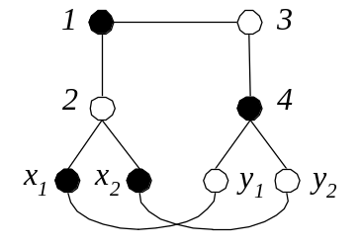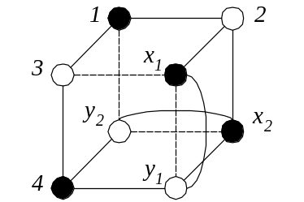
Figure 8. Leaf nodes x₁ and x₂ have edges to link respectively to y₁ and y₂ in H₃.

Induction step: We partition H_{h+1} into two H_{h}’s by the most significant bit, and embed DT_{h-1} into H_{h} as the hypothesis above describe. We can merge two DT_{h-1}’s to DT_{h} as shown in Figure 9. The links between x_{i} (1≤i≤2^{h-1}) and y_{i} of DT_{h} are the same as the hypothesis since leaf nodes of two DT_{h-1}’s are also leaf nodes of DT_{h} after merging. Therefore, the lemma is proved. □

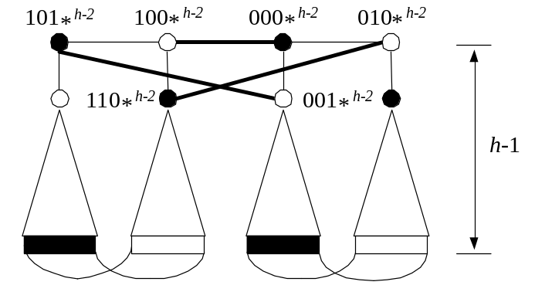
Figure 9. Construction of DT_{h} from two DT_{h-1}’s. The added edges are shown in solid lines. Nodes 000*^{h-2} and 100*^{h-2} are the double roots of DT_{h}.

Now, we show how to embed TM_{h} into H_{h+1}.

Theorem 2. A tree machine TM_{h} (h≥1) can be embedded into H_{h+1} with dilation 1, congestion 2 and load 2.

Proof. Since DT_{h} can be embedded into H_{h+1}, we let two nodes on level 1 of DT_{h} embed respectively into the nodes on level 0 and 2h of TM_{h}. Hence, the nodes between level 0 and h-1 of TM_{h} are embedded into the left-subtree of the roots of DT_{h}. Likewise, the nodes between level 2h and h+1 of TM_{h} are embedded into the right-subtree of the roots of DT_{h} (see Figure 10). Now, we discuss how to embed the nodes on level h of TM_{h} into H_{h+1}.

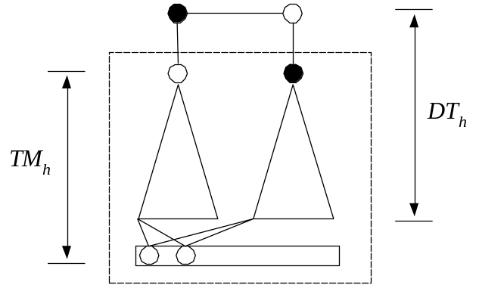
Figure 10. Embedding of TM_{h} into the DT_{h} contained in H_{h+1}.

For two son nodes (on level h) of each node on level h-1 of TM_{h}, we embed one son node into its upper parent node (on level h-1) and embed the other son node into its lower parent node (on level h+1). The upper parent node has an edge to link to the lower parent node by Lemma 2. Hence, the dilation of two edges linking the node on level h-1 and its two son nodes on level h are respectively 0 and 1. Similarly, the dilation of two edges linking the node on level h+1 and its two son nodes on level h are respectively 0 and 1. The congestion of the edges between leaf x_{i} (1≤i≤2^{h-1}) and y_{i} of DT_{h} are 2 in H_{h+1}. The load of leaf nodes of DT_{h} are 2 in H_{h+1}. Therefore, TM_{h} is embedded into H_{h+1} with dilation 1, congestion 2 and load 2. □

A tree machine TM_{h} with 2^{h+1}+2^{h}-2 nodes is embedded into H_{h+1} and this embedding of Theorem 2 is load-balanceable. Next, we show how to embed TM_{h} into H_{n} (h≥n). First, we need three lemmas as follows.

Lemma 3. DT_{h-1} (h≥1) can be embedded into H_{h} as each leaf node of DT_{h-1} has an edge to link to a certain internal node of DT_{h-1} [16].

Next lemma shows how to embed a double-rooted complete binary tree of height h, DT_{h}, into H_{h} with load-balance.

Lemma 4. DT_{h} (h≥1) can be embedded into H_{h} with dilation 1, load 2 and congestion 2.

Proof. First, we embed DT_{h-1} into H_{h}, then we consider how to embed 2^{h} leaf nodes of DT_{h} into H_{h} as follows. Each leaf node of DT_{h} has to be embedded into different node in H_{h} to load-balance. There are half leaf nodes of DT_{h} to be embedded into their parent nodes (leaf nodes of DT_{h-1}) and remaining leaf nodes of DT_{h} are embedded to internal nodes of DT_{h-1} (see Figure 11). There is no dilation and congestion between half leaf nodes of DT_{h} and their parent nodes since these leaf nodes are embedded into their parent nodes. The dilation of the edges between remaining leaf nodes (embedded into internal nodes of DT_{h-1}) of DT_{h} and their parent nodes are 1 by Lemma 3. Hence, the load is 2 and the dilation is 1 for such embedding DT_{h} into H_{h}.

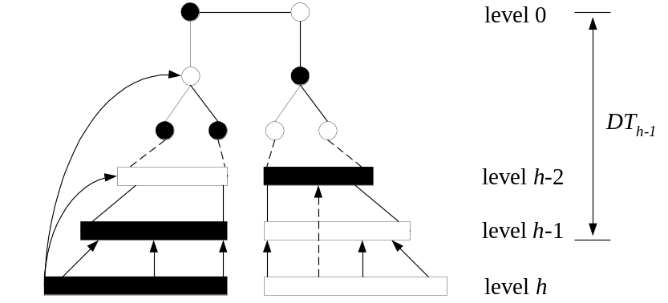
Figure 11. Embedding 2^{h} leaf nodes of DT_{h} into the DT_{h-1} contained in H_{h}. The leaf nodes of left subtree (right subtree) of DT_{h} are embedded into their parent nodes and white nodes (black nodes) between level h-2 and 0, where → depicts embedding.

There are 2^{h-2} leaf nodes of DT_{h} are embedded into the internal nodes on level h-2 of DT_{h-1} for embedding 2^{h} leaf nodes of DT_{h} into H_{h}. These leaf nodes link to their parent nodes (on level h-1) to use the same edges as embedding DT_{h-1}, and the congestion of half edges between level h-1 and h-2 of DT_{h-1} are 2 in H_{h}. Therefore, DT_{h} can be embedded into H_{h} with dilation 1, load 2 and congestion 2. □

By Lemma 4, we show how to embed DT_{h} into H_{h} with load-balance. Next lemma describes the links between leaf nodes x_{i} and y_{i} (1≤i≤2^{h-1}) of DT_{h} for embedding DT_{h} into H_{h}.

Lemma 5. Embedding DT_{h} into H_{h}, leaf node x_{i} (1≤i≤2^{h-1}) is embedded into node X_{i} of H_{h}, and leaf node y_{i} is embedded into node Y_{i} of H_{h}. There is an edge to link node X_{i} and Y_{i}, and this edge is unused for embedding the edges between level h-1 and h-2 of DT_{h} into H_{h}.

Proof. We prove the lemma by induction on h.

Hypothesis: Embedding DT_{h-1} into H_{h-1}, leaf node x_{i} (1≤i≤2^{h-2}) is embedded into node X_{i} of H_{h-1}, and leaf node y_{i} is embedded into node Y_{i} of H_{h-1}. There is an edge to link node X_{i} and Y_{i}, and this edge is unused for embedding the edges between level h-2 and h-3 of DT_{h-1} into H_{h-1}.

Basis step: When h=1 and 2, it is trivial. DT₃ is embedded into H₃ as shown in Figure 12. The figure describes the links between leaf nodes x₁, x₂, x₃, x₄ and y₁, y₂, y₃, y₄.

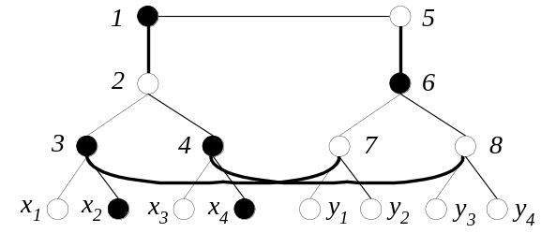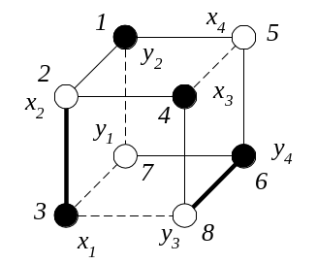
Figure 12. Nodes x₁, x₂, x₃, x₄, y₁, y₂, y₃ and y₄ are embedded into nodes 3, 2, 4, 5, 7, 1, 8 and 6, respectively. Node x_{i} (1≤i≤4) has an edge to link to y_{i}, and this edge are unused for embedding the edges (solid lines) between level 2 and 1 of DT₃ into H₃, where the congestion of solid lines are 2.

Induction step: We partition H_{h} into two H_{h-1}’s by the most significant bit. By hypothesis, leaf node x_{i} (1≤i≤2^{h-2}) of DT_{h-1} is embedded into node X_{i} of H_{h-1}, and leaf node y_{i} of DT_{h-1} is embedded into node Y_{i} of H_{h-1}. There is an edge to link X_{i} and Y_{i}, and this edge is unused for embedding the edges between level h-2 and h-3 of DT_{h-1} into H_{h-1}. Hence, we can merge two DT_{h-1}’s into DT_{h} as shown in Figure 13. The links between x_{i} (1≤i≤2^{h-1}) and y_{i} of DT_{h} are the same as the hypothesis since the three added edges in Figure 13 are extra edges that do not affect the links in the hypothesis. Therefore, the edge between level h-2 and h-3 of both DT_{h-1}’s become to the edges between level h-1 and h-2 of DT_{h}, and the lemma is proved. □

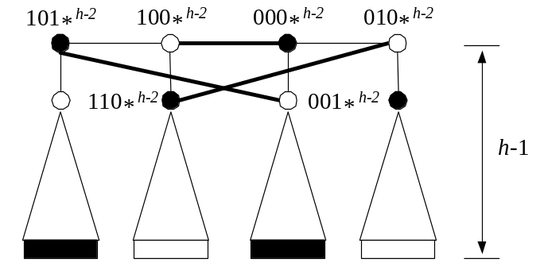
Figure 13. Construction of DT_{h} from two DT_{h-1}’s. The added edges are shown in solid lines. Nodes 000*^{h-2} and 100*^{h-2} are the double roots of DT_{h}.

Theorem 3. A tree machine TM_{h} (h≥1) can be embedded into H_{h} with dilation 1, congestion 3 and load 3.

Proof. First, DT_{h} can be embedded into H_{h} with dilation 1, congestion 2 and load 2 by Lemma 4. We let two nodes on level 1 of DT_{h} embedded respectively into the nodes on level 0 and level 2h of TM_{h}. Then the nodes between level 0 and h-1 of TM_{h} are embedded into the left-subtree of the roots of DT_{h}. Likewise, the nodes between level 2h and h+1 of TM_{h} are embedded into the right-subtree of the roots of DT_{h} (see Figure 14). Next, we consider how to embed the nodes on level h of TM_{h} into H_{h}.

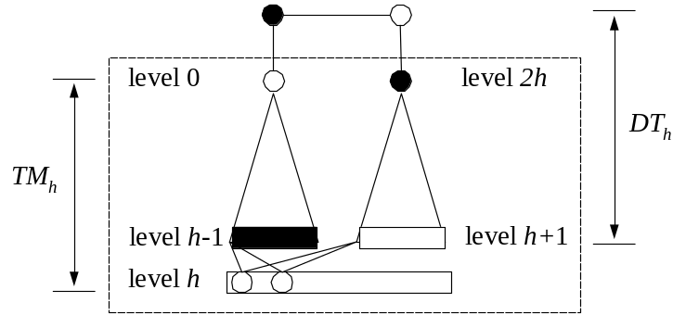
Figure 14. Embedding of TM_{h} into the DT_{h} contained in H_{h}.

For two son nodes (on level h) of each node on level h-1 of TM_{h}, we embed one son node into its upper parent node (on level h-1) and the other son node into its lower parent node (on level h+1). By Lemma 5, the upper parent node has an edge to link to the lower parent node and this edge is unused for embedding the edges between level h-1 and h-2 of DT_{h} into H_{h}. The congestion of half edges between level h-1 and h-2 are 2 and those of others are 1 by Lemma 4. Hence, the dilation of two edges linking the node on level h-1 and its two sons on level h are respectively 0 and 1. Similarly, the dilation of two edges linking the node on level h+1 and its two sons on level h are respectively 0 and 1. The congestion of edges linking between level h-1 and h+1 of TM_{h} increase by 2 and become to 3 since these edges maybe be used to embedded DT_{h} into H_{h}. The load increases by 1, and it remains load-balance. Therefore, TM_{h} is embedded into H_{h} with dilation 1, congestion 3 and load 3. □

Theorem 4. A tree machine TM_{h} can be embedded into H_{n} (h>n≥1) with dilation 1, congestion 3 and load 2^{h-n+1}+2^{h-n}.

Proof. First, we embed TM_{h} into TM_{n}; that is we embed the nodes between level n and 2h-n of TM_{h} into their ancestor nodes on level n of TM_{h} (see Figure 15). Hence, the load of each node on level n of TM_{n} is:

(2^{h+1}+2^{h}-2-2×(2^{n}-1))/2^{n}=2^{h-n+1}+2^{h-n}-2

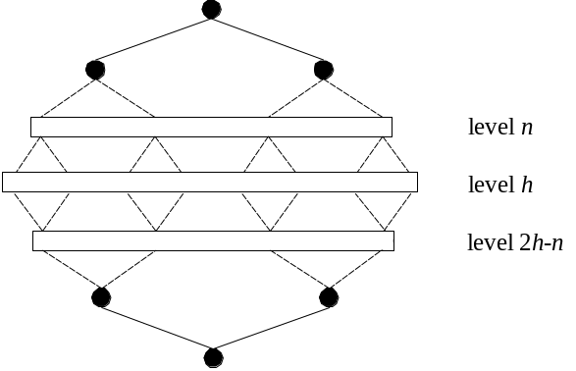
TM_{h}

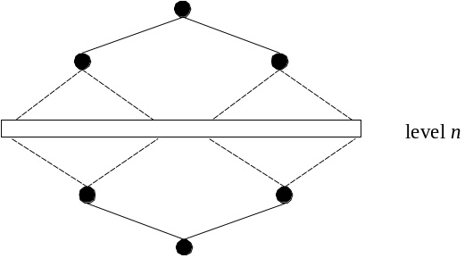
TM_{n}
Figure 15. Embedding TM_{h} into TM_{n}.

, and there is no dilation and congestion for this embedding. By Theorem 3, TM_{n} can be embedded into H_{n} with dilation 1, congestion 3 and load 3. Therefore, TM_{h} can be embedded into H_{n} with load 2^{h-n+1}+2^{h-n}-2+3-1=2^{h-n+1}+2^{h-n}, the dilation and congestion are altered. The theorem is proved. □

5. Conclusion

Öhring and Das [14] have described how to embed a tree machine of dimension h into an incomplete hypercube which comprises an (h+1)-dimensional hypercube and an h-dimensional hypercube with load 1, dilation 2, congestion 2 and expansion (2^{h+1}+2^{h})/(2^{h+1}+2^{h}-2). In this paper, we have shown how to embed a tree machine into an incomplete hypercube with load 1, dilation 2, congestion 2 and expansion 1, and how to embed a large tree machine into a hypercube with optimal load.

Reference

- C. L. Seitz, The Cosmic Cube, Commun, ACM 28 (1985) 22-33.
- J. P. Hayes, T. N. Mudge, Q. F. Stout, S. Colley and J. Palmer, A Micoprocessor-based Hypercube Supercomputer, IEEE Mico 6 (1986) 6-17.
- Y. Saad and M. H. Schultz, Topological Properties of Hypercubes, IEEE Trans. Computers C-37 (7) (1988) 867-872.
- D. A. Read and R. M. Fujimoto, Multicomputer Network: Message-Based Parallel Processing, Cambridge, MA: MIT Press (1987).
- T. Leighton, Introduction To Parallel Algorithms and Architectures: Arrays, Trees, Hypercubes (Morgan Kaufmann, Reading, MA, 1992).
- H. P. Katseff, Incomplete Hypercubes, IEEE Trans. Computer 37 (5) (1988) 604-608.
- H. C. Chen and N. F. Tzeng, Enhanced Incomplete Hypercubes, Proc. Int. Conf. Parallel Processing 1 (1989) 270-277.
- N. F. Tzeng, Structural Properties of Incomplete Hypercubes, Proc. 10th Int. Conf. Distrib. Comout. Syst. (1990) 262-269.
- N. F. Tzeng, H. L. Cheng and P. J. Chuang, Embeddings in incomplete hypercubes, Proc. of Int. Conf. on Parallel Processing 3 (1990) 335-339.
- J. L. Bentley and H. T. Kung, A Tree Machine for Searching Problems, Proc. IEEE 1979 Int. Conf. Parallel Processing (1979) 257-266.
- S. A. Browning, The Tree Machine: a Highly Concurrent Computing Environment, Tech. Rep. 1980: TR 3760, Computer Science, California Institute of Technology (Jan. 1980).
- A. Gupta, A. Boals and N. Sherwani, On Optimal Embeddings into Incomplete Hypercubes, Proc. the Fifth Int. Parallel Processing Symp. (1991) 416-423.
- K. Efe, Embedding Mesh of Trees in the Hypercube, J. Parallel and Distrib. Comput. 11 (1991) 222-230.
- S. Öhring and S. K. Das, Incomplete Hypercubes: Embeddings of Tree-Related Networks, J. Parallel and Distrib. Comput. 26 (1995) 36-47.
- A. L. Rosenberg, Issues in the Study of Graph Embeddings, In H. Noltemeir (ed.). Graph-Theoretic Concept in Computer Science (Proc. Int. Workshop WG80), Lecture Notes in Computer Science, Springer-Verlag, New York 100 (1981) 151-176.
- C. C. Chen and R. J. Chen, Optimal Embedding of Large Complete Binary Trees into Hypercubes, J. of Information Science and Engineering 12 (2) (1996) 307-314.

