KChAP/Kvβ1.2 Interactions and Their Effects on Cardiac Kv Channel Expression
Y.A Kuryshev, B. A. Wible, T. I. Gudz, A. N. Ramirez, and A. M. Brown
Am J Physiol Cell Physiol 281, pp. 290-299, 2001
- Introduction
- KChAP and Kvβ-subunits are two types of cytoplasmic proteins known to interact with and alter processing of voltage-dependent K⁺ (Kv) channels.
- Kvβ-subunits interact with members of the Kv1.x subfamily, with Kv2.2 and Kv4.x channels.
- KChAP in addition to Kv1.x interacts with Kv2.1 and Kv4.3 channels.
- Kvβ-subunits coassemble with Kvα-subunits to form stable Kvα/β hetero- oligomeric channels.
- KChAP interacts with Kvα-subunits only transiently.
- Kvβ-subunits enhance the trafficking of Kv channels to the plasma membrane without affecting whole cell Kvα-subunit protein levels.
- KChAP increases Kvα-subunit protein levels.
- Kvβ-subunits change Kv1.x channel gating by virtue of their tight association with mature channels.
- KChAP has no effect on gating.
- KChAP may increase K⁺ currents directly by its chaperone effects on Kv2.1 and Kv4.3 and indirectly by suppressing the block of Kv1.x channels by Kvβ1.2.
- Kvβ-subunits may decrease K⁺ currents directly by block of Kv1.x channels or indirectly by suppressing the chaperone effect of KChAP on Kv2.1 and Kv4.3.
- Results
- The Kvα-subunit binding fragment of KChAP was localized to a stretch of 98 amino acids in the middle of the protein, which we called KChAP-M.
- Binding sites for Kvα NH2 termini and Kvβ-subunits are located within the same 98-amino acid fragment of KChAP.
- At a 2:1 ratio of Kvβ1.2 to KChAP cRNA, the expression enhanced of Kv2.1 currents by KChAP was eliminated.
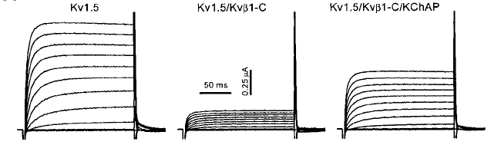
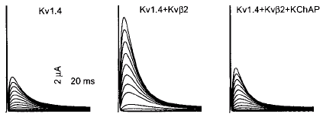
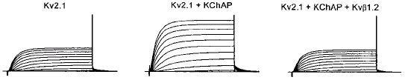
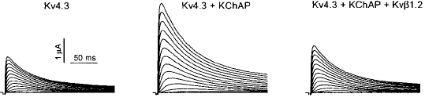
- Discussion
- There are two functionally distinct classes of cytoplasmic Kv channel modulatory proteins that have been described to date.
- The first class includes those subunits that bind tightly to the NH2 termini of Kvα-subunits, exist as part of the mature cell-surface channel complexes, and alter channel gating and/or expression. These include the Kvβ-subunits, which are specific for Kva1 channels, and the recently described KChIP family, which binds only to Kva4 subunits.
- KchAP belongs to a second class of modulators and acts as a chaperone to increase a subset of Kvα currents. KChAP differs from Kvβ-subunits or KChIP in that it interacts only transiently with the NH2 termini of Kvα-subunits, thus behaving more as a true chaperone.
Created by : Chu-Ting Tseng
Date : Jan. 16, 2004

